Supplementary Methods, Tables, and Figures
Supplementary Methods:
RREAS Data comparison with ROMS
Data from conductivity-temperature-depth casts from RREAS survey were used to compare ROMS estimates of the depth of the 26.0 isopycnal and isothermal layer depth (ILD) to observations. This was due to observed inconsistencies between ROMS estimates of the 26.0 isopyncal and CTD observations throughout the California Current after the switch in ROMS forcing in 2011 (Schroeder et al., 2019). Pearson’s correlation coefficients were calculated between the observed 26.0 isopycnal (to the nearest meter) and ROMS estimates (to the nearest 0.1˚ by 0.1˚ cell) for all data (Figure S1a), by year (Figure S1b), and by latitude (Figure S1c). ILD for both ROMS temperature fields and CTD casts was estimated as the depth which temperature differed 0.5˚C from sea surface temperature (Brodie et al., 2018). Pearson’s correlation coefficients between ROMS estimates of ILD and CTD observations were calculated for all data (Figure S1d), by year (Figure S1e), and by latitude (Figure S1f).
NWFSC Pre-Recruit Survey
The Northwest Fisheries Science Center conducts a survey serving as an extension of the RREAS within the coastal ecosystem off Oregon and Washington to quantify the environmental conditions and biota found along the California Current and to elucidate ecosystem-level processes affecting managed and protected marine resources (Auth 2017). The survey gear and sampling schema is similar to that of the RREAS. Full data and information can be found here: https://www.webapps.nwfsc.noaa.gov/apex/parrdata/inventory/tables/table/prerecruit_survey_trawl_data_catch).
Due to the lack of strata, mean recruitment variables (temperature, relaxation events, and wind stress curl) were calculated at the 1˚ latitudinal scale for each line of the survey. Recruitment estimates at the 1˚ scale were used as a predictor for observations of presence/absence. All other environmental predictors were matched to stations exactly as done for the RREAS data. We only use the presence/absence component for validation due to the lack of equivalent strata for a recruitment comparison and the different size of squid caught, making it unlikely the abundance model would compare fairly.

Table S1: Number of hauls by stratum and year for the RREAS. Note that strata-year combinations with <5 hauls were not included in modeling effort as to not include under sampled regions and times.
Year | Stratum | No. of Hauls
1998 | C | 78
1999 | C | 77
2000 | C | 87
2001 | C | 80
2002 | C | 67
2003 | C | 88
2004 | C | 80
2004 | NC | 15
2004 | S | 19
2004 | SC | 5
2005 | C | 75
2005 | NC | 16
2005 | S | 28
2005 | SC | 11
2006 | C | 67
2006 | NC | 27
2006 | S | 28
2006 | SC | 20
2007 | C | 86
2007 | NC | 24
2007 | S | 26
2007 | SC | 18
2008 | C | 33
2008 | NC | 10
2008 | S | 30
2008 | SC | 22
2009 | C | 76
2009 | NC | 12
2009 | S | 15
2009 | SC | 20
2010 | C | 79
2010 | NC | 23
2010 | S | 16
2010 | SC | 5
2011 | C | 48
2011 | NC | 8
2011 | SC | 2
2012 | C | 61
2012 | S | 11
2012 | SC | 11
2013 | C | 61
2013 | N | 14
2013 | NC | 16
2013 | S | 22
2013 | SC | 22
2014 | C | 69
2014 | N | 11
2014 | NC | 22
2014 | S | 14
2014 | SC | 25
2015 | C | 66
2015 | N | 14
2015 | NC | 20
2015 | S | 35
2015 | SC | 26
2016 | C | 60
2016 | N | 3
2016 | NC | 7
2016 | S | 29
2016 | SC | 32
2017 | C | 41
2017 | N | 11
2017 | NC | 15
2017 | S | 15
2017 | SC | 9
2018 | C | 53
2018 | N | 11
2018 | NC | 16
2018 | S | 29
2018 | SC | 17
2019 | C | 47
2019 | N | 4
2019 | NC | 10
2019 | S | 21
2019 | SC | 20
2020 | C | 15
2021 | C | 47
2021 | N | 12
2021 | NC | 9
2021 | S | 27
2021 | SC | 17
Table S2: Mean and standard deviation (SD) of market squid dorsal mantle lengths (DML) collected from the Rockfish Recruitment and Ecosystem Assessment Survey (RREAS) from 2004-2018.
Year | Mean DML (mm) | SD DML (mm)
2004 | 43.16 | 29.53
2005 | 53.61 | 32.09
2006 | 28.26 | 23.23
2007 | 34.47 | 19.27
2008 | 25.90 | 18.78
2009 | 33.71 | 21.80
2010 | 34.16 | 12.92
2011 | 27.44 | 15.49
2012 | 52.34 | 24.64
2013 | 47.04 | 20.94
2014 | 40.70 | 18.95
2015 | 38.12 | 14.54
2016 | 57.95 | 25.89
2017 | 53.85 | 29.71
2018 | 59.86 | 34.72

Table S3: List of ports falling within each fishing region used for comparison with model estimates.
Port | Region
BODEGA BAY | Region1
CRESCENT CITY | Region1
EUREKA | Region1
FIELDS LANDING | Region1
MILL CREEK | Region1
MONTEREY | Region1
MOSS LANDING | Region1
PRINCETON-HALF MOON | Region1
SAN FRANCISCO | Region1
SANTA CRUZ | Region1
AVILA/PORT SAN LUIS | Region2
MORRO BAY | Region2
OXNARD | Region2
PORT HUENEME | Region2
REDONDO BEACH | Region2
SAN PEDRO | Region2
SANTA BARBARA HARBOR | Region2
TERMINAL ISLAND | Region2
VENTURA | Region2

Table S4: Sensitivity of haul-specific abundance (R² and root-mean-square-error; RMSE) and presence/absence (area under the curve; AUC) model fit to error in the ‘recruitment’ component of the model.
Estimate | AUC | R2 | RMSE
Point Est | 0.89 | 0.471 | 2.21
95% | 0.88 | 0.413 | 3.01
5% | 0.89 | 0.49 | 1.76
+1 SE | 0.90 | 0.45 | 2.58
-1 SE | 0.89 | 0.49 | 1.92
Random Sampling | 0.87 (0.86-0.89) | 0.43 (0.39-0.47) | 2.39 (2.27-2.52)

Table S5: Comparison of model-derived indices of market squid abundance and South survey indices of abundance to California Sea Lion diet metrics from San Nicolas Island and San Clemente Island. Rows in bold indicate superior model fit.

Rookery | Season | Response | Predictor | Model Form | R² | p-value
San Nicolas Island | Summer | Freq. Occurr. | Abundance (Hurdle) | Betaregression | 0.474 | 0.019
 | Summer | Freq. Occurr. | Survey Index | Betaregression | 0.660 | 0.001
 | Summer | Mean num. squid | Abundance (Hurdle) | Log-normal | 0.868 | <0.001
 | Summer | Mean num. squid | Survey Index | Log-normal | 0.551 | 0.026
 | Fall | Freq. Occurr. | Abundance (Hurdle) | Betaregression | 0.101 | 0.059
 | Fall | Freq. Occurr. | Survey Index | Betaregression | 0.025 | 0.451
 | Fall | Mean num. squid | Abundance (Hurdle) | Log-normal | 0.453 | 0.046
 | Fall | Mean num. squid | Survey Index | Log-normal | 0.286 | 0.103
San Clemente Island | Summer | Freq. Occurr. | Abundance (Hurdle) | Betaregression | 0.364 | 0.040
 | Summer | Freq. Occurr. | Survey Index | Betaregression | 0.342 | 0.068
 | Summer | Mean num. squid | Abundance (Hurdle) | Log-normal | 0.356 | 0.026
 | Summer | Mean num. squid | Survey Index | Log-normal | 0.397 | 0.141
 | Fall | Freq. Occurr. | Abundance (Hurdle) | Betaregression | 0.272 | 0.073
 | Fall | Freq. Occurr. | Survey Index | Betaregression | 0.467 | 0.007
 | Fall | Mean num. squid | Abundance (Hurdle) | Log-normal | 0.388 | 0.052
 | Fall | Mean num. squid | Survey Index | Log-normal | 0.259 | 0.104

Table S6: Comparison of regressions using model estimates of market squid abundance compared to core strata (Region 1) or south (Region 2) survey indices for predicting Region 1 and 2 landings.

Season | Region | Predictor | Model Form | R² | p-value
July-Sept | 1 | Abundance (Hurdle) | Log-Normal | 0.263 | 0.078
 | 1 | Survey Index | Log-Normal | 0.242 | 0.079
 | 2 | Abundance (Hurdle) | Log-Normal | 0.201 | 0.150
 | 2 | Survey Index | Log-Normal | 0.160 | 0.151

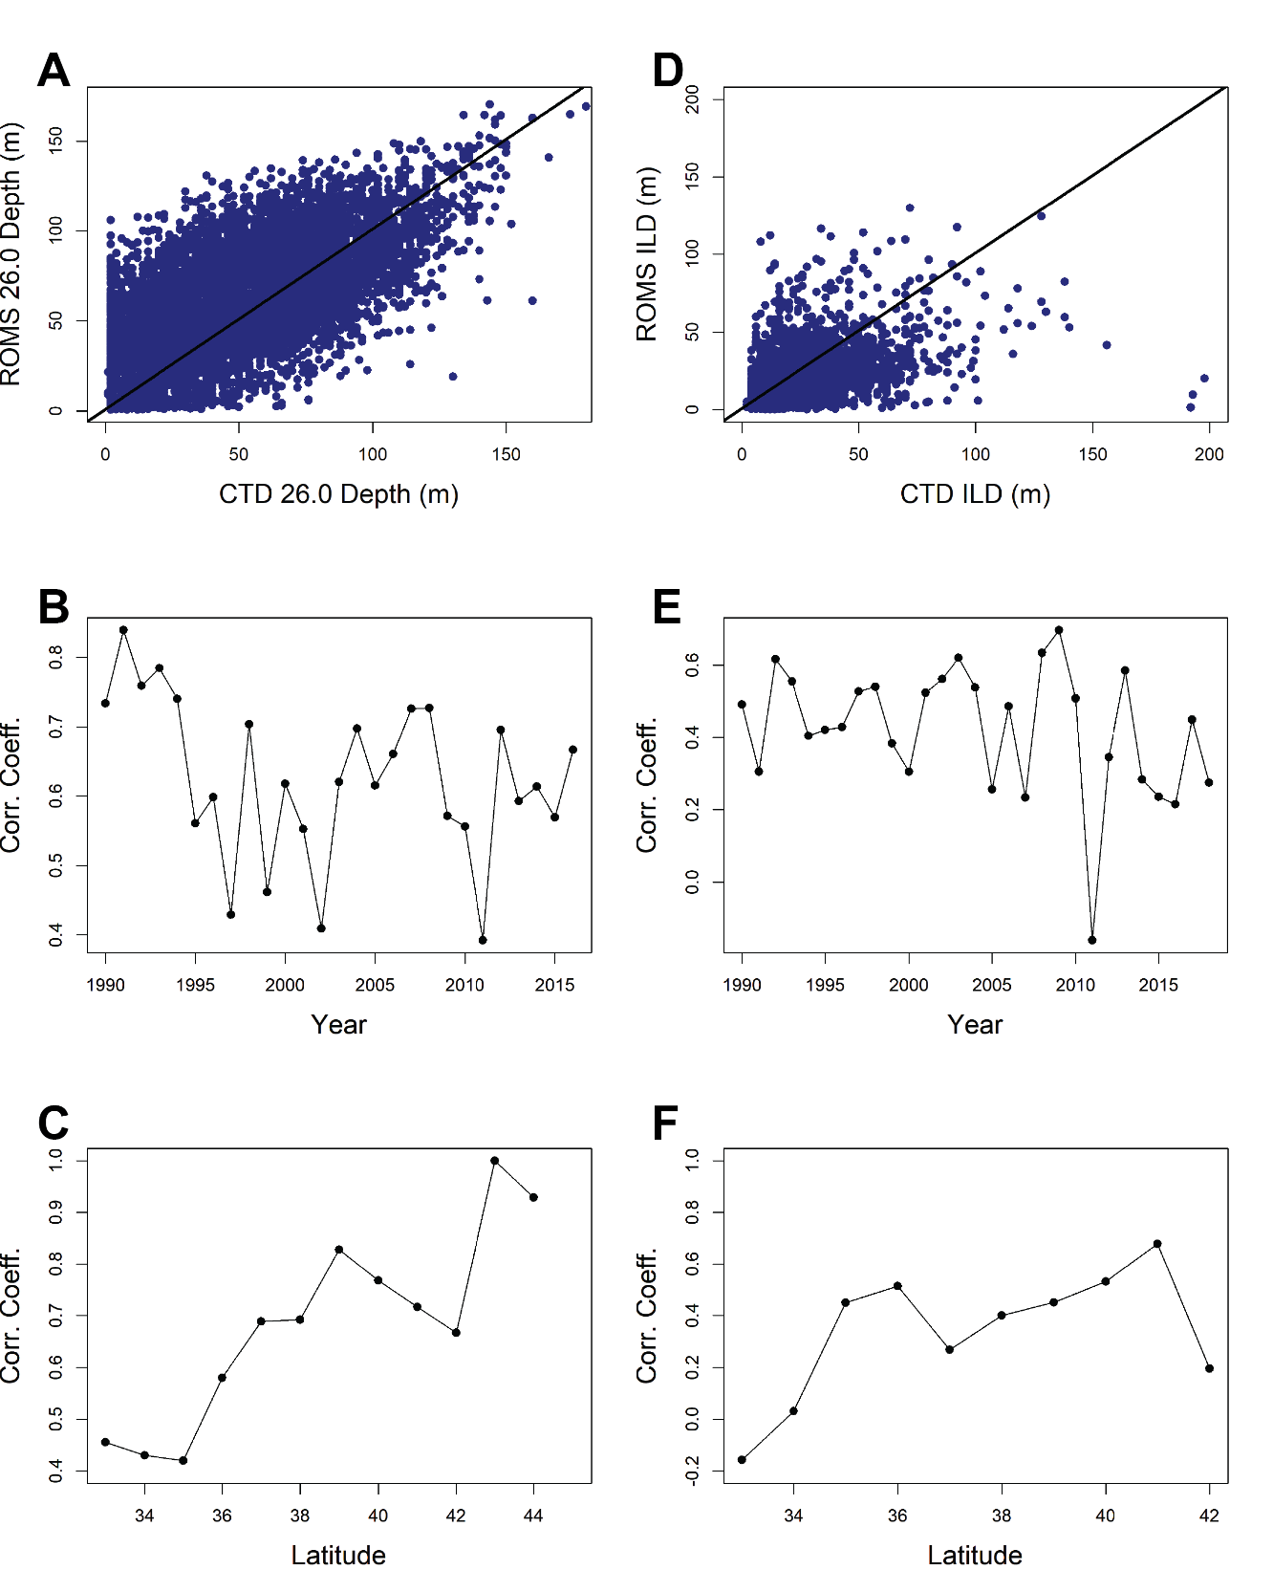
Fig S1. Comparison of depth of the 26.0 isopycnal (A-C) and isothermal layer depth (D-F) between CTD values and ROMS overall (A,D), by year (B,E), and by latitude for 2012-2018 (C,F).
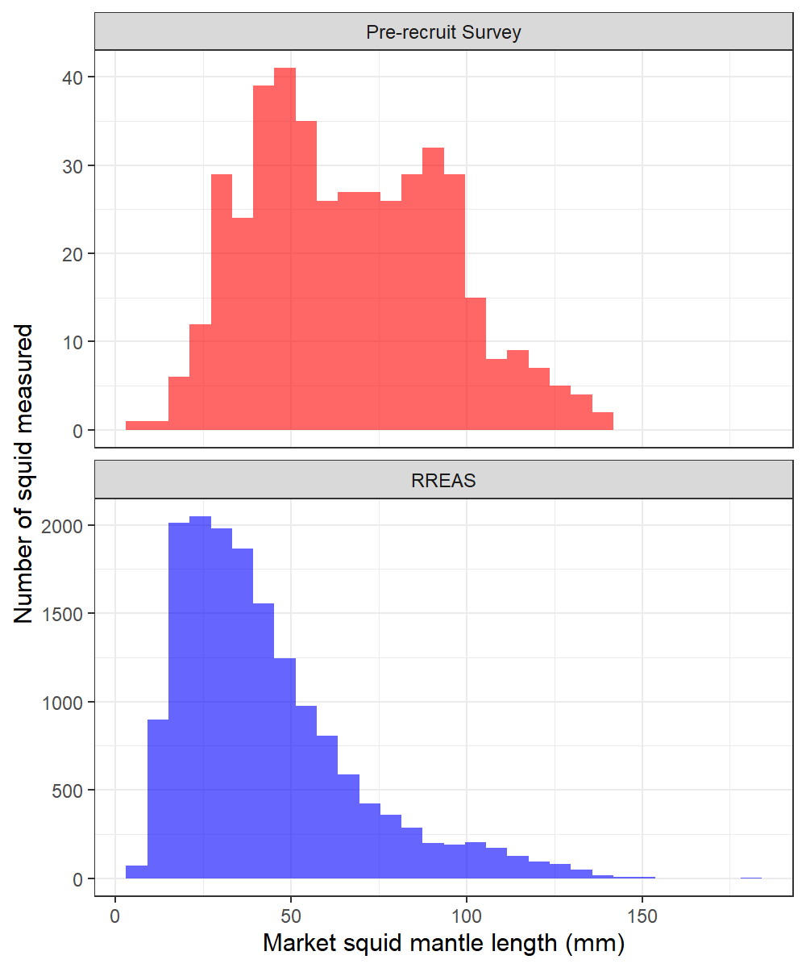
Fig S2: Length-frequency distribution for market squid collected in the Northwest Fisheries Science Center Pre-Recruit Survey (n=434; 2011-2019; red) and the Rockfish Recruitment and Ecosystem Assessment Survey (n=16262; 2004-2018; blue).

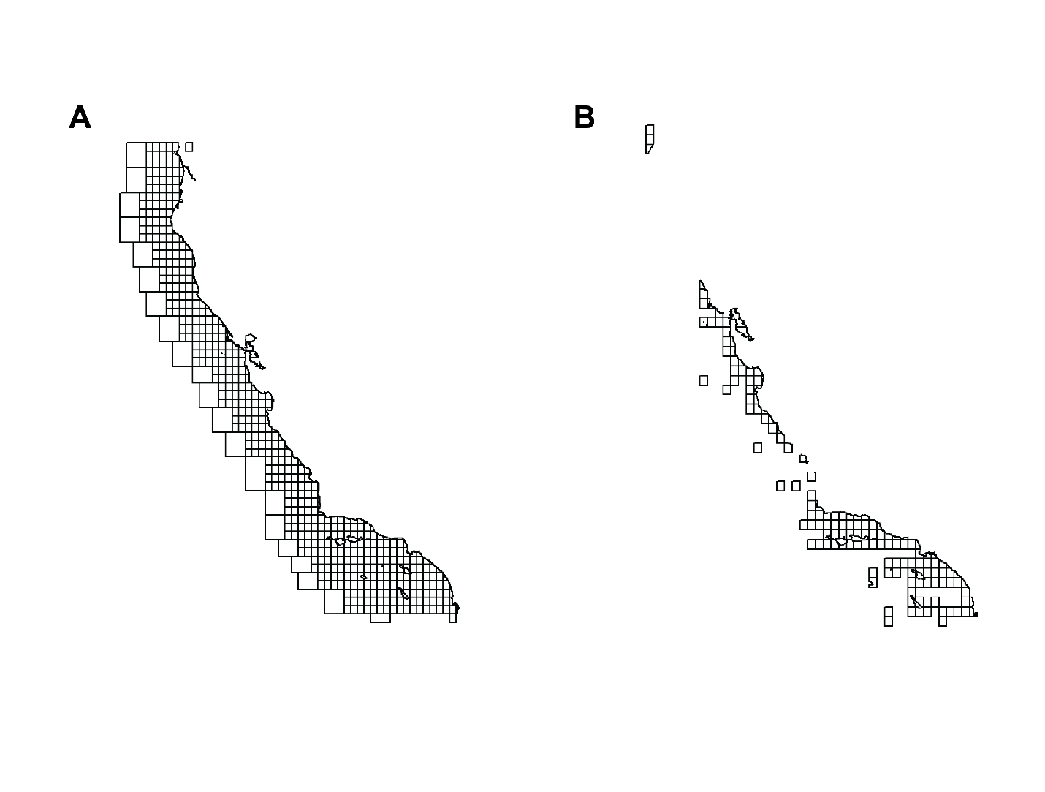
Fig S3. All California Department of Fish and Wildlife commercial fishing blocks (A) and blocks that are used for comparison of model landings which average >5 landings per year and are not ‘offshore’ blocks (B). ‘Offshore’ blocks are the largest offshore blocks in (A).

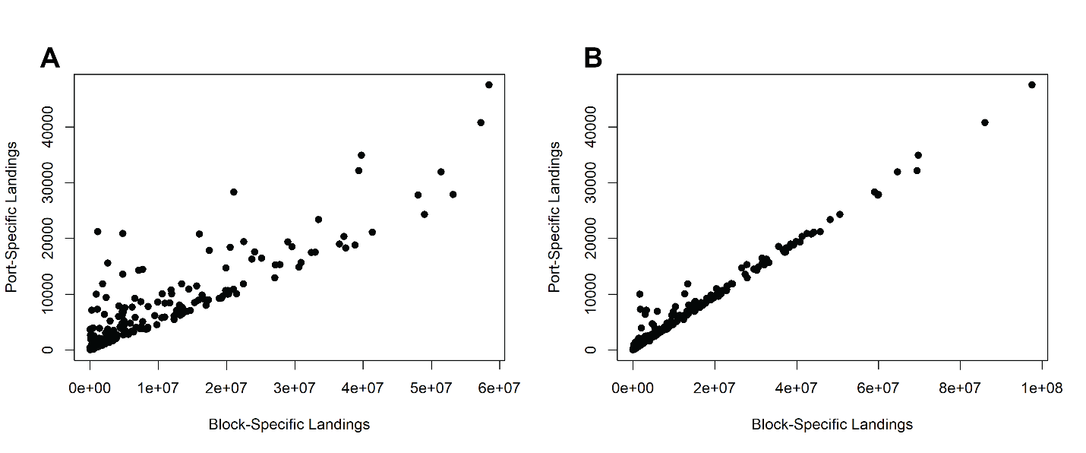
Fig S3. Comparison of block specific landings to port specific landings when only accounting for blocks strictly within Region 2 (A) and when combining blocks within Region 2 and Region 3 (B). Panel B indicates market squid caught in Region 3 are being landed in Region 2 ports.

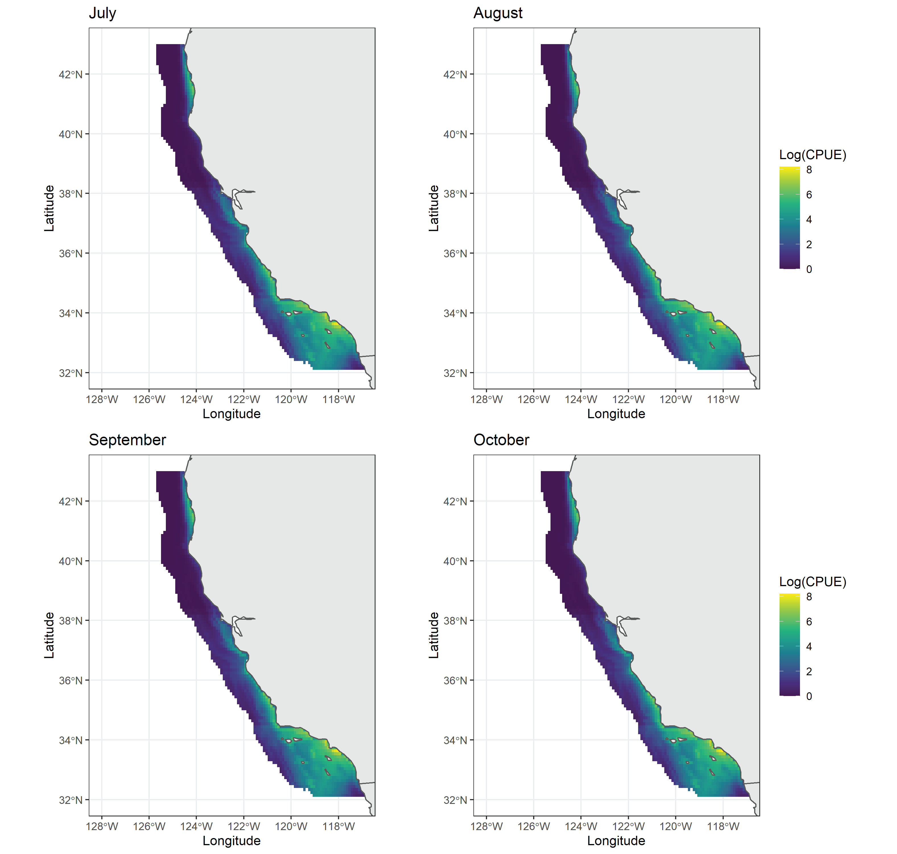
Fig S5. Monthly climatology of market squid abundance estimated by the hurdle model. All plots are on the same scale.

