Appendix
Table A1. Number of salmon lethally sampled at the end of the experiment (N) at each enclosure location. Numbers in parentheses denotes “placebo” fish stocked to keep the same number of fish per enclosure over the course of the experiment.
Region | Location | N
Butte Sink | BSW1 | 7 (3)
 | BSW2 | 10 (4)
 | BSC1 | 10 (4)
Upper Bypass | UBA1 | 10 (3)
 | UBW1 | 10 (2)
Lower Bypass | LBW1 | 10 (2)
 | LBA1 | 10 (1)
 | LBA2 | 10 (6)
Sacramento River | SRC1 | 9 (7)
 | SRC2 | 10 (4)
 | SRC3 | 8 (2)
 | SRC4 | 10
Feather River | FRC1 | 9 (5)

Table A2. Higher taxonomic units (HTUs) defined for ambient and gut invertebrate taxa.
HTU | Comment
Amphipoda | Rare in pelagic invertebrate samples
Cladocera
Copepoda
Insecta
Ostracoda
Rotifera | Rare in gut samples

Table A3. Number of fish (Nfish) used for the mixed effect modelling at each location.
Location | Enclosure | Nfish | Region | Type
BSC1 | 1 | 3 | Butte Sink | Channel
BSC1 | 2 | 3 | Butte Sink | Channel
BSW2 | 1 | 3 | Butte Sink | Wetland
BSW2 | 2 | 3 | Butte Sink | Wetland
BSW1 | 1 | 3 | Butte Sink | Wetland
BSW1 | 2 | 4 | Butte Sink | Wetland
UBA1 | 1 | 4 | Upper Bypass | Agriculture
UBA1 | 2 | 3 | Upper Bypass | Agriculture
UBW1 | 1 | 4 | Upper Bypass | Wetland
UBW1 | 2 | 4 | Upper Bypass | Wetland
LBA1 | 1 | 4 | Lower Bypass | Agriculture
LBA1 | 2 | 5 | Lower Bypass | Agriculture
LBA2 | 1 | 4 | Lower Bypass | Agriculture
LBA2 | 2 | 0 | Lower Bypass | Agriculture
LBW1 | 1 | 4 | Lower Bypass | Wetland
LBW1 | 2 | 4 | Lower Bypass | Wetland
FRC1 | 1 | 4 | Feather River | Channel
FRC1 | 2 | 0 | Feather River | Channel
SRC3 | 1 | 3 | Sacramento River | Channel
SRC3 | 2 | 3 | Sacramento River | Channel
SRC1 | 1 | 2 | Sacramento River | Channel
SRC1 | 2 | 0 | Sacramento River | Channel
SRC2 | 1 | 4 | Sacramento River | Channel
SRC2 | 2 | 2 | Sacramento River | Channel
SRC4 | 1 | 5 | Sacramento River | Channel
SRC4 | 2 | 5 | Sacramento River | Channel

Table A4. Paired t-test models (using pairwise_t_test function in R) showing the significance level of enclosure number (Group 1 and Group 2) on fish growth rates within a given location and time period. Bold numbers show p.value <0.05.
Location | Period | Group 1 |  | Group 2 |  | p.value
BSC1 | 1 | 2 | 1 |  | 0.30228
BSC1 | 2 | 2 | 1 |  | 0.899142
BSC1 | 3 | 2 | 1 |  | 0.101284
BSW1 | 1 | 2 | 1 |  | 0.867487
BSW1 | 2 | 2 | 1 |  | 0.024936
BSW1 | 3 | 2 | 1 |  | 0.710055
BSW2 | 1 | 2 | 1 |  | 0.760742
BSW2 | 2 | 2 | 1 |  | 0.403661
BSW2 | 3 | 2 | 1 |  | 0.797107
LBA1 | 1 | 2 | 1 |  | 0.448304
LBA1 | 2 | 2 | 1 |  | 0.859534
LBA1 | 3 | 2 | 1 |  | 0.644203
LBW1 | 1 | 2 | 1 |  | 0.28492
LBW1 | 2 | 2 | 1 |  | 0.194838
LBW1 | 3 | 2 | 1 |  | 0.727446
SRC2 | 1 | 2 | 1 |  | 0.161052
SRC2 | 2 | 2 | 1 |  | 0.720856
SRC2 | 3 | 2 | 1 |  | 0.429621
SRC3 | 1 | 2 | 1 |  | 0.826724
SRC3 | 2 | 2 | 1 |  | 0.644658
SRC3 | 3 | 2 | 1 |  | 0.394888
SRC4 | 1 | 2 | 1 |  | 0.296462
SRC4 | 2 | 2 | 1 |  | 0.192058
SRC4 | 3 | 2 | 1 |  | 0.139593
UBA1 | 1 | 2 | 1 |  | 0.689804
UBA1 | 2 | 2 | 1 |  | 0.169484
UBA1 | 3 | 2 | 1 |  | 0.459733
UBW1 | 1 | 2 | 1 |  | 0.716446
UBW1 | 2 | 2 | 1 |  | 0.010208
UBW1 | 3 | 2 | 1 |  | 0.256038
Table A5. Best mixed effect model’s parameter mean estimates and confidence intervals (CI).

SGR
Predictors Estimates CI
(Intercept) | 0.82 | 0.18 – 1.46
NMDS2 | -0.72 | -1.31 – -0.14
sdTemp | 0.56 | 0.07 – 1.04
meanCHL | 0.22 | 0.11 – 0.32
NMDS2 * sdTemp | -0.02 | -0.50 – 0.46
NMDS2 * meanCHL | 0.10 | -0.02 – 0.22
sdTemp * meanCHL | -0.03 | -0.11 – 0.05
(NMDS2 * sdTemp) * meanCHL | -0.00 | -0.12 – 0.12
Random Effects
σ2 | 0.59
τ00 PIT | 0.00
τ00 Location | 0.22
N Location | 13
N PIT | 83
Observations 249
Marginal R2 / Conditional R2 0.509 / NA

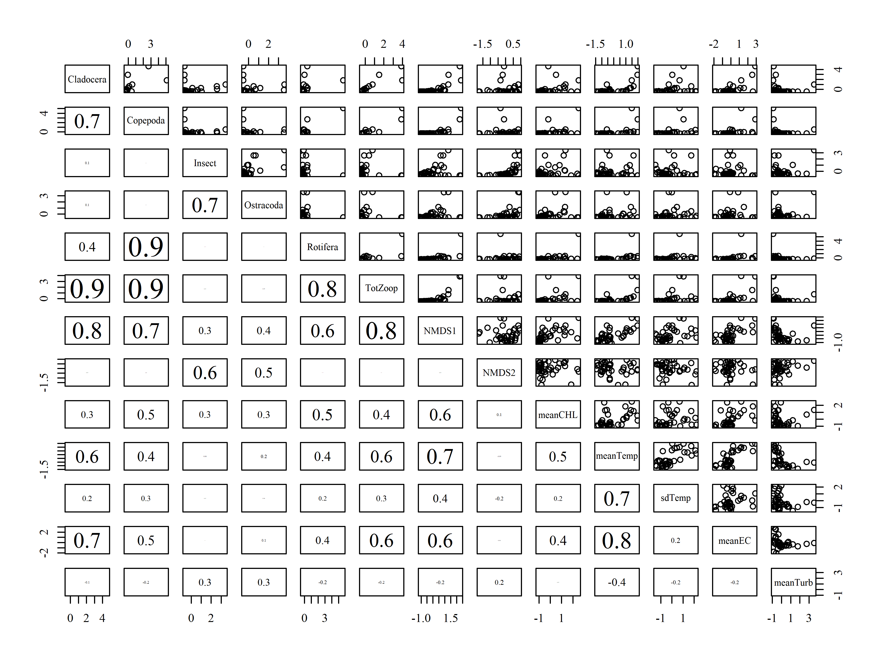
Figure A1. Pearson coefficient (r) between environmental factors considered in mixed effect models

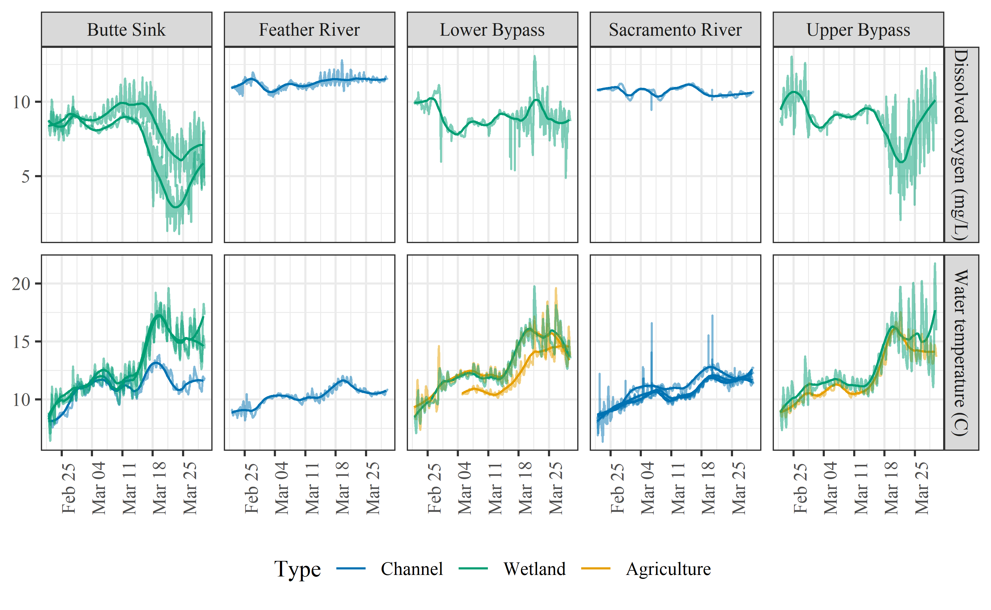Figure A2. Continuous dissolved oxygen (DO) and water temperature grouped by region and colored by habitat type.

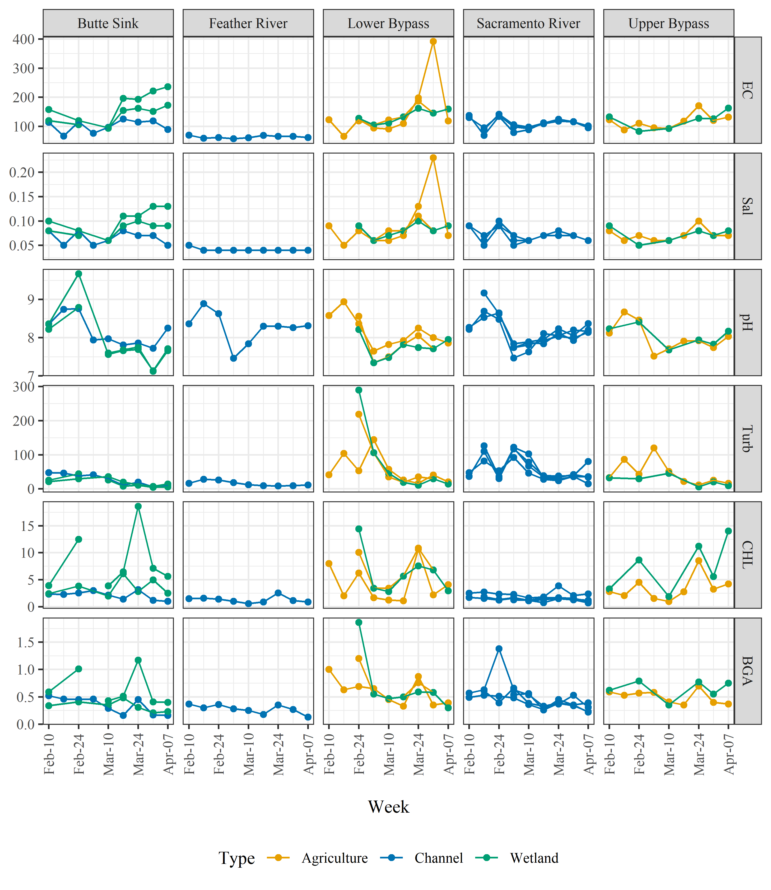Figure A3. Electrical conductivity (EC), salinity (Sal), pH, turbidity (Turb), chlorophyll a (CHL), and blue-green algae (BGA) stack plot, grouped by region and colored by habitat type. Each line shows the factor values for each monitored enclosure.

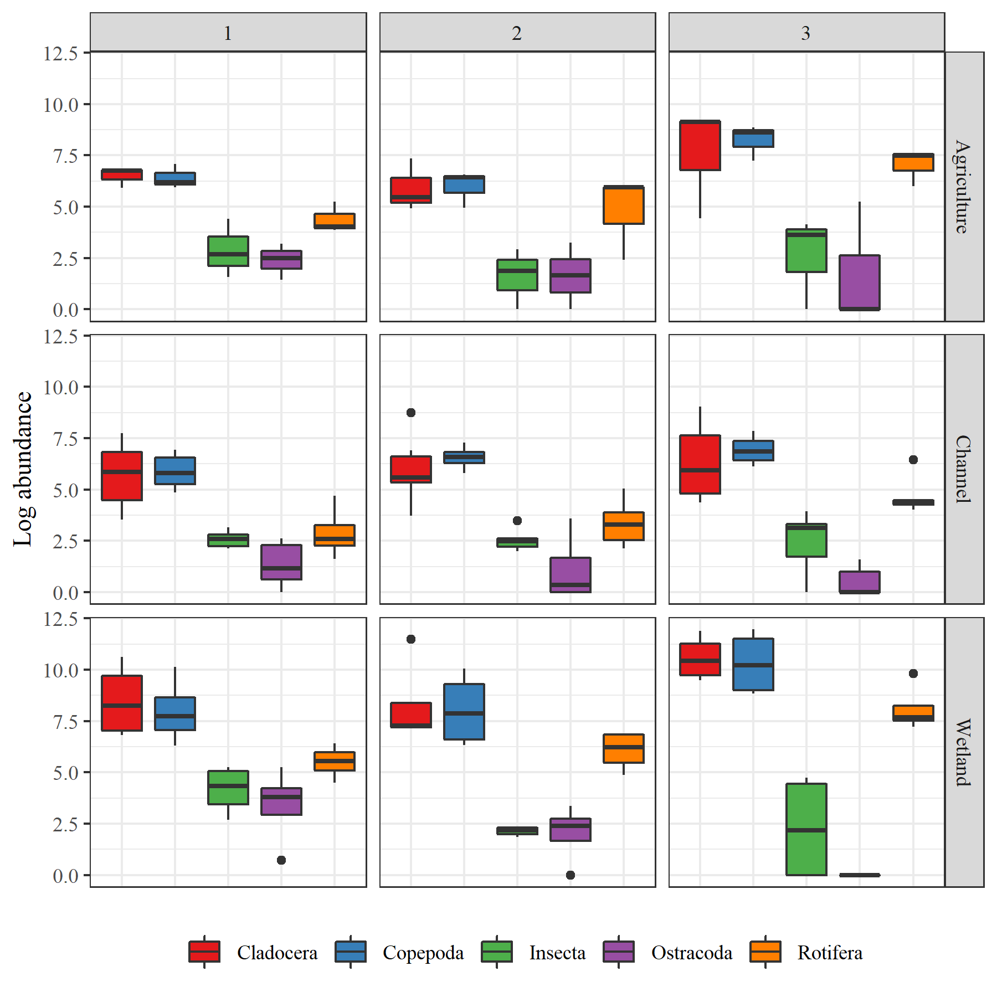Figure A4. Boxplot of ambient pelagic invertebrate log-abundance grouped by HTU (see Table A2 for list of HTUs) for each habitat type and bi-weekly time period, with period 1 = weeks 1 & 2, period 2 = weeks 3 & 4, and period 3 = weeks 5 & 6 of the experiment.

