S1. Fitting to data, ensemble configurations and projections
The US Pacific sardine stock assessment used for model calibration integrates age and length compositions from trawl surveys and fisheries landings, an acoustic index of abundance, egg production–based indices of abundance, and catches for two fishing fleets, the Pacific Northwest (PNW) and the combined Californian and Mexican (MexCal) fleet (Hill, Crone, and Zwolinski 2018). In this model, parameters for sardine fishing mortality rates were pre-calibrated for each age class and each of the two fleets. For each fleet, fisheries selectivity per age class s_{n,f} (cf. equation 1.2) and geographical availability a_{f} were estimated by fitting to annual data for L_{n} and N_{n} and the annual latitudinal position of spawning habitat center of gravity L, for 1980–2010 (MexCal) and 2000–2010 (PNW). ROMS-NEMUCSC output was averaged over the period of highest sardine spawning activity, April to June, and the 24 spatial zones of the sardine population model grid for SST and plankton groups, while CUTI was averaged over the 8 latitudinal rows (Fig. 1b). Plankton group biomass was summed over the upper 200m depth.
Alternative biological model configurations were identified by sensitivity analyses varying all calibration parameters (cf. Supplem. Table S1) in a Latin Hypercube grid in ~200,000 runs. We selected an initial set of 300 model configurations based on correlation with the stock assessment total abundance estimate during 1980-2010, with Pearson’s R > 0.65 and a normalized standard deviation between 0.5 and 2, in order to consider both phase and amplitude of fluctuations (Joliff et al. 2009). Selected configurations were further optimized using a directed Powell search algorithm as integrated in Stella Architect, fitting to sardine numbers at ages 1–8 during 1980-2010 based on lowest squared errors. From the 50 optimized parameter configurations with best fits to numbers-at-age (R² > 0.70 to total abundance estimate), a final ensemble configuration set for projections was created by selecting 9 divergent model configurations, spanning the range of total sardine abundance projections under all three downscaled earth system models (ESMs), and the range of parameter values for the 50 numbers-at-age-optimized model configurations.
Sardine predation mortality, juvenile number and total egg production were not constrained by data due to high uncertainty and patchiness in available data. The final ensemble configuration (Suppl. Table S1) spans different 1) distributions of adult natural mortality rate and reproductive investment over age classes (Suppl. Fig. S1), 2) response curve shapes for temperature-dependent early life stage mortality (Suppl. Fig. S7), 3) rates of larval and juvenile starvation mortality in response to two food items (Suppl. Fig S1), 4) diet compositions and functional responses of adult consumption (Suppl. Fig. S1), and 5) predator rates to determine density-dependent predation mortality (Suppl. Table S1).
For model calibration, age–dependent background (natural) mortality rate was varied as M_{n} = M₁ – MR * (n-1), with M₁ a base mortality rate for age 1, and MR a reduction in mortality rate per age class n > 1 (Table S1). Total adult mortality rates (combined predation and background natural mortality weighted by age class abundance) in the ensemble configurations range from M = 0.27 – 0.73, and encompass estimates of Pacific sardine natural mortality rates from other models and empirical work (Murphy 1967; MacCall 1979; Butler 1993; Hill, Crone, and Zwolinski 2018).
The increase of egg production with age class, and temporal delay from consumption to egg production vary among model configurations (cf. Suppl. Fig. S2, Tab. S1). For model calibration, reproductive investment was varied as RI_{n} = RI₁ * (1– RD * (n–1)), with RI₁ a reproductive investment at age 1, and RD a relative increase in RI per age class n > 1 (Table S1). Total egg production R_{tot} was smoothed by a delay time t_{f} varying among model configurations using Stella Architect’s DELAY1 function for determining the number of newly spawned eggs H₀, to allow for differences in spawning timing and carryover effects between years resulting from individual condition.
This allows dynamically food-dependent, lagged and density-dependent reproductive investment with varying decreases over age classes, while not constraining the total number of produced eggs due to high data uncertainty (Hill, Crone, and Zwolinski 2018). To allow for a range of different spatial migration strategies, as available adult survey data is patchy, the model ensemble configurations span a range of maximum adult migration distances, from spawning area towards areas of highest food availability (Suppl. Tab. S1, Suppl. Fig. S2 center row).
Total mortality rates of eggs and larvae, influenced by SST, vary from 0.9997 to 0.999983, depending on model configuration. Total mortality rates in the subsequent feeding larvae and juvenile stage range from 0.94 to 0.996, and in one model configuration (#5) reach 1.0 (recruitment failure) in some years during model calibration (Suppl. Fig. S4). Adult diet composition varies widely among model configurations, with mesozooplankton being on average the most highly represented group, but some configurations dominated by diatom or krill consumption, while ELS starvation depends more on nanophytoplankton than on microzooplankton availability for 6 of 9 model configurations (Suppl. Tab. S1, Fig. S1).
In one model configuration (#5), which forms the lower uncertainty bound during much of the projections, ELS starvation mortality, exacerbated by food loss due to larval offshore transport, reaches 100% already during the calibration period (Suppl. Figs. S3+S4). However, complete sardine recruitment failures have not been recorded by aging data used in stock assessment (Hill, Crone, and Zwolinski 2018). Also, adult mortality rates are constant over age classes in this model configuration, while they are found to decrease with age in empirical studies (Butler 1993). Thus, while this model configuration represents a possible fit in the wide parameter bounds used during model calibration, we regard it as biologically unlikely.
As an additional sensitivity analysis, food-driven processes were disabled by setting their rates to constant mean values, and three alternative best-fitting configurations identified using the Differential Evolution algorithm in Stella as described above: a) no food effects (only temperature T as a driver, best fit to total sardine abundance R²=0.53); b) only adult food effects and T driving, R²=0.58; c) only ELS food effects and T driving, best R²=0.59. During projections, the alternative configurations reach very high sardine abundance levels, as the removal of food-dependent processes reduces density limitation (Supplemental Figure S10).
Sardine population projections were run in the 9 ensemble model configurations from 2020 to 2100, starting from 2020 numbers-at-age estimates from the sardine stock assessment, and using fisheries age selectivity and availability, and spawning and feeding habitat relations from the calibration period. During the projections, ELS center of gravity follows the T_{SPA} obtained from data fitting and is therefore the same across ecological ensemble members. By contrast, feeding adult COG is determined by the zone of optimal food availability and a maximum migration distance specific to each ensemble configuration.
Total annual landings L_{tot} = ∑ (L_{n}) for future projections are a constant fraction of population abundance in the previous year, as L_{tot (y)} = N_{tot (y-1)} * 0.0832, found by linear regression of 1980–2014 stock assessment data (R² = 0.68), and a catch cutoff value at 150.000 tons stock biomass, which is subtracted from the stock biomass estimate. The current harvest guideline for Pacific sardine uses this cutoff value and a fraction of the biomass in the bounds E_{MSY} = 0.05–0.2, multiplied by 0.87 for the mean sardine distribution in US waters. Biomass here was calculated from annual modeled sardine numbers and mean sardine individual weight-at-age from 2005-2018 (Hill, Crone, and Zwolinski 2018).

Table S1: Model ensemble configurations with parameters, calibration ranges and values for each configuration (cf. Table 1, main manuscript, and text section S1). For T_{lim}, a value range providing good fits during calibration is used for projections.
category | parameter | description | food item | unit | calibr. range | ensemble configuration
 |  |  |  |  |  | 1 | 2 | 3 | 4 | 5 | 6 | 7 | 8 | 9
Adult stock | M₁ | Background mortality rate age 1 |  | – | 0.2 – 0.6 | 0.43 | 0.30 | 0.39 | 0.26 | 0.34 | 0.32 | 0.40 | 0.35 | 0.31
 | MR | Reduction of M per age class > 1 |  | – | 0 – 0.2 | 0.06 | 0.08 | 0.19 | 0.11 | 0.01 | 0.01 | 0.01 | 0.12 | 0.10
Predation | p | Predation rate |  | – | 0 – 0.4 | 0.39 | 0.19 | 0.21 | 0.31 | 0.20 | 0.15 | 0.36 | 0.26 | 0.33
 | g_{p} | Predator growth rate |  | – | 100 – 100.000 | 1.00E+05 | 5.00E+04 | 1.01E+04 | 8.00E+04 | 8.00E+04 | 9.00E+04 | 4.01E+04 | 3.01E+04 | 7.01E+04
 | m_{p} | Predator quadratic mortality rate |  | – | 0.0001 – 0.1 | 0.01 | 0.03 | 0.04 | 0.09 | 0.05 | 0.09 | 0.07 | 0.03 | 0.07
 | f_{p} | Sardine predator feedback |  | – | 0 – 0.7 | 0.14 | 0.63 | 0.69 | 0.48 | 0.35 | 0.36 | 0.21 | 0.30 | 0.10
Early life stages (non-feeding) | T_{b} | Base ELS mortality rate |  | – | 0.6 – 1 | 0.92 | 0.92 | 0.95 | 0.88 | 0.92 | 0.92 | 0.94 | 0.88 | 0.89
 | T_{s} | Thermal mortality slope |  | – | 1 – 5 | 2.22 | 4.90 | 3.55 | 4.90 | 3.91 | 1.13 | 2.43 | 2.96 | 1.35
 | T_{lim} | ELS thermal limit  (uncertainty range) |  | °C | 13 – 27 | 17.5–19.5 | 15.5– 18.5 | 16.0–19.0 | 16.0–18.5 | 16.0–19.0 | 19.0–20.5 | 16.5–19.5 | 16.5–19.5 | 19.0–20.5
 | d_{temp} | Temperature-sensitive ELS development time |  | months | 3 – 10 | 7.57 | 9.90 | 6.62 | 8.16 | 9.39 | 9.09 | 9.35 | 6.64 | 5.56
 | d_{min} | Minimum ELS development time |  | months | 1 – 4 | 2.81 | 3.61 | 2.13 | 3.27 | 3.58 | 2.74 | 3.63 | 2.81 | 3.00
 | d_{s} | Development time slope |  | – | 0.2 – 1 | 0.52 | 0.82 | 0.47 | 0.34 | 0.86 | 0.63 | 0.76 | 0.36 | 0.30
ELS  (feeding) | M_{j} | Late larvae-juvenile mortality rate |  | – | 0.9 – 1 | 0.954 | 0.961 | 0.976 | 0.921 | 0.956 | 0.959 | 0.920 | 0.938 | 0.972
 | s₁, s₂ | Starvation factor per food item | PS | – | 0 – 1 | 0.04 | 0.14 | 0.11 | 0.12 | 0.14 | 0.14 | 0.08 | 0.12 | 0.00
 |  |  | ZS | – |  | 0.09 | 0.01 | 0.00 | 0.09 | 0.13 | 0.04 | 0.01 | 0.10 | 0.02
Consumption & reproduction | K’ | Unlimited stock level |  | Individ. | 10⁹ – 10¹² | 1.31E+10 | 1.09E+10 | 7.21E+09 | 7.11E+09 | 1.07E+10 | 7.14E+09 | 7.10E+09 | 7.10E+09 | 7.01E+09
 | C_{i max} | Maximum consumption per individual (per food item) | PL | – | 1000 – 300.000 | 1.99E+03 | 2.50E+05 | 2.49E+05 | 1.53E+05 | 9.00E+04 | 2.99E+04 | 1.51E+05 | 3.12E+04 | 2.99E+05
 |  |  | ZM | – |  | 6.34E+04 | 1.00E+05 | 2.62E+03 | 2.97E+05 | 2.41E+05 | 2.70E+05 | 1.01E+05 | 2.12E+05 | 3.03E+04
 |  |  | ZL | – |  | 2.17E+05 | 1.06E+05 | 5.70E+04 | 2.99E+05 | 1.20E+05 | 8.97E+04 | 2.99E+05 | 1.04E+03 | 2.11E+05
 | C_{i min} | Relative consumption per individual at minimum food level (per food item) | PL | – | 0 – 1 | 0.85 | 0.09 | 0.11 | 0.50 | 0.61 | 0.70 | 0.60 | 0.41 | 0.67
 |  |  | ZM | – |  | 0.33 | 0.41 | 0.71 | 0.62 | 0.90 | 0.89 | 0.60 | 0.90 | 0.61
 |  |  | ZL | – |  | 0.26 | 0.40 | 0.50 | 0.91 | 0.99 | 0.20 | 0.40 | 0.41 | 0.60
 | t_{q} | Consumption smoothing period |  | months | 1 – 48 | 39.94 | 36.17 | 47.90 | 1.10 | 12.67 | 12.83 | 47.90 | 12.94 | 24.60
 | K_{min} | Minimum stock limit |  | individ. | 7*10⁹ – 5*10¹¹ | 9.86E+09 | 9.99E+09 | 8.86E+09 | 7.25E+09 | 7.10E+09 | 7.12E+09 | 1.00E+10 | 7.17E+09 | 7.10E+09
 | RI₁ | Reprod. investment at age 1 |  | – | 0.05 – 0.2 | 0.18 | 0.19 | 0.12 | 0.14 | 0.17 | 0.06 | 0.16 | 0.07 | 0.13
 | RD | Increase of RI per age class > 1 |  | – | 0.2 – 1 | 0.34 | 0.59 | 0.85 | 0.57 | 0.60 | 0.35 | 0.93 | 0.85 | 0.32
Adult distribution | CF | Adult concentration factor |  | – | 0.5 – 3 | 0.62 | 0.60 | 2.40 | 0.59 | 1.13 | 1.76 | 0.60 | 0.54 | 3.00
 | LD | Local density limitation factor |  | – | 0 – 1 | 0.99 | 0.50 | 0.75 | 0.02 | 0.24 | 0.50 | 0.01 | 0.24 | 0.22
 | FM | Foraging migration distance |  | – | 0 – 1 | 0.96 | 0.62 | 0.74 | 0.87 | 0.51 | 0.52 | 0.63 | 0.50 | 0.74

Table S2. Annual catch of age classes 1–8 (individuals) of the Pacific sardine Northern subpopulation for the Pacific Northwest (PNW) and Californian-Mexican (MexCal) fleets, from a long-term research stock assessment model (Kuriyama et al. submitted).

 | MexCal
year | Age1 | Age2 | Age3 | Age4 | Age5 | Age6 | Age7 | Age8
1980 | 1974130 | 1205020 | 12241 | 35 | 6 | 0 | 0 | 0
1981 | 199268 | 321573 | 14972 | 10 | 3 | 0 | 0 | 0
1982 | 1166981 | 1882050 | 760757 | 3290 | 29 | 1 | 0 | 0
1983 | 1533151 | 1826881 | 177314 | 10545 | 627 | 1 | 0 | 0
1984 | 9864905 | 13174017 | 3535802 | 273812 | 111963 | 1042 | 4 | 0
1985 | 3881200 | 8764330 | 1069379 | 69396 | 44133 | 2491 | 80 | 0
1986 | 2825283 | 9259000 | 4583708 | 287558 | 134851 | 12648 | 2274 | 3
1987 | 20494890 | 16139470 | 6194570 | 2045909 | 675927 | 55966 | 9559 | 51
1988 | 15708470 | 19293630 | 2015828 | 942436 | 749369 | 60885 | 6958 | 68
1989 | 41036000 | 50248600 | 25497900 | 1384190 | 1546234 | 298018 | 46130 | 480
1990 | 32397610 | 51769800 | 58219300 | 4493820 | 1791810 | 388444 | 191215 | 1938
1991 | 19932913 | 43561300 | 131589700 | 24223550 | 9971350 | 851565 | 282008 | 5435
1992 | 263524019 | 197192100 | 139841600 | 40663020 | 35394210 | 5295570 | 756203 | 32229
1993 | 92078710 | 50544210 | 1763743 | 8261 | 64686 | 8008 | 6199 | 220
1994 | 439206900 | 113158100 | 36306700 | 348590 | 20007 | 22758 | 8862 | 499
1995 | 256122600 | 93184900 | 19807520 | 1204276 | 250085 | 2236 | 6447 | 222
1996 | 88429090 | 185350100 | 34618540 | 625113 | 860210 | 30776 | 613 | 148
1997 | 206716500 | 119889900 | 63983800 | 3970940 | 1713846 | 431635 | 34491 | 239
1998 | 631179000 | 209332000 | 75449700 | 24773170 | 9283630 | 696259 | 419721 | 1790
1999 | 755572100 | 190984400 | 3552683 | 2390675 | 3582610 | 264408 | 27119 | 520
2000 | 243478000 | 344653000 | 8771231 | 4513997 | 3530600 | 1450944 | 111802 | 1024
2001 | 198341800 | 118301600 | 51199800 | 8649320 | 4617840 | 957046 | 523350 | 3840
2002 | 442952000 | 123356300 | 13217230 | 12488210 | 10461820 | 1387542 | 344909 | 11002
2003 | 83198900 | 76821300 | 12607860 | 3128610 | 16975950 | 3570010 | 783953 | 30943
2004 | 702266000 | 4998810 | 6364600 | 693761 | 800513 | 926430 | 356674 | 8599
2005 | 352493000 | 195612500 | 549557 | 1057035 | 466426 | 126593 | 155347 | 3355
2006 | 663082000 | 233635800 | 31395400 | 346166 | 1060890 | 141395 | 36157 | 5040
2007 | 413104900 | 734079000 | 38106900 | 3963723 | 101819 | 71166 | 23081 | 4307
2008 | 500590000 | 382909000 | 57581700 | 3573828 | 7537772 | 24963 | 54409 | 4046
2009 | 264795000 | 161706000 | 23629500 | 8776183 | 13220187 | 2757577 | 27388 | 6800
2010 | 353907000 | 82318620 | 14968370 | 1584514 | 6264541 | 937271 | 537165 | 1555
2011 | 169510500 | 219434800 | 42792200 | 18107710 | 22174170 | 11854230 | 3449451 | 67792
2012 | 4644553 | 73794210 | 26983420 | 1669791 | 5026586 | 1232643 | 1681944 | 42966
2013 | 5552232 | 8100566 | 24145750 | 3700510 | 1551695 | 665104 | 284776 | 20318
2014 | 3903414 | 596979 | 1073355 | 8705381 | 2310191 | 274520 | 93989 | 4237
2015 | 307824 | 312488 | 110213 | 58788 | 489686 | 31944 | 8978 | 1413
2016 | 13279093 | 26320390 | 5728450 | 357963 | 1781461 | 2322542 | 460464 | 26484
2017 | 3035565 | 22904094 | 8718556 | 370326 | 222984 | 158274 | 700130 | 13779
2018 | 15397303 | 21369936 | 30681144 | 2979794 | 1006623 | 92854 | 216522 | 56957
 | PNW
year | Age1 | Age2 | Age3 | Age4 | Age5 | Age6 | Age7 | Age8
1980 | 0 | 0 | 0 | 0 | 0 | 0 | 0 | 0
1981 | 0 | 0 | 0 | 0 | 0 | 0 | 0 | 0
1982 | 0 | 0 | 0 | 0 | 0 | 0 | 0 | 0
1983 | 0 | 0 | 0 | 0 | 0 | 0 | 0 | 0
1984 | 0 | 0 | 0 | 0 | 0 | 0 | 0 | 0
1985 | 0 | 0 | 0 | 0 | 0 | 0 | 0 | 0
1986 | 0 | 0 | 0 | 0 | 0 | 0 | 0 | 0
1987 | 0 | 0 | 0 | 0 | 0 | 0 | 0 | 0
1988 | 0 | 0 | 0 | 0 | 0 | 0 | 0 | 0
1989 | 0 | 0 | 0 | 0 | 0 | 0 | 0 | 0
1990 | 0 | 0 | 0 | 0 | 0 | 0 | 0 | 0
1991 | 0 | 0 | 0 | 0 | 0 | 0 | 0 | 0
1992 | 0 | 0 | 0 | 0 | 0 | 1 | 8452 | 12266
1993 | 0 | 0 | 0 | 0 | 0 | 0 | 0 | 0
1994 | 0 | 0 | 0 | 0 | 0 | 0 | 0 | 0
1995 | 0 | 0 | 0 | 0 | 0 | 0 | 56988 | 58865
1996 | 0 | 0 | 0 | 0 | 0 | 33 | 26691 | 196287
1997 | 0 | 0 | 0 | 0 | 0 | 37 | 121507 | 25486
1998 | 0 | 0 | 0 | 0 | 0 | 119 | 2732642 | 342135
1999 | 0 | 1452138 | 2854160 | 1703499 | 1809566 | 345047 | 79227 | 62740
2000 | 0 | 19477830 | 58734590 | 23049690 | 13178300 | 13747630 | 2596434 | 1071423
2001 | 0 | 3976922 | 81353400 | 48275400 | 17196510 | 9565400 | 9913630 | 2650744
2002 | 0 | 6231222 | 27063869 | 90043900 | 53378502 | 18316956 | 10162640 | 13368198
2003 | 2139353 | 90664870 | 25309380 | 18962930 | 62914640 | 37112420 | 12701086 | 16381613
2004 | 91823720 | 33740126 | 75622170 | 24250151 | 17118984 | 55845790 | 33376461 | 26307179
2005 | 0 | 286737861 | 22120735 | 52324867 | 17274029 | 11731814 | 38364736 | 41058949
2006 | 0 | 77739000 | 263114000 | 3824520 | 8753040 | 2918490 | 1959100 | 13284160
2007 | 0 | 0 | 164272000 | 194029000 | 2360820 | 5326450 | 1773330 | 9325910
2008 | 0 | 0 | 131836000 | 88295600 | 83977200 | 931890 | 2086650 | 4366587
2009 | 0 | 0 | 0 | 150789570 | 97186680 | 75269480 | 774700 | 5408131
2010 | 0 | 0 | 0 | 86721637 | 149246257 | 82755924 | 50075373 | 4150640
2011 | 0 | 44256880 | 31741270 | 69017720 | 48291500 | 75700700 | 33038190 | 20920037
2012 | 0 | 150960280 | 212114610 | 44158193 | 72700910 | 54777086 | 78978380 | 56964139
2013 | 0 | 0 | 210903310 | 64993296 | 17508295 | 20898423 | 16561439 | 42173305
2014 | 0 | 0 | 9815570 | 58431760 | 12255230 | 3521693 | 3872281 | 11473681
2015 | 0 | 0 | 0 | 0 | 0 | 7 | 65407 | 291028
2016 | 0 | 0 | 0 | 0 | 0 | 54 | 349198 | 548928
2017 | 0 | 0 | 0 | 0 | 0 | 0 | 10771 | 5931
2018 | 0 | 0 | 0 | 0 | 0 | 0 | 6197 | 44349

Table S3: Abundance of age classes 1–8 (individuals) for the Pacific sardine Northern subpopulation from a long-term research stock assessment model (Kuriyama et al. submitted).

year | Age1 | Age2 | Age3 | Age4 | Age5 | Age6 | Age7 | Age8
1981 | 2.580E+07 | 6.217E+06 | 1.403E+05 | 5.600E+02 | 7.500E+01 | 2.000E+00 | 0.000E+00 | 0.000E+00
1982 | 5.409E+07 | 1.414E+07 | 3.095E+06 | 7.009E+04 | 3.050E+02 | 4.000E+01 | 1.000E+00 | 0.000E+00
1983 | 1.195E+08 | 2.874E+07 | 6.551E+06 | 1.299E+06 | 3.659E+04 | 1.480E+02 | 2.100E+01 | 1.000E+00
1984 | 2.539E+08 | 6.572E+07 | 1.516E+07 | 3.516E+06 | 7.160E+05 | 1.992E+04 | 8.200E+01 | 1.200E+01
1985 | 2.417E+08 | 1.322E+08 | 2.696E+07 | 5.811E+06 | 1.754E+06 | 3.152E+05 | 1.031E+04 | 4.900E+01
1986 | 2.033E+08 | 1.319E+08 | 6.906E+07 | 1.422E+07 | 3.185E+06 | 9.438E+05 | 1.737E+05 | 5.713E+03
1987 | 5.362E+08 | 1.088E+08 | 6.688E+07 | 3.448E+07 | 7.561E+06 | 1.660E+06 | 5.154E+05 | 9.827E+04
1988 | 9.806E+08 | 2.844E+08 | 5.102E+07 | 3.292E+07 | 1.805E+07 | 3.831E+06 | 8.953E+05 | 3.356E+05
1989 | 9.793E+08 | 5.237E+08 | 1.425E+08 | 2.690E+07 | 1.772E+07 | 9.628E+06 | 2.103E+06 | 6.813E+05
1990 | 5.949E+08 | 5.101E+08 | 2.621E+08 | 6.513E+07 | 1.408E+07 | 8.876E+06 | 5.182E+06 | 1.518E+06
1991 | 7.971E+08 | 2.955E+08 | 2.123E+08 | 1.013E+08 | 3.053E+07 | 6.356E+06 | 4.642E+06 | 3.591E+06
1992 | 2.590E+09 | 3.685E+08 | 9.338E+07 | 5.015E+07 | 3.524E+07 | 1.079E+07 | 3.057E+06 | 4.407E+06
1993 | 1.920E+09 | 1.242E+09 | 1.187E+08 | 3.161E+06 | 1.154E+07 | 4.590E+06 | 3.642E+06 | 3.661E+06
1994 | 4.529E+09 | 9.814E+08 | 6.462E+08 | 6.509E+07 | 1.755E+06 | 6.380E+06 | 2.551E+06 | 4.064E+06
1995 | 1.145E+10 | 2.190E+09 | 4.751E+08 | 3.437E+08 | 3.598E+07 | 9.623E+05 | 3.512E+06 | 3.653E+06
1996 | 6.216E+09 | 6.154E+09 | 1.155E+09 | 2.565E+08 | 1.907E+08 | 1.987E+07 | 5.346E+05 | 3.950E+06
1997 | 6.248E+09 | 3.366E+09 | 3.321E+09 | 6.294E+08 | 1.424E+08 | 1.056E+08 | 1.100E+07 | 2.320E+06
1998 | 1.018E+10 | 3.316E+09 | 1.812E+09 | 1.807E+09 | 3.477E+08 | 7.814E+07 | 5.753E+07 | 7.219E+06
1999 | 1.014E+10 | 5.215E+09 | 1.733E+09 | 9.568E+08 | 9.888E+08 | 1.871E+08 | 4.303E+07 | 3.458E+07
2000 | 1.951E+09 | 5.017E+09 | 2.789E+09 | 9.512E+08 | 5.252E+08 | 5.426E+08 | 1.029E+08 | 4.275E+07
2001 | 1.564E+09 | 9.048E+08 | 2.582E+09 | 1.504E+09 | 5.119E+08 | 2.822E+08 | 2.927E+08 | 7.872E+07
2002 | 2.377E+09 | 7.152E+08 | 4.143E+08 | 1.342E+09 | 7.906E+08 | 2.682E+08 | 1.488E+08 | 1.963E+08
2003 | 4.676E+08 | 9.996E+08 | 3.139E+08 | 2.080E+08 | 6.850E+08 | 4.023E+08 | 1.376E+08 | 1.777E+08
2004 | 1.444E+10 | 2.015E+08 | 4.527E+08 | 1.485E+08 | 1.003E+08 | 3.260E+08 | 1.952E+08 | 1.540E+08
2005 | 1.123E+10 | 7.462E+09 | 8.902E+07 | 2.011E+08 | 6.689E+07 | 4.473E+07 | 1.464E+08 | 1.572E+08
2006 | 1.330E+10 | 5.951E+09 | 3.847E+09 | 4.046E+07 | 9.079E+07 | 3.023E+07 | 2.027E+07 | 1.379E+08
2007 | 5.015E+09 | 6.749E+09 | 3.092E+09 | 1.958E+09 | 2.017E+07 | 4.502E+07 | 1.509E+07 | 7.921E+07
2008 | 3.220E+09 | 2.384E+09 | 3.398E+09 | 1.614E+09 | 9.898E+08 | 1.000E+07 | 2.243E+07 | 4.708E+07
2009 | 1.476E+09 | 1.400E+09 | 1.175E+09 | 1.760E+09 | 8.277E+08 | 4.874E+08 | 4.931E+06 | 3.435E+07
2010 | 2.623E+09 | 6.032E+08 | 7.212E+08 | 6.009E+08 | 8.596E+08 | 3.833E+08 | 2.231E+08 | 1.803E+07
2011 | 2.729E+09 | 1.158E+09 | 2.862E+08 | 3.629E+08 | 2.847E+08 | 3.958E+08 | 1.737E+08 | 1.087E+08
2012 | 1.956E+08 | 1.367E+09 | 4.400E+08 | 1.077E+08 | 1.364E+08 | 1.040E+08 | 1.525E+08 | 1.110E+08
2013 | 3.933E+07 | 1.055E+08 | 5.716E+08 | 1.293E+08 | 3.681E+07 | 3.987E+07 | 3.237E+07 | 8.387E+07
2014 | 8.269E+07 | 1.771E+07 | 4.907E+07 | 2.074E+08 | 4.389E+07 | 1.258E+07 | 1.365E+07 | 4.126E+07
2015 | 2.628E+08 | 4.318E+07 | 9.470E+06 | 2.300E+07 | 9.070E+07 | 1.900E+07 | 5.567E+06 | 2.470E+07
2016 | 3.968E+08 | 1.457E+08 | 2.331E+07 | 5.206E+06 | 1.277E+07 | 5.016E+07 | 1.041E+07 | 1.650E+07
2017 | 1.537E+08 | 2.110E+08 | 6.166E+07 | 9.224E+06 | 2.632E+06 | 5.783E+06 | 2.620E+07 | 1.434E+07
2018 | 3.189E+08 | 8.333E+07 | 1.004E+08 | 2.814E+07 | 4.861E+06 | 1.299E+06 | 3.101E+06 | 2.203E+07

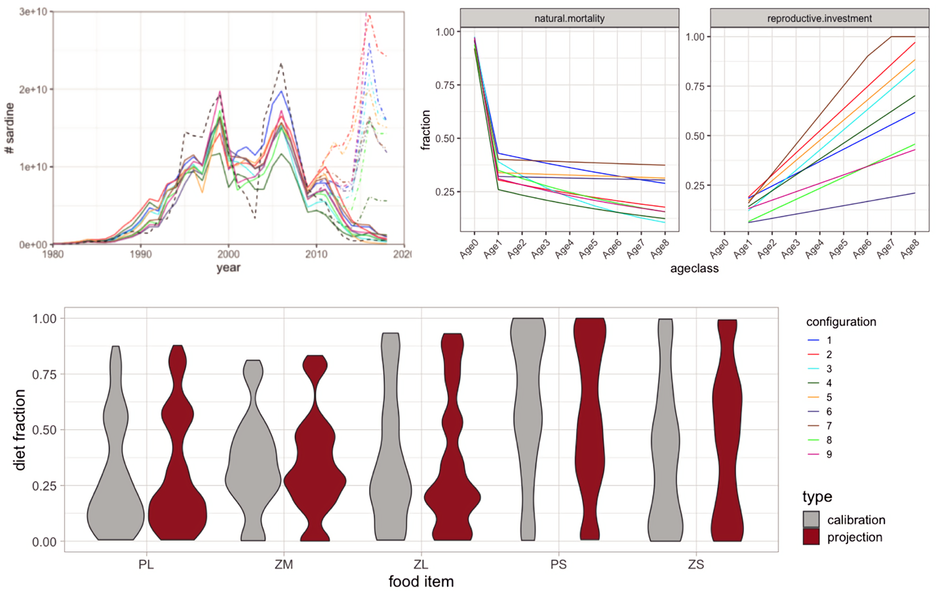

Fig. S1: a) Total sardine abundance during calibration and testing period (dotted line: stock assessment estimate, testing period 2011–2018: solid lines are low food availability scenario, dot-dashed lines are high food availability scenario), b) Sardine background natural mortality per age class and reproductive investment (fraction of consumed energy invested in egg production) per age class, c) distribution of adult diet composition (relative consumption of food items PL, ZM, ZL) and early life stage diet (relative starvation mortality related to food items PS and ZS), shown as range across model configurations, during calibration period (grey) and pooled projections under three ESMs (brown)

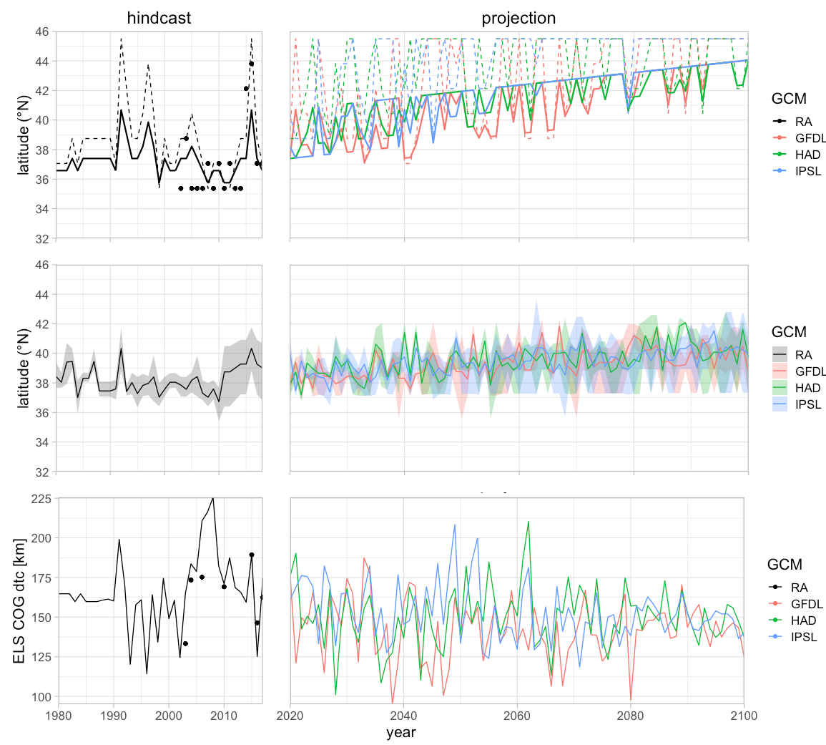

Fig S2: Annual center of gravity (COG) of sardine spawning and feeding habitat during model calibration (left column, dots: peak sardine egg and larvae concentration from CalCOFI data binned into model cells) and during projections under three different earth system models (right column, red: GFDL, green: HAD, blue: IPSL). Top row: Sardine latitudinal COG of spawning habitat (solid line, same for all model configurations), based on fit to annual latitude of optimal SST (13.5°C, dashed line). Center row: Adult feeding habitat latitudinal COG (mean and range among model configurations), based on maximum feeding migration distance and best food availability for different primary food items. Bottom row: Spawning habitat cross-shore (distance to coast) COG driven by upwelling strength (CUTI), compared to data for a subset of upwelling-influenced model cell rows 4 to 7 (cf. Fig. 1, section 2.3).

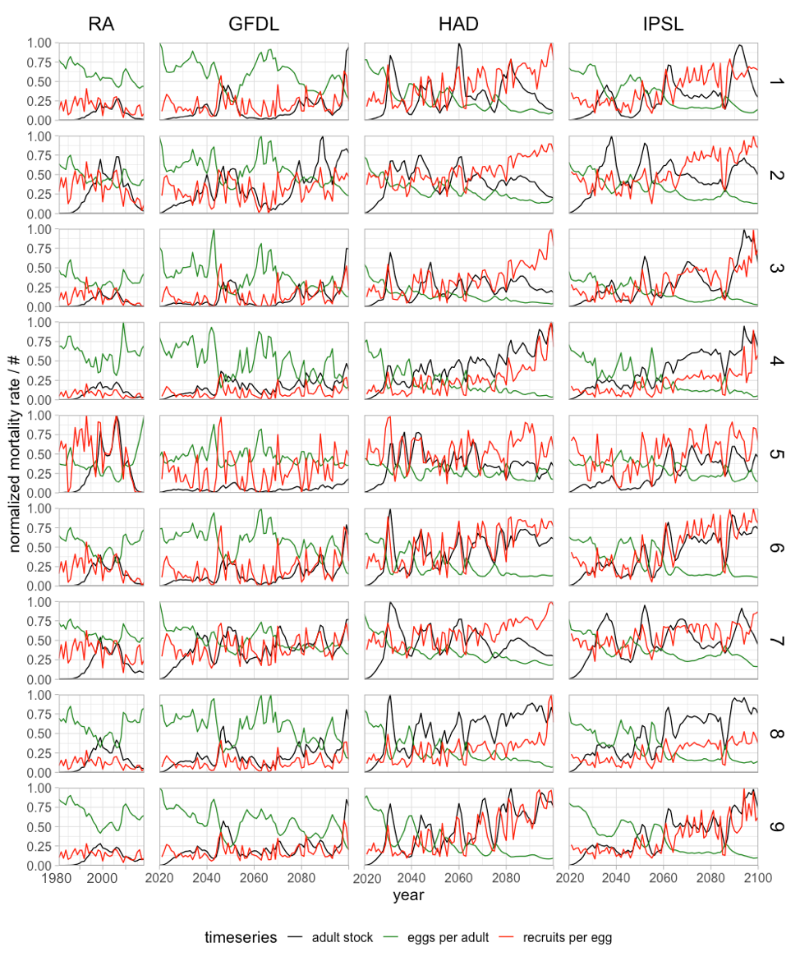Fig. S3: Sardine adult number, eggs per adult, and recruits per egg (normalized among model configurations) output from the population model, for ensemble configurations 1–9 during ROMS reanalysis / NEMUCSC hindcast (RA) used for model calibration, and projections under three downscaled ROMS-NEMUCSC-ESMs (GFDL, HAD, IPSL)

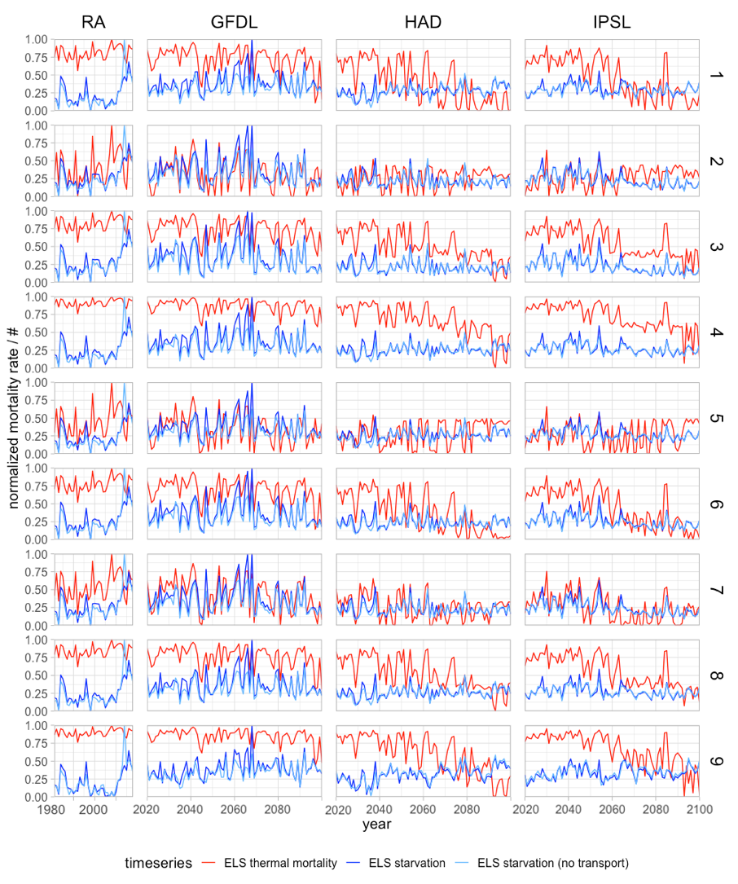

Fig. S4. Sardine egg and larval thermal mortality rate (red), starvation mortality rate of feeding larvae and juveniles (blue), and hypothetical starvation mortality rate without offshore transport (light blue) from the population model. Normalized among ensemble configurations 1–9 (rows), during ROMS reanalysis / NEMUCSC hindcast (RA) used for model calibration, and projections under three downscaled ROMS-NEMUCSC-ESMs (GFDL, HAD, IPSL)

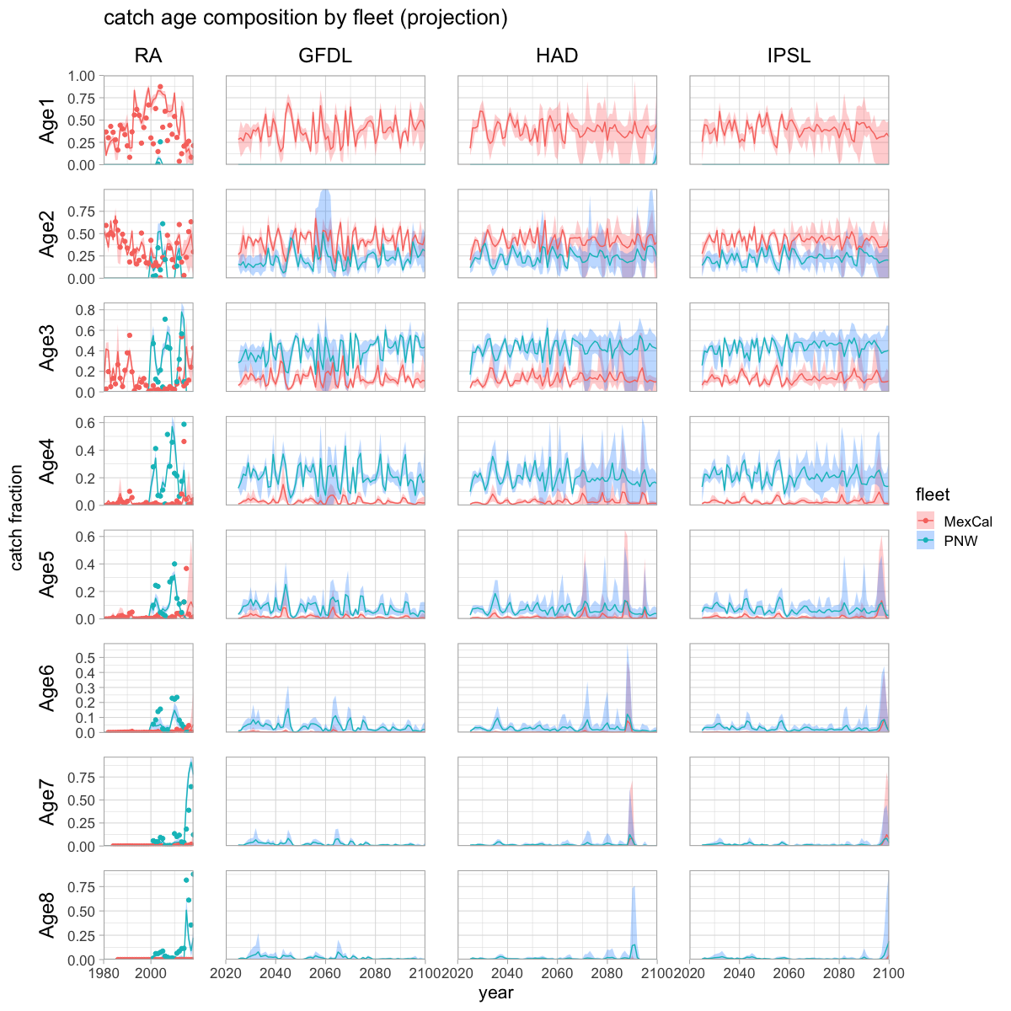

Fig. S5. Catch age composition (mean and range of 9 model configurations) for PNW (blue) and MexCal (red) fleets by year, during historical calibration period (RA, left, dots: stock assessment data) and during projections (GFDL, HAD, IPSL)

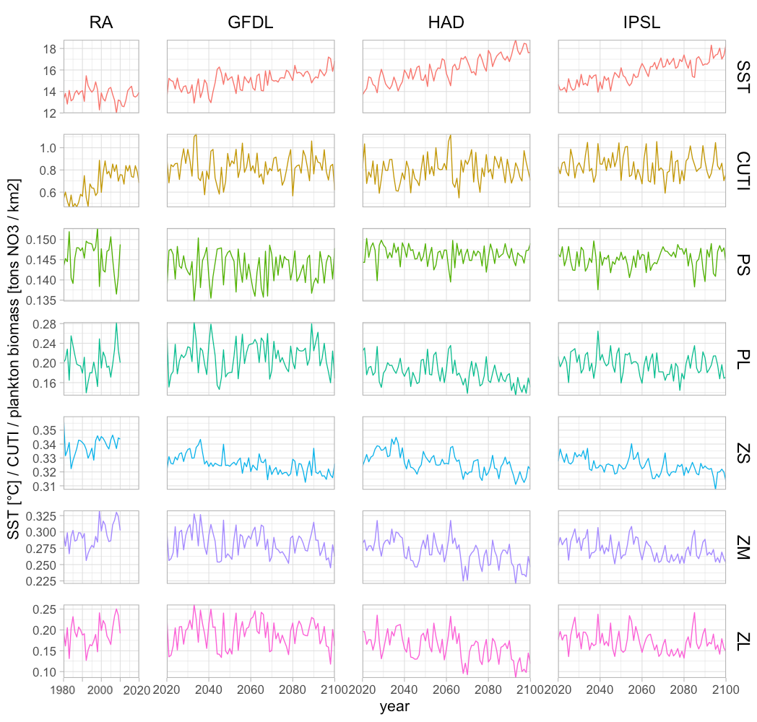
Fig. S6: Environmental driver time series (mean over model domain for spring months) from ROMS-NEMUCSC hindcast (RA) and three regionally downscaled ROMS-NEMUCSC-ESM projections (GFDL, HAD, IPSL): Sea Surface Temperature (SST), CUTI upwelling index, and five plankton compartments nanophytoplankton (PS), diatoms (PL), microzooplankton (ZS), mesozooplankton (ZM), and predatory zooplankton (ZL)

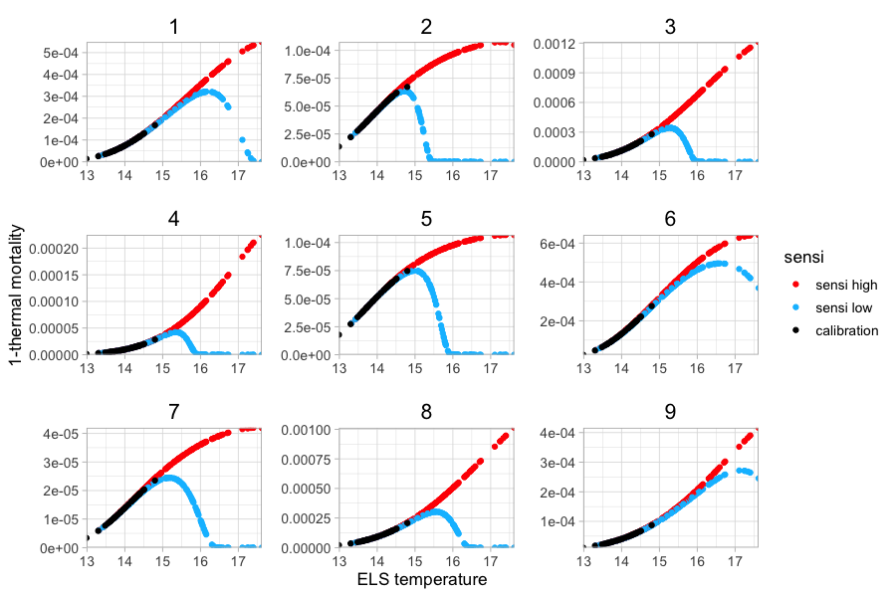
Fig. S7: Early life stage (ELS) temperature response curves (surface temperature integrated over sardine spawning habitat vs. total temperature-dependent survival rate during ELS) by model configuration (1–9) for all downscaled earth system model projections. Black: model calibration under ROMS hindcast, red/blue: upper and lower confidence boundary used in future projections for extrapolation of the ELS temperature response beyond the calibrated range.

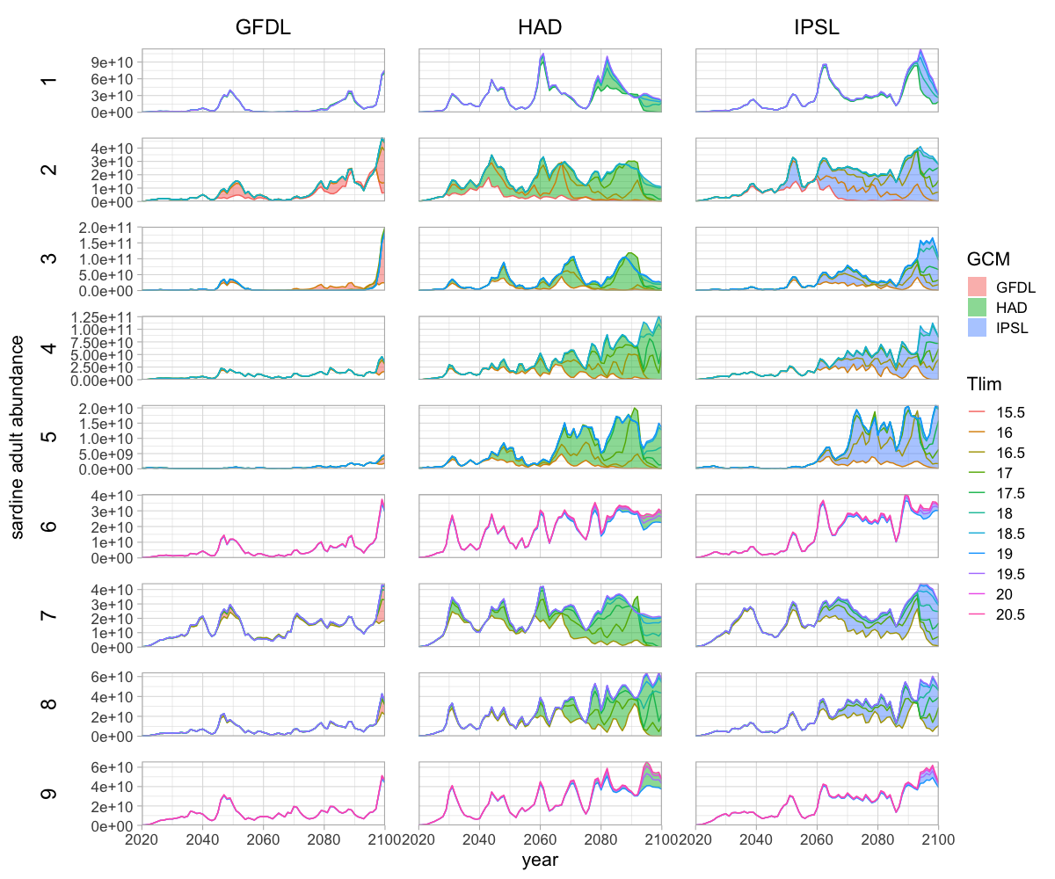Fig. S8: Sensitivity of sardine population projections to the parameter T_{lim} (temperature survival limit of early life stages), per model ensemble configuration (1–9) under three downscaled ROMS-NEMUCSC-ESM projections (GFDL, HAD, IPSL). Projection range (colored areas) and trajectories for values in 0.5°C steps between the lowest Tlim with a good fit during the calibration period (0.99 of best R2 and higher), and the highest Tlim with significant impact on projections (>1% deviation in an annual value).
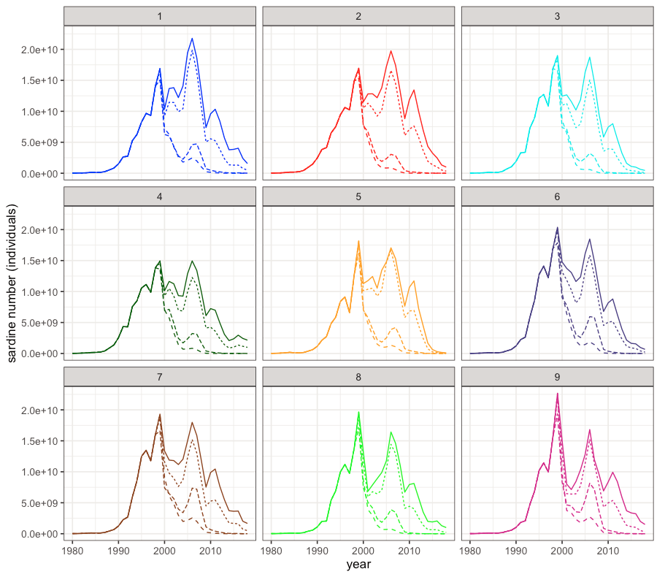
Fig. S9: Fisheries sensitivity analysis. Sardine adult population number for each model configuration (1–9), under historical fishing mortality (1x, solid line), and with fishing mortalities after the year 1999 set at two-fold (dotted), five-fold (short dashed) and 10-fold (long dashed) of historical annual values

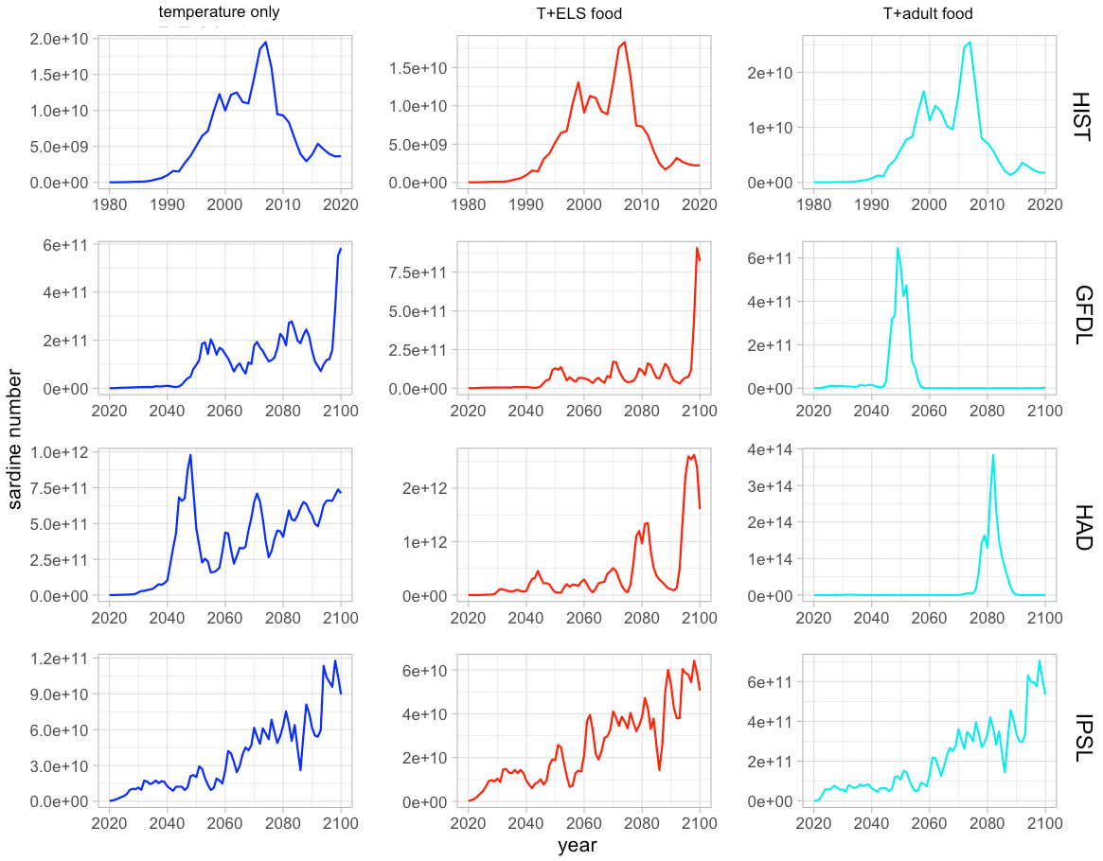
Fig. S10: Sensitivity analysis for food-dependent model processes. Total sardine abundance for best-fitting alternative model configurations without food-dependent processes (temperature-dependent processes only, left column), temperature-dependent and early life stage food-dependent processes (center column) and temperature-dependent and adult food-dependent processes (right column) for calibration and testing period (HIST; assuming low food availability for 2011-18, see text) and three regionally downscaled ROMS-NEMUCSC-ESM projections (GFDL, HAD, IPSL).

