FVCOM Mass Balance check
To check the FVCOM mass conservation, we have calculated the volume flux going in/out through the transects shown in Figure S1. We have used a linear function described in the FVCOM manual (Chen et al., 2013) for velocity reconstruction at the cell edges. The depth-averaged velocity, multiplied by the time-varying total depth and width, provided volume flux through each cell edge at the transect. Then, taking an integral over the transect represented the total volume flux for each case. An example of the volume flux is given in Figure S2, which shows the time-varying flux for the Bay-Marsh system and regular FVCOM model case. Subsequently, we used a zero-upcrossing method to isolate the individual tides for wave-averaging, shown using red circles in Figure S2. Ultimately, the tide-averaged quantities provided us with the residual that verifies mass conservation.
Figure S3 shows changes to the residual after every tide cycle for four different model simulations: first, we tested both FVCOM regular and the modified model with the Bay-Marsh case (Figure S3 a1-a2), and then, we ran both models for the Bay-Channel-Marsh case (Figure S3 a3-a4). Results on the left panel show that, for the regular model, both test cases (a1 & a3) have an increased net volume flux at tide cycle 4. This particular cycle covered the time window when the marsh berm got overtopped during the flood and the system started to store water – reducing the ebb volume flux. The Bay-Marsh case needed two tide cycles: 4 and 5, to submerge the entire region due to its larger surface area than the Bay-Channel-Marsh case, which required one. In contrast, with the modified FVCOM model – where we are draining the ponded region using slots, we can see an improved mass balance for both cases (Figure S3 a2 and a4). At the same time, the right panel of Figure S3 shows the ratio of residual flux to the peak flux magnitude, demonstrating that the residual is less than 1% of the total volume that goes in/out through the transect for most of the tide cycles.
(a)
(b)
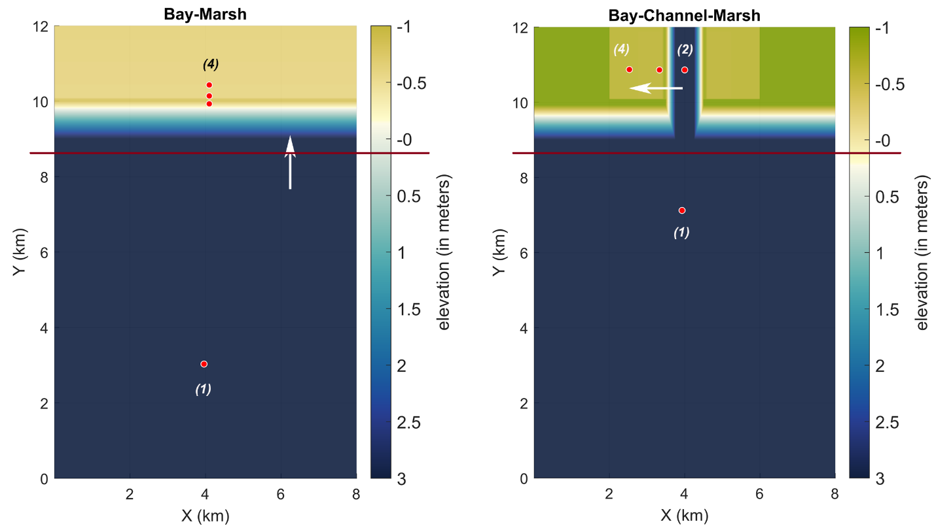
Figure S1: Idealized cases used for model performance check, also shown in Figure 07 in the main text: a) A Bay-Marsh system, where a well-defined marsh berm at the shoreline separates the land and water body, making an isolated depression over land during low tide; b) A Bay-Marsh-Channel system, where a tidal channel separates the marsh platform into two similar isolated depressions. Figures (a) and (b) red solid lines show the transect lines used for model volume flux estimation.

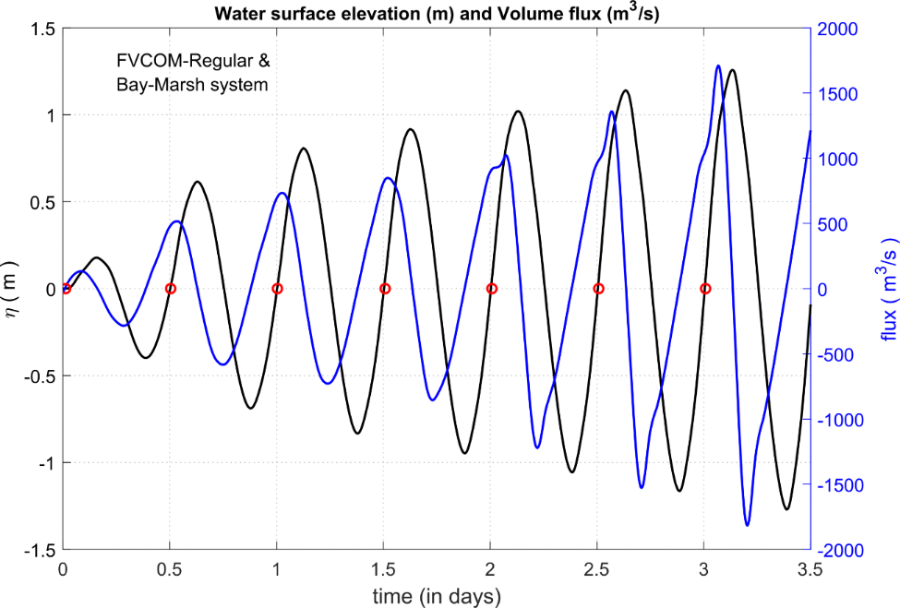
Figure S2: An example of time-varying water surface elevation at the mid-point of the transect (shown using solid black line) and volume flux (solid blue line) for the Bay-Marsh system case – using the regular FVCOM model. The red circles represent zero-crossings of the water surface elevation used for the tidal (or time) averaging.

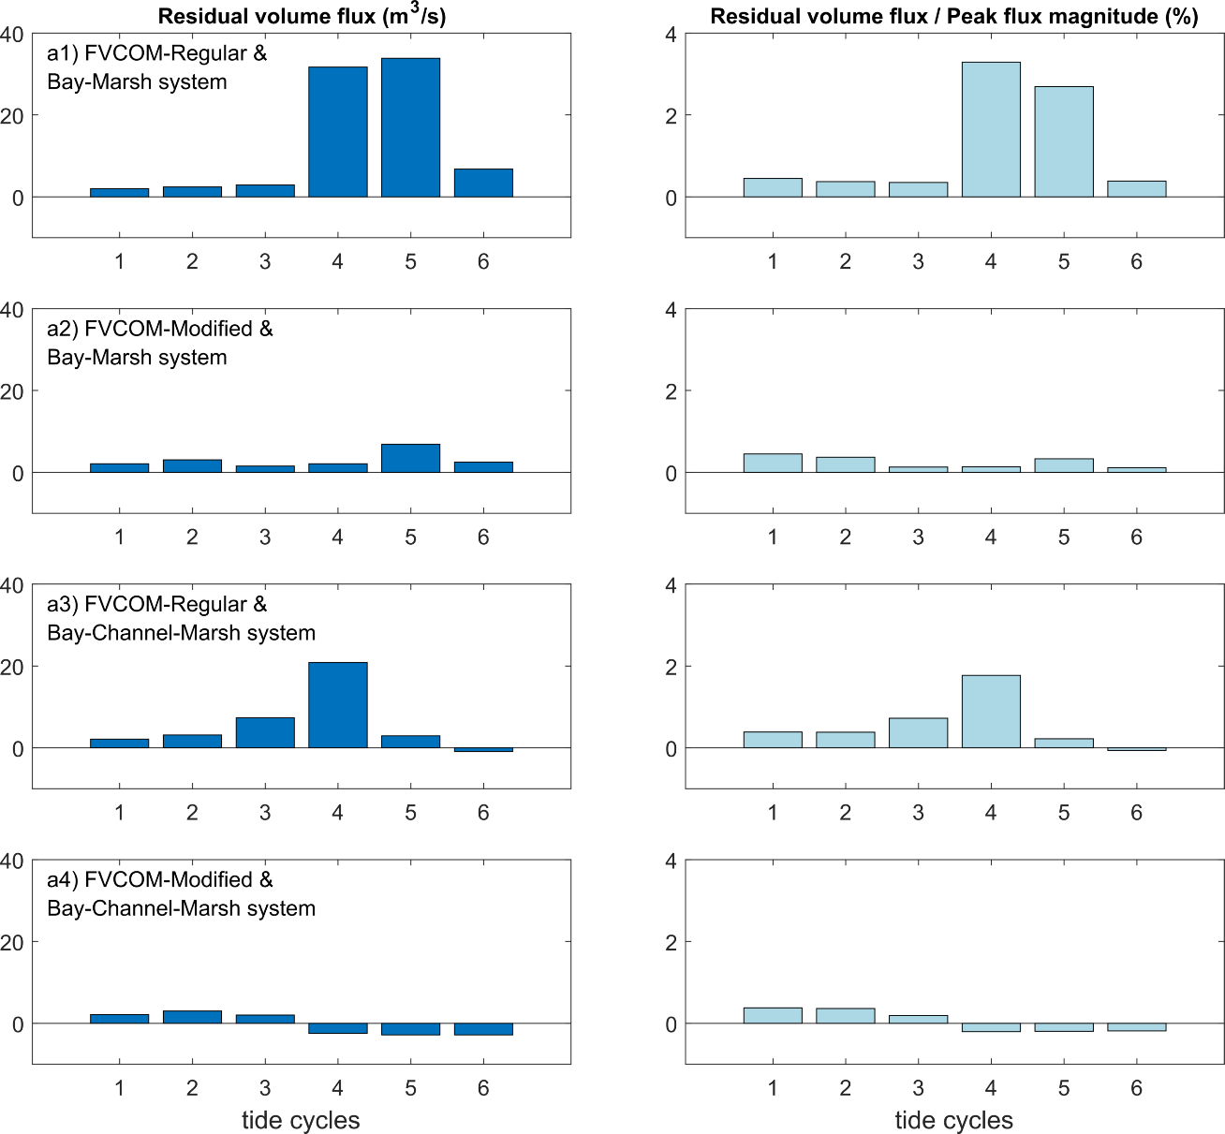
Figure S3: (a) Tide-averaged volume flux (m³/s) comparison for the two cases using different FVCOM models. a1-a2: Bay-Marsh system case with the regular and modified model; a3-a4: a similar comparison with the Bay-Marsh-Channel system. (b) Comparison of normalized residual volume flux (residual volume flux divided by the peak flux magnitude) at each tide cycle (%).

