Supporting Information

Title
Evaluating biodegradable alternatives to plastic mesh for small-scale oyster reef restoration

Authors
Devin Comba, Terence A. Palmer, Natasha J. Breaux, Jennifer Beseres Pollack*

Author Affiliation
Harte Research Institute for Gulf of Mexico Studies
Texas A&M University-Corpus Christi
Corpus Christi
TX 78412
USA

* Corresponding author
E-mail: jennifer.pollack@tamucc.edu

Journal
Restoration Ecology

Date
December 17, 2021

Tables
Table S1. p values of main effects ANOVAs. Bold values indicate significant differences (α= 0.05). Station was included as a random effect. *Oyster height includes the control treatment as a factor level, while the other metrics account for tray effects. Transformations used prior to ANOVA are in parentheses.
Comparison | Effect | Oyster Density  (4th root) | Oyster Height*  (Log base e) | Fauna Density  (4th root) | Fauna Biomass  (4th root) | Fauna Diversity  (no transformation)
Treatment Types*:  Bagged versus Loose Shell | Treatment | 0.254 | 0.001 | 3.44E-05 | 1.01E-05 | 0.757
 | Depth | 0.624 | 0.838 | 0.011 | 0.026 | 0.032
 | Date | 8.66E-46 | 1.61E-45 | 0.437 | 6.08E-10 | 0.048
 | Treatment x Depth | 0.447 | 0.129 | 0.599 | 0.037 | 0.997
 | Treatment x Date | 0.005 | 7.04E-05 | 0.103 | 0.009 | 0.996
 | Depth x Date | 0.358 | 0.069 | 3.36E-04 | 0.285 | 0.727
 | Treatment x Depth x Date | 0.084 | 0.187 | 0.815 | 0.131 | 0.904

Table S2. ANOVA outputs for transformed oyster and fauna metrics. Station was included in the model as a random effect (y ~ Treatment * Depth * Date + (1|Station)).
Oyster Density (4th root)
Effect | Sum Sq | Mean Sq | NumDF | DenDF | F value | Pr(>F)
Treatment | 1.829 | 1.829 | 1 | 96.000 | 1.317 | 0.254
Depth | 0.371 | 0.371 | 1 | 5.742 | 0.267 | 0.624
Date | 1119.468 | 279.867 | 4 | 96.000 | 201.541 | 8.66E-46
Treatment:Depth | 0.808 | 0.808 | 1 | 96.000 | 0.582 | 0.447
Treatment:Date | 21.899 | 5.475 | 4 | 96.000 | 3.943 | 0.005
Depth:Date | 6.146 | 1.536 | 4 | 96.000 | 1.106 | 0.358
Treatment:Depth:Date | 11.770 | 2.943 | 4 | 96.000 | 2.119 | 0.084
Oyster Height (log base e)
Effect | Sum Sq | Mean Sq | NumDF | DenDF | F value | Pr(>F)
Treatment | 7.220 | 3.610 | 2 | 120 | 7.080 | 0.001
Depth | 0.021 | 0.021 | 1 | 120 | 0.042 | 0.838
Date | 303.292 | 75.823 | 4 | 120 | 148.696 | 1.61E-45
Treatment:Depth | 2.125 | 1.063 | 2 | 120 | 2.084 | 0.129
Treatment:Date | 18.636 | 2.329 | 8 | 120 | 4.568 | 7.04E-05
Depth:Date | 4.569 | 1.142 | 4 | 120 | 2.240 | 0.069
Treatment:Depth:Date | 5.874 | 0.734 | 8 | 120 | 1.440 | 0.187
Fauna Density (4th root)
Effect | Sum Sq | Mean Sq | NumDF | DenDF | F value | Pr(>F)
Treatment | 37.107 | 37.107 | 1 | 98.000 | 18.853 | 3.44E-05
Depth | 13.209 | 13.209 | 1 | 98.000 | 6.711 | 0.011
Date | 7.500 | 1.875 | 4 | 98.000 | 0.953 | 0.437
Treatment:Depth | 0.549 | 0.549 | 1 | 98.000 | 0.279 | 0.599
Treatment:Date | 15.590 | 3.897 | 4 | 98.000 | 1.980 | 0.103
Depth:Date | 45.280 | 11.320 | 4 | 98.000 | 5.751 | 3.36E-04
Treatment:Depth:Date | 3.072 | 0.768 | 4 | 98.000 | 0.390 | 0.815
Fauna Biomass (4th root)
Effect | Sum Sq | Mean Sq | NumDF | DenDF | F value | Pr(>F)
Treatment | 15.619 | 15.619 | 1 | 94.177 | 21.784 | 1.01E-05
Depth | 5.852 | 5.852 | 1 | 6.679 | 8.162 | 0.026
Date | 45.370 | 11.342 | 4 | 94.380 | 15.820 | 6.08E-10
Treatment:Depth | 3.208 | 3.208 | 1 | 94.177 | 4.474 | 0.037
Treatment:Date | 10.287 | 2.572 | 4 | 94.156 | 3.587 | 0.009
Depth:Date | 3.660 | 0.915 | 4 | 94.380 | 1.276 | 0.285
Treatment:Depth:Date | 5.224 | 1.306 | 4 | 94.156 | 1.822 | 0.131
Fauna Diversity (no transformation)
Effect | Sum Sq | Mean Sq | NumDF | DenDF | F value | Pr(>F)
Treatment | 0.155 | 0.155 | 1 | 94.008 | 0.097 | 0.757
Depth | 16.263 | 16.263 | 1 | 4.102 | 10.107 | 0.032
Date | 16.064 | 4.016 | 4 | 94.019 | 2.496 | 0.048
Treatment:Depth | 0.000 | 0.000 | 1 | 94.008 | 0.000 | 0.997
Treatment:Date | 0.278 | 0.069 | 4 | 94.007 | 0.043 | 0.996
Depth:Date | 3.299 | 0.825 | 4 | 94.019 | 0.512 | 0.727
Treatment:Depth:Date | 1.666 | 0.417 | 4 | 94.007 | 0.259 | 0.904
Table S3. Similarity percentage (SIMPER) results comparing fauna communities of deep and shallow sites. Abundances were root-transformed before analysis. N = 118 samples.

Parameters
Resemblance: S17 Bray-Curtis similarity
Cut off for low contributions: 90.00%

Group Deep
Average similarity: 48.73

Species Av.Abund Av.Sim Sim/SD Contrib% Cum.%
Panopeidae 6.25 18.26 1.36 37.48 37.48
Eurypanopeus turgidus 2.89 6.10 0.99 12.52 50.00
Petrolisthes sp. 3.83 5.22 0.68 10.71 60.71
Alpheus heterochaelis 1.60 4.59 1.50 9.41 70.12
Gobiosoma bosc 1.57 3.75 1.08 7.70 77.82
Pyrgocythara plicosa 1.67 3.36 0.96 6.90 84.72
Bittiolum varium 1.47 3.14 0.71 6.44 91.16

Group Shallow
Average similarity: 65.13

Species Av.Abund Av.Sim Sim/SD Contrib% Cum.%
Petrolisthes sp. 7.34 14.03 3.42 21.54 21.54
Panopeidae 4.44 8.23 2.02 12.64 34.18
Eurypanopeus turgidus 3.70 7.09 2.06 10.89 45.07
Alpheus heterochaelis 2.64 4.92 1.67 7.56 52.63
Costoanachis avara 3.33 4.86 1.48 7.46 60.09
Gobiosoma bosc 2.26 4.24 2.30 6.51 66.60
Pyrgocythara plicosa 2.99 4.08 1.71 6.26 72.86
Parvanachis ostreicola 2.99 3.99 1.31 6.12 78.98
Boonea impressa 3.55 3.58 0.84 5.49 84.47
Opsanus beta 1.63 3.20 2.11 4.92 89.39
Marshallora nigrocincta 2.58 2.87 1.04 4.41 93.80

Groups Deep & Shallow
Average dissimilarity = 55.45

Deep Shallow
Species Av.Abund Av.Abund Av.Diss Diss/SD Contrib% Cum.%
Petrolisthes sp. 3.83 7.34 8.25 1.50 14.88 14.88
Panopeidae 6.25 4.44 5.69 1.20 10.26 25.14
Boonea impressa 0.08 3.55 4.83 1.19 8.70 33.84
Costoanachis avara 0.27 3.33 4.61 1.70 8.32 42.16
Parvanachis ostreicola 0.18 2.99 4.13 1.59 7.45 49.61
Eurypanopeus turgidus 2.89 3.70 3.61 1.17 6.51 56.12
Marshallora nigrocincta 0.14 2.58 3.47 1.30 6.25 62.38
Pyrgocythara plicosa 1.67 2.99 3.16 1.26 5.70 68.08
Eurypanopeus depressus 0.84 1.96 2.62 1.11 4.72 72.80
Alpheus heterochaelis 1.60 2.64 2.39 1.18 4.30 77.10
Bittiolum varium 1.47 0.64 2.20 0.99 3.96 81.07
Gobiosoma bosc 1.57 2.26 1.97 1.11 3.56 84.63
Astyris lunata 0.74 1.08 1.79 0.88 3.24 87.86
Opsanus beta 0.90 1.63 1.69 1.18 3.05 90.92

Table S4. Lab experiment statistical output from three-way repeated measures ANOVA (grazing experiment) and three-way main effects ANOVA (light and temperature experiment). Bold values indicate p < 0.05.
Experiment | Effect | DFn | DFd | F | p value | ges
Grazing Experiment | Treatment | 1 | 366 | 66.699 | 5.18E-15 | 0.154
 | Material | 2 | 366 | 13.064 | 3.31E-06 | 0.067
 | Days | 1 | 366 | 0.181 | 0.671 | 0.000
 | Treatment:Material | 2 | 366 | 3.627 | 0.028 | 0.019
 | Treatment:Days | 1 | 366 | 73.778 | 2.55E-16 | 0.168
 | Material:Days | 2 | 366 | 0.707 | 0.494 | 0.004
 | Treatment:Material:Days | 2 | 366 | 4.084 | 0.018 | 0.022
Light and Temperature Experiment | Material | 2 | 351 | 33.369 | 5.41E-14 | 0.160
 | Treatment | 8 | 351 | 0.805 | 0.598 | 0.018
 | Days | 1 | 351 | 1.318 | 0.252 | 0.004
 | Treatment:Material | 16 | 351 | 0.359 | 0.990 | 0.016
 | Treatment:Days | 2 | 351 | 0.102 | 0.903 | 0.001
 | Material:Days | 8 | 351 | 1.400 | 0.195 | 0.031
 | Treatment:Material:Days | 16 | 351 | 0.559 | 0.913 | 0.025

Figures
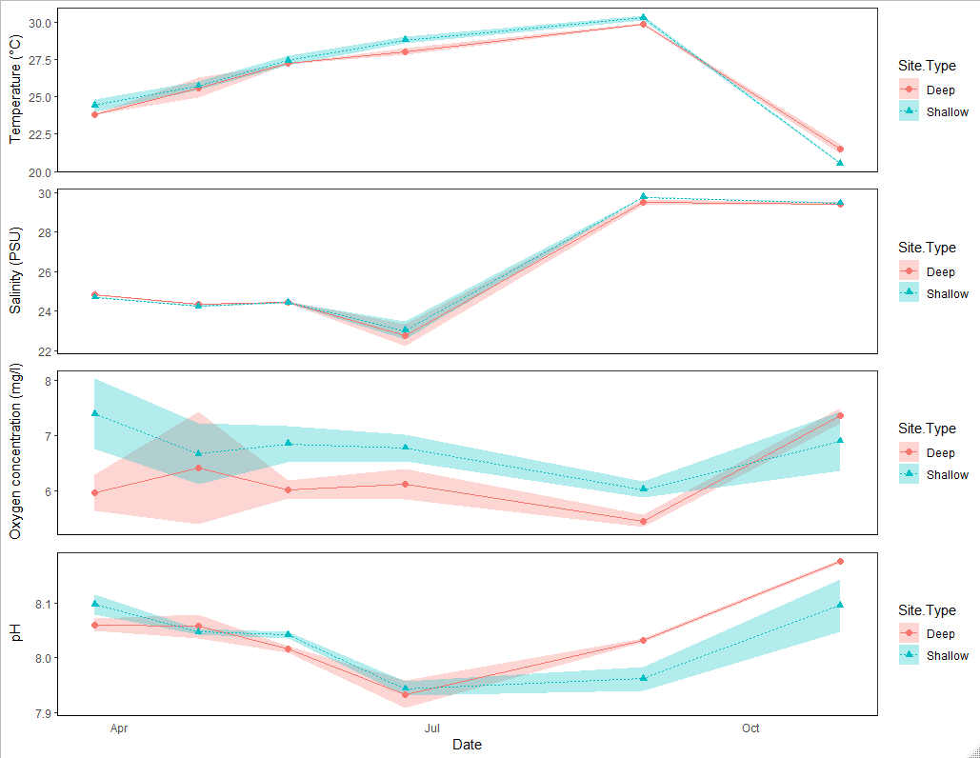
a
b.
c
d.
Sampling Month and Year
Mar-20 Apr-20 May-20 Jun-20 Aug-20 Oct-20
Figure S1. Mean temperature (a), salinity (b), dissolved oxygen (c), and pH (d) at deep (~1 m) and shallow (<0.5 m) sites over time. Shading indicates standard deviation.

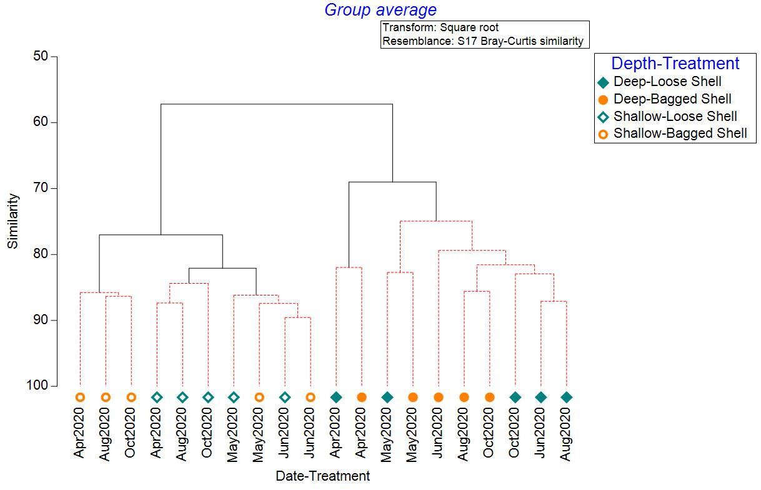
Figure S2. Cluster analysis (group average method) with similarity profile (SIMPROF) test of square root transformed fauna samples by depth and treatment. Black bars indicate meaningful clusters (p < 0.05).

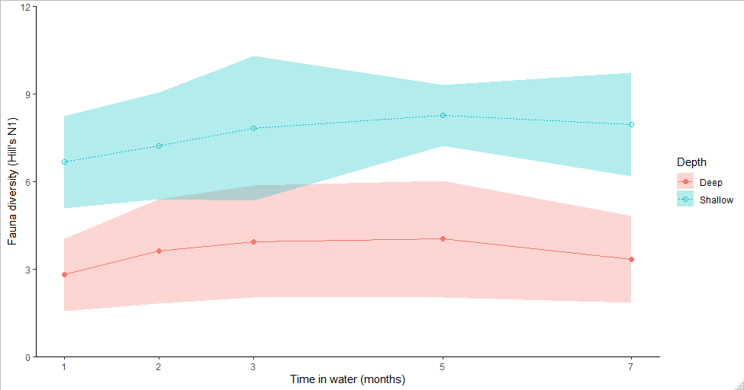
Figure S3. Fauna diversity in combined treatments in deep (~1 m) and shallow (<0.5 m) sites over time. Shading indicates standard deviation.

