Supplemental Information

Appendix A
Detailed history of the NEFSC Study Fleet Program.

Pilot Phases (2001-2005)
Palmer et al. (2007) provides a thorough review of the initial phases of the Study Fleet program, summarizing the early programmatic and technical details. In 2001, a prototype laptop logbook specific to northeast groundfish reporting regulations was developed by the University of New Hampshire (UNH). The prototype logbook was further enhanced and implemented from 2003-2005, and compared favorably to other options because it matched regulatory requirements with fishery observer processes. Specifically, the UNH logbook allowed for data to satisfy both regulatory applications like attributing catch to a large geographic region while at the same time providing information that could be used for scientific purposes like estimating catch per unit effort on a haul basis. In this early phase, NEFSC staff provided contract oversight and technical guidance (e.g., database coding and data standards) to the logbook developers, and suggested technology options for investigation.

Once the electronic logbooks were developed, three regional organizations (Gulf of Maine Research Institute (GMRI), Cape Cod Commercial Hook Fishermen’s Association, and the Manomet Center for Conservation Science) were tasked with recruiting as many as 30 commercial fishing vessels to pilot the logbooks. Participants were contracted and compensated for their efforts as in other reference fleet programs (e.g., Nedreaas et al. 2006). Hardware and software options were tested on vessels of varying gear types and fisheries, primarily New England groundfish vessels. Vessels hailed from Portland, ME; Gloucester, MA; Chatham, MA; and New Bedford, MA. This work established a solid foundation on which to build a program, and many of the key systems in use today were developed in this focused period.

Study Fleet development and diversification (2006-2012)
Beginning in 2006, management of the Study Fleet program and further development of the electronic logbook software transitioned from academic and independent research institutions to the NEFSC. This shift in programmatic responsibility was followed by a period of hardware and software performance enhancements based on the data comparisons previously described (Palmer et al. 2007). Some of these enhancements included improving the ELB coding for regional ports, fishing licenses, and fishing permit numbers. Additionally, an attempt was made to transition to modern species market and grade standards (i.e., information about the condition of fish that are not landed whole), improve gear coding, and enhance training and use of peripheral data loggers (for temperature & depth) to support validation of haul based effort metrics. These enhancements were targeted at improving the quality of the data collected by the Study Fleet program as well as enhancing data utility to end users.

Between 2008 and 2012, participants in the Mid-Atlantic and Southern New England regions expressed interest in joining the Study Fleet program. The number of vessels participating in the Study Fleet expanded from roughly 20 to 30 vessels (with interest from more captains, but budgets limited total enrollment in the program). These included large trawl vessels targeting haddock (Melanogrammus aeglefinus), squids (Doryteuthis pealeii and Illex illecebrocus), and summer flounder (Paralichthys dentatus) primarily from Southern New England, longline vessels targeting tilefish, and vessels targeting hagfish (Myxine glutinosa). This group of new participants represented vessels from diverse fisheries, including smaller fleets like hagfish and tilefish fisheries where the addition of these vessels represented a significant amount of new, detailed information on a large proportion of the fishery. Others were participants in larger fisheries (e.g., large mesh multispecies groundfish fishery), where each vessel still represented only a small fraction of the total fishery.

Study Fleet expansion (2013 - 2020)
The next phase in the trajectory of the Study Fleet program resulted from an external funding opportunity to cover vessel equipment costs and field staff support in 2013 through the Pacific States Marine Fisheries Commission (PSMFC). This funding allowed the program to coordinate equipment investments to expand ELB use and other peripheral equipment (i.e., gear-mounted temperature and depth loggers). The intention was that vessels would become more proficient with electronic reporting and develop an interest in contributing haul-level data more appropriate for research applications. However, the vessels recruited during this expansion tended to utilize the logbook software for regulatory reporting (aggregate catch and effort), rather than scientific data collection (haul-level catch, effort, and environment). This expansion was contracted through Cornell University and GMRI who provided field coordinators and local technical support. The fisheries where this expansion of non-research vessels using the ELB occurred included Atlantic herring (Clupea harengus), Atlantic mackerel, butterfish (Peprilus triacanthus), longfin squid (Doryteuthis pealeii), shortfin squid (Illex illecebrosus), summer flounder (Paralichthys dentatus), ocean quahog (Arctica islandica), and Atlantic surf clam (Spisula solidissima).

During this period, the number of contracted Study Fleet trip records began to plateau and then decline, while the number of trip records reported for regulatory purposes expanded rapidly (Figure 2). In addition to expanding use of the ELB for regulatory reporting, the number of vessels contributing oceanographic information also increased during this period. The loggers that were deployed by vessels collected bottom temperatures and depth with little disruption during routine fishing operations. This was the result of the expansion of the number of probes deployed on contracted Study Fleet vessels reporting at the haul (rather than trip) level. For these participants the data provided electronic verification of gear setting and hauling timing, as well as the gears position within the water column.

In 2017, a survey of NEFSC staff was conducted to assess interest in and use of the Study Fleet data. The survey found that the Study Fleet data had mostly been applied to stock assessments (white papers or working papers) and that the catch data was the most commonly used data product from the program (Blackburn 2017).

Appendix B
Participation in the haul-by-haul program between 2007 and 2020.

The number of trips in each year for each vessel is shown with shading (darker colors indicate more trips in a given year). Vessels are broken out by the U.S. state abbreviation which the vessel is associated with (MA - Massachusetts, NJ - New Jersey, and RI - Rhode Island). The panel labeled ‘Other’ includes vessels from the states of New York, New Hampshire, and Maine. Vessels are represented by a unique number in a single row. Occasionally captains participating moved between vessels (e.g, 117 to 123) however this was rare in the data set.
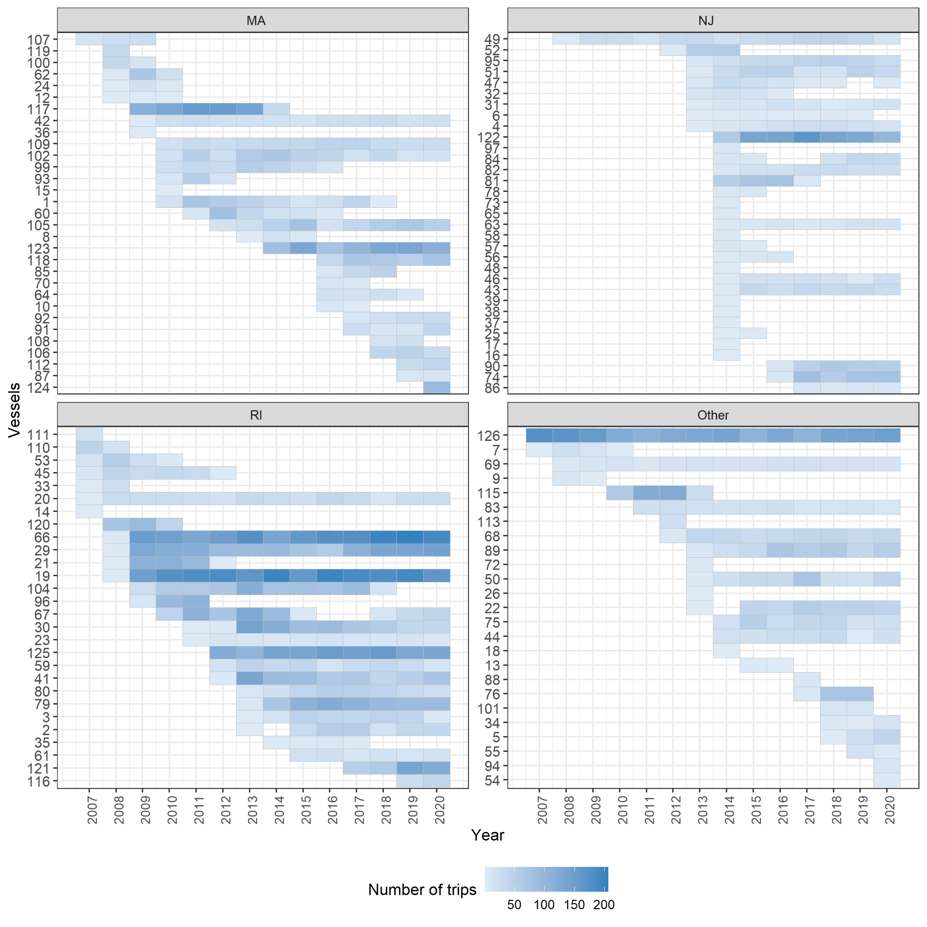

Appendix C
The proportion of the total trips and vessels included in the Study Fleet

The proportion of regional vessels (dark blue open circles) and trips (light blue closed circles) landing each species reported through Study Fleet, relative to the trend in total commercial landings of the species. As in Figure 6 here six species of high commercial interest are shown.

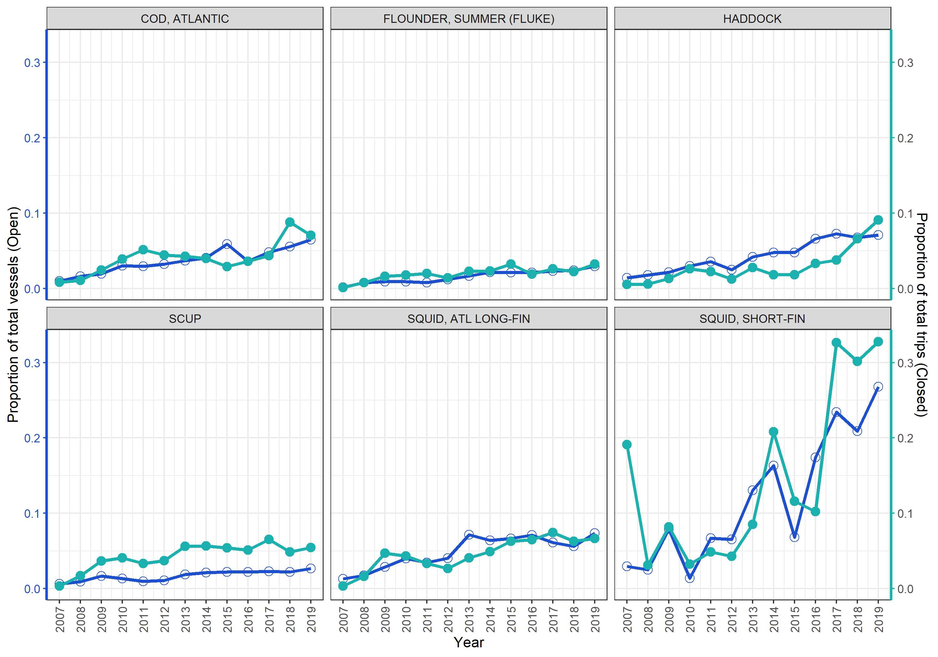

Appendix D
Specific details for the ELB used to support the Study Fleet Program.

The electronic logbook system (ELB) is and has been comprised of a dedicated laptop, typically a Windows machine running a current version of the operating system. A form filling software called Fisheries Logbook and Data Recording Software (FLDRS) has been continuously developed to support the Study Fleet and regulatory vessel trip reporting in the region. In addition to simple catch item identity and weight, the software pairs with a GPS receiver to auto-populate location information functionality of the logbook. The GPS units provide a National Marine Electronics Association (NMEA 0183) sentence combination. These sentence combinations provide the necessary data for each trip including date, time, latitude, longitude, course (true), speed (knots/hr), fix quality, and number of satellites available. FLDRS saves 20-second interval GPS polling data in a text file on the local computer. Typically, Study Fleet staff will collect the files during routine vessel visits, bring them back to the NEFSC, and upload them through a web based application. System modifications are currently being tested to automate transmission of GPS files concurrently with the ELB data via automated WiFi connections providing a significant improvement in timely data availability while reducing field support labor. A depth sounder is an optional component of the system that allows Study Fleet participants to integrate depth information in the GPS polling file and also allows users to auto-populate the depth field required by the FLDRS software. In addition to pairing with a depth sounder, the ELB software can also pair with a Vessel Monitoring System (VMS) unit. When this feature is enabled the FLDRS software can use the VMS to transmit a trip data file to a NMFS e-mail account where it is ultimately uploaded to a database. Trip data can also be submitted via a WiFi connection.

