**Supplementary Material for:**

**Pathways of Pelagic Connectivity:**

***Eukrohnia hamata* (Chaetognatha) in the Arctic Ocean**

Haley M. DeHart1, Leocadio Blanco-Bercial2, Mollie Passacantando3, Jennifer M. Questel4, and Ann Bucklin1*

1Department of Marine Sciences, University of Connecticut, Groton, CT, USA

2Bermuda Institute of Ocean Science, St. George's, Bermuda

3Department of Marine and Coastal Sciences, Rutgers University, New Brunswick, NJ, USA

4Institute of Marine Science, University of Alaska, Fairbanks, AK, USA

*Corresponding Author: Ann Bucklin

Email: ann.bucklin@uconn.edu

**Supplementary Figure 1**. Loci in the catalog, final loci, and variant sites in the final loci at M values from M=0 to M=6 (left side graphs). The maximum number of variant sites is reached at M=2. Higher M values did not significantly reduce the number of loci in the catalog. Same statistics for n=M±1 (right side graphs). The value of n did not significantly affect the number of loci in the catalog or the number of variant sites for n > 0; the maximum number of retained final loci was maximized at n = 2.

|  |
| --- |
|  |

**Supplementary Figure 2.** BAYESCAN results for SNPs under selection, for SNPs with a MAF > 0.05. With prior odds = 100, only two SNPs were candidate for selection, independently of the FDR level. If the Prior Odds were set to 10, more markers were flagged as candidates for selection. Vertical lines mark the threshold for each FDR level. Dashed lines indicate the FDR levels used for downstream analyses. In the lower pannel, the identifier for each SNP were removed for clarity.

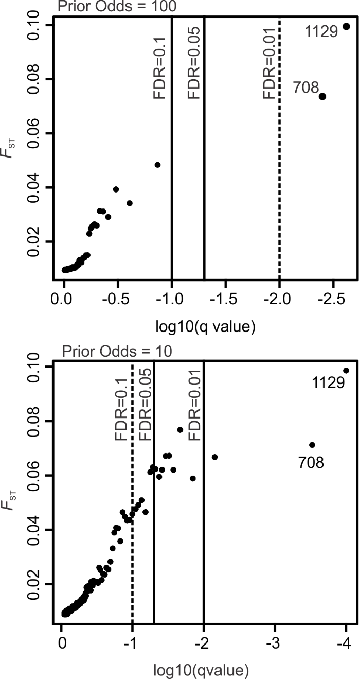

**Supplementary Figure 3.** Box and whiskers plot showing quartiles (box), 95% confidence interval (whiskers) and outliers (circles) of the F-distances between regions, derived from 1,000 iterations using randomly chosen sets of SNPs, after removal of any candidates for selection in BAYESCAN with prior odds = 10 and FDR = 0.10. NB: Scales of the Y axis change between statistics. Key: 1: Beaufort Sea; 2: Chukchi Sea; 3: Amerasian Basin; 4: Eurasian Basin; 5: Fram Strait; 6: Labrador Sea.

|  |  |
| --- | --- |
|  |  |
|  |  |

**Supplementary Figure 4.** STRUCTURE results for K=1 to K=8, including minor clustering patterns, from CLUMPAK (Kopelman et al., 2015); see documentation for more information. The figures represent results from 100 different combinations of 1 SNP per tag. (A) All SNPs: 1 SNP per tag, without removing candidates for selection; (B) Removal of any candidates for selection in BAYESCAN with prior odds (PP) = 10; False Discovery Rate (FDR) =0.01; (C) PP=100; FDR=0.05. See text for details.

(A) (B) (C)

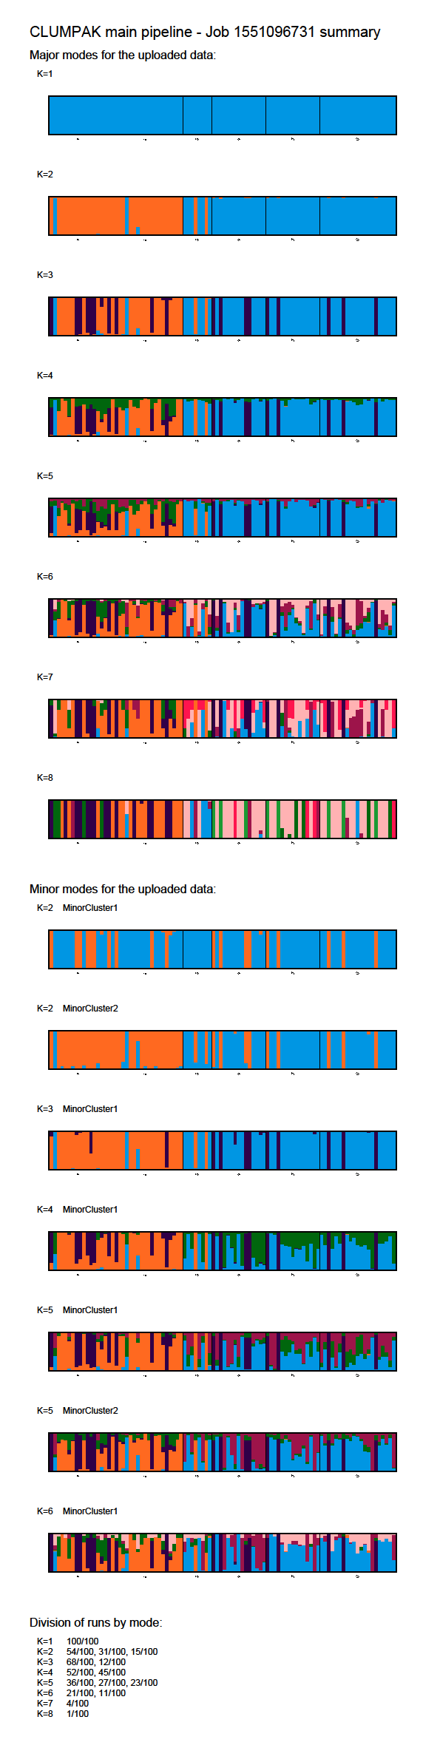 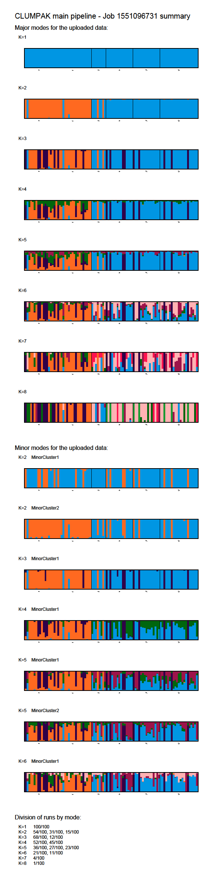 

**Supplementary Table 1.** Sample collection metadata by specimen voucher number with

GenBank Accession numbers for COI and SRA BioSample numbers for SNP ddRAD data.



**Supplementary Table 1 (continued)**

