Supplementary Material
Table S1. Physical and carbonate chemistry parameters at each of the stations (mariculture, three reefs, and offshore). Stations are arranged from inshore to offshore. Values are mean ± standard deviation. Mean values between seasons across all stations are also reported. n = number of samples.
Station | Season | n | Temperature (°C) | Salinity (PSU) | TA (µmol kg⁻¹) | DIC (µmol kg⁻¹) | pH | pCO₂ (µatm) | Ω_{Arag}
Mariculture | Dry | 3 | 31.5 (0.1) | 33.1 (0.0) | 2178.3 (3.3) | 2018.2 (8.3) | 7.71 (0.01) | 953 (35) | 2.07 (0.05)
 | Wet | 3 | 30.5 (0.1) | 29.6 (0.1) | 2195.4 (0.8) | 1935.8 (12.5) | 7.97 (0.01) | 483 (25) | 3.16 (0.05)
Reef 1 | Dry | 6 | 31.3 (0.2) | 33.4 (0.0) | 2193.2 (2.4) | 1920.8 (7.1) | 7.94 (0.01) | 512 (15) | 3.22 (0.07)
 | Wet | 6 | 29.9 (0.7) | 30.5 (0.3) | 2186.9 (5.2) | 1942.5 (44.4) | 7.95 (0.08) | 525 (109) | 3.01 (0.47)
Reef 2 | Dry | 6 | 31.3 (0.1) | 33.4 (0.0) | 2183.5 (8.4) | 1913.2 (24.6) | 7.94 (0.03) | 514 (49) | 3.19 (0.17)
 | Wet | 6 | 29.6 (0.6) | 30.6 (0.3) | 2128.3 (3.9) | 1850.9 (14.4) | 8.03 (0.02) | 406 (22) | 3.31 (0.18)
Reef 3 | Dry | 6 | 31.0 (0.1) | 33.6 (0.0) | 2169.6 (14.2) | 1894.6 (7.1) | 7.95 (0.04) | 492 (47) | 3.22 (0.22)
 | Wet | 6 | 29.4 (0.4) | 31.2 (0.2) | 2115.2 (11.0) | 1863.6 (10.0) | 7.97 (0.02) | 464 (25) | 3.00 (0.11)
Offshore | Dry | 5 | 31.0 (0.1) | 33.6 (0.0) | 2182.7 (3.6) | 1900.0 (12.6) | 7.97 (0.02) | 477 (28) | 3.32 (0.12)
 | Wet | 3 | 29.3 (0.0) | 31.2 (0.0) | 2123.8 (4.0) | 1840.8 (5.0) | 8.03 (0.00) | 398 (3) | 3.32 (0.01)
Total | Dry | 26 | 31.2 (0.2) | 33.4 (0.1) | 2181.8 (11.3) | 1920.2 (39.7) | 7.92 (0.08) | 552 (153) | 3.10 (0.41)
 | Wet | 24 | 29.7 (0.6) | 30.7 (0.6) | 2147.5 (34.4) | 1886.4 (48.8) | 7.99 (0.05) | 459 (72) | 3.14 (0.28)

Table S2. Summary of analyses (two-way ANOVA) comparing all variables among reef stations (Reef), between time of sampling (Season) and the interaction of the factors (Reef x Season). Data are log-transformed except for pH. p-values < 0.05 are highlighted. Df = degrees of freedom; Ss = sum of squares.
Variable | Reef |  |  |  | Season |  |  |  | Station x Season
 | Df | Ss | F | p | Df | Ss | F | p | Df | Ss | F | p
Temperature (°C) | 2 | 0.0002 | 2.505 | 0.0990 | 1 | 0.005 | 128.912 | < 0.0001 | 2 | 0.00002 | 0.279 | 0.7590
Salinity (PSU) | 2 | 0.0003 | 16.135 | < 0.0001 | 1 | 0.012 | 1435.369 | < 0.0001 | 2 | 0.0001 | 7.336 | 0.0030
TA (µmol kg⁻¹) | 2 | 0.0006 | 97.837 | < 0.0001 | 1 | 0.0005 | 182.532 | < 0.0001 | 2 | 0.0002 | 32.318 | < 0.0001
DIC (µmol kg⁻¹) | 2 | 0.001 | 21.397 | < 0.0001 | 1 | 0.0003 | 10.999 | 0.0020 | 2 | 0.0006 | 11.071 | 0.0003
pH | 2 | 0.008 | 2.831 | 0.0750 | 1 | 0.013 | 8.658 | 0.0060 | 2 | 0.010 | 3.538 | 0.0420
pCO₂ (µatm) | 2 | 0.017 | 3.928 | 0.0310 | 1 | 0.015 | 6.971 | 0.0130 | 2 | 0.018 | 4.128 | 0.0260
Ω_{Arag} | 2 | 0.003 | 1.412 | 0.2590 | 1 | 0.002 | 2.015 | 0.1660 | 2 | 0.005 | 1.946 | 0.1610
Nitrate (µM) | 2 | 0.584 | 5.700 | 0.0110 | 1 | 0.359 | 6.997 | 0.0150 | 2 | 0.061 | 0.599 | 0.5590
Nitrite (µM) | 2 | 0.004 | 0.163 | 0.8510 | 1 | 0.383 | 33.382 | < 0.0001 | 2 | 0.034 | 1.487 | 0.2490
Ammonium (µM) | 2 | 0.045 | 0.722 | 0.4970 | 1 | 0.024 | 0.779 | 0.3880 | 2 | 0.255 | 4.094 | 0.0320
Phosphate (µM) | 2 | 0.059 | 12.333 | 0.0003 | 1 | 0.352 | 147.495 | < 0.0001 | 2 | 0.019 | 3.918 | 0.0360
Silicate (µM) | 2 | 0.013 | 0.812 | 0.4570 | 1 | 0.217 | 26.849 | < 0.0001 | 2 | 0.066 | 4.091 | 0.0320
N:P ratio | 2 | 0.019 | 0.399 | 0.6760 | 1 | 0.721 | 29.502 | < 0.0001 | 2 | 0.152 | 3.112 | 0.0660
DO (mg L⁻¹) | 2 | 0.019 | 3.253 | 0.0530 | 1 | 0.007 | 2.454 | 0.1280 | 2 | 0.014 | 2.367 | 0.1110
Chl-a (µg L⁻¹) | 2 | 3.004 | 16.85 | < 0.0001 | 1 | 0.309 | 3.462 | 0.0770 | 2 | 2.948 | 16.535 | < 0.0001
Turbidity (FTU) | 2 | 0.438 | 7.799 | 0.0020 | 1 | 0.0007 | 0.026 | 0.8730 | 2 | 0.065 | 1.16 | 0.3270

Table S3. Water quality parameters at each of the stations (mariculture, three reefs, and offshore). Stations are arranged from inshore to offshore. Values are mean ± standard deviation. Mean values between seasons across all stations are also reported. n = number of samples.
Station | Season | n | Nitrate (µM) | Nitrite (µM) | Ammonium (µM) | Phosphate (µM) | Silicate (µM) | N:P ratio | DO (mg L⁻¹) | Chl-a (µg L⁻¹) | Turbidity (FTU)
Mariculture | Dry | 3 | 0.48 (0.17) | 0.18 (0.01) | 12.71 (3.54) | 1.97 (0.26) | 8.98 (3.39) | 6.78 (1.57) | 2.96 (0.26) | 1.08 (0.36) | 0.50 (0.02)
 | Wet | 3 | 0.95 (0.71) | 0.06 (0.02) | 5.01 (2.79) | 0.48 (0.06) | 9.39 (0.53) | 12.68 (7.80) | 7.10 (0.15) | 11.04 (3.36) | 0.87 (0.07)
Reef 1 | Dry | 6 | 0.60 (0.20) | 0.14 (0.04) | 6.52 (2.16) | 0.92 (0.13) | 12.49 (2.76) | 7.81 (1.35) | 6.88 (1.72) | 0.35 (0.14) | 0.54 (0.21)
 | Wet | 3-6 | 0.93 (0.75) | 0.06 (0.02) | 8.95 (5.84) | 0.44 (0.02) | 13.69 (2.29) | 22.78 (12.90) | 6.81 (1.03) | 5.29 (2.16) | 0.50 (0.33)
Reef 2 | Dry | 6 | 0.80 (0.24) | 0.13 (0.02) | 7.09 (1.59) | 0.70 (0.06) | 11.13 (2.89) | 11.52 (2.81) | 5.65 (0.44) | 0.20 (0.17) | 0.29 (0.04)
 | Wet | 3-6 | 1.96 (1.06) | 0.09 (0.02) | 4.53 (1.70) | 0.43 (0.01) | 21.08 (4.12) | 15.12 (2.93) | 6.84 (0.11) | 0.13 (0.07) | 0.39 (0.13)
Reef 3 | Dry | 6 | 0.43 (0.24) | 0.13 (0.03) | 4.37 (1.05) | 0.65 (0.12) | 10.02 (1.91) | 7.70 (1.87) | 5.92 (0.31) | 0.35 (0.23) | 0.24 (0.04)
 | Wet | 3-6 | 0.78 (0.63) | 0.08 (0.02) | 10.78 (8.77) | 0.41 (0.01) | 17.33 (1.60) | 28.58 (21.32) | 5.91 (0.17) | 0.11 (0.04) | 0.24 (0.02)
Offshore | Dry | 3-5 | 0.45 (0.26) | 0.09 (0.02) | 4.41 (1.05) | 0.65 (0.08) | 7.33 (0.47) | 7.53 (1.08) | 6.06 (0.09) | 0.40 (0.31) | 0.18 (0.03)
 | Wet | 3 | 0.72 (0.46) | 0.03 (0.02) | 12.96 (9.87) | 0.42 (0.02) | 32.50 (4.58) | 32.24 (21.30) | 6.30 (0.01) | 0.16 (0.05) | 0.29 (0.01)
Total | Dry | 24-26 | 0.57 (0.25) | 0.14 (0.04) | 6.63 (3.14) | 0.90 (0.44) | 10.45 (2.84) | 8.54 (2.52) | 5.77 (1.39) | 0.41 (0.34) | 0.34 (0.17)
 | Wet | 15-24 | 1.07 (0.79) | 0.06 (0.03) | 8.45 (6.54) | 0.43 (0.04) | 18.80 (8.54) | 22.28 (14.97) | 6.56 (0.66) | 3.35 (4.73) | 0.43 (0.26)

Table S4. Summary of results obtained from SeaFET pH sensor in each reef station.
Station | Season | pH |  |  |  | Temperature (°C)
 |  | Mean | Min. | Max | Range | Mean | Min. | Max | Range
Reef 1
 | Dry | 7.94 | 7.78 | 8.11 | 0.33 | 31.23 | 30.96 | 31.70 | 0.75
 | Wet | 8.00 | 7.85 | 8.07 | 0.22 | 29.50 | 29.10 | 30.30 | 0.51
Reef 2
 | Dry | 8.03 | 7.83 | 8.18 | 0.35 | 30.94 | 30.43 | 31.55 | 1.12
 | Wet | 7.95 | 7.86 | 8.04 | 0.18 | 29.04 | 28.77 | 29.30 | 0.54
Reef 3
 | Dry | 8.03 | 7.99 | 8.08 | 0.09 | 30.38 | 30.20 | 30.53 | 0.33
 | Wet | 7.99 | 7.87 | 8.08 | 0.22 | 29.46 | 29.31 | 29.67 | 0.36

Table S5. Summary of results of diel variability of physical (temperature, salinity) and carbonate chemistry (TA, DIC, pH, pCO₂, Ω_{Arag}) parameters obtained in each reef station. pH and temperature were recorded from the pH sensor, other parameters were obtained from diel sampling.
Station | Season | Sample size | Temperature (°C) |  | Salinity |  | TA (µmol kg⁻¹) |  | DIC (µmol kg⁻¹) |  | pH |  | pCO₂ (µatm) |  | Ω_{Arag}
 |  |  | Mean | Range | Mean | Range | Mean | Range | Mean | Range | Mean | Range | Mean | Range | Mean | Range
Reef 1
 | Dry | 8 | 31.2 | 31.0 - 31.5 | 33.4 | 33.3 - 33.5 | 2193.8 | 2182.7 - 2204.8 | 1920.8 | 1831.3 - 1984.2 | 7.94 | 7.82 - 8.10 | 527 | 326 - 706 | 3.24 | 2.58 - 4.20
 | Wet | 15 | 29.5 | 29.1 - 30.1 | 30.6 | 30.2 - 31.6 | 2112.0 | 2087.8 - 2151.8 | 1854.2 | 1828.1 - 1890.2 | 7.99 | 7.95 - 8.04 | 441 | 390 - 494 | 3.09 | 2.88 - 3.40
Reef 2
 | Dry | 8 | 31.0 | 30.4 - 31.3 | 33.5 | 33.3 - 33.6 | 2184.9 | 2155.8 - 2224.4 | 1864.2 | 1767.9 - 2008.6 | 8.03 | 7.85 - 8.14 | 414 | 279 - 679 | 3.73 | 2.65 - 4.43
 | Wet | 21 | 29.1 | 28.8 - 29.6 | 30.8 | 30.0 - 31.4 | 2122.4 | 2103.4 - 2152.3 | 1876.2 | 1845.1 - 1942.2 | 7.97 | 7.90 - 8.05 | 471 | 384 - 584 | 2.96 | 2.59 - 3.43
Reef 3
 | Dry | 7 | 30.3 | 30.1 - 30.5 | 33.3 | 33.1 - 33.5 | 2172.2 | 2160.3 - 2190.1 | 1862.6 | 1829.1 - 1894.0 | 8.03 | 8.00 - 8.06 | 399 | 357 - 431 | 3.59 | 3.45 - 3.81
 | Wet | 16 | 29.5 | 29.2 - 29.7 | 31.6 | 31.5 - 31.8 | 2115.9 | 2092.3 - 2129.7 | 1850.8 | 1784.8 - 1884.0 | 7.99 | 7.94 - 8.07 | 440 | 344 - 512 | 3.14 | 2.82 - 3.64

Table S6. Results (model II linear regression) of the relationship between salinity-normalized dissolved inorganic carbon (nDIC) and salinity-normalized total alkalinity (nTA) for the three reef stations. p-values < 0.05 are highlighted. NCP:NCC ratio is also calculated.
Station | Season | Slope | NCP:NCC ratio | Intercept | R² | p
Reef 1
 | Dry | -0.02 | -104.36 | 2199.53 | 0.03 | 0.7042
 | Wet | 0.31 | 5.42 | 1570.30 | 0.29 | 0.0371
Reef 2
 | Dry | 0.29 | 5.96 | 1620.18 | 0.96 | < 0.0001
 | Wet | 0.32 | 5.28 | 1557.65 | 0.22 | 0.0300
Reef 3
 | Dry | 0.50 | 2.96 | 1208.23 | 0.52 | 0.0677
 | Wet | 0.24 | 7.37 | 1687.18 | 0.61 | 0.0004

Table S7. Summary of percent cover of the benthos in each reef station per season derived from phototransect surveys and image analysis. Stations are arranged left to right with increasing proximity to mariculture area. Benthic components are classified by functional groups. Values are mean ± standard deviation. n = number of transects. Dry season data was obtained in February 2021.
Station | Reef 1 |  | Reef 2 |  | Reef 3
Season | Dry | Wet | Dry | Wet | Dry | Wet
No. of transects | 4 | 5 | 5 | 5 | -- | 5
Hard coral | NA | NA | 21.87 (3.96) | 18.96 (4.61) | -- | 28.49 (6.62)
Coralline algae | 4.58 (3.86) | NA | 6.15 (0.77) | 18.32 (2.52) | -- | 10.47 (1.79)
Halimeda | 0.92 (1.07) | 0.72 (1.14) | NA | NA | -- | NA
Fleshy macroalgae | 5.95 (5.00) | 7.28 (7.59) | 3.77 (2.50) | 7.36 (2.78) | -- | 5.21 (5.28)
Turf algae/dead coral with algae | 58.90 (2.25) | 68.48 (12.78) | 50.12 (4.02) | 29.08 (5.79) | -- | 39.08 (5.40)
Dead coral | 22.51 (3.32) | 12.12 (11.08) | 13.85 (5.05) | 20.60 (4.42) | -- | 2.96 (0.99)
Octocoral | 0.82 (0.49) | 1.52 (1.93) | 0.28 (0.33) | 0.36 (0.09) | -- | 10.81 (3.47)
Other lifeform | 0.47 (0.44) | 0.68 (0.48) | 0.32 (0.18) | 0.12 (0.11) | -- | 0.04 (0.09)
Rubble/sand/rock | 5.84 (4.11) | 9.20 (1.84) | 3.64 (1.54) | 5.20 (4.84) | -- | 2.95 (1.88)

Table S8. PERMANOVA results of benthic cover during wet season based on Bray-Curtis distances with 999 permutations. Df: Degrees of freedom; Ss: sum of squares.
Source | Df | Ss | R² | F | p
Station | 2 | 0.652 | 0.79 | 23.122 | 0.001
Residuals | 12 | 0.169 | 0.21 | NA | NA
Total | 14 | 0.822 | 1.00 | NA | NA

Table S9. Summary of analyses (ANOVA) comparing functional groups among reef stations during the wet season. Percentage cover data were arcsine-transformed prior to analysis. p-values < 0.05 are highlighted. Df: Degrees of freedom; MS: Mean square.
Functional group | Source | Df | MS | F | p
Hard coral | Station | 2 | 0.440 | 145.778 | < 0.0001
 | Error | 12 | 0.003
Dead coral | Station | 2 | 0.114 | 4.963 | 0.0269
 | Error | 12 | 0.023
Turf algae | Station | 2 | 0.232 | 23.979 | < 0.0001
 | Error | 12 | 0.010
Coralline algae | Station | 2 | 0.263 | 423.044 | < 0.0001
 | Error | 12 | 0.001
Fleshy macroalgae | Station | 2 | 0.005 | 0.313 | 0.7368
 | Error | 12 | 0.0144

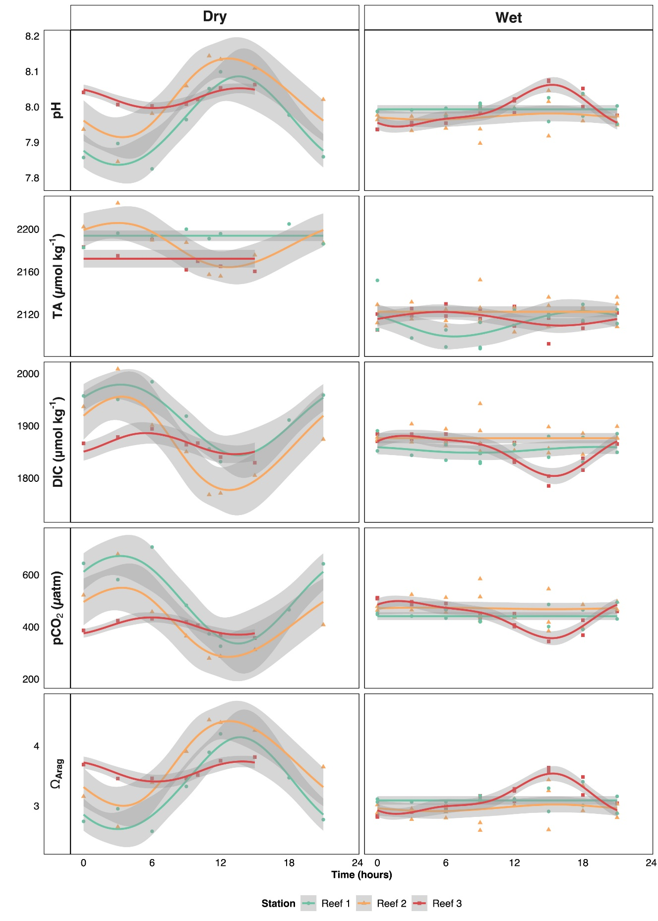
Figure S1. Diel composite time series of carbonate chemistry parameters divided by season. Data were normalized as the change since midnight (Time = 0). The lines represent cyclic cubic spline fits of the data, shaded areas represent 95% confidence interval.
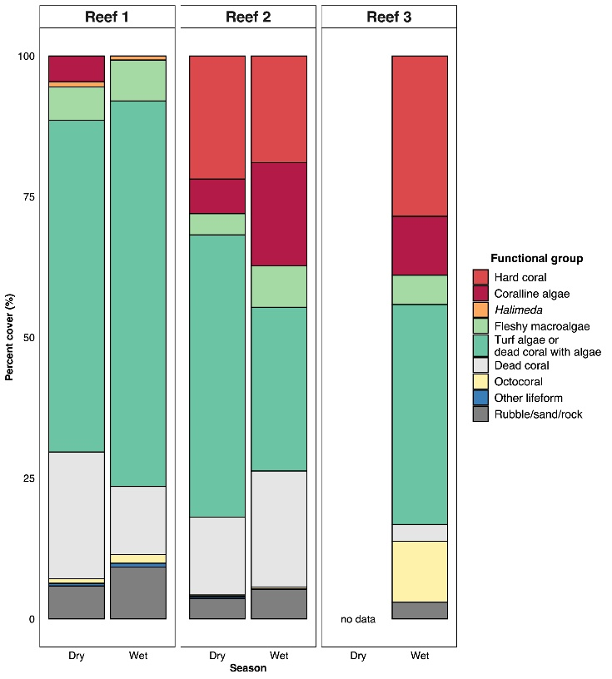
Figure S2. Summary of percent cover of the benthos in each reef station per season derived from phototransect surveys and image analysis. Stations are arranged left to right with increasing proximity to mariculture area. Benthic components are classified by functional groups. Dry season data was obtained in February 2021.

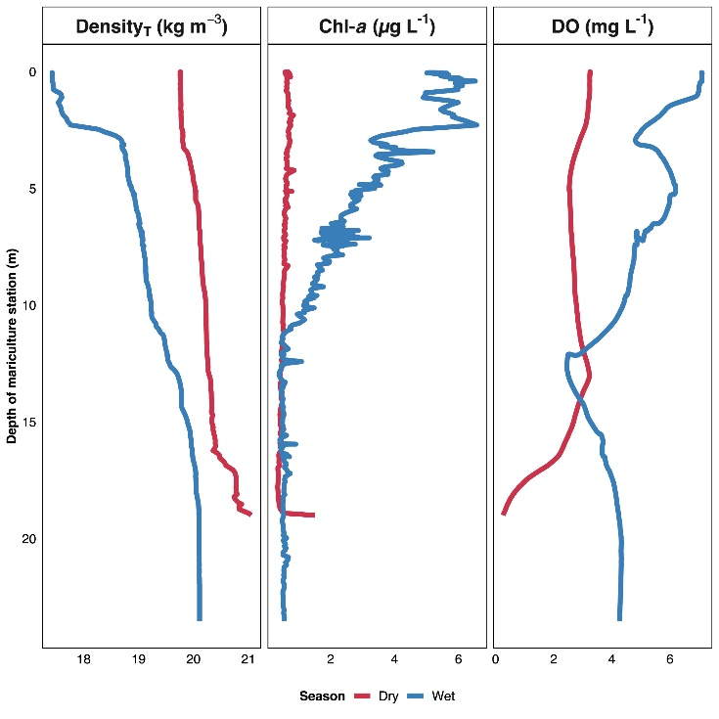
Figure S3. Vertical profiles of seawater density, chlorophyll-a, and DO in the mariculture station, divided per season.

