SUPPORTING INFORMATION

Floodplain trophic subsidies in a modified river network: Managed foodscapes of the future?

Table S1. Site coordinates and capture regions colored to match those used in Fig. 1, showing river distance in river kilometers (rkm) from the Yolo Bypass outlet (Sacramento River [SAC] basin) and Cosumnes River [COS] floodplain outlet (San Joaquin River [SJR] basin) to each capture site (Fig. 8). Gear types: SEIN = 15 m beach seine, KDTR = Kodiak trawl, MWT = midwater trawl.
Station | Gear | Site code (Fig. 1) | Site name | Latitude (DD) | Longitude (DD) | Region | Upstream /downstream of floodplain outlet | rkm below COS | rkm below Yolo
SR055E | SEIN | SH | Sherwood Harbor | 38.52638986 | -121.5279611 | Lower Sacramento | Upstream
SR055M | KDTR /MWT | SH | Sherwood Harbor | 38.53278804 | -121.5233336 | Lower Sacramento | Upstream
SR049E | SEIN | GB | Garcia Bend | 38.47563125 | -121.5418676 | Lower Sacramento | Upstream
SR043W | SEIN | CL | Clarksburg | 38.38291834 | -121.5208793 | Lower Sacramento | Upstream
SS011N | SEIN | SS | Steamboat Slough | 38.30460903 | -121.5748618 | Lower Sacramento | Upstream
SR024E | SEIN | KO | Koket | 38.24046854 | -121.5547133 | Lower Sacramento | Upstream
SR017E | SEIN | IS | Isleton | 38.16272446 | -121.6115635 | Lower Sacramento | Upstream
SR014W | SEIN | RV | Rio Vista | 38.18462753 | -121.6615231 | Yolo runoff | Downstream (SAC) |  | 22.5
SR012W | SEIN | SB | Sandy Beach | 38.1392055 | -121.6950223 | Yolo runoff | Downstream (SAC) |  | 30.3
MS001N | SEIN | SI | Sherman Island | 38.05412097 | -121.784866 | West Delta | Downstream (SAC) |  | 48.7
SB018X | MWT | CI | Chipps Island | 38.04365479 | -121.9112847 | Chipps Island | Downstream (SAC) |  | 60.8
SJ063W | SEIN | BB | Big Beach | 37.72359418 | -121.2962159 | Lower San Joaquin | Upstream
SJ056E | SEIN | MO | Mossdale | 37.78533934 | -121.3063476 | Lower San Joaquin | Upstream
SJ054M | KDTR | MO | Mossdale | 37.80564933 | -121.3156297 | Lower San Joaquin | Upstream
SJ051E | SEIN | DR | Dos Reis | 37.82827412 | -121.31015 | Lower San Joaquin | Upstream
SJ074W | SEIN | SB | Sturgeon Bend | 37.67227165 | -121.244883 | Lower San Joaquin | Upstream
SF014E | SEIN | WI | Wimpy's | 38.22524194 | -121.4906176 | Cosumnes runoff | Downstream (SJR) | 18.0
MK004W | SEIN | BW | B&W Marina | 38.12564164 | -121.5793298 | Cosumnes runoff | Downstream (SJR) | 39.8
LP003E | SEIN | TE | Terminous | 38.10995862 | -121.5002135 | Cosumnes runoff | Downstream (SJR) | 40.2
SJ005N | SEIN | ED | Eddo's | 38.04902171 | -121.6983803 | West Delta | Downstream (SJR) | 67.3
SJ001S | SEIN | AD | Antioch Dunes | 38.01482461 | -121.7828837 | West Delta | Downstream (SJR) | 78.3

Table S2. Sample sizes (incl. fish with empty stomachs used in Index of Fullness calculations) by region and year (2014-15 pooled due to low sample sizes within year and identical inundation periods)
Year | Region | N fish
2014-15 | Chipps Island | 513
2014-15 | Cosumnes runoff | 26
2014-15 | Lower Sacramento | 104
2014-15 | Lower San Joaquin | 196
2014-15 | West Delta | 38
2014-15 | Yolo runoff | 37
2016 | Chipps Island | 235
2016 | Cosumnes runoff | 40
2016 | Lower Sacramento | 213
2016 | Lower San Joaquin | 24
2016 | West Delta | 10
2016 | Yolo runoff | 15
2017 | Chipps Island | 130
2017 | Cosumnes runoff | 63
2017 | Lower Sacramento | 254
2017 | Lower San Joaquin | 268
2017 | West Delta | 31
2017 | Yolo runoff | 55
2018 | Chipps Island | 355
2018 | Cosumnes runoff | 13
2018 | Lower Sacramento | 231
2018 | Lower San Joaquin | 157
2018 | West Delta | 8
2018 | Yolo runoff | 17
 | TOTAL | 3033

Table S3. Total number of prey items identified in this study and the mean dry weight (DW) applied (as per the grouping specified in column 2). Most weights were estimated as part of this study, some were provided by Cramer Fish Sciences (CFS) and some were obtained from the literature. Figures referenced in DW source refer to the figure numbers used in the specified source (not the current study). Life stages are indicated by letters (_A = adult, _N = nymph, _L = larva, _P = pupa). Terrestrial forms indicated by _terr and/or ‘Y’ in the ‘Terrestrial’ column. Seven individuals (last two rows) were excluded due to lack of taxonomic resolution.

Taxa_life stage identified | Taxa_life stage grouping used | Phylum | Class | Sub-class | Order | Sub-order | Family | Terrestrial | Mean DW per individual (g) | DW source | Total N
Amphipoda_A | Amphipoda_other_A | Arthropoda | Malacostraca |  | Amphipoda |  |  |  | 0.00082 | This study | 2356
Corophiidae_A | Corophiidae_A | Arthropoda | Malacostraca |  | Amphipoda |  | Corophiidae |  | 0.00093 | This study | 8482
Arachnida_A | Araneae_A | Arthropoda | Arachnida |  | Araneae |  |  | Y | 0.00059 | This study | 222
Araneae_A | Araneae_A | Arthropoda | Arachnida |  | Araneae |  |  | Y | 0.00059 | This study | 235
Isoptera_A | Isoptera_A | Arthropoda | Insecta |  | Blattodea | Isoptera |  | Y | 0.001 | Matsuura 2006 (https://doi.org/10.1603/0013-8746(2006)99[625:EEOMIT]2.0.CO;2) [Midpoint of Fig. 1] | 1
Branchiopoda_A | Cladocera_A | Arthropoda | Branchiopoda |  | Cladocera |  |  |  | 0.0005 | This study | 1
Chydoridae_A | Cladocera_A | Arthropoda | Branchiopoda |  | Cladocera |  |  |  | 0.0005 | This study | 165
Cladocera_A | Cladocera_A | Arthropoda | Branchiopoda |  | Cladocera |  |  |  | 0.0005 | This study | 26437
Carabidae_A | Coleoptera_A | Arthropoda | Insecta |  | Coleoptera |  |  |  | 0.00086 | This study | 1
Coleoptera_A | Coleoptera_A | Arthropoda | Insecta |  | Coleoptera |  |  |  | 0.00086 | This study | 216
Dytiscidae_A | Coleoptera_A | Arthropoda | Insecta |  | Coleoptera |  |  |  | 0.00086 | This study | 1
Hydraenidae_A | Coleoptera_A | Arthropoda | Insecta |  | Coleoptera |  |  |  | 0.00086 | This study | 1
Staphylinidae_A | Coleoptera_A_terr | Arthropoda | Insecta |  | Coleoptera |  |  | Y | 0.00086 | This study | 2
Coleoptera_L | Coleoptera_L | Arthropoda | Insecta |  | Coleoptera |  |  |  | 0.00102 | This study | 91
Dytiscidae_L | Coleoptera_L | Arthropoda | Insecta |  | Coleoptera |  |  |  | 0.00102 | This study | 12
Elmidae_A | Coleoptera_L | Arthropoda | Insecta |  | Coleoptera |  |  |  | 0.00102 | This study | 1
Elmidae_L | Coleoptera_L | Arthropoda | Insecta |  | Coleoptera |  |  |  | 0.00102 | This study | 1
Gyrinidae_L | Coleoptera_L | Arthropoda | Insecta |  | Coleoptera |  |  |  | 0.00102 | This study | 1
Collembola_A | Collembola_A | Arthropoda | Entognatha |  | Collembola |  |  |  | 0.00038 | This study | 565
Cumacea_A | Cumacea_A | Arthropoda | Malacostraca |  | Cumacea |  |  |  | 0.00054 | This study | 1480
Decapoda_L | Decapoda_L | Arthropoda | Malacostraca |  | Decapoda |  |  |  | 0.06213 | Benke 1999 regression [Assumed a carapace length of 10mm (~midpoint of CFS lengths)] | 15
Ceratopogonidae_L | Ceratopogonidae_L | Arthropoda | Insecta |  | Diptera |  | Ceratopogonidae |  | 0.00006 | Linley, J. R. (1985). Growth and Survival of Culicoides Melleus Larvae (Diptera: Ceratopogonidae) on Four Prey Organisms. Journal of Medical Entomology, 22(2), 178-189. doi:10.1093/jmedent/22.2.178 [midpoint of Fig 4] | 44
Chaoboridae_L | Chironomidae_L | Arthropoda | Insecta |  | Diptera |  | Chironomidae |  | 0.0005 | This study | 2
Chironomidae_L | Chironomidae_L | Arthropoda | Insecta |  | Diptera |  | Chironomidae |  | 0.0005 | This study | 4579
Culicidae_L | Culicidae_L | Arthropoda | Insecta |  | Diptera |  | Culicidae | Y | 0.00044 | This study | 13
Ceratopogonidae_A | Diptera_other_A | Arthropoda | Insecta |  | Diptera |  |  |  | 0.00053 | This study | 1
Chironomidae_A | Diptera_other_A | Arthropoda | Insecta |  | Diptera |  |  |  | 0.00053 | This study | 156
Culicidae_A | Diptera_other_A | Arthropoda | Insecta |  | Diptera |  |  |  | 0.00053 | This study | 2
Diptera_A | Diptera_other_A | Arthropoda | Insecta |  | Diptera |  |  |  | 0.00053 | This study | 8071
Tipulidae_A | Diptera_other_A | Arthropoda | Insecta |  | Diptera |  |  |  | 0.00053 | This study | 1
Diptera_L | Diptera_other_L | Arthropoda | Insecta |  | Diptera |  |  |  | 0.00062 | This study | 692
Empididae_L | Diptera_other_L | Arthropoda | Insecta |  | Diptera |  |  |  | 0.00062 | This study | 1
Tabanidae_L | Diptera_other_L | Arthropoda | Insecta |  | Diptera |  |  |  | 0.00062 | This study | 1
Cecidomyiidae_P | Diptera_other_P | Arthropoda | Insecta |  | Diptera |  |  |  | 0.00065 | This study | 1
Chironomidae_P | Diptera_other_P | Arthropoda | Insecta |  | Diptera |  |  |  | 0.00065 | This study | 36
Diptera_P | Diptera_other_P | Arthropoda | Insecta |  | Diptera |  |  |  | 0.00065 | This study | 14458
Empididae_P | Diptera_other_P | Arthropoda | Insecta |  | Diptera |  |  |  | 0.00065 | This study | 1
Simuliidae_P | Diptera_other_P | Arthropoda | Insecta |  | Diptera |  |  |  | 0.00065 | This study | 35
Simuliidae_L | Simuliidae_L | Arthropoda | Insecta |  | Diptera |  | Simuliidae |  | 0.0002 | Wotton, R. S. (1980). Bacteria as food for blackfly larvae (Diptera: Simuliidae) in a lake-outlet in Finland. Annales Zoologici Fennici, 17(2), 127-130. [based on the mean DW (estimated from body length) of Simuliidae] | 47
Syrphidae_L | Syrphidae_L | Arthropoda | Insecta |  | Diptera |  | Syrphidae |  | 0.00342 | Barlow, C.A., 1979 ENERGY UTILIZATION BY LARVAE OF A FLOWER FLY, SYRPHUS COROLLAE (DIPTERA: SYRPHIDAE). The Canadian Entomologist 111, 897-904. [Table 2 averaged DW for each age] | 1
Ephemeroptera_A | Ephemeroptera_A | Arthropoda | Insecta |  | Ephemeroptera |  |  |  | 0.00025 | Cramer Fish Sciences | 62
Baetidae_N | Ephemeroptera_N | Arthropoda | Insecta |  | Ephemeroptera |  |  |  | 0.00068 | This study | 7
Ephemeroptera_N | Ephemeroptera_N | Arthropoda | Insecta |  | Ephemeroptera |  |  |  | 0.00068 | This study | 325
Heptageniidae_N | Ephemeroptera_N | Arthropoda | Insecta |  | Ephemeroptera |  |  |  | 0.00068 | This study | 1
Aphididae_A | Aphididae_A | Arthropoda | Insecta |  | Hemiptera |  | Aphididae | Y | 0.0005 | This study | 1988
Aphididae_N | Aphididae_N | Arthropoda | Insecta |  | Hemiptera |  | Aphididae | Y | 0.00025 | Greenslade, A.F.C., et al 2016. Triticum monococcum lines with distinct metabolic phenotypes and phloem-based partial resistance to the bird cherry-oat aphid Rhopalosiphum padi. The Annals of applied biology 168, 435-449. | 455
Corixidae_A | Corixidae_A_N | Arthropoda | Insecta |  | Hemiptera |  | Corixidae |  | 0.00111 | This study | 350
Corixidae_N | Corixidae_A_N | Arthropoda | Insecta |  | Hemiptera |  | Corixidae |  | 0.00111 | This study | 39
Hemiptera_A | Hemiptera_other_A | Arthropoda | Insecta |  | Hemiptera |  |  |  | 0.00068 | This study | 2064
Notonectidae_A | Hemiptera_other_A | Arthropoda | Insecta |  | Hemiptera |  |  |  | 0.00068 | This study | 2
Cicadellidae_A | Hemiptera_other_A_terr | Arthropoda | Insecta |  | Hemiptera |  |  | Y | 0.00068 | This study | 1
Cicadidae_A | Hemiptera_other_A_terr | Arthropoda | Insecta |  | Hemiptera |  |  | Y | 0.00068 | This study | 22
Cimicidae_A | Hemiptera_other_A_terr | Arthropoda | Insecta |  | Hemiptera |  |  | Y | 0.00068 | This study | 5
Miridae_A | Hemiptera_other_A_terr | Arthropoda | Insecta |  | Hemiptera |  |  | Y | 0.00068 | This study | 1
Psyllidae_A | Hemiptera_other_A_terr | Arthropoda | Insecta |  | Hemiptera |  |  | Y | 0.00068 | This study | 12
Hemiptera_N | Hemiptera_other_N | Arthropoda | Insecta |  | Hemiptera |  |  |  | 0.000217707 | This study | 88
Formicidae_A | Hymenoptera_A | Arthropoda | Insecta |  | Hymenoptera |  |  | Y | 0.00071 | This study | 12
Hymenoptera_A | Hymenoptera_A | Arthropoda | Insecta |  | Hymenoptera |  |  | Y | 0.00071 | This study | 987
Isopoda_A | Isopoda_A | Arthropoda | Malacostraca |  | Isopoda |  |  |  | 0.00043 | This study | 48
Lepidoptera_A | Lepidoptera_A | Arthropoda | Insecta |  | Lepidoptera |  |  |  | 0.02 | Kuhsel et al 2016 [20mg was the median DW for adult butterflies from https://www.researchgate.net/publication/303634267_Surface_area_-_volume_ratios_in_insects/figures?lo=1] | 11
Lepidoptera_L | Lepidoptera_L | Arthropoda | Insecta |  | Lepidoptera |  |  |  | 0.00615 | This study | 29
Megaloptera_L | Megaloptera_L | Arthropoda | Insecta |  | Megaloptera |  |  |  | 0.0008 | Mothiversen, T., Thorup, J., 1987. Population dynamics and production of Sialis lutaria L. (Megaloptera) in the Danish River Suså. Freshwater Biology 17, 461-469. [Midpoint of Fig. 1] | 3
Mysida_A | Mysida_A | Arthropoda | Malacostraca |  | Mysida |  |  |  | 0.0007 | This study | 2749
Neuroptera_A | Neuroptera_other_A | Arthropoda | Insecta |  | Neuroptera |  |  |  | 0.001252 | Romeis, J., Dutton, A., Bigler, F., 2004. Bacillus thuringiensis toxin (Cry1Ab) has no direct effect on larvae of the green lacewing Chrysoperla carnea (Stephens) (Neuroptera: Chrysopidae). Journal of Insect Physiology 50 2-3, 175-183. [Table 1 DW for Neuroptera fed Bt-sucrose] | 11
Neuroptera_L | Neuroptera_other_L | Arthropoda | Insecta |  | Neuroptera |  |  |  | 0.001252 | Used DW for Neuroptera_A based on similar size/morphology | 2
Sisyridae_L | Sisyridae_L | Arthropoda | Insecta |  | Neuroptera |  | Sisyridae |  | 0.001252 | Used DW for Neuroptera_A based on similar size/morphology | 1
Odonata_A | Odonata_A_N | Arthropoda | Insecta |  | Odonata |  |  |  | 0.00488 | This study | 3
Odonata_N | Odonata_A_N | Arthropoda | Insecta |  | Odonata |  |  |  | 0.00488 | This study | 188
Plecoptera_A | Plecoptera_A_N | Arthropoda | Insecta |  | Plecoptera |  |  |  | 0.0006 | This study | 13
Plecoptera_N | Plecoptera_A_N | Arthropoda | Insecta |  | Plecoptera |  |  |  | 0.0006 | This study | 90
Psocoptera_A | Psocoptera_A_N | Arthropoda | Insecta |  | Psocoptera |  |  | Y | 0.0003 | This study | 300
Psocoptera_N | Psocoptera_A_N | Arthropoda | Insecta |  | Psocoptera |  |  | Y | 0.0003 | This study | 1
Tanaidacea_A | Tanaidacea_A | Arthropoda | Malacostraca |  | Tanaidacea |  |  |  | 0.00051 | This study | 1426
Thysanoptera_A | Thysanoptera_A | Arthropoda | Insecta |  | Thysanoptera |  |  | Y | 0.00045 | This study | 316
Trichoptera_A | Trichoptera_A | Arthropoda | Insecta |  | Trichoptera |  |  |  | 0.00127 | This study | 203
Hydropsychidae_L | Trichoptera_L | Arthropoda | Insecta |  | Trichoptera |  |  |  | 0.00069 | This study | 54
Leptoceridae_L | Trichoptera_L | Arthropoda | Insecta |  | Trichoptera |  |  |  | 0.00069 | This study | 3
Trichoptera_L | Trichoptera_L | Arthropoda | Insecta |  | Trichoptera |  |  |  | 0.00069 | This study | 1932
Trichoptera_P | Trichoptera_L | Arthropoda | Insecta |  | Trichoptera |  |  |  | 0.00069 | This study | 9
Actinopterygii_L | Actinopterygii_L | Chordata | Actinopterygii |  |  |  |  |  | 0.001 | https://www.st.nmfs.noaa.gov/spo/FishBull/932/pepin.pdf [based on the ~10mm larval fish in Fig 1] | 146
Acari_A | Hydracarina_A_N | Arthropoda | Arachnida | Acari |  |  |  |  | 0.00001 | Cramer Fish Sciences § | 2
Hydracarina_A | Hydracarina_A_N | Arthropoda | Arachnida | Acari |  |  |  |  | 0.00001 | Cramer Fish Sciences § | 368
Hydracarina_N | Hydracarina_A_N | Arthropoda | Arachnida | Acari |  |  |  |  | 0.00001 | Cramer Fish Sciences § | 4
Bivalvia_A | Bivalvia_A | Mollusca | Bivalvia |  |  |  |  |  | 0.00001 | http://www.fao.org/3/y5720e/y5720e0b.htm ["Dry tissue weight was measured to 0.01 mg" on page 5] | 11
Gastropoda_A | Gastropoda_A | Mollusca | Gastropoda |  |  |  |  |  | 0.00007 | Cramer Fish Sciences | 2
Copepoda_A | Copepoda_A | Arthropoda | Maxillopoda | Copepoda |  |  |  |  | 0.00047 | This study | 4255
Maxillopoda_A | Copepoda_A | Arthropoda | Maxillopoda | Copepoda |  |  |  |  | 0.00047 | This study | 7
Cyprididae_A | Ostracoda_A | Arthropoda | Ostracoda |  |  |  |  |  | 0.00049 | This study | 94
Ostracoda_A | Ostracoda_A | Arthropoda | Ostracoda |  |  |  |  |  | 0.00049 | This study | 5056
Insecta_A | Insecta_A |  |  |  |  |  |  |  |  | Excluded as too much DW variation in taxa to estimate DW | 6
Orthoptera_A | Orthoptera_A | Arthropoda | Insecta |  | Orthoptera |  |  |  |  | Excluded as too much DW variation in taxa to estimate DW | 1
§ Note similar to 24.5ug mean mite weight from Douce 1976 ("163 weighings were made utilizing 1528 mites, representing 25 species of adults and 16 groups of immature stages of several species") but as Cramer estimate is local we used that. Nymphs and adults similar size.
Table S4. Mean Cladocera catch per unit effort (CPUE = number per cubic meter) and standard deviation (SD) by year (Jan-June emigration season) and month. Monthly averages at each site were averaged to produce these values.
 | Cladocera CPUE across all sites shown in Fig. 1
Year | Jan-June mean | Jan-June SD | Month | Monthly mean | Monthly SD
2014 | 1146.9 | 4799.0 | 1 | 453.0 | 1858.7
 |  |  | 2 | 1047.8 | 3598.8
 |  |  | 3 | 174.3 | 425.6
 |  |  | 4 | 2045.8 | 8601.9
 |  |  | 5 | 467.3 | 1177.9
 |  |  | 6 | 2693.0 | 6872.5
2015 | 900.1 | 4648.8 | 1 | 38.0 | 57.2
 |  |  | 2 | 150.8 | 233.0
 |  |  | 3 | 53.5 | 117.5
 |  |  | 4 | 423.3 | 975.8
 |  |  | 5 | 1570.0 | 4872.5
 |  |  | 6 | 3165.1 | 10131.3
2016 | 1903.9 | 5831.6 | 1 | 567.8 | 1340.5
 |  |  | 2 | 363.4 | 430.7
 |  |  | 3 | 669.5 | 2069.4
 |  |  | 4 | 2386.1 | 6648.6
 |  |  | 5 | 2161.9 | 3223.0
 |  |  | 6 | 5235.7 | 11633.4
2017 | 2297.1 | 10596.6 | 1 | 565.6 | 864.9
 |  |  | 2 | 444.8 | 254.4
 |  |  | 3 | 376.8 | 311.9
 |  |  | 4 | 577.6 | 631.5
 |  |  | 5 | 5819.3 | 13751.7
 |  |  | 6 | 5830.9 | 21947.5
2018 | 1385.7 | 7581.7 | 1 | 365.2 | 1254.1
 |  |  | 2 | 356.9 | 810.5
 |  |  | 3 | 820.5 | 2479.0
 |  |  | 4 | 1653.9 | 5583.0
 |  |  | 5 | 532.8 | 1032.9
 |  |  | 6 | 4596.9 | 17704.1

A B
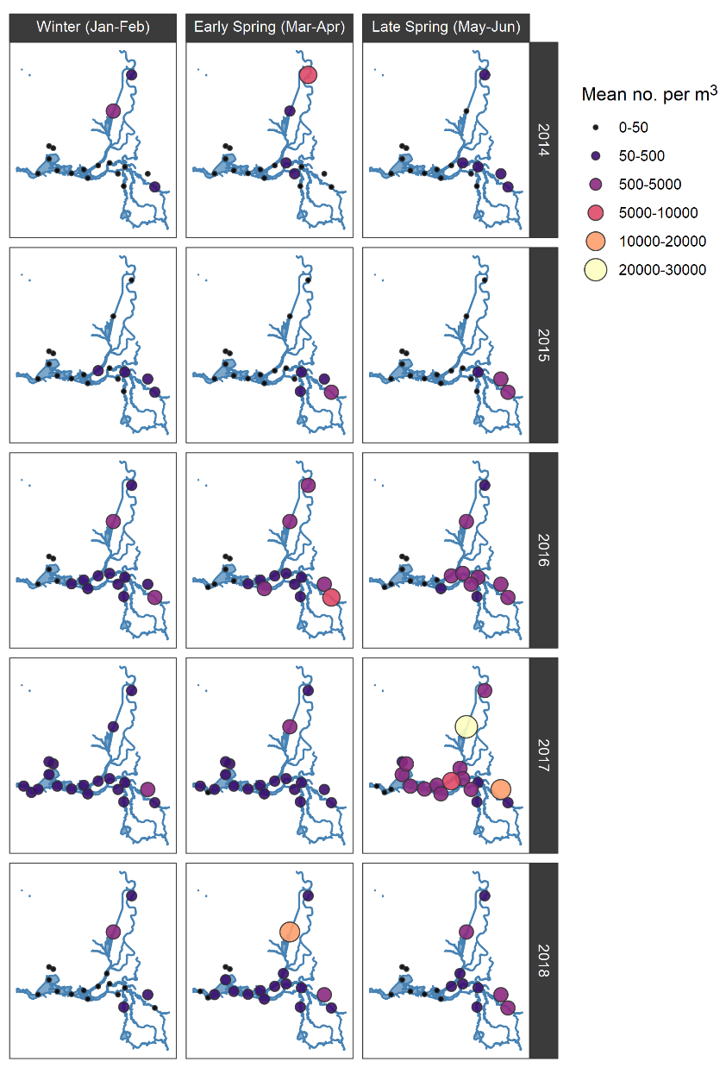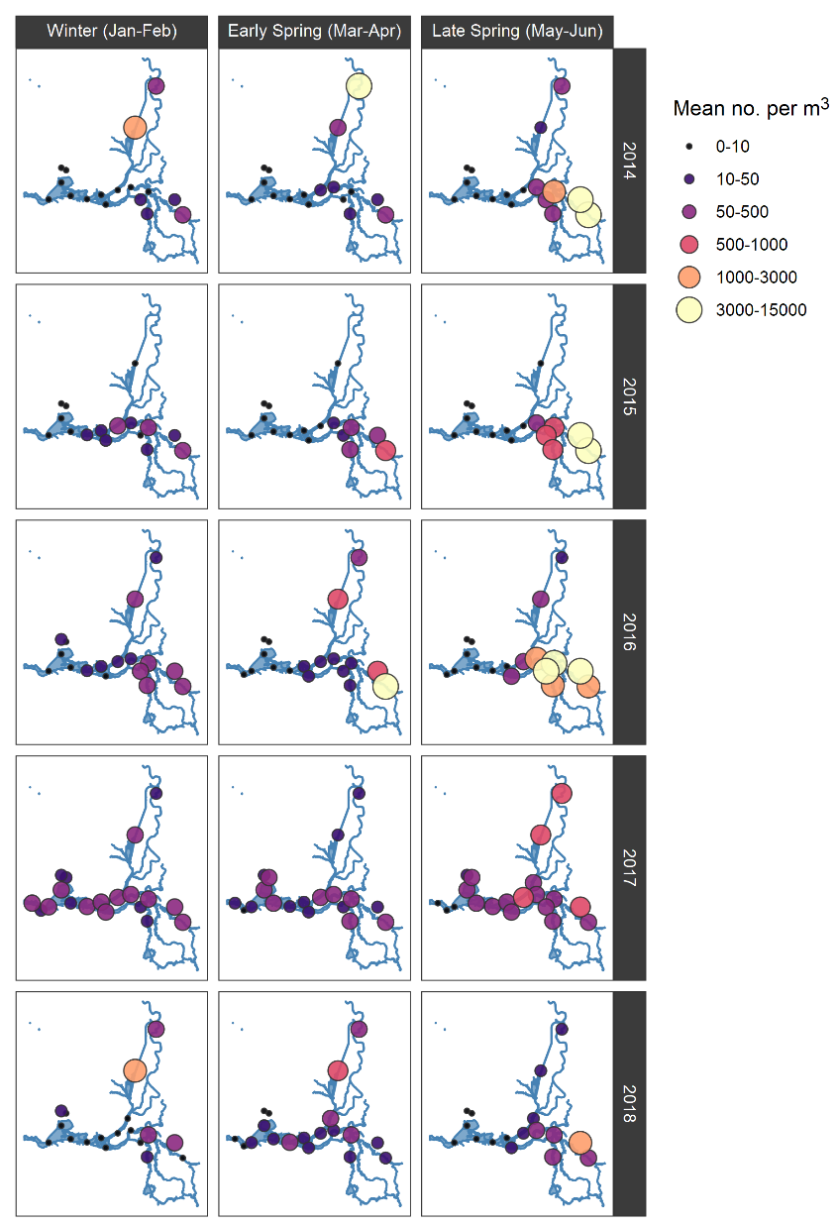

Fig. S1 Mean bimonthly densities of (A) Bosmina spp. and (B) Daphnia spp. in Jan-June 2014-2018 in the Sacramento-San Joaquin River Delta. Size and color of symbol indicates estimated abundance per meter squared (see key).

Fig. S2 (A) The fraction of total monthly Delta outflow represented by the Cosumnes River (circles) and Yolo Bypass (triangles) across the study period, estimated from CA DWR’s Dayflow metric. (B) The ratio of Cosumnes River monthly total flow to Yolo Bypass monthly total flow across the study period, where points above the red line indicate months when Cosumnes flows exceeded Yolo Bypass flows.

