Supplemental Material
Supplemental Material 1. Cabo Verde artisanal fishery boat. Phots of Samir Martins
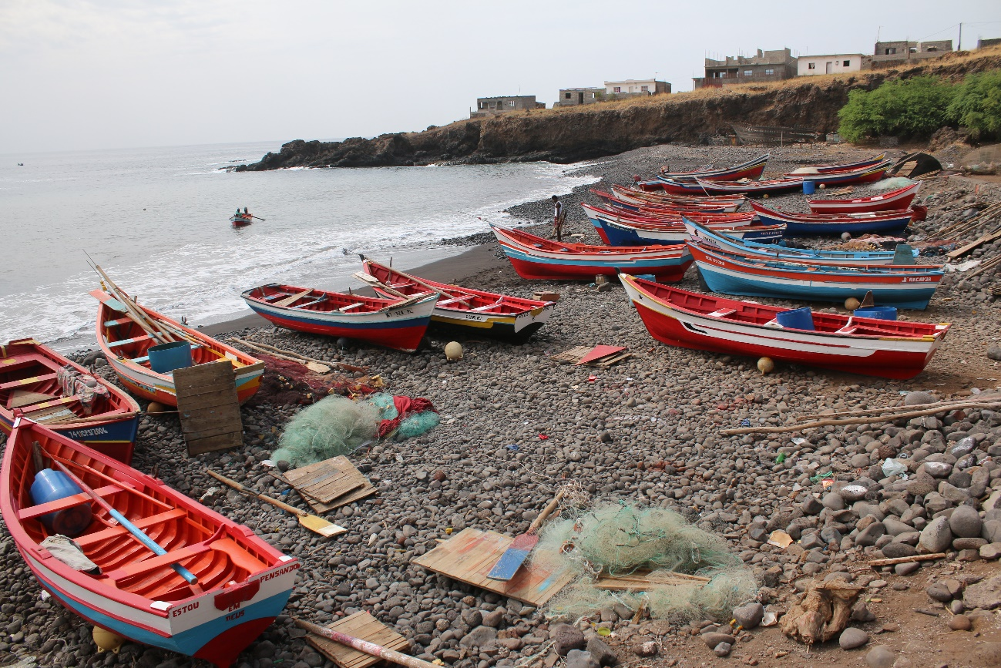
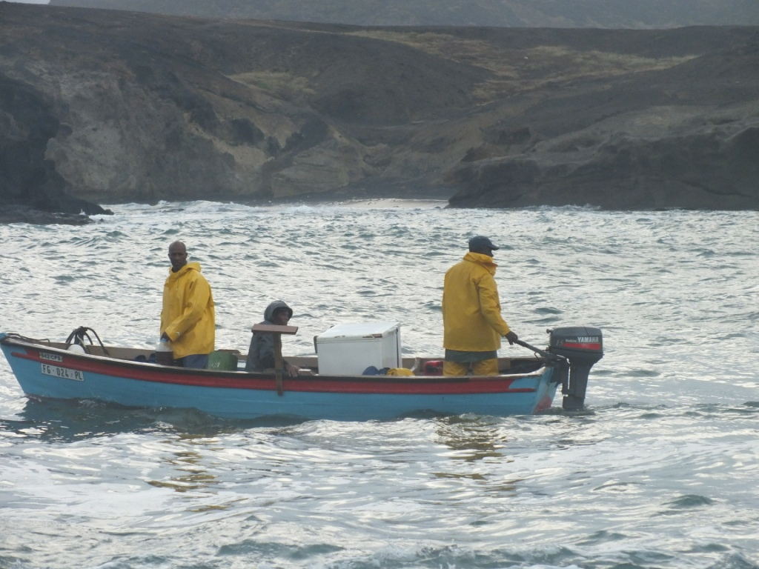
Supplemental Material 2. Questionnaire forms used in the study
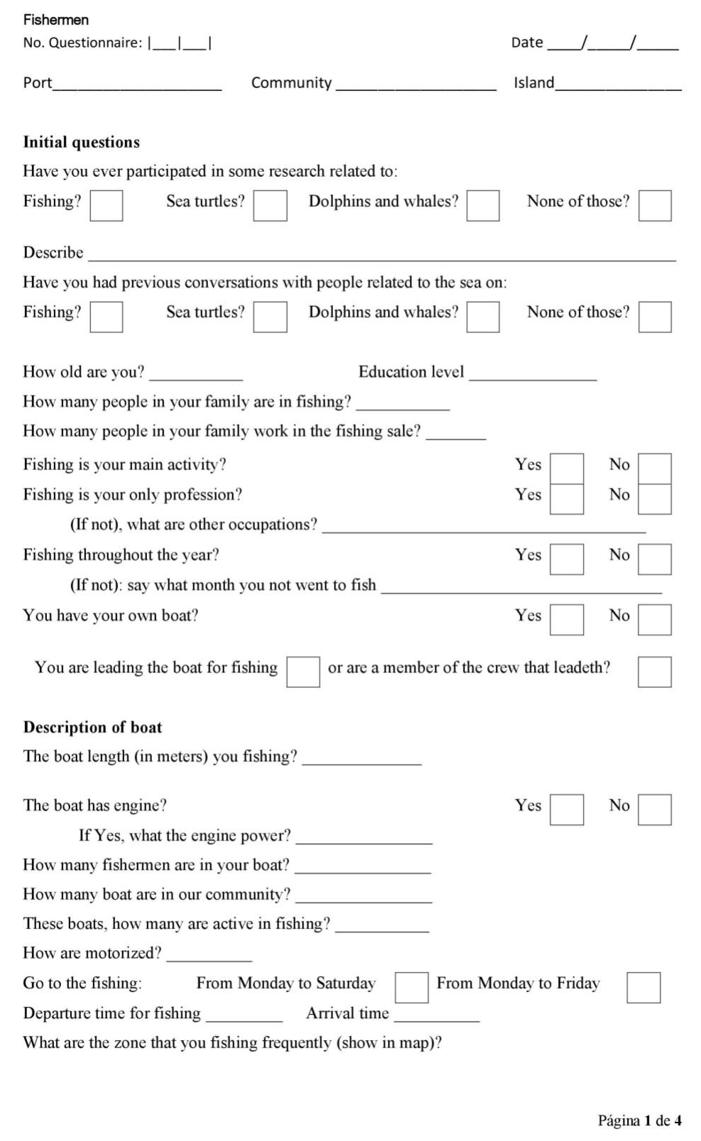
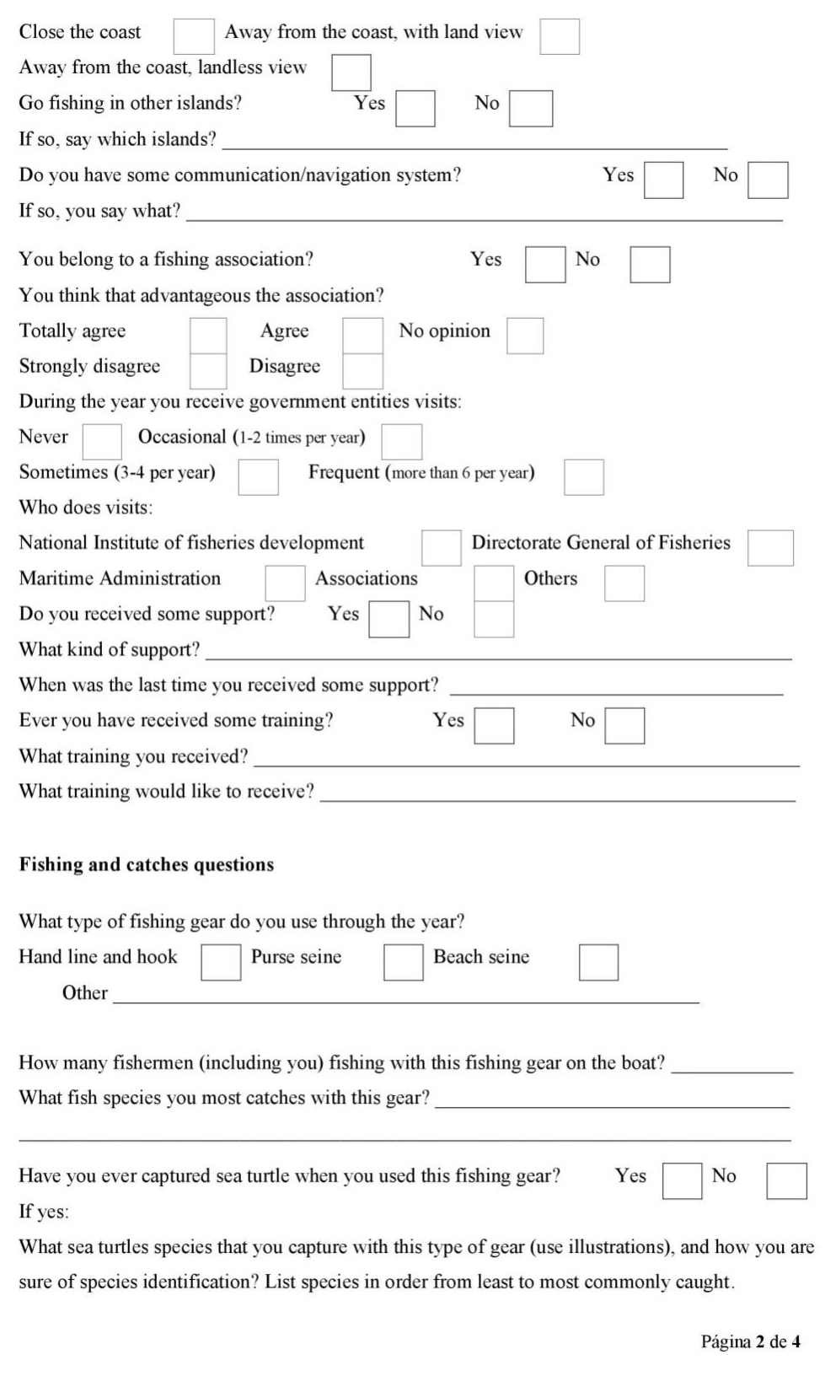
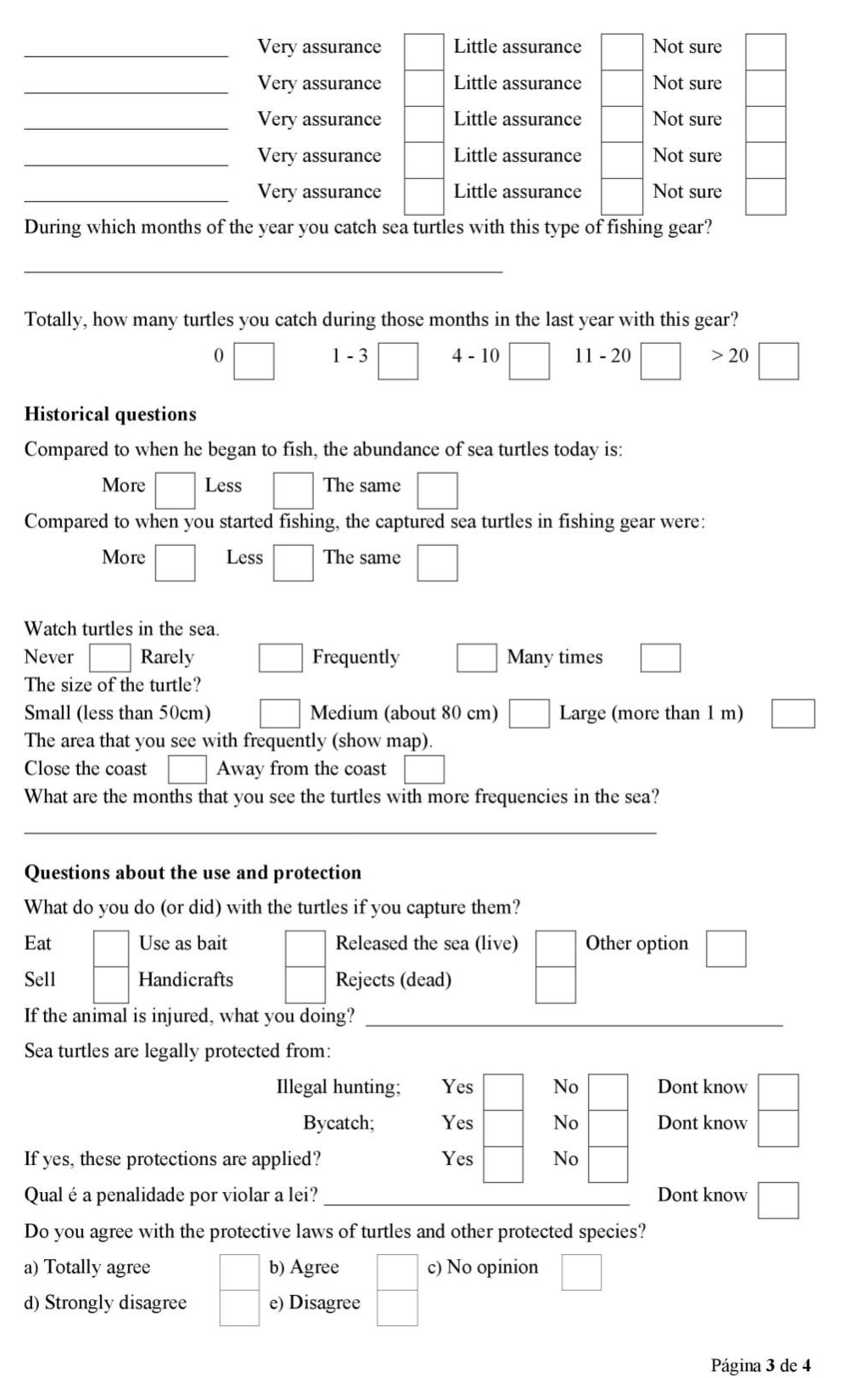
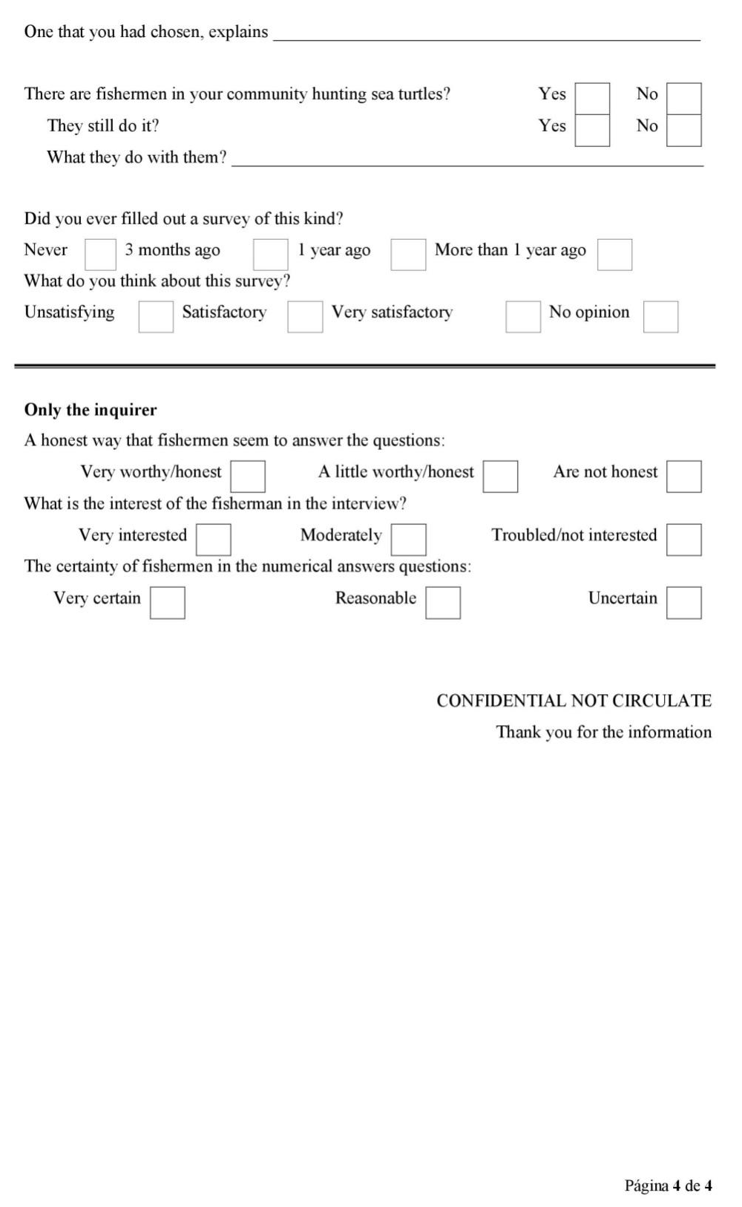
Supplemental Material 3
List of sea turtle photos used in species identification, including common name (Portuguese), English and scientific:
1: | Tartaruga vermelha (comum), | Loggerhead turtle | Caretta caretta
2: | Tartaruga verde | Green turtle | Chelonia mydas
3: | Tartaruga-de-casco-levantado | Hawksbill turtle | Eretmochelys imbricata
4: | Tartaruga olivacea | Olive ridley turtle | Lepidochelys olivacea
5: | Tartaruga parda | Leatherback turtle | Dermochelys coriacea

