Supplementary material 1. Three examples to demonstrate that the abundance estimator (Equation 9) is robust to different types of movement. In the first example, movement is diffusive; in the second, directional; in the third, a mix of diffusive and directional.

Example 1. Diffusive movement.
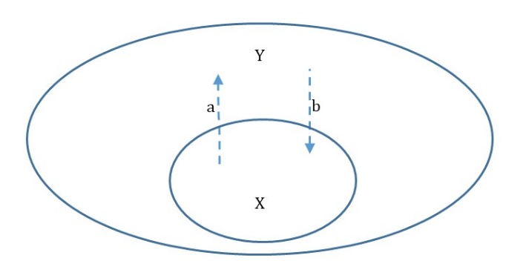
In example 1, X_{t} is the number of fish inside the array at time t, and Y_{t} is the number outside. Fish leave the array at rate a and enter at rate b. In practice these rates would be estimated from telemetry information, but in this example are considered as given. Allow the capture/detection probability to be p, which is assumed equal for tagged and untagged fish. At the time of tagging, t=1, n₁=pX₁ fish are captured and tagged.
Now move forward one time step (t=2) to the time of sampling. The number of fish we are attempting to estimate is X₂,
$X_{2}=X_{1}-aX_{1}+bY_{1}=\left(1-a\right)X_{1}+bY_{2}$
The number of tagged fish that remain in the array at t=2 is,
$n_{2}=\left(1-a\right)n_{1}=\left(1-a\right)pX_{1}$
The number of fish that are captured at t=2 is,
${K=pX}_{2}$
The number of fish that are captured at t=2 that were also tagged is,
$k=pn_{2}=p\left(1-a\right)pX_{1}=p^{2}\left(1-a\right)X_{1}$
Then, following Equation 9, the estimate of abundance at t=2, N₂, is
$N_{2}={n_{2}K}/k=\frac{\left[\left(1-a\right)pX_{1}{pX}_{2}\right]}{\left[p^{2}\left(1-a\right)X_{1}\right]}=X_{2}$
Thus, the estimator N₂ equals the value we are attempting to estimate, X₂.

Example 2. Directed movement.
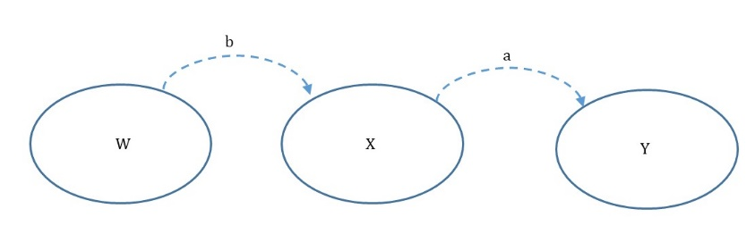
In example 2, X_{t} is the number of fish inside the array at time t, W_{t} is the number at a source location, and Y_{t} is the number at a sink location. This scenario might represent a seasonal migration, as suggested by the reviewer. As in example 1, fish leave the array at rate a and enter at rate b, and the capture/detection probability is p. At the time of tagging, t=1, n₁=pX₁ fish are captured and tagged. At the time of sampling (t=2), the number of fish we are attempting to estimate is X₂,
$X_{2}=X_{1}-aX_{1}+bW_{1}=\left(1-a\right)X_{1}+bW_{2}$
The number of tagged fish that remain in the array at t=2 is,
$n_{2}=\left(1-a\right)n_{1}=\left(1-a\right)pX_{1}$
The number of fish that are captured at t=2 is,
${K=pX}_{2}$
The number of fish that are captured at t=2 that were also tagged is,
$k=pn_{2}=p\left(1-a\right)pX_{1}=p^{2}\left(1-a\right)X_{1}$
Then, following Equation 9, the estimate of abundance at t=2, N₂, is
$N_{2}={n_{2}K}/k=\frac{\left[\left(1-a\right)pX_{1}{pX}_{2}\right]}{\left[p^{2}\left(1-a\right)X_{1}\right]}=X_{2}$
Thus, the estimation properties are the same in examples 1 and 2, and the estimator equals the actual abundance.

Example 3. Diffusive and directed movement (with numbers).
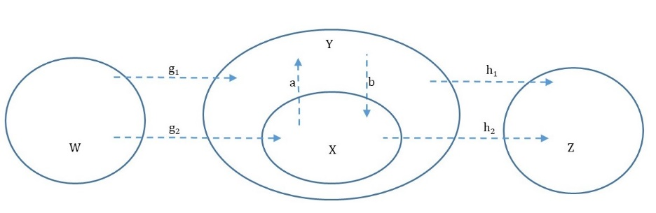
Let n represent the number of tagged fish inside the array (i.e., a subset of X), let m represent the number of tagged fish that are outside the array but remain in the surrounding area (i.e., a subset of Y), and let o represent the number of tagged fish that are outside the array and have emigrated (i.e, a subset of Z). The governing equations are:
W_{t+1} = W_{t} ‒ g₁W_{t} ‒ g₂W_{t}
Y_{t+1} = Y_{t} + g₁W_{t} + aX_{t} ‒ bY_{t} ‒ h₁Y_{t}
X_{t+1} = X_{t} + g₂W_{t} + bY_{t} – aX_{t} – h₂X_{t}
Z_{t+1} = Z_{t} + h₁Y_{t} + h₂X_{t}
n_{t+1} = n_{t} + bm_{t} – an_{t} – h₂n_{t}
m_{t+1} = m_{t} + an_{t} ‒ bm_{t} – h₁m_{t}
o_{t+1} = o_{t} + h₁m_{t} + h₂n_{t}

At time of tagging, let the arbitrarily chosen abundance in each area be W₁=1000, X₁=400, Y₁=800, and Z₁=500. Assume the following arbitrarily chosen movement rates: g₁=0.1, g₂=0.05, a=0.2, b=0.15, h₁=0.08, h₂=0.06, and p=0.25. The number of tagged fish inside the array is n₁=0.25*400=100, and the number of tagged fish outside is m₁=o₁=0. Carry this forward two time steps:
W₂ = 1000‒0.1*1000-0.05*1000 = 850
Y₂ = 800+0.1*1000+0.2*400-0.15*800-0.08*800 = 796
X₂ = 400+0.05*1000+0.15*800-0.2*400-0.06*400 = 466
Z₂ = 500+0.08*800+0.06*400 = 588
n₂ = 100+0.15*0-0.2*100-0.06*100 = 74
m₂ = 0+0.2*100-0.15*0-0.08*0 = 20
o₂ = 0+0.08*0+0.06*100 = 6

W₃ = 850‒0.1*850-0.05*850 = 722.5
Y₃ = 796+0.1*850+0.2*466-0.15*796-0.08*796 = 791.12
X₃ = 466+0.05*850+0.15*796-0.2*466-0.06*466 = 506.74
Z₃ = 588+0.08*796+0.06*466 = 679.64
n₃ = 74+0.15*20-0.2*74-0.06*74 = 57.76
m₃ = 20+0.2*74-0.15*20-0.08*20 = 30.2
o₃ = 6 +0.08*20+0.06*74 = 12.04

At time steps t=2 and 3, the number of fish captured would be:
K₂ = pX₂ = 116.5
K₃ = pX₃ = 126.685

And, the number captured that are tagged would be:
k₂ = pn₂ = 18.5
k₃ = pn₃ = 14.44

Then, the estimates of abundance inside the array (Equation 9) would be:
N₂ = 74*116.5/18.5 = 466 = X₂
N₃ = 57.76*126.685/14.44 = 506.74 = X₃

Again, the abundance estimator works. What matters is the ratio of tagged fish recaptured/resighted to the total number of fish recaptured. The type of movement might affect that ratio, but that causes no bias because an estimate of the ratio is obtained directly from sampling, and because abundance is estimated at the time of recapture, not the time of tagging.
Although the estimator is robust to the type of movement, the system dynamics are affected. Diffusive movement would be expected (on average) to result in equilibrium numbers of tagged and untagged fish inside and outside the array. Directional movement would result in tagged fish only leaving the array. If emigration is the only directional movement, then the ratio of tagged to untagged fish would be expected to remain constant, at least until all the tagged fish were depleted from the study area. If immigration occurs (as in the above examples), then the ratio of tagged to untagged fish would diminish over time.

