Supplementary material for Jacobsen et al 2021.
This supplementary material for Jacobsen et al 2021 “Climate-mediated stock redistribution causes increased risk and challenges for fisheries management” covers a table describing the parameters, variables and subscripts used (Table S1), the equations governing the operating model (OM) and estimation model (EM) (Table S2), a table including the likelihood functions in the estimation model (Table S3), equations describing how the harvest control rules calculates an annual total allowable catch (Table S4), and a supplementary analysis which applies a HCR that distributes the TAC annually based on the biomass observed in the survey.
Subscripts denoted on variables in table S2-S4 describe both indexes (e.g., numbers at age age, $N_{a}$) or variable type (e.g., numbers in catch $N_{C})$ or combinations thereof. We refer to table S1 for the description of variables and subscripts. Additionally, time notation is divided into years and seasons, denoted $y$ and $t$, respectively, in order to distinguish inter and intra-annual effects.
  - Supplementary tables and figures
Table S1: Notation used to describe variables and parameters used in operating and estimation models. Operating model (OM) values describe the features of the population and fishery, some of which are estimated parameters in the estimation model (EM).
Notation | OM Value ([range]) | Explanation | Estimated as parameter in EM
Time and Space
y | years | [1966:2050] | No
t | season | [1:4] | No
$$i$$ | Spatial area | 1,2 | No
$$Ω$$ | Initial spatial distribution | [0.25, 0.75] | No
Life history
a | Age | [1...A] | No
A | Max age | 20 | No
M | Natural mortality | 0.2 yr⁻¹ | Yes
$$R_{0}$$ | Unfished recruitment | 2276865 | Yes
$$w_{s}$$ | Weight of spawners |  | No
$$w_{C}$$ | Weight at age in catch |  | No
$$w_{I}$$ | Weight at age in survey |  | No
b | Bias adjustment | [0;1] | No
h | Steepness | 0.8 | Yes
Z | Total mortality |  | Yes
State variables
N | Numbers of fish |  | No
R | Recruitment |  | No
F | Fully selected fishing mortality |  | Yes
R | Recruitment |  | No
Harvest control rules
HCR₀ | Default harvest control rule |  | No
MD | Management decision rule |  | No
AC | Actual catch rule |  | No
Derived variables
C | Catch |  | No
S | Spawning biomass |  | No
$$S_{0}$$ | Unfished spawning biomass |  | No
I | Survey index |  | No
V | Biomass vulnerable to fishing |  | No
H | Harvest rate |  | No
$$τ_{I}$$ | Age composition in survey |  | No
$$τ_{C}$$ | Age composition in catch |  | No
$$ϕ_{I}$$ | Survey variance parameter for Dirichlet distribution |  | Yes
$$ϕ_{C}$$ | Catch variance parameter for Dirichlet distribution |  | Yes
Bias adjustment
$$b_{y}$$ | Bias adjustment | [0;b_{max}] | No
$$y_{b,(1…4)}$$ | Years for bias adjustment ramp |  | No
$$b_{max}$$ | Maximum bias adjustment | 0.87 | No
Stochastic variables
$$\tilde{R}$$ | Recruitment deviations | $$N( 0,σ_{R}^{2})$$ | Yes
$${\tilde{R}}_{0}$$ | Initial recruitment deviations | $$N( 0,σ_{R}^{2})$$ | Yes
$$σ_{R}^{2}$$ | Recruitment standard deviation | 1.4 | Yes
$$ϵ_{I,y}$$ | Survey observation error | $$N(0,σ_{I}^{2})$$ | No
$$σ_{I }^{2}$$ | Survey error standard deviation | 0.26 | Yes
$$ϵ_{C,y}$$ | Time varying selectivity | $$N(0, σ_{C}^{2})$$ | Yes
$$σ_{C}^{2}$$ | Selectivity standard deviation* | 1.4 | No
Selectivity
s | Fisheries selectivity | [0;1]
$$s'$$ | Selectivity function
$$p_{a,I}$$ | Survey selectivity parameters | [0.59, -0.23, 0.28, 0.39] | Yes
$$p_{a,C}$$ | Fisheries selectivity parameters | [2.47, 0.91, 0.40, 0.22, 0.47] | Yes
$$A_{C,min},A_{I,min}$$ | Minimum age in catch (C) and survey (I) age compositions | 1,2 | No
$$A_{C,max},A_{s,max}$$ | Maximum age in catch and survey age compositions | 15 | No
q | Survey catchability | 1.14 | No
Movement
$$ω$$ | Movement function | [0…κ] | No
$$κ$$ | Max movement rate | 0.35 | No
$$κ_{return}$$ | Return rate (season 4) | 0.85 | No
$$κ_{out}$$ | Southern movement in season 1-3 and Northern movement in season 4. | 0.05 | No
$$a_{50}$$ | Age at 50% of max movement rate | 6 | No
$$γ$$ | Slope of movement function | 0.9 | No

Table S2: Equations used to govern the population, fishing, and observation processes in the operating model. Notation is described in Table S1.

Equation | Description | Reference
Abundance
$${}_{a,y=0}=\left\{\begin{aligned}R_{0}e^{-\sum_{k=0}^{a}{M_{a}}} if a<A \\ \frac{N_{A-1}e^{-\sum_{k= 0}^{A}{M_{a}}}}{1-e^{-M_{A}}} if a=A\end{aligned}\right.$$ | Equilibrium  abundance | EQ 1
$$S_{y,i}= 0.5\sum_{a}{w_{s,a,y}N_{a,y,i}}$$ | Spawning biomass | EQ 2
$$N_{a,y=1966, t=1}=\left\{\begin{aligned}R_{0}e^{\sum_{k=0}^{a}{{-M}_{a}}}e^{-0.5σ_{R}^{2}b_{y}+{\tilde{R}}_{0}} if a<A \\ \frac{N_{A-1}e^{-\sum_{k= 0}^{A}{M_{a}}}}{1-e^{-M_{A}}}e^{-0.5σ_{R}^{2}b_{y}+{\tilde{R}}_{0}} if a=A\end{aligned}\right.$$ | Initial abundance | EQ 3
$$R_{y,i}=\frac{4hR_{0,i}S_{y,i}}{S_{0,i}\left(1-h\right)+S_{y,i}\left(5h-1\right)}e^{-0.5σ_{R}^{2}b_{y}+{\tilde{R}}_{y}}$$ | Recruitment | EQ 4
$$b_{y}= \left\{\begin{aligned}0 if y≤y_{1,b} \\ b_{max}\left(1-\frac{y-y_{1,b}}{y_{2,b}-y_{1,b}}\right) if y_{1,b}<y<y_{2,b} \\ b_{max} if y_{2,b}≤y≤y_{3,b} \\ b_{max}\left(1-\frac{y_{3,b}-y}{y_{4,b}-y_{3,b}}\right) if y_{3,b}<y<y_{4,b} \\ 0.5 if y_{4,b}≤y \end{aligned}\right.$$ | Bias adjustment | EQ 5
$$Z_{a}=M_{a}+s_{a}F$$ | Total mortality | EQ 6
$$N_{y+1, a+1, t=1,i}=\left\{\begin{aligned}R_{y,i}e^{-Z_{t=4, 0,i}} if a=0 \\ N_{y,a,t=4,i}e^{-Z_{y,a,t=4,i}}f(ω_{a,t,i}) if 1≤a≤A-1 \\ {(N}_{y,A-1, t=4,i}e^{-Z_{y, t=4, A-1,i}}+ N_{y,A, t=4}e^{-Z_{y,t=4, A},i})f(ω_{a,t,i})& if a=A \end{aligned}\right.$$ | Annual change in abundance | EQ 7
Fisheries
$$s_{a,i}=exp⁡(s_{a,i}^{'}-\max\left(s_{a,i}\right))$$ | Selectivity | EQ 8
$$s_{C,a,y}^{'} = \sum_{k=, a_{min,C}}^{A_{max,C}}{p_{C,a,y}}$$ | Selectivity parameter | EQ 9
$$p_{C,a,y }=p_{C,a,y}+ϵ_{C,y}$$ | Time varying selectivity | EQ 10
$$C_{t,a,i,y}=\frac{s_{t,a,i,y}F_{t,a,i,y}}{Z_{t,a,i,y}}\left(1-e^{-Z_{t,a,i,y}}\right)N_{t,a,i,y}w_{C,t,a,y}$$ | Seasonal catch (weight) | EQ 11
$$N_{C,t,a,i,y}=\frac{s_{t,a,i,y}F_{t,a,i,y}}{Z_{t,a,i,y}}\left(1-e^{-Z_{t,a,i},y}\right)N_{t,a,i,y}$$ | Seasonal catch (numbers) | EQ 12
$V_{y,t,i}= \sum_{a}{N_{a,y,t,i}s_{a,y,i}w_{C,y}}$. | Vulnerable biomass | EQ13
Movement
$$N_{y=1966,t=1,a,i}=N_{y=1966,a, t=1}Ω_{i}$$ | Initial spatial distribution | EQ 14
$${\ddot{N}}_{y,t,a,i}=N_{y,t-1,a,i}e^{-Z_{y,t-1,a,i}}$$
$$N_{y,t,a,i}= \left\{\begin{aligned}{\ddot{N}}_{y,t-1,a,i=1}+{\ddot{N}}_{y,t-1,a,i=2}ω_{t,a,i=2}-{\ddot{N}}_{y,t,a, i=1}ω_{t,a,i=1} if i=1 \\ {\ddot{N}}_{y,t-1,a,i=2}+{\ddot{N}}_{y,t-1,a i=1}ω_{t,a,i=1}-{\ddot{N}}_{y,t,a, i=2}ω_{t,a,i=2} if i=2\end{aligned}\right.$$ | Movement between areas | EQ 15
$$ω_{a=2..A,t,i=2}=\left\{\begin{aligned}\frac{κ_{i}}{1+e^{-γ\left(a-a_{50}\right)}} if t<4 \\ κ_{out} if t=4\end{aligned}\right.$$ | Age specific northward movement rate | EQ 16
$$ω_{a=2…A,t,i =1}= \left\{\begin{aligned}κ_{out} if t<4 &&&&&&& \\ κ_{return} if t=4\end{aligned}\right.$$ | Southward movement rate | EQ 17
Data generation
$$C_{y}= \sum_{t}{\sum_{a}{\sum_{i}{C_{t,a,i,y}}}}$$ | Annual observed catch (weight) | EQ 18
$$N_{C,y,a}= \sum_{t}{\sum_{i}{N_{C,t,a,i,y}}}$$ | Annual numbers of age in catch | EQ19
$$τ_{C, a,y}=\frac{N_{C,y,a, t}}{\sum_{k=1}^{A}{N_{C,y,a,t}}}$$ | Age composition in catch | EQ 20
$$s_{a, I}^{'} = \sum_{k=, A_{min,I}}^{A_{max,I,}}{p_{a,I}}$$ | Survey selectivity parameter | EQ 21
$$I_{y,t}=q\sum_{k=0}^{A}{\sum_{i= 1}^{i=2}{N_{y,a,t,i}w_{I,y,a}s_{I,a}e^{ϵ_{I}}}}$$ | Survey biomass | EQ 22
$$N_{I,y,t,a,i}=q\sum_{i=1}^{i=2}{N_{y,a,t,i}s_{I,a}e^{ϵ_{I}}}$$ | Survey numbers at age | EQ 23
$$τ_{I, a,y}=\frac{N_{I,y,a, t}}{\sum_{k=1}^{A}{N_{I,y,a,t}}}$$ | Age composition in survey | EQ 24

Table S3: Likelihood components for the estimation model. Bars (-) denote estimated quantity from the EM.

Likelihood components and variables
$$n_{I,y}$$ |  | Sample size in survey age compositions
$$n_{C,y}$$ |  | Sample size in catch age compositions
$$I_{y} \sim N(\log\left({\overline{I}}_{y}\right), σ_{I }^{2})$$ |  | Fit to survey | EQ 25
$$C_{y}\sim N(\log\left({\overline{C}}_{y,t}\right), {0.1}^{2})$$ |  | Fit to catch | EQ 26
$$L_{Ia}=logΓ\left(n_{I}+1\right)-\sum{(logΓ\left(n_{I,y}τ_{I,a}+1\right))+logΓ\left(ϕ_{I}n_{I,y}\right)-logΓ\left(n_{I,y}+ϕ_{I}n_{I,y}\right)+\sum{logΓ(n_{I,y}τ_{I,a}+ϕ_{I}n_{i,y}{\overline{τ}}_{i,a})-logΓ(ϕ_{I}n_{I,y}{\overline{τ}}_{I,a})}}$$ |  | Survey age composition likelihood | EQ 27
$$L_{Ia}=logΓ\left(n_{C,y}+1\right)-\sum{(logΓ\left(n_{C,y}τ_{C,a}+1\right)+logΓ\left(ϕ_{C}n_{C,y}\right)-logΓ\left(n_{C,y}+ϕ_{C}n_{C,y}\right)+\sum{logΓ(n_{C,y}τ_{C,a}+ϕ_{C}n_{C,y}{\overline{τ}}_{C,a}-logΓ(ϕ_{C}n_{C,y}{\overline{τ}}_{C,a})}}$$ |  | Catch age composition likelihood | EQ 28
$$L_{R}=\frac{0.5{\log\left(\overline{{\tilde{R}}_{y}}\right)}^{2}}{σ_{R}^{2}}+b_{y}\log\left(σ_{r}^{2}\right)$$ |  | Penalty on recruitment deviations | EQ 29
$$L_{R}=\frac{0.5{\log\left(\overline{{\tilde{R}}_{0}}\right)}^{2}}{σ_{R}^{2}}$$ |  | Penalty on recruitment deviations for initial distribution | EQ 30
$$L_{s}=\frac{0.5p_{C}^{2}}{σ_{C}^{2}}$$ |  | Penalty on selectivity deviations | EQ 31
$$h \sim beta(\overline{h},β_{prior},α_{prior})$$ |  | Prior on steepness, h | EQ 32
$$M \sim \frac{0.5{\left(\log\left(\overline{M}\right)-\log\left(0.2\right)\right)}^{2}}{0.01}$$ |  | Prior on natural mortality, M | EQ 33

Table S4: Calculation of reference points and harvest control rules used in the three harvest scenarios (HCR0, MD and AC).
Harvest control rules
$N_{a,SPR}= \left\{\begin{aligned}1e^{-\sum_{k=1}^{A}{Z_{a}}} \\ \frac{N_{A-1}}{1-e^{-Z_{a}}}\end{aligned}\right.$ |  | Spawning potential ratio numbers at age | EQ 34
$$SPR=\frac{\sum_{k=1}^{A}{0.5N_{a,SPR}w_{a,S}}}{S_{0}}$$ |  | Spawning potential ratio | EQ 35
$$TAC_{y+1, HCR_{0}}= \left\{\begin{aligned}0 if\frac{S_{y}}{S_{0}}<0.1 \\ HV_{y}(\left(S_{y}-0.1S_{0}\right)\left(\frac{\frac{0.4S_{0}}{S_{y}}}{0.4S_{0}-0.1S_{0}}\right) 4 ≥\frac{S_{y}}{S_{0}} ≥0.1 \\ HV_{y} if \frac{S_{y}}{S_{0}}>0.4\end{aligned}\right.$$ |  | Total allowable catch with default harvest control rule | EQ 36
$TAC_{y+1,MD}=\left\{\begin{aligned}TAC_{y+1, HCR_{0}} if TAC_{y+1,MD}>TAC_{y+1, HCR_{0}} \\ 139483+0.38TAC_{y+1, HCR_{0}} if TAC_{y+1,MD}≤TAC_{y+1, HCR_{0}}\end{aligned}\right.$ |  | Total allowable catch in the “Management Decision” rule | EQ 37
$TAC_{y+1,AC}=\left\{\begin{aligned}HCR_{0} if TAC_{y+1,AC}>TAC_{y+1, HCR_{0}} \\ 177193.5 +0.18TAC_{y+1, HCR_{0}} if TAC_{y+1,AC}≤TAC_{y+1, HCR_{0}}\end{aligned}\right.$ |  | Total allowable catch in the “Actual Catch” rule | EQ 38

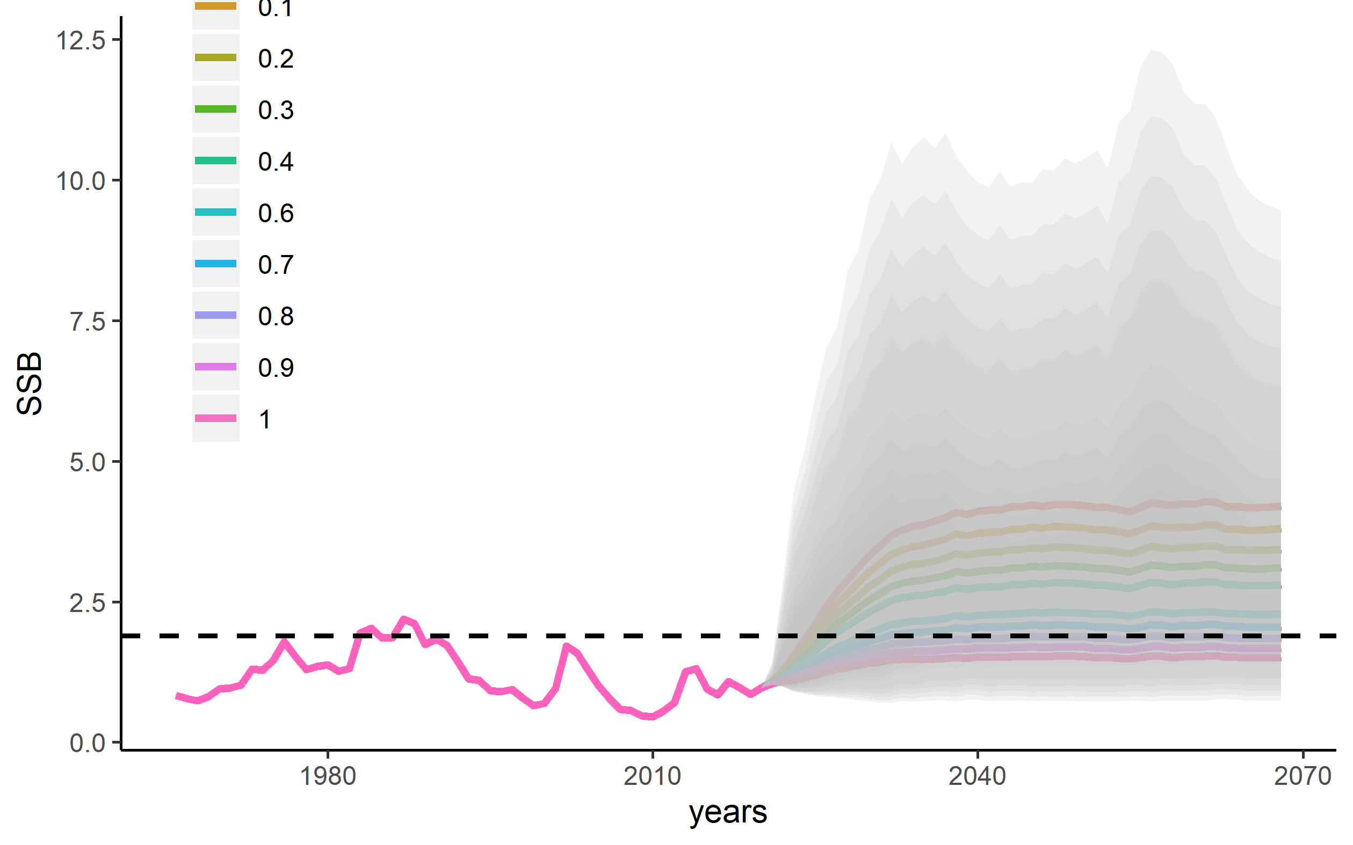
Figure S1: Spawning stock biomass in an unfished scenario with different bias adjustment values to recruitment (n = 1000 runs for each bias adjustment). Solid lines indicate the medians, dashed line indicates unfished spawning biomass (Equation M2), and shading indicates the 5th and 95th quantiles.

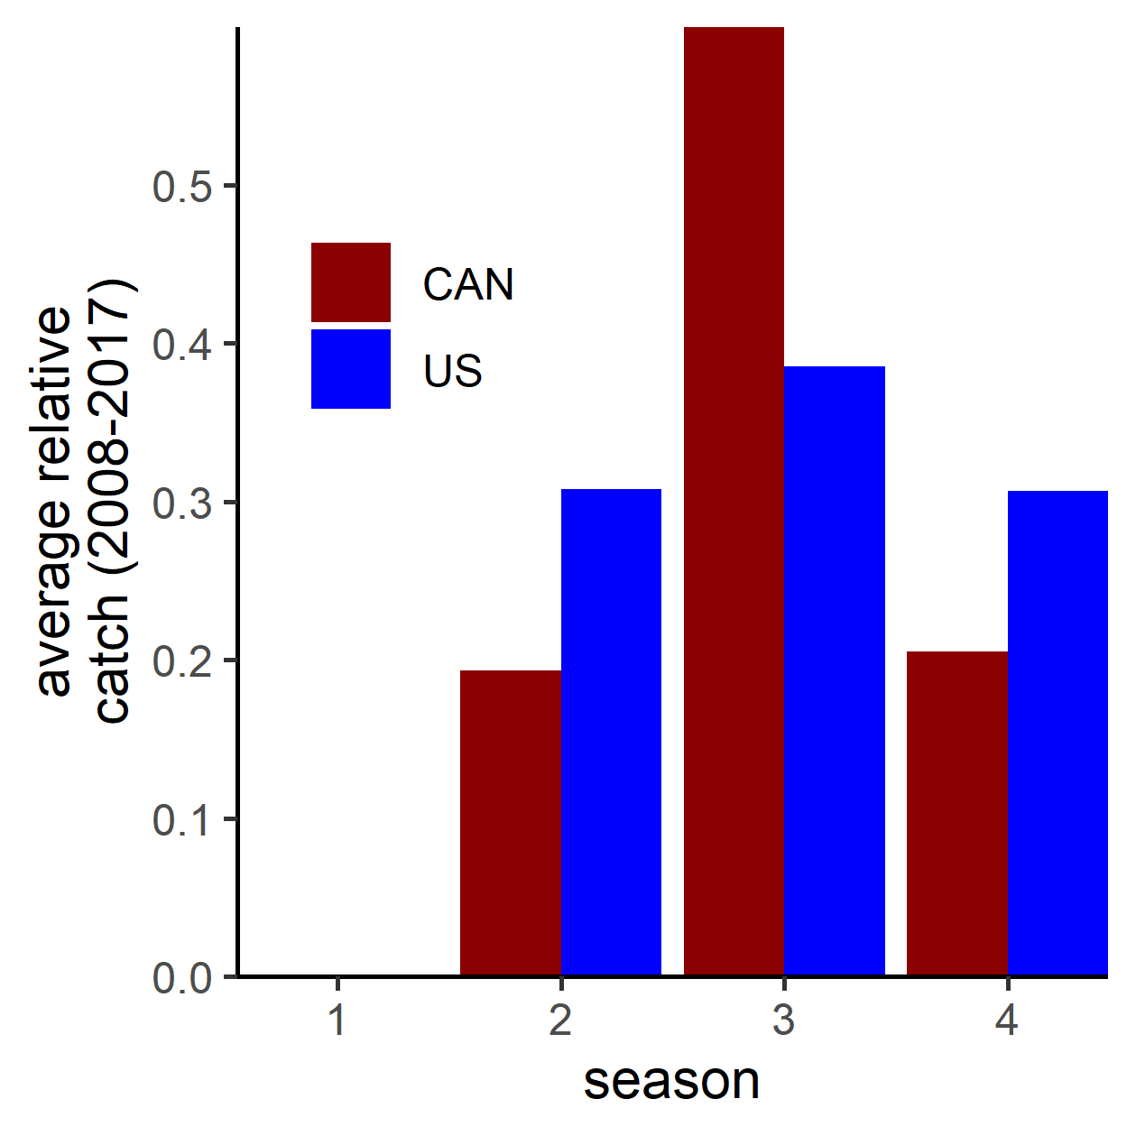
Figure S2: Average relative catch per season from the years 2008-2017. The values for each country are used in the projection period to determine how the TAC is divided among seasons (1-4) for each of the modeled areas.

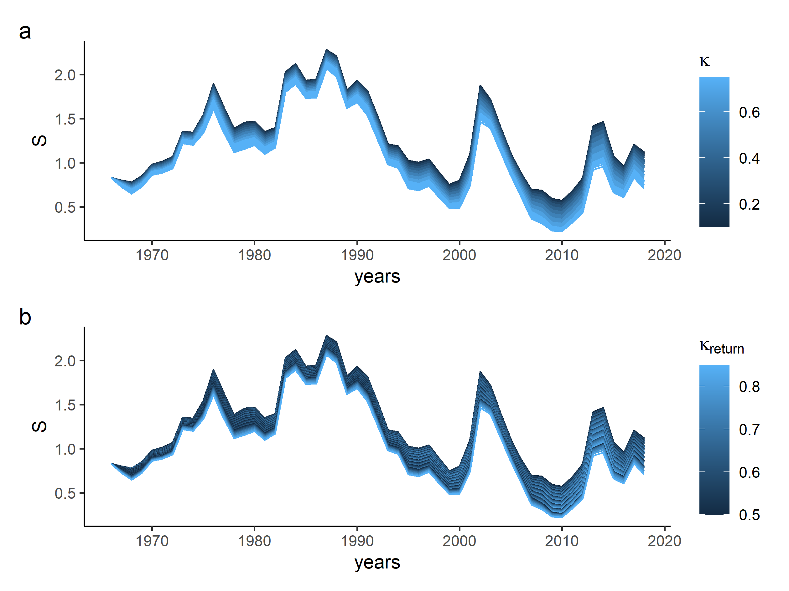
Figure S3: Combinations of viable movement rates in a historical context for Pacific hake. a shows how max movement rate, $κ$, changes historical simulations of spawning biomass, and b) denotes how the return rate, $κ_{return}$impacts historical biomass estimates.
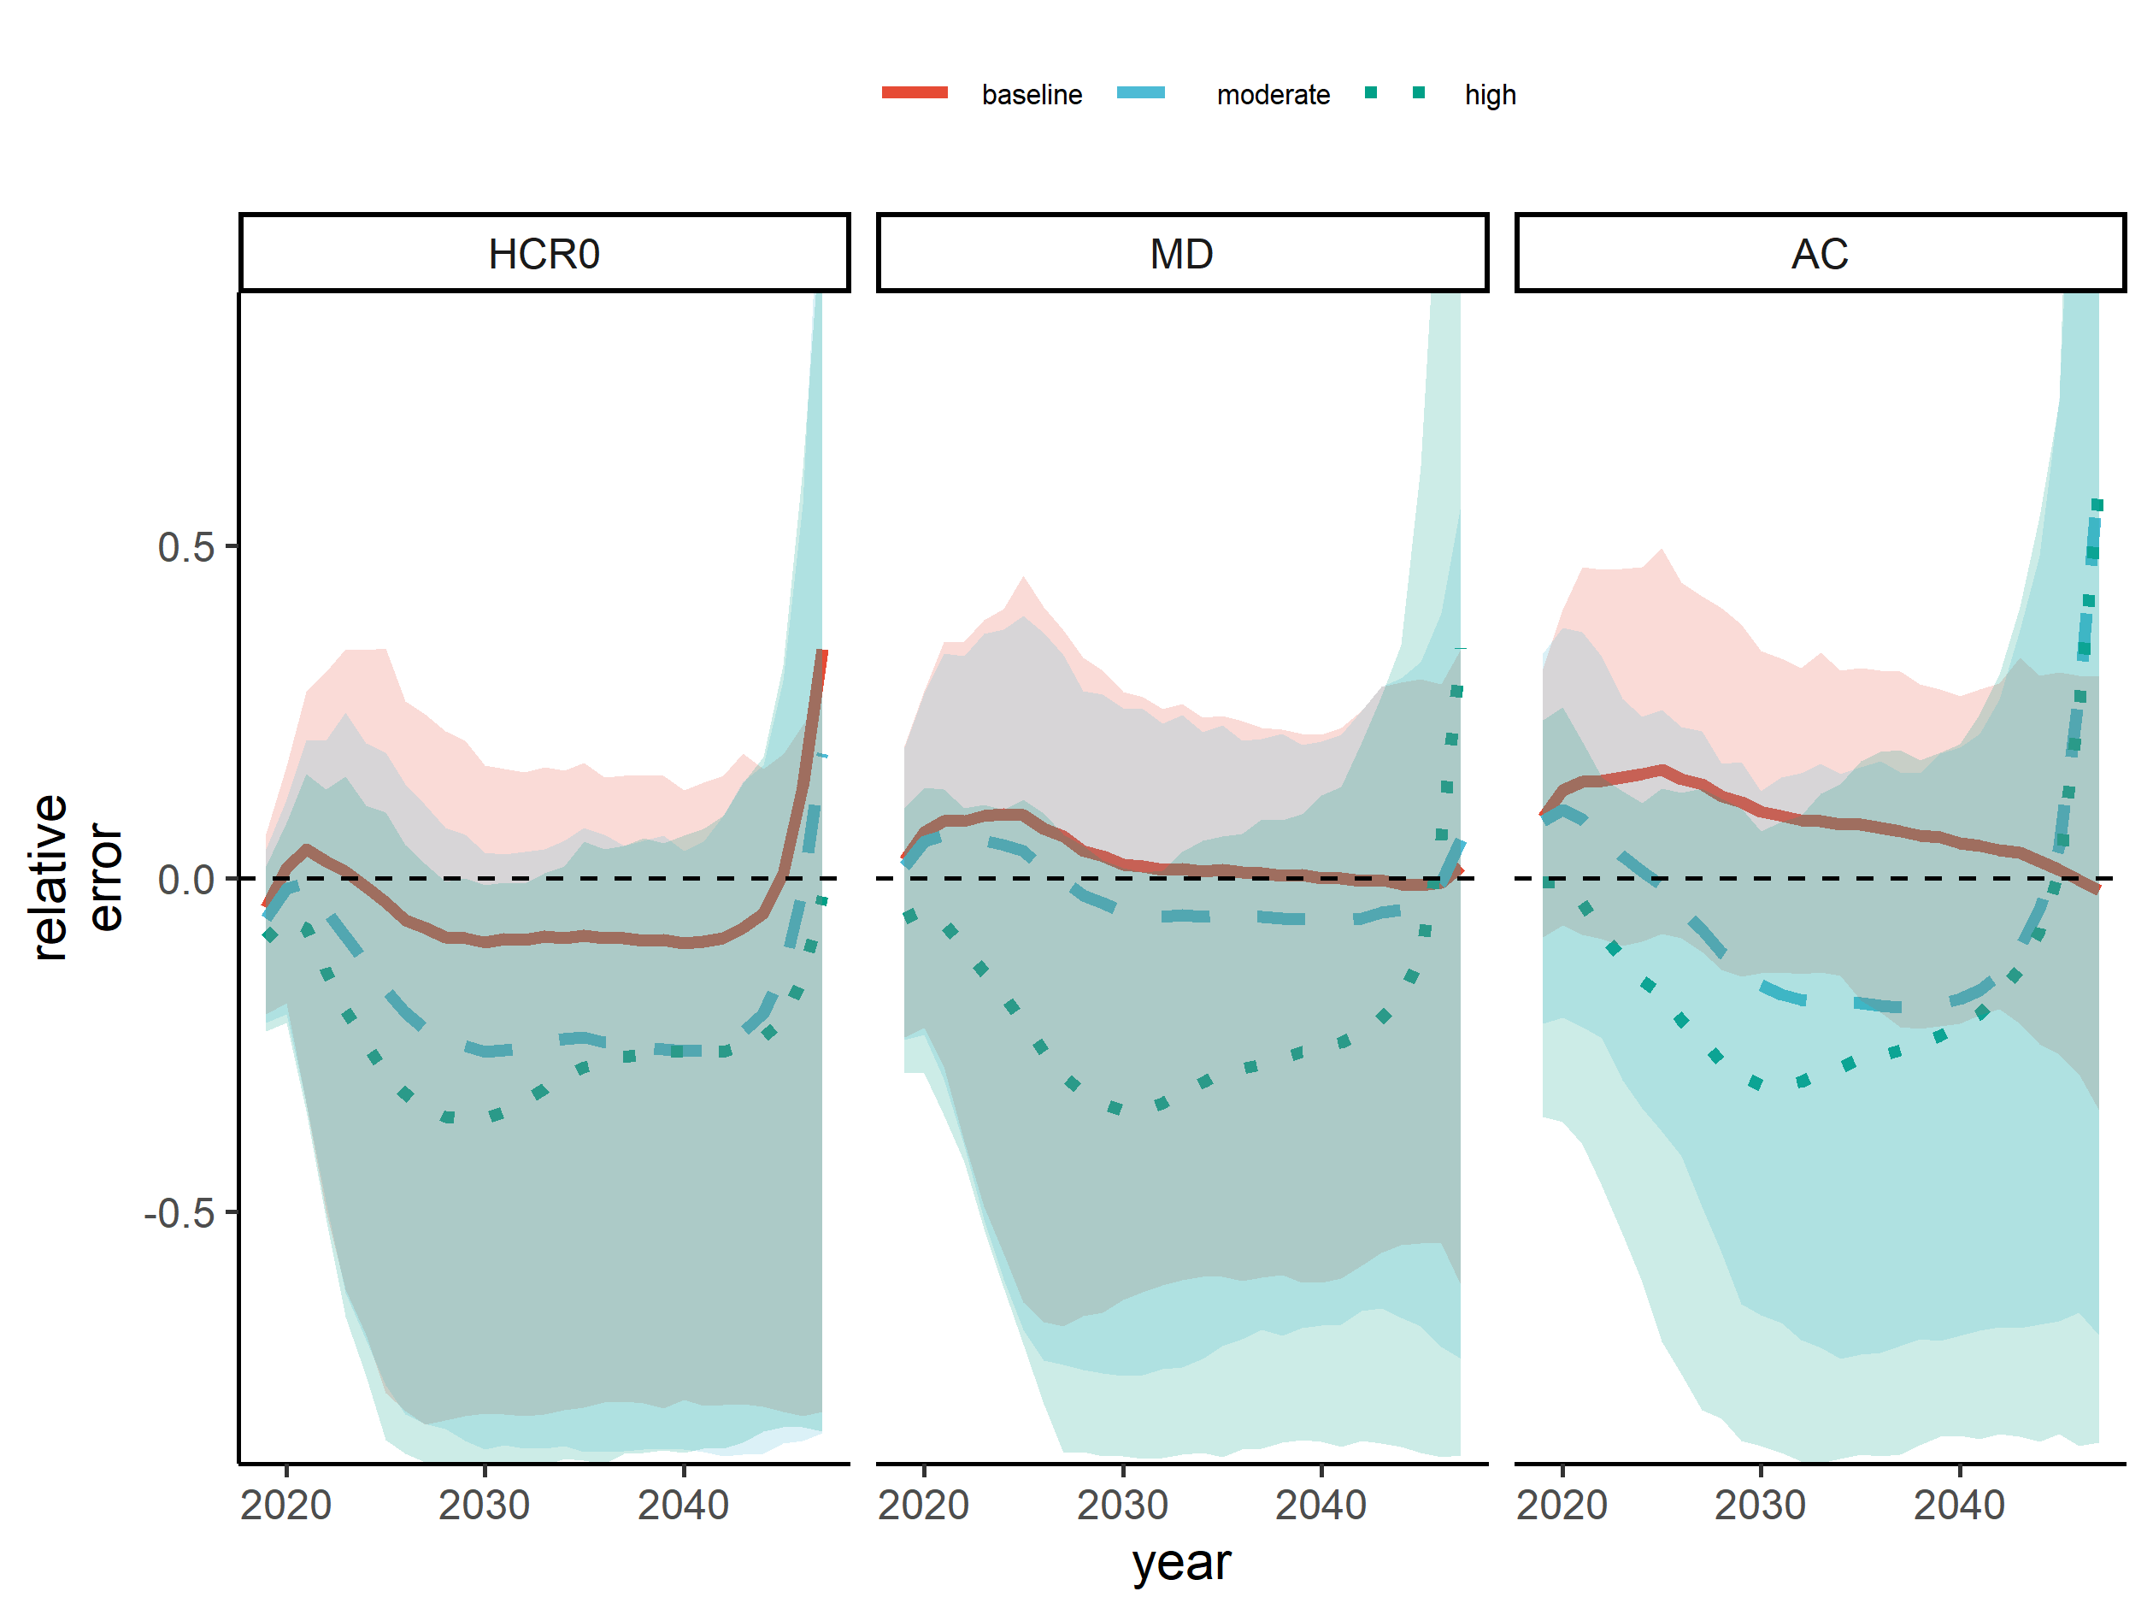
Figure S4. Median relative error (lines) of the spawning stock biomass estimation for the three climate scenarios (colors and line types) and three HCRs (panels). Shading represents the 5th and 95th quantiles. The total allowable catches are defined as $HCR_{0}$: baseline harvest control rule, MD: management decision rule, AC: actual catch.

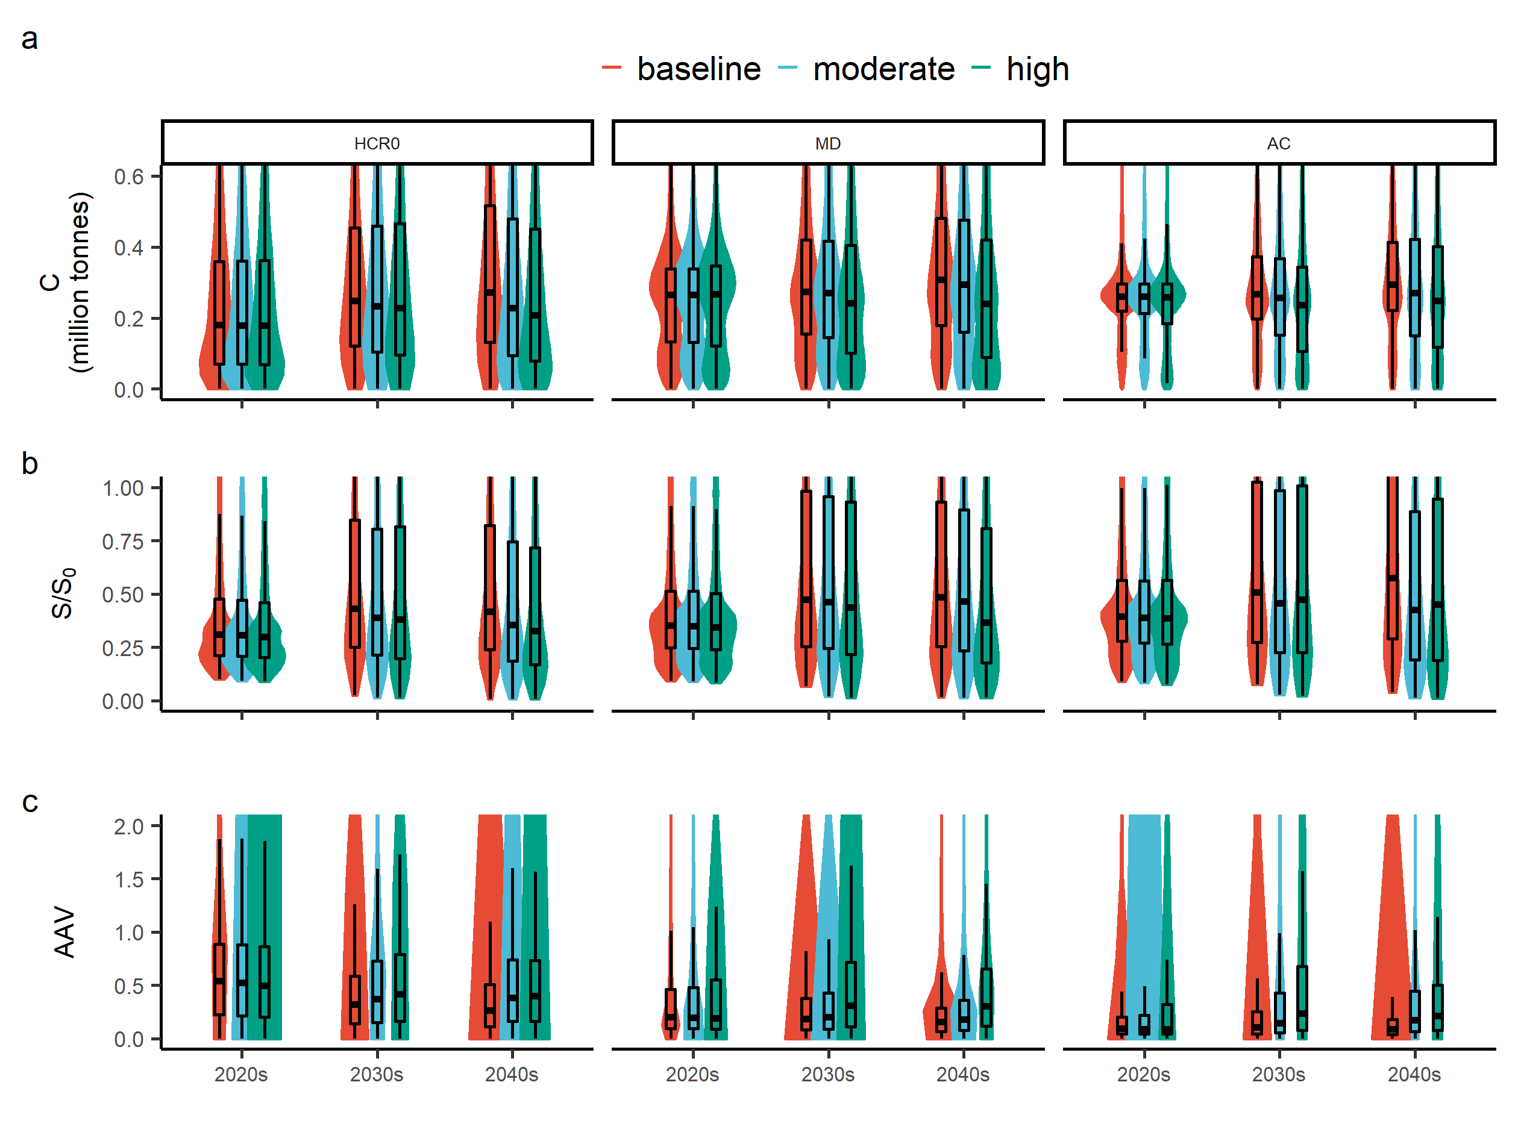
Figure S5: Coastwide (area-aggregated) performance metrics by decade are shown as overlaid violin and box plots. The colors denote the three alternative states of nature (‘baseline’,
‘moderate’, and ‘high’) with regards to how climate change influences movement rates. Panel sets describe alternative HCRs, where the total allowable catches are defined as $HCR_{0}$: baseline harvest control rule, MD: management decision rule, AC: actual catch.

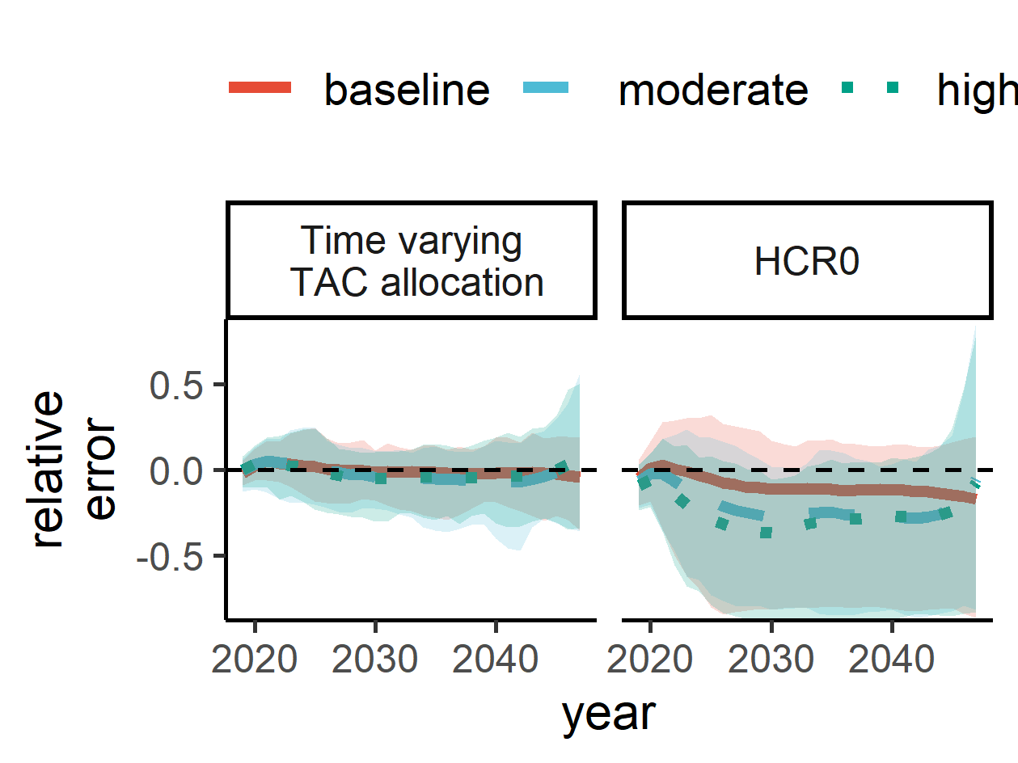
Figure S6: Median relative error (lines) associated with estimated spawning stock biomass in the time varying TAC allocation and HCR₀ scenario. Each line represents a climate scenario. Shading represents the 5th and 95th quantiles.

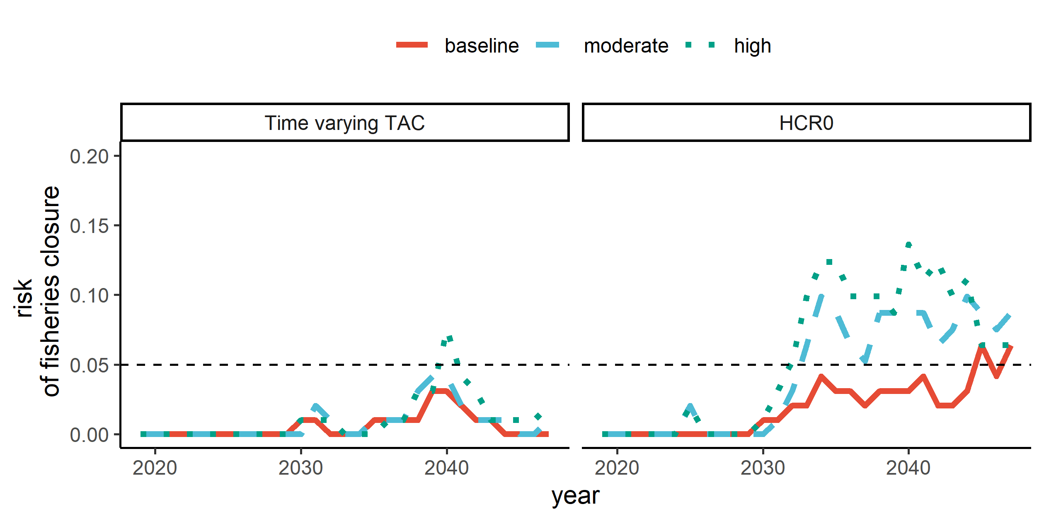
Figure S7; Time series of total risk (fraction of years where $S<0.1S_{0}$) under the three different climate and three different catch scenarios. Movement scenarios are denoted by solid, dashed and dotted lines for the baseline, moderate and high scenarios, respectively. Panel sets describe alternative catch scenarios defined as $HCR_{0}$ baseline HCR, and a time varying TAC. The horizontal dashed line represents 0.05, which is the desired risk threshold described by fishery managers.

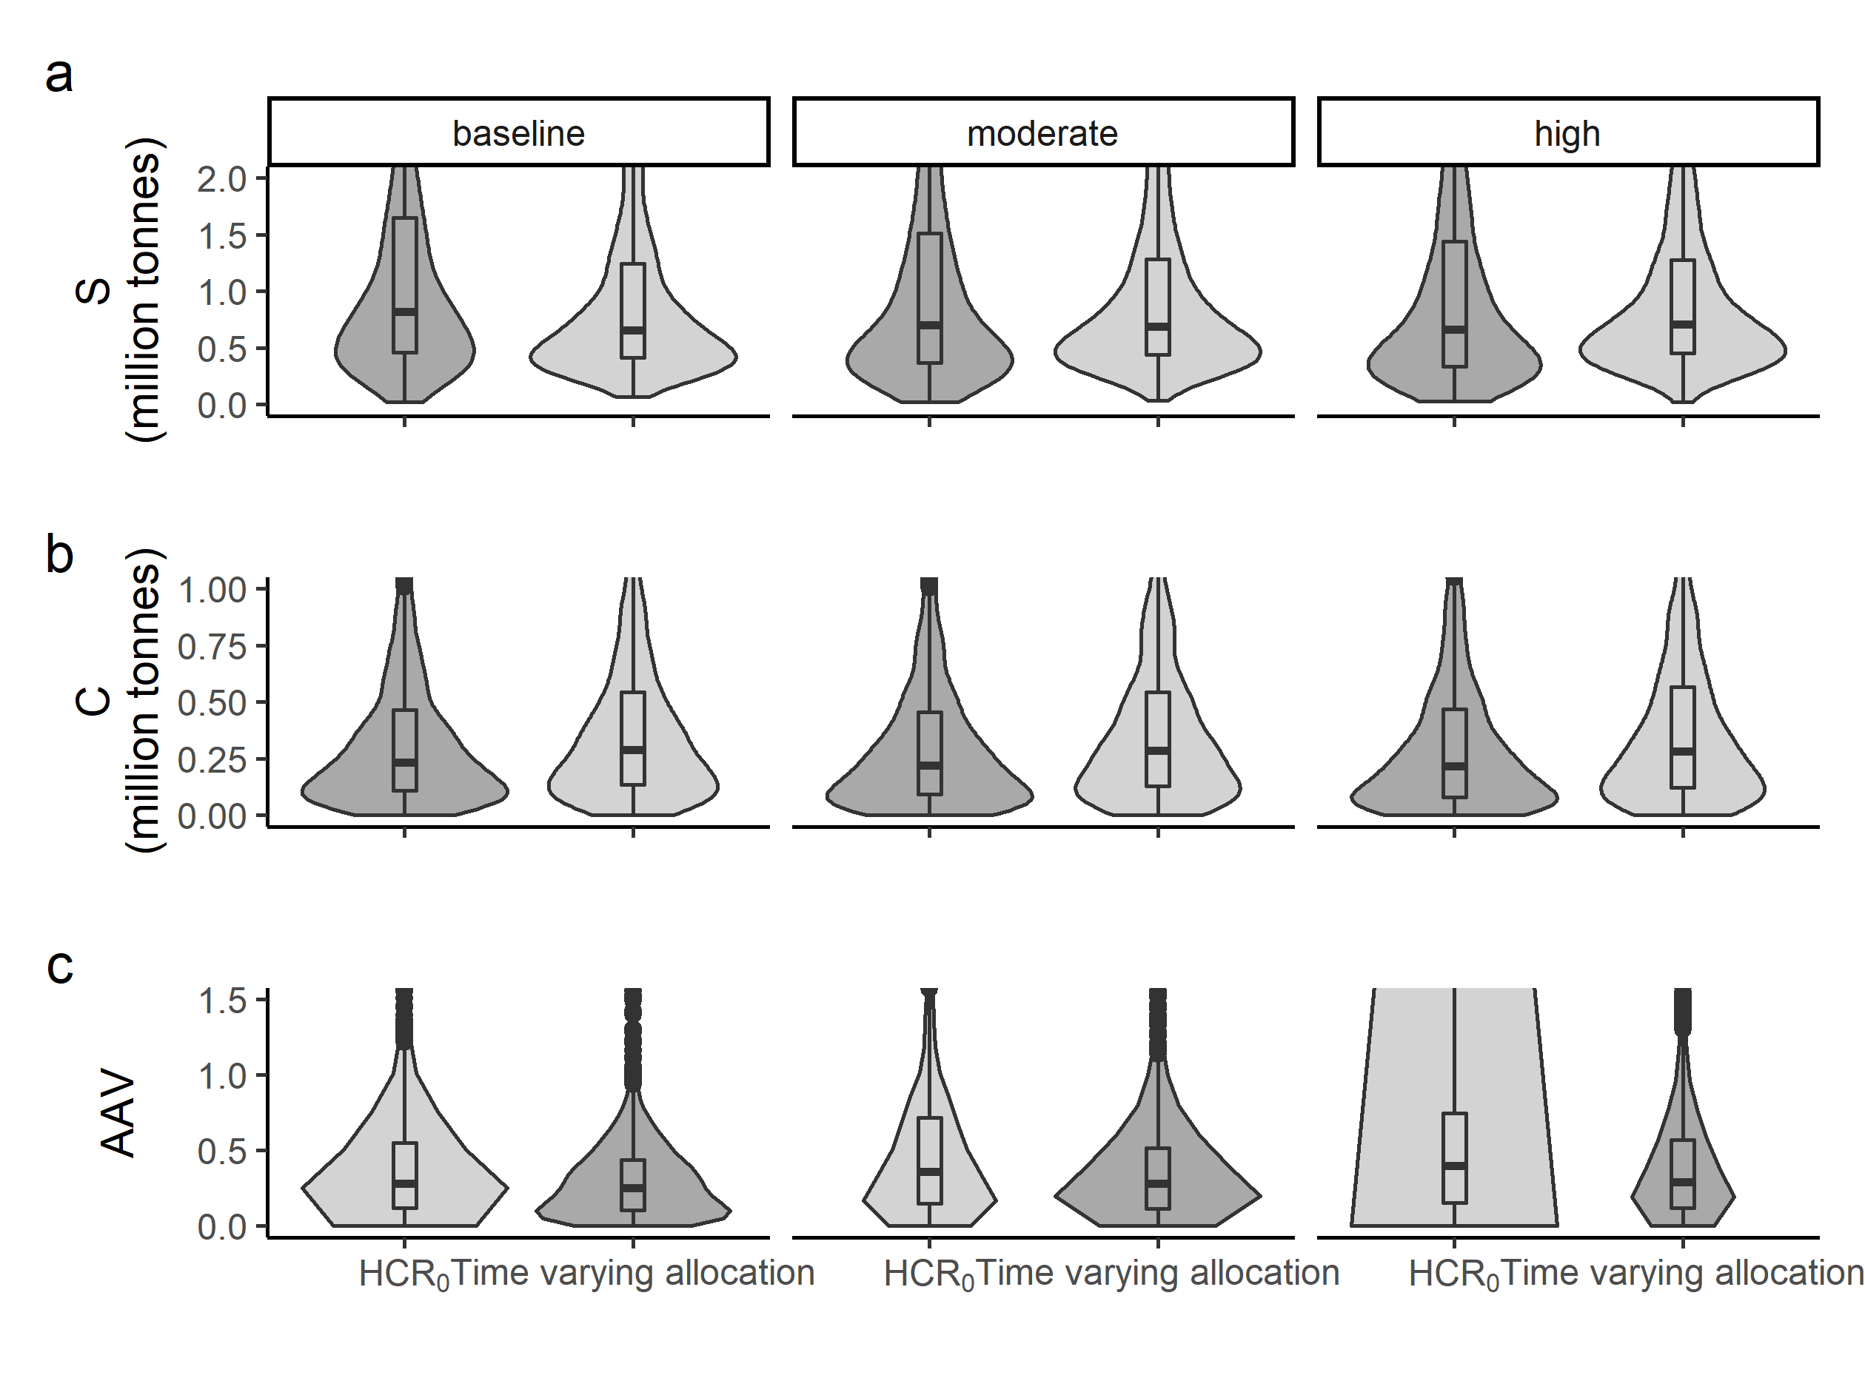
Figure S8: Violin plot of long term (after year 2030) coastwide performance metrics with $HCR_{0}$ representing the baseline harvest control rule with constant TAC allocation, and Time varying allocation representing time varying allocation based on the previous year’s survey abundance in each area.

