Supplementary Figures
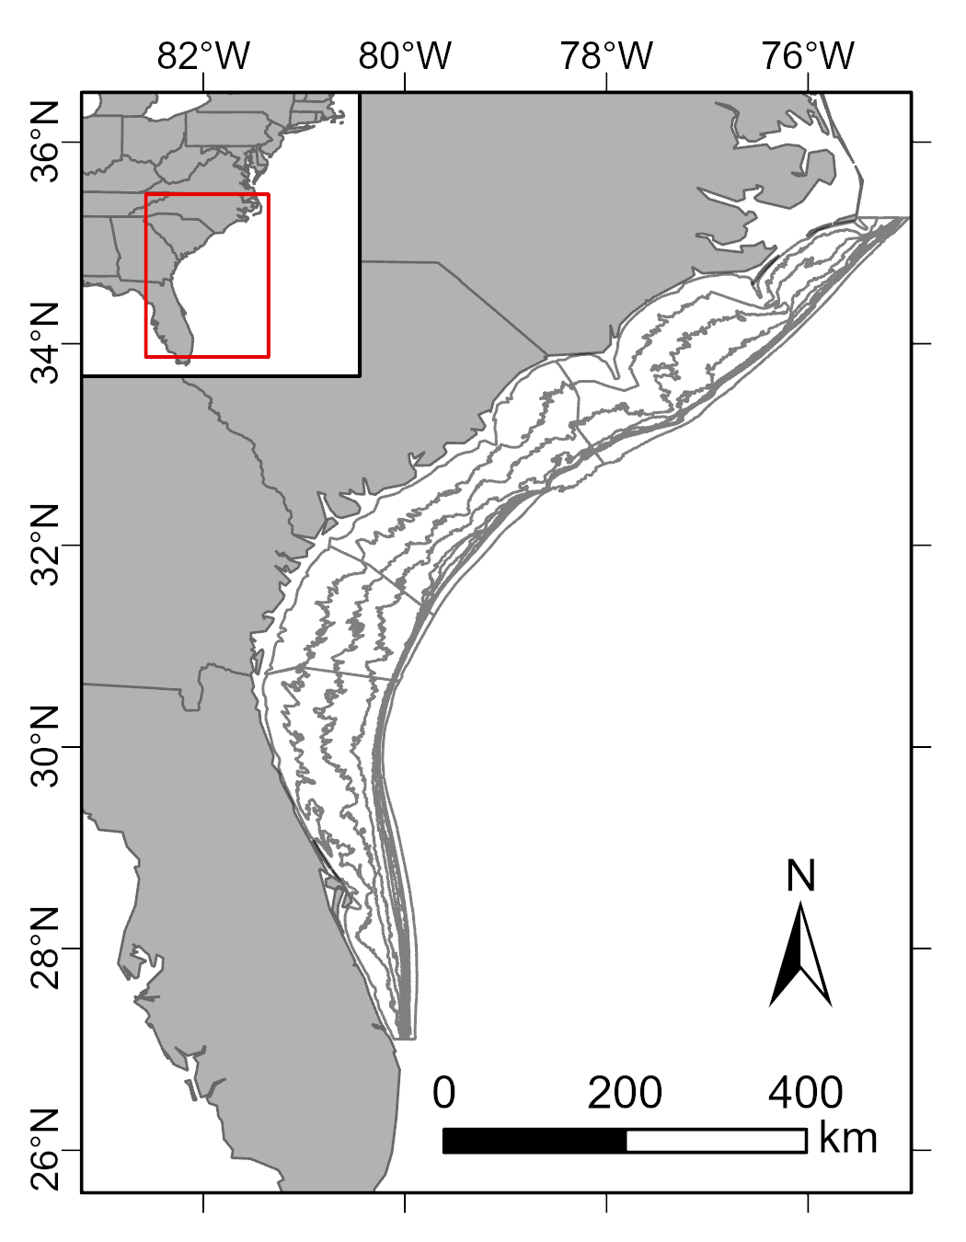
Figure S1: Geographic scope of study from Cape Hatteras, NC to St. Lucie, FL. Artificial versus natural reef extents were compared across the whole region and by depth strata and state (gray lines). Depth bins are depicted at a fine resolution (10 m) for depths 10 m to 100 m and at a coarser resolution (100 m) for depths 100 m to 200 m. Inset shows broader geographic context.

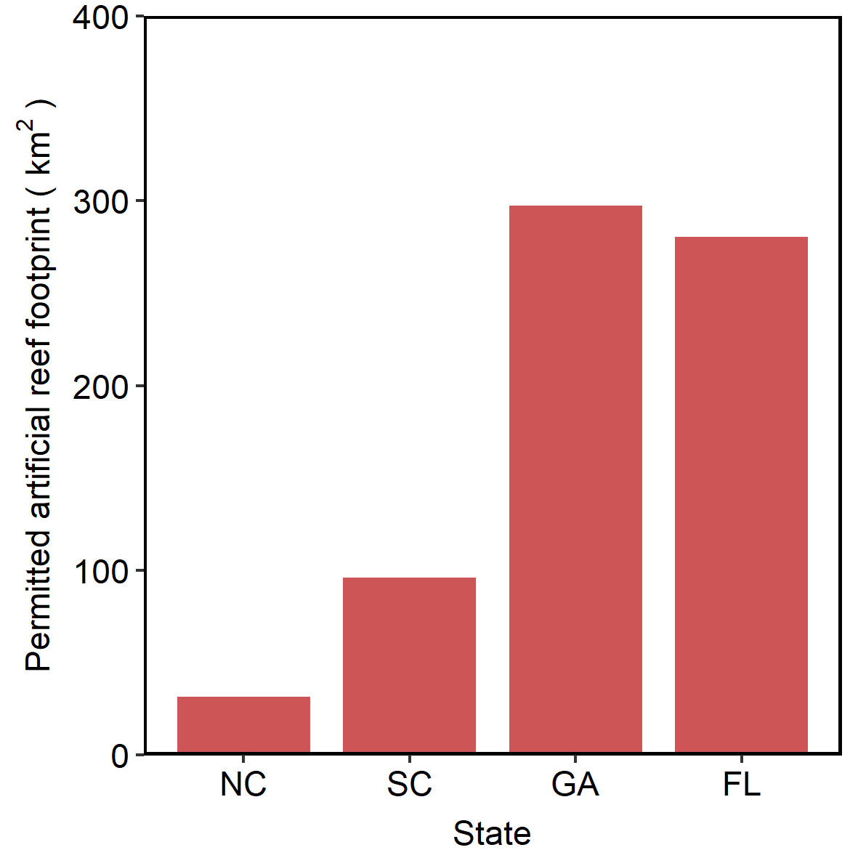
Figure S2: Permitted area of artificial reef zones. The permitted areas, or plots, are zones of the ocean where artificial reef structures can be deployed.

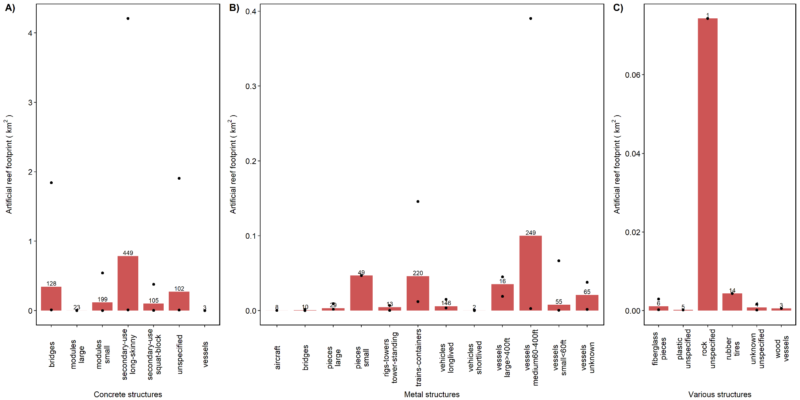
Figure S3: Artificial reef extent estimated from classified structures approach for concrete, metal, and various artificial reef materials and associated structures. Value above bars is the number of deployments of each structure type across the southeast US states. Black circles represent the maximum and minimum extent values, if applicable (e.g., n > 1). Note different y-axis scales.

Supplementary Tables

Table S1: Artificial reef structures and their composition (e.g., material, type, sub_type), vertical relief, degradation rate, and description. For each structure, minimum, mean, and maximum extent (m²) per count and per ton are provided. Overall minimum, mean, and maximum deployment extent (m²) across the dataset in m² are also noted. For the entire SEUS region, the count (e.g., number of deployments in which a structure was sunk) and the minimum, mean, and maximum summed coverage of this structure type across all deployments in the region is also provided.
 |  |  |  |  |  |  | count extent (m² / count) |  |  | ton extent (m² / ton) |  |  | deployment extent (m² / deploy.) |  |  | SEUS region (m², for min, mean, max)
structure | material | type | sub_type | relief | degrad | description | min | mean | max | min | mean | max | min | mean | max | n | min | mean | max
concrete_bridges | concrete | bridges | NA | > 2 m | low | concrete bridge material, including spans, dividers, and pilings | 0.16 | 11.26 | 69.68 | 0.56 | 1.67 | 5.03 | 69.68 | 865.94 | 2377.48 | 128 | 10551.55 | 344098.60 | 1840788.00
concrete_modules_small | concrete | modules | small | < 2 m | low | low-relief concrete modules specifically for reef formation, such as Reef Balls | 0.02 | 8.32 | 42.2 | 0.65 | 2.07 | 4.07 | 3.48 | 519.11 | 2110.05 | 199 | 546.92 | 119556.3 | 541523.2
concrete_modules_large | concrete | modules | large | > 2 m | low | high-relief concrete modules specifically for reef formation, such as tetrahedrons | 0.48 | 4.17 | 9.29 | 1.33 | 1.45 | 3.1 | 3.99 | 44.16 | 278.71 | 23 | 356.07 | 3089.39 | 6884.12
concrete_secondary-use_long-skinny | concrete | secondary-use | long-skinny | < 2 m | low | concrete structures of secondary use with long or skinny shape, such as pipes, pilings, utility poles, railroad ties, culverts | 0.2 | 5.77 | 41.07 | 0.01 | 2.46 | 28.15 | 8.07 | 1853.04 | 8226.43 | 449 | 11540.49 | 786206.5 | 4208009
concrete_secondary-use_squat-block | concrete | secondary-use | squat-block | < 2 m | low | concrete structures of secondary use with squat or block shape, such as junction boxes, ballast blocks, boxes, catch basins | 0.44 | 7.39 | 26.36 | 0.3 | 1.76 | 6.23 | 20.95 | 796.97 | 3011.39 | 105 | 3659.04 | 102178.9 | 379965
concrete_unspecified | concrete | unspecified | NA | < 2 m | low | concrete rubble or other concrete structures with unspecified type or shape | 4.83 | 62.31 | 470.61 | 0.04 | 1.68 | 9.36 | 3.23 | 1826.35 | 12107.9 | 102 | 8293.09 | 273037.7 | 1905357
concrete_vessels | concrete | vessels | NA | > 2 m | low | concrete vessels, of any size | 41.81 | 55.06 | 67.63 | 7.96 | 7.96 | 7.96 | 41.81 | 55.06 | 67.63 | 3 | 125.42 | 165.18 | 202.9
fiberglass_pieces | fiberglass | pieces | NA | > 2 m | high | fiberglass pieces of any size, such as boat molds | 13.02 | 62.93 | 117.29 | NA | NA | NA | 30.49 | 147.29 | 586.47 | 6 | 221.67 | 1071.19 | 2932.35
metal_aircraft | metal | aircraft | NA | > 2 m | medium | metal aircraft | 5.82 | 7.01 | 8.2 | NA | NA | NA | 11.64 | 21.98 | 37.88 | 8 | 215.34 | 275.37 | 346.53
metal_bridges | metal | bridges | NA | > 2 m | medium | metal bridge pieces, such as spans | NA | NA | NA | NA | NA | NA | 14.06 | 83.5 | 154.8 | 10 | 140.6 | 835.05 | 1548
metal_pieces_large | metal | pieces | large | > 2 m | medium | large, high relief (>2m tall) metal pieces, such as cable reels, missile sleeves, oil tanks, and yarn racks | 4.74 | 7.63 | 25.18 | 1.9 | 1.9 | 1.9 | 25.18 | 69.64 | 114.09 | 29 | 1821.32 | 3340.59 | 9403.06
metal_pieces_small | metal | pieces | small | < 2 m | high | small, low relief (<2m tall) metal pieces, such as chicken transport cages and cables | NA | NA | NA | 2.14 | 2.14 | 2.14 | 955.11 | 955.11 | 955.11 | 49 | 46800.35 | 46800.35 | 46800.35
metal_rigs-towers_tower-standing | metal | rigs-towers | tower-standing | > 2 m | medium | metal towers or oil rigs that are standing | NA | NA | NA | NA | NA | NA | 20.9 | 359.42 | 522.58 | 13 | 271.74 | 4672.44 | 6793.53
metal_trains-containers | metal | trains-containers | NA | > 2 m | high | metal train boxcars or shipping containers | 11.6 | 31.03 | 63.38 | NA | NA | NA | 57.99 | 237.01 | 790.78 | 220 | 12015.53 | 45981.64 | 145747.8
metal_vehicles_longlived | metal | vehicles | NA | > 2 m | medium | metal vehicles, such as army tanks, that have a low rate of degradation and are thus "shortlived" | NA | NA | NA | NA | NA | NA | 24.59 | 40.65 | 102.08 | 146 | 3590.67 | 5935.39 | 14903.72
metal_vehicles_shortlived | metal | vehicles | NA | > 2 m | high | metal vehicles that have a high rate of degradation and are thus "longlived" | NA | NA | NA | NA | NA | NA | 80 | 187.5 | 360 | 2 | 160 | 375 | 720
metal_vessels_medium60-400ft | metal | vessels | medium60-400ft | > 2 m | medium | medium metal vessels and barges, between 60 ft and 400 ft long | 11.52 | 401.44 | 1567.88 | 0.06 | 2.15 | 12.49 | 34.48 | 395.69 | 1567.88 | 249 | 2868.47 | 99958.83 | 390402.1
metal_vessels_small<60ft | metal | vessels | small<60ft | > 2 m | medium | small metal vessels (often recreational) and barges, less than 60 ft long | 10.41 | 143.78 | 1211.32 | 3.96 | 3.96 | 3.96 | 10.41 | 184.93 | 1211.32 | 55 | 572.55 | 7907.77 | 66622.6
metal_vessels_large>400ft | metal | vessels | large>400ft | > 2 m | medium | large metal vessels and barges, greater than 400 ft | 1185.64 | 2205.13 | 2811.56 | NA | NA | NA | 1185.64 | 2172.58 | 2811.56 | 16 | 18970.24 | 35282.06 | 44984.96
metal_vessels_unknown | metal | vessels | NA | >2 m | medium | unknown metal vessels of any length | 25.26 | 322.8 | 582.96 | NA | NA | NA | 25.26 | 376.31 | 582.96 | 65 | 1641.9 | 20981.88 | 37892.4
plastic_unspecified | plastic | unspecified | NA | < 2 m | medium | plastic structures, such as plastic modules, plastic containers, plastic pipes | NA | NA | NA | NA | NA | NA | 35.12 | 35.12 | 35.12 | 5 | 175.59 | 175.59 | 175.59
rock_unspecified | rock | unspecified | NA | < 2 m | low | rock structures, such as boulders and quarry rock | NA | NA | NA | NA | NA | NA | 74322.43 | 74322.43 | 74322.43 | 1 | 74322.43 | 74322.43 | 74322.43
rubber_tires | rubber | tires | NA | < 2 m | high | rubber tires | 0.02 | 0.02 | 0.02 | NA | NA | NA | 430.73 | 430.73 | 430.73 | 14 | 4352.61 | 4352.61 | 4352.61
unknown_unspecified | unknown | unspecified | NA | NA | NA | structures of unknown material and unspecified type | NA | NA | NA | NA | NA | NA | 34.25 | 204.49 | 411.32 | 4 | 137 | 817.95 | 1645.28
wood_vessels | wood | vessels | NA | > 2 m | high | wooden vessel, of any size | 185.81 | 185.81 | 185.81 | NA | NA | NA | 185.81 | 185.81 | 185.81 | 3 | 557.42 | 557.42 | 557.42

Table S2: Artificial reef footprint estimates by region, state, and depth bin. The bin (e.g., region, state, depth) and bin class (e.g., state name, depth bin name) are provided. For each bin and bin class, the total area (km2) of the bin is provided. Artificial reef extent based on permitted area is given. Structure-based estimates using a measured approach, plot percentage approach, and classified structures approach are also detailed. For each estimation, the estimated area in km2, as well as the percentage of the total bin area, are provided.
 |  |  |  |  |  |  |  | structure - plot percent |  |  |  |  |  | structure - classified structures
 |  |  |  | permitted |  | structure - measured |  | mean |  | max |  | min |  | mean |  | max |  | min
reef type | bin | bin class | bin km2 | km2 | % | km2 | % | km2 | % | km2 | % | km2 | % | km2 | % | km2 | % | km2 | %
artificial | region | NA | 103220 | 705.25 | 0.68 | NA | NA | 4.02 | <0.01 | 28.70 | 0.03 | 0.04 | <0.01 | 1.98 | <0.01 | 9.73 | 0.01 | 0.2 | <0.01
artificial | state | NC | 30862 | 31.64 | 0.10 | 0.30 | <0.01 | 0.18 | <0.01 | 1.28 | <0.01 | <0.01 | <0.01 | 0.41 | <0.01 | 2.45 | 0.01 | 0.02 | <0.01
artificial | state | SC | 26732 | 95.08 | 0.36 | NA | NA | 0.55 | <0.01 | 3.90 | 0.01 | <0.01 | <0.01 | 0.32 | <0.01 | 1.33 | <0.01 | 0.02 | <0.01
artificial | state | GA | 14476 | 297.29 | 2.05 | NA | NA | 1.69 | 0.01 | 12.1 | 0.08 | 0.01 | <0.01 | 0.28 | <0.01 | 1.3 | 0.01 | 0.02 | <0.01
artificial | state | FL | 31150 | 280.52 | 0.90 | NA | NA | 1.60 | 0.01 | 11.42 | 0.04 | 0.01 | <0.01 | 0.97 | <0.01 | 4.65 | 0.01 | 0.14 | <0.01
artificial | depth | 10-20m | 26935 | 336.67 | 1.25 | NA | NA | 1.92 | 0.01 | 13.7 | 0.05 | 0.02 | <0.01 | 1.25 | <0.01 | 6.68 | 0.02 | 0.06 | <0.01
artificial | depth | 20-30m | 28127 | 157.48 | 0.56 | NA | NA | 0.90 | <0.01 | 6.41 | 0.02 | 0.01 | <0.01 | 0.17 | <0.01 | 0.78 | <0.01 | 0.01 | <0.01
artificial | depth | 30-40m | 21101 | 57.28 | 0.27 | NA | NA | 0.33 | <0.01 | 2.33 | 0.01 | <0.01 | <0.01 | 0.05 | <0.01 | 0.14 | <0.01 | 0.03 | <0.01
artificial | depth | 40-50m | 11208 | 4.03 | 0.04 | NA | NA | 0.02 | <0.01 | 0.16 | <0.01 | <0.01 | <0.01 | 0.01 | <0.01 | 0.07 | <0.01 | <0.01 | <0.01
artificial | depth | 50-60m | 2436 | 11.43 | 0.47 | NA | NA | 0.07 | <0.01 | 0.47 | 0.02 | <0.01 | <0.01 | <0.01 | <0.01 | <0.01 | <0.01 | <0.01 | <0.01
artificial | depth | 60-70m | 2216 | NA | NA | NA | NA | NA | NA | NA | NA | NA | NA | NA | NA | NA | NA | NA | NA
artificial | depth | 70-80m | 1737 | NA | NA | NA | NA | NA | NA | NA | NA | NA | NA | NA | NA | NA | NA | NA | NA
artificial | depth | 80-90m | 975 | NA | NA | NA | NA | NA | NA | NA | NA | NA | NA | NA | NA | NA | NA | NA | NA
artificial | depth | 90-100m | 861 | 62.16 | 7.22 | NA | NA | 0.35 | 0.04 | 2.53 | 0.29 | <0.01 | <0.01 | NA | NA | NA | NA | NA | NA
artificial | depth | 100-200m | 7624 | NA | NA | NA | NA | NA | NA | NA | NA | NA | NA | NA | NA | NA | NA | NA | NA

Table S3: Natural reef footprint estimates by region, state, and depth bin. The bin (e.g., region, state, depth) and bin class (e.g., state name, depth bin name) are provided. For each bin and class, the total area (km2) of the bin is provided. Natural reef extent based on the TNC synthesis, NCCOS model (>0.63), and polygon approach are detailed. For each extent, the estimated area in km2, as well as the percentage of the total bin area, are provided.
 |  |  |  | TNC synthesis |  | NCCOS model (>0.63) |  | polygon
reef type | bin | bin class | bin km2 | km2 | % | km2 | % | km2 | %
natural | region | NA | 103220 | 3602 | 3.49 | 1506 | 1.46 | 2852.59 | 2.76
natural | state | NC | 30862 | 1318 | 4.27 | 532 | 1.72 | 1197.61 | 3.88
natural | state | SC | 26732 | 498 | 1.86 | 745 | 2.79 | 620.46 | 2.32
natural | state | GA | 14476 | 175 | 1.21 | 79 | 0.55 | 243.73 | 1.68
natural | state | FL | 31150 | 1611 | 5.17 | 151 | 0.48 | 790.79 | 2.54
natural | depth | 10-20m | 26935 | 180 | 0.67 | 2 | 0.01 | 378.36 | 1.4
natural | depth | 20-30m | 28127 | 465 | 1.65 | 371 | 1.32 | 644.77 | 2.29
natural | depth | 30-40m | 21101 | 205 | 0.97 | 461 | 2.18 | 661.35 | 3.13
natural | depth | 40-50m | 11208 | 95 | 0.85 | 121 | 1.08 | 284.24 | 2.54
natural | depth | 50-60m | 2436 | 237 | 9.73 | 347 | 14.24 | 142.55 | 5.85
natural | depth | 60-70m | 2216 | 256 | 11.55 | 107 | 4.83 | 348.63 | 15.73
natural | depth | 70-80m | 1737 | 505 | 29.07 | 39 | 2.25 | 116.47 | 6.71
natural | depth | 80-90m | 975 | 406 | 41.64 | 19 | 1.95 | 58.99 | 6.05
natural | depth | 90-100m | 861 | 298 | 34.61 | 18 | 2.09 | 57.28 | 6.65
natural | depth | 100-200m | 7624 | 954 | 12.51 | 21 | 0.28 | 159.94 | 2.1

Supplementary Text

Text S1: Evaluation of Dunn and Halpin natural reef predictive model.
When developing approaches for estimating natural reef extent in the SEUS, we evaluated a model from Dunn and Halpin (2009) (Dunn and Halpin 2009) that predicts the probability of occurrence for natural reef or hard-bottom derived using a step-wise generalized linear model with predictors including depth, measures of seafloor complexity (e.g., slope and rugosity), and spatial metrics (e.g., distance from shore, distance to shelf). Depths were provided by a composite regional Coastal Relief Model with grid resolution of 90 m by 90 m. The model was validated using observations from a coastwide assessment of natural reef or hard-bottom habitats (SEAMAP 2001). The performance of this model was assessed by Dunn and Halpin using AUC values, with an overall accuracy of about 70% (Dunn and Halpin 2009). The output is a gridded raster with continuous values representing a probability from 0 to 1.
Our team mapped these values in a GIS to evaluate distribution of values and spatially compare qualitatively with common geomorphological features. Overall, the model appeared to misclassify features such as large sand shoals around the capes of the SEUS as high probability of hard-bottom (Pickens and Tayor 2020). Furthermore, the model output displayed relatively low probability of hard-bottom at the end of the upper continental slope, where modern observation indicates prevalence of exposed rock (see above description). Because of the apparent biases, we elected to not consider this model in estimates of hard-bottom coverage in the SEUS or in our comparisons with other techniques described in this paper.

Text S2: Dataset for natural reef estimation using polygon approach.
The comprehensive spatial dataset of sonar mapping, survey data, and information from fishers used to delineate polygons corresponding to natural reefs, included the following. Since 2010, the National Marine Fisheries Service Southeast Fisheries Science Center’s Southeast Fishery-Independent Survey (SEFIS) has been accumulating information from myriad sources on locations of natural reefs in the SEUS to expand their sampling frame for reef-associated fish species. For instance, this SEFIS spatial dataset includes most multibeam and side-scan sonar maps in the SEUS (~ <15% of the SEUS has been mapped) from the NOAA National Centers of Environmental Information (e.g., data repository), state agencies, and academic researchers. Scientific survey data were gathered from multiple sources including sampling information from the Southeast Reef Fish Survey (Bacheler and Shertzer 2020), longlines, trawls, and hook-and-line gears that have captured reef fish species from various projects over time (e.g., Rudershausen et al. 2008, Mitchell et al. 2014), comprehensive sampling data from Florida Fish and Wildlife Research Institute (e.g., Christiansen et al. 2020), reef fish catches and locations from scientific observers on fishing vessels, and underwater surveys from divers (e.g., Whitfield et al. 2014), remotely-operated vehicles (Harter et al. 2008), and submersibles (Schobernd and Sedberry 2009). The last major data source included in the SEFIS spatial dataset was catch and location data from fishers themselves in the SEUS. Dozens of commercial and recreational fishers provided tens of thousands of locations where they have caught reef fish species in the SEUS.

