Supplementary Materials

S1: Region- and species-specific comparisons of Fulton’s K and lipid storage
In the CECS, all lipid-based condition factors were higher in polar cod during a cold year (2013) compared to fish collected in the warm year of 2017 (i.e. one-way ANOVA, %TAG F_{1,63} = 51.5, p < 0.001, Fig. S1A). We also noted a significant decline in calanoid-copepod fatty acid storage in 2017 in fish from the same region, indicating that polar cod were storing less energy from large lipid-rich copepods than measured in 2013 (ANOVA F_{1,75} = 33.6, p < 0.001, S1A).
In the NECS, polar cod were similarly in lower lipid-based condition in 2017 compared to both the colder year of 2013 and a warm year (2019) where additional catch data were available. Lipid metrics for polar cod in 2019 were similar to those measured in an earlier cold year (2013), while fish were generally heavier at a given length in 2017 than in the other two years (ANOVA, F_{2,195} = 19.28, p < 0.001, Fig. S1A). Levels of calanoid copepod lipids in fish from the NECS were similar in 2013 and 2019 but were significantly lower in 2017 (ANOVA, F_{2,200} = 4.06, p < 0.019).
We made annual comparisons of saffron cod condition between 2012 and 2017 in the SECS and the CECS, but relatively low abundances of this species in contemporary survey years (2017, 2019, Levine et al., in review) precluded other comparisons. We found significant region-specific declines in most lipid-based condition factors in saffron cod from 2012 to 2017 (S1B). In the SECS, total lipids per WWT dropped more than 50% from 2012 (24.2 ± 2.3 mg.g⁻¹) to 2017 (9.6 ± 0.26 mg.g⁻¹, Fig. 4a). This pattern was similar for the proportion of storage lipids, %TAG, as well as storage of total calanoid FA (S1B). Trends of decreasing lipid-based condition metrics in 2017 were also significant for saffron cod in the CECS but were less extreme than fish sampled from the SECS. We measured no change in Fulton’s K morphometric condition for saffron cod in either region between years (i.e. CECS, ANOVA, F_{1,63} = 0.01, p = 0.91), despite dramatic declines in lipid-based condition (i.e. CECS, total lipid ANOVA, F_{1,64} = 16.39, p < 0.001).
Walleye pollock from the SECS and CECS were analyzed in both contemporary warm years (2017 and 2019). In the SECS, pollock showed significantly higher Fulton’s K in 2017 than in 2019, while lipid-based condition metrics indicated an opposite trend with fish in 2019 having significantly higher total FA per WWT and calanoid copepod storage lipids (S1C). In the CECS, walleye pollock were in better lipid-based condition in 2019 for all lipid metrics, but there was no significant difference in Fulton’s K across the two contemporary sampling years (Fig. 5b). In 2019, pollock were unexpectedly sampled in the NECS (see Wildes et al., accepted; Levine et al., in review), but these fish were in poor morphometric and lipid-based condition compared to pollock in more southern areas of the Chukchi Sea.

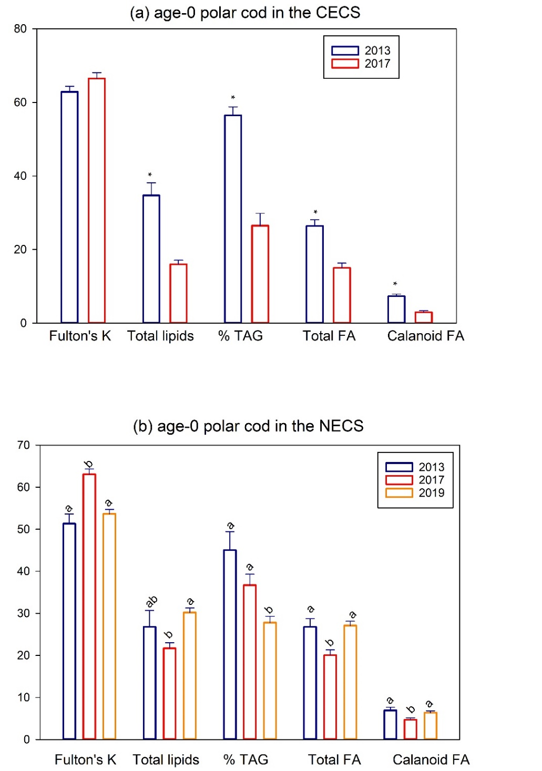
Fig. S1A. Region-specific annual differences in condition metrics and lipid storage of age-0 polar cod in the central eastern Chukchi Sea (CECS) and the northeastern Chukchi Sea (NECS). Fish were collected in one historical cold year (2013) and two current warm years (2017 and 2019). Polar cod were only captured in the NECS in 2019. Fulton’s K (*100 percentage), total lipids (mg.g⁻¹ WWT), triacylglycerols (% TAG), total fatty acids (mg.g⁻¹ WWT), and total calanoid copepod fatty acid storage (∑ C₂₀+C₂₂ MUFA mg.g⁻¹ WWT fish) are shown as mean ± SE by region-year. In the CECS, * indicate significantly higher values in 2013 than 2017, while in the NECS, different letters represent significant differences between years, ANOVA, p < 0.05.

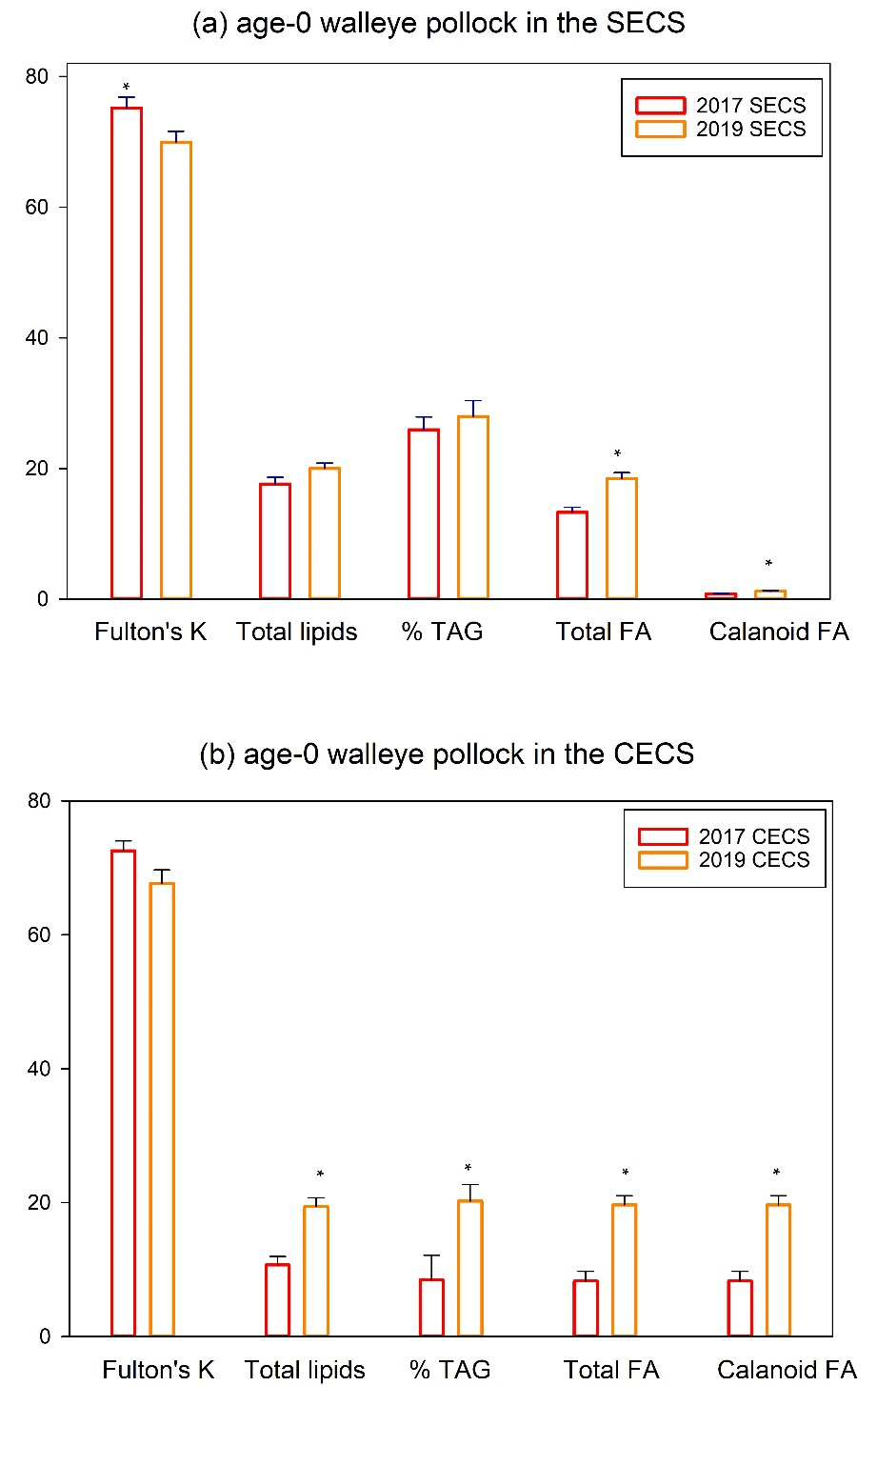
Fig. S1B. Region-specific annual differences in condition metrics and lipid storage of age-0 walleye pollock cod in the southeastern Chukchi Sea (SECS) and the central eastern Chukchi Sea (CECS). Fish were collected in two current warm years (2017 and 2019). Fulton’s K (*100 percentage), total lipids (mg.g⁻¹ WWT), triacylglycerols (% TAG), total fatty acids (mg.g⁻¹ WWT), and total calanoid copepod fatty acid storage (∑ C₂₀+C₂₂ MUFA mg.g⁻¹ WWT fish) are shown as mean ± SE by region-year. Statistical differences between 2017 and 2019 in the SECS and CECS are indicated by an * with walleye pollock having higher lipid indices in 2019 in the CECS than in 2017, ANOVA, p < 0.05.
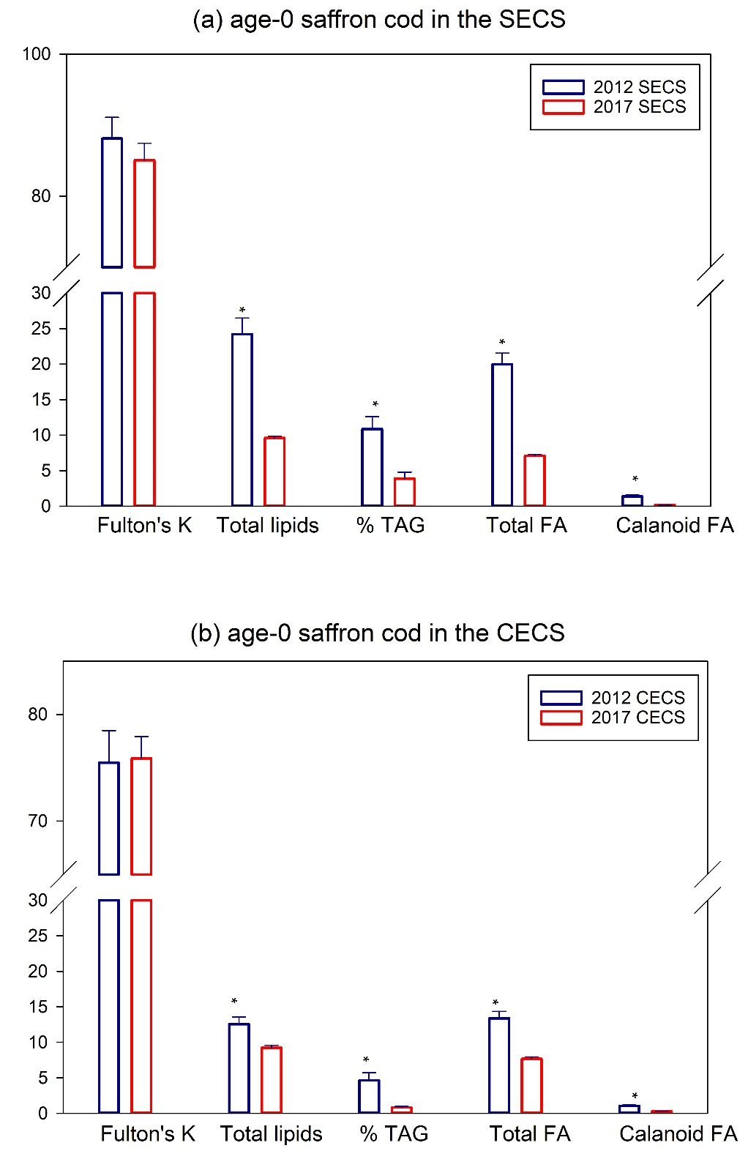
Fig. S1C. Region-specific annual differences in condition metrics and lipid storage of age-0 saffron cod in the southeastern Chukchi Sea (SECS) and the central eastern Chukchi Sea (CECS). Fish were collected in one historical cold year (2012) and one current warm year (2017). Fulton’s K (*100 percentage), total lipids (mg.g⁻¹ WWT), triacylglycerols (% TAG), total fatty acids (mg.g⁻¹ WWT), and total calanoid copepod fatty acid storage (∑ C₂₀+C₂₂ MUFA mg.g⁻¹ WWT fish) are shown as mean ± SE by region-year. Statistical differences between 2012 and 2017 in the SECS and 2012 and 2017 in the CECS are indicated by an * with saffron cod having higher lipid indices in 2012 (cold) compared to 2017 (warm), ANOVA, p < 0.05.

