Supplementary Material
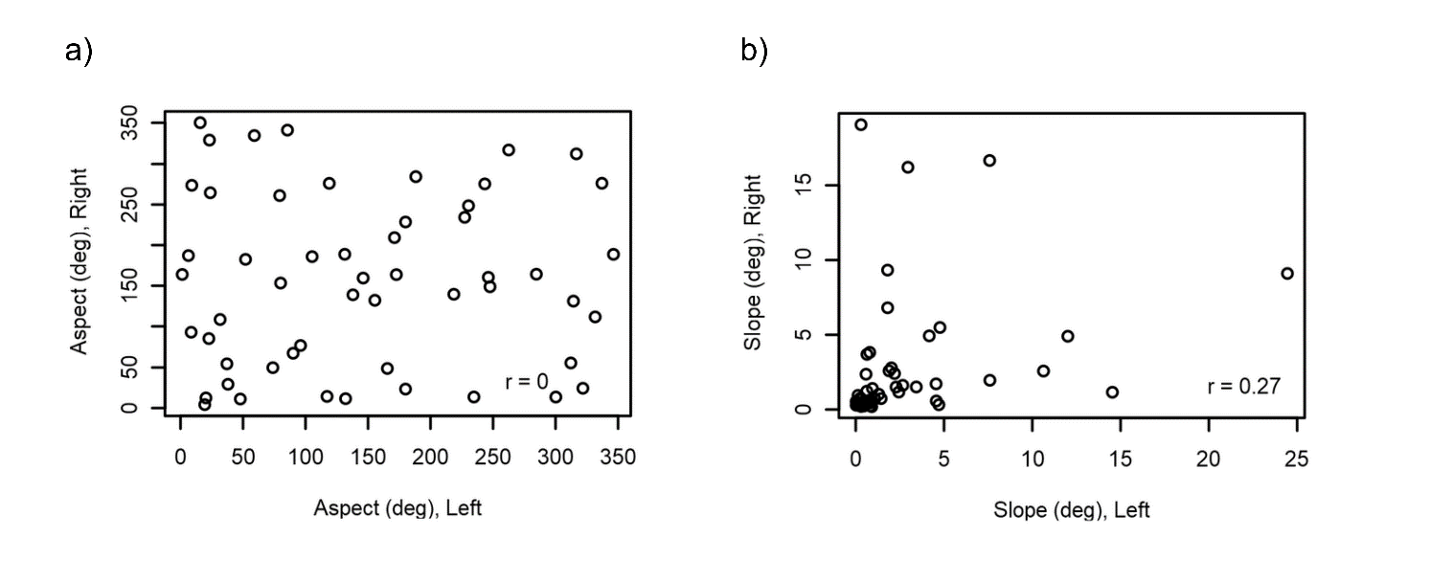
Figure S1. Correlation plots of aspect (a) and slope (b) showing a weak relationship between the left and right location estimates of localized sperm whale acoustic encounters.

