Table S1. Growth Transition matrix for skipjack Low growth model from 2019 stock assessment (presented in manuscript) used in the Brownie models.
 | Size class t + 1
Size class t | 21-40 | 41-50 | 51-60 | 61-70 | 71+
21-40 | 0.095 | 0.854 | 0.051 | 0 | 0
41-50 | 0 | 0.324 | 0.67 | 0.006 | 0
51-60 | 0 | 0.002 | 0.54 | 0.457 | 0.001
61-70 | 0 | 0 | 0.011 | 0.736 | 0.252
71+ | 0 | 0 | 0 | 0.008 | 0.992

Table S2. Growth Transition matrix for yellowfin Tag growth from Eveson et al 2020 (presented in manuscript) used in the Brownie models.
 | Size class t + 1
Size class t | 21-40 | 41-50 | 51-60 | 61-70 | 71-80 | 81-90 | 91-100 | 101+
21-40 | 0.1549 | 0.5443 | 0.2793 | 0.0214 | 0 | 0 | 0 | 0
41-50 | 0.02 | 0.245 | 0.519 | 0.202 | 0.014 | 0 | 0 | 0
51-60 | 0.001 | 0.034 | 0.2813 | 0.4875 | 0.1822 | 0.014 | 0 | 0
61-70 | 0 | 0.002 | 0.0529 | 0.3097 | 0.4535 | 0.1668 | 0.015 | 0
71-80 | 0 | 0 | 0.005 | 0.074 | 0.331 | 0.42 | 0.148 | 0.022
81-90 | 0 | 0 | 0 | 0.009 | 0.0991 | 0.3433 | 0.3594 | 0.1892
91-100 | 0 | 0 | 0 | 0.001 | 0.018 | 0.132 | 0.316 | 0.533
101+ | 0 | 0 | 0 | 0 | 0 | 0 | 0.0051 | 0.9949

Table S3. Growth Transition matrix for skipjack High growth model from 2019 stock assessment, results shown below used in the Brownie models.
 | Size class t + 1
Size class t | 21-40 | 41-50 | 51-60 | 61-70 | 71+
21-40 | 0.065 | 0.7984 | 0.1365 | 1.00E-04 | 0
41-50 | 4.00E-04 | 0.223 | 0.7443 | 0.0323 | 0
51-60 | 0 | 0.002 | 0.3925 | 0.5959 | 0.0096
61-70 | 0 | 0 | 0.0086 | 0.5808 | 0.4106
71+ | 0 | 0 | 0 | 0.0061 | 0.9939

Table S4. Growth Transition matrix for yellowfin otolith only growth model from Farley et al. (2020) (WCPFC-SC16-SA-WP-02) results shown below used in the Brownie models.
 | Size class t + 1
Size class t | 21-40 | 41-50 | 51-60 | 61-70 | 71-80 | 81-90 | 91-100 | 101+
21-40 | 0.196 | 0.505 | 0.267 | 0.031 | 0.001 | 0 | 0 | 0
41-50 | 0.034 | 0.278 | 0.481 | 0.19 | 0.017 | 0 | 0 | 0
51-60 | 0.001 | 0.045 | 0.307 | 0.47 | 0.164 | 0.013 | 0 | 0
61-70 | 0 | 0.002 | 0.056 | 0.337 | 0.455 | 0.14 | 0.009 | 0
71-80 | 0 | 0 | 0.003 | 0.069 | 0.365 | 0.437 | 0.116 | 0.01
81-90 | 0 | 0 | 0 | 0.004 | 0.084 | 0.393 | 0.389 | 0.13
91-100 | 0 | 0 | 0 | 0 | 0.006 | 0.112 | 0.378 | 0.504
101+ | 0 | 0 | 0 | 0 | 0 | 0 | 0 | 1

Table S5. Values of skipjack tuna natural mortality per year at length for the selected attrition model with both assumed growth models.
Programme | Growth model | 21-40 | 41-50 | 51-60 | 61-70 | 71+
SSAP | Low | 5.60 | 1.04 | 1.04 | 1.39 | 2.40
RTTP | Low | 6.69 | 1.99 | 0.96 | 1.53 | 1.95
PTTP-early | Low | 5.63 | 2.35 | 1.33 | 2.26 | 0.37
PTTP-late | Low | 5.96 | 2.03 | 1.71 | 2.62 | 1.02
SSAP | High | 6.20 | 0.75 | 0.75 | 2.41 | 2.54
RTTP | High | 7.67 | 1.96 | 0.47 | 2.13 | 1.85
PTTP-early | High | 6.39 | 2.37 | 1.28 | 2.41 | 0.81
PTTP-late | High | 6.43 | 2.06 | 1.33 | 2.94 | 1.40

Table S6. Values of yellowfin tuna natural mortality per year at length for the selected attrition model.
Programme | Growth model | 21-40 | 41-50 | 51-60 | 61-70 | 71-80 | 81-90 | 91-100 | 101+
RTTP | Tag & otolith | 4.19 | 2.24 | 0.14 | 0.14 | 0.60 | 0.60 | 1.68 | 1.42
PTTP-early | Tag & otolith | 5.07 | 1.68 | 1.78 | 0.27 | 0.41 | 1.72 | 1.71 | 0.65
PTTP-late | Tag & otolith | 4.39 | 1.78 | 0.51 | 0.38 | 0.89 | 0.42 | 3.20 | 1.23
RTTP | Otolith | 4.73 | 2.30 | 0.05 | 0.05 | 0.80 | 0.80 | 2.40 | 1.36
PTTP-early | Otolith | 5.43 | 1.87 | 1.55 | 0.27 | 0.19 | 1.83 | 1.71 | 0.80
PTTP-late | Otolith | 4.60 | 1.80 | 0.83 | 0.03 | 0.79 | 1.52 | 1.59 | 1.39

Table S7. Values of skipjack tuna natural mortality per year at length for various tagging programmes, mixing periods and growth models estimated by Brownie models.
Programme | Mixing Period | Growth Model | 21-40 | 41-50 | 51-60 | 61-70 | 71+
PTTP-early | 1 | Low | 4.43 | 1.651 | 1.786 | 0.834 | 0.175
PTTP-early | 2 | Low | 3.607 | 1.699 | 1.411 | 1.066 | 0.324
PTTP-late | 1 | Low | 3.827 | 1.132 | 1.73 | 1.748 | 0
PTTP-late | 2 | Low | 3.735 | 0.8 | 1.319 | 2.391 | 0
RTTP | 1 | Low | 4.359 | 1.55 | 0.922 | 0.769 | 0.26
RTTP | 2 | Low | 4.4 | 1.262 | 0.829 | 1.022 | 0.26
SSAP | 1 | Low | 4.072 | 0.988 | 1.124 | 1.343 | 6.779
SSAP | 2 | Low | 2.779 | 0.62 | 1.698 | 1.126 | 4.68
PTTP-early | 1 | Low | 4.498 | 1.678 | 1.987 | 0.399 | 0.483
PTTP-early | 2 | Low | 3.63 | 1.683 | 1.293 | 0.6 | 0.466
PTTP-late | 1 | High | 3.874 | 1.061 | 1.585 | 2.243 | 0
PTTP-late | 2 | High | 3.569 | 0.699 | 1.11 | 2.031 | 0
RTTP | 1 | High | 4.449 | 1.531 | 0.428 | 0.435 | 1.278
RTTP | 2 | High | 4.469 | 1.11 | 0.305 | 0.353 | 0.529
SSAP | 1 | High | 3.986 | 0.937 | 0.929 | 0.48 | 8.809
SSAP | 2 | High | 2.635 | 0.539 | 1.802 | 0.375 | 4.749

Table S8. Values of yellowfin tuna natural mortality per year at length for various tagging programmes, mixing periods estimated by Brownie models.
Programme | Mixing Period | Growth Model | 21-40 | 41-50 | 51-60 | 61-70 | 71-80 | 81-90 | 91-100 | 100+
PTTP | 1 | Tag & otolith | 3.67 | 1.282 | 0.732 | 0.932 | 0.67 | 0.67 | 0.67 | 0.67
PTTP | 2 | Tag & otolith | 3.663 | 1.057 | 0.385 | 0.744 | 0.794 | 0.794 | 0.794 | 0.794
RTTP | 1 | Tag & otolith | 3.018 | 1.814 | 1.447 | 1.523 | 0.931 | 0.931 | 0.931 | 0.931
RTTP | 2 | Tag & otolith | 3.143 | 1.702 | 1.664 | 1.986 | 0.834 | 0.834 | 0.834 | 0.834
PTTP | 2 | Tag & otolith | 3.598 | 1.045 | 0.43 | 0.788 | 0.754 | 0.754 | 0.754 | 0.754
PTTP-early | 1 | Otolith | 3.599 | 1.379 | 0.877 | 1.052 | 0.689 | 0.689 | 0.689 | 0.689
PTTP-late | 1 | Otolith | 3.702 | 0.985 | 0.975 | 1.959 | 0.178 | 0.178 | 0.178 | 0.178
RTTP | 1 | Otolith | 2.977 | 1.772 | 1.42 | 1.518 | 0.921 | 0.921 | 0.921 | 0.921
RTTP | 2 | Otolith | 3.099 | 1.676 | 1.635 | 1.969 | 0.819 | 0.819 | 0.819 | 0.819

a) Releases b) Recaptures
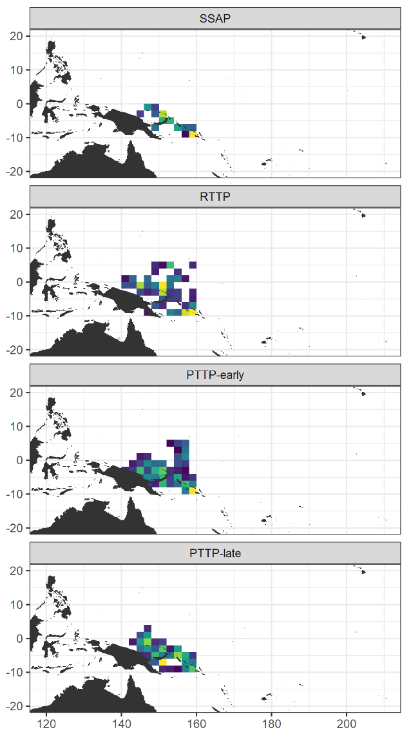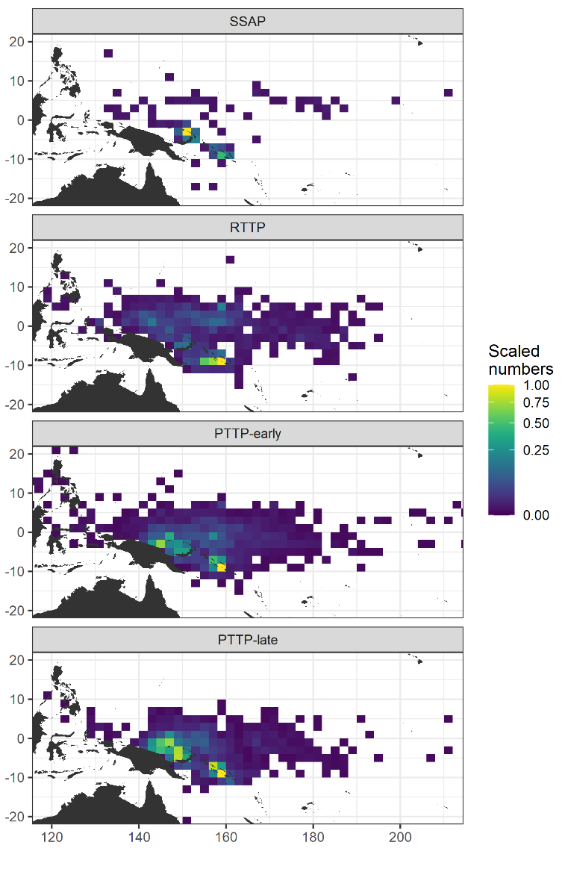
Figure S1 Map of modelled skipjack a) tag releases and b) recaptures by tagging programme at a 2° spatial resolution. For each panel, the data were scaled relative to the (panel-specific) maximum and a square root transformation applied, to facilitate comparison between programmes.

a) Releases b) Recaptures
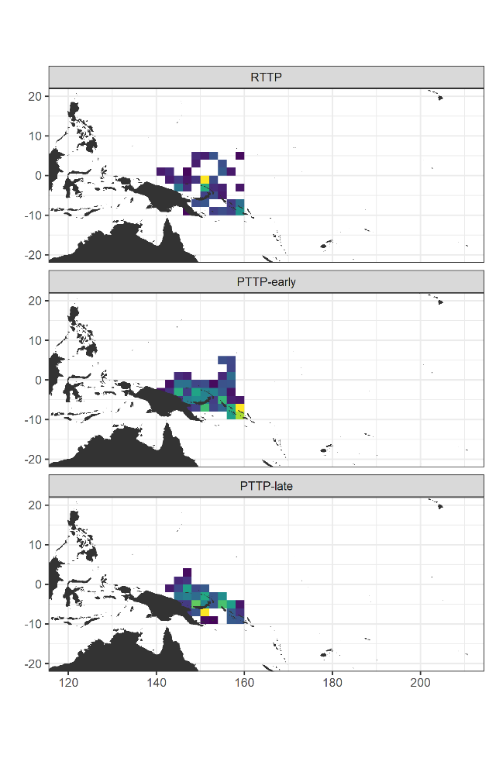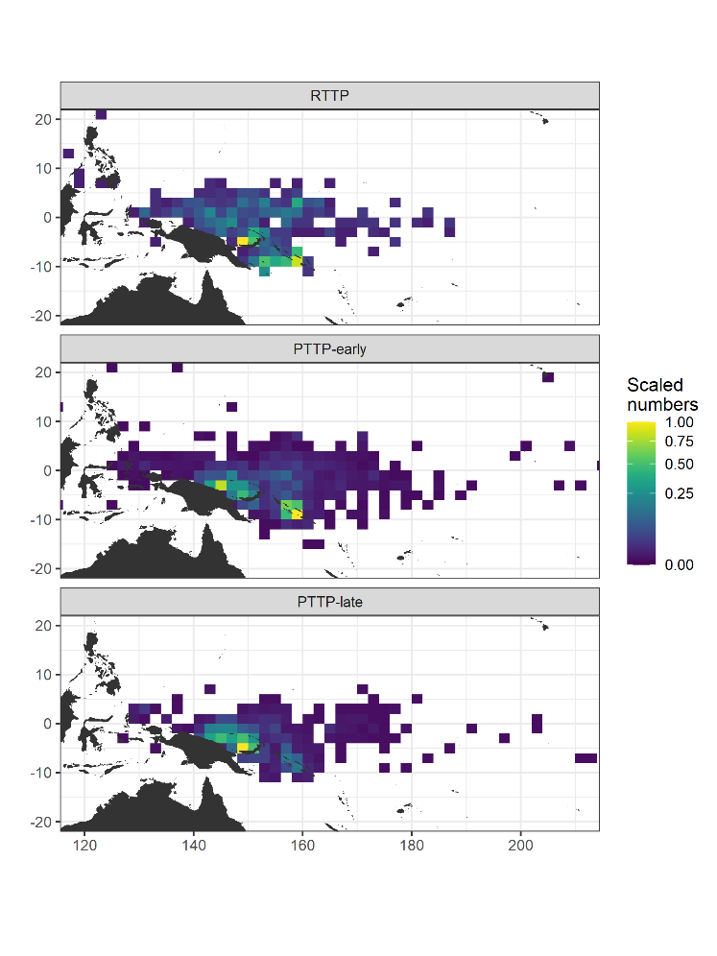
Figure S2 Map of modelled yellowfin a) tag releases and b) recaptures by tagging programme at a 2° spatial resolution. For each panel, the data were scaled relative to the (panel-specific) maximum and a square root transformation applied, to facilitate comparison between programmes.

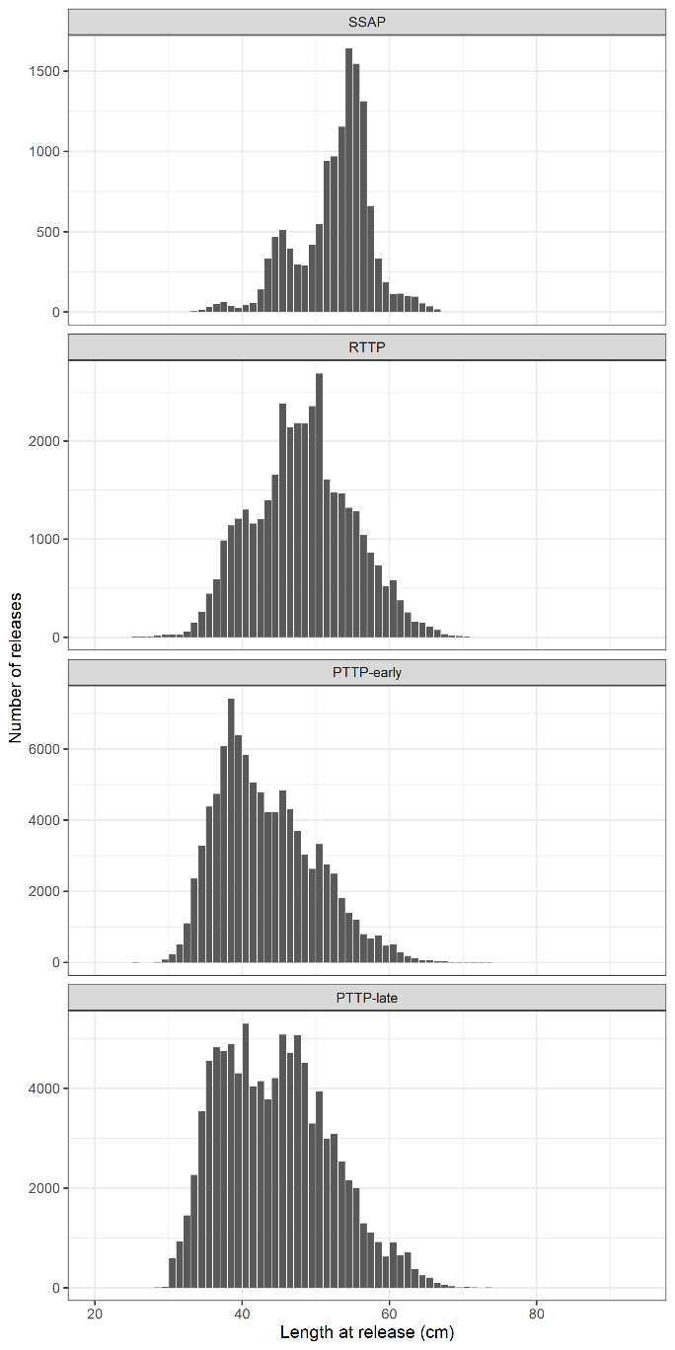
Figure S3 Modelled skipjack tag releases by 1cm length bin by tagging programme.

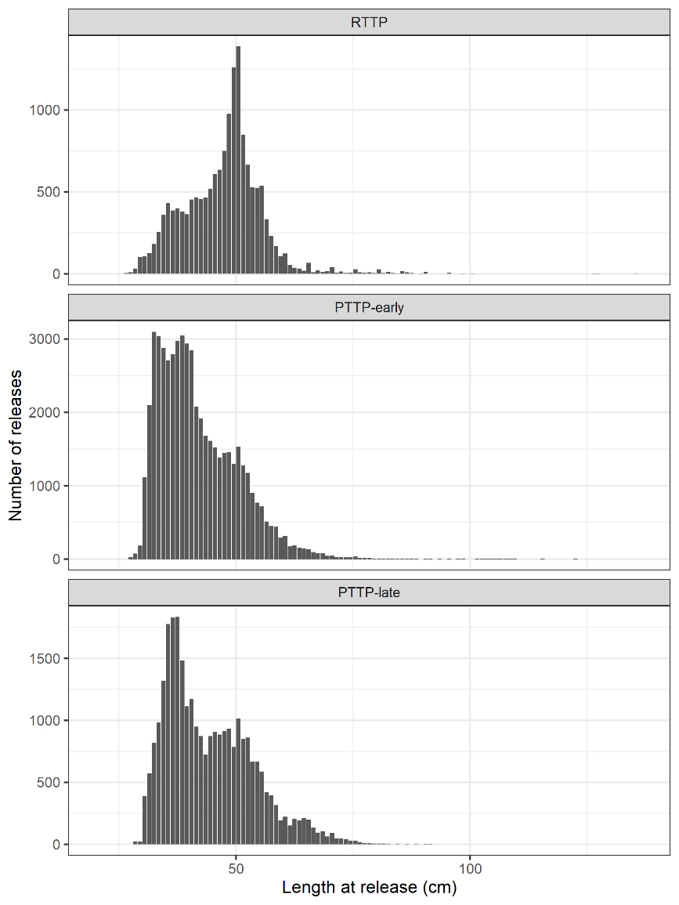
Figure S4 Modelled yellowfin tag releases by 1cm length bin by tagging programme.

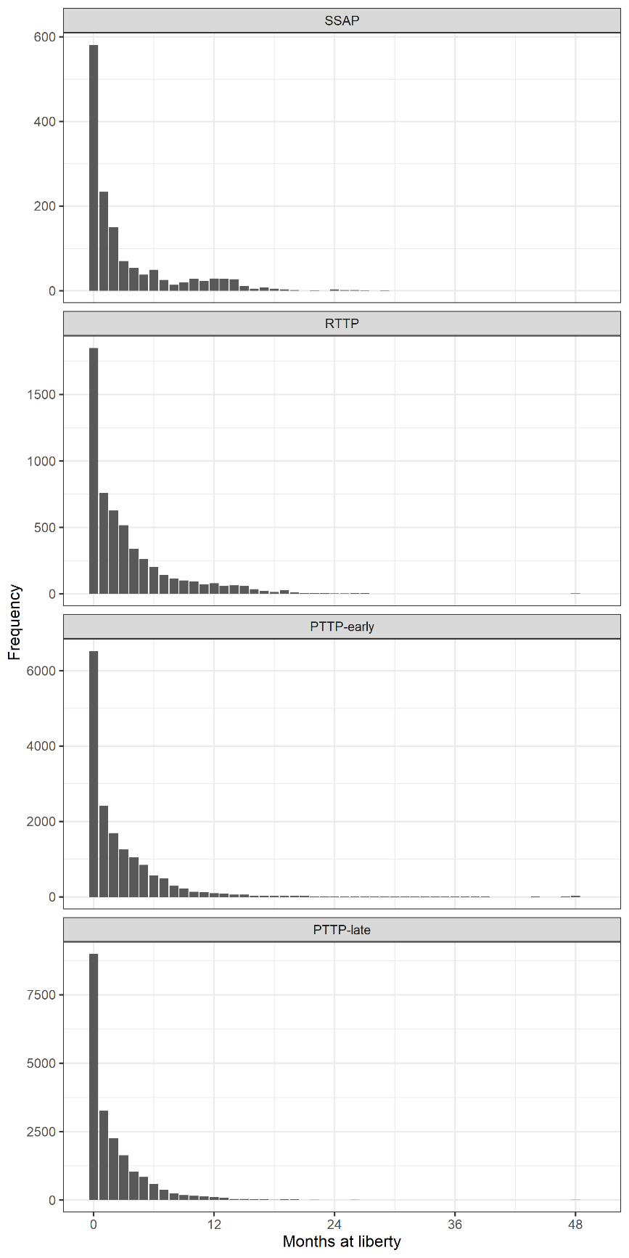
Figure S5 Months at liberty for modelled skipjack tag recaptures by tagging programme. Recaptures after 48 months at liberty were grouped together.

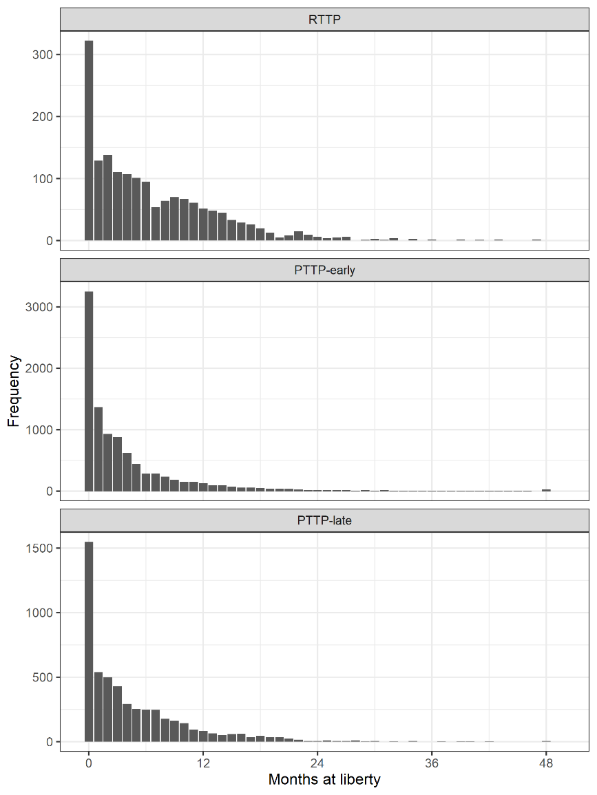
Figure S6 Months at liberty for modelled yellowfin tag recaptures by tagging programme. Recaptures after 48 months at liberty were grouped together.

a) Skipjack
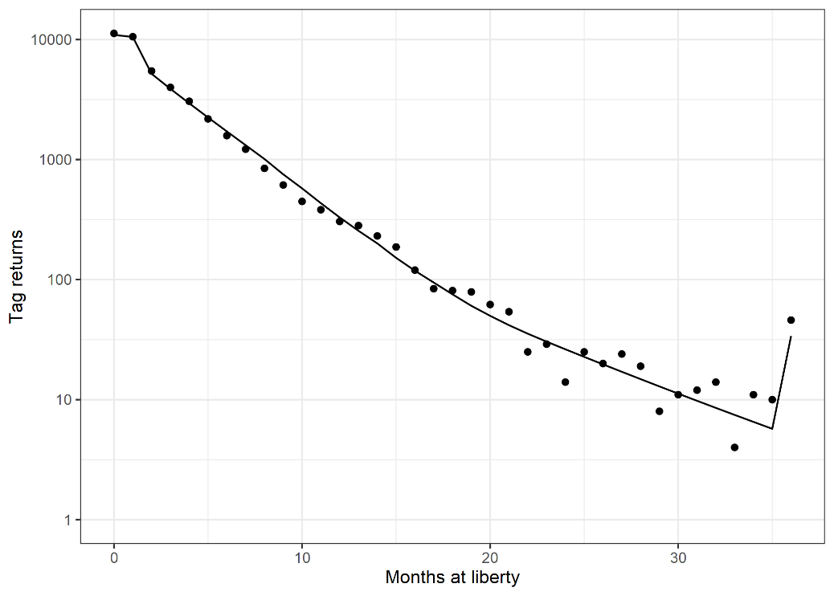
b) Yellowfin
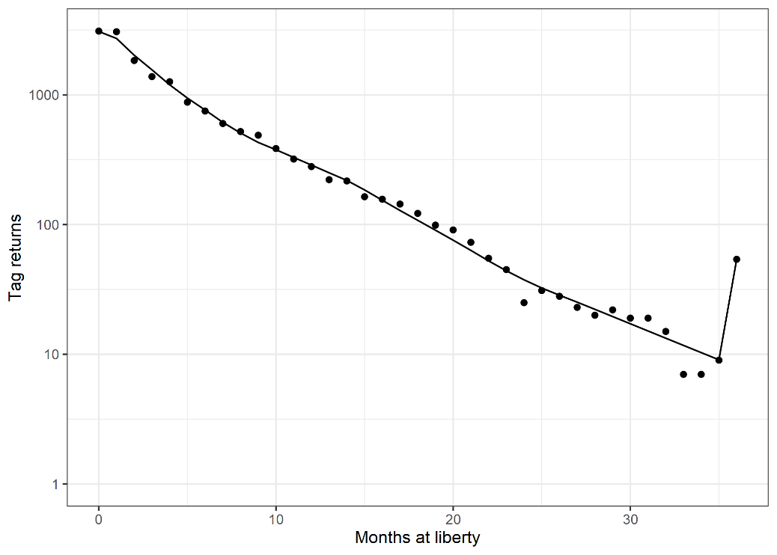
Figure S7 Estimated (line) and observed (points) tag recaptures against months at liberty for the selected a) skipjack and b) yellowfin attrition models. Recaptures for ≥36 months at liberty were combined.

a) Skipjack
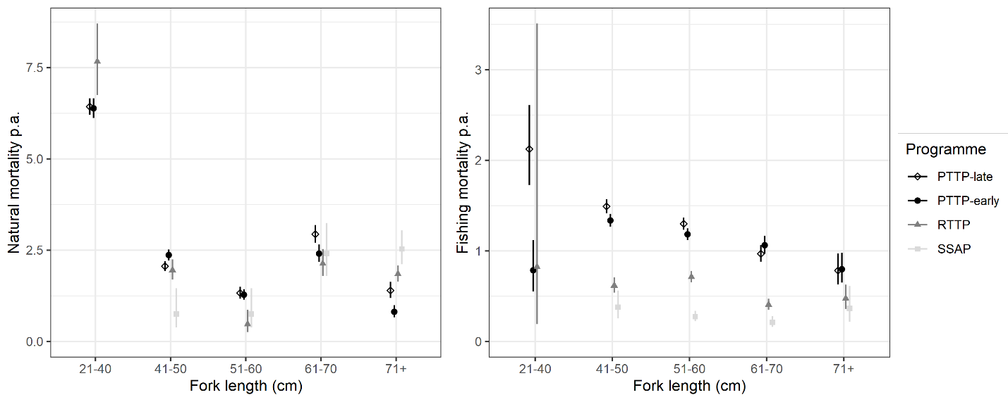
b) Yellowfin
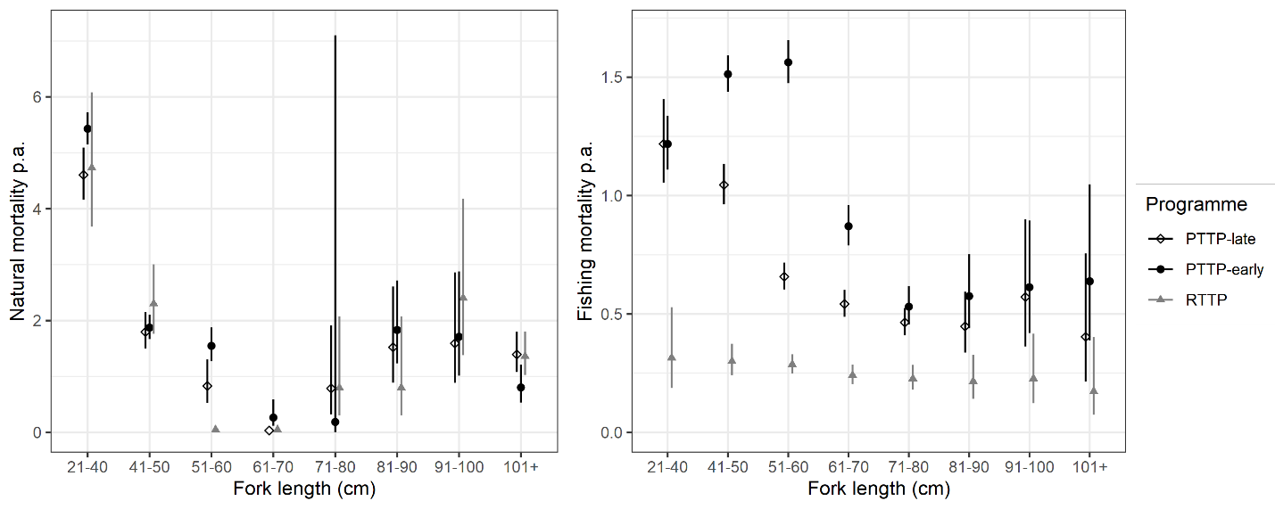
Figure S8 Estimated $M_{s}$ and $F_{s}$ parameters and 95% confidence intervals for the selected skipjack and yellowfin attrition models with the alternative assumed growth rates (see Methods). a) The skipjack attrition model with programme-specific $M_{s}$ and $F_{s}$ and a mixing period of 2 months, and b) the yellowfin attrition model with shared $M_{s}$ and programme-specific $F_{s}$ and a mixing period of 1 month. For both skipjack and yellowfin, the PTTP was split into two effective tagging programmes: the PTTP-early with releases from 2006 to 2009; and, the PTTP-late with releases from 2011 to 2017. There was insufficient data to reliably estimate $M_{s}$ and $F_{s}$ for 21-40cm skipjack during the SSAP (see text), and so these parameters are not included in the plot (M = 6.2, F = 0.12).

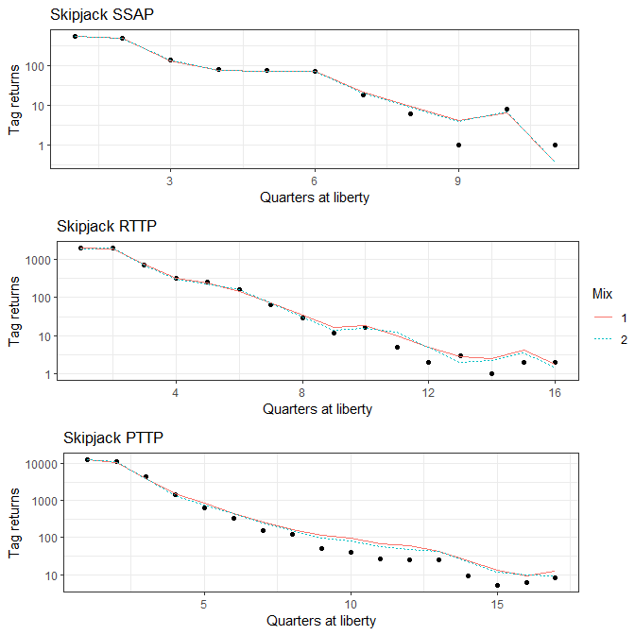
Figure S9 Estimated (line) and observed (points) tag recaptures against quarter at liberty for the selected skipjack Brownie models.
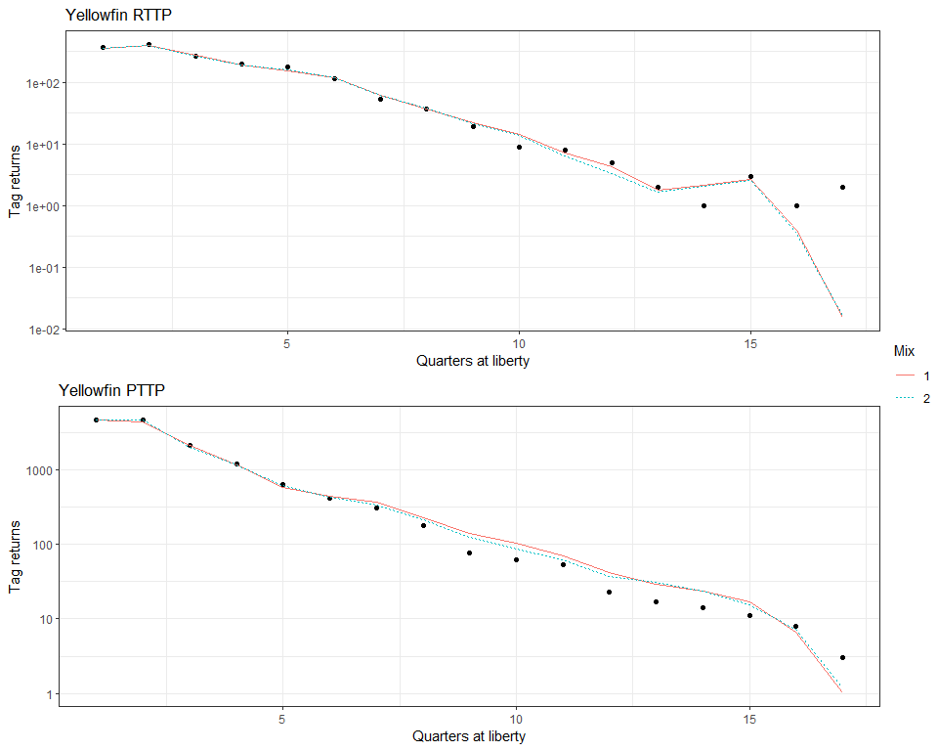
Figure S10 Estimated (line) and observed (points) tag recaptures against quarter at liberty for the selected yellowfin Brownie models.

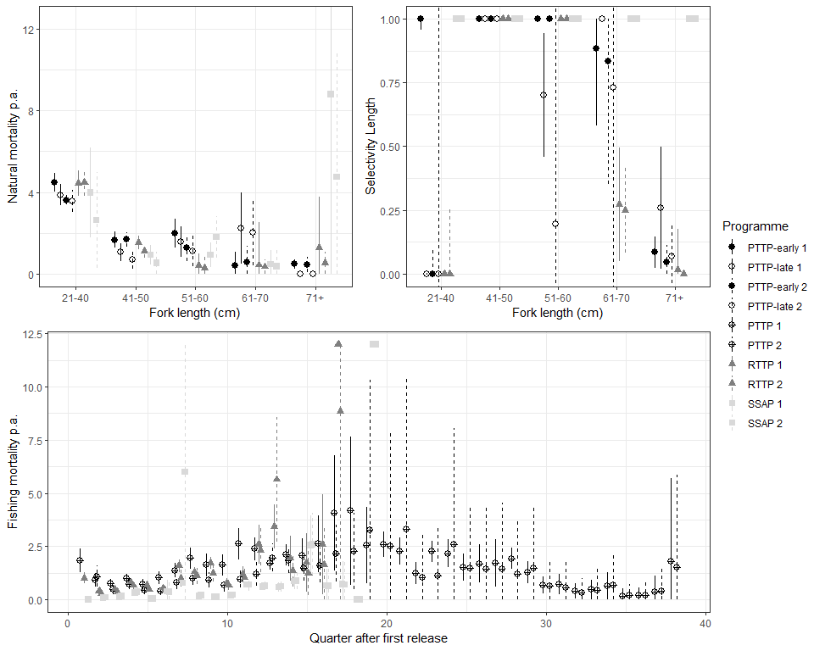
Figure S11. Estimated $M_{s}$, $f_{t}$, and $η_{s}$ from length-based Brownie models chosen by AIC for skipjack tuna in the western Pacific Ocean for three tagging programs with either 1 or 2 mixing quarters using the High growth model. The natural mortality and selectivity for length bins in the PTTP were modeled as separate parameters before and after 2011, indicated by PTTP-early and -late.
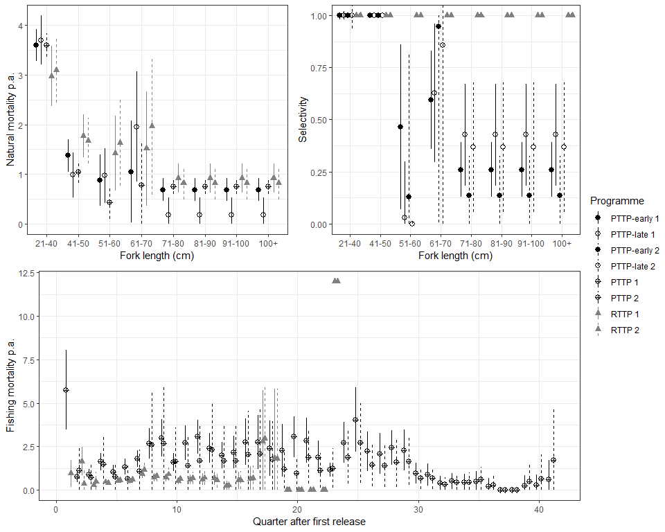
Figure S12. Estimated $M_{s}$, $f_{t}$, and $η_{s}$ from length-based Brownie models chosen by AIC for yellowfin tuna in the western Pacific Ocean for two tagging programs with either 1 or 2 mixing quarters using the otolith only growth model. The natural mortality and selectivity for length bins in the PTTP were modeled as separate parameters before and after 2011, indicated by PTTP-early and -late for a mixing period of 1 quarter, but only selectivity was modeled separately for a mixing period of 2 quarters.

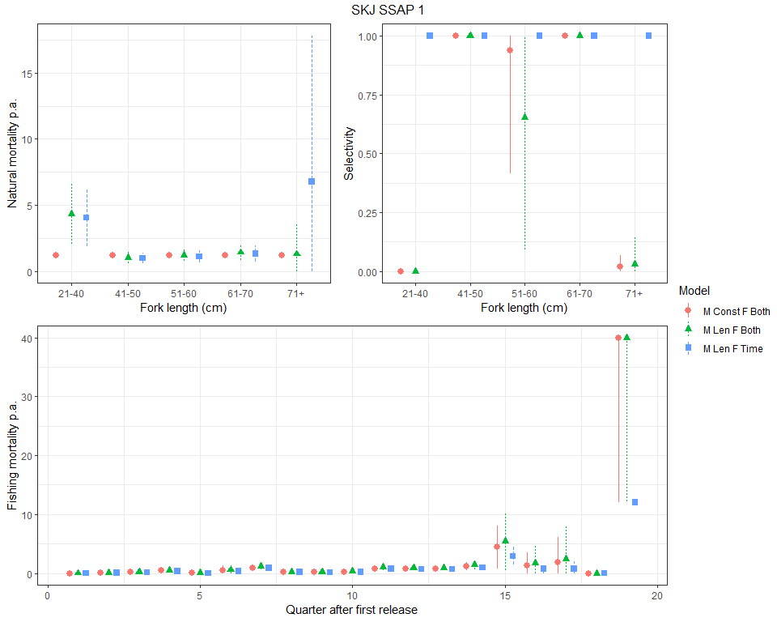
Figure S13. Comparison of estimated $M_{s}$, $f_{t}$, and $η_{s}$ from three length-based Brownie models that were within 10 Delta AIC for skipjack tuna in the western Pacific Ocean for the SSAP tagging program with 1 mixing quarter. M Const means natural mortality was shared across all lengths, F Both means both $f_{t}$ and $η_{s}$ were estimated whereas F Time means only $f_{t}$ is estimated and $η_{s}$ equals 1 for all length bins.
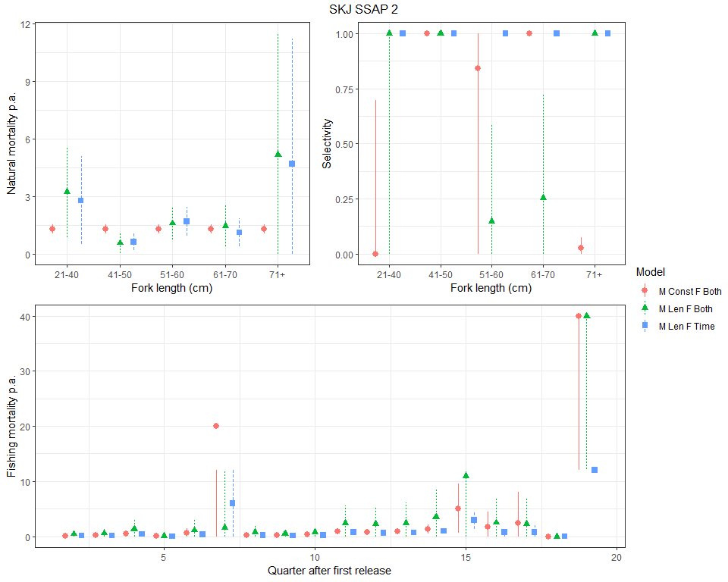
Figure S14. Comparison of estimated $M_{s}$, $f_{t}$, and $η_{s}$ from two length-based Brownie models that were within 10 Delta AIC for skipjack tuna in the western Pacific Ocean for the SSAP tagging program with 2 mixing quarters. Model Both means both $f_{t}$ and $η_{s}$ were estimated whereas Model Time means only $f_{t}$ is estimated and $η_{s}$ equals 1 for all length bins.

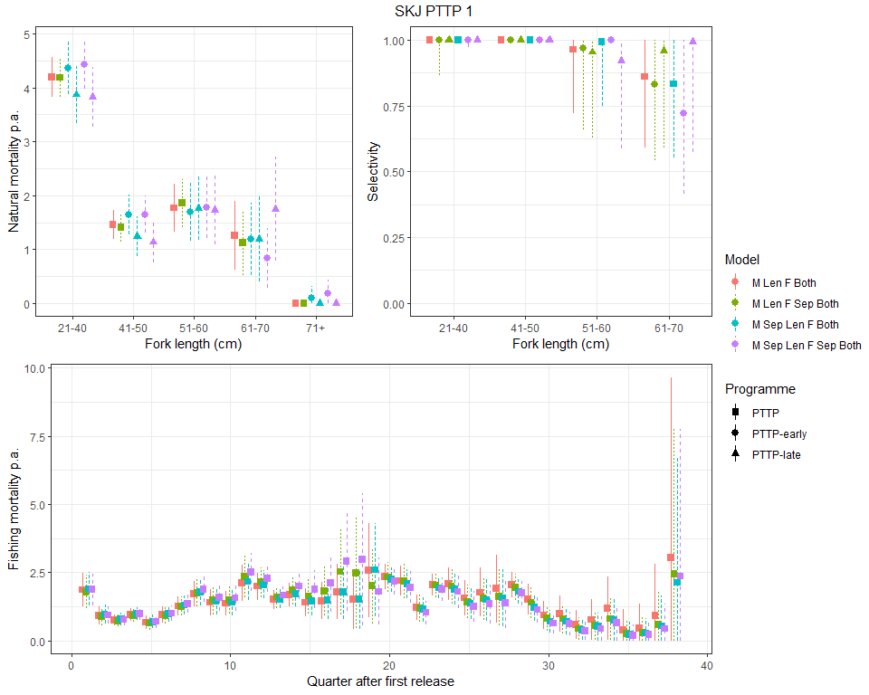
Figure S15. Comparison of estimated $M_{s}$, $f_{t}$, and $η_{s}$ from two length-based Brownie models that were within 10 Delta AIC for skipjack tuna in the western Pacific Ocean for the PTTP tagging program with 1 mixing quarter. Model M Len Sep means natural mortality is modeled separately before and after 2011, whereas M Len is modeled constant across time. Similarly, F Sep Both models separate $η_{s}$ before and after 2011, whereas F Both models these parameters as constant across time.
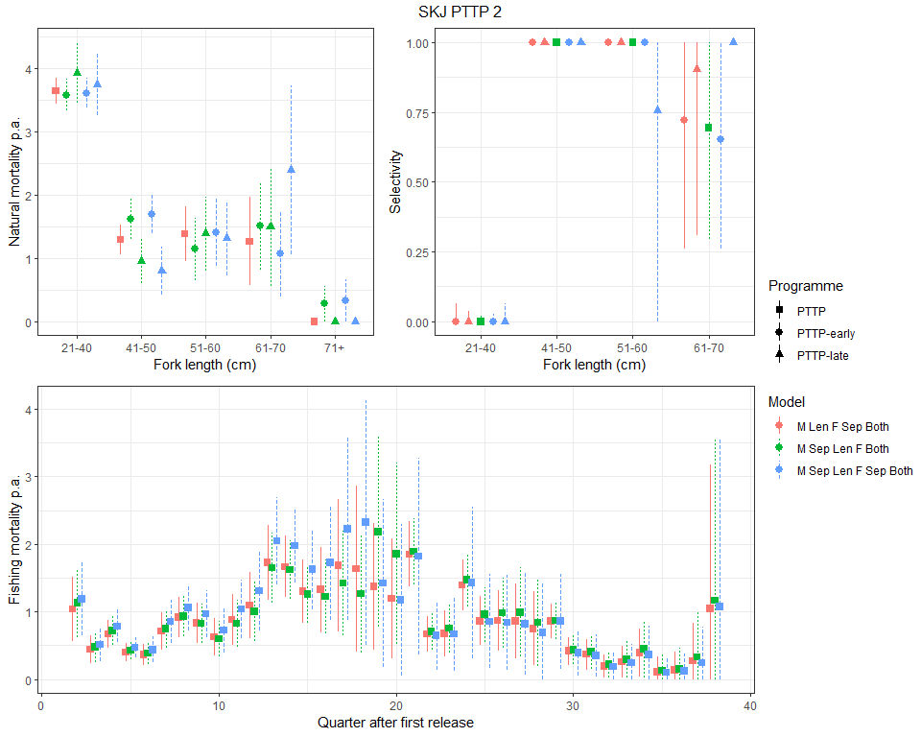
Figure S16. Comparison of estimated $M_{s}$, $f_{t}$, and $η_{s}$ from two length-based Brownie models that were within 10 Delta AIC for skipjack tuna in the western Pacific Ocean for the PTTP tagging program with 2 mixing quarters. Model M Len Sep means length-specific natural mortality is modeled separately before and after 2011, whereas M Len is modeled constant across time. Similarly, F Sep Both models separate $η_{s}$ before and after 2011, whereas F Both models these parameters as constant across time.
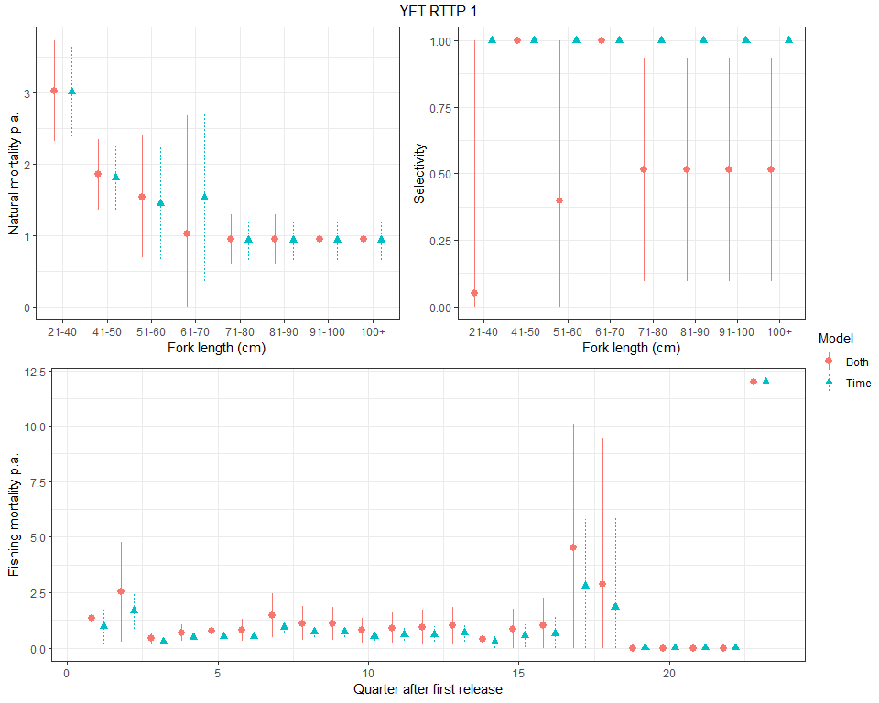 Figure S17. Comparison of estimated $M_{s}$, $f_{t}$, and $η_{s}$ from two length-based Brownie models that were within 10 Delta AIC for yellowfin tuna in the western Pacific Ocean for the RTTP tagging program with 1 mixing quarter. Model Both means both $f_{t}$ and $η_{s}$ were estimated whereas Model Time means only $f_{t}$ is estimated and $η_{s}$ equals 1 for all length bins.

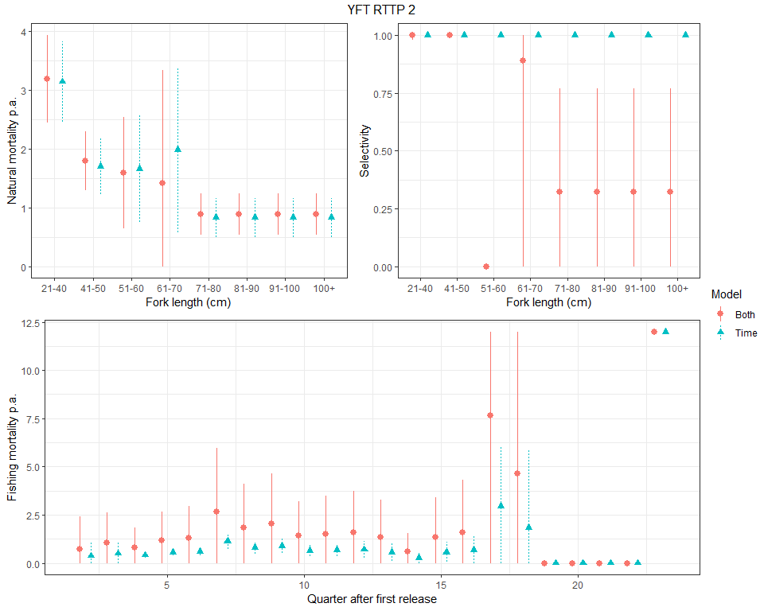
Figure S18. Comparison of estimated $M_{s}$, $f_{t}$, and $η_{s}$ from two length-based Brownie models that were within 10 Delta AIC for yellowfin tuna in the western Pacific Ocean for the RTTP tagging program with 2 mixing quarters. Model Both means both $f_{t}$ and $η_{s}$ were estimated whereas Model Time means only $f_{t}$ is estimated and $η_{s}$ equals 1 for all length bins.

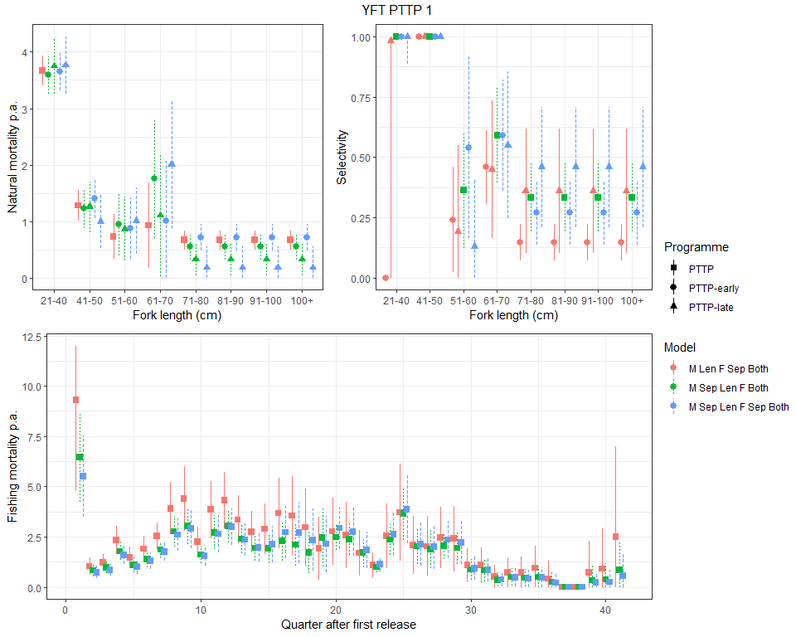
Figure S19. Comparison of estimated $M_{s}$, $f_{t}$, and $η_{s}$ from two length-based Brownie models that were within 10 Delta AIC for yellowfin tuna in the western Pacific Ocean for the PTTP tagging program with 1 mixing quarter. Model M Len Sep means length-specific natural mortality is modeled separately before and after 2011, whereas M Len is constant across time. Similarly, F Sep Both models separate $η_{s}$ before and after 2011, whereas F Both models these parameters as constant across time.

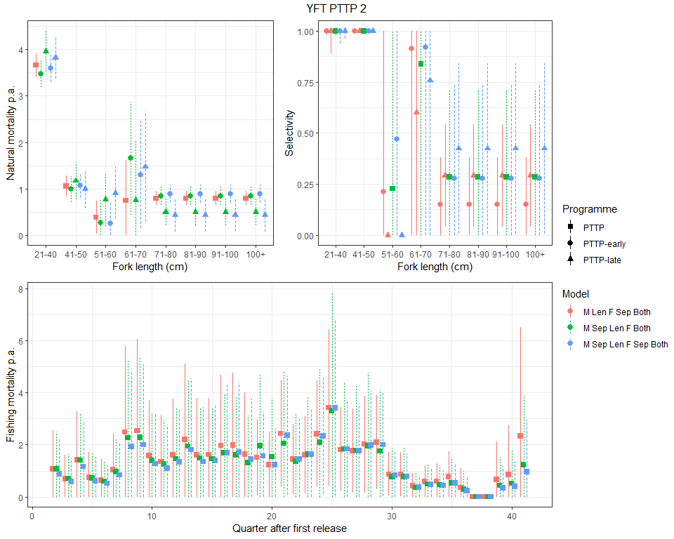
Figure S20. Comparison of estimated $M_{s}$, $f_{t}$, and $η_{s}$ from two length-based Brownie models that were within 10 Delta AIC for yellowfin tuna in the western Pacific Ocean for the PTTP tagging program with 2 mixing quarters. Model M Len Sep means length-specific natural mortality is modeled separately before and after 2011, whereas M Len is constant across time. Similarly, F Sep Both models separate $η_{s}$ before and after 2011, whereas F Both models these parameters as constant across time.

