Supplemental Tables and Figures

Table S1. Sample sizes of surveys conducted for a) coral density and benthic cover across depth, sector, and years used in PERMANOVA analysis to assess post-bleaching recovery composition, and b) herbivore biomass used to examine temporal change in herbivore biomass and the post-bleaching relationship between the benthic cover assemblage and herbivore biomass
- Coral Density and Benthic Cover
Depth | Sector | 2016 |  | 2017 |  | 2018
Depth | Sector | Coral | Cover | Coral | Cover | Coral | Cover
Shallow | Non-upwelling | 7 | 15 | 8 | 19 | 7 | 19
Shallow | Upwelling | 2 | 4 | 3 | 3 | 3 | 5
Mid-depth | Non-upwelling | 13 | 25 | 10 | 16 | 13 | 30
Mid-depth | Upwelling | 4 | 7 | 2 | 9 | 0 | 6
Deep | Non-upwelling | 3 | 7 | 7 | 9 | 3 | 6
Deep | Upwelling | 1 | 2 | 2 | 4 | 2 | 6

- Herbivore biomass
Year | 2015 | 2016 | 2017 | 2018
N | 60 | 30 | 28 | 39

Table S2. Mean (SE) for adult and juvenile colony density (indiv. m⁻²) by coral genera. These estimates and errors were calculated incorporating sampling weights and strata given the complex NCRMP study design. As such, these values differ slightly from those presented in Vargas-Ángel al (2019) for 2015–2017 calculated using simple random sampling.

 | Adult |  |  |  |  | Juvenile
Genus | 2015 | 2016 | 2017 | 2018 |  | 2015 | 2016 | 2017 | 2018
Acropora | 0.1 (0.05) | 0 | 0 | 0 |  | 0.03 (0.03) | 0 | 0 | 0
Coscinaria | 0.002 (0.002) | 0 | 0 | 0.03 (0.02) |  | 0.004 (0.004) | 0 | 0 | 0
Favia | 0.03 (0.02) | 0.02 (0.01) | 0.08 (0.05) | 0 |  | 0 | 0 | 0.01 (0.01) | 0
Favites | 0.008 (0.006) | 0.009 (0.005) | 0.002 (0.002) | 0.01 (0.01) |  | 0 | 0 | 0 | 0
Goniastrea | 0.001 (0.001) | 0 | 0 | 0 |  | 0 | 0 | 0 | 0
Hydnophora | 0.001 (0.001) | 0.005 (0.003) | 0.005 (0.004) | 0.005 (0.003) |  | 0 | 0 | 0 | 0
Isopora | 0.002 (0.002) | 0 | 0 | 0 |  | 0 | 0 | 0 | 0
Leptastrea | 0.01 (0.01) | 0 | 0.003 (0.003) | 0.003 (0.003) |  | 0.004 (0.004) | 0 | 0.005 (0.005) | 0
Leptoseris | 0.12 (0.04) | 0.05 (0.01) | 0.03 (0.01) | 0.16 (0.07) |  | 0.02 (0.02) | 0 | 0.006 (0.006) | 0.08 (0.05)
Montipora | 3.80 (0.64) | 0.007 (0.005) | 0 (0) | 0.007 (0.007) |  | 0.32 (0.08) | 0 | 0 | 0
Pavona | 0.52 (0.13) | 0.08 (0.022) | 0.18 (0.05) | 0.58 (0.18) |  | 0.11 (0.09) | 0.009 (0.007) | 0.09 (0.03) | 0.31 (0.17)
Pocillopora | 2.22 (0.29) | 0.05 (0.01) | 0.03 (0.008) | 0.11 (0.03) |  | 0.17 (0.045) | 0.014 (0.014) | 0.027 (0.014) | 0.031 (0.024)
Porites | 0.08 (0.03) | 0.02 (0.007) | 0.02 (0.007) | 0.01 (0.01) |  | 0 | 0 | 0.01 (0.01) | 0 (0)
Psammocora | 0.16 (0.05) | 0.05 (0.02) | 0.05 (0.02) | 0.15 (0.07) |  | 0.03 (0.01) | 0 | 0.02 (0.01) | 0.08 (0.05)

Table S3. Results of the db-RDA full model and partial analyses relating herbivore biomass by grazing type to benthic cover (using collocated fish and benthic cover survey data from 2015-2018, n= 157).

Herbivores | % explained | Variance | Pseudo- F | p
Full Model | 8% | 0.47 | 6.58 | < 0.001
Partial Models
Scraper / Excavator | 5% | 0.42 | 11.58 | 0.001
Browser / Grazer | <2% | 0.06 | 1.58 | 0.1

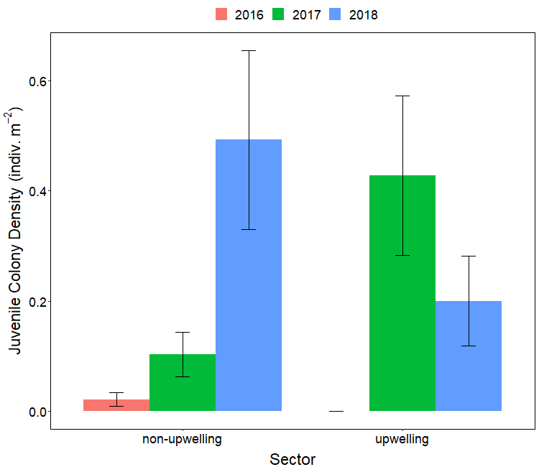

Figure S1. Juvenile colony density (mean ± SE) by sector and year following the mass bleaching event. No juveniles were observed in the upwelling sector in 2016.
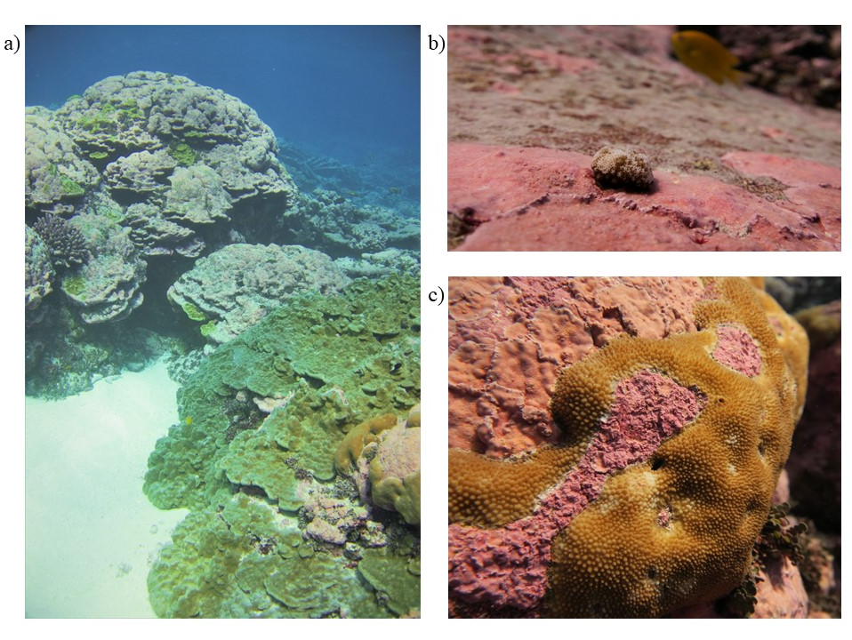
Figure S2. While no massive (e.g., < 2m diameter) Porites colonies were quantified during the 2018 coral demographic surveys, several large surviving colonies were observed by divers in the shallow reef area (a), exhibiting varying ranges in partial mortality such as the live colony in the foreground and the dead colony covered in CCA in the background. Coral juveniles like this Pocillopora (b) were observed growing atop coralline algae, while other colonies like this Hydnophora (c) appear to be competing with thick crusts of coralline algae.

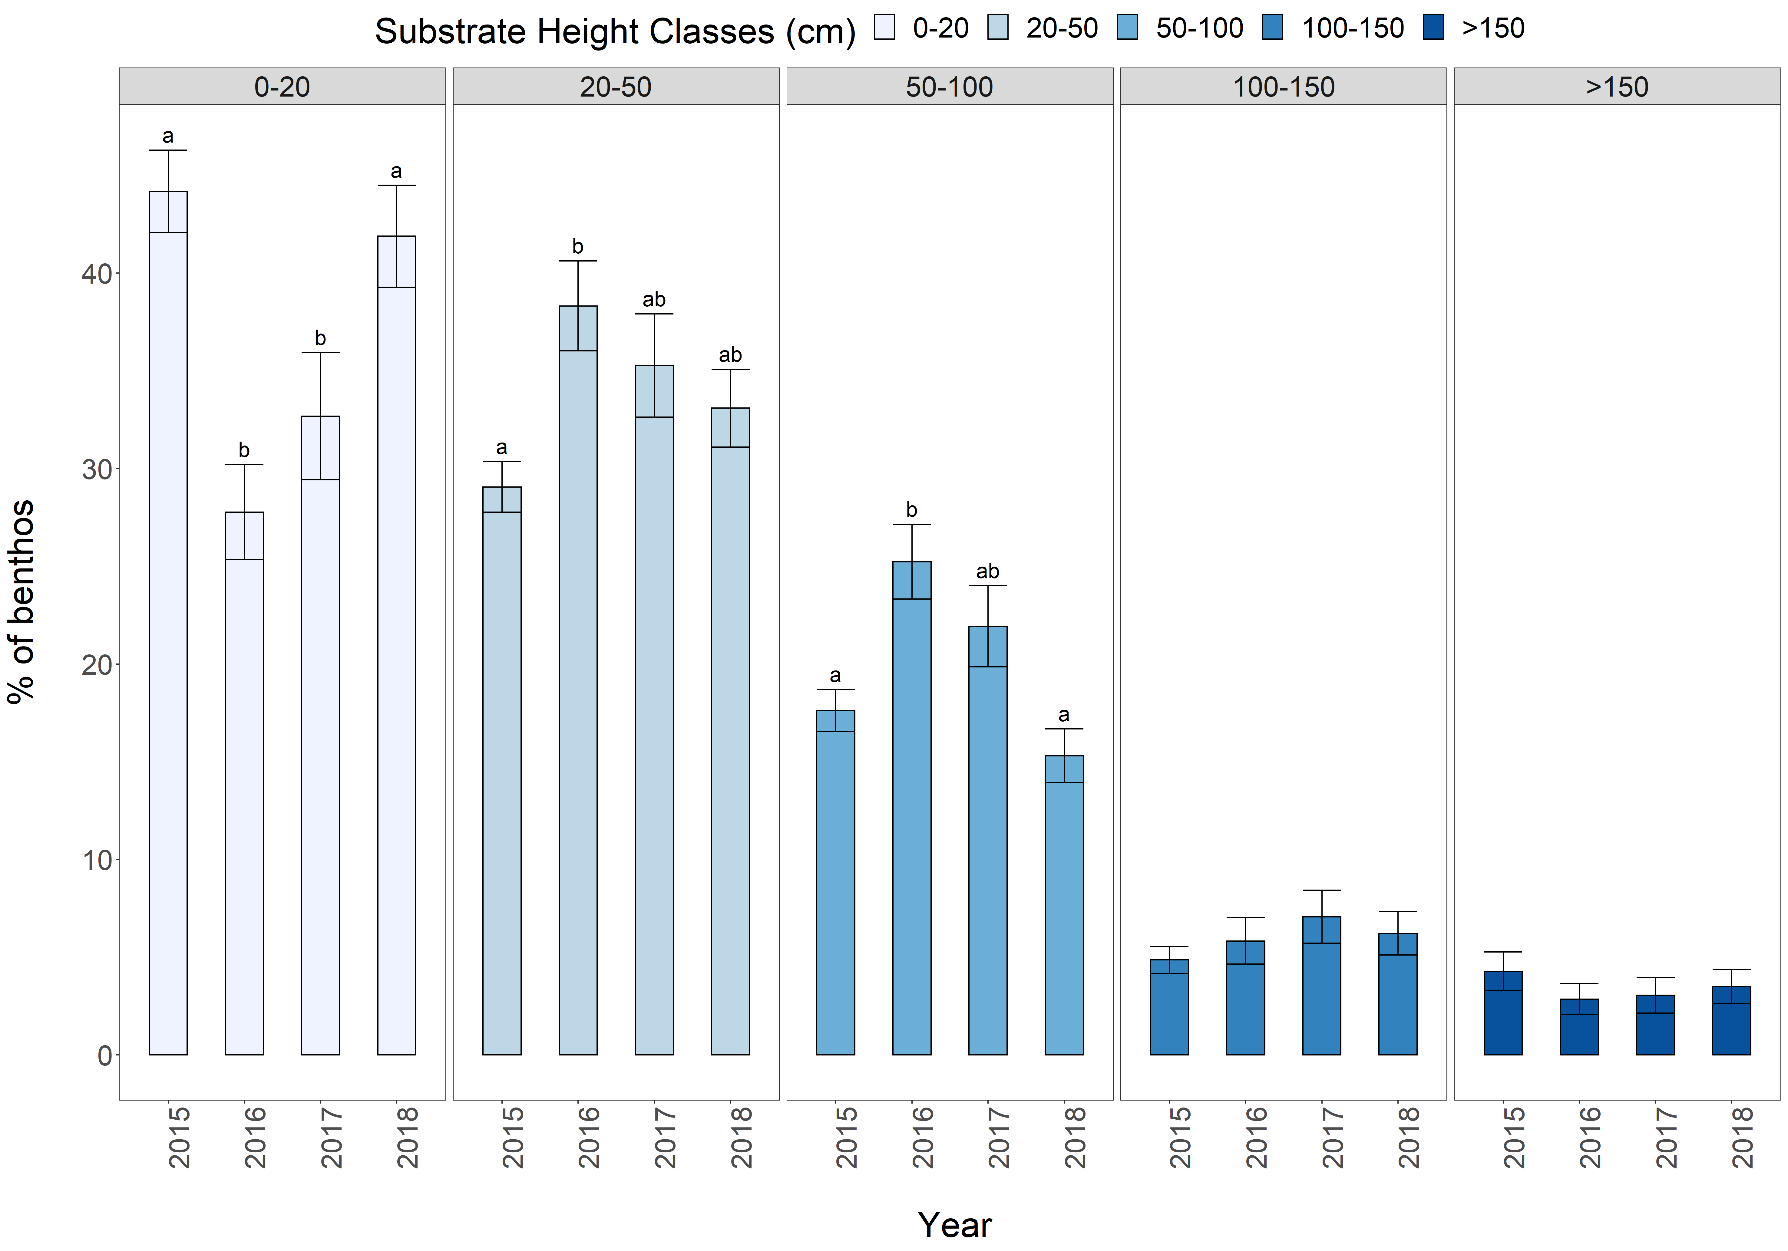
Figure S3. Visual estimates of substrate complexity measured as the percent of the benthos at each fish survey site (mean ± SE) occupied by each five classes of substrate height. Significant differences among years for a given substrate height class are denoted by differing letters based on Dunn’s multiple comparison tests following significant Kruskal-Wallis tests. No letters indicate no differences among years for a given class (Kruskal-Wallis, p > 0.05).

