Geophysical Research Letters
Supporting Information for
Factors affecting the 2019 North Atlantic hurricane season and the role of the Indian Ocean Dipole
Kimberly M. Wood¹, Philip J. Klotzbach², Jennifer M. Collins³, Louis-Philippe Caron⁴, Ryan E. Truchelut⁵, Carl J. Schreck⁶
¹Department of Geosciences, Mississippi State University, Mississippi State, MS, USA
²Department of Atmospheric Science, Colorado State University, Fort Collins, CO, USA
³School of Geosciences, University of South Florida, Tampa, FL, USA
⁴Barcelona Supercomputing Center, Barcelona, Spain
⁵WeatherTiger, Tallahassee, FL, USA
⁶North Carolina State University (NCSU), Cooperative Institute for Satellite Earth System Studies (CISESS), Asheville, NC, USA

Contents of this file

Figures S1 to S2

Introduction
This supporting information document includes additional figures to further illustrate points made in the manuscript. Figure S1 provides maps of 2019 monthly sea surface temperature (SST) anomalies relative to the 1981-2010 climatological base period calculated from the Centennial in-situ Observation-Based Estimates (COBE) dataset (https://ds.data.jma.go.jp/tcc/tcc/products/elnino/cobesst/cobe-sst.html). Figure S2 depicts a diagram of the September-October 2019 Wheeler-Hendon index (Wheeler & Hendon, 2004), a metric that quantifies the behavior of the Madden-Julian Oscillation (http://www.bom.gov.au/climate/mjo/graphics/rmm.74toRealtime.txt).
Figure S1 was generated using the following Python packages:
- Matplotlib (https://matplotlib.org/)
- NumPy (https://numpy.org/)
- Cartopy (https://scitools.org.uk/cartopy/docs/latest/)
- xarray (http://xarray.pydata.org/en/stable/)
Figure S2 was generated using Matplotlib and NumPy.

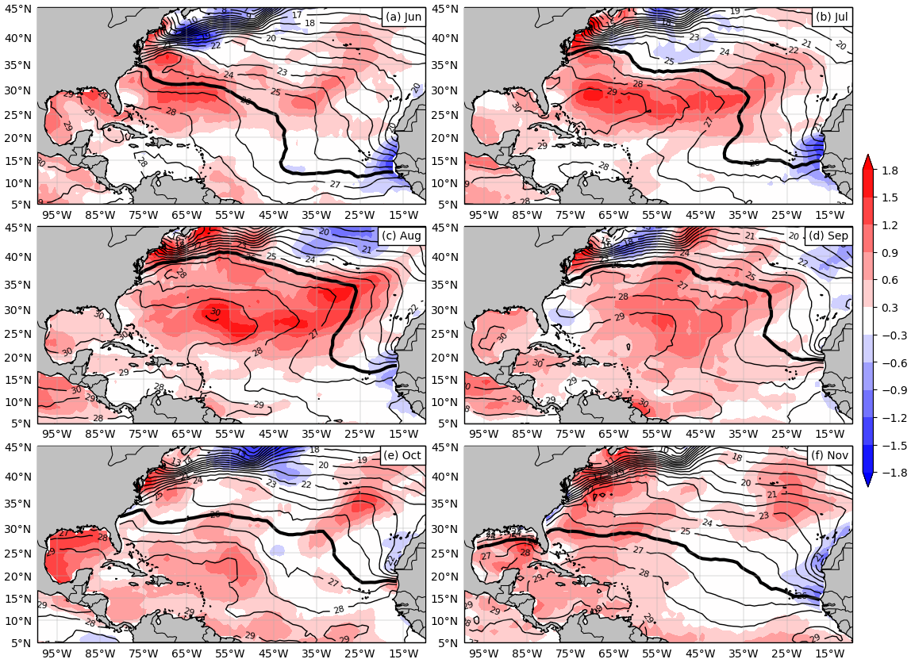

Figure S1. Monthly SST anomalies (°C; shading) and values (°C; contours) in 2019 for the months of (a) June, (b) July, (c) August, (d) September, (e) October, and (f) November. In each panel, the 26°C isotherm is highlighted by the thicker black contour. Anomalies are relative to the 1981-2010 climatological base period.

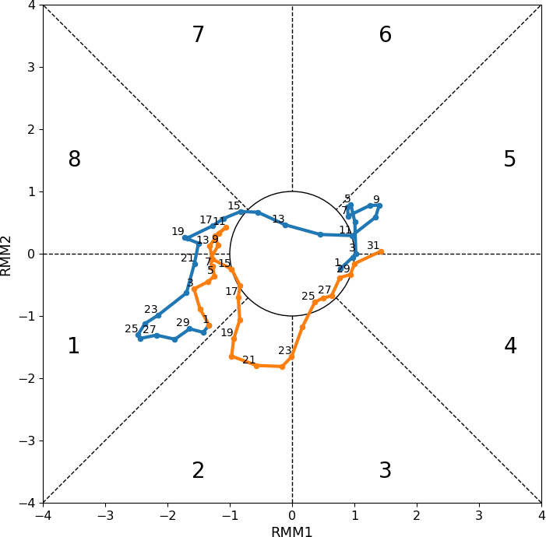

Figure S2. The Wheeler-Hendon Real-time Multivariate MJO (RMM; Wheeler & Hendon, 2004) index for September 2019 (blue) and October 2019 (orange). Dots indicate daily values. Dates are labeled every other day.

