

*Geophysical Research Letters*

Supporting Information for

**Longwave Emission Trends over Africa and Implications for Atlantic Hurricanes**

Lei Zhang1*, Thomas Rechtman2, Kristopher B. Karnauskas1,3, Laifang Li4, Jeffrey P. Donnelly5, and James P. Kossin6

1*Cooperative Institute for Research in Environmental Sciences, University of Colorado, Boulder, CO, USA.

2University of Central Florida at CU Boulder SMART Program.

3Department of Atmospheric and Oceanic Sciences, University of Colorado, Boulder, CO, USA.

4Earth and Ocean Sciences, Nicholas School of the Environment, Duke University, Durham, NC, USA.

5Department of Geology and Geophysics, Woods Hole Oceanographic Institution, Woods Hole, Massachusetts, USA.

6NOAA National Centers for Environmental Information, Center for Weather and Climate, Madison, Wisconsin, USA.

**Contents of this file:**

Figures. S1 to S4

Table S1

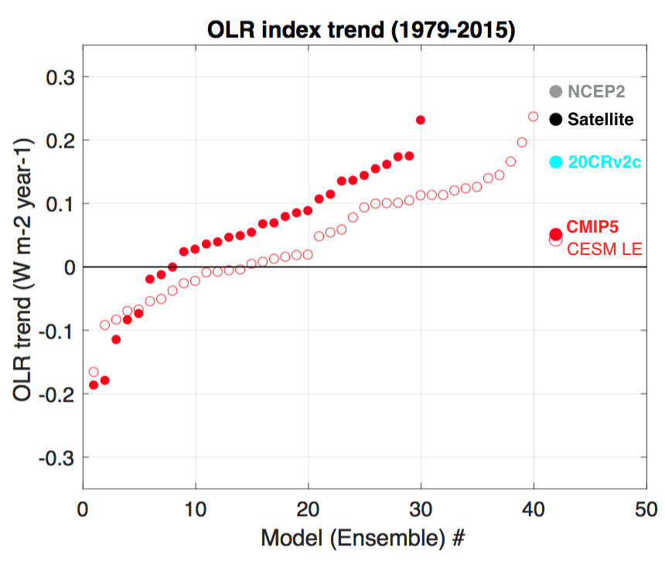

**Figure S1** OLR index trend during the satellite era (1979-2015) in satellite observation (black), NCEP2 reanalysis (gray), 20CRv2c (cyan, 1979-2014) and climate models (red). Red filled circles for 30 CMIP5 climate models and red open circles for the 40-member ensemble of CESM simulations. Ensemble mean results are shown on the right end. Units are W m-2 year-1. The OLR index trend observed by satellite and in the NCEP2 reanalysis are statistically significant at 95% confidence level.

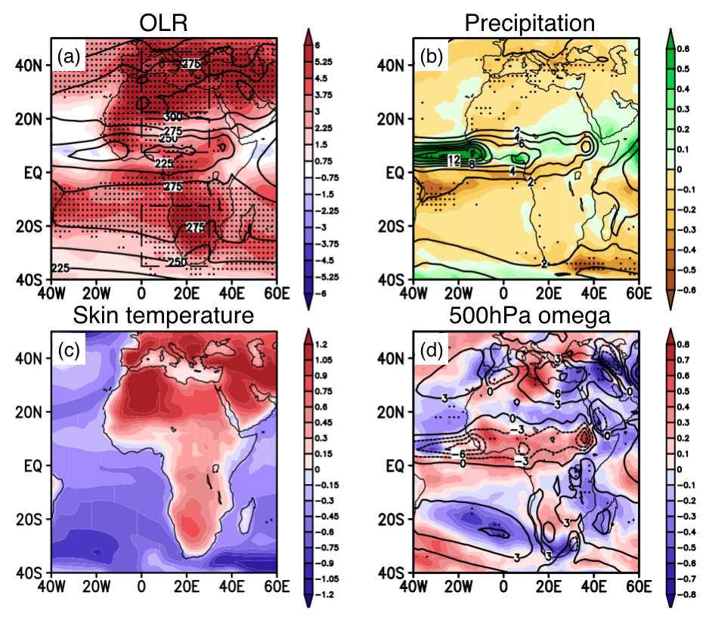

**Figure S2** (**a**) Multi-model mean OLR trend (2006-2100) in July from RCP4.5 experiments (shading, W m-2 century-1) and OLR climatology (contour, W m-2). (**b**) As in (a) but for precipitation (units are mm day-1 century-1 for the trend and mm day-1 for climatology). (**c**) for skin temperature (K century-1, domain mean warming removed) and (**d**) for 500hPa omega (units are 0.01Pa s-1 century-1 for the trend and 0.01Pa s-1 for climatology).

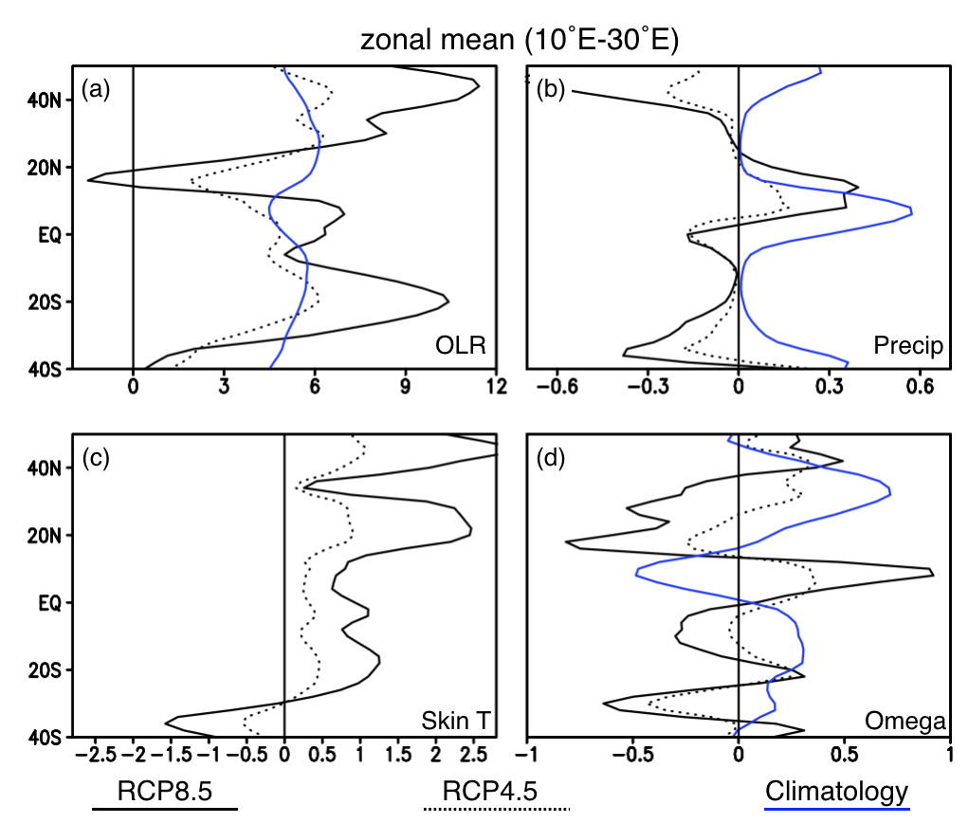

**Figure S3** Zonal mean (10˚E-30˚E) linear trend of various variables in July from RCP4.5 (dotted black) and RCP8.5 (solid black) experiments. Solid blue lines are for climatological profiles. (**a**) for OLR (W m-2 century-1 for trend, 50 W m-2 for climatology), (**b**) for precipitation (mm day-1 century-1 for trend, cm day-1 for climatology), (**c**) for skin temperature (K century-1, domain averaged warming removed) and (**d**) for 500hPa omega (0.01Pa s-1 century-1 for trend, 0.1Pa s-1 for climatology).

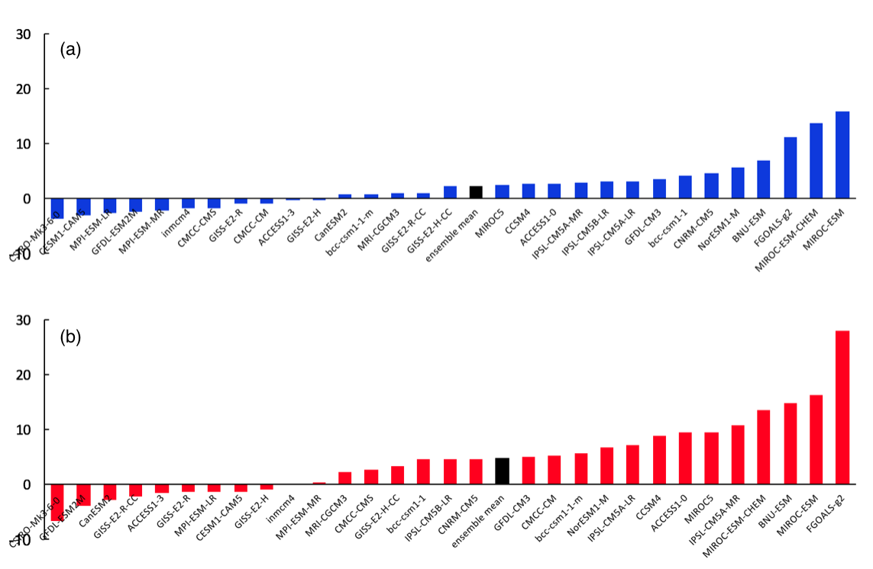

**Figure S4** Change in the 72-year low-pass filtered OLR index (2096–2100 relative to 2006–2010) in the 30 CMIP5 models under RCP4.5 (**a**) and RCP8.5 (**b**). Black histograms denote the ensemble mean values.

**Table S1.** List of the 30 CMIP5 climate models used for analysis in this study. 11 models that are used for single-forcing experiments are marked in the bold fonts.

|  |  |  |
| --- | --- | --- |
| **Model** | **Modeling center (Group)** | **AGCM Resolution** |
| ACCESS1-0 | The Centre for Australian Weather and Climate Research | 1.875˚1.25˚ |
| ACCESS1-3 | 1.875˚1.25˚ |
| BCC-CSM1-1 | Beijing Climate Center, China Meteorological Administration | 2.8125˚  2.8125˚ |
| BCC-CSM1-1-M | Beijing Climate Center, China Meteorological Administration | 1.125˚  1.125˚ |
| BNU-ESM | College of Global Change and Earth System Science, Beijing Normal University | 2.8125˚  2.8125˚ |
| **CanESM2** | Canadian Centre for Climate Modelling and Analysis | 2.8125° × 2.8125° |
| **CCSM4** | University of Miami - RSMAS | 1.25˚×0.9424˚ |
| **CESM1-CAM5** | National Center for Atmospheric Research | 1.25˚×0.9424˚ |
| CMCC-CM | Centro Euro-Mediterraneo per I Cambiamenti Climatici | 0.75˚0.75˚ |
| CMCC-CMS | 1.875˚1.875˚ |
| CNRM-CM5 | Centre National de Recherches Meteorologiques / Centre Europeen de Recherche et Formation Avancees en Calcul Scientifique | 1.40625˚  1.40625˚ |
| **CSIRO-Mk3-6-0** | Commonwealth Scientific and Industrial Research Organization in collaboration with Queensland Climate Change Centre of Excellence | 1.875˚1.875˚ |
| **FGOALS-g2** | LASG, Institute of Atmospheric Physics, Chinese Academy of Sciences | 2.8125˚3˚ |
| **GFDL-CM3** | NOAA Geophysical Fluid Dynamics Laboratory | 2.5˚2˚ |
| **GFDL-ESM2M** |
| **GISS-E2-H** | NASA Goddard Institute for Space Studies | 2.5˚2˚ |
| GISS-E2-H-CC |
| **GISS-E2-R** |
| GISS-E2-R-CC |
| INMCM4 | Institute for Numerical Mathematics | 2˚1.5˚ |
| **IPSL-CM5A-LR** | Institut Pierre-Simon Laplace | 3.75° × 1.875° |
| IPSL-CM5A-MR | 2.5˚1.258˚ |
| IPSL-CM5B-LR | 3.75˚1.875˚ |
| MIROC-ESM-CHEM | Japan Agency for Marine-Earth Science and Technology, Atmosphere and Ocean Research Institute (The University of Tokyo), and National Institute for Environmental Studies | 2.8125˚  2.8125˚ |
| MIROC-ESM |
| MIROC5 | Atmosphere and Ocean Research Institute (The University of Tokyo), National Institute for Environmental Studies, and Japan Agency for Marine-Earth Science and Technology | 1.40625˚  1.40625˚ |
| MPI-ESM-LR | Max Planck Institute for Meteorology | 1.875˚1.875˚ |
| MPI-ESM-MR |
| MRI-CGCM3 | Meteorological Research Institute | 1.125˚1.125˚ |
| **NorESM1-M** | Norwegian Climate Centre | 2.5° × 1.875° |