Journal of Geophysical Research: Atmospheres
Supporting Information for
Long-term trends for marine sulfur aerosol in the Alaskan Arctic and relationships with temperature
Claire E. Moffett¹, Tate E. Barrett^{1,2}*, Jun Liu³, Matthew J. Gunsch^{3†}, Lucia Upchurch⁴, Patricia K. Quinn⁵, Kerri A. Pratt³, Rebecca J. Sheesley^{1,2}
¹Department of Environmental Science, Baylor University, Waco, TX, USA.
²The Institute of Ecological, Earth, and Environmental Sciences, Baylor University, Waco, TX, USA.
³Department of Chemistry, University of Michigan, Ann Arbor, MI, USA.
⁴Joint Institute for the Study of the Atmosphere and Ocean, University of Washington, Seattle, WA, USA.
⁵Pacific Marine Environmental Laboratories, National Oceanic and Atmospheric Administration, Seattle, WA, USA.
*Now at Barrett Environmental, McKinney, TX, USA.
†Now at Merck & Co., Inc., Kenilworth, NJ, USA.

Contents of this file

Text S1
Figures S1 to S10
Tables S1 to S3

Introduction
This supporting information document contains a detailed description of the one week back trajectories as well as additional figures and tables not included in the main text.

Text S1.
One-week back trajectories run with NOAA’s HYSPLIT model extended further than the regions defined for the 48-hour back trajectories. Following previously defined regions reported in literature as well as chlorophyll data, additional regions were defined in order to properly describe the one-week back trajectories (Figure S1). In the 48-hour back trajectories the Chukchi and Beaufort Sea regions were open bins, so anything north and east of the Beaufort Sea boundaries and north and west of the Chukchi Sea boundaries would have been counted towards those regions. Therefore, the first region added was the Arctic Ocean to represent the open ocean north of the Chukchi and Beaufort Seas. To the east of the sites the Canadian Arctic Archipelago and Hudson Bay were defined as one region, and to the west the East Siberian Sea was separated from the Chukchi Sea. Along the Russian Arctic Coast regions were created for the Laptev Sea, the Kara Sea, and the Barents Sea. The Laptev, Kara, and Barents Sea are referred to as the Russian Arctic Coast as a small number of back trajectories extended that far along the Russian Coast. To the south the Gulf of Alaska, the northern Pacific, and the Sea of Okhotsk were defined as individual regions but were grouped as the Northern Pacific after analysis showed a small percentage of back trajectories reached these regions. Regions for the Greenland Sea, Greenland, and Baffin Bay were individual, but were also combined due to the small number of back trajectories in those areas. A region was created for the Northern Atlantic and Iceland Basin, however no back trajectories extended that far.
Overall the one-week back trajectories do not change source regions of importance with the exception of the addition of the Arctic Ocean. Utqiaġvik receives 33% of its back trajectories from the east (Beaufort Sea, east coast, and Canadian Arctic Archipelago) and 39% from the west (Chukchi Sea, west coast, East Siberian Sea, and the Bering Strait/Sea). Back trajectories from over the Arctic Ocean contribute 16% and from the interior of Alaska is 3%. The remaining regions all make up less than 3% of the back trajectories. Oliktok Point receives 42% of its air masses from the east and 29% from the west. Compared to Utqiaġvik it receives slightly less air mass influence from over the Arctic Ocean with 13%, and more from over the interior of Alaska with 9%. The remaining regions also make up less than 3% each of the back trajectories.

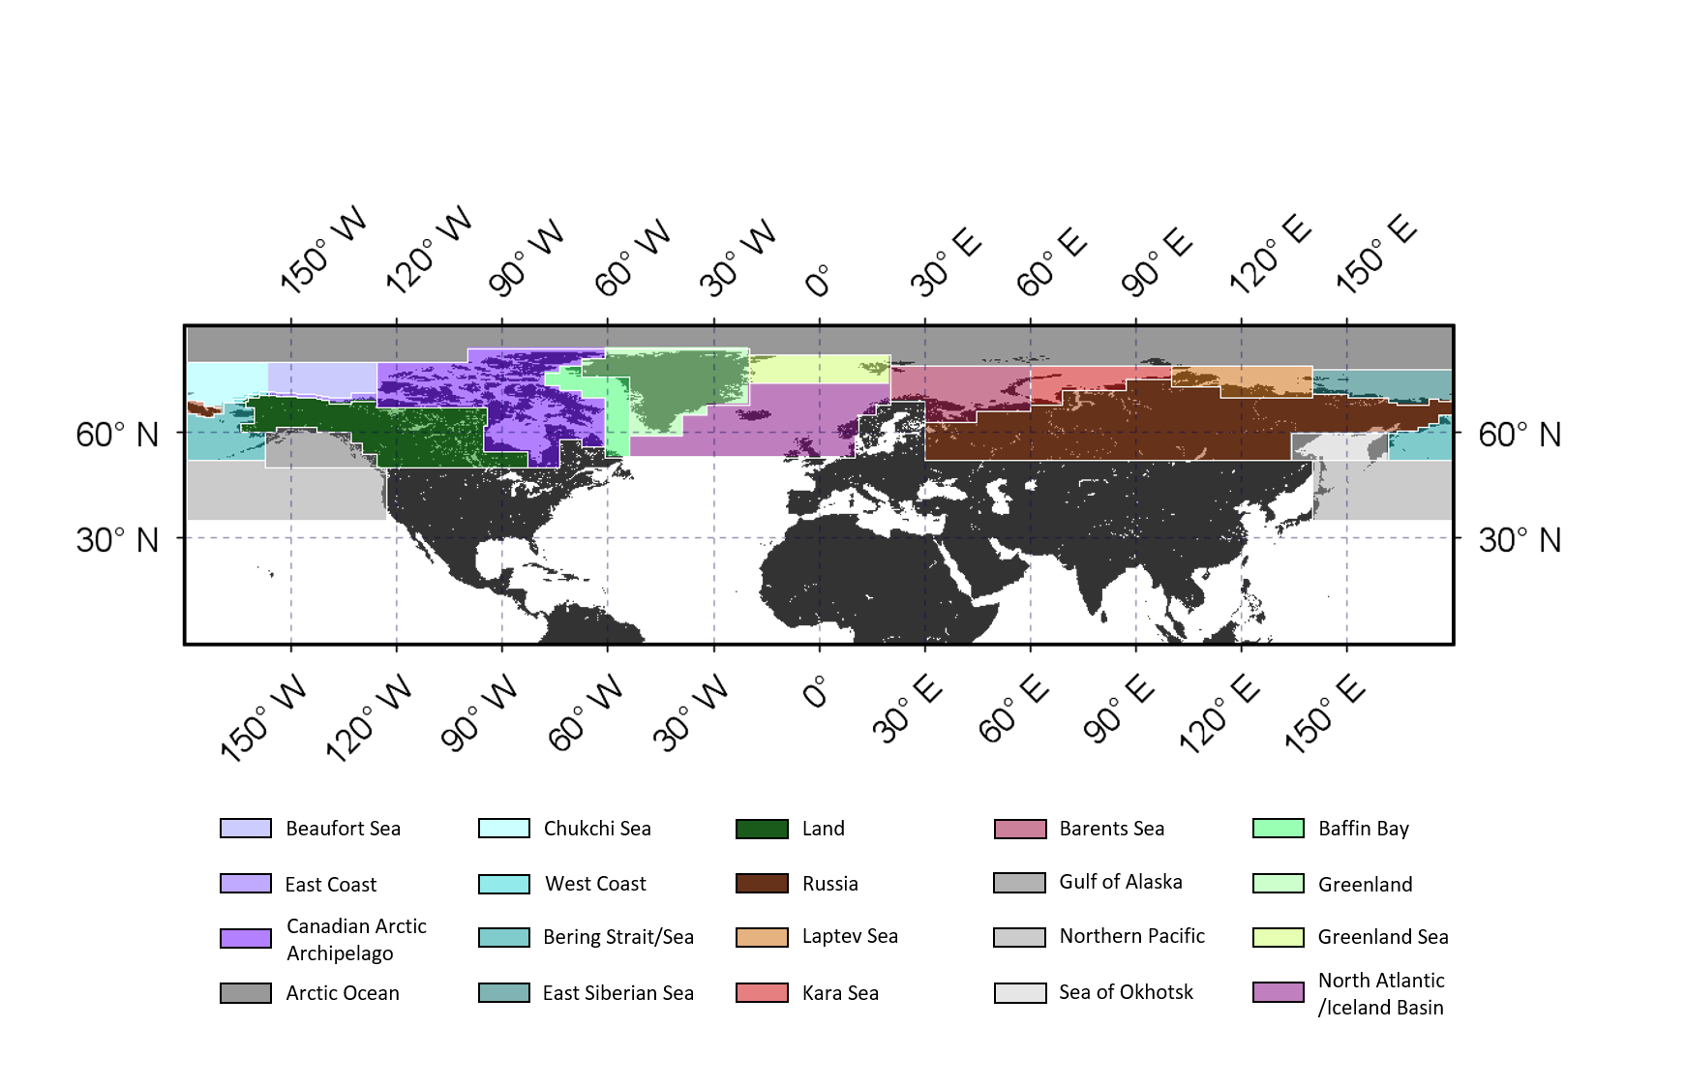

Figure S1. The regions defined for the one-week back trajectories.

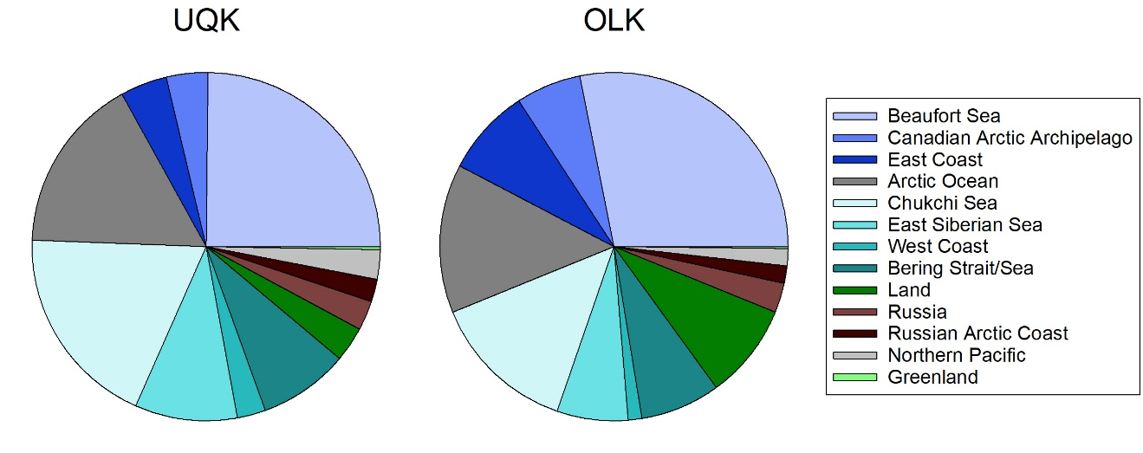Figure S2. The average percent contributions of air masses from the one-week back trajectories from the different geographic areas over all sampling periods (summers in 2015, 2016, and 2017).

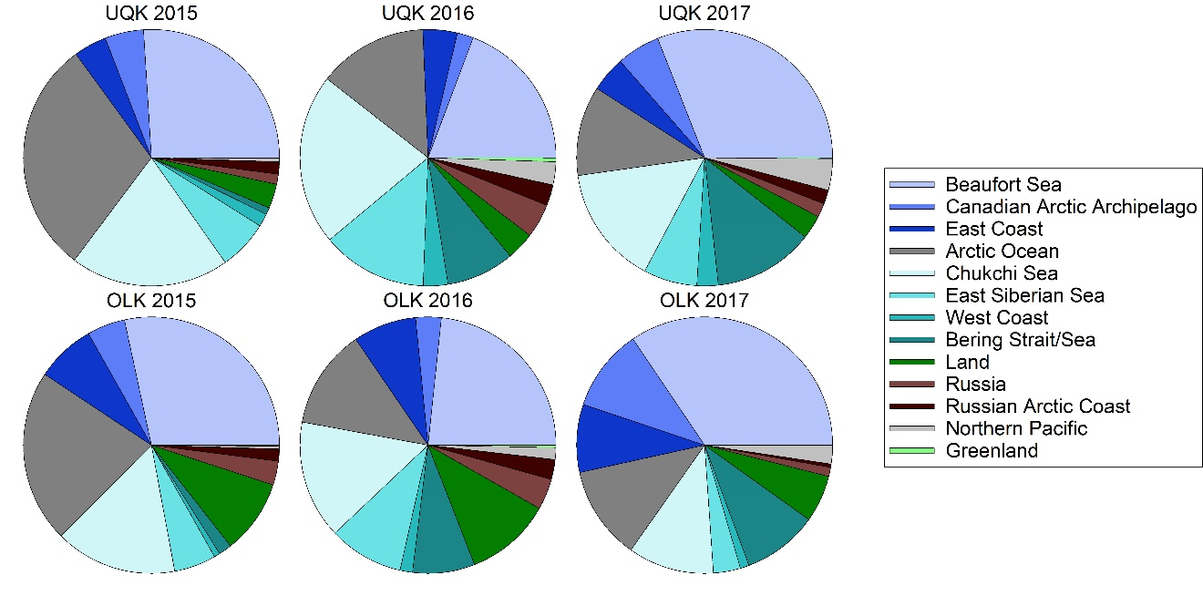Figure S3. The average percent contributions of air masses from the one-week back trajectories from the different geographic areas for the individual summers at each site.

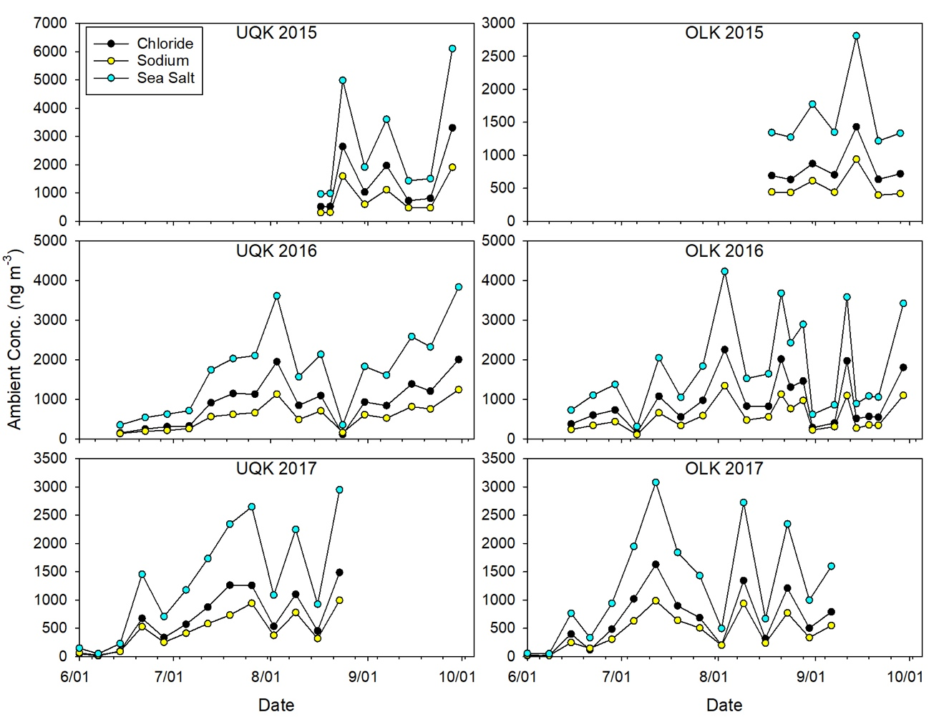Figure S4. Ambient concentrations of chloride, sodium, and sea salt in total suspended particulate (TSP) matter samples over each summer at Utqiaġvik (UQK) and Oliktok Point (OLK), AK.

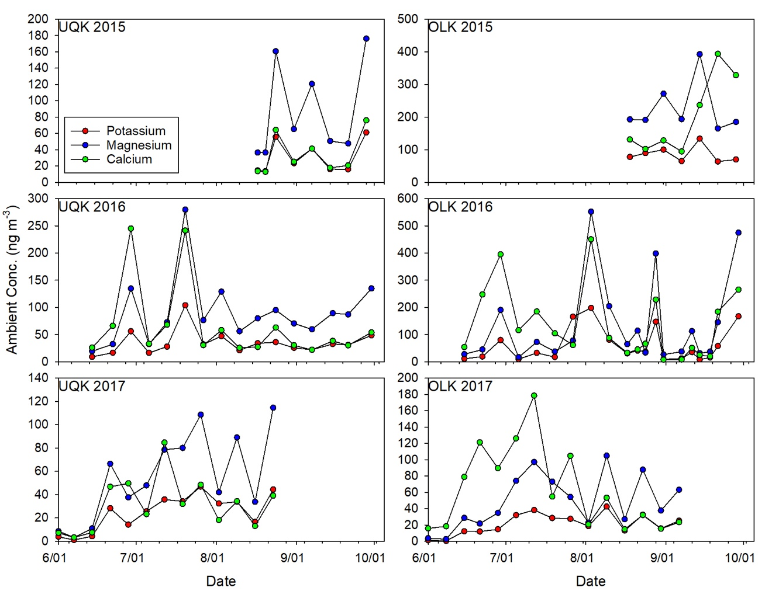

Figure S5. The ambient concentrations of potassium, magnesium, and calcium in TSP samples over each summer at Utqiaġvik (UQK) and Oliktok Point (OLK), AK.

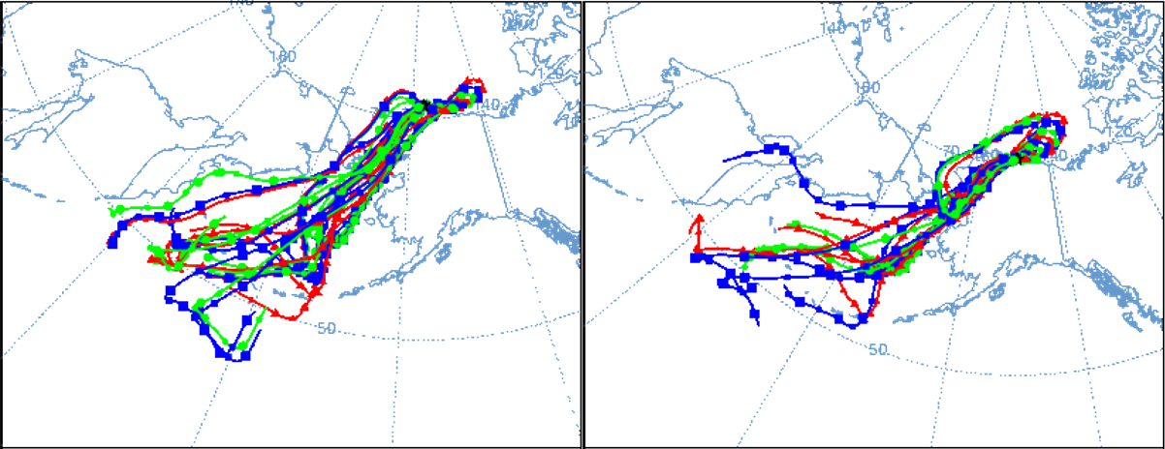

Figure S6. The NOAA HYSPLIT 48 hr backward air mass trajectories for the samples collected between June 21st and 28th, 2017. Utqiaġvik (left) and Oliktok Point (right) both received air mass influence from the Bering Strait and Sea and the Beaufort Sea.

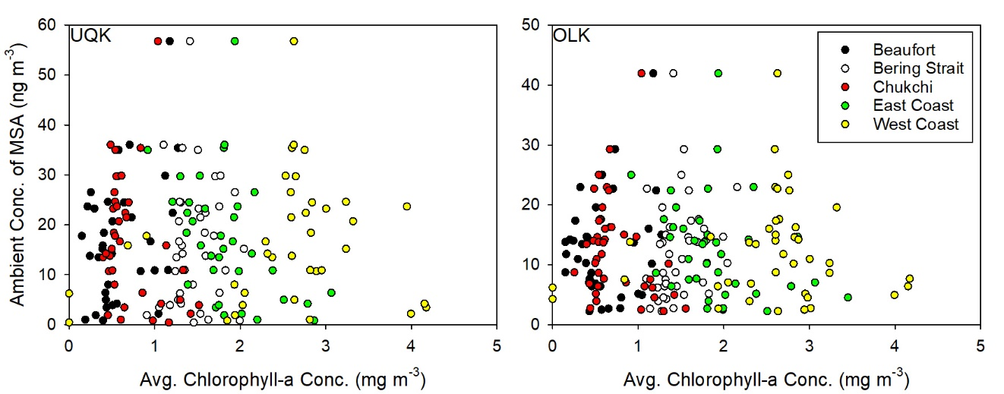
Figure S7. The ambient concentration of MSA versus the average Chlorophyll-a concentration for each sample for the different marine regions surrounding the sites.

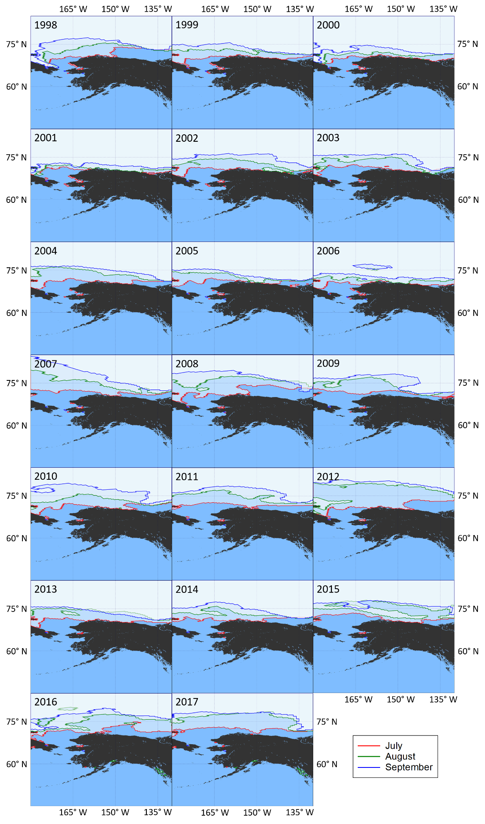
Figure S8. The average sea ice extent for 1998-2017 for the months of July, August, and September. The images show the data from 45° N-85° N and 130°W-180° W.

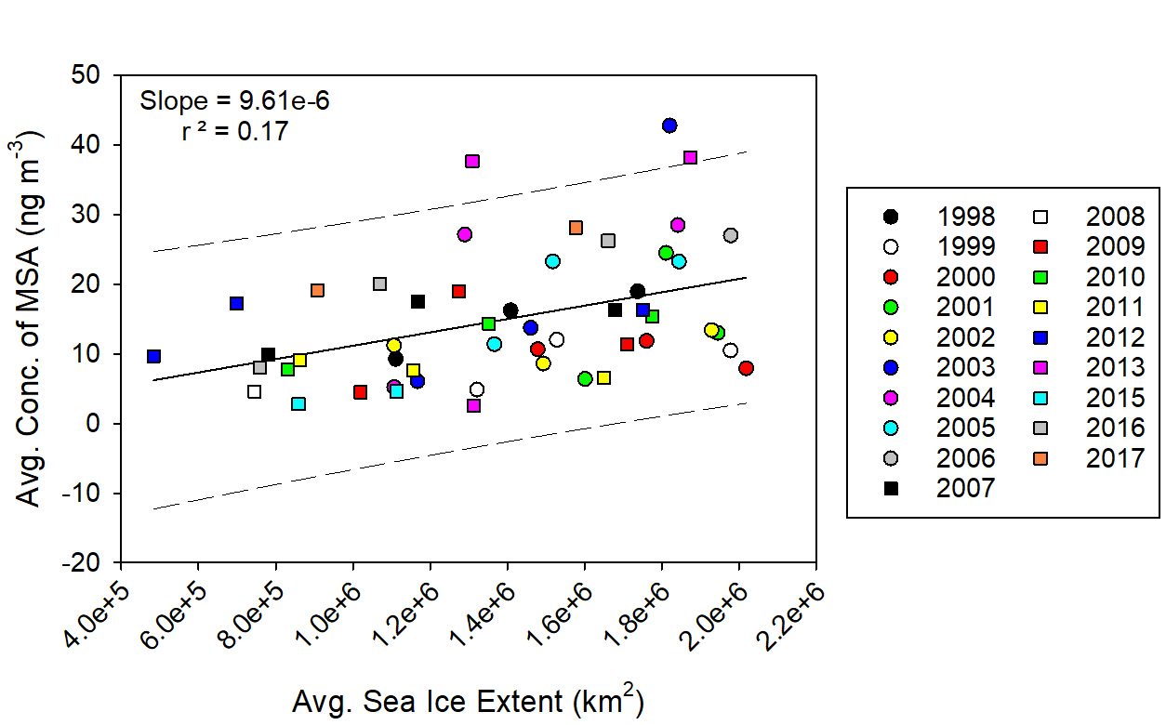
Figure S9. A linear regression of the average monthly sea ice extent (km2) and the average monthly concentration of MSA (ng m-3) for the years 1998-2017 with the 95% prediction interval. The sea ice extent represents the extent between 45° N-85° N and 130°W-180° W.

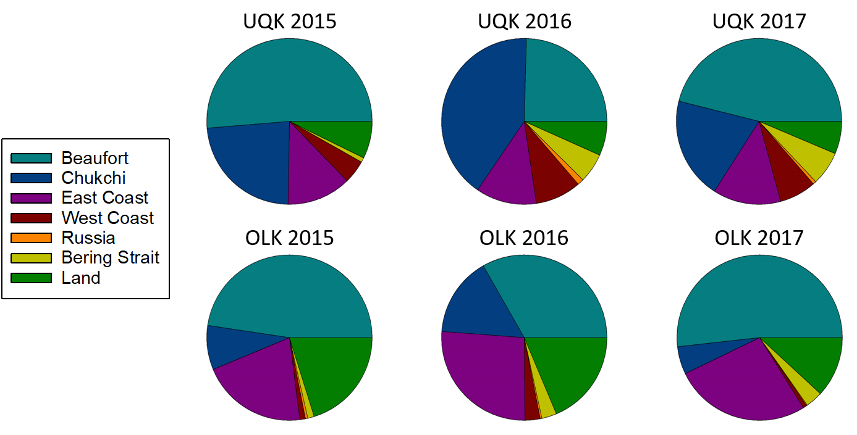

Figure S10. The average percentage of each backward air mass trajectory that lies in each geographical region for each year and site (UQK=Utqiaġvik; OLK=Oliktok Point).

Compound | MDL (mg L⁻¹)
Chloride | 0.008
Nitrite | 0.005
Bromide | 0.012
Nitrate | 0.019
Sulfate | 0.031
Sodium | 0.014
Ammonium | 0.005
Potassium | 0.009
Magnesium | 0.004
Calcium | 0.031
Acetate | 0.002
Formate | 0.011
Malate | 0.007
Malonate | 0.095
MSA | 0.009
Oxalate | 0.050

Table S1. The method detection limit (MDL) for inorganic anions and cations and organic acids by ion chromatography analysis.

Meteorological Parameter | Utqiaġvik, AK |  |  | Oliktok Point, AK
 | 2015 | 2016 | 2017 | 2015ª | 2016 | 2017
Avg. Temp. (°C) | 2.55 | 2.26 | 3.31 | 1.43 | 4.35 | 4.66
Avg. Max. Temp. (°C) | 5.46 | 5.42 | 6.09 | 4.24 | 8.75 | 8.39
Avg. Min. Temp. (°C) | 0.60 | 0.09 | 1.40 | -0.52 | 1.74 | 2.42
Avg. Wind Speed (m s⁻¹) | 5.23 | 5.37 | 5.70 | 5.72 | 5.44 | 5.95
Avg. Max. Wind Speed (m s⁻¹) | 9.86 | 9.19 | 9.57 | 9.64 | 9.92 | 9.83
Avg. Min. Wind Speed (m s⁻¹) | 2.09 | 2.03 | 2.43 | 2.31 | 1.93 | 2.60
ªNo data is available before August 2015

Table S2. The average, average daily maximum, and average daily minimum temperature and wind speed for each summer.

 | Utqiaġvik, AK (ng m⁻³) |  |  | Oliktok Point, AK (ng m⁻³)
 | 2015 | 2016 | 2017 | 2015 | 2016 | 2017
Chloride | 1436 ± 217 | 1138 ± 139 | 901 ± 250 | 817 ± 124 | 1113 ± 108 | 732 ± 142
Nitrite | 0.34 ± 0.06 | 0.14 ± 0.02 | 9 ± 2 | 0.09 ± 0.03 | 0.17 ± 0.05 | 8 ± 1
Bromide | 2.8 ± 0.5 | 0.13 ± 0.03 | 1.4 ± 0.4 | <MDL | 1.7 ± 0.2 | 5 ± 1
Nitrate | 19 ± 3 | 22 ± 3 | 48 ± 16 | 48 ± 9 | 26 ± 3 | 57 ± 11
Sulfate | 250 ± 35 | 280 ± 32 | 189 ± 49 | 203 ± 30 | 254 ± 23 | 173 ± 30
Sodium | 850 ± 128 | 708 ± 85 | 621 ± 171 | 530 ± 81 | 678 ± 65 | 508 ± 97
Ammonium | 6 ± 1 | 11 ± 1 | 7 ± 2 | 25 ± 5 | 14 ± 2 | 6 ± 1
Potassium | 30 ± 5 | 33 ± 4 | 32 ± 8 | 86 ± 13 | 75 ± 9 | 25 ± 4
Magnesium | 88 ± 13 | 88 ± 10 | 70 ± 20 | 228 ± 35 | 201 ± 25 | 57 ± 11
Calcium | 34 ± 5 | 38 ± 5 | 26 ± 7 | 204 ± 33 | 139 ± 18 | 27 ± 5
Acetate | 0.18 ± 0.05 | 3.7 ± 0.5 | <MDL | 4.6 ± 0.7 | 4.1 ± 0.6 | <MDL
Formate | 0.7 ± 0.1 | 3.4 ± 0.5 | <MDL | 1.9 ± 0.3 | 2.8 ± 0.4 | 0.3 ± 0.08
Malate | 0.34 ± 0.09 | 3.5 ± 0.6 | 21 ± 5 | 0.3 ± 0.1 | 3.2 ± 0.4 | 34 ± 8
Malonate | 0.7 ± 0.2 | 3.1 ± 0.5 | 8 ± 2 | <MDL | 1.5 ± 0.2 | 10 ± 2
MSA | 3.3 ± 0.5 | 14 ± 2 | 15 ± 4 | 7 ± 1 | 11 ± 1 | 10 ± 2
Oxalate | 2.2 ± 0.4 | 6.6 ± 0.9 | 3 ± 1 | <MDL | 3.3 ± 0.7 | 11 ± 3
nss-SO₄²⁻ | 96 ± 14 | 153 ± 19 | 79 ± 20 | 100 ± 15 | 122 ± 11 | 75 ± 14
nss-K⁺ | 3.4 ± 0.6 | 7 ± 1 | 10 ± 3 | 67 ± 10 | 52 ± 7 | 6 ± 1
nss-Mg²⁺ | 13 ± 2 | 25 ± 3 | 16 ± 4 | 164 ± 25 | 127 ± 17 | 8 ± 2
nss-Ca²⁺ | 7 ± 2 | 11 ± 2 | 2.8 ± 0.8 | 184 ± 31 | 114 ± 16 | 7 ± 2
Sea Salt | 2685 ± 405 | 2179 ± 264 | 1814 ± 502 | 1596 ± 243 | 2109 ± 203 | 1480 ± 284

Table S3. The average ambient concentrations of inorganic anions and cations, and organic acids, over August and September for each site.

