Geophysical Research Letters
Supporting Information for
Surface Wetness as an Unexpected Control on Forest Exchange of Volatile Organic Acids
S.R. Fulgham¹, D.B. Millet², H.D. Alwe², A.H. Goldstein³, S. Schobesberger⁴, and D.K. Farmer¹
¹ Department of Chemistry, Colorado State University, Fort Collins, Colorado 80523, United States.
² Department of Soil, Water, and Climate, University of Minnesota, Minneapolis-Saint Paul, Minnesota 55108, United States.
³ Department of Environmental Science, Policy, and Management, University of California Berkeley, Berkeley, California 94720, United States.
⁴ Department of Applied Physics, University of Eastern Finland, Kuopio, 70211, Finland.

Contents of this file

Text S1 to S2
Figures S1 to S11
Tables S1 to S2

Introduction
This supporting information presents brief discussions of eddy covariance flux measurements and filtering used at Manitou Experimental Forest Observatory (MEFO) (Section S1) and the calculation of volumetric phase ratios for phase distribution analysis (Section S2). Supporting figures include seasonal isocyanic acid (HNCO) exchange velocity (V_{ex}) plotted as a function of dew point depression (T-T_{d}) at MEFO in Figure S1, an intercomparison of V_{ex} versus T-T_{d} for several volatile organic acids at three different measurement sites in Figures S2-S4, dew point depression histograms from three different flux measurement sites in Figure S5, HNCO temperature-dependent partitioning space plot in Figure S6, exponential temperature dependence of HNCO mixing ratio in Figure S7, modified van’t Hoff plots for HNCO sorted by wet and dry conditions at MEFO in Figure S8, ΔH_{obs} derived from slopes of modified van’t Hoff plots displayed as a function of ΔH_{solvation} from the literature for five acids under wet and dry conditions in Figure S9, modified van’t Hoff plots for isoprene sorted by wet and dry conditions at University of Michigan Biological Station (UMBS) in Figure S10, and formic acid dependence upon latent heat flux at SMEAR 2 in Hyytiälä, Finland, in Figure S11. Average acetate CIMS organic acid sensitivities are listed in Table S1, and linear best fits and correlation coefficients for Figure 3 are listed in Table S2.

S1. Eddy flux

We calculate the quasi-continuous flux (F) as the averaged product of the instantaneous deviations of the vertical wind speed (w’) and the acid mixing ratio (C’) from their 30-minute means.

$F= \overline{w'C'}$ (S1)

The exchange velocity (V_{ex}) is the flux normalized by the mean mixing ratio ($\overline{C}$) and represents the rate at which trace gases move between the biosphere and atmosphere:

$V_{ex}=\frac{F}{\overline{C}}$ (S2)

V_{ex} enables us to compare fluxes across different measurement sites where ambient mixing ratios vary and accounts for the bidirectionality of organic acid fluxes. Positive exchanges (+F and +V_{ex}) are upwards, away from ecosystem surfaces. Negative exchanges (-F and -V_{ex}) represent downward fluxes from the atmosphere towards ecosystem surfaces.

We filter the data to ensure that the vertical exchange is limited to local sources and sinks within the forest (~0.8 – 1.6 km² fetch) and that assumptions of the eddy covariance technique are met (Fulgham et al., 2019).
We distinguish flux periods that are “wet” versus “dry” following Altimir et al. (2006). A flux period is considered “wet” if: (1) precipitation exceeds 0 cm hr⁻¹, (2) relative humidity (RH) exceeds 70%, or (3) either condition 1 or 2 was met within the previous 12 hours. All other flux periods are “dry”. We exclude flux periods with temperatures at or below 10°C, in which condensed water could occur as ice or snow. We account for differences in air temperature and leaf surface temperature by choosing a freezing temperature threshold higher than 0°C. Of 1073 flux periods above freezing temperatures during SPiFFY, 329 (31%) were wet and 744 (69%) were dry.

S2. Volumetric phase ratios

Volumetric phase ratios are calculated assuming evenly distributed, 50 nm thick organic (X_{org}) and water (X_{w}) films on canopy surfaces. We assume a surface to volume ratio ($\frac{S}{V}$) of 0.0713 m⁻¹. Fractional phase ratios of 99:1, 90:10, 50:50, 10:90, and 1:99 are calculated for the interface of each phase on the plot using the appropriate ratios of equations 1 – 3 in the main text.

$\frac{V_{org}}{V_{gas}}=X_{org}×\frac{S}{V}$ (S3)

$\frac{V_{w}}{V_{gas}}=X_{w}×\frac{S}{V}$ (S4)

$\frac{V_{org}}{V_{w}}=\frac{X_{org}}{X_{w}}$ (S5)

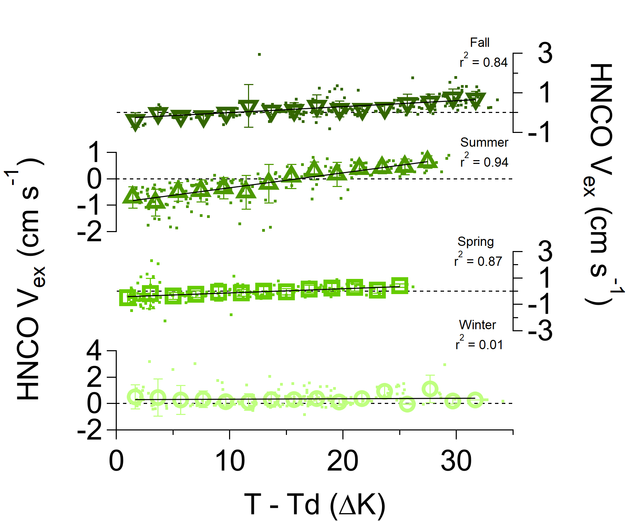Figure S1. HNCO V_{ex} exhibit strong linear correlations with T-T_{d} at MEFO during all seasons except for winter. Data (small squares) are averaged into 20 evenly spaced T-T_{d}bins (large hollow shapes) based on the range of T-T_{d} values. Whiskers represent standard deviations.

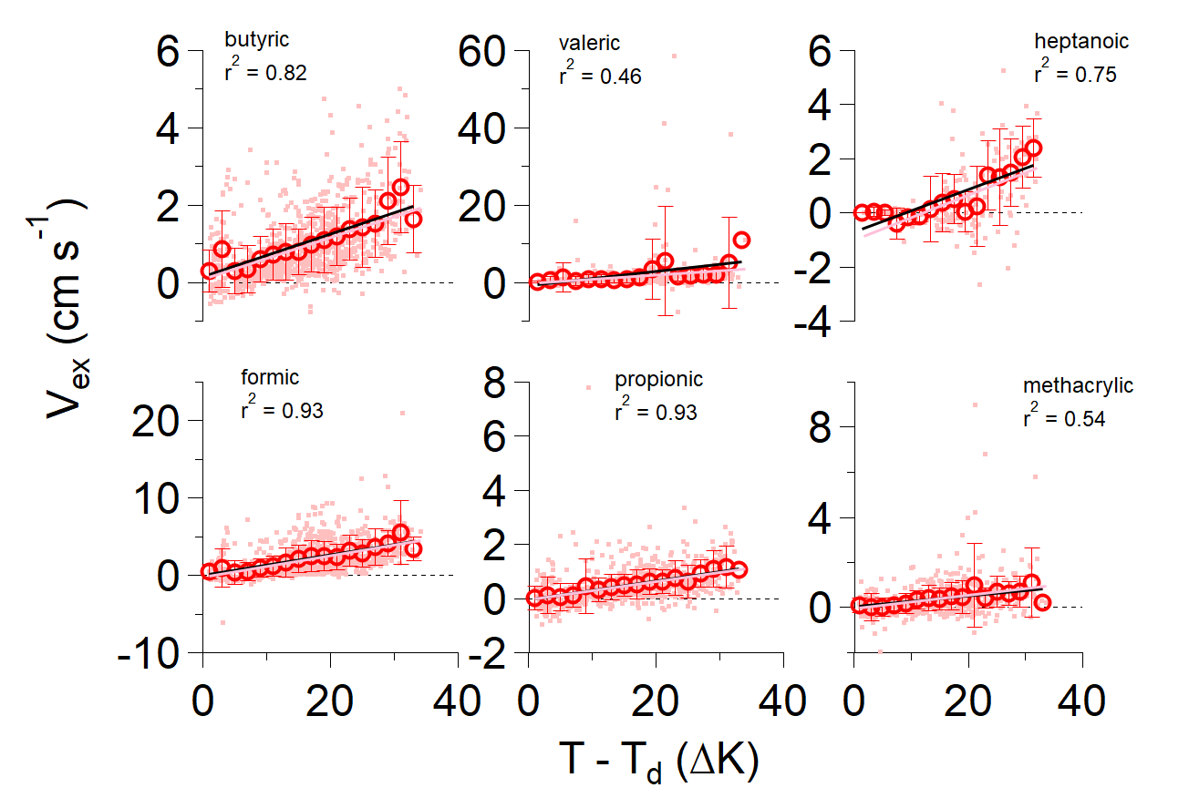

Figure S2. Exchange velocities (V_{ex}) of six volatile organic acids increase linearly with dew point depression (T-T_{d}) at the Manitou Experimental Forest Observatory (MEFO) pine forest site. Dots represent all data, and open circles are the averages of 20 evenly spaced T-T_{d} bins with corresponding standard deviations. All the data (pink lines) and binned data (black lines) are each fit with linear least squares regressions. Correlation coefficients are shown for binned data.

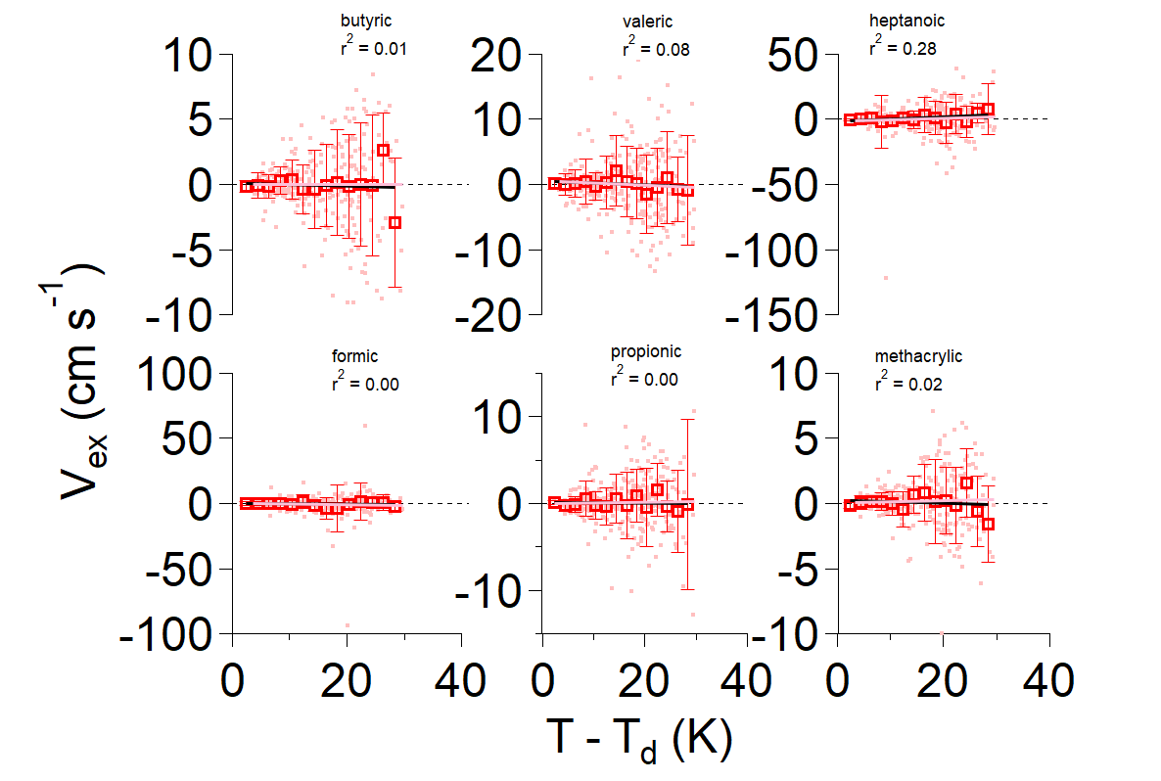

Figure S3. Exchange velocities (V_{ex}) of six volatile organic acids increase linearly with dew point depression (T-T_{d}) at the California orange orchard site. Dots represent all data, and open circles are the averages of 20 evenly spaced T-T_{d} bins with corresponding standard deviations. All the data (pink lines) and binned data (black lines) are each fit with linear least squares regressions. Correlation coefficients are shown for binned data.

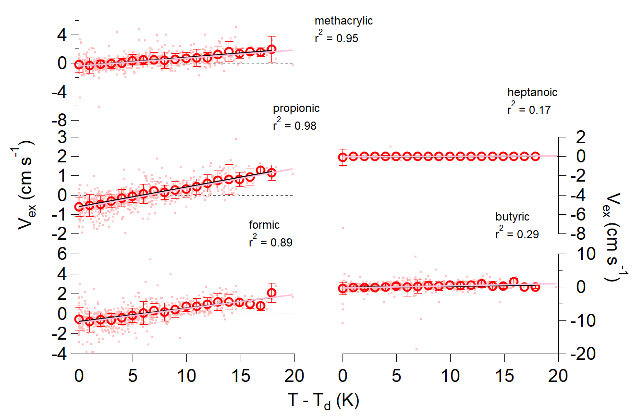

Figure S4. Exchange velocities (V_{ex}) of six volatile organic acids increase linearly with dew point depression (T-T_{d}) at the University of Michigan Biological Station (UMBS) mixed forest site. Dots represent all data, and open circles are the averages of 20 evenly spaced T-T_{d} bins with corresponding standard deviations. All the data (pink lines) and binned data (black lines) are each fit with linear least squares regressions. Correlation coefficients are shown for binned data.

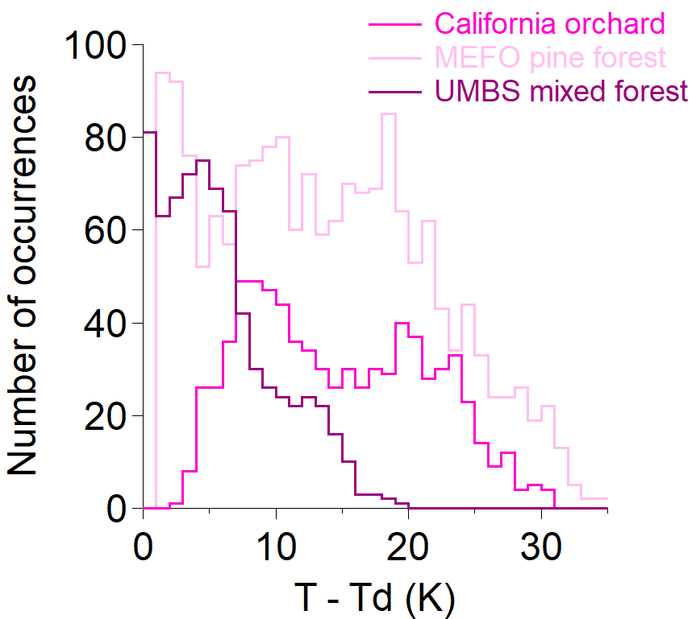

Figure S5. Pine forest at MEFO and mixed canopy forest at UMBS sites exhibit low T-T_{d} (< 5 ∆K) frequently, while California orange orchard flux periods rarely experience the wettest T-T_{d} values. Histograms are averaged to 35 evenly spaced bins.

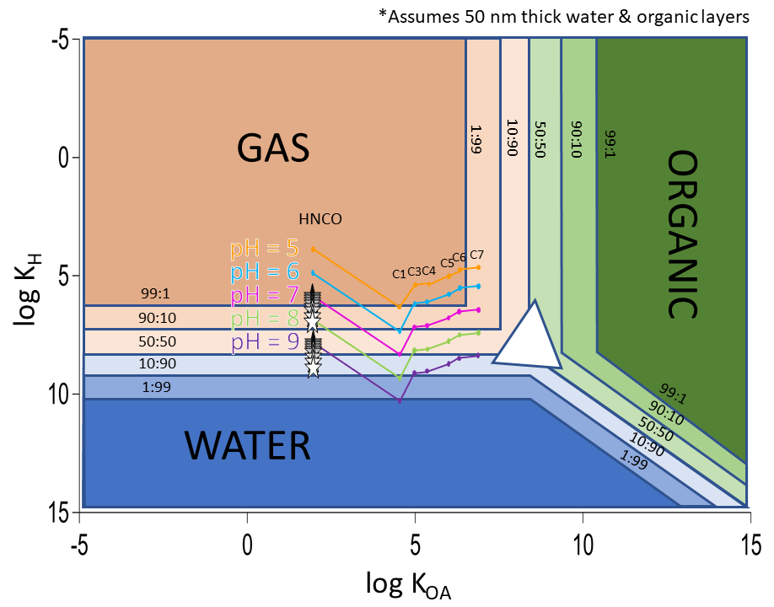

Figure S6. Partitioning space plot represents the volatility distribution of isocyanic acid (HNCO) and different alkanoic organic acids (C1 for formic acid, C3 for propionic acid, etc.) at MEFO. Stars represent the aqueous solubility enhancement of HNCO at lower temperatures. Shown here are temperatures -10°C (white) to 30°C (dark gray) in 5°C increments. Temperature-dependent changes in organic phase solubility are not included. pH isopleths are connected to guide the eye. All data shown are at standard pressure.

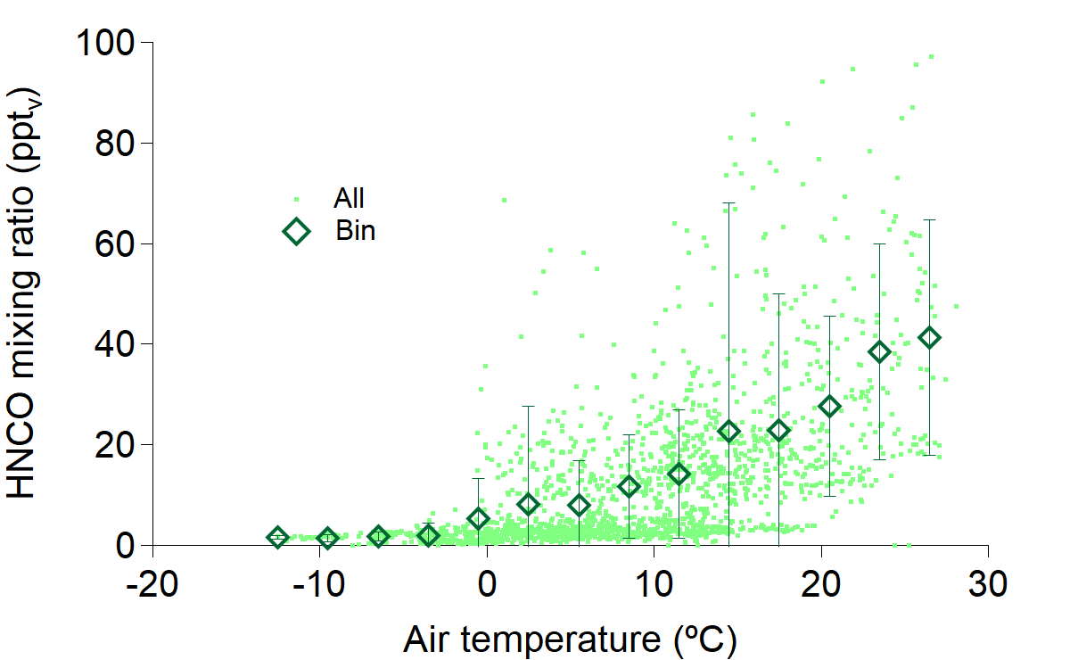

Figure S7. Ambient HNCO mixing ratios increase with increasing air temperature. Diamonds represent HNCO averages over 20-evenly-spaced temperature bins, and whiskers are standard deviation.

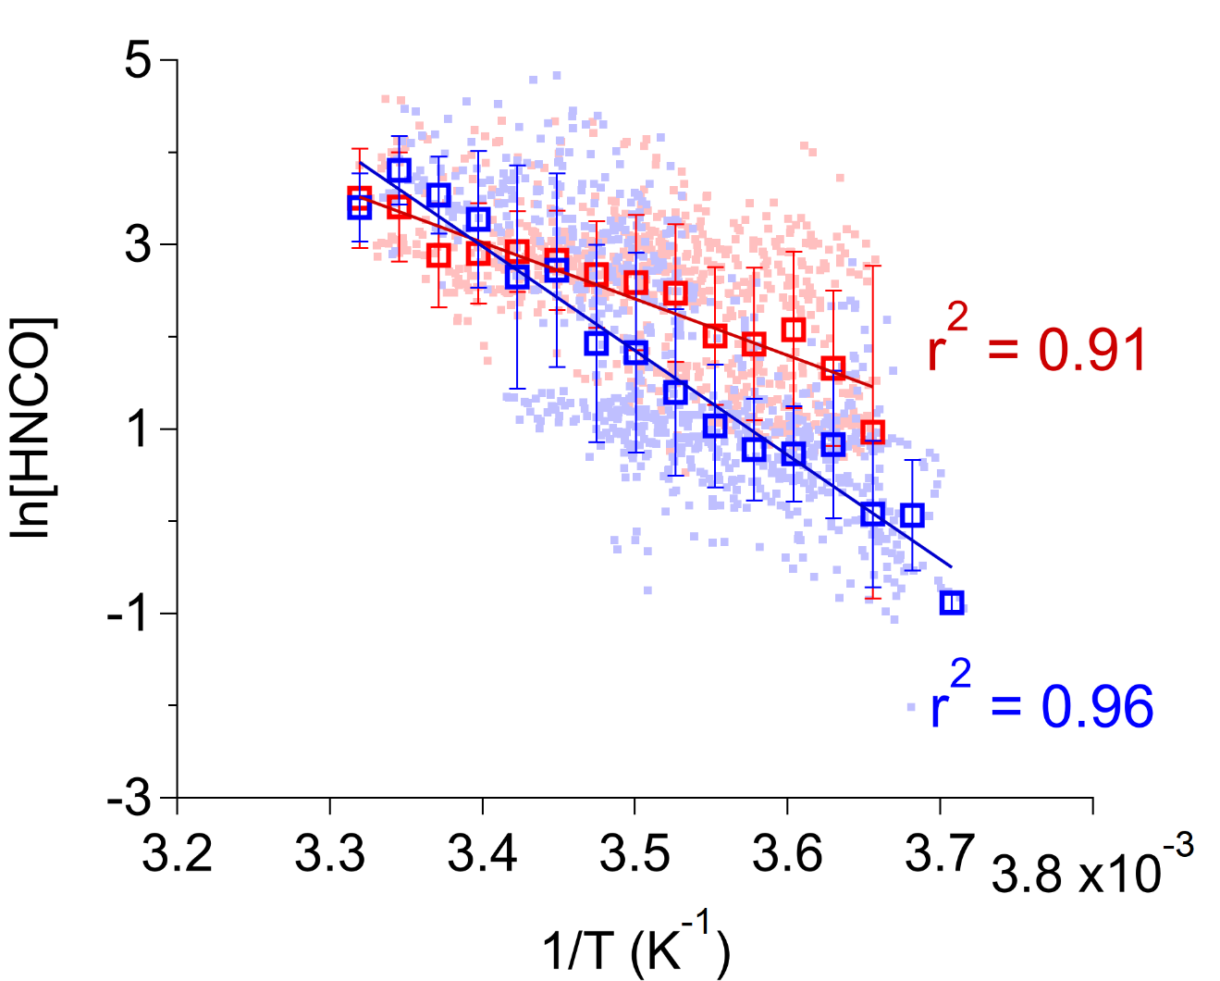

Figure S8. Binned natural logarithms of HNCO mixing ratios linearly depend upon inverse temperatures measured at MEFO during both wet (blue) and dry (red) periods. Data (small squares) are averaged into 20 evenly spaced 1/T bins. Whiskers represent standard deviations associated with the bin averages. Wet and dry sorting follows the algorithm description in section 2.3.

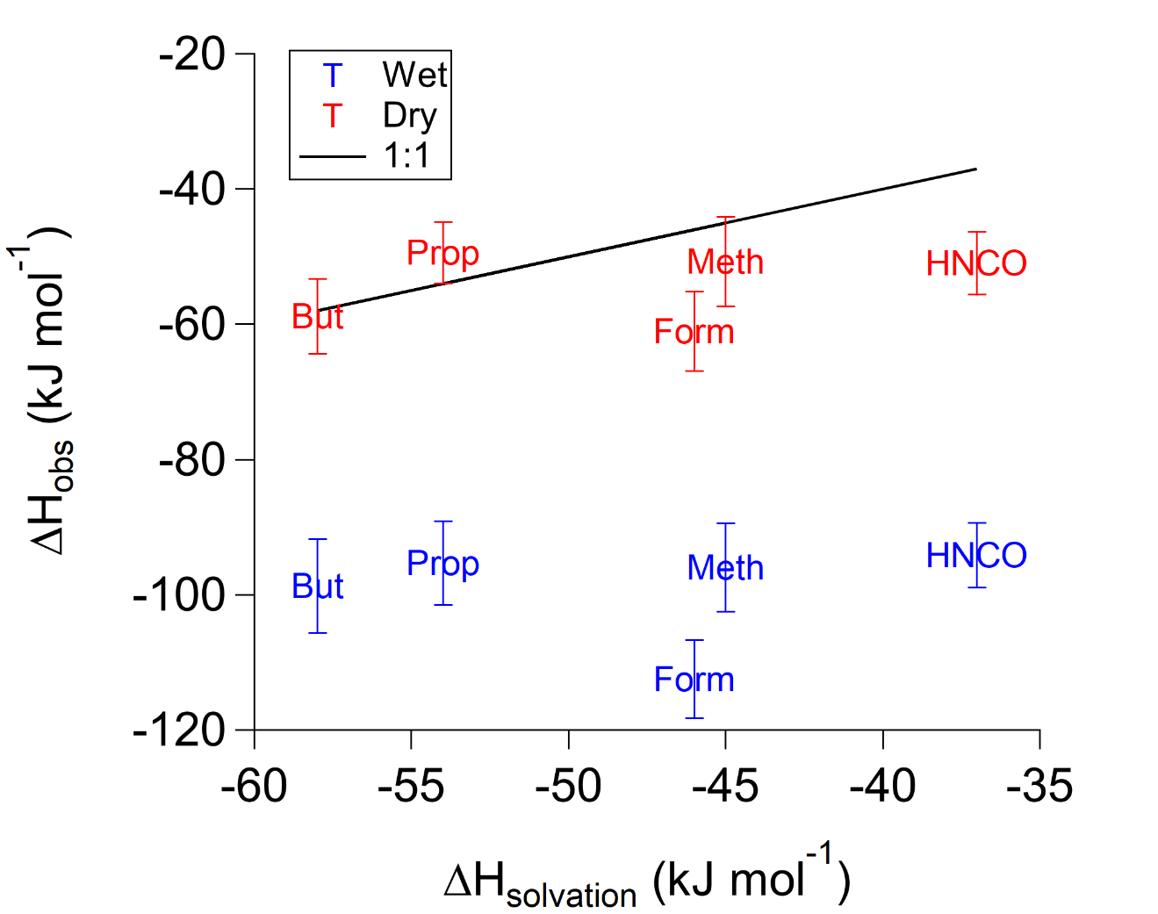

Figure S9. Observed enthalpies of solvation (ΔH_{obs}) for five acids (HNCO, formic, propionic, butyric, and methacrylic acids) are similar to intrinsic literature values (ΔH_{solvation}) when the forest is dry (red), but not when wet (blue). Under wet conditions, ΔH_{obs} is more exothermic and favors aqueous partitioning.

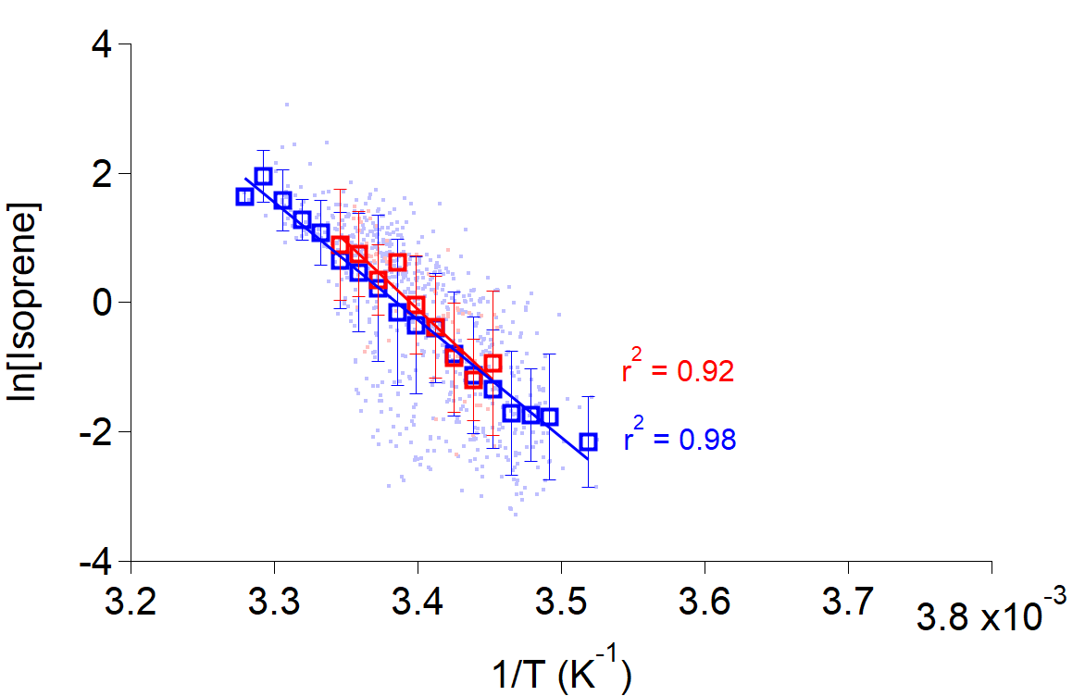

Figure S10. Modified van’t Hoff plot for isoprene measured at University of Michigan Biological Station (Alwe et al., 2019). Data are sorted into periods with (blue) and without (red) surface wetness according to Altimir et al. (2006). Linear regressions of evenly spaced binned data agree within uncertainty: ${\ln\left[Isoprene\right]}_{wet}=\left(-18200 ±600\right)×\frac{1}{T}+\left(61.5±2\right)$; ${ln⁡[Isoprene]}_{dry}=\left(-20800±2000\right)×\frac{1}{T}+(70.7±8)$.

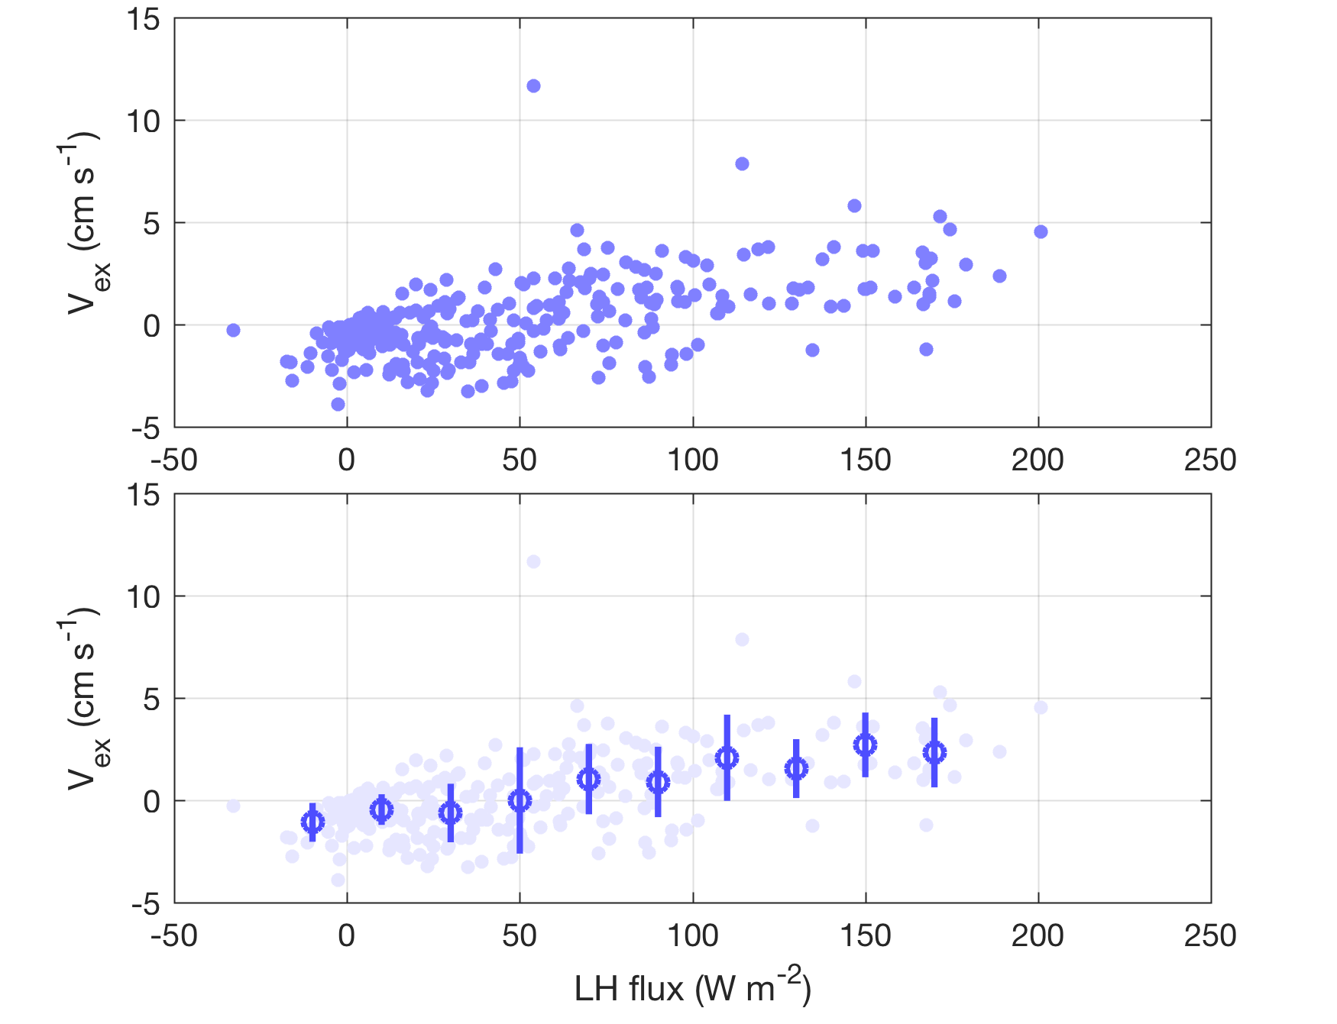

Figure S11. Formic acid exchange velocity (V_{ex}) increases with latent heat flux (LH) at SMEAR 2 in Hyytiälä, Finland. Data are flux-quality filtered according to Schobesberger et al. (2016). Open circles in bottom panel represent 20 W m⁻² binned averages with whiskers as standard deviations.

Volatile organic acid | 0.2 s Campaign Average Sensitivity (ncps ppt⁻¹)
C₄H₈O₂ | 230
HCOOH | 460
C₃H₆O₂ | 150
C₄H₆O₂ | 450
C₅H₁₀O₂ | 46
C₇H₁₄O₂ | 9.9
HNCO | 1700

Table S1. The average sensitivity across all flux periods is listed for measured VOAs at 5 Hz data acquisition frequency. Calculation of HNCO sensitivities is described in section 2.2.
Acid name | Best-fit line | Slope (cm s⁻¹ K⁻¹) | Intercept (cm s⁻¹) | r²
Propionic | California orchard (all) | 0.0061 ± 0.02 | 0.034 ± 0.4 | 0.00
 | California orchard (bin) | -0.19 ± 0.03 | 0.22 ± 0.5 | 0.04
 | UMBS mixed forest (all) | 0.10 ± 0.004 | -0.66 ± 0.03 | 0.47
 | UMBS mixed forest (bin) | 0.10 ± 0.003 | -0.56 ± 0.03 | 0.99
 | MEFO pine forest (all) | 0.034 ± 0.002 | -0.054 ± 0.05 | 0.18
 | MEFO pine forest (bin) | 0.035 ± 0.002 | -0.036 ± 0.05 | 0.93
Formic | California orchard (all) | -0.037 ± 0.08 | -0.10 ± 1 | 0.00
 | California orchard (bin) | -0.014 ± 0.06 | -0.30 ± 1 | 0.00
 | UMBS mixed forest (all) | 0.14 ± 0.008 | -0.89 ± 0.06 | 0.32
 | UMBS mixed forest (bin) | 0.13 ± 0.01 | -0.77 ± 0.1 | 0.89
 | MEFO pine forest (all) | 0.14 ± 0.008 | -0.24 ± 0.1 | 0.25
 | MEFO pine forest (bin) | 0.13 ± 0.01 | -0.029 ± 0.3 | 0.87
Butyric | California orchard (all) | 0.00022 ± 0.03 | -0.0029 ± 0.4 | 0.00
 | California orchard (bin) | -0.0095 ± 0.04 | 0.072 ± 0.7 | 0.01
 | UMBS mixed forest (all) | 0.068 ± 0.01 | -0.26 ± 0.09 | 0.04
 | UMBS mixed forest (bin) | 0.044 ± 0.02 | -0.088 ± 0.2 | 0.29
 | MEFO pine forest (all) | 0.054 ± 0.003 | 0.078 ± 0.06 | 0.24
 | MEFO pine forest (bin) | 0.055 ± 0.007 | 0.15 ± 0.1 | 0.82
Valeric | California orchard (all) | -0.036 ± 0.04 | 0.60 ± 0.6 | 0.00
 | California orchard (bin) | -0.030 ± 0.03 | 0.53 ± 0.5 | 0.08
 | UMBS mixed forest (all) | n/a | n/a | n/a
 | UMBS mixed forest (bin) | n/a | n/a | n/a
 | MEFO pine forest (all) | 0.083 ± 0.01 | -1.0 ± 0.3 | 0.03
 | MEFO pine forest (bin) | 0.18 ± 0.05 | -0.87 ± 1 | 0.46
Methacrylic | California orchard (all) | 0.0091 ± 0.02 | 0.022 ± 0.3 | 0.00
 | California orchard (bin) | -0.012 ± 0.02 | 0.27 ± 0.4 | 0.02
 | UMBS mixed forest (all) | 0.11 ± 0.008 | -0.37 ± 0.06 | 0.21
 | UMBS mixed forest (bin) | 0.12 ± 0.007 | -0.38 ± 0.07 | 0.95
 | MEFO pine forest (all) | 0.000026 ± 0.00005 | 0.37 ± 0.06 | 0.00
 | MEFO pine forest (bin) | 0.024 ± 0.006 | 0.034 ± 0.1 | 0.54
Heptanoic | California orchard (all) | 0.12 ± 0.1 | -1.4 ± 2 | 0.00
 | California orchard (bin) | 0.19 ± 0.09 | -1.83 ± 2 | 0.28
 | UMBS mixed forest (all) | 0.0033 ± 0.003 | -0.030 ± 0.02 | 0.00
 | UMBS mixed forest (bin) | 0.0017 ± 0.0009 | -0.019 ± 0.009 | 0.17
 | MEFO pine forest (all) | 0.083 ± 0.01 | -1.02 ± 0.3 | 0.23
 | MEFO pine forest (bin) | 0.078 ± 0.01 | -0.71 ± 0.2 | 0.75

Table S2. Equations for best-fit curves for 6 volatile organic acid exchange velocities (V_{ex}) as a function of dew point depression (T-T_{d}). See Fig. 3 for visual representation of propionic acid, which represent the general trends.

