Journal of Geophysical Research
Supporting Information for
Constraining fossil fuel CO₂ emissions from urban area using OCO-2 observations of total column CO₂
Xinxin Ye(1), Thomas Lauvaux(1)†, Eric A. Kort(2), Tomohiro Oda(3,4), Sha Feng(1), John C. Lin(5), Emily G. Yang(2), Dien Wu(5)
(1) Department of Meteorology and Atmospheric Science, The Pennsylvania State University, University Park, PA 16803, USA, (2) Department of Climate and Space Sciences and Engineering, University of Michigan, Ann Arbor, MI 48109, USA, (3) Global Modeling and Assimilation Office, NASA Goddard Space Flight Center, Greenbelt, MD 20706, USA, (4) Goddard Earth Sciences Technology and Research, Universities Space Research Association, Columbia, MD 21046, USA, (5) Department of Atmospheric Sciences, University of Utah, Salt Lake City, UT 84132, USA, †Now at Laboratoire des Sciences du Climat et de l’Environnement, CEA, CNRS, UVSQ/IPSL, Université Paris-Saclay, Orme des Merisiers, Gif-sur-Yvette cedex 91191, France

Contents of this file

Text S1
Figures S1 to S7
Introduction
This document contains supplementary information including supporting description and illustration of methods and results. All auxiliary materials are contained in this file.

Text S1.
1.1 Theoretical basis of the transformation method for propagating transport model errors to X_{CO2}
We describe the theoretical basis of the method for propagating the transport model errors on the simulated X_{CO2}. This method is deployed in order to represent the impact of transport model errors with high computational efficiency, since performing the forward simulations with random errors would require large computational costs.
The diffusion equation of CO₂ as a passive tracer is a linear partial differential equation, when assuming 1) constant wind speed coinciding with x direction, 2) negligible turbulent diffusion in x direction compared to advection, and 3) constant eddy diffusivity in y and z directions. The equation takes the form of
$\frac{∂\overline{c}}{∂t}+\overline{u}\frac{∂\overline{c}}{∂x}=K_{y}\frac{∂^{2}\overline{c}}{∂y^{2}}+K_{z}\frac{∂^{2}\overline{c}}{∂z^{2}}+Q$ (S1)
where $\overline{c}$ is the CO₂ concentration, Q is the fossil-fuel CO₂ emissions and t is time. Molecular diffusion is assumed to be negligible, and the wind velocity $\overline{u}$ coincides with the x direction. Ky and Kz are eddy diffusivities, assumed to be constant. We further assume that the CO2 emissions in a city can be equivalent to a point source located at $\left(x_{0}, y_{0}\right)$, where $x_{0}=\sum_{i,j}{e(i,j)x(i,j)/}E, y_{0}=\sum_{i,j}{e(i,j)y(i,j)/E}$, e is the emission map, and $E=\sum_{i,j}{e\left(i,j\right)}$ is the total emission within the model domain. The point source can be formulated as $Q_{s}δ(x-x_{0})δ(y-y_{0})δ(z)$, where $Q_{s}$ is the mass emission strength in gC s-1. Then equation S1 can be non-dimensionalized by setting $x-x_{0}= L_{x}x_{c}, y-y_{0}={L_{y}y}_{c}, z=L_{z}z_{c}, \overline{c}=\frac{Q_{s}}{ L_{x}L_{y}L_{z}}τ{\overline{c}}_{c}, and t=τt_{c}$, where the variables with subscription “c” represent their nondimensional counterparts. The length scales are: $L_{x}=\overline{u}τ, L_{y}=\sqrt{K_{y}τ}, and L_{z}=\sqrt{K_{z}τ}$. Then the non-dimensionalized equation of S1 is:
$\frac{∂\overline{c_{c}}}{∂t_{c}}+\frac{∂\overline{c_{c}}}{∂x_{c}}=\frac{∂^{2}\overline{c_{c}}}{∂y_{c}^{2}}+\frac{∂^{2}\overline{c_{c}}}{∂z_{c}^{2}}+δ(x_{c})δ(y_{c})δ(z_{c})$ (S2)
According to this equation, the nondimensional concentration $\overline{c_{c}}$ is independent of wind speed, eddy diffusivities, and surface fluxes. Therefore, given the numerical solution of X_{CO2} by the simulations, the plume under perturbed wind speed can be estimated by transforming the simulation results. When considering a random error ($θ$) in wind direction, we rotate the simulated plume by an angle $θ$ about ($x_{0}, y_{0}$) to get $\overline{c_{r}}(x_{r}, y_{r},t)$. Then we transform the rotated plume to get $\overline{c_{r'}}\left(x_{r'},y_{r'},t\right)= \overline{c_{r}}(x_{r},y_{r},t)$, where $x_{r'}=\frac{\overline{u}+ε}{\overline{u}}\left(x_{r}-x_{0}\right)+x_{0}, y_{r'}=y_{r},z_{r'}=z_{r}, \overline{c_{r'}}= \overline{c_{r}}\frac{\overline{u}}{\overline{u}+ε}$. This method is derived under assumption that the wind speeds and the random errors are spatially uniform, which can be generally valid within several tens of kilometers from the emission center, i.e. a typical spatial scale of a city. Since the OCO-2 observations are available only in daytime, the fossil-fuel CO₂ emitted locally are mostly confined within the planetary boundary layer (PBL) and well mixed. Thus, we used the average wind speed within the PBL and its typical error statistics for $\overline{u}$ and ε for the perturbation.
1.2 Idealized test of the emission optimization method
An idealized test of the emission optimization methods is conducted based on a Gaussian plume to compare the method of optimizing total integral ffX_{CO2} enhancement, i.e. X_{CO2} increment caused by fossil fuel emissions, and the least square error method. The pseudo observations are constructed by sampling along a track cutting the plume with an angle ranging from 0° to 90°. The errors in wind speeds and wind directions are defined as -2.0 to 2.0 ms⁻¹ and -30° to 30° with an interval of 0.04 ms⁻¹ and 0.6°, respectively, and imposed to the plume using the method detailed in section 2.5.1. Figure S1 shows the scaling factor calculated by optimizing the total X_{CO2} enhancements and by least square error method. The blank top-left corners in Figs. S1c and S1d correspond to cases excluded in the calculation when the track is nearly parallel to the perturbed plume, thus the plume is not or only partially observed. With wind speed error imposed, the two methods yield similar distributions of the scaling factor (Figs. S1a, S1b). However, for wind direction error, the scaling factor is mostly less than one (the truth of S) when using the least square error method. The scaling factor will exhibit a skewed distribution. Therefore, we used total X_{CO2} enhancement for the emission optimization purpose.
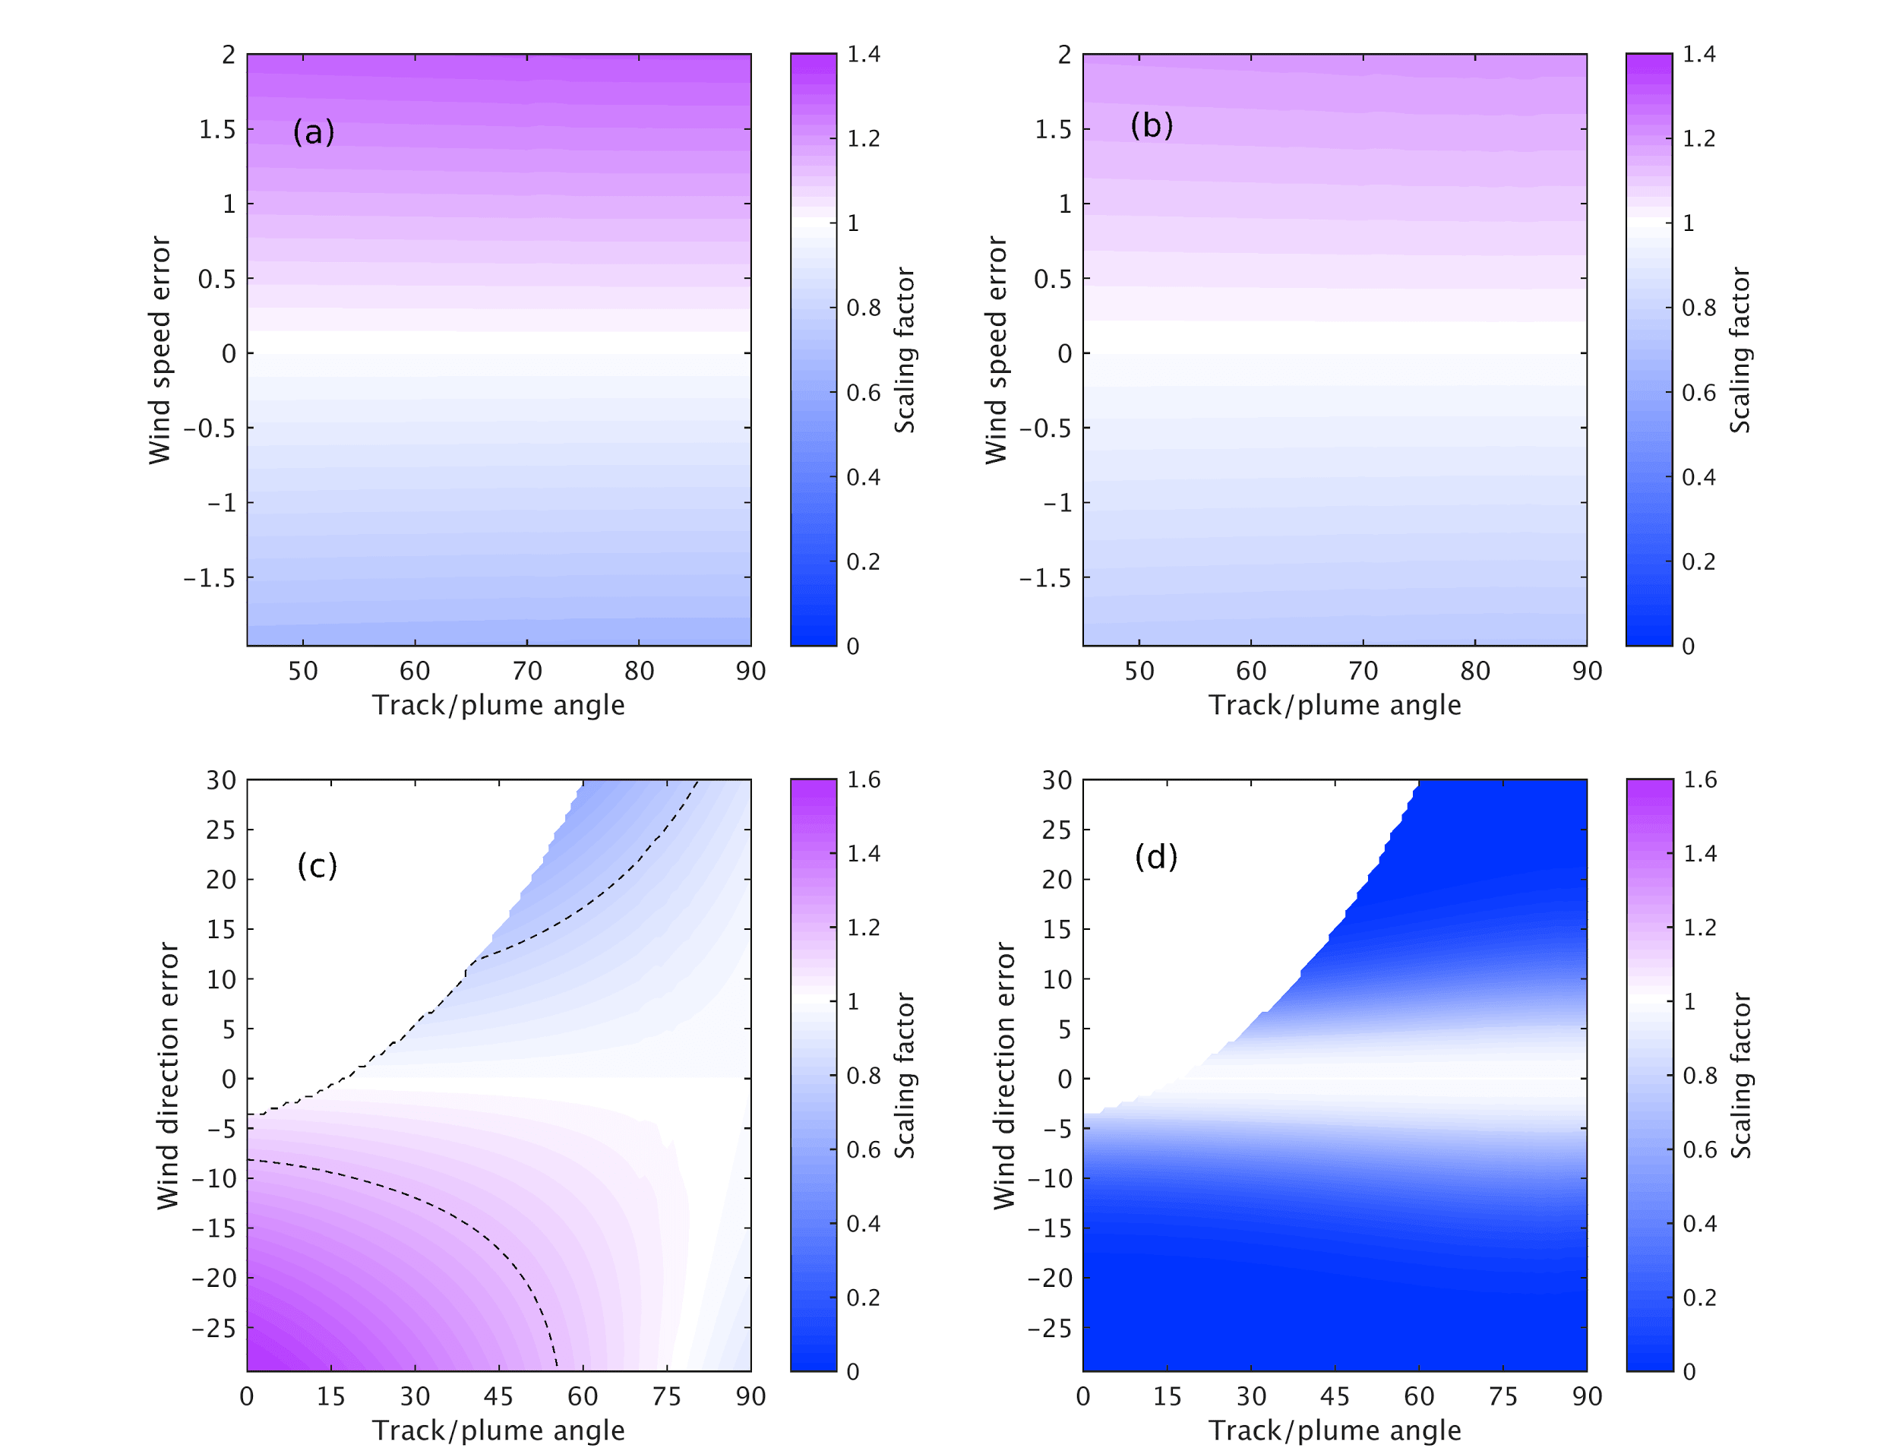
Figure S1. Scaling factor calculated by optimizing total enhancement of the X_{CO2} (a and c) and by least square error (b and d). An idealized eastward Gaussian plume is used here, with the angle between the plume axis and the pseudo track varying from 0° to 90°. The range of wind speed errors is -2.0 to 2.0 ms⁻¹ with an interval of 0.04 ms⁻¹ (a and b), and -30° to 30° for wind direction errors with an interval of 0.6° (c and d).

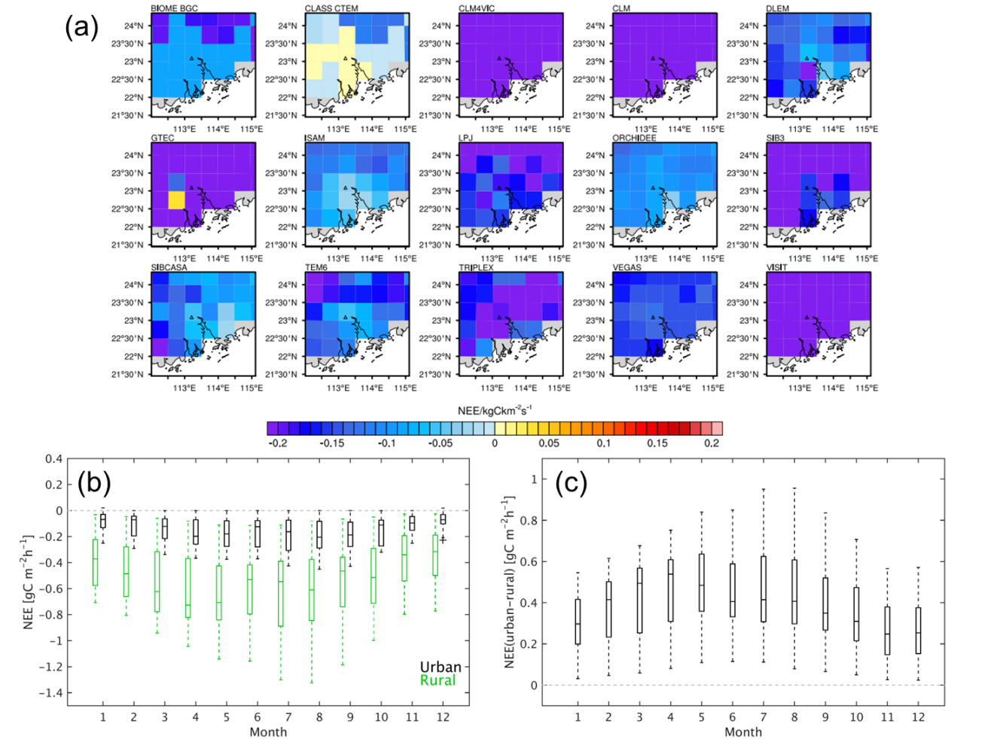
Figure S2. (a) Biogenic carbon fluxes (Net Ecosystem Exchange, NEE) over the Peral River Delta (PRD) region of China, provided by the 15 terrestrial biosphere models in the Multi-scale Synthesis and Terrestrial Model Intercomparison Project (MsTMIP). The data have been temporally downscaled from monthly values to three-hourly (Fisher et al., 2016), and the NEE at about 11:00-13:00 (local time) averaged in July 2010 have been shown. Panels (b) and (c) show the NEE averaged over urban and rural area and their difference in July 2010. For each box, the central mark indicates the median NEE from the 15 models, and the bottom and top edges indicate the 25th and 75th percentiles, respectively. The whiskers represent the extreme values with the maximum length of 1.5 times the interquartile range. Data points beyond the whiskers are displayed using “+”.

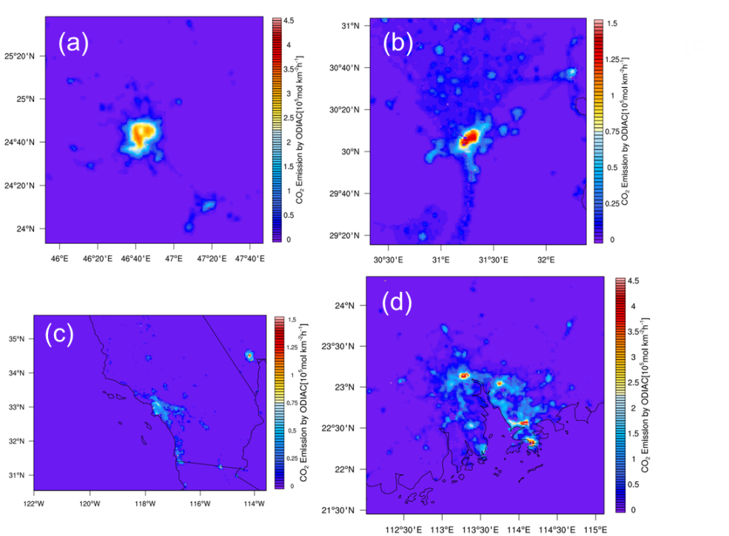
Figure S3. Fossil-fuel CO₂ emissions based on ODIAC product for (a) Riyadh, Saudi Arabia, (b) Cairo, Egypt, (c) Los Angeles, the U.S. and (d) Pearl River Delta (PRD), China. Note that the color scales are not the same.
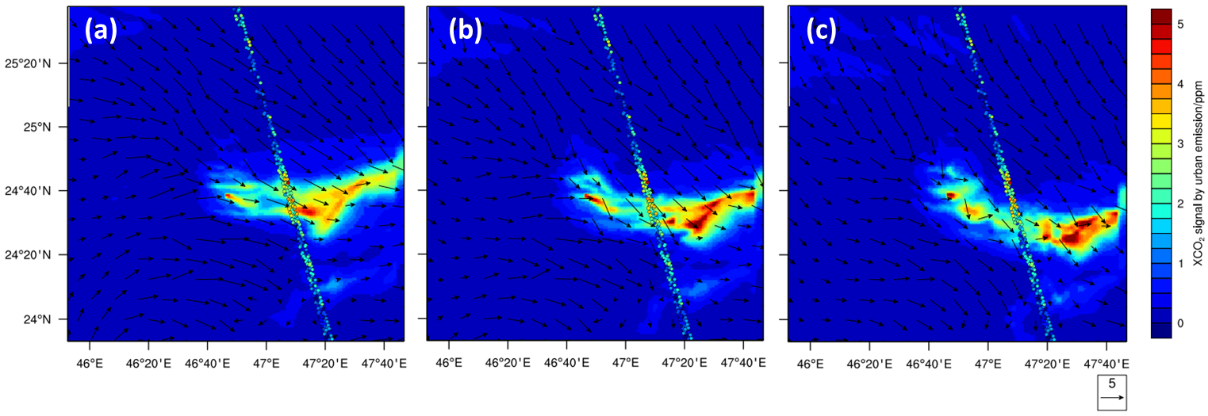
Figure S4. Simulated fossil fuel X_{CO2} enhancement over Riyadh and 10-m wind vectors from the 1-km spatial resolution domain at (a) 09:00 UTC, (b) 10:00 UTC, and (c) 11:00 UTC on December 29, 2014. The colored dots represent the OCO-2 X_{CO2} observed at about 10:00 UTC, with quality flag (QF)=0 and background concentration subtracted.
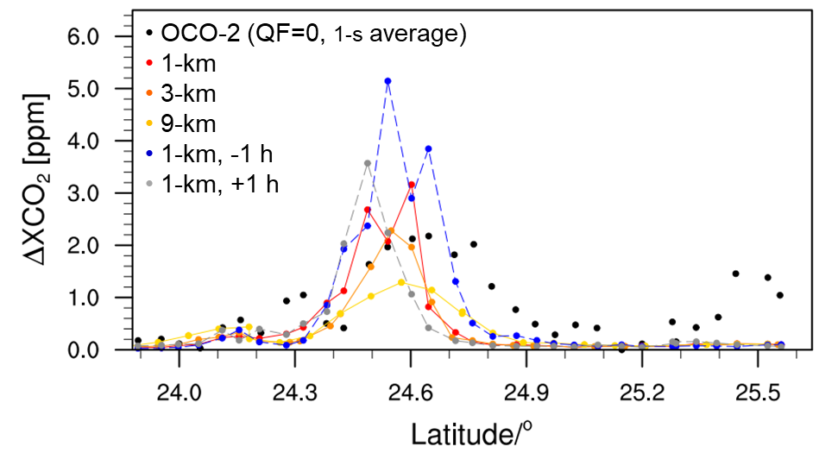
Figure S5. Observed and simulated fossil-fuel XCO2 enhancement along the latitudinal range of interest over Riyadh. The black dots represent the OCO-2 data at around 10:00 UTC on December 29, 2014, filtered with quality flag (QF=0). Background concentration is subtracted. The dotted lines in red, orange, and yellow stand for simulation results at 10:00 UTC, from 1-km, 3-km and 9-km resolution domains respectively. The blue and gray dash-dotted lines represent simulations at the relative time of -1 h and +1 h (09:00 and 11:00 UTC).
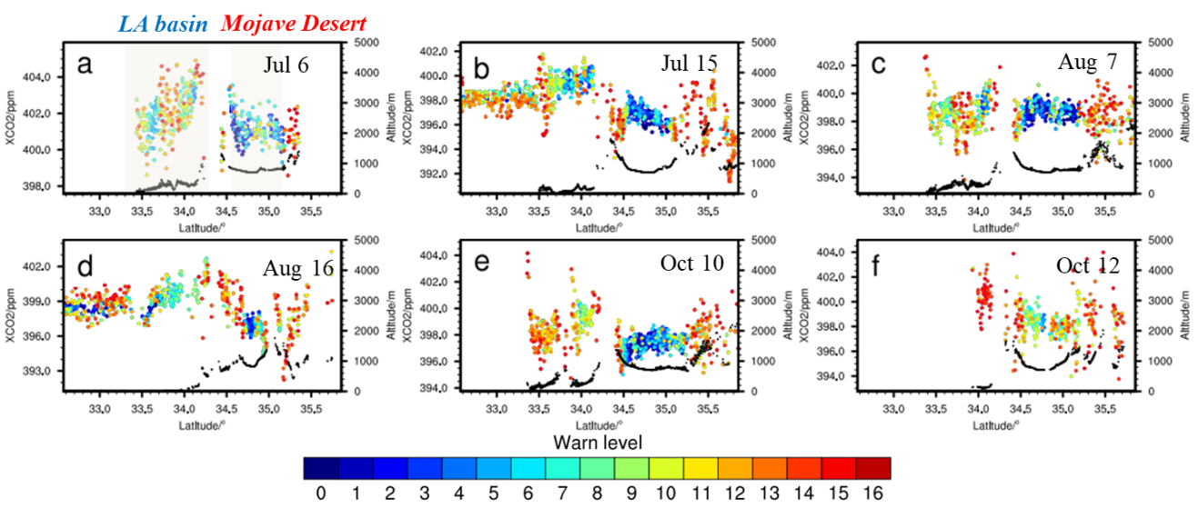
Figure S6. OCO-2 tracks in 2015 over LA on the days labeled on each panel. The colored dots stand for X_{CO2} soundings, color coded by warn level. The black dots represent terrain height. Soundings with high warn levels are mostly found over regions with complex topography, i.e. the northern and southern edges of the Mojave Desert, which is highlighted by the grey shading in panel (a). Gradient in X_{CO2} of about 2-4 ppm over LA basin and the desert are shown. For specification of the background concentration of X_{CO2}, these tracks are chopped at the northern edge of the desert to avoid including the soundings to the north with high warning levels and large variability due to the complex terrain.

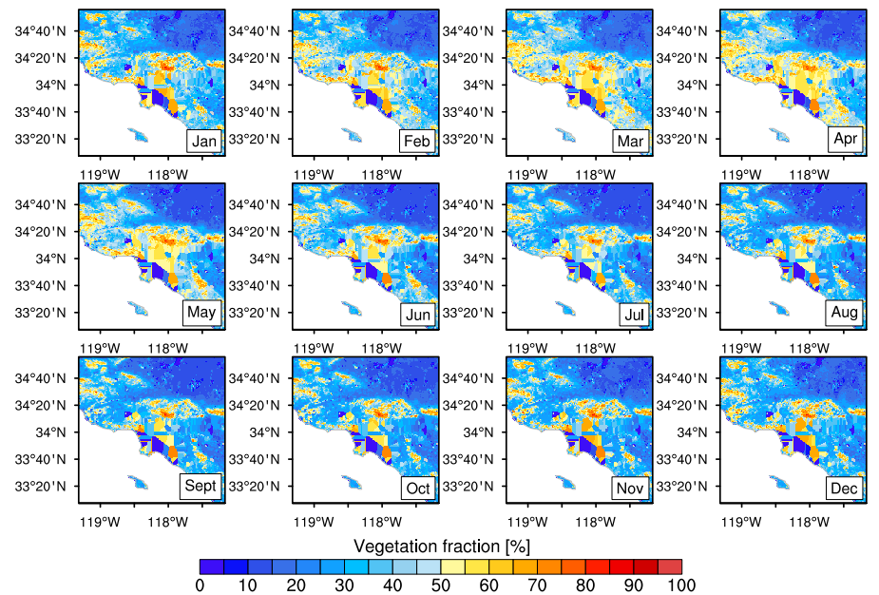
Figure S7. Monthly Green Vegetation Fraction (GVF) over Los Angeles and the surrounding area. The data are based on MODIS climatological observations from 2001 to 2010, which is available since WRF v3.6. Compared to the improved GVF in Fig. 2c of the study by Vahmani and Ban-Weiss (2016), which is derived using the monthly normalized difference vegetation index (NDVI) product (MOD13A3) acquired by MODIS and averaged over 2012, there are some unrealistic values and structures over LA.

References
Fisher, J. B., Sikka, M., Huntzinger, D. N., Schwalm, C. and Liu, J.: Technical note: 3-hourly temporal downscaling of monthly global terrestrial biosphere model net ecosystem exchange, Biogeosciences, 13(14), 4271–4277, doi:10.5194/bg-13-4271-2016, 2016.
Vahmani, P. and Ban-Weiss, G. A.: Impact of remotely sensed albedo and vegetation fraction on simulation of urban climate in WRF-urban canopy model: A case study of the urban heat island in Los Angeles, J. Geophys. Res. Atmos., 121(4), 1511–1531, doi:10.1002/2015JD023718, 2016.

