Journal of Geophysical Research
Supporting Information for
Source Characterization of Volatile Organic Compounds in the Colorado Northern Front Range Metropolitan Area during Spring and Summer 2015

A. Abeleira¹, I. B. Pollack^{1,2}, B. Sive³, Y. Zhou², E.V. Fischer², D.K. Farmer^{1*}

1. Department of Chemistry, Colorado State University, Fort Collins, CO, 80523, USA
2. Department of Atmospheric Sciences, Colorado State University, Fort Collins, CO, 80523, USA
3. National Park Service, Air Resources Division, Lakewood, CO, 80228, USA
*Corresponding author: Delphine Farmer, Email: <delphine.farmer@colostate.edu>

Contents of this file

Text S1
Figures S1 to S15
Tables S1 to S2

Introduction
A description of quality of fit parameters and solution robustness (FPEAK) investigations for the PMF analyses is presented in text S1. The supporting information contains time-series and diel cycles of supporting trace gas measurements, and a histogram of surface temperature at the measurement site (Figures S1 – S4) for spring (20 March 2015 – 17 May 2015) and summer (24 July 2015 – 14 August 2015). Time-series of PMF factor outputs used in the PMF analyses are presented in Figures S5 – S6. Correlations between select factors are presented in S7. Correlations between the Traffic factor and traffic markers (CO2 and NOx) are presented in S8. Diel factors of select VOCs, PMF factors, temperature, and JNO2 are presented in S10 – S11. Diel cycles of total OH reactivity and the components of OH reactivity are presented in S12, with a breakdown of the contribution of individual PMF factors on VOC reactivity for spring and summer. A more comprehensive mixing ratio and VOC reactivity statistics table is presented in Table S1. Table S2 contains PMF reconstruction statistics of a subset of measured VOCs.

Text S1. Q/Q_{exp}, FPEAK, and Bootstrapping Investigation.

Although a global minimum solution is usually reached with the PMF least-squares fitting process, it is not necessarily a unique solution. Varying the FPEAK parameter allows one to investigate the rotational ambiguity of a particular PMF solution, which is inherent to this type of factor analysis. We explored an FPEAK range of ±3 for both datasets. In the spring PMF analysis, Q/Q_{exp} was very stable (range of 2.47 to 2.51, RSD < 1%) across an FPEAK range of ± 1. A sharp rise in Q/Q_{exp} occurred at FPEAK > 1, and a gradual rise in Q/Q_{exp} occurred at FPEAK < -1 (sharp increase at FPEAK <-2). The summer PMF analysis resulted in similar FPEAK dependencies. Within an FPEAK range of ± 1, Q/Q_{exp} was stable (5.85 to 5.88, RSD < 1%). At FPEAK <-1.6, the PMF algorithm fails to converge. As FPEAK is increased above 1.4, Q/Q_{exp} increases slowly. We chose PMF solutions for both seasons at FPEAK = 1 based on previous studies, in which the largest positive FPEAK value prior to a large increase in Q/Q_{exp} generally represents the most realistic solution [Hopke, 2000].

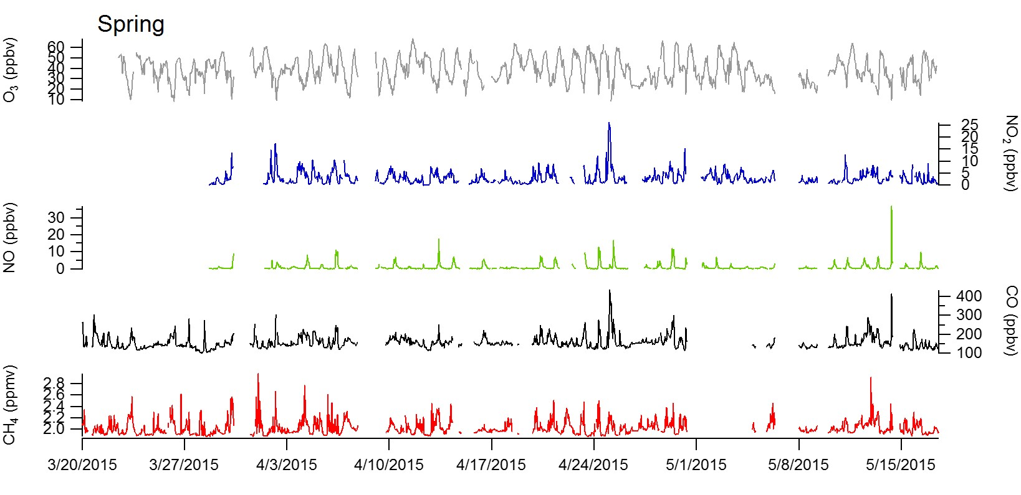
Figure S1. Spring (20 March 2015 – 17 May 2015) time-series for CH₄ (red), CO (black), NO (green), NO₂ (blue) and O₃ (grey) averaged to ± 2 minutes around each VOC sampling point timestamp.
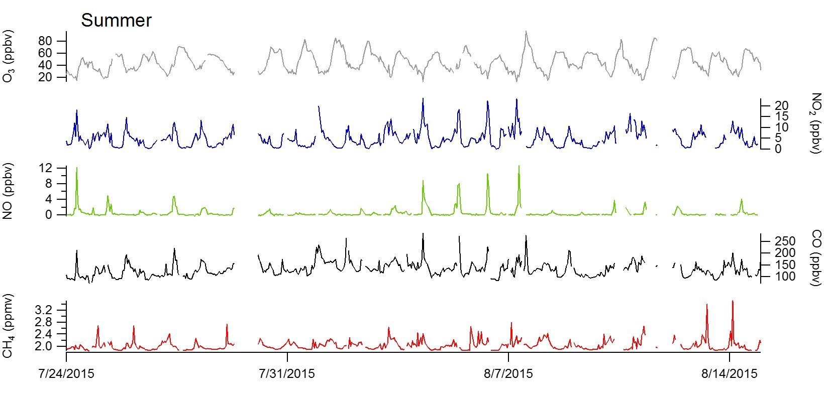
Figure S2. Summer (24 July 2015 – 14 August 2015) time-series for CH₄ (red), CO (black), NO (green), NO₂ (blue) and O₃ (grey) averaged to ± 2 minutes around each VOC sampling point timestamp.

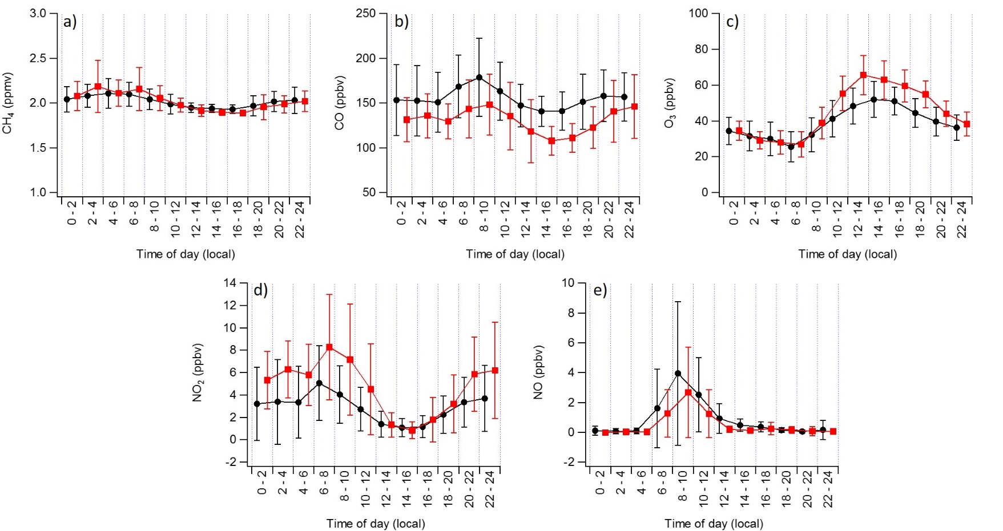

Figure S3. Diel cycles of (a) CH₄, (b) CO, (c) O₃, (d) NO₂, and (e) NO₂ for spring (black circles, 20 March 2015 – 17 May 2015) and summer (red squares, 24 July 2015 – 14 August 2015) binned by two hours. Stacked plots are slightly offset on the x-axis for viewing purposes. Error bars represent ± 1 standard deviation of bin means.

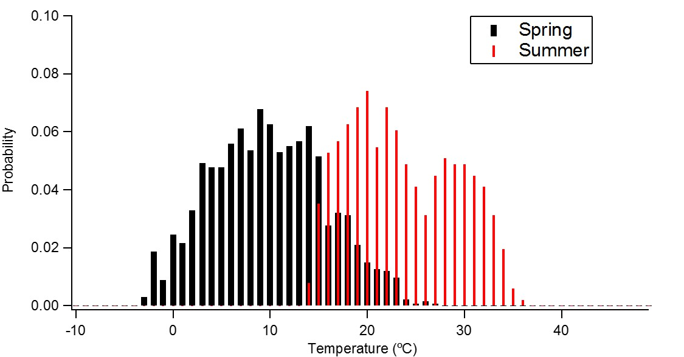

Figure S4. Histogram of spring (black, 20 March - 17 May 2015) and summer (red, 24 July 2015 – 14 August 2015) ambient air temperatures (10 m a.g.l) at the BAO site.

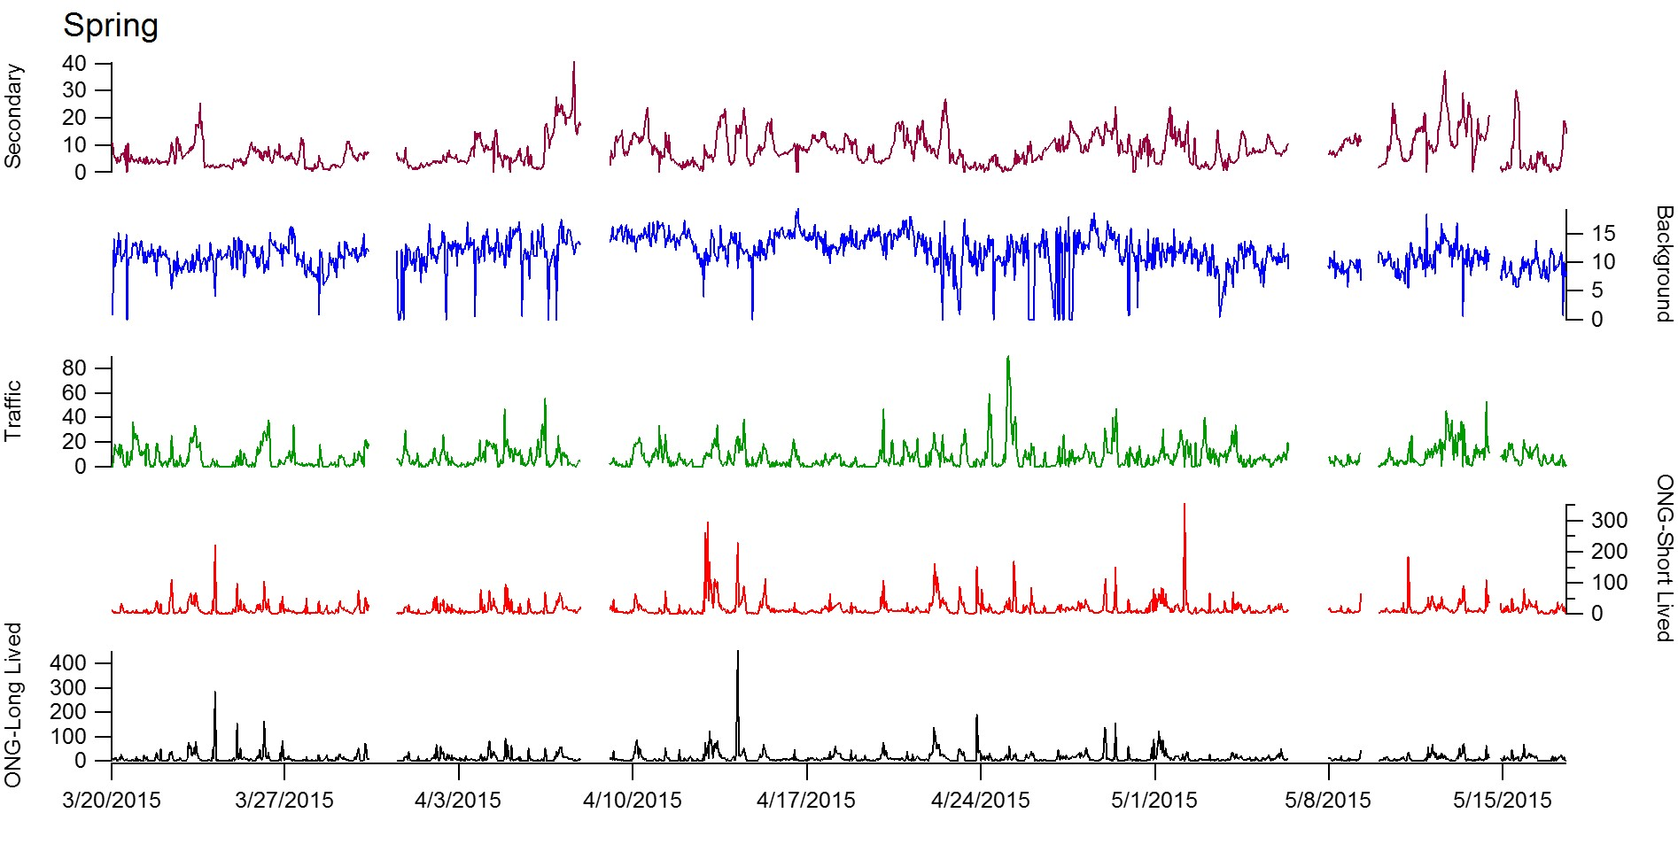
Figure S5. Spring (20 March 2015 – 17 May 2015) time-series for PMF factors: ONG-Short Lived (black), ONG-Long Lived (red), Traffic (green), Background (blue), and Secondary (purple).

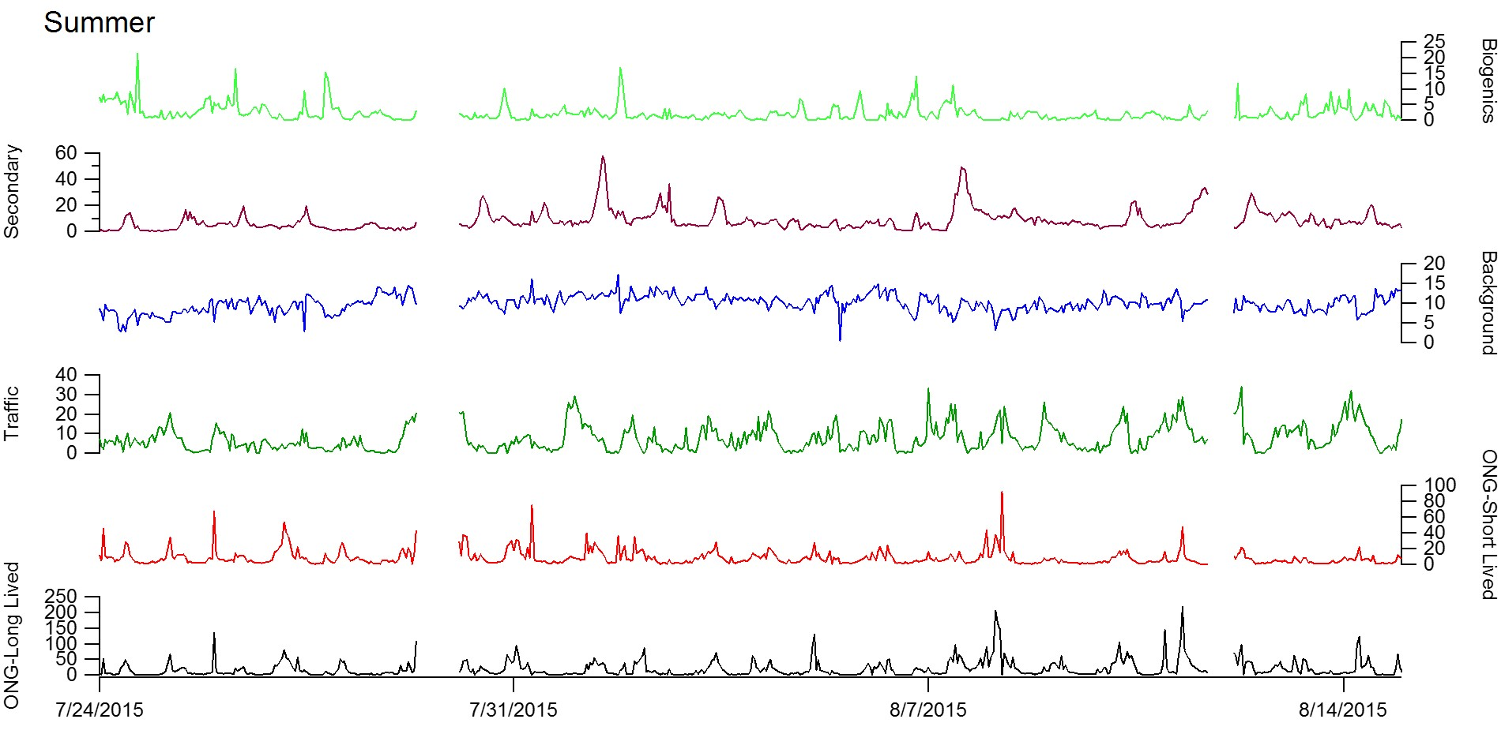
Figure S6. Summer (24 July 2015 – 14 August 2015) time-series for PMF factors: ONG-Short Lived (black), ONG-Long Lived (red), Traffic (green), Background (blue), Secondary (purple), and Biogenics (lime green).

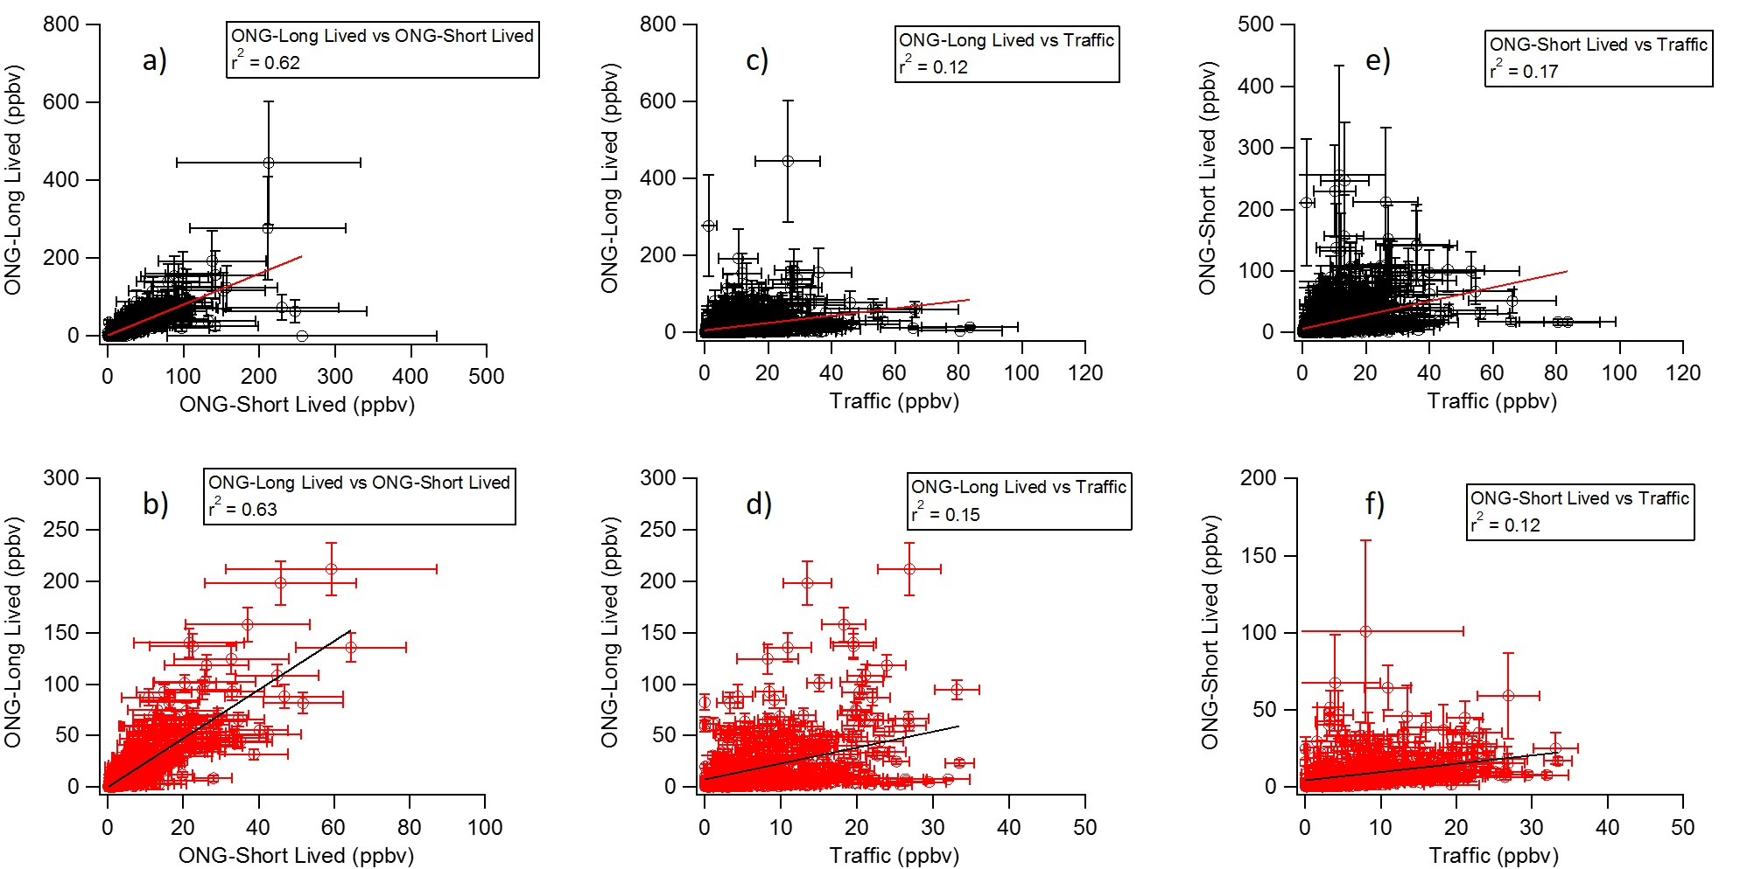

Figure S7. Correlations of ONG-Short-Lived Vs ONG-Long-Lived factors for (a) spring (black, 20 March 2015 – 17 May 2015) and (b) summer (red, 24 July 2015 – 14 August 2015), ONG-Short Lived Vs Traffic (c) spring and (d) summer, and ONG-Long Lived vs Traffic (e) spring and (f) summer. Error bars represent ± 1 standard deviation from mean of bootstrapping analysis.

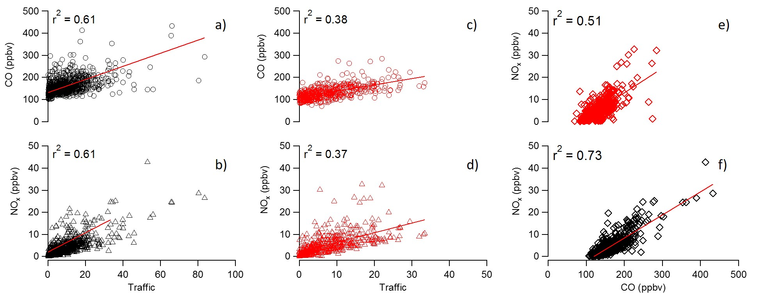
Figure S8. a) Correlations between (a) CO and (b) NO_{x} and the Traffic factor for spring (20 March 2015 – 17 May 2015). Correlations between (c) CO and (d) NO_{x} and the Traffic factor for summer (24 July 2015 – 14 August 2015). Correlations between NO_{x} and CO for (e) summer and (f) spring.

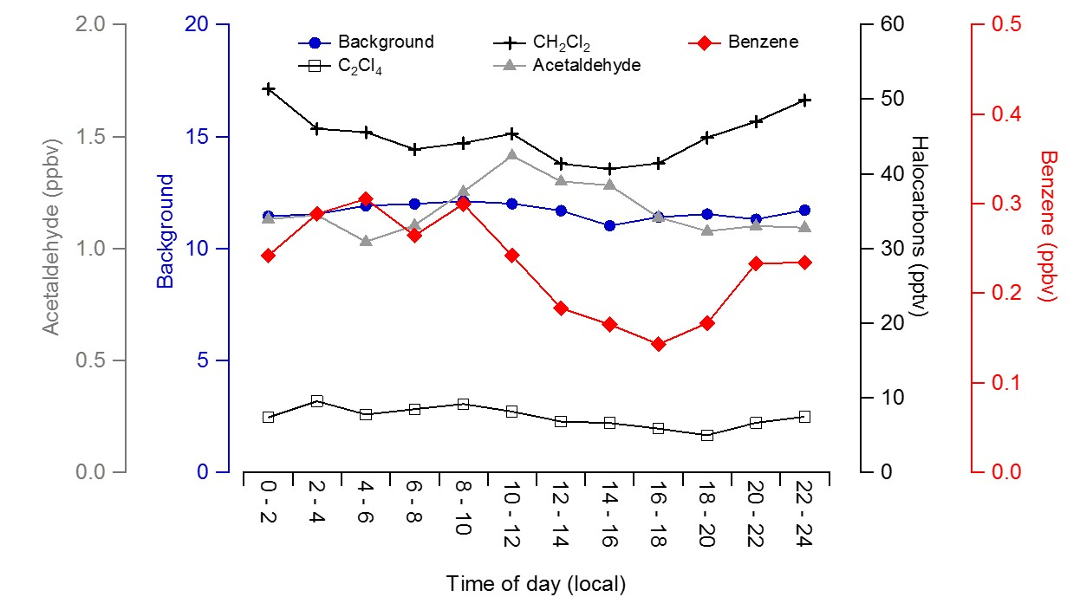
Figure S9. Diel cycles with 2-hour time bins of the spring Background factor with major contributors to the Background factor (Acetaldehyde, CH₂Cl₂, C2₂Cl₄, and Benzene).

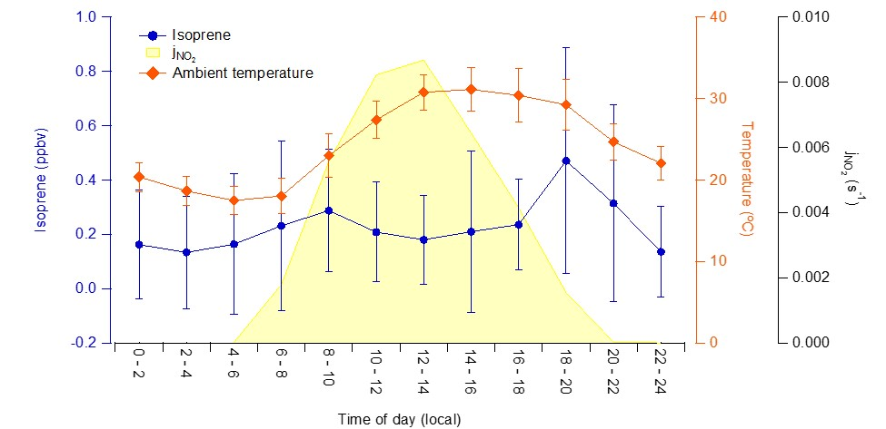
Figure S10. Average diel cycles of isoprene (blue circles) and temperature (red diamonds) for summer (24 July 2015 – 14 August 2015). Isoprene was measured hourly with an online GC system. Error bars represent plus/minus one standard deviation for each two-hour time bin. NO₂ photolysis rates (j_{NO2}) was measured during the previous summer (2014) at the BAO site by the National Center for Atmospheric Research using a CCD Actinic Flux Spectroradiometer. These photolysis rates provide a proxy for diel profiles in photon flux at the site.

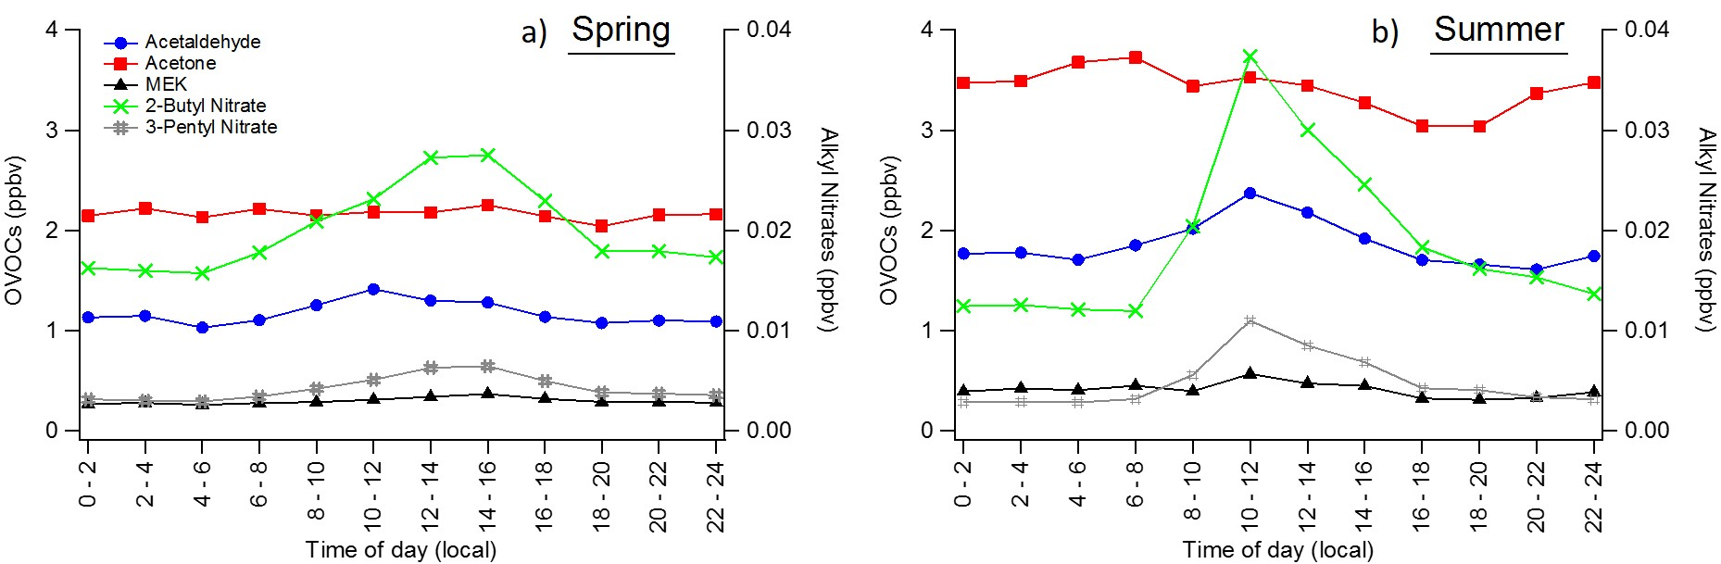
Figure S11. Diel cycles of measured OVOCs, 2-butyl nitrate, and 3-pentyl nitrate for (a) spring (20 March 2015 – 17 May 2015) and (b) summer (24 July 2015 – 14 August 2015) with two-hour binning.

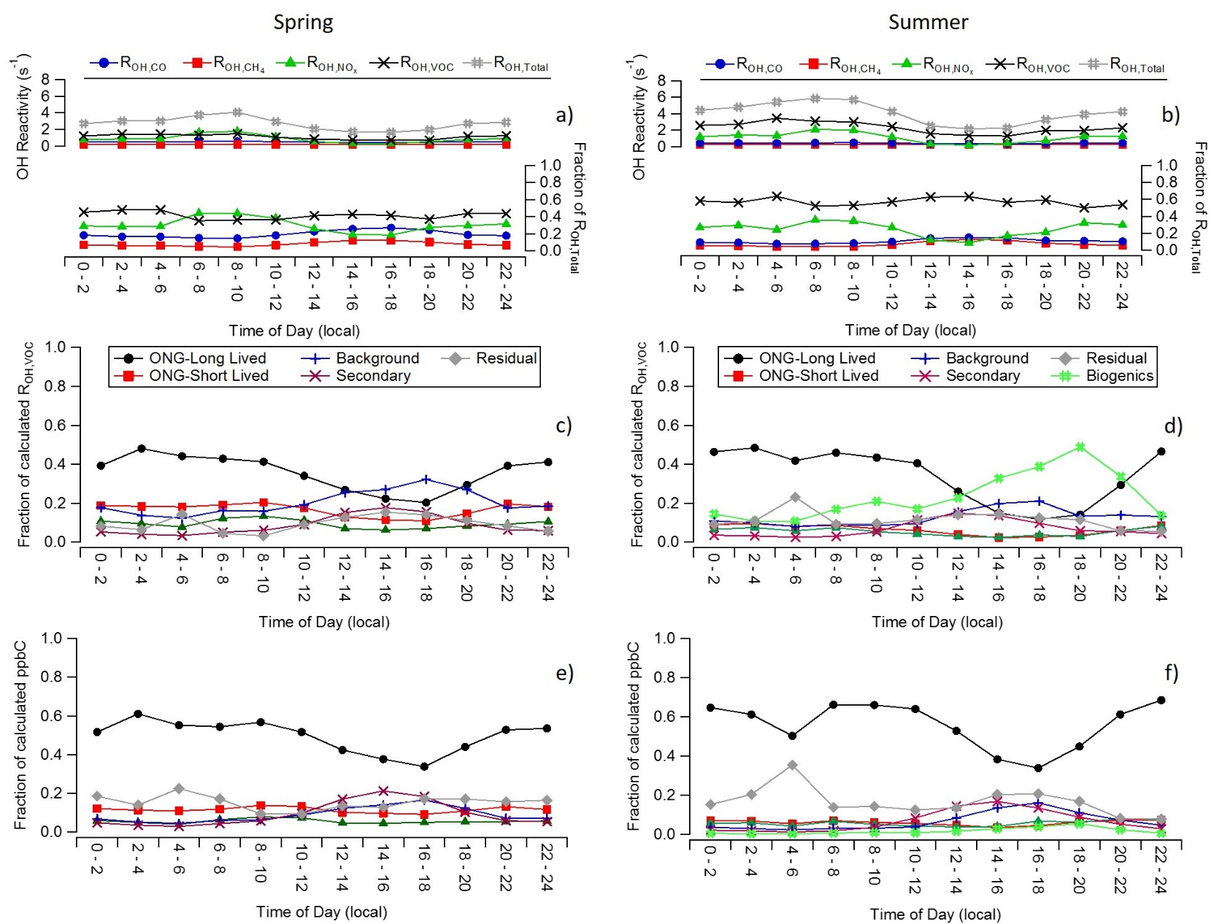
Figure S12. The top row shows diel cycles of calculated OH Reactivity (R_{OH,Total}, s⁻¹) for the (a) spring (20 March 2015 – 17 May 2015) and (b) summer (24 July 2015 – 14 August 2015). Each major contributor to total calculated OH reactivity (R_{OH,X}: X = VOCs, NO_{x}, CO, or CH₄) is shown stacked in a separate color. Figures c – f show the contributions from each PMF factor to the calculated VOC reactivity (R_{OH,VOC}, s⁻¹) and calculated carbon mixing ratio as a diel cycles. R_{OH,Total} and R_{OH,X} were calculated using E1, E2, and E3 described in the introduction. The rate constants (k_{OH,X}) of trace gases and VOCs were adjusted for ambient temperature and pressure (see references in Table 1). For each factor the mixing ratio of each measured compound was reconstructed. The VOC reactivity contribution of each compound for each factor was determined from the PMF factor mixing ratio reconstructions and the temperature and pressure adjusted rate constant with OH. The contribution of each PMF factor to organic carbon mixing ratio (ppbC) is summarized in as diel cycles (e, f).

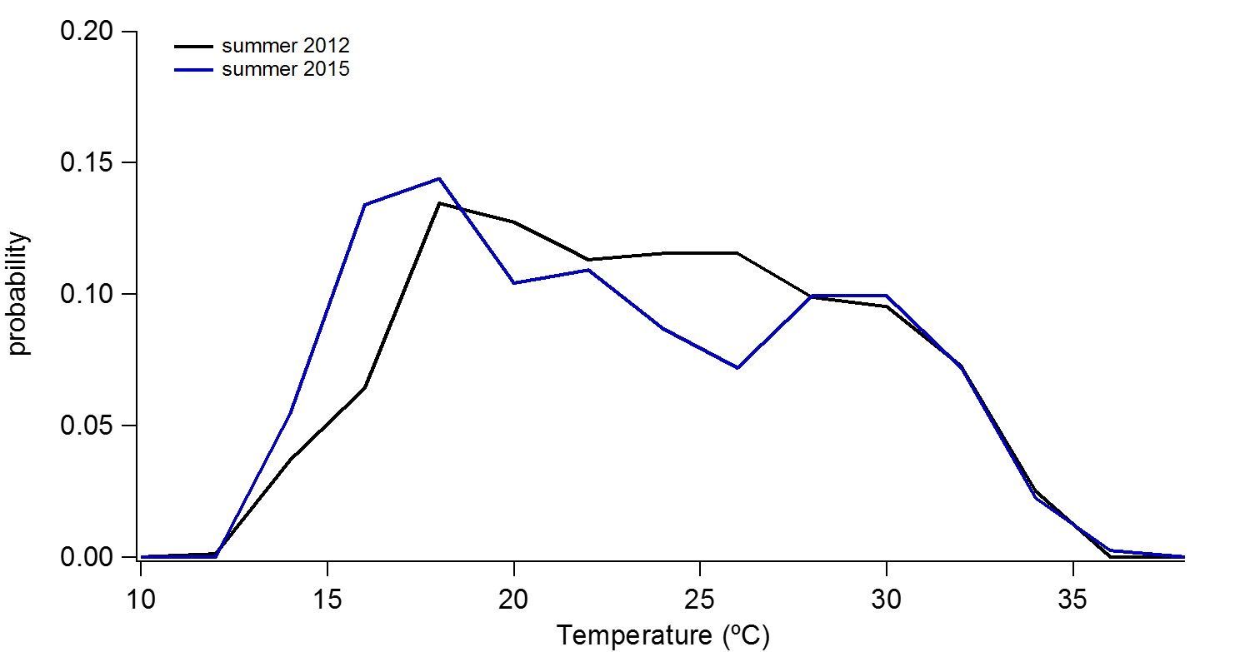
Figure S13. Histogram of ambient sampling temperatures for 7/26 – 8/12 for summer 2012 (black) and summer 2015 (blue).

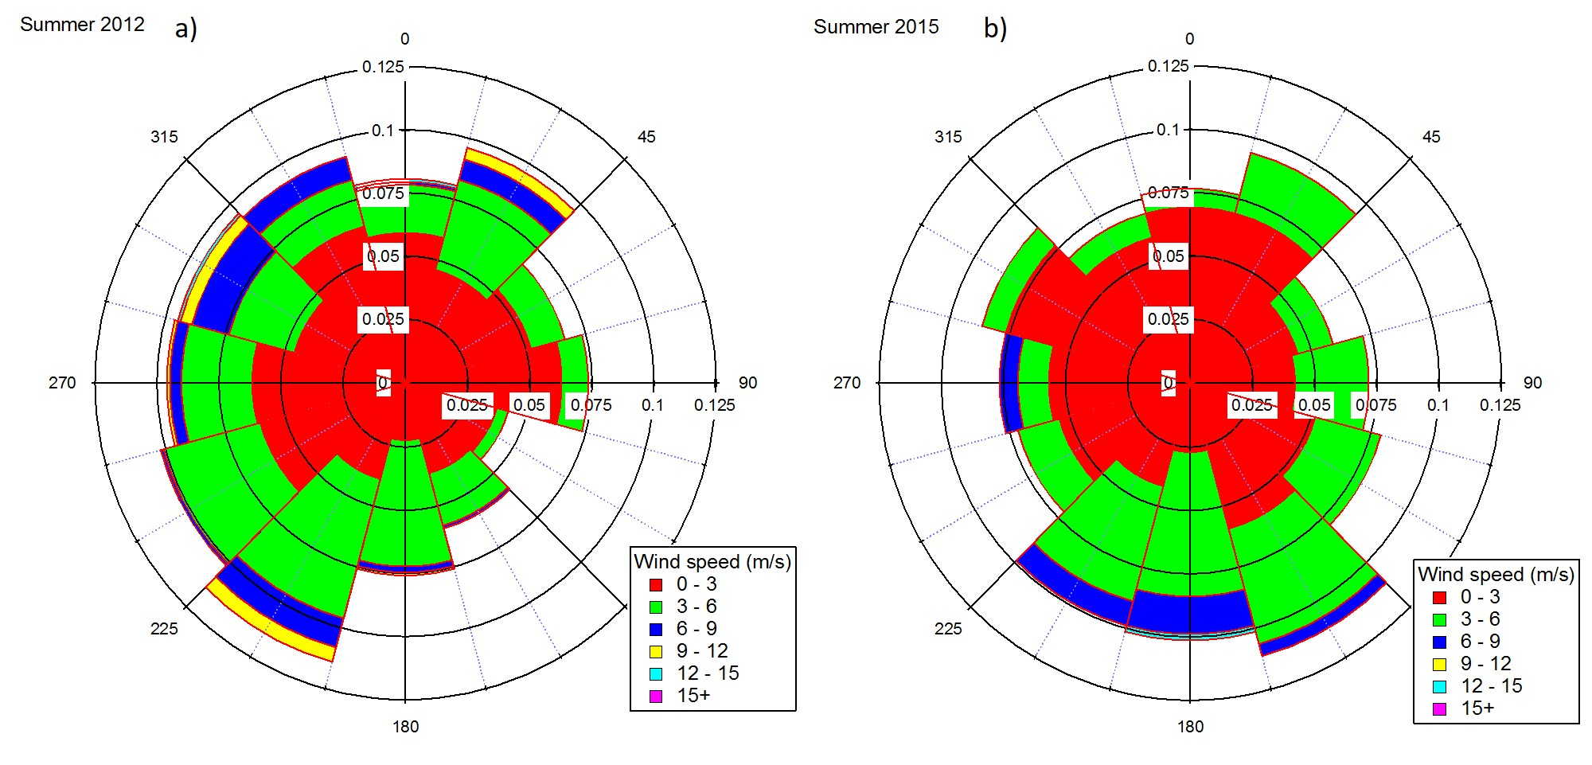

Figure S14. Histogram of ambient sampling temperatures for 7/26 – 8/12 for summer 2012 (black) and summer 2015 (blue).

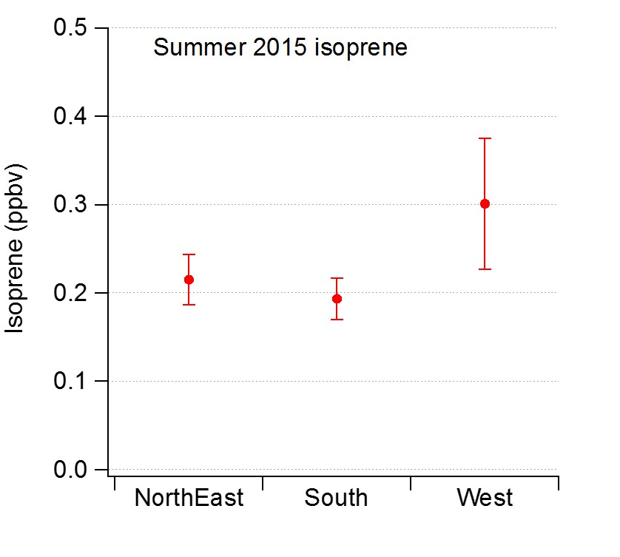
Figure S15. Wind enhancement plot for isoprene summer 2015.

 | Spring |  |  |  | Summer
 | Mixing Ratios (ppb_{v})ª |  | R_{OH,VOC} (s⁻¹)ª |  | Mixing Ratios (ppb_{v})ª |  | R_{OH,VOC} (s⁻¹)ª
Compound | Max | Average | Max | Average | Max | Average | Max | Average | k_{OH,VOC}^{b} | Ref^{c} | LOD (ppb_{v})
Ethane | 443 | 16 (22) | 1.95 | 0.07 (0.10) | 338 | 23 (33) | 1.6 | 0.1 (0.2) | 0.25 | a | 0.008
Propane | 205 | 9 (13) | 4.3 | 0.2 (0.3) | 149 | 8 (11) | 3.2 | 0.2 (0.2) | 1.09 | a | 0.01
i-Butane | 28 | 1 (1) | 1.37 | 0.04 (0.07) | 14 | 2 (2) | 0.68 | 0.07 (0.09) | 2.1 | a | 0.007
n-Butane | 59 | 2 (3) | 2.8 | 0.1 (0.2) | 78 | 4 (6) | 3.7 | 0.2 (0.3) | 2.4 | a | 0.005
i-Pentane | 62 | 1 (3) | 5.1 | 0.1 (0.2) | 82 | 3 (5) | 6.8 | 0.2 (0.4) | 3.6 | a | 0.003
n-Pentane | 49 | 1 (2) | 3.7 | 0.1 (0.2) | 82 | 3 (5) | 6.3 | 0.2 (0.4) | 3.8 | a | 0.003
n-Hexane | 6.5 | 0.2 (0.3) | 0.68 | 0.02 (0.03) | 6.8 | 0.4 (0.5) | 0.72 | 0.04 (0.05) | 5.2 | a | 0.004
Cyclohexane | 4.2 | 0.2 (0.3) | 0.60 | 0.03 (0.04) | 2.2 | 0.2 (0.2) | 0.31 | 0.03 (0.03) | 7 | a | 0.02
2,3-dimethylpentane | 2.0 | 0.1 (0.1) | 0.30 | 0.02 (0.02) | 0.76 | 0.09 (0.09) | 0.11 | 0.01 (0.01) | 7 | c | 0.02
2-methylhexane | 0.61 | 0.04 (0.05) | 0.092 | 0.006 (0.008) | 0.72 | 0.09 (0.09) | 0.11 | 0.01 (0.01) | 7 | c | 0.02
3-methylhexane | 2.5 | 0.1 (0.2) | 0.38 | 0.02 (0.03) | 1.3 | 0.1 (0.1) | 0.19 | 0.01 (0.02) | 7 | c | 0.02
n-Heptane | 2.3 | 0.1 (0.2) | 0.32 | 0.02 (0.03) | 1.5 | 0.1 (0.2) | 0.21 | 0.02 (0.02) | 6.76 | a | 0.01
Methylcyclohexane | 4.0 | 0.2 (0.3) | 0.81 | 0.05 (0.07) | 2.3 | 0.2 (0.2) | 0.47 | 0.04 (0.05) | 9.6 | a | 0.02
2,2,4-trimethylpentane | 0.63 | 0.05 (0.07) | 0.042 | 0.004 (0.004) | 0.66 | 0.06 (0.06) | 0.044 | 0.004 (0.004) | 3.34 | a | 0.02
2,2,3-trimethylpentane | 0.34 | 0.02 (0.03) | 0.048 | 0.003 (0.005) | 0.55 | 0.03 (0.04) | 0.075 | 0.004 (0.006) | 6.6 | a | 0.02
2-Methylheptane | 1.02 | 0.07 (0.09) | 0.19 | 0.01 (0.02) | 0.54 | 0.04 (0.05) | 0.097 | 0.008 (0.009) | 9 | c | 0.02
3-Methylheptane | 0.58 | 0.04 (0.05) | 0.109 | 0.007 (0.010) | 0.56 | 0.06 (0.07) | 0.11 | 0.01 (0.01) | 9 | c | 0.01
n-Octane | 1.06 | 0.06 (0.08) | 0.18 | 0.01 (0.01) | 0.54 | 0.06 (0.07) | 0.09 | 0.01 (0.01) | 8.11 | a | 0.02
Ethene | 2.11 | 0.04 (0.01) | 0.45 | 0.01 (0.02) | 1.9 | 0.3 (0.2) | 0.36 | 0.05 (0.04) | 8.5 | a | 0.003
Propene | 0.49 | 0.01 (0.02) | 0.33 | 0.005 (0.009) | 0.41 | 0.05 (0.04) | 0.23 | 0.03 (0.02) | 26.3 | a | 0.01
cis-2-Butene | 0.19 | 0.01 (0.01) | 0.25 | 0.01 (0.02) | 0.35 | 0.02 (0.03) | 0.42 | 0.03 (0.04) | 56.4 | a | 0.004
Isoprene |  |  |  |  | 2.0 | 0.2 (0.3) | 4.0 | 0.5 (0.5) | 100 | a | 0.01
Benzene | 2.3 | 0.2 (0.2) | 0.059 | 0.006 (0.005) | 1.1 | 0.2 (0.1) | 0.028 | 0.004 (0.003) | 1.22 | a | 0.03
Toluene | 2.5 | 0.3 (0.3) | 0.21 | 0.02 (0.02) | 1.5 | 0.3 (0.2) | 0.12 | 0.02 (0.02) | 5.63 | a | 0.02
Ethylbenzene | 0.58 | 0.03 (0.05) | 0.085 | 0.005 (0.007) | 0.95 | 0.04 (0.05) | 0.132 | 0.005 (0.008) | 7 | a | 0.01
ortho-Xylene | 0.35 | 0.03 (0.04) | 0.10 | 0.01 (0.01) | 0.47 | 0.05 (0.05) | 0.13 | 0.01 (0.01) | 13.6 | a | 0.010
Ethyne | 2.3 | 0.2 (0.1) | 0.044 | 0.004 (0.003) | 2.1 | 0.2 (0.2) | 0.036 | 0.004 (0.003) | 0.87 | d | 0.006
Table S1. Summary of statistics for spring and summer 2015 mixing ratios and OH reactivity at the BAO site
 | Spring |  |  |  | Summer
 | Mixing Ratios (ppb_{v})ª |  | R_{OH,VOC} (s⁻¹)ª |  | Mixing Ratios (ppb_{v})ª |  | R_{OH,VOC} (s⁻¹)ª
Compound | Max | Average | Max | Average | Max | Average | Max | Average | k_{OH,VOC}^{b} | Ref^{c} | LOD (ppb_{v})
Acetaldehyde | 4.9 | 1.2 (0.5) | 1.2 | 0.3 (0.1) | 5.7 | 1.9 (0.6) | 1.3 | 0.4 (0.1) | 15 | a | 0.08
Acetone | 5.9 | 2.2 (0.7) | 0.021 | 0.008 (0.002) | 8 | 3 (1) | 0.026 | 0.001 (0.004) | 0.17 | a | 0.1
Methyl ethyl ketone | 1.6 | 0.3 (0.2) | 0.040 | 0.008 (0.004) | 2.5 | 0.4 (0.3) | 0.063 | 0.010 (0.006) | 1.22 | a | 0.06
CFCl₃ (CFC-11) | 0.41 | 0.25 (0.03) | 5.5x10⁻¹⁶ | 9x10⁻¹⁷ (7x10⁻¹⁷) | 0.36 | 0.20 (0.02) | 1.0x10⁻¹⁵ | 3x10⁻¹⁶ (2x10⁻¹⁶) | 1x10⁻¹³ | e | 7x10⁻⁵
CCl₂FCClF₂ (CFC-113) | 0.102 | 0.076 (0.006) | 6.6x10⁻⁷ | 4.9x10⁻⁷ (4x10⁻⁸) | 0.111 | 0.061 (0.007) | 6.8x10⁻⁷ | 3.7x10⁻⁷ (4x10⁻⁸) | 0.0003 | e | 2x10⁻⁴
CH₂Cl₂ | 0.25 | 0.05 (0.02) | 5.1x10⁻⁴ | 9x10-5 (4x10-5) | 1.84 | 0.04 (0.09) | 0.0039 | 1x10⁻⁴ (2x10⁻⁴) | 0.1 | e | 0.006
CHCl₃ | 0.031 | 0.010 (0.002) | 6.1x10⁻⁵ | 1.6x10⁻⁵ (5x10⁻⁶) | 0.022 | 0.009 (0.003) | 4.2x10⁻⁵ | 1.8x10⁻⁵ (6x10⁻⁶) | 0.001 | f | 2x10⁻⁴
CH₂Br₂ | 0.0080 | 0.002 (0.001) | 1.9x10⁻⁵ | 4.3x10⁻⁵ (2x10⁻⁶) | 0.0028 | 0.0010 (4x10⁻⁴) | 6x10⁻⁶ | 2x10⁻⁶ (1x10⁻⁶) | 0.12 | e | 6x10⁻⁵
CHBrCl₂ | 0.0043 | 5x10⁻⁴ (3x10⁻⁴) | 1.5x10⁻⁵ | 2x10⁻⁶ (1x10⁻⁶) | 0.0059 | 8x10⁻⁴ (8x10⁻⁴) | 2.0x10⁻⁵ | 3x10⁻⁶ (3x10⁻⁶) | 0.17 | e | 2x10⁻⁵
C₂Cl₄ | 0.093 | 0.007 (0.006) | 3.5x10⁻⁴ | 3x10⁻⁵ (2x10⁻⁵) | 0.025 | 0.006 (0.003) | 8x10⁻⁵ | 2x10⁻⁵ (1x10⁻⁵) | 0.17 | f | 7x10⁻⁵
Methylnitrate | 0.012 | 0.004 (0.001) | 5x10⁻⁶ | 2x10⁻⁶ (1x10⁻⁶) | 0.021 | 0.003 (0.002) | 1.00x10⁻⁵ | 1.4x10⁻⁶ (8x10⁻⁷) | 0.023 | a | 2x10⁻⁴
Ethylnitrate | 0.011 | 0.004 (0.001) | 4x10⁻⁵ | 1x10⁻⁵ (1x10⁻⁵) | 0.023 | 0.002 (0.002) | 8.4x10⁻⁵ | 9x10⁻⁶ (6x10⁻⁶) | 0.018 | a | 4x10⁻⁴
2-Propylnitrate | 0.048 | 0.013 (0.006) | 2.9x10⁻⁴ | 8x10⁻⁵ (4x10⁻⁵) | 0.045 | 0.011 (0.006) | 2.6x10⁻⁴ | 6x10⁻⁵ (4x10⁻⁵) | 0.029 | a | 2x10⁻⁴
1-Propylnitrate | 0.0080 | 0.002 (0.001) | 9x10⁻⁵ | 2x10⁻⁵ (1x10-5) | 0.0082 | 0.0012 (9x10⁻⁴) | 1.0x10⁻⁴ | 1x10⁻⁵ (1x10⁻⁵) | 0.58 | a | 8x10⁻⁴
2-Butylnitrate | 0.11 | 0.02 (0.01) | 0.0020 | 4x10⁻⁴ (3x10⁻⁴) | 0.12 | 0.02 (0.02) | 0.0021 | 3x10⁻⁴ (3x10⁻⁴) | 0.86 | a | 5x10⁻⁴
3-Pentylnitrate | 0.032 | 0.004 (0.004) | 6.9x10⁻⁴ | 9x10⁻⁵ (8x10⁻⁵) | 0.035 | 0.005 (0.005) | 7.0x10⁻⁴ | 1.0x10⁻⁴ (9x10⁻⁵) | 1 | a | 2x10⁻⁴
2-Pentylnitrate | 0.040 | 0.006 (0.005) | 0.0015 | 2x10⁻⁴ (2x10⁻⁴) | 0.055 | 0.007 (0.007) | 0.0019 | 3x10⁻⁴ (3x10⁻⁴) | 1.7 | a | 2x10-4
Table S1 continued.
- Standard deviation of averages reported in parentheses
- Units of k_{OH,VOC}: 10⁻¹² cm³ molec⁻¹ s⁻¹
- References for k_{OH,VOC}: (a) Atkinson et al. [2003], (b) Rosen et al. [2004], (c) Farmer et al. [2011], (d) Atkinson [1986], (e) Sander et al. [2015], (f) Atkinson et al. [2001]

 | Spring |  | Summer
Compound | slope | r² | Slope | r²
Ethane | 0.43 (0.1) | 0.57 | 0.51 (0.02) | 0.65
i-Butane | 0.952 (0.003) | 0.98 | 0.984 (0.007) | 0.98
n-Butane | 0.934 (0.002) | 0.99 | 0.958 (0.005) | 0.98
i-Pentane | 0.640 (0.007) | 0.87 | 0.81 | 0.9
n-Pentane | 0.713 (0.006) | 0.91 | 0.738 (0.010) | 0.92
n-Hexane | 0.821 (0.004) | 0.97 | 0.878 (0.008) | 0.96
n-Heptane | 0.834 (0.005) | 0.95 | 0.939 (0.008) | 0.97
n-Octane | 0.590 (0.10) | 0.73 | 0.80 (0.01) | 0.9
Cyclohexane | 0.931 (0.005) | 0.97 | 0.954 (0.008) | 0.97
2-Methylheptane | 0.794 (0.007) | 0.88 | 0.77 (0.02) | 0.81
Toluene | 0.825 (0.008) | 0.89 | 0.91 (0.02) | 0.88
Ortho-xylene | 0.42 (0.01) | 0.5 | 0.49 (0.02) | 0.54
Ethylbenzene | 0.49 (0.01) | 0.63 | 0.44 (0.01) | 0.57
isoprene |  |  | 0.967 (0.004) | 0.99
Acetaldehyde | 0.34 (0.02) | 0.26 | 0.54 (0.02) | 0.52
Methyl ethyl ketone | 0.46 (0.01) | 0.55 | 0.46 (0.02) | 0.5
CH₂Cl₂ | 0.12 (0.01) | 0.06 | 0.08 (0.01) | 0.07
C₂Cl₄ | 0.330 (0.009) | 0.49 | 0.57 (0.2) | 0.65
CHCl₃ | 0.28 (0.02) | 0.09 | 0.39 (0.02) | 0.38
Methylnitrate | 0.34 (0.01) | 0.24 | 0.31 (0.02) | 0.39
Ethylnitrate | 0.83 (0.01) | 0.68 | 0.90 (0.02) | 0.87
1-propylnitrate | 0.65 (0.01) | 0.6 | 0.78 (0.02) | 0.76
2-propylnitrate | 0.984 (0.009) | 0.89 | 1.05 (0.02) | 0.9
2-butylnitrate | 0.950 (0.006) | 0.94 | 0.961 (0.010) | 0.95
2-pentylnitrate | 0.859 (0.005) | 0.95 | 0.80 (0.01) | 0.93
3-pentylnitrate | 0.878 (0.006) | 0.94 | 0.81 (0.01) | 0.93
R_{OH,VOC} | 0.909 (0.004) | 0.97 | 0.900 (0.007) | 0.97
ppbC | 0.905 (0.006) | 0.95 | 0.84 (0.01) | 0.93

Table S2. Statistics of PMF Reconstructions for select VOCs for spring and summer. Reconstructions are calculated from PMF factor time-series and PMF factor profile output. 1-sided linear regression of species mixing ratio reconstructions versus measured mixing ratios were used to generate slope values with errors in parentheses.

