How Quickly Will the Offshore Ecosystem Recover from the 2010 Deepwater Horizon Oil Spill? Lessons Learned from the 1979 Ixtoc-1 Oil Well Blowout - Supplement

Melissa Rohal¹, Noe Barrera¹, Elva Escobar-Briones², Gregg Brooks⁴, David Hollander³, Rebekka Larson⁴, Paul A. Montagna¹*, Marissa Pryor¹, Isabel C. Romero³, Patrick Schwing^{3,4}

¹Texas A&M University - Corpus Christi, Harte Research Institute for Gulf of Mexico Studies, 6300 Ocean Drive, Unit 5869, Corpus Christi, Texas 78412, USA.
²Universidad Nacional Autonoma de Mexico, Instituto de Ciencias del Mar y Limnologia, A.P. 70-305 Ciudad Universitaria, 04510 Mèxico, D.F. MEXICO
³University of South Florida, College of Marine Science, 140 7th Ave S., St Petersburg, FL 33701, USA.
⁴Eckerd College, 4200 54th Ave. S. Saint Petersburg, FL, 33711, USA.

*Corresponding author, others listed alphabetically. Phone: 361-825-2040, Email: Paul.Montagna@tamucc.edu

Introduction
Additional figure and tables. There was only one benthic metric, the nematode to copepod ratio (NC) that was correlated with PC1 (Table S1). However, three variables: meiofauna richness (Mei_S), meiofauna Shannon diversity (Mei_H´), and meiofauna Hill diversity (Mei_N1) were correlated with PC3 (Fig. S1). This means when PAH was low, diversity and evenness was high.

Table S1. Spearman correlation coefficients (r) between benthic infaunal metrics and he PCA scores, with probabilities (p) that the coefficient is zero, and sample size (n).

Metric | Statistic | Factor1 | Factor2 | Factor3
Mac_nm2 | r | 0.2717 | -0.3059 | 0.2769
 | p | 0.1620 | 0.1134 | 0.1538
 | n | 28 | 28 | 28
Mac_S | r | -0.0182 | -0.3327 | 0.2240
 | p | 0.9269 | 0.0837 | 0.2519
 | n | 28 | 28 | 28
Mac_H' | r | -0.1281 | -0.3629 | 0.0991
 | p | 0.5160 | 0.0577 | 0.6160
 | n | 28 | 28 | 28
Mac_N1 | r | -0.1773 | -0.3076 | 0.0832
 | p | 0.3666 | 0.1113 | 0.6738
 | n | 28 | 28 | 28
Mac_J' | r | -0.2233 | -0.1270 | -0.2896
 | p | 0.2533 | 0.5196 | 0.1350
 | n | 28 | 28 | 28
Mei_nm2 | r | 0.2528 | 0.0418 | 0.3011
 | p | 0.3833 | 0.8873 | 0.2955
 | n | 14 | 14 | 14
Mei_S | r | 0.1342 | -0.1012 | 0.6491
 | p | 0.6474 | 0.7306 | 0.0120
 | n | 14 | 14 | 14
Mei_H' | r | -0.1033 | -0.0242 | 0.5560
 | p | 0.7253 | 0.9346 | 0.0389
 | n | 14 | 14 | 14
Mei_N1 | r | -0.1033 | -0.0242 | 0.5560
 | p | 0.7253 | 0.9346 | 0.0389
 | n | 14 | 14 | 14
Mei_J' | r | -0.2967 | 0.1121 | 0.3495
 | p | 0.3030 | 0.7028 | 0.2207
 | n | 14 | 14 | 14
NC | r | 0.7451 | -0.1604 | -0.1824
 | p | 0.0022 | 0.5838 | 0.5325
 | n | 14 | 14 | 14
Dorvilleidae | r | 0.3630 | -0.5391 | 0.1364
 | p | 0.2020 | 0.0467 | 0.6419
 | n | 14 | 14 | 14
COPE | r | -0.3099 | 0.0462 | 0.3407
 | p | 0.2809 | 0.8755 | 0.2333
 | n | 14 | 14 | 14
NEMA | r | 0.3495 | -0.0110 | 0.1517
 | p | 0.2207 | 0.9703 | 0.6048
 | n | 14 | 14 | 14

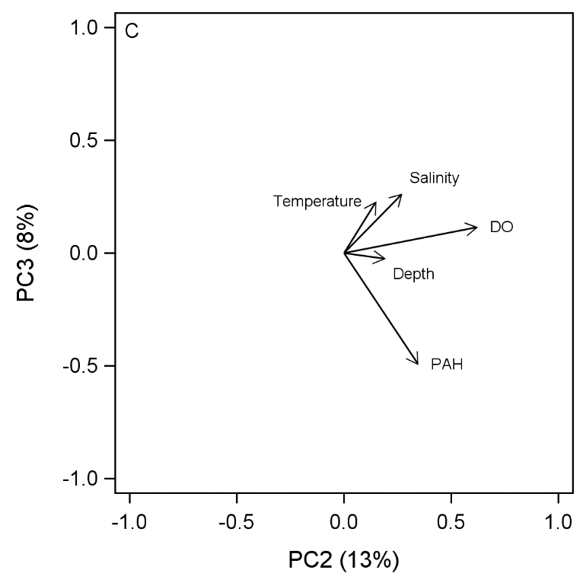
Fig. S1. Complement to Figure 2, Principal components analysis (PCA) of the environmental variables measured at each station. C) PC2 versus PC3.

