Supplementary Material

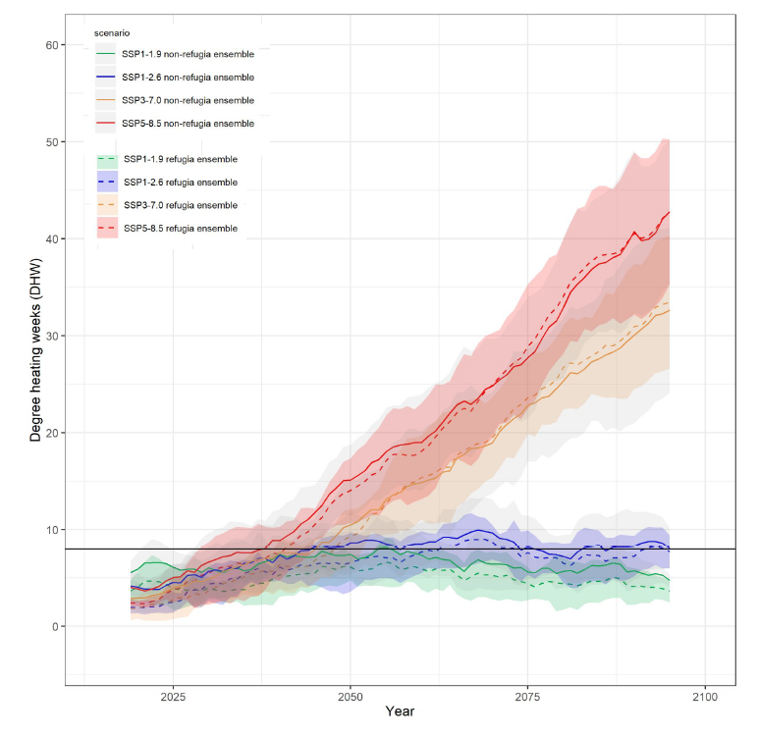
Supplementary Figure 1. Metrics of coral stress were extracted across the Great Barrier Reef for four socioeconomic pathways and an ensemble of five climate models for non-refugia and refugia locations. Coral stress metrics disaggregate magnitude as Degree Heating Weeks (DHW) shown using a rolling window of 11 years. The multi-model ensemble is made up of MRI-ESM2-0, EC-Earth3-Veg, UKESM1-0-LL, CNRM-ESM2-1, and IPSL-ESM2-0. Shaded areas denote the standard deviation for each scenario averaged across models. The horizontal black line in 1A marks 8 DHW, a metric of coral stress that often leads to mortality.
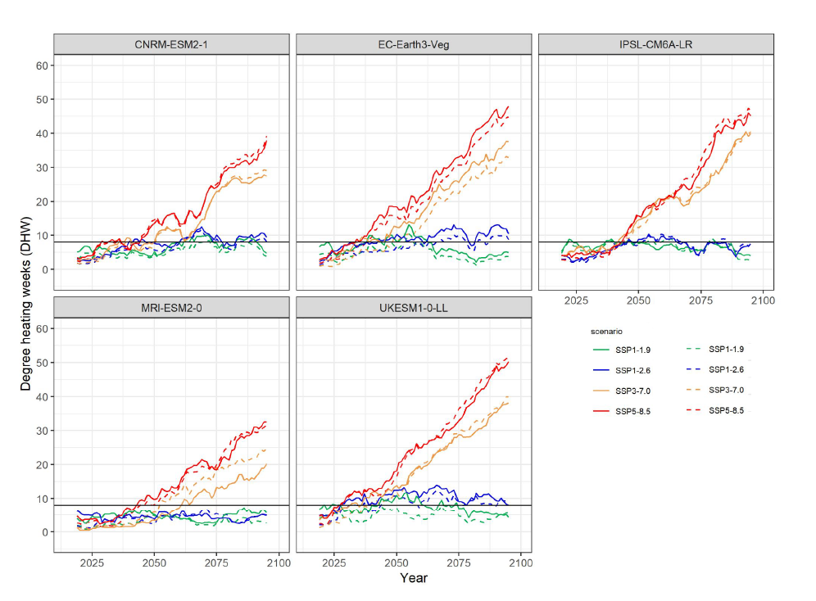
Supplementary Figure 2. Metrics of coral stress were extracted across the Great Barrier Reef for each of the five climate models with four socioeconomic pathways for non-refugia and refugia locations. Coral stress metrics disaggregate magnitude as Degree Heating Weeks (DHW) shown using a rolling window of 11 years. The horizontal black line marks 8 DHW, a metric of coral stress that often leads to mortality.

(a)
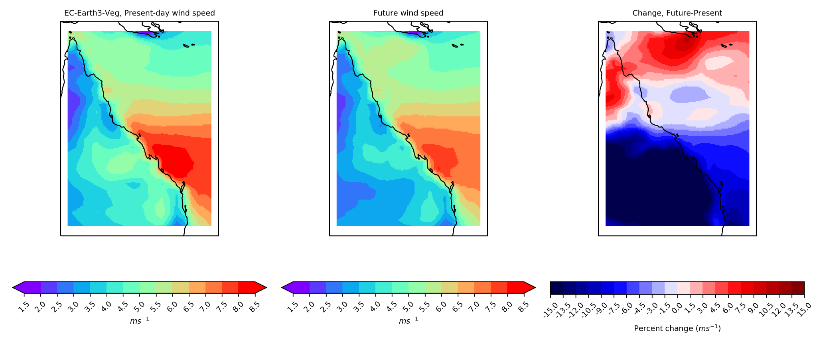
(b)
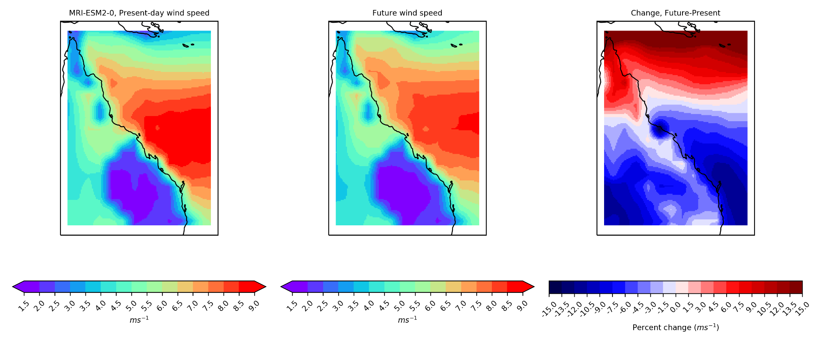
(c)
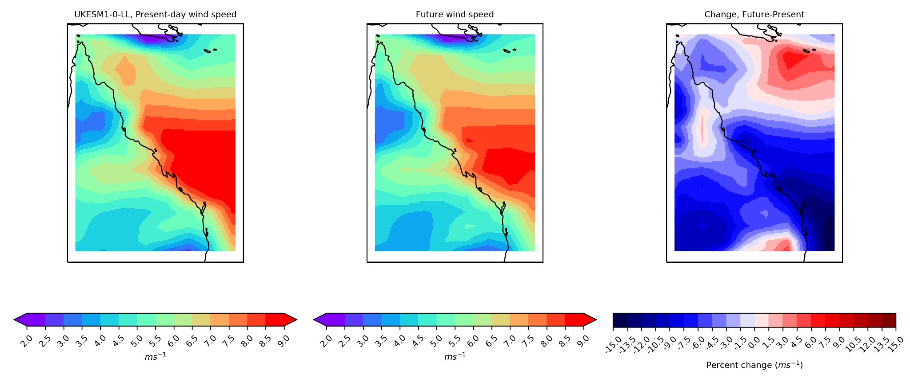
(d)
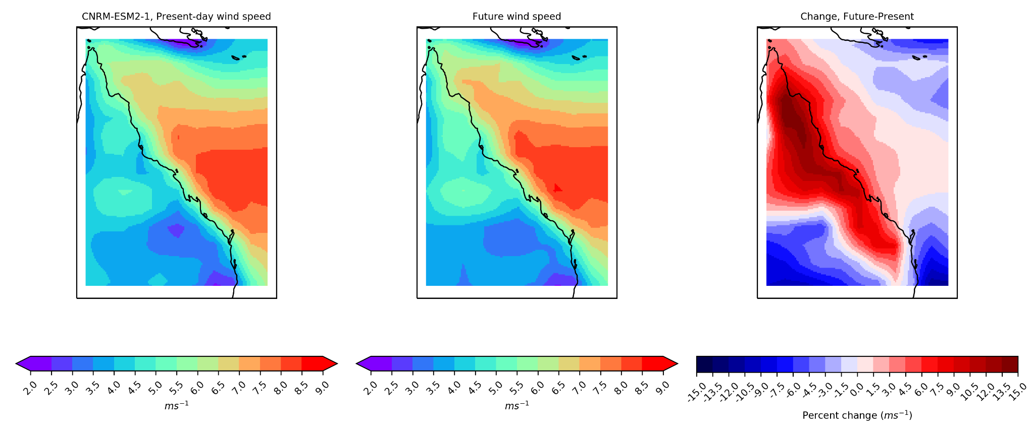
(e)
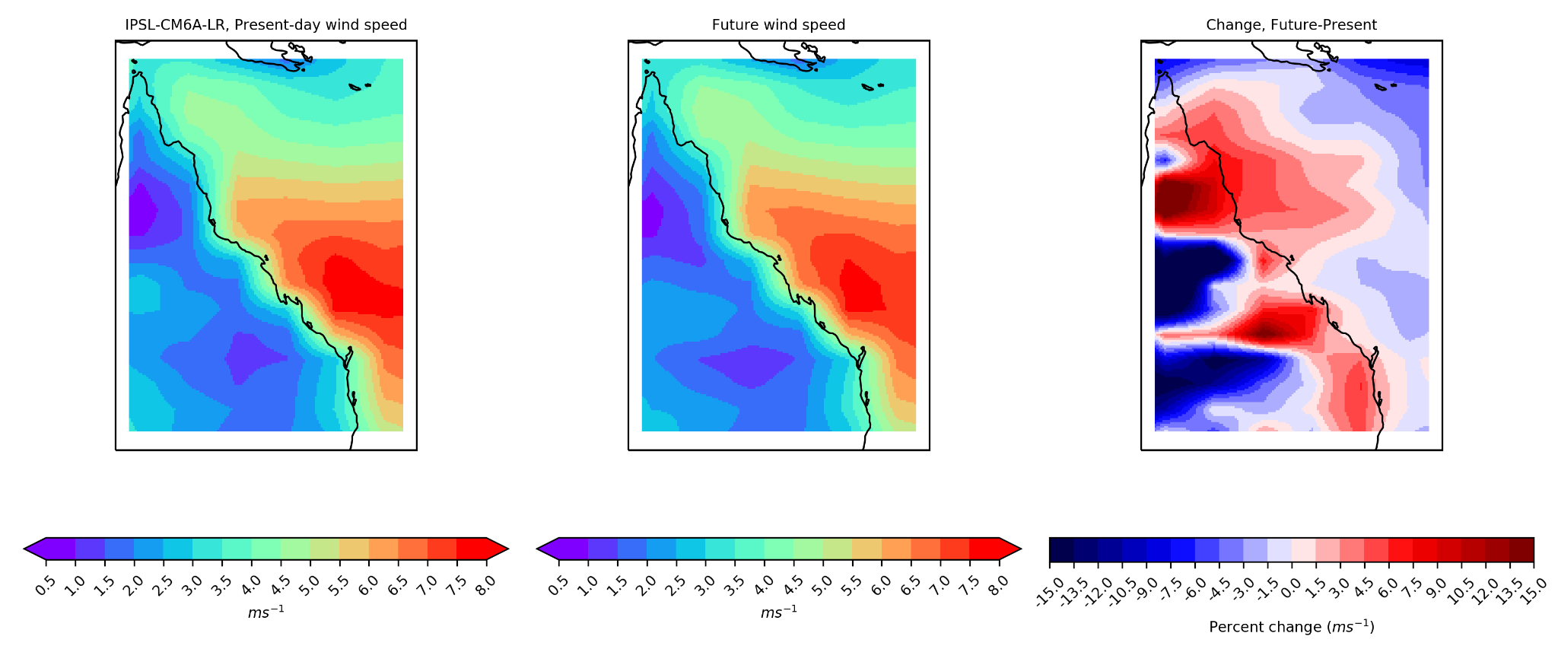
Supplementary Figure 3. Wind speed is shown under SSP5-8.5 for present-day, future, and the difference in wind speed during bleaching conditions per model (a) EC-Earth3-Veg, (b) MRI-ESM2-0, (c) UKESM1-0-LL, (d) CNRM-ESM2-1, and (e) IPSL-ESM2-0. Bleaching conditions are defined as austral summer months, December, January, February, March, calculated as austral summer years (i.e., July 31, 2050 – August 1, 2051) with the annual maximum DHW across the Great Barrier Reef Marine Park Authority boundary having a median value of DHW ≥ 2.

(a)
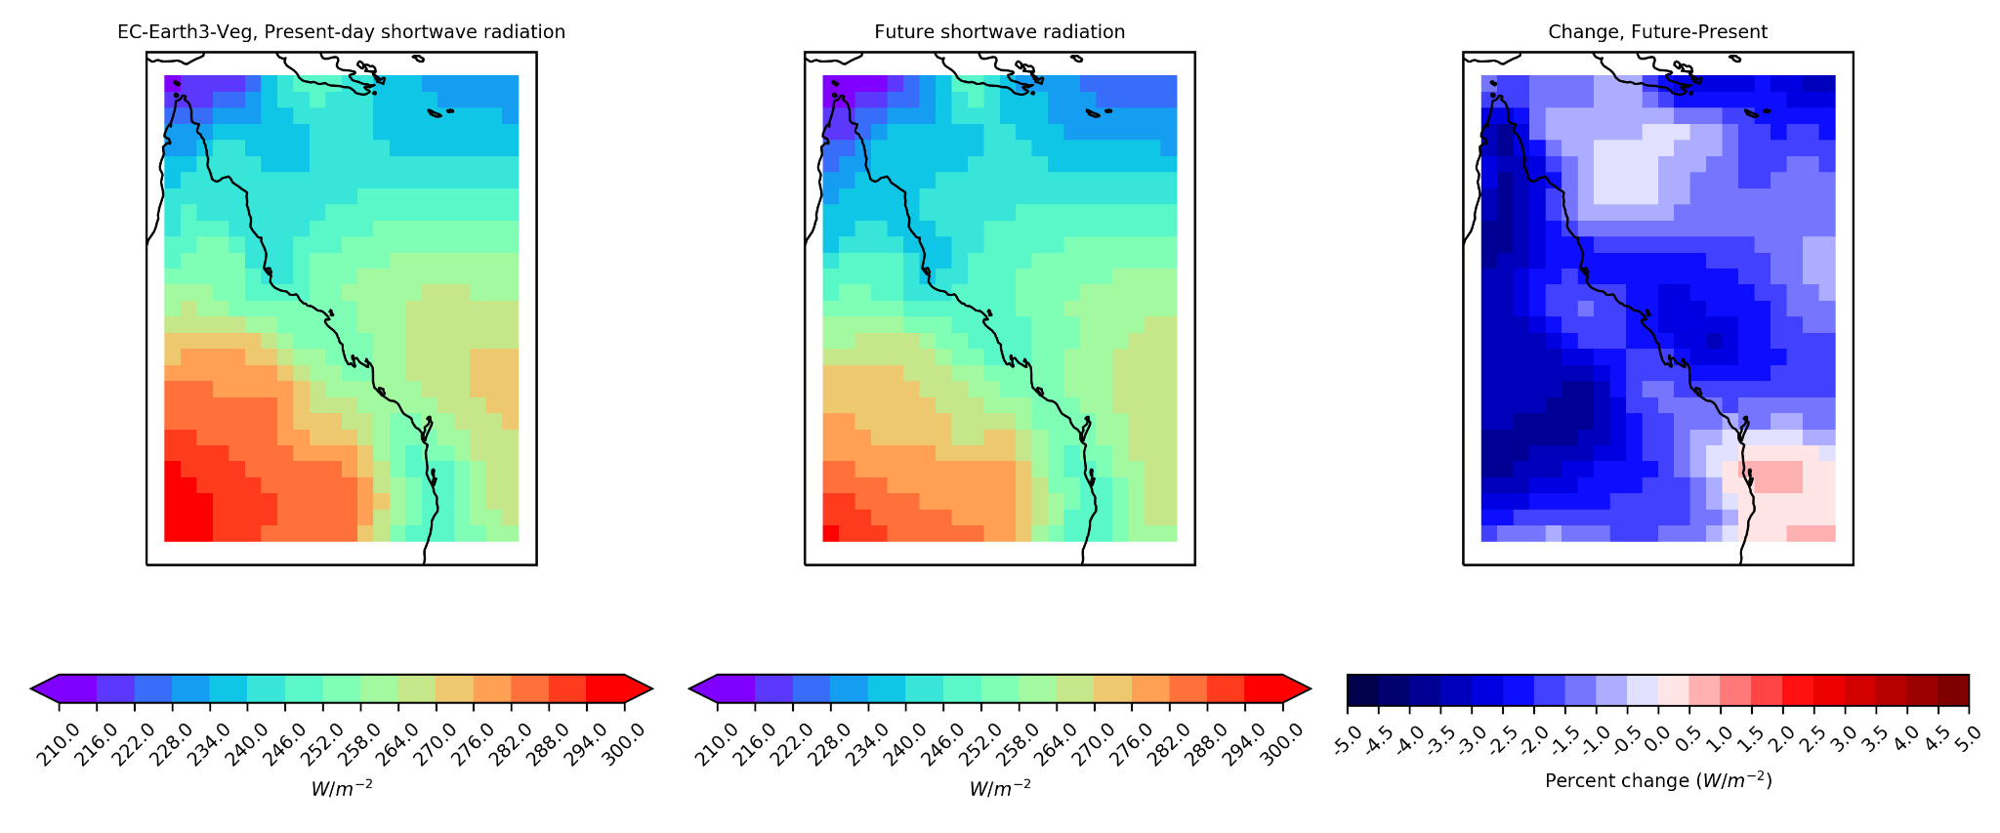
(b)
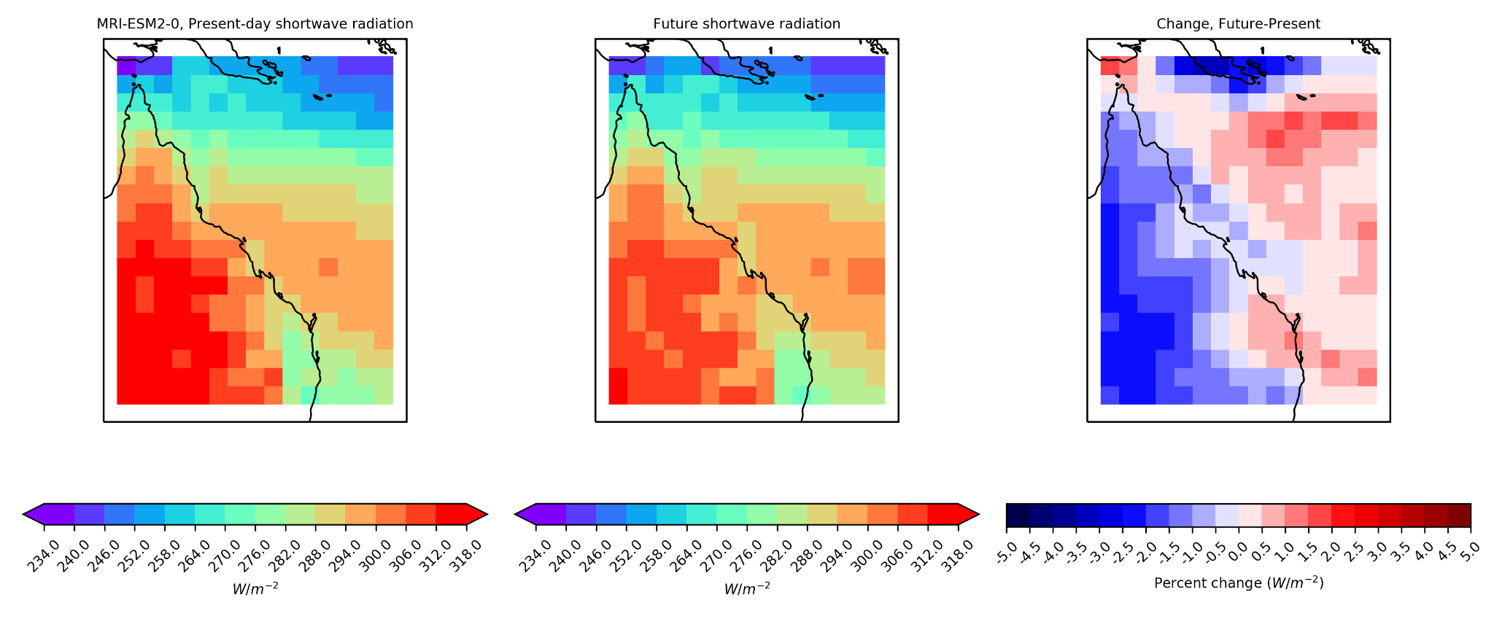
(c)
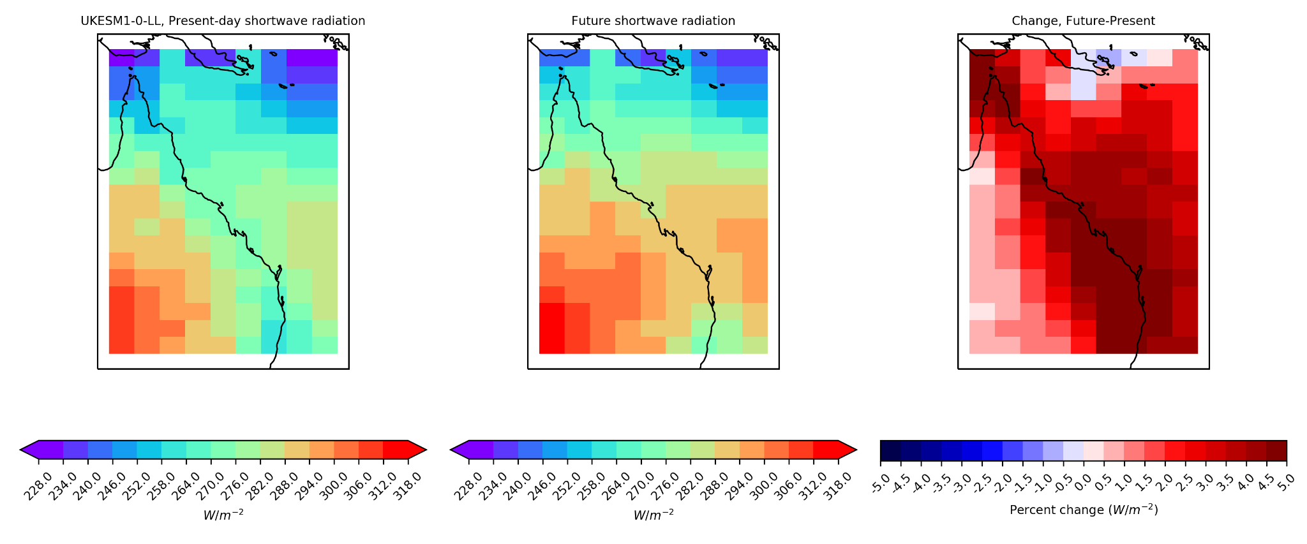
(d)
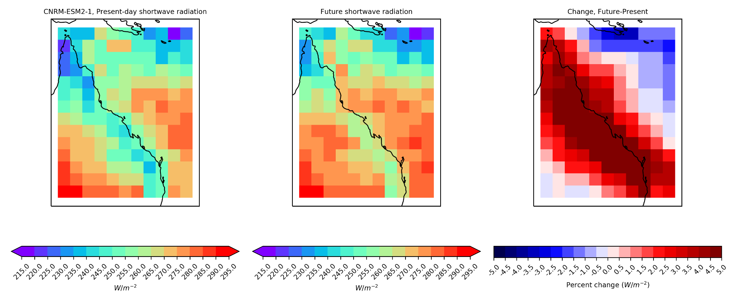
(e)
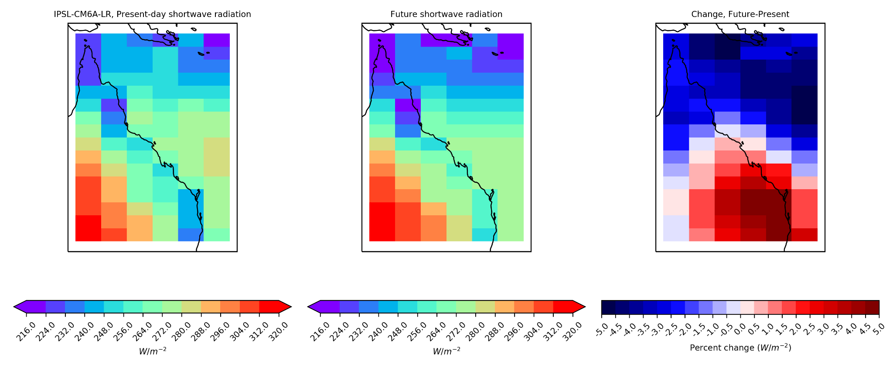
Supplementary Figure 4. Shortwave radiation is shown under SSP5-8.5 for present-day, future, and the difference in shortwave radiation during bleaching conditions per model (a) EC-Earth3-Veg, (b) MRI-ESM2-0, (c) UKESM1-0-LL, (d) CNRM-ESM2-1, and (e) IPSL-ESM2-0. Bleaching conditions are defined as austral summer months, December, January, February, March, calculated as austral summer years (i.e., July 31, 2050, – August 1, 2051) with the annual maximum DHW across the Great Barrier Reef Marine Park Authority boundary having a median value of DHW ≥2.

