Supplementary material:

AQI Category | AQI Value | 24-hour PM_{2.5} concentration (μg m⁻³)
Good | 0 - 50 | 0 - 15.4
Moderate | 51 - 100 | 15.5 - 40.4
Unhealthy for sensitive groups | 101 - 150 | 40.5 - 65.4
Unhealthy | 151 - 200 | 65.5 - 150.4
Very unhealthy | 201 - 300 | 150.5 - 250.4
Hazardous | > 300 | > 250.5
Table 1: EPA - Air Quality Index (AQI) for PM_{2.5}

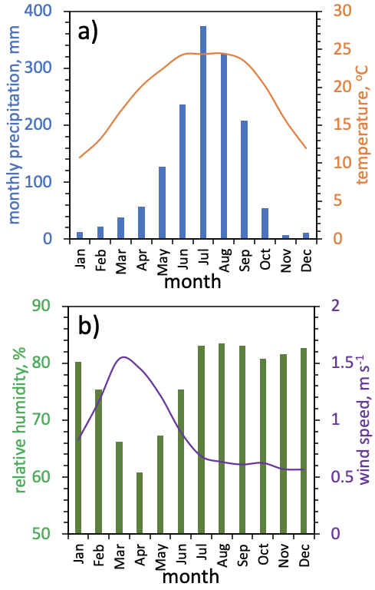
Figure S1: Monthly average weather condition in Kathmandu based on the average monthly data from 1980 to 2017. The upper panel (a) shows the total monthly precipitation (bar plot) and the average monthly temperature (line plot). The lower panel (b) shows the average monthly relative humidity (bar plot) and wind speed (line plot).

