

*Journal of Geophysical Research: Oceans*

Supporting Information for

**Transports and pathways of the tropical AMOC return flow from Argo data and shipboard velocity measurements**

Franz Philip Tuchen1,2, Peter Brandt1,3, Joke F. Lübbecke1,3,

Rebecca Hummels1

1 GEOMAR Helmholtz Centre for Ocean Research Kiel, Kiel, Germany

2 now at NOAA Atlantic Oceanographic and Meteorological Laboratory, Miami, FL, USA

3 Faculty of Mathematics and Natural Sciences, Kiel University, Kiel, Germany

Corresponding author address:

Franz Philip Tuchen, GEOMAR Helmholtz Centre for Ocean Research Kiel,

Düsternbrooker Weg 20, 24105 Kiel, Germany

Email: [ftuchen@geomar.de](mailto:ftuchen@geomar.de) / [franz.philip.tuchen@noaa.gov](mailto:franz.philip.tuchen@noaa.gov)

**Contents of this file:**

Figures:

* S1: 12 individual sections of shipboard current velocity measurements (11°S)
* S2: ARGO-HR sections for different reference levels
* S3: Tropical upwelling for different reference levels
* S4: Meridional transport as a function of density (Eastern Boundary)

Tables:

* S5: List of cruises and data sources at 11°S
* S6: List of cruises and data sources at 5°S
* S7: List of cruises and data sources at 35°W
* S8: List of cruises and data sources at 23°W

Text:

* Description of the mean current velocity sections along 11°S, 5°S, 35°W, and 23°W from shipboard measurements

*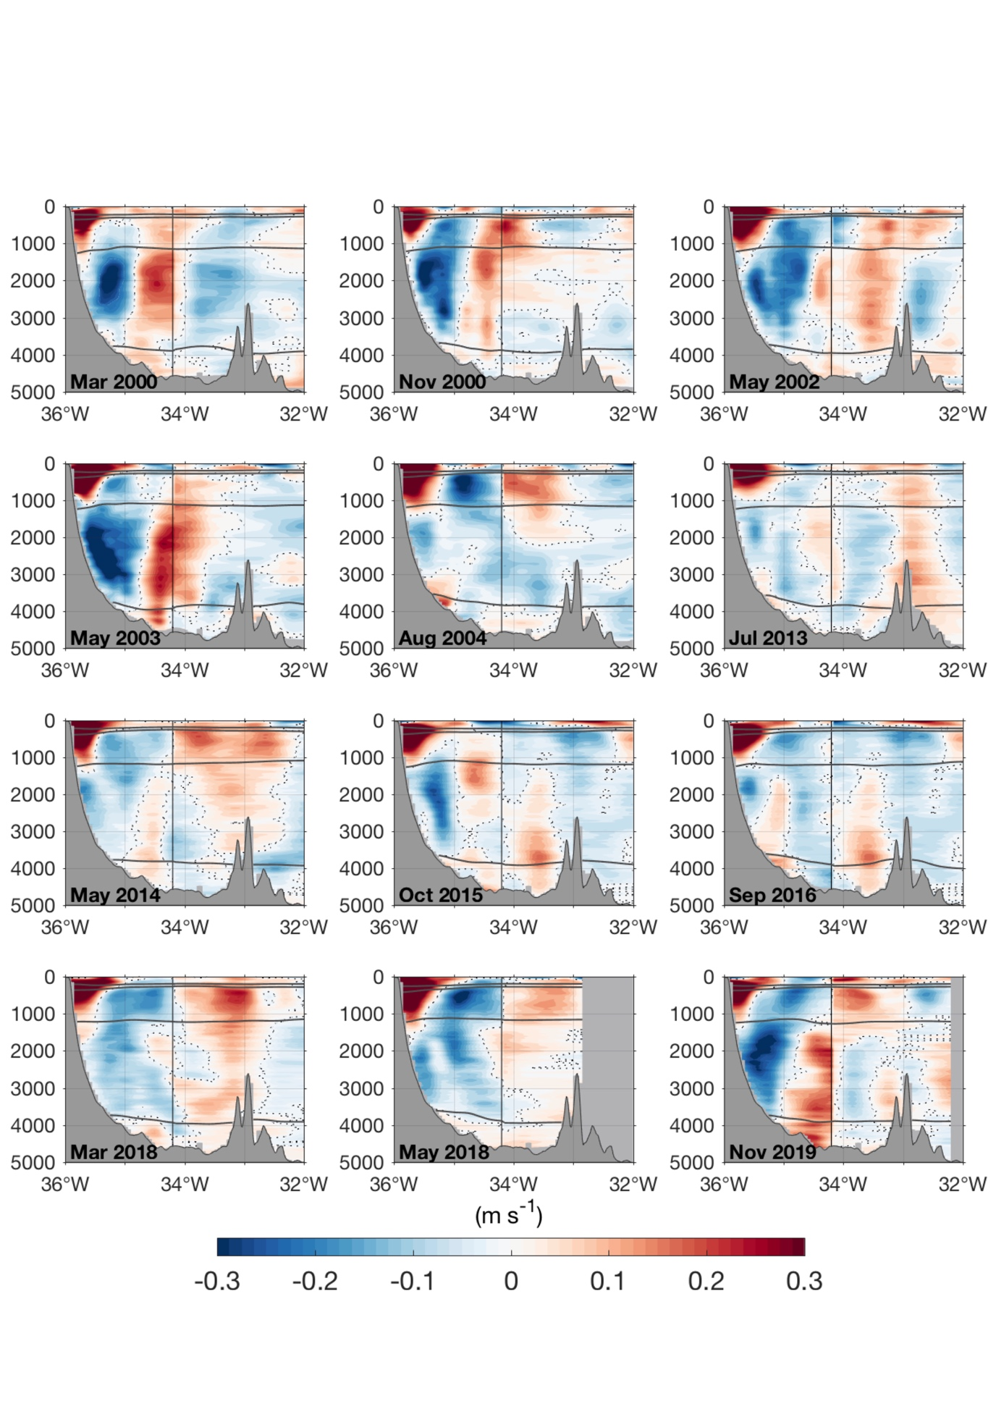*

***Figure S1:*** *Individual**ship sections of meridional (east of 34.2°W) and alongshore (west of 34.2°W) velocity at 11°S from 2000-2019. Solid thick lines represent neutral density surfaces and separate water masses according to Tab. 1. Dashed contours mark the zero-velocity line.*

***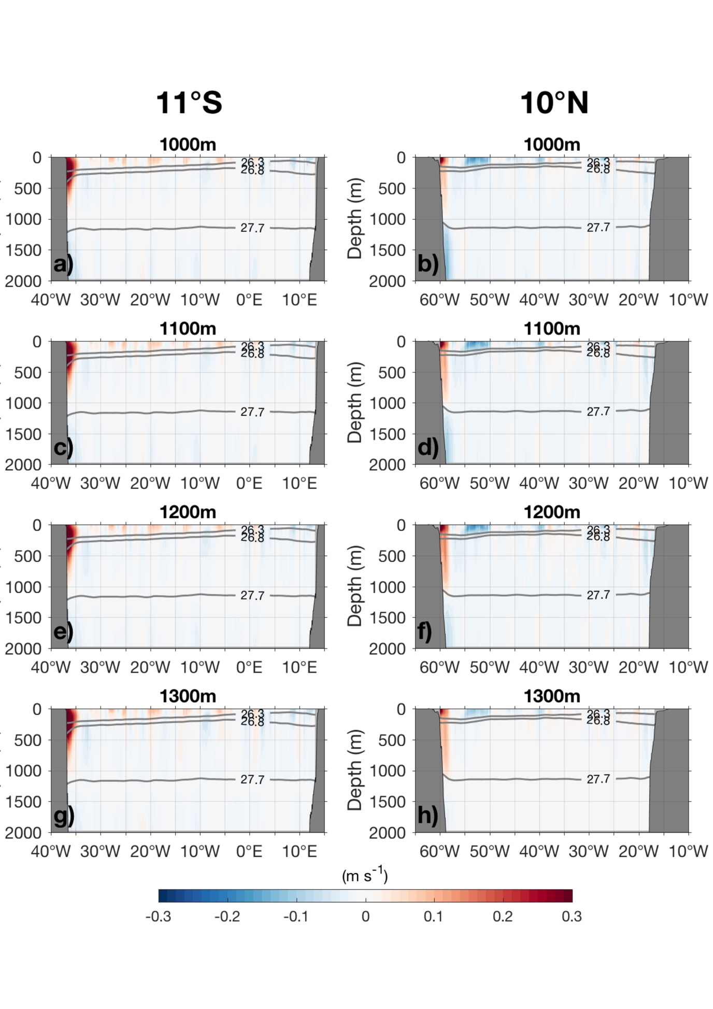Figure S2:*** *Meridional absolute geostrophic velocity sections for different reference levels of no motion at (a, b) 1,000m, (c, d) 1,100m, (e, f) 1,200m and (g, h) 1,300m at 11°S and 10°N from the climatological ARGO-HR product.*

***Figures/Fig_S3.pdf***

***Figure S3:*** *Volume balances and associated water mass transformation rates in between 11°S and 10°N from ARGO-HR as described in Fig. 9 based on differing reference levels of no motion. Water mass layers are defined in Tab. 1. The volume balance (squares; positive (negative) values indicate a convergence (divergence) of volume) and resulting diapycnal transport estimates (arrows) are given for the high-resolution Argo product based on the assumption of volume conservation within each individual water mass layer. The surface layer volume budget also includes the freshwater supply due to precipitation, evaporation and river runoff (blue square) according to Dai & Trenberth (2003).*

***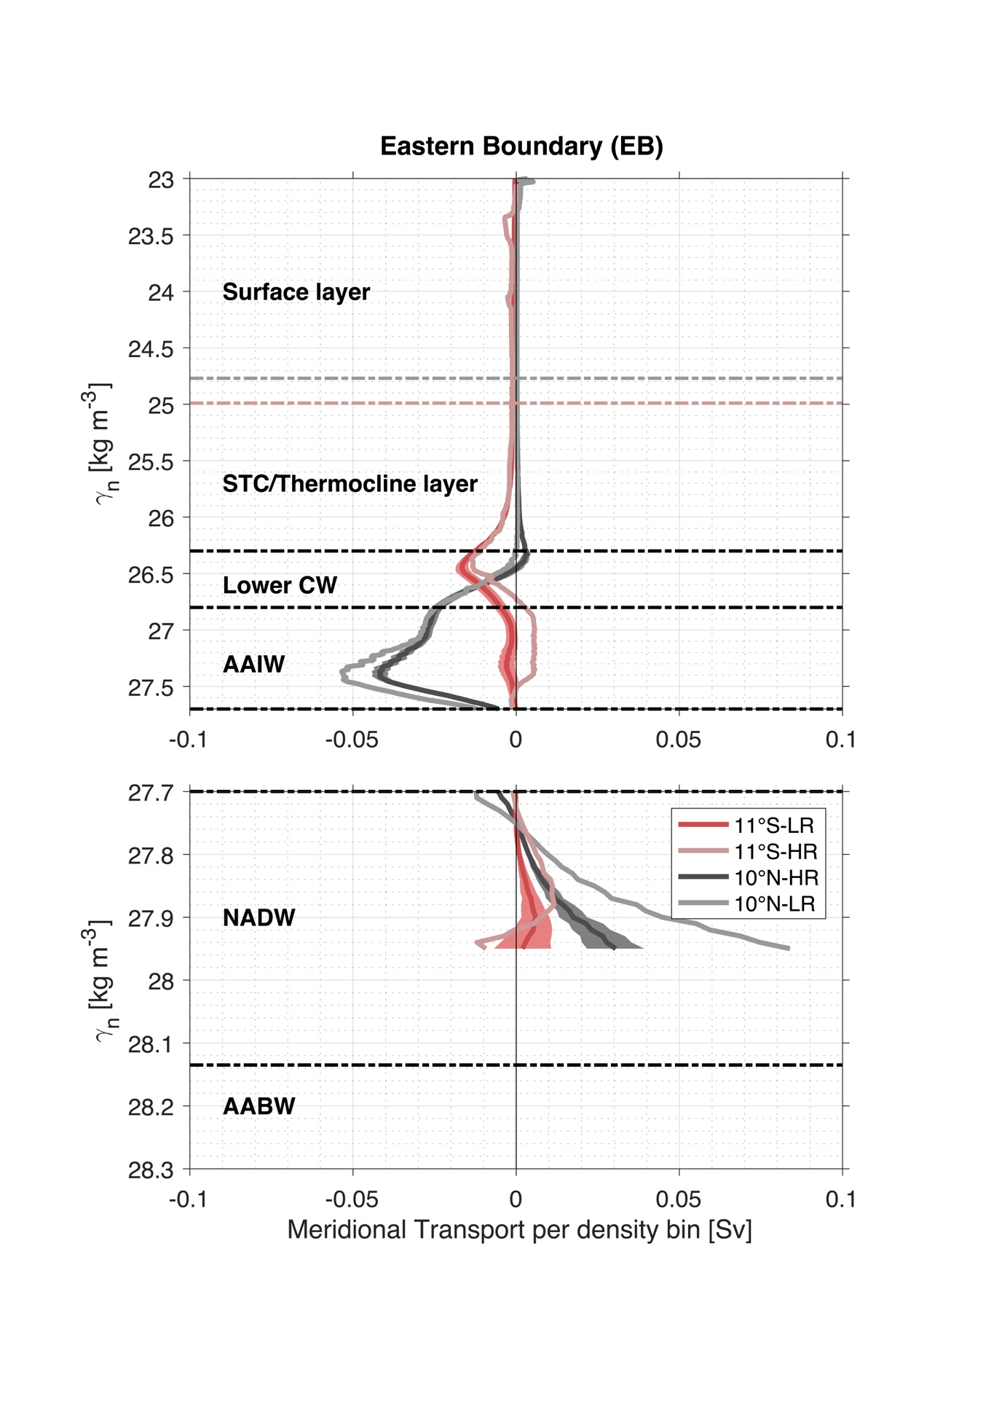***

***Figure S4:*** *Same as Fig. 5 but for the eastern boundary part of the zonal sections along 11°S (reddish) and 10°N (blackish). The eastern boundary at 11°S (10°N) is defined as eastward of 9°E (20°W).*

|  |  |  |
| --- | --- | --- |
| 11°S | Time Period | Source |
| RV Meteor M47/1 | March 2000 | <https://doi.org/10.1594/PANGAEA.873266> (LADCP) |
| RV Sonne S151 | November 2000 | <https://doi.org/10.1594/PANGAEA.869645> (LADCP) |
| RV Meteor M53/2 | May/June 2002 | <https://doi.org/10.1594/PANGAEA.869651> (LADCP) |
| RV Sonne S170 | May 2003 | <https://doi.org/10.1594/PANGAEA.869641> (LADCP) |
| RV Meteor M62/2 | August 2004 | <https://doi.org/10.1594/PANGAEA.869655> (LADCP) |
| RV Meteor M98 | July 2013 | <https://doi.org/10.1594/PANGAEA.873265> (LADCP)  <https://doi.org/10.1594/PANGAEA.869656> (vmADCP) |
| RV Meteor M106 | May 2014 | <https://doi.org/10.1594/PANGAEA.869634> (LADCP)  <https://doi.org/10.1594/PANGAEA.901421> (vmADCP) |
| RV Meteor M119 | September/October 2015 | <https://doi.org/10.1594/PANGAEA.877351> (LADCP)  <https://doi.org/10.1594/PANGAEA.877375> (vmADCP) |
| RV Meteor M130 | September 2016 | <https://doi.org/10.1594/PANGAEA.915871> (LADCP)  <https://doi.org/10.1594/PANGAEA.904389> (vmADCP) |
| RV Meteor M145 | March 2018 | <https://doi.org/10.1594/PANGAEA.915873> (LADCP)  <https://doi.org/10.1594/PANGAEA.899170> (vmADCP) |
| RV Meteor M148 | May 2018 | <https://doi.org/10.1594/PANGAEA.939883> (LADCP)  <https://doi.org/10.1594/PANGAEA.937657> (vmADCP) |
| RV Meteor M159 | November 2019 | <https://doi.org/10.1594/PANGAEA.939896> (LADCP)  <https://doi.org/10.1594/PANGAEA.937680> (vmADCP) |

***Table S5:*** *Individual research cruises and data sources along 11°S.*

|  |  |  |
| --- | --- | --- |
| 5°S | Time Period | Source |
| RV Meteor M14/2 | October 1990 | <https://doi.org/10.1594/PANGAEA.873335> (PEGASUS) |
| RV Meteor M16/3 | June 1991 | <https://doi.org/10.1594/PANGAEA.873388> (PEGASUS)  <https://doi.org/10.1594/PANGAEA.319324> (vmADCP) |
| RV Meteor M22/2 | November 1992 | <https://doi.org/10.1594/PANGAEA.873389> (PEGASUS)  <https://doi.org/10.1594/PANGAEA.873269> (LADCP)  <https://doi.org/10.1594/PANGAEA.319326> (vmADCP) |
| RV Meteor M27/3 | March 1994 | <https://doi.org/10.1594/PANGAEA.319330> (vmADCP) |
| RV Meteor M47/1 | March 2000 | <https://doi.org/10.1594/PANGAEA.873266> (LADCP) |
| RV Sonne S151 | November 2000 | <https://doi.org/10.1594/PANGAEA.869645> (LADCP) |
| RV Meteor M53/2 | May 2002 | <https://doi.org/10.1594/PANGAEA.869651> (LADCP) |
| RV Sonne S170 | May 2003 | <https://doi.org/10.1594/PANGAEA.869641> (LADCP) |
| RV Meteor M62/2 | August 2004 | <https://doi.org/10.1594/PANGAEA.869655> (LADCP) |
| RV Meteor M98 | July 2013 | <https://doi.org/10.1594/PANGAEA.873265> (LADCP)  <https://doi.org/10.1594/PANGAEA.869656> (vmADCP) |
| RV Meteor M106 | May 2014 | <https://doi.org/10.1594/PANGAEA.869634> (LADCP)  <https://doi.org/10.1594/PANGAEA.901421> (vmADCP) |
| RV Meteor M119 | October 2015 | <https://doi.org/10.1594/PANGAEA.877351> (LADCP)  <https://doi.org/10.1594/PANGAEA.877375> (vmADCP) |
| RV Meteor M130 | September/October 2016 | <https://doi.org/10.1594/PANGAEA.915871> (LADCP)  <https://doi.org/10.1594/PANGAEA.904389> (vmADCP) |
| RV Meteor M145 | March 2018 | <https://doi.org/10.1594/PANGAEA.915873> (LADCP)  <https://doi.org/10.1594/PANGAEA.899170> (vmADCP) |
| RV Meteor M159 | November 2019 | <https://doi.org/10.1594/PANGAEA.939896> (LADCP)  <https://doi.org/10.1594/PANGAEA.937680> (vmADCP) |

***Table S6:*** *Individual research cruises and data sources along 5°S*

|  |  |  |
| --- | --- | --- |
| 35°W | Time Period | Source |
| RV Meteor M14/2 | October 1990 | <https://doi.org/10.1594/PANGAEA.873335> (PEGASUS)  <https://doi.org/10.1594/PANGAEA.873333> (LADCP) |
| RV Meteor M16/3 | June 1991 | <https://doi.org/10.1594/PANGAEA.873388> (PEGASUS)  <https://doi.org/10.1594/PANGAEA.873271> (LADCP)  <https://doi.org/10.1594/PANGAEA.319324> (vmADCP) |
| RV Meteor M22/2 | November 1992 | <https://doi.org/10.1594/PANGAEA.873389> (PEGASUS)  <https://doi.org/10.1594/PANGAEA.319326> (vmADCP) |
| RV L’Atalante  CITHER 1 | February 1993 | <https://doi.org/10.17600/93000010> (Cruise details) |
| RV Meteor M27/3 | March 1994 | <https://doi.org/10.1594/PANGAEA.319330> (vmADCP) |
| RV Le Noroit  ETAMBOT 1 | September 1995 | <https://campagnes.flotteoceanographique.fr/file?id=51572_1> (vmADCP) |
| RV Edwin A. Link ETAMBOT 2 | April 1996 | <https://campagnes.flotteoceanographique.fr/file?id=51612_1> (vmADCP) |
| RV La Thalassa  Equalant 99 | August 1999 | <https://campagnes.flotteoceanographique.fr/file?id=68212_1> (vmADCP)  <https://campagnes.flotteoceanographique.fr/file?id=68212_2> (vmADCP)  <https://campagnes.flotteoceanographique.fr/file?id=68212_3> (vmADCP)  <https://campagnes.flotteoceanographique.fr/file?id=68212_4> (vmADCP) |
| RV Meteor M47/1 | March 2000 | <https://doi.org/10.1594/PANGAEA.873266> (LADCP) |
| RV Sonne S152 | November 2000 | <https://doi.org/10.1594/PANGAEA.873261> (LADCP) |
| RV Oceanus OC365/4 | March 2001 | <https://www.nodc.noaa.gov/archive/arc0023/0056193/1.1/data/0-data/OC365L04/ADCP/> (LADCP)  <https://www.nodc.noaa.gov/archive/arc0023/0056193/1.1/data/0-data/OC365L04/ADCP2/3654/> (vmADCP) |
| RV Ron Brown 0201 | February 2002 | <https://currents.soest.hawaii.edu/ron_brown/rb0201/cont_D.html> (Cruise details) |
| RV Meteor M53/2 | May 2002 | <https://doi.org/10.1594/PANGAEA.869651> (LADCP) |
| RV Sonne S171 | May 2003 | <https://doi.org/10.1594/PANGAEA.873268> (LADCP) |
| RV Meteor M62/2 | August 2004 | <https://doi.org/10.1594/PANGAEA.869655> (LADCP) |
| RV Meteor M68/2 | June 2006 | [https://doi.org/10.1594/PANGAEA.874876](https://doi.pangaea.de/10.1594/PANGAEA.874876) (vmADCP) |

***Table S7:*** *Individual research cruises and data sources along 35°W*

|  |  |  |
| --- | --- | --- |
| 23°W | Time Period | Source |
| RV Meteor M47/1 | March 2000 | <https://doi.org/10.1594/PANGAEA.873266> (LADCP) |
| RV Meteor M55/1 | October/November 2002 | <https://doi.org/10.1594/PANGAEA.877591> (vmADCP) |
| RV Polarstern PSXXII\_5 | June 2005 | <https://doi.org/10.1594/PANGAEA.877358> (vmADCP) |
| RV Ronald H. Brown RB200605A | May/June 2006 | <ftp://ftp.aoml.noaa.gov/phod/pub/PNE/PNE2006/> (LADCP & vmADCP) |
| RV Ronald H. Brown RB200605B | June/July 2006 | <ftp://ftp.aoml.noaa.gov/phod/pub/PNE/PNE2006/> (LADCP & vmADCP) |
| RV Meteor M68/2 | June 2006 | [https://doi.org/10.1594/PANGAEA.874876](https://doi.pangaea.de/10.1594/PANGAEA.874876) (vmADCP) |
| RV L’Atalante IFM-GEOMAR4  (2 sections) | February/March 2008 | <https://doi.org/10.1594/PANGAEA.811565> (LADCP) |
| RV Polarstern PSXXV\_5 | April/May 2008 | <https://doi.org/10.1594/PANGAEA.877357> (vmADCP) |
| RV Ronald H. Brown PNE09 | July/August 2009 | <ftp://ftp.aoml.noaa.gov/phod/pub/PNE/PNE2009/> (vmADCP) |
| RV Polarstern PSXXVI\_1 | October/November 2009 | <https://doi.org/10.1594/PANGAEA.877355> (vmADCP) |
| RV Meteor M80/1 | November 2009 | <https://doi.org/10.1594/PANGAEA.811718> (LADCP)  <https://doi.org/10.1594/PANGAEA.877364> (vmADCP) |
| RV Meteor M81/1 | February/March 2010 | <https://doi.org/10.1594/PANGAEA.877359> (vmADCP) |
| RV Polarstern PSXXVI\_4 | April/May 2010 | <https://doi.org/10.1594/PANGAEA.877354> (vmADCP) |
| RV Ronald H. Brown PNE10 | April/May 2010 | <ftp://ftp.aoml.noaa.gov/phod/pub/PNE/PNE2010/> (LADCP & vmADCP) |
| RV Maria S. Merian MSM 18/2 | May 2011 | <https://doi.org/10.1594/PANGAEA.846777> (LADCP)  <https://doi.org/10.1594/PANGAEA.877352> (vmADCP) |
| RV Maria S. Merian MSM 18/3 | June 2011 | <https://doi.org/10.1594/PANGAEA.844007> (vmADCP) |
| RV Ronald H. Brown PNE11 | July/August 2011 | <ftp://ftp.aoml.noaa.gov/phod/pub/PNE/PNE2011/> (vmADCP) |
| RV Maria S. Merian MSM 22/1 | November 2012 | <https://doi.org/10.1594/PANGAEA.846763> (LADCP) <https://doi.org/10.1594/PANGAEA.841476> (vmADCP) |
| RV Ronald H. Brown PNE13a | January/February 2013 | <ftp://ftp.aoml.noaa.gov/phod/pub/PNE/PNE2013/2013a/> (LADCP & vmADCP) |
| RV Ronald H. Brown PNE13b | November/December 2013 | <ftp://ftp.aoml.noaa.gov/phod/pub/PNE/PNE2013/2013b/> (LADCP & vmADCP) |
| RV Meteor M106 | May 2014 | <https://doi.org/10.1594/PANGAEA.869634> (LADCP)  <https://doi.org/10.1594/PANGAEA.901421> (vmADCP) |
| RV Polarstern PSXXX\_1\_2 | November 2014 | <https://doi.org/10.1594/PANGAEA.877353> (vmADCP) |
| RV Endeavor PNE14 | December 2014 – February 2015 | <ftp://ftp.aoml.noaa.gov/phod/pub/PNE/PNE2014/> (LADCP & vmADCP) |
| RV Meteor M119 | September/October 2015 | <https://doi.org/10.1594/PANGAEA.877351> (LADCP)  <https://doi.org/10.1594/PANGAEA.877375> (vmADCP) |
| RV Meteor M130 | September 2016 | <https://doi.org/10.1594/PANGAEA.915871> (LADCP)  <https://doi.org/10.1594/PANGAEA.904389> (vmADCP) |
| RV Ronald H. Brown PNE17 | February/March 2017 | <ftp://ftp.aoml.noaa.gov/phod/pub/PNE/PNE2017/> (LADCP & vmADCP) |
| RV Meteor M145 | March 2018 | <https://doi.org/10.1594/PANGAEA.915873> (LADCP)  <https://doi.org/10.1594/PANGAEA.899170> (vmADCP) |

***Table S8:*** *Individual research cruises and data sources along 23°W*

**Mean current velocity sections along 11°S, 5°S, 35°W, and 23°W from shipboard measurements:**

The presented mean sections of current velocity derived from shipboard measurements as shown in Fig. 1 for 11°S and in Fig. 10 for 5°S, 35°W, and 23°W are provided via zenodo: <https://doi.org/10.5281/zenodo.5772272> (*Tuchen et al. 2022)*. The individual files include the mean velocity field as well as the mean neutral density field in longitude-depth space for the zonal sections along 11°S and 5°S and in latitude-depth space for the meridional sections along 35°W and 23°W. The mean sections are an average of the individual sections listed in Tab. S5, S6, S7 and S8. Please note that the 11°S section consists of a zonal part and a cross-shore part (see Fig. 3). Velocities along the cross-shore part of the 11°S-section are rotated clockwise by 36° in order to derive along-shore velocities. Since current velocities derived from shipboard measurements typically do not cover the upper 10-20 m and are often extrapolated to the surface, the upper 10 m are replaced by the gridded mean surface current velocities at 1/4° horizontal resolution derived from satellite-tracked surface drifting buoys (*Laurindo et al. 2017*) that were horizontally interpolated to the resolution of the individual ship sections.

**REFERENCES**

Laurindo, L., Mariano, A., & Lumpkin, R. (2017): An improved near-surface velocity climatology for the global ocean from drifter observations. *Deep-Sea Research Part I*, 124, 73-92, <https://doi.org/10.1016/j.dsr.2017.04.009>

Tuchen, F. P., Brandt, P., Lübbecke, J. F., & Hummels, R. (2022): Mean current velocity sections along 11°S, 5°S, 35°W, and 23°W from shipboard measurements used in "Transports and pathways of the tropical AMOC return flow from Argo data and shipboard velocity measurements" (Version 1) [Data set]. *Zenodo*. <https://doi.org/10.5281/zenodo.5772272>