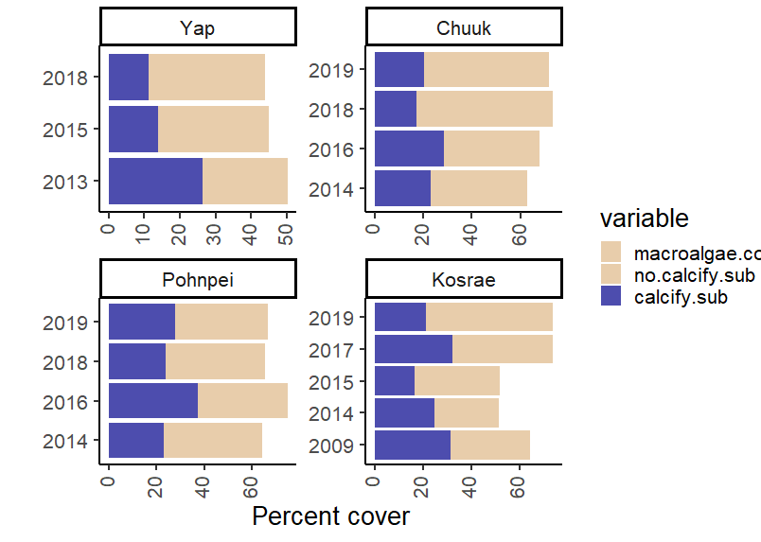
a)

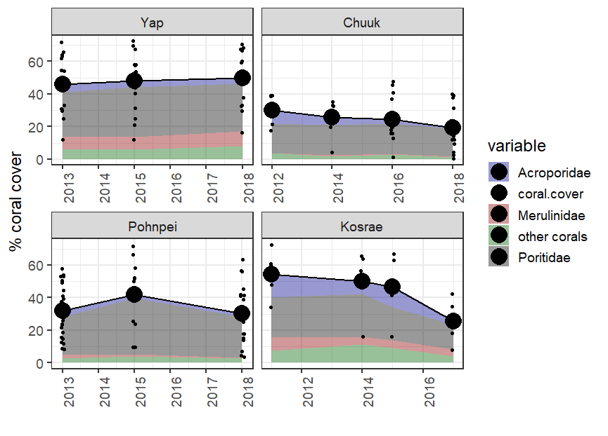
b)

S1 Figure. Trends in non-coral calcifying versus non-calcifying substrates (a) and coral cover (b) across the study islands exposed to the their most recent disturbance event that was investigated in the present study (red arrows). The most dominant non-coral, calcifying substrates that were impacted by disturbances included crustose coralline algae and soft corals to a lesser extent (a, blue color). The most dominant non-calcifying substrates that responded to temperature stress events included turf and macroalgae, as well as cyanobacteria and encrusting red/brown algae with little calcification (i.e., Lobophora and some species within Peyssonneliaceae) (a, brown color). Coral cover data along the same disturbance timeline showing trends for four major coral groups (b) (Acroporidae, Poritidae, Merulinidae, and all other corals grouped). Data were derived from benthic photo quadrats taken along replicate 50m transects noted in the methods. Together, these graphs highlight the loss of coral and/or calcifying substrates associated with the most recent thermal stress event, and the replacement with non-calcifying substrates. In turn, these trends were associated with fish assemblage responses reported in the results.

