Supplementary data
Figures

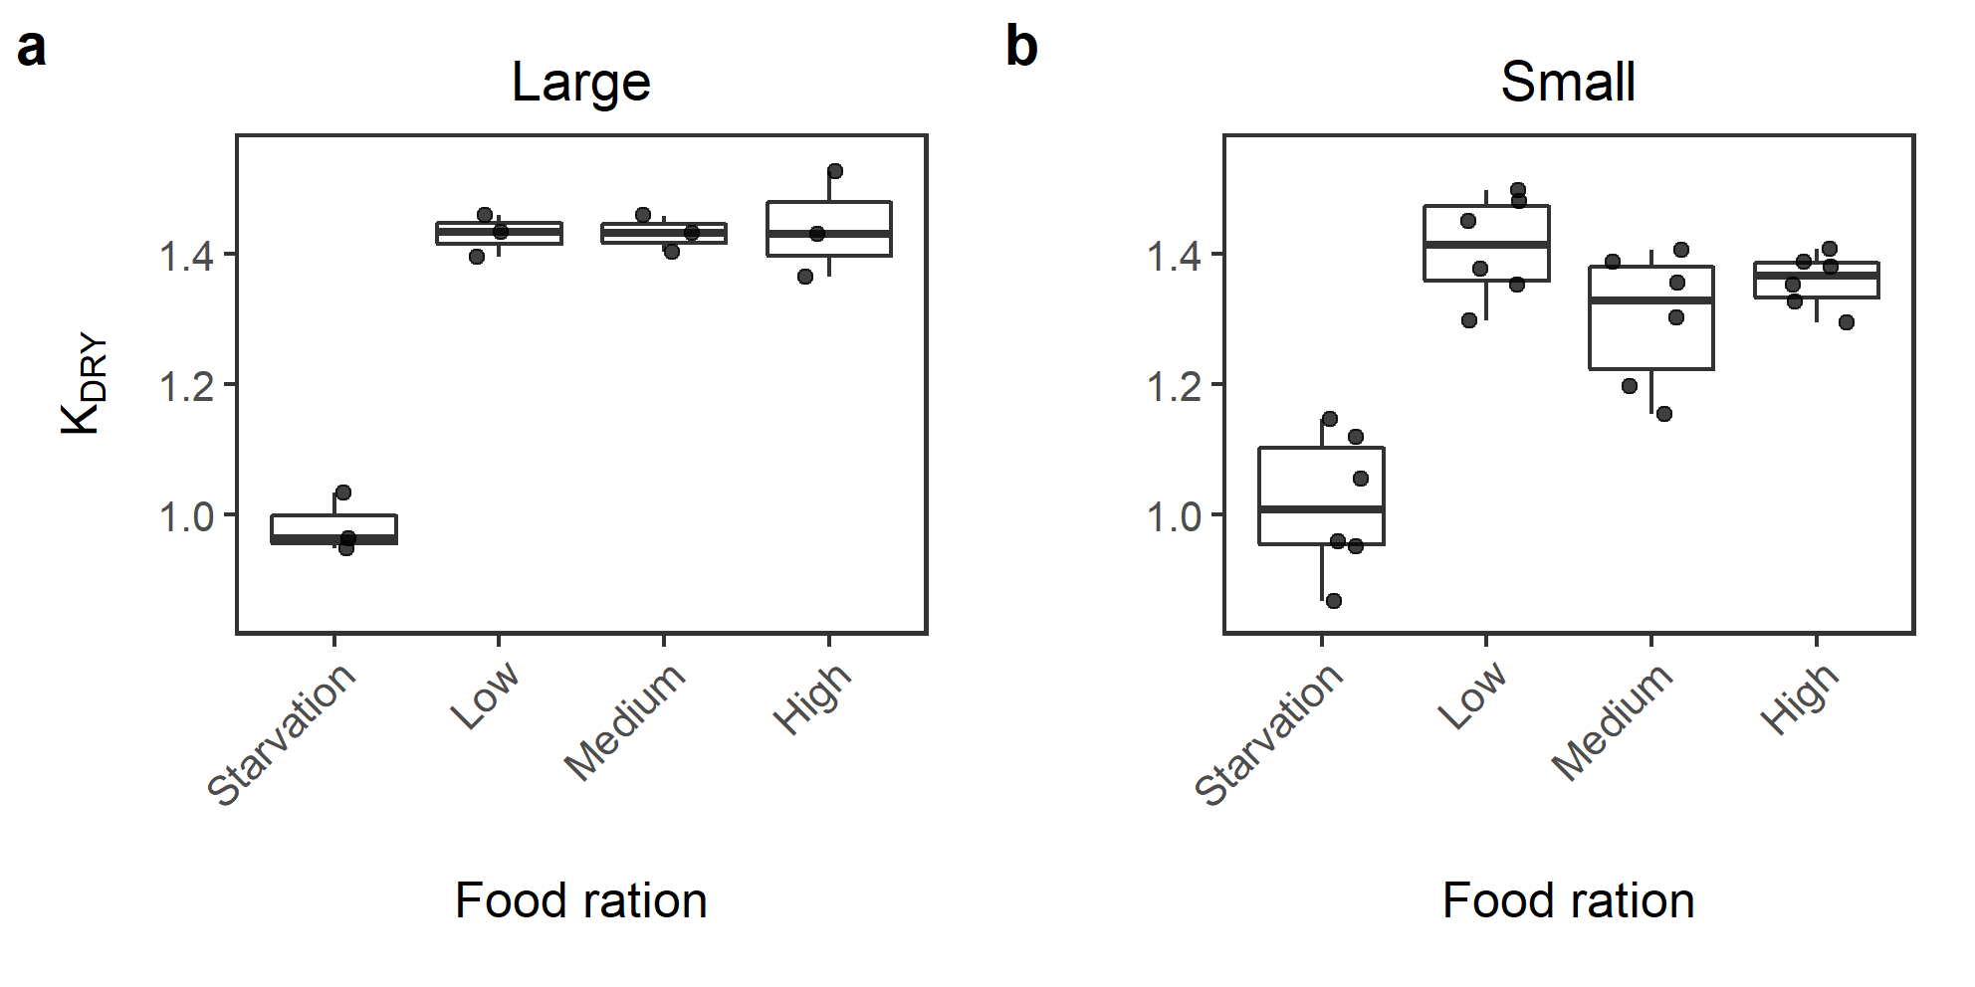
Figure S1. Fulton’s condition factor K (K_{DRY}) of (a) large and (b) small juvenile Atlantic cod under four feeding rations (starvation [0.0%], low [2.5%], medium [5.0%] and high [10% dry body weight]) (n=24 small size class, 12 large size class tanks). The bold line represents the median. The lower and upper hinges correspond to the first and third quantiles, and the upper and lower whiskers extend to the largest and smallest value within 1.5x the interquartile range. Individual points represent K_{DRY} values by tank.

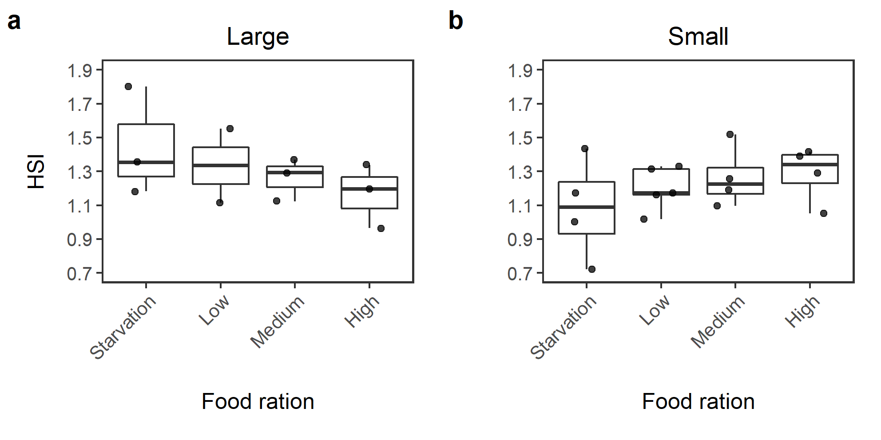
Figure S2. Mean hepatosomatic index (HSI) by tank of (a) large and (b) small juvenile Atlantic cod under four feeding rations (starvation [0.0%], low [2.5%], medium [5.0%] and high [10% dry body weight]) (n=24 small size class, 12 large size class tanks). The bold line represents the median. The lower and upper hinges correspond to the first and third quantiles, and the upper and lower whiskers extend to the largest and smallest value within 1.5x the interquartile range. Individual points represent HSI values by tank.

Table S1. Analysis of Deviance table for the effect of size and ration on Fulton’s condition factor K (K_{WET}) over the duration of the experiment. Model was written as a general linear model with repeated measures (tank). Error distribution is Gaussian with an identity link (n=116).
Explanatory Variable | Chi-square | DF | P-value
Intercept | 3206.03 | 1 | <0.001
Ration | 3.77 | 3 | 0.287
Size | 3.71 | 1 | 0.054
Day of Experiment | 150.35 | 1 | <0.0001
Ration x Day of Experiment | 167.89 | 3 | <0.0001
Size x Day of Experiment | 13.70 | 1 | .0002

Table S2. Analysis of Variance table for the effect of size and ration on change in Fulton’s condition factor K (ΔK_{DRY}). Model was written as a general linear model with Gaussian error distribution (n=36).
Explanatory Variable | Sum of Squares | DF | F-Value | P-value
Intercept | 0.83 | 1 | 125.13 | <0.0001
Ration | 0.99 | 3 | 49.56 | <0.0001
Size | 0.04 | 1 | 5.94 | 0.02
Residuals | 0.21 | 31

Table S3. Analysis of Variance table for the effect of size and ration on change in hepatosomatic index (ΔHSI). Model was written as a general linear model with Gaussian error distribution (n=36).
Explanatory Variable | Sum of Squares | DF | F-Value | P-value
Intercept | 0.64 | 1 | 12.98 | 0.0015
Ration | 0.0035 | 3 | 0.024 | 0.99
Size | 1.85 | 1 | 37.42 | <0.0001
Residuals | 1.14 | 23

Table S4. Analysis of Deviance table for the effect of size and ration on specific growth rate (SGR_{W}). Model was written as a general linear mixed effect model with Gaussian error distribution and identity link (n=36).
Explanatory Variable | Chi-square | DF | P-value
Ration | 277.89 | 3 | <0.0001
Size | 0.27 | 1 | 0.606
Day of Experiment | 14.29 | 1 | 0.0002

Table S5. Analysis of Deviance table for the effect of size and ration on specific growth rate (SGR_{L}). Model was written as a general linear mixed effect model with Gaussian error distribution and identity link (n=36).
Explanatory Variable | Chisquare | DF | P-value
Ration | 42.78 | 3 | <0.0001
Size | 3.37 | 1 | 0.066
Day of Experiment | 4.15 | 1 | 0.041

Table S6. Analysis of Variance table for the effect of size, ration, and temperature on feeding rate. Model was written as a general linear model with Gaussian error distribution and identity link (n=143).
Explanatory Variable | Sum of Squares | DF | F-Value | P-value
Intercept | 2.13 | 1 | 1323.24 | <0.0001
Ration | 0.037 | 2 | 11.51 | <0.0001
Size | 0.0015 | 1 | 0.91 | 0.34
Temperature | 0.45 | 1 | 279.20 | <0.0001
Residuals | 0.16 | 97

Table S7. Analysis of Variance table for the effect of size, ration, and temperature on food conversion efficiency (FCE). Model was written as a general linear model with Gaussian error distribution and identity link (n=114).
Explanatory Variable | Sum of Squares | DF | F-Value | P-value
Intercept | 20.70 | 1 | 66.52 | <0.0001
Ration | 2.79 | 2 | 4.48 | 0.01
Size | 2.23 | 1 | 7.15 | 0.0086
Temperature | 1.07 | 1 | 3.44 | 0.066
Residuals | 33.92 | 109

