Supplemental information for “Evaluating land surface phenology retrieved from the Advanced Himawari Imager using in-situ observations from the Phenological Eyes Network”

Contents of this file:
Supplementary tables S1-S6
Supplementary figures S1 – S6

Supplementary table
Table S1. Geographic coordinate and land cover of the study sites.
Site | Latitude/Longitude | Land cover
Fuji-Hokuroku (FHK) | 35.44°N / 138.76°E | Deciduous needleleaf forest
Mase flux site (MSE) | 36.05°N / 140.03°E | Rice paddy
Mt. Tsukuba (MTK) | 36.23°N / 140.10°E | Mixed forest
TERC grass field (TGF) | 36.11°N / 140.10°E | Grass
Takayama flux site (TKY) | 36.14°N / 137.42°E | Deciduous broadleaf forest
Teshio CC-LaG site (TSE) | 45.01°N / 142.11°E | Deciduous needle-leaf plantation and dwarf bamboo

Table S2. The standard deviation in the detected SOS across latitudinal and elevation gradients
 | High Latitude: 42°N – 45.5°N
Elevation (m) | Urban | Rice paddy | Non-rice crop | Grass | Deciduous  forest | Evergreen  forest
0 - 200 | 13 | 14 | 9 | 8 | 8 | 8
200 - 500 | 8 | 9 | 8 | 8 | 7 | 7
500 – 3100 | 8 | 5 | 6 | 11 | 8 | 8
 | Medium Latitude: 38.5°N – 42°N
0 - 200 | 28 | 30 | 24 | 18 | 15 | 19
200 - 500 | 18 | 14 | 14 | 14 | 12 | 17
500 – 3100 |  | 5 | 11 | 8 | 7 | 13
 | Low Latitude: 35°N – 38.5°N
0 - 200 | 31 | 30 | 24 | 21 | 17 | 19
200 - 500 | 23 | 21 | 19 | 16 | 14 | 19
500 – 3100 | 20 | 18 | 17 | 12 | 13 | 19

Table S3. The standard deviation in the detected EOS across latitudinal and elevation gradients
 | High Latitude: 42°N – 45.5°N
Elevation (m) | Urban | Rice paddy | Non-rice crop | Grass | Deciduous  forest | Evergreen  forest
0 - 200 | 20 | 20 | 15 | 11 | 9 | 10
200 - 500 | 17 | 17 | 11 | 8 | 8 | 7
500 – 3100 | 8 | 9 | 4 | 11 | 9 | 10
 | Medium Latitude: 38.5°N – 42°N
0 - 200 | 25 | 16 | 24 | 23 | 23 | 25
200 - 500 | 20 | 21 | 20 | 14 | 12 | 18
500 – 3100 |  | 1 | 10 | 15 | 7 | 8
 | Low Latitude: 35°N – 38.5°N
0 - 200 | 27 | 22 | 23 | 26 | 24 | 27
200 - 500 | 27 | 28 | 26 | 21 | 20 | 34
500 – 3100 | 26 | 29 | 26 | 17 | 17 | 34

Table S4. The standard deviation in the detected SOF across latitudinal and elevation gradients
 | High Latitude: 42°N – 45.5°N
Elevation (m) | Urban | Rice paddy | Non-rice crop | Grass | Deciduous  forest | Evergreen  forest
0 - 200 | 20 | 10 | 11 | 15 | 13 | 17
200 - 500 | 10 | 8 | 12 | 14 | 11 | 13
500 – 3100 | 11 | 6 | 8 | 14 | 12 | 14
 | Medium Latitude: 38.5°N – 42°N
0 - 200 | 20 | 14 | 16 | 16 | 16 | 18
200 - 500 | 12 | 15 | 13 | 13 | 14 | 17
500 – 3100 |  | 9 | 12 | 12 | 12 | 13
 | Low Latitude: 35°N – 38.5°N
0 - 200 | 24 | 17 | 20 | 19 | 20 | 22
200 - 500 | 22 | 20 | 19 | 15 | 19 | 23
500 – 3100 | 16 | 20 | 17 | 15 | 17 | 22

Table S5. The standard deviation in the detected EOF across latitudinal and elevation gradients
 | High Latitude: 42°N – 45.5°N
Elevation (m) | Urban | Rice paddy | Non-rice crop | Grass | Deciduous  forest | Evergreen  forest
0 - 200 | 20 | 17 | 17 | 33 | 23 | 27
200 - 500 | 16 | 7 | 12 | 18 | 14 | 15
500 – 3100 | 8 | 4 | 5 | 15 | 12 | 14
 | Medium Latitude: 38.5°N – 42°N
0 - 200 | 27 | 22 | 23 | 18 | 17 | 17
200 - 500 | 14 | 11 | 10 | 10 | 10 | 11
500 – 3100 |  | 4 | 7 | 7 | 8 | 9
 | Low Latitude: 35°N – 38.5°N
0 - 200 | 47 | 34 | 34 | 30 | 21 | 25
200 - 500 | 27 | 21 | 20 | 16 | 14 | 24
500 – 3100 | 17 | 17 | 16 | 14 | 12 | 19

Table S6. Summary of the regression statistics.
 | x=PEN, y=AHI |  |  |  |  | x=PEN, y=MODIS |  |  |  |  | x=AHI, y=MODIS
 | R² | Intercept | Slope | p |  | R² | Intercept | Slope | p |  | R² | Intercept | Slope | p
SOS | 0.75 | -26.46 | 1.23 | <0.001 |  | 0.46 | -9.71 | 1.11 | <0.05 |  | 0.59 | 16.21 | 0.88 | <0.005
EOS | 0.43 | 15.05 | 0.95 | <0.05 |  | 0.01 | 156.84 | 0.10 | >0.5 |  | 0.13 | 128.94 | 0.28 | >0.5
SOF | 7E-8 | 243.10 | 5E-3 | >0.5 |  | 1E-3 | 146.99 | 0.42 | >0.5 |  | 4E-3 | 167.72 | 0.36 | >0.5
EOF | 0.49 | 55.52 | 0.89 | <0.05 |  | 0.41 | -34.00 | 1.14 | <0.05 |  | 0.57 | -30.04 | 1.05 | <0.005

Supplementary figures
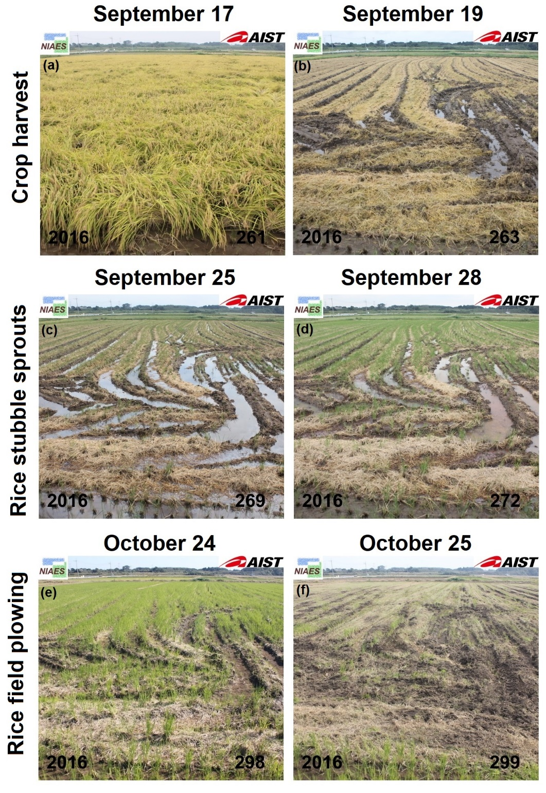
Figure S1. The abrupt changes in crop cover between September 17 and October 25, 2016 at the MSE site. The top, middle and bottom panels showing images of crop harvest, emergence of rice stubble sprouts and the removal of stubble sprouts by plowing, respectively.

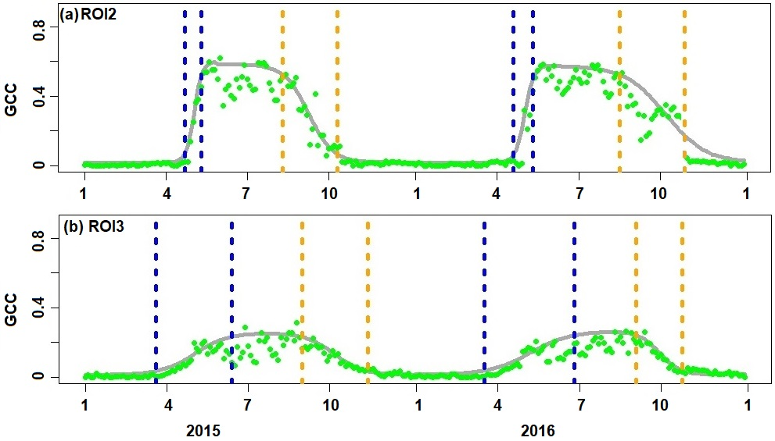
Figure S2. Phenological detection results for ROI2 and ROI3 at the MSE site. Solid green circles represent the original snow-free GCC, respectively. The grey solid lines represent the reconstructed greenness trajectories. The blue dashed lines represent the detected SOS and EOS whereas orange dashed lines represent SOF and EOF.

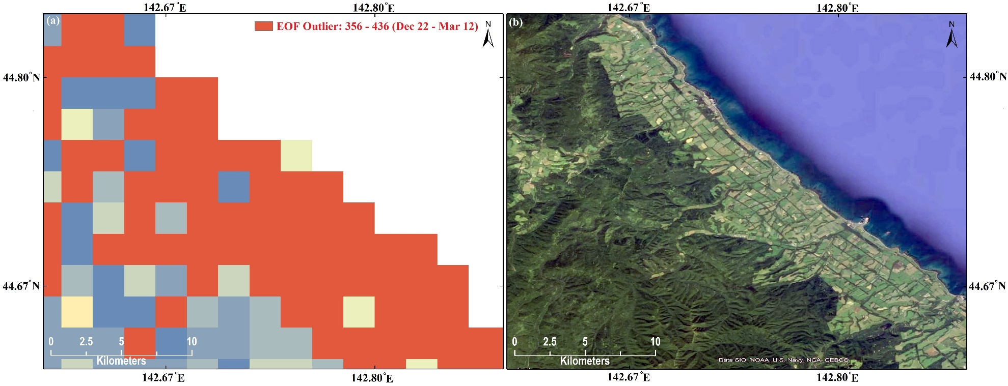
Figure S3. The spatial pattern of EOF outliers (a) and a high-resolution Google Earth image (b) in the coastal areas of northern Japan. The acquisition date of the Google Earth image is 12/30/2016.

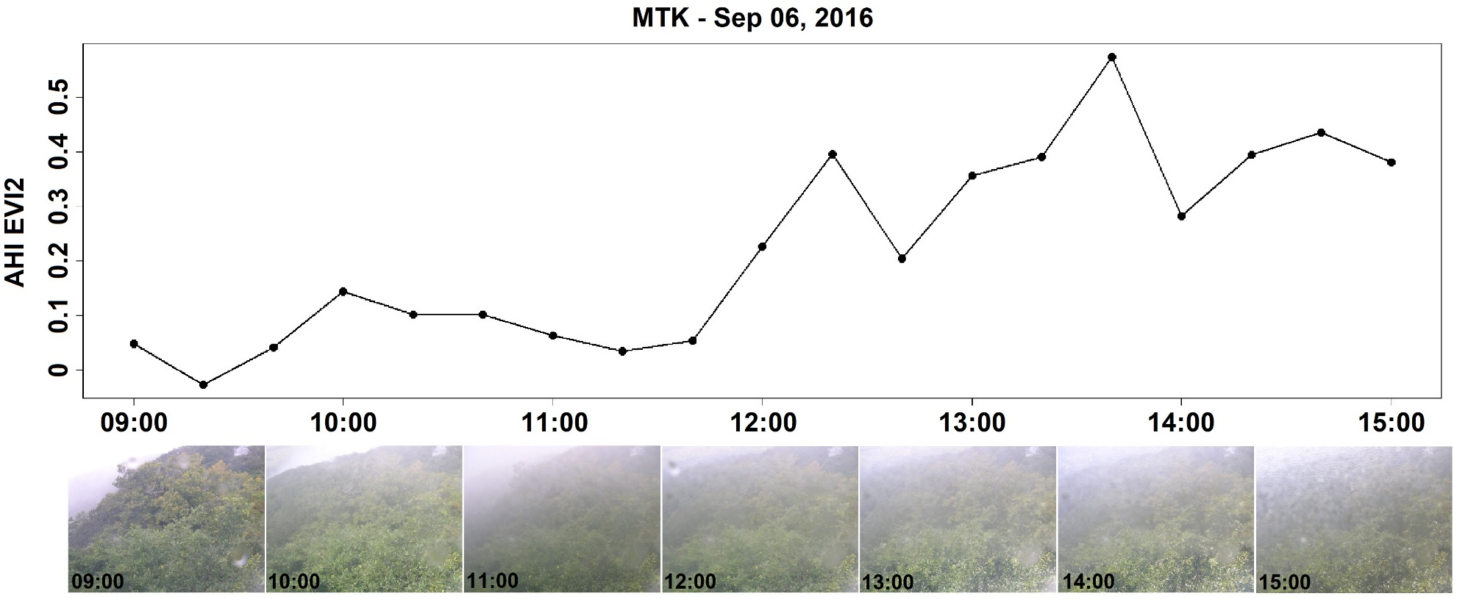
Figure S4. The 20min EVI2 (top row) and hourly photographs (bottom row) between 09:00 and 15:00 at the MTK site on September 06, 2016.

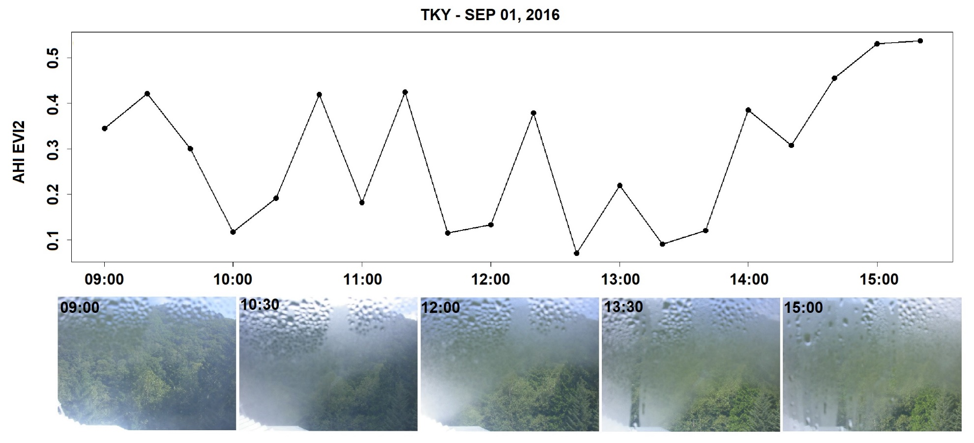
Figure S5. The 20min EVI2 (top row) and 90min photographs (bottom row) between 09:00 and 15:00 at the TKY site on September 01, 2016.

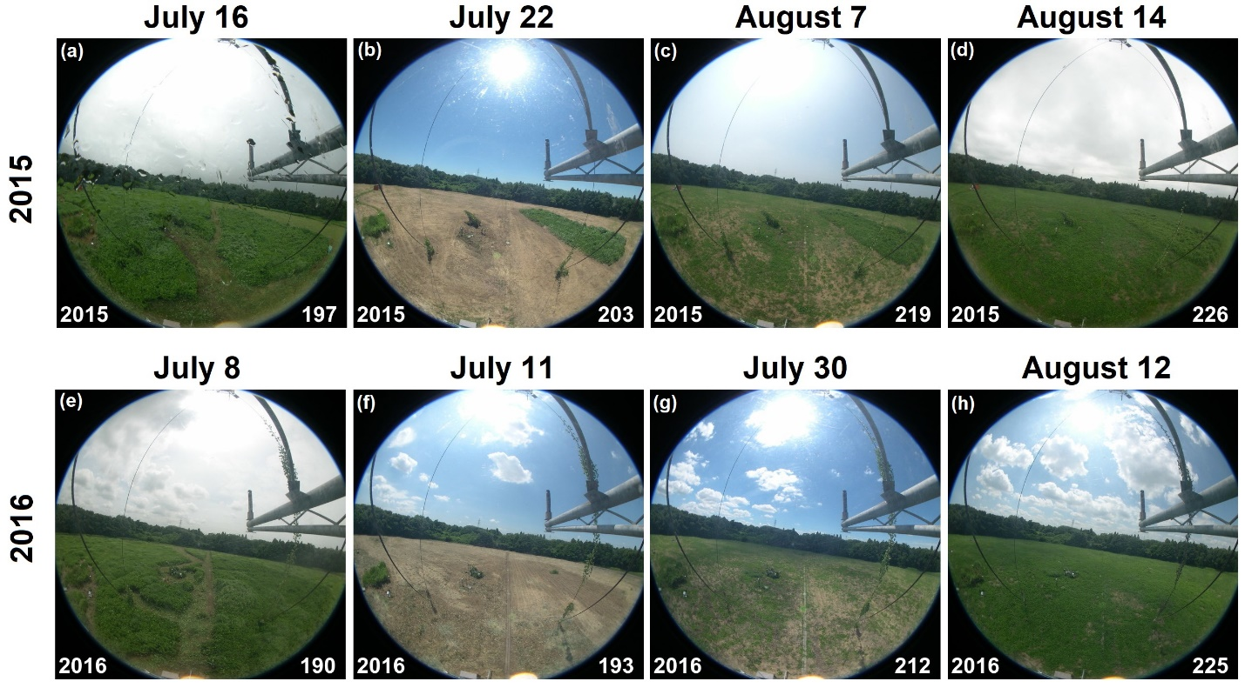
Figure S6. The rapid harvest and regrowth of grass during summer at the TGF site in 2015 and 2016. Day of year is reported at the lower right corner of each panel.

