Intercept Port by Survey Wave.



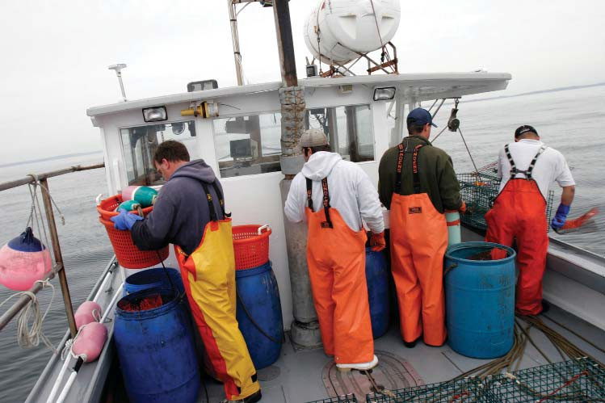

Interviewer’s Name: Date: OMB Control No. 0648-0636

Port Name: Expiration Date: 7/31/2021

Participant Sex: M or F

Length of Interview: min.

**Social Sciences Branch**

**Northeast Fisheries Science Center**

**Woods Hole, MA**

**Socio-Economic Survey of Hired Captains and Crew in New England and Mid-Atlantic Commercial Fisheries**

*Public reporting burden for this collection of information is estimated to average 20 minutes per response, including the time for reviewing instructions, searching existing data sources, gathering and maintaining the data needed, and completing and reviewing the collection of information. Send comments regarding this burden estimate or any other suggestions for reducing this burden to Lisa L. Colburn, 28 Tarzwell Dr., Narragansett, RI 02882. Email: lisa.l.colburn@noaa.gov*

**Notwithstanding any other provisions of the law, no person is required to respond to, nor shall any person be subjected to a penalty for failure to comply with, a collection of information subject to the requirements of the Paperwork Reduction Act, unless that collection of information displays a currently valid OMB Control Number.**

***In this survey, please tell us about your fishing in the last year.***

***The information you provide will remain private and you will not be identified with your answers.***

**1. What fisheries do you target? Of these, which do you consider your primary fishery in terms of income?**

**2. What port did you primarily work out of in the last year?**

Port State Country_______________

**3. Are any members of your family (for example, parents, children, siblings, uncles/aunts, cousins, in- laws) involved in commercial fishing or other fishing-related activities (for example, book-keeping, provisioning vessels, marketing)**?

1. YES

2. NO

**4. How many generations of your family have fished commercially including yourself?**

Generations

**5. How long have you been involved in commercial fishing? If less than a year, how many months?**

YEARS

MONTHS

**6. What percentage does fishing contribute to your annual household income?**

_____% (If 100% SKIP to Q8)

**7. If you have other sources of household income besides fishing, please list the top three most important sources of income other than fishing for your household.**

|  |  |
| --- | --- |
|  | Source |
| Most important |  |
| 2nd most important |  |
| 3rd most important |  |

***In the following questions, we are interested in gathering demographic data about crew.***

**8. What is your age? ___________**

**9. Are you of Hispanic, Latino, or Spanish origin? “Hispanic or Latino” refers to a person of Cuban, Mexican, Puerto Rican, South or Central American, or other Spanish culture or origin, regardless of race.**

1. Yes
2. No

**10. Which racial category describes you? (CHECK ALL THAT APPLY)**

|  |  |
| --- | --- |
| 1. | White |
| 2. | Black or African American |
| 3. | American Indian or Alaska Native |
| 4. | Asian |
| 5. | Native Hawaiian or Other Pacific Islander |
| 6. | Some other race (please specify): __________________ |

**11. What is the primary language you speak at home?**

1. English
2. Spanish
3. Portuguese
4. Other:

**12. Where were you born?**

1. U.S.
2. Outside U.S.

**13. About how many miles do you travel from where you live to where your primary vessel docked for the past year?**

__________Miles

**14. What is your marital status?**

1. Never Married
2. Married
3. Widowed
4. Divorced
5. Separated
6. Living with an unmarried partner

**15. What is the highest level of education you’ve completed?**

1. Some high school

2. High school diploma/equivalency

3. Associate’s/ two year degree

4. Bachelor’s/ four year degree

5. Graduate degree

***Within your primary fishery, consider the vessel you worked on the most in the last year.***

***Please answer the following questions based on your fishing activities on that primary vessel.***

**16. How many days (24 hour periods) does a typical trip last before returning to port?**

_Days

**17. What was the average size of the crew in the last year (including the captain)?**

_______Members

**18. How many hours per day (24 hour period) did you usually work while on a fishing trip?**

_______Hours

**19. Was the vessel you worked on most in the last year owner-operated?**

1. YES

2. NO

3. DON’T KNOW

**20. What was the main port of landing for that vessel in the last year?**

Port State Country_______________

***In the following questions, please tell us about your fishing activities and employment on your primary vessel.***

**21. What was your position on the vessel in the last year? (CHECK ALL THAT APPLY).**

1. Captain

2. Deck hand

3. Engine mechanic

4. Cook

5. Other (please specify):______________

**22. Which of the following was the first crew position you ever had when you began fishing?**

1. Captain

2. Deck hand

3. Engine Mechanic

4. Cook

5. Other (please specify): ______________

**23. How were you hired for the vessel you currently work on?**

1. Word of mouth

2. Referred by a friend

3. Related to owner

4. Related to non-owner crew member (may include hired captain)

5. Previous work with the same vessel

6. Advertisement

7. Other

**24. How difficult was it for you to find employment on your vessel?**

1. Very easy

2. Easy

3. Neither easy nor difficult

4. Difficult

5. Very difficult

**25. As of today, how many years have you worked on your primary vessel?**

**__________**Years

**__________**Months

**26. How many different vessel owners did you work for in the last year?**

___________Vessel owners

**27. Did you have health insurance in the last year?**

1. YES (CONTINUE)

2. NO (SKIP TO Q29)

**28. Where did the insurance come from?**

1. From employer (the vessel owner)

2. From another employer I have

3. Spouse’s/partner’s place of employment

4. Private insurance

5. Federal or state insurance program

6. Other

***In the following questions please tell us how revenues and expenses are distributed amongst crew.***

**29. For your current vessel, how were you paid?**

1. A share system: revenues and expenses were shared between the boat and crew (CONTINUE)

2. Other (e.g., per trip, hourly), please specify:________________(SKIP TO Q32)

**30. For share systems, what were the typical percentages distributed to the boat (the vessel owner) and crew?**

**_______**% Boat (owner) share

**_______**% Crew share

**_______**Don’tKnow

**31. For share systems, which trip expenses were usually deducted? (CHECK ALL THAT APPLY)**

1. Fuel/Oil
2. Ice
3. Fishing quota or days-at-sea
4. Food
5. General fishing supplies (hooks, bags, totes, gloves, etc.)
6. Bait
7. Other ____________________

***In the following section, we are going to go through a series of scale questions regarding how you feel about regulations in your primary fishery and how satisfied you are with commercial fishing.***

**32. Please indicate the extent to which you agree or disagree with the following statements regarding the rules and regulations in your primary fishery. (CHECK ONE RESPONSE PER ITEM)**

|  |  |  |  |  |  |
| --- | --- | --- | --- | --- | --- |
|  | Strongly Disagree | Disagree | Neutral | Agree | Strongly Agree |
| 1. The rules and regulations change so quickly it is hard to keep up. | 1 | 2 | 3 | 4 | 5 |
| 1. The fines that are associated with breaking the rules and regulations of my primary fishery are fair. | 1 | 2 | 3 | 4 | 5 |
| 1. I feel that the regulations in my primary fishery are too restrictive. | 1 | 2 | 3 | 4 | 5 |
|  |  |  |  |  |  |

**33. Have you ever participated in any aspect of federal fisheries management (such as attending meetings, writing letters, or serving on a committee)?**

1. YES

2. NO

**34. Please indicate the extent to which you agree or disagree with the following statements about** **fishing as a career. (CHECK ONE ITEM PER RESPONSE)**

|  |  |  |  |  |  |
| --- | --- | --- | --- | --- | --- |
|  | Strongly Disagree | Disagree | Neutral | Agree | Strongly Agree |
| a. Fishing is just a job to me. | 1 | 2 | 3 | 4 | 5 |
| b. Leaving the fishing industry is something that I have considered. | 1 | 2 | 3 | 4 | 5 |

**\*\*\*SCALE CHANGE\*\*\***

**35. How satisfied or dissatisfied are you with the following items relating to the job of fishing? (CHECK ONE ITEM PER RESPONSE)**

|  |  |  |  |  |  |  |
| --- | --- | --- | --- | --- | --- | --- |
|  |  | Very  Dissatisfied | Dissatisfied | Neutral | Satisfied | Very  Satisfied |
| a. | Your actual earnings | 1 | 2 | 3 | 4 | 5 |
| b. | The predictability of your earnings | 1 | 2 | 3 | 4 | 5 |
| c. | Job safety (e.g. physical risks to you from working as a fisherman) | 1 | 2 | 3 | 4 | 5 |
| d. | The amount of time spent away from home | 1 | 2 | 3 | 4 | 5 |
| e. | Physical fatigue of the job | 1 | 2 | 3 | 4 | 5 |
| f. | Healthfulness of the job (e.g how your job as a fisherman may impact your physical and mental health) | 1 | 2 | 3 | 4 | 5 |
| g. | Adventure of the job | 1 | 2 | 3 | 4 | 5 |
| h. | Challenge of the job | 1 | 2 | 3 | 4 | 5 |
| i. | Opportunity to be your own boss | 1 | 2 | 3 | 4 | 5 | |

**36. In general, how satisfied are you with: (CHECK ONE ITEM PER RESPONSE)**

|  |  |  |  |  |  |
| --- | --- | --- | --- | --- | --- |
|  | Very Dissatisfied | Dissatisfied | Neutral | Satisfied | Very Satisfied |
| a. Your life | 1 | 2 | 3 | 4 | 5 |
| b. Your physical health | 1 | 2 | 3 | 4 | 5 |
| c. The overall health of the marine environment | 1 | 2 | 3 | 4 | 5 |

**37. Would you advise a young person to enter fishing?**

1. YES

2. NO

3. UNSURE

**38. Would you still be a commercial fisherman if you had your life to live over?**

1. YES

2. NO

3. UNSURE

**39. What was your annual fishing income in the last year?**

1. Less than $10,000

2. $10,000 - $19,999

3. $20,000 - $29,999

4. $30,000 - $39,999

5. $40,000 - $49,999

6. $50,000 - $59,999

7. $60,000 - $69,999

8. $70,000 - $79,999

9. $80,000 - $89,999

10. $90,000 - $99,999

11. $100,000 - $119,999

12. $120,000 or more

***Your contribution to this eﬀort is greatly appreciated. Thank you!***