Journal of Geophysical Research-Atmospheres
Supporting Information for
The convective-to-total precipitation ratio and the "drizzling" bias in climate models

Di Chen¹, Aiguo Dai² and Alex Hall¹

¹ Department of Atmospheric and Oceanic Sciences, University of California, Los Angeles, Los Angeles, CA, USA, ²Department of Atmospheric and Environmental Sciences, University at Albany, State University of New York, Albany, NY, USA

Contents of this file

Figures S1 to S2

Introduction

This file contains seven supporting figures:
- Figure S1 shows the effect of PC/PR ratio and resolution on precipitation characteristics (frequency, intensity, and duration), separately for models with < 2° and > 2° resolution.
- Figure S2 shows the relationship between resolution and precipitation metrics, but removing two lowest-resolution models.
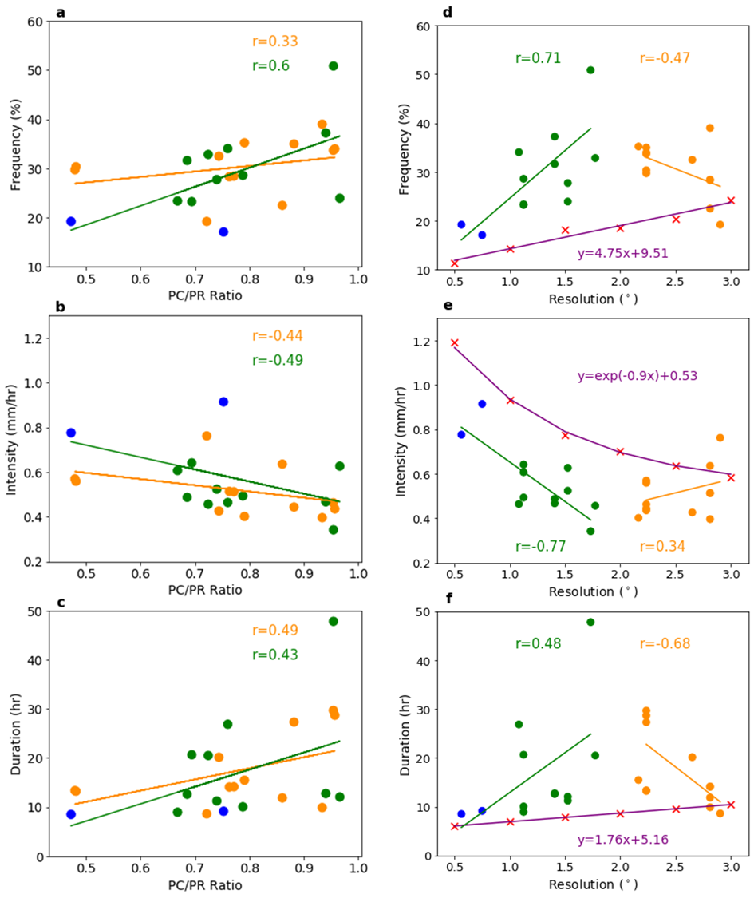
Figure S1. (Left) Same as Figure 3d-f but divided models into < 2° and > 2° resolution for computing correlation coefficients. (Right) Same as Figure 4b-d but divided models into < 2° and > 2° resolution for computing correlation coefficients.

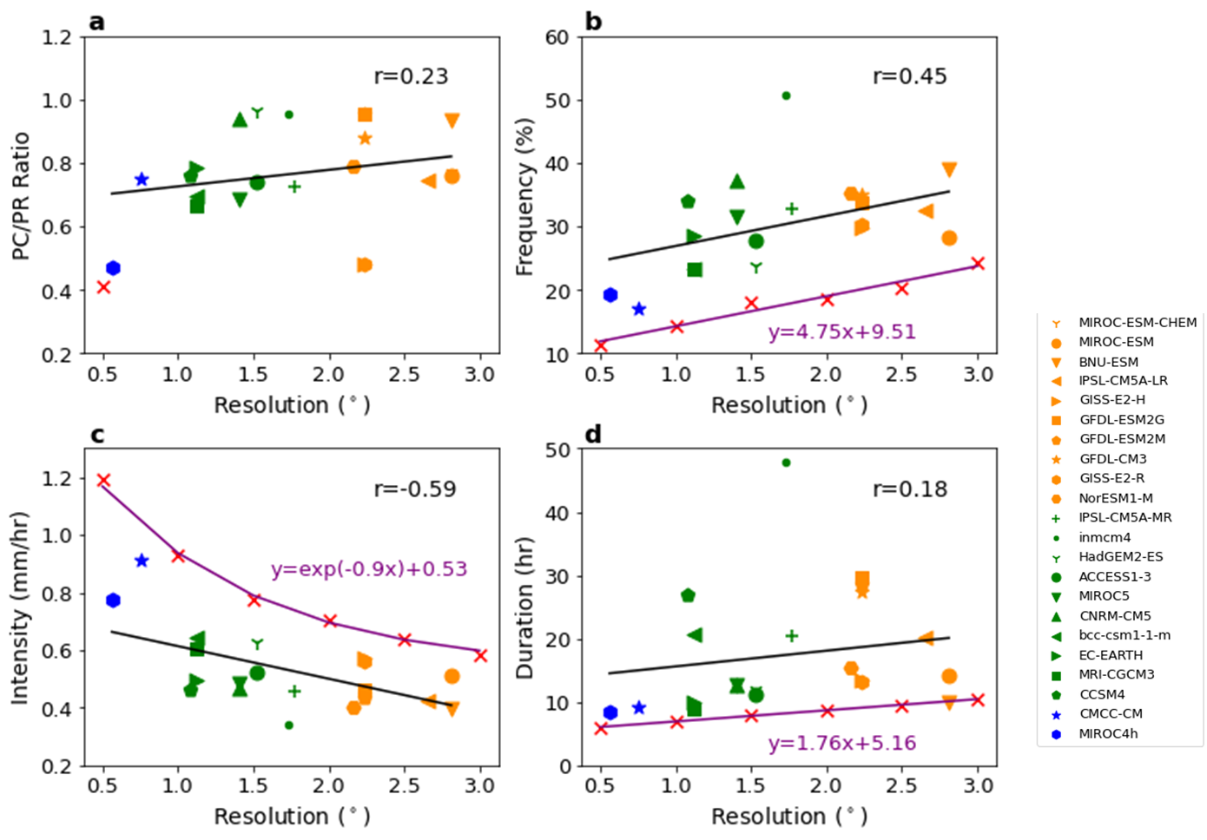
Figure S2. Same as Figure 4, but not including FGOALS-g2 and bcc-csm1-1.

