Global Biogeochemical Cycles
Supporting Information for
Mixed layer carbon cycling at the Kuroshio Extension Observatory
Andrea J. Fassbender^{1,2,*}, Christopher L. Sabine¹, Meghan F. Cronin¹, and Adrienne J. Sutton^{1,3}

¹NOAA Pacific Marine Environmental Laboratory, Seattle, Washington, USA
²Monterey Bay Aquarium Research Institute, Moss Landing, California, USA
³Joint Institute for the Study of the Atmosphere and Ocean, University of Washington, Seattle, Washington, USA

*fassbender@mbari.org

Contents of this file

Text S1 to S2
Figure S1
Table S1

Introduction
This document provides deployment depths of salinity and temperature sensors positioned along the KEO mooring line and shows how equation (6) was derived from equations (4) and (5). It also includes information about the total alkalinity (TA)-salinity relationship as well as the dissolved inorganic carbon (DIC)-temperature-nitrate relationship characterized from ship data collected within the top 250 m of water in the region between 25ºN and 33ºN and 138ºE and 151ºE (solid-lined box in Figure 1). These relationships were used to estimate DIC and TA gradients from mooring, float, and World Ocean Atlas data and are discussed in manuscript Section 3.4. Additionally, a table of mean monthly errors associated with salinity, DIC, and TA budget terms is included. Further details about the uncertainty analysis can be found in the supporting information of Fassbender et al., [2016].

Text S1:
Deployment depths of salinity and temperature sensors on the KEO mooring line. Because this is a slack-line mooring, the sensor pressure was used to determine the depth of the sensor in the water.

Salinity sensor deployment depths (m):
1, 5 (until Nov 2005), 10, 15 (after Jun 2005), 25, 35 (after Jun 2005), 50, 75, 100 (after Sep 2009), 125 (after Jun 2005), 150, 175 (until Nov 2005), 200 (until Nov 2005), 225 (after Sep 2007), 275 (after Nov 2005), 325 (after Nov 2005), 400 (until Feb 2007), 425 (after Sep 2007), 475 (KEO-2005 only), 525 (after Sep 2005)

Temperature sensor deployment depths (m):
1, 5, 10, 15, 16 (after Sep 2015), 18, 20 (after Jul 2013), 25, 35, 40 (after Sep 2009), 50, 75, 100, 105 (KEO-2008 only), 125 (after June 2005), 150, 175 (after June 2005), 200 (until Feb 2007), 225 (after Jun 2005), 250 (KEO-2005 only), 275 (after Jun 2005), 300 (until Feb 2007), 325 (after Jun 2005), 350 (until Nov 2005), 375 (after Jun 2005), 400 (until Feb 2007), 425 (after Jun 2005), 450 (Jun 2005 – Feb 2007), 475 (after Jun 2005), 500 (until Feb 2007), 525 (after Jun 2005)

Text S2:
The following text display how equations 4 and 5 can be rearranged to make equation 6 by applying stoichiometric relationships.

${\left.\frac{∂DIC}{∂t}\right|}_{Bio}= {\left.\frac{∂DIC}{∂t}\right|}_{NCP}+ {\left.\frac{∂DIC}{∂t}\right|}_{{CaCO}_{3}}$ (4)
${\left.\frac{∂TA}{∂t}\right|}_{Bio}= {\left.\frac{∂TA}{∂t}\right|}_{NCP}+ {\left.\frac{∂TA}{∂t}\right|}_{{CaCO}_{3}}$ (5)
Stoichiometric relationships [Anderson and Sarmiento, 1994]:

${\left.\frac{∂TA}{∂t}\right|}_{{CaCO}_{3}}= {\left.2\text{×}\frac{∂DIC}{∂t}\right|}_{{CaCO}_{3}}$

${\left.\frac{∂TA}{∂t}\right|}_{NCP}= {\left.\left(\frac{-17}{117}\right)\text{×}\frac{∂DIC}{∂t}\right|}_{NCP}$

Substitution and rearrangement:
${\left.\frac{∂TA}{∂t}\right|}_{Bio}= {\left.\left(\frac{-17}{117}\right)\text{×}\frac{∂DIC}{∂t}\right|}_{NCP}+ {\left.2\text{×}\frac{∂DIC}{∂t}\right|}_{{CaCO}_{3}}$

${\left.\frac{∂DIC}{∂t}\right|}_{{CaCO}_{3}}= \frac{{\left. \frac{∂TA}{∂t}\right|}_{Bio}-{\left.\left(\frac{-17}{117}\right)\text{×}\frac{∂DIC}{∂t}\right|}_{NCP}}{2}$

${\left.\frac{∂DIC}{∂t}\right|}_{Bio}- {\left.\frac{∂DIC}{∂t}\right|}_{NCP}= \frac{{\left. \frac{∂TA}{∂t}\right|}_{Bio}-{\left.\left(\frac{-17}{117}\right)\text{×}\frac{∂DIC}{∂t}\right|}_{NCP}}{2}$

Isolate and solve for the NCP term:

${\left.2\text{×}\frac{∂DIC}{∂t}\right|}_{Bio}- 2\text{×}{\left.\frac{∂DIC}{∂t}\right|}_{NCP}= {\left. \frac{∂TA}{∂t}\right|}_{Bio}-{\left.\left(\frac{-17}{117}\right)\text{×}\frac{∂DIC}{∂t}\right|}_{NCP}$

$- 2\text{×}{\left.\frac{∂DIC}{∂t}\right|}_{NCP}+ {\left.\left(\frac{-17}{117}\right)\text{×}\frac{∂DIC}{∂t}\right|}_{NCP}= {\left. \frac{∂TA}{∂t}\right|}_{Bio}- {\left.2\text{×}\frac{∂DIC}{∂t}\right|}_{Bio}$

${\left.\frac{∂DIC}{∂t}\right|}_{NCP}= \frac{{\left. \frac{∂TA}{∂t}\right|}_{Bio}- {\left.2\text{×}\frac{∂DIC}{∂t}\right|}_{Bio}}{\left(-2+ \frac{-17}{117}\right)}$ (6)

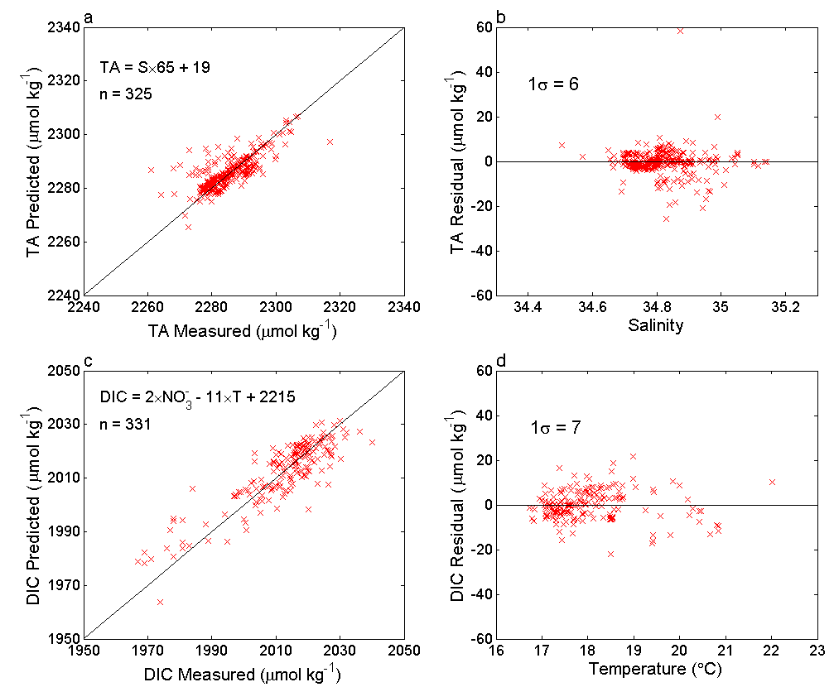
Figure S1. Evaluation of regional relationships for TA and DIC determined from repeat hydrography cruise samples collected from the upper 250 m of water within the solid-lined box in Figure 1. (a) TA values predicted from salinity vs. measured TA values. The TA-salinity relationship is shown as well as the 1:1 line and the number of observations going into the relationship (n). (b) TA residuals vs. salinity. (c) DIC values predicted from nitrate and temperature vs. measured DIC values. The DIC relationship with nitrate and temperature is shown as well as the 1:1 line and the number observations going into the relationship (n). (d) DIC residuals vs. temperature.

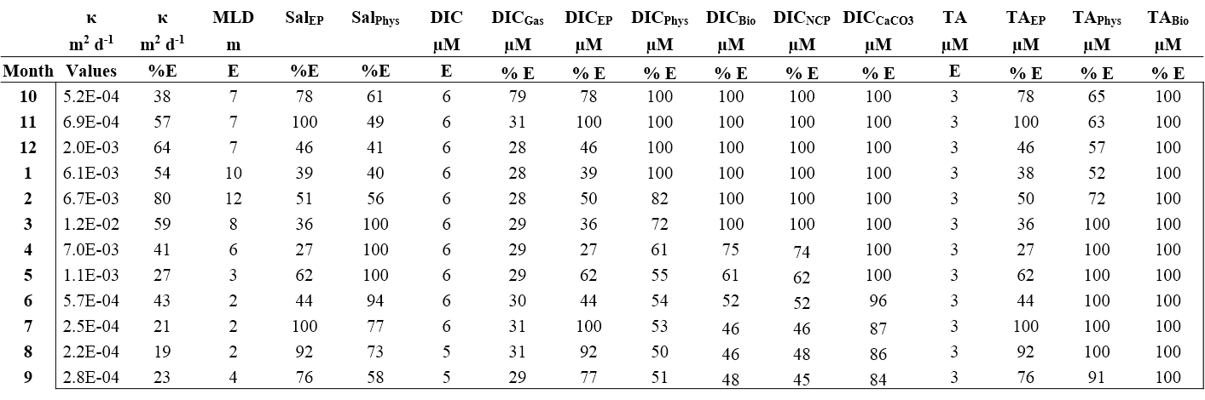

Table S1. Diffusivity (κ) climatology and monthly % errors for κ. Errors for each term in the salinity, DIC, and TA budgets are also given. These values were calculated by averaging the monthly errors across all deployments, and not through the propagation of errors. As a result, they are larger than the uncertainty bounds shown in Figures 6 and 7 of the manuscript, which were calculated through the propagation of errors when averaging across deployments. Errors given for the mixed layer depth, DIC, and TA represent the average of daily estimates from each month across all years. For this table, µM is used as shorthand for µmol kg⁻¹.

References:
Anderson, L. A., and J. L. Sarmiento (1994), Redfield ratios of remineralization determined by nutrient data analysis, Global Biogeochem. Cycles, 8(1), 65–80.
Fassbender, A. J., C. L. Sabine, and M. F. Cronin (2016), Net community production and calcification from 7 years of NOAA Station Papa Mooring measurements, Global Biogeochem. Cycles, 30(2), 250–267, doi:10.1002/2015GB005205.

