Supplementary Figures & Tables:

Table S1 | Bivariate Pearson’s correlation coefficients (r) between all variables considered for modeling for the entire ROI. *Variables with |r| > 0.8 were considered collinear and therefore not used in the same candidate models.
 | Slope | Distance from shore | Rugosity | Sky view factor | C. ursinus proximity | P. vitulina proximity
Elevation | 0.15 | 0.17 | -0.11 | 0.09 | 0.76 | 0.73
Slope |  | -0.37 | 0.35 | -0.82* | 0.29 | 0.16
Distance from shore |  |  | -0.22 | 0.41 | -0.03 | 0.34
Rugosity |  |  |  | -0.46 | 0.10 | -0.01
Sky view factor |  |  |  |  | -0.27 | -0.06
C. ursinus proximity |  |  |  |  |  | 0.63

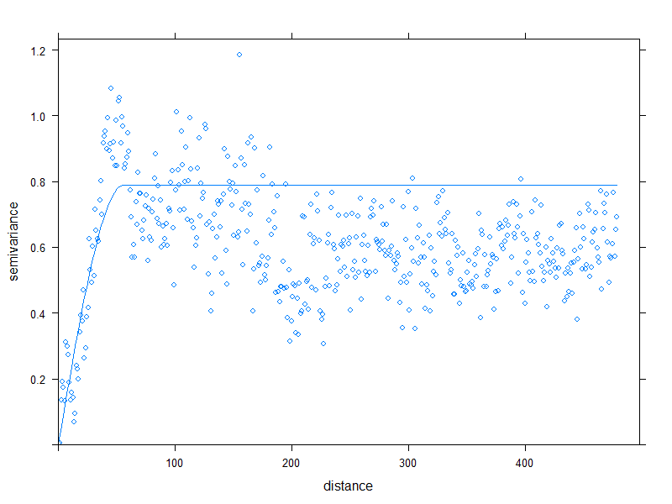
Figure S1 | Variogram of residuals from a GAM generated to predict ‘Probability of C. ursinus occurrence’ using only terrain characteristics. A fit spherical model of semivariance (blue line) indicates spatial autocorrelation of model results over close distances (0–56.2 m), which corresponded to a Moran’s statistic standard deviate of 15.89 (p < 0.001).

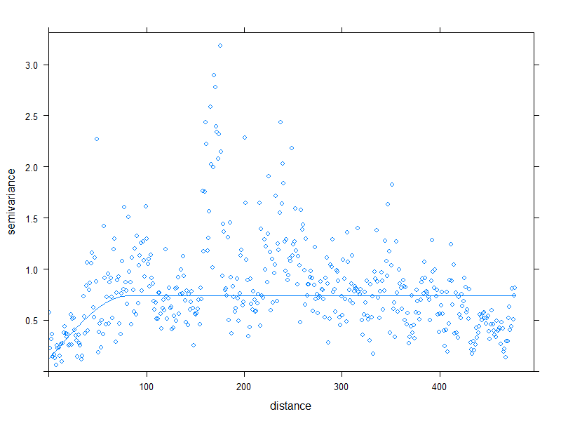
Figure S2 | Variogram of residuals from a GAM generated to predict ‘Probability of p. Vitulina occurrence’ using only terrain characteristics. A fit spherical model of semivariance (blue line) indicates spatial autocorrelation of model results over close distances (0–82.4 m), which corresponded to a Moran’s statistic standard deviate of 8.26 (p < 0.001).

