Supplemental 1: Derivation of total and relative predation
The total biomass of juvenile pollock consumed $P_{\text{total, }i}$ (“total predation”, kg) by a given species of predator in year $i$ is calculated as the sum of estimated predation $P_{ij}$ (kg km⁻²) in each grid cell $j$ and year $i$, multiplied by the area of each grid cell $A_{j}$. In turn, $P_{ij}$ is the product of the ratio of prey mass consumed per predator biomass (kg prey per kg predator) $D_{ij}$ and the estimated biomass-density of the predator species $B_{ij}$ (kg km⁻²):
$$P_{\text{total, }i}= \sum_{j=1}^{n}{P_{ij} ×A_{j}}= \sum_{j=1}^{n}{D_{ij}×B_{ij}×A_{j}}$$
“Relative predation,” $P_{\text{relative, }i}$ (in kg prey per kg predator), is the rate of prey biomass consumption by a species of predator, normalized by the estimated predator biomass, and represents a weighted average of the average prey mass per predator biomass$D_{ij}$ in each grid cell $j$, weighted by the estimated predator biomass in grid cell $j$:
$$P_{\text{relative,} i}= \frac{\sum_{j=1}^{n}{D_{ij}×B_{ij}×A_{j}}}{\sum_{j=1}^{n}{B_{ij}×A_{j}}}$$
Thus, the total predation for year $i$ is the product of the relative predation multiplied by the total biomass of the predator across the EBS survey region:
$$P_{\text{total,} i}= P_{\text{relative,} i}×\sum_{j=1}^{n}{B_{ij}×A_{j}}$$
The years for which sufficient stomach contents data existed for analyses were: 1986-1987, 1989, 1991-2003, and 2006-2015 for arrowtooth flounder; 1984-2003 and 2005-2015 for Pacific cod; 1984-1985, 1989-1995, 1997-1999, 2002-2003, 2006-2008, and 2010-2015 for Pacific halibut; and 1987-2015 for adult walleye pollock.

Supplemental 2: Overlap metrics used in this study
We quantify the extent of spatial overlap between juvenile pollock and predators using three metrics: area overlap, the global index of collocation, and the local index of collocation. Area overlap is a simple and intuitive metric which assesses the proportion of a set of locations for which both a predator and prey co-occur (Saraux et al. 2014). We calculated area overlap between juvenile pollock and each respective predator as the proportion of grid cells for which both species were predicted to occur:
$$\frac{\sum_{i}^{n}{ A_{i} 1\left( p_{\text{prey, i}}> δ_{\text{prey}} , p_{\text{pred,i}} > δ_{\text{pred}}\right)}}{\sum_{i}^{n}{ A_{i}}}$$
Where $A_{i}$ is the area at grid cell $i$, $p$ is the predicted probability of encounter, and $1\left( p_{\text{prey, i}} p_{\text{pred,i}} \right)$ is an indicator which is 1 if both the predator and prey had a predicted probability of encounter above the species-specific prediction threshold $δ_{\text{prey}}$ / $δ_{\text{pred}}$ at grid cell $i$, and 0 otherwise. Prediction thresholds were chosen for each species by maximizing the sum of sensitivity and specificity across grid cell estimates (Jiménez-Valverde and Lobo 2007, Liu et al. 2016).
The global index of collocation uses the centers of gravity of the distributions of two species, as well as the geographic dispersion in the estimated grid-cell biomass, to assess the geographical similarity between two species ranges (Woillez et al. 2007). It is given by:
$$1- \frac{∆{CG}_{\text{prey, pred}}^{2}}{∆{CG}_{\text{prey, pred}}^{2}+I_{\text{prey}}+ I_{\text{pred}}}$$
Where $∆{CG}_{\text{prey, pred}}^{2}$ is the squared Euclidean distance between the centers of gravity of the distributions of the prey species and the predator species, expressed as Universal Transverse Mercator (UTM) zone 2 coordinates (eastings and northings). The center of gravity for each species $j$ is the mean location of species $j$ in the EBS survey region, derived from the biomass estimates $B_{ij}$ for each grid cell $i$ and corresponding grid-cell UTM coordinates $\left(x_{ij}, y_{ij}\right)$:
$${CG}_{j}= \left(\frac{\sum_{i=1}^{n}{x_{i}B_{ij}}}{\sum_{i=1}^{n}{B_{ij}}}, \frac{\sum_{i=1}^{n}{y_{i}B_{ij}}}{\sum_{i=1}^{n}{B_{ij}}}\right)$$
$I_{\text{prey}}$ and $I_{\text{pred}}$ are the inertia values for the prey and predator species, respectively. The inertia $I_{j}$ of a population of species $j$ is a measure of the dispersion of that population around the center of gravity, and is given by:
$$I_{j}= \frac{\sum_{i=1}^{n}{\left({(x_{i}-{CGx}_{j})}^{2}+ {(y_{i}-{CGy}_{j})}^{2}\right)}B_{ij}}{\sum_{i=1}^{n}{B_{ij}}}$$
However, shifts in the global index of collocation for two species may not be ecologically relevant, because two species which do not overlap on fine scales (e.g. because of distinct habitat preferences) may nonetheless have distributions with similar centers of gravity (Kotwicki and Lauth 2013). The local index of collocation (also known as “Pianka’s O”) assesses the fine-scale (i.e. grid-scale) correlation between estimates of predator and prey biomass across the survey region and serves as an approximation of the rate of interspecific encounter relative to all intraspecific encounters (Hurlbert 1978). It is calculated as:
$$\frac{\sum_{i}^{n}{\left(B_{\text{pred},i}×B_{\text{prey},i}\right)}}{\sqrt{\sum_{i}^{n}{B_{\text{pred},i}^{2}\sum_{i}^{n}{B_{\text{prey},i}^{2}}}}}$$
where $B_{i}$ is the estimated biomass at grid cell $i$.

Supplemental 3: Additional Figures

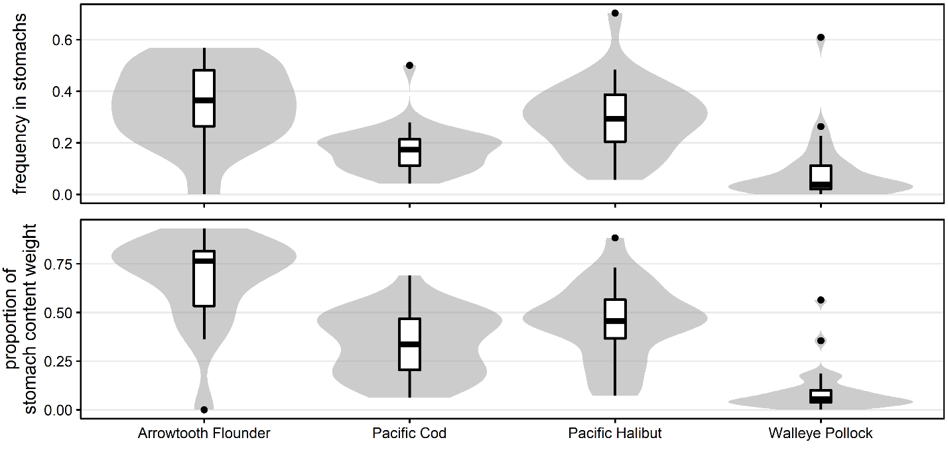
Figure S1. Violin plots, with overlayed boxplots, summarizing the annual importance of pollock to the diets of each species of predator, as the proportion of stomach contents by weight and the frequency of occurrence in sampled predator stomachs. Diets are summarized only for predators above the minimum sizes used for analysis, which are arrowtooth flounder ≥30cm, Pacific cod ≥30cm, Pacific halibut ≥50cm, and walleye pollock ≥40cm. Empty stomachs were excluded from the summary.

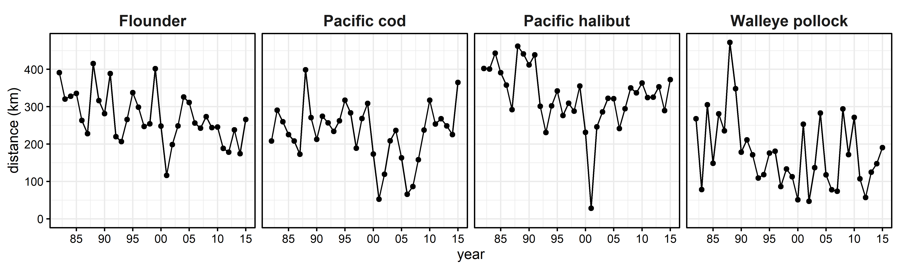
Figure S2. Annual time-series plots of the Euclidean distance (km) between juvenile pollock range centroids (in UTM eastings and northings) and predator range centroids, with centroids calculated from fitted grid-cell biomass estimates.

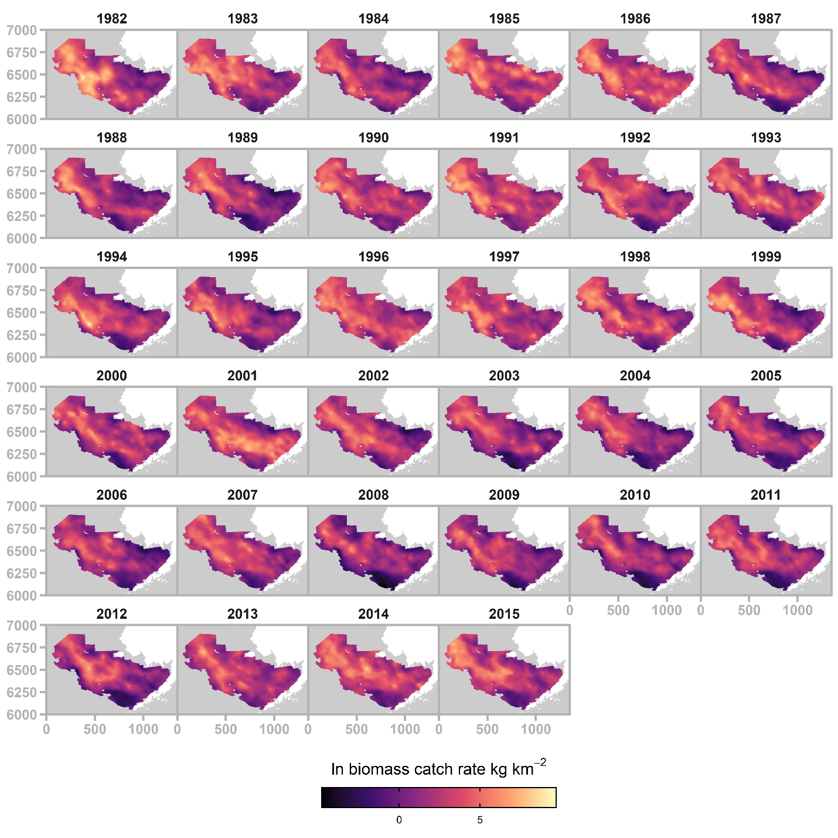
Figure S3. Annual maps of fitted biomass catch rate (ln kg/km²) for juvenile walleye pollock.
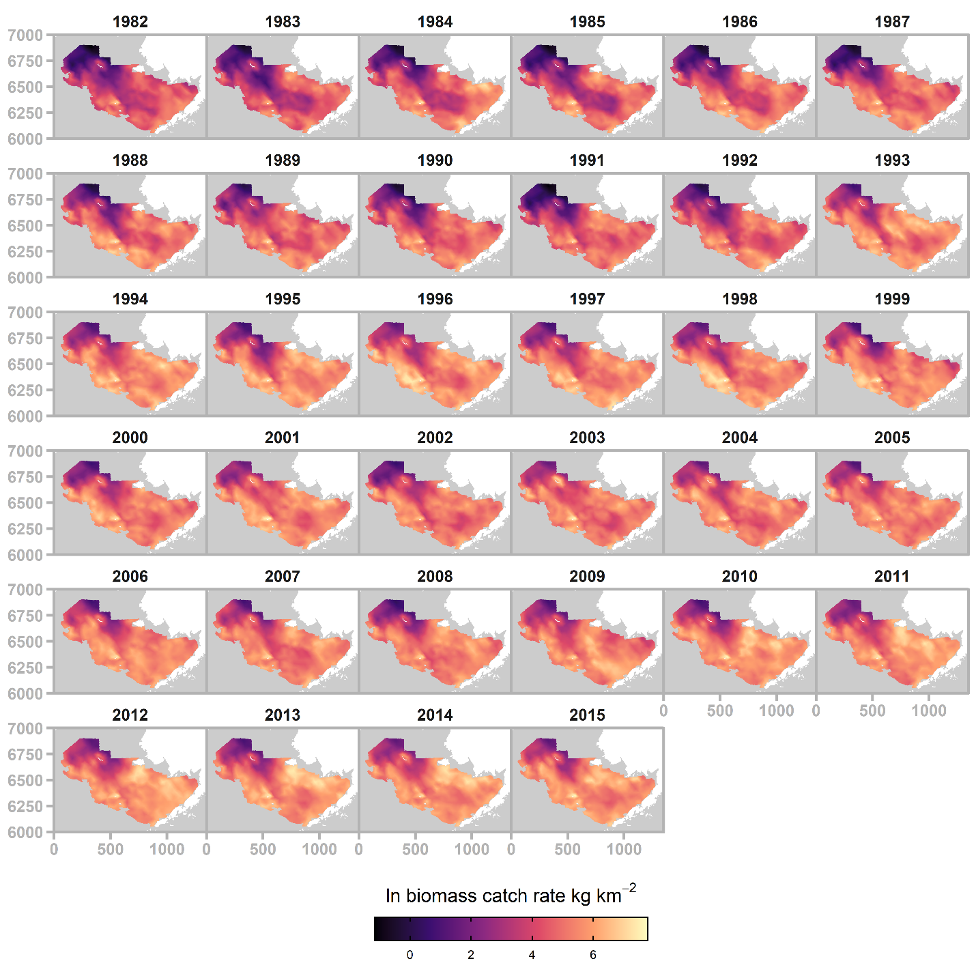
Figure S4. Annual maps of fitted biomass catch rate (ln kg/km²) for Pacific halibut.
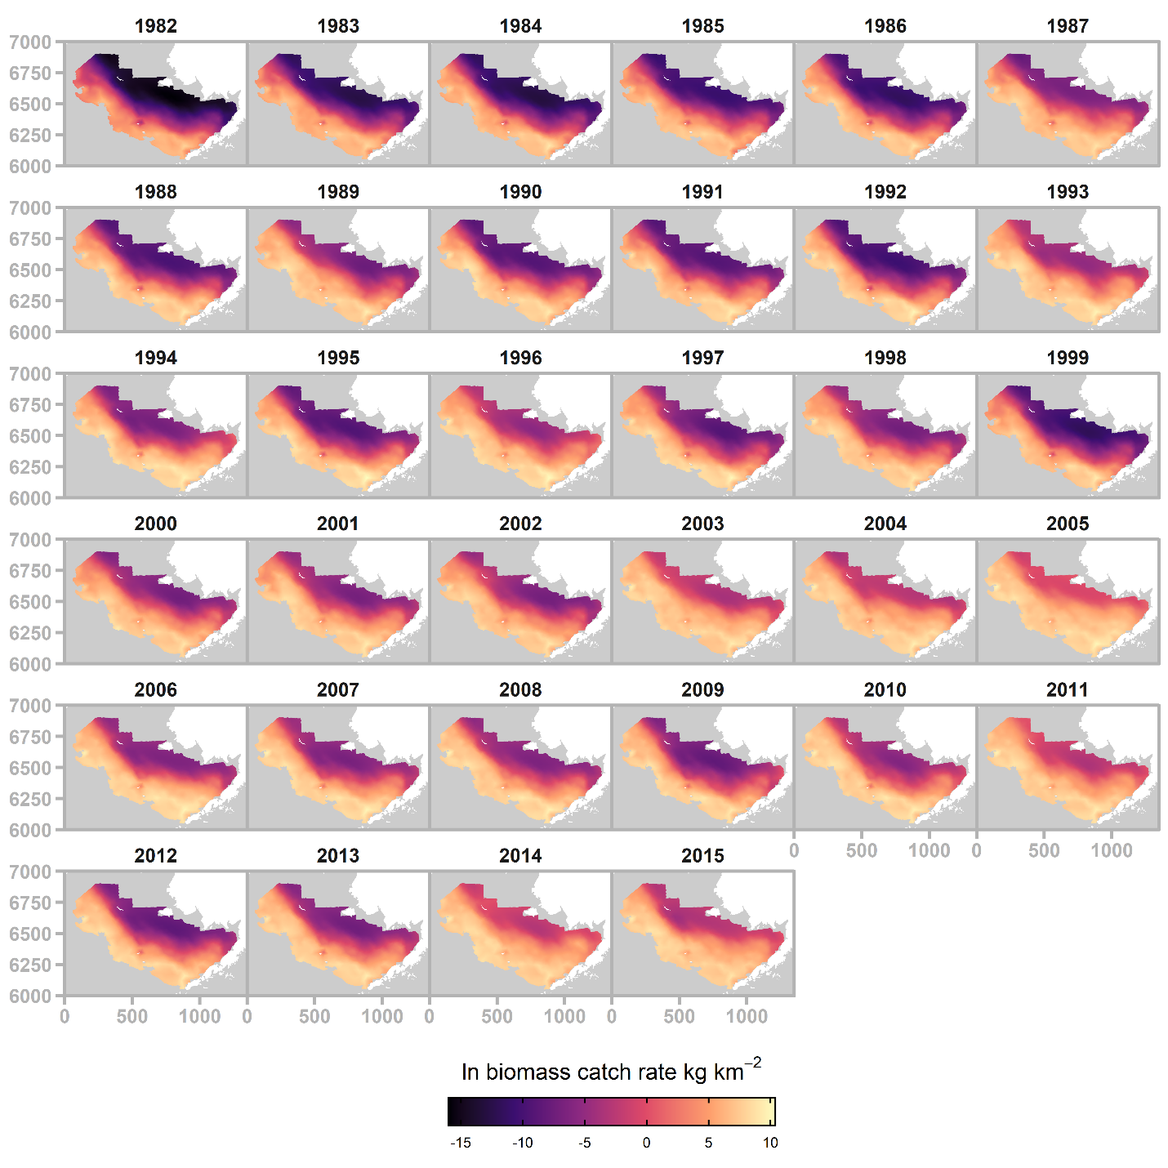
Figure S5. Annual maps of fitted biomass catch rate (ln kg/km²) for arrowtooth flounder.

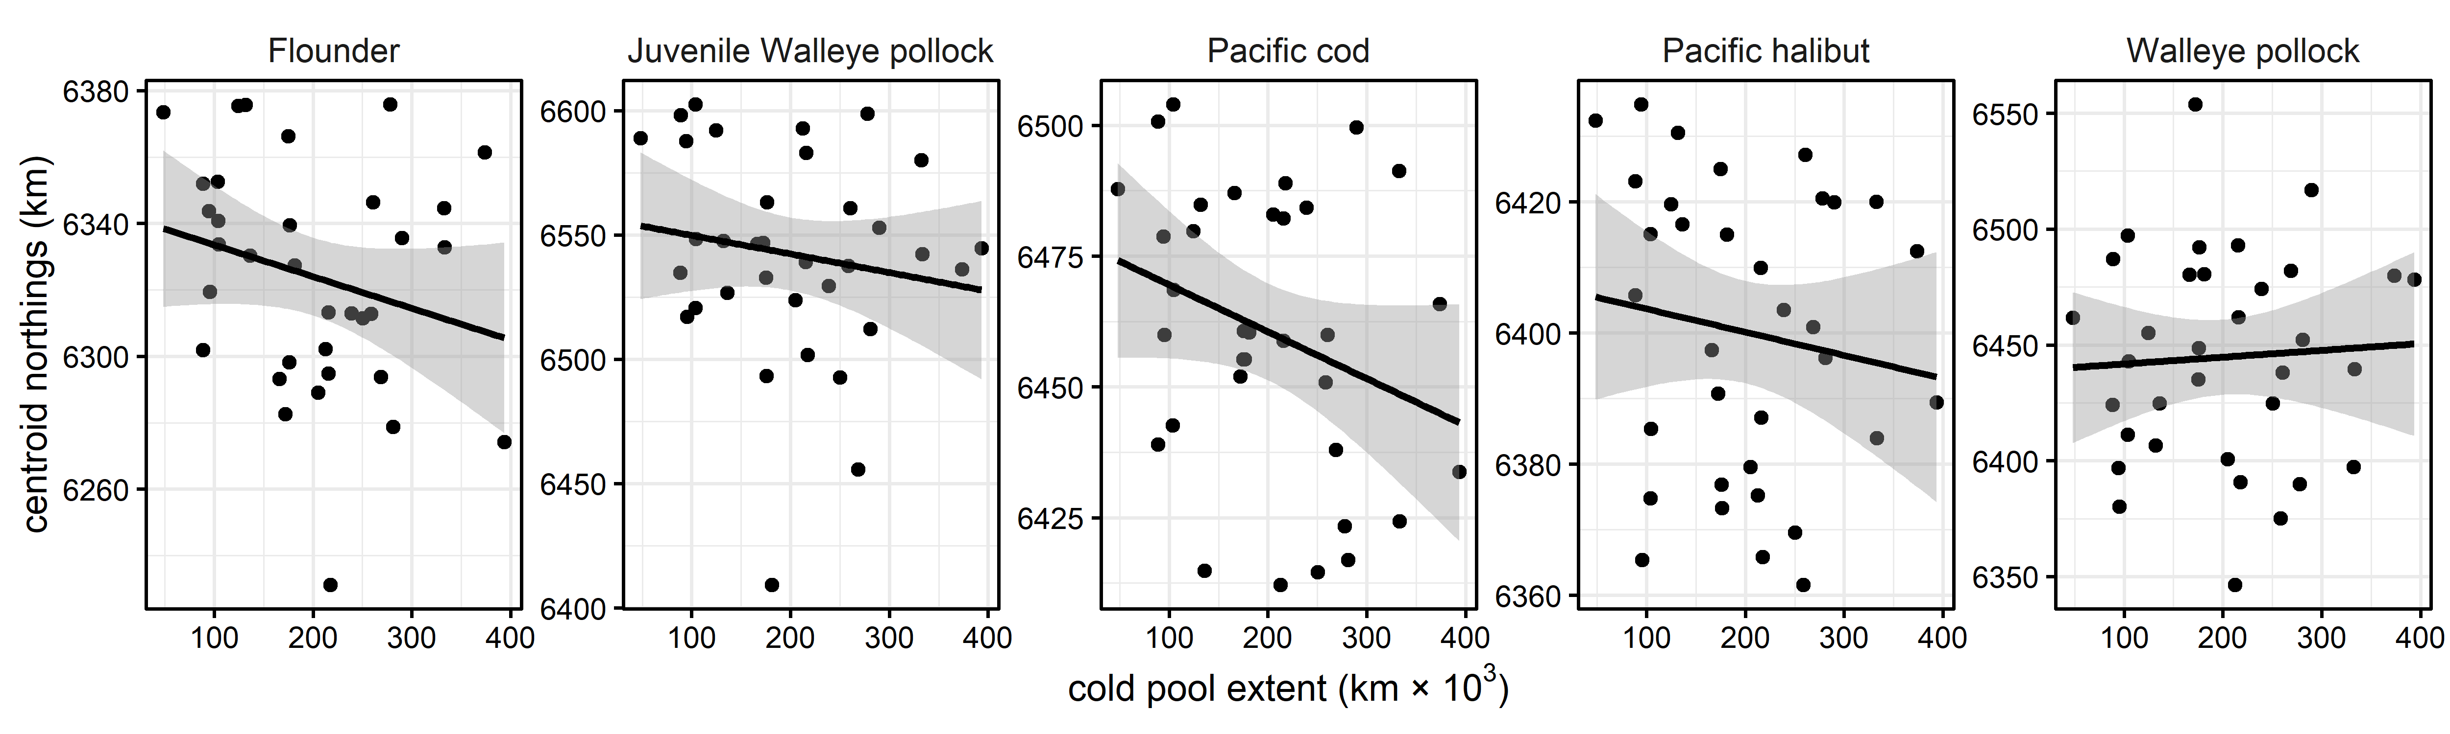
Figure S6. Bivariate plots of species range centroids (obtained from grid-cell predictions) against the extent of the cold pool (≤2 °C), with fitted regression lines and 95% confidence intervals.

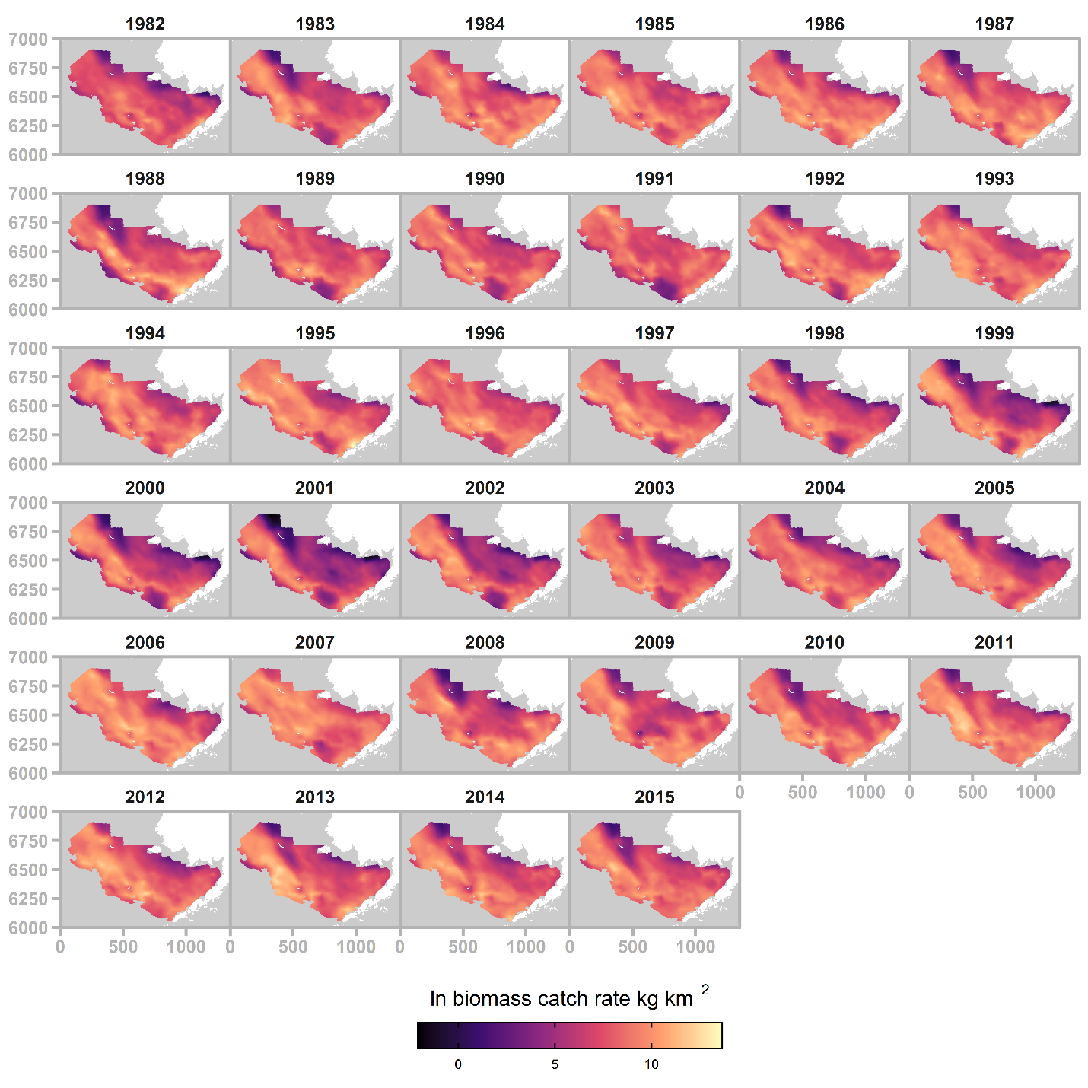
Figure S7. Annual maps of fitted biomass catch rate (ln kg/km²) for adult walleye pollock.

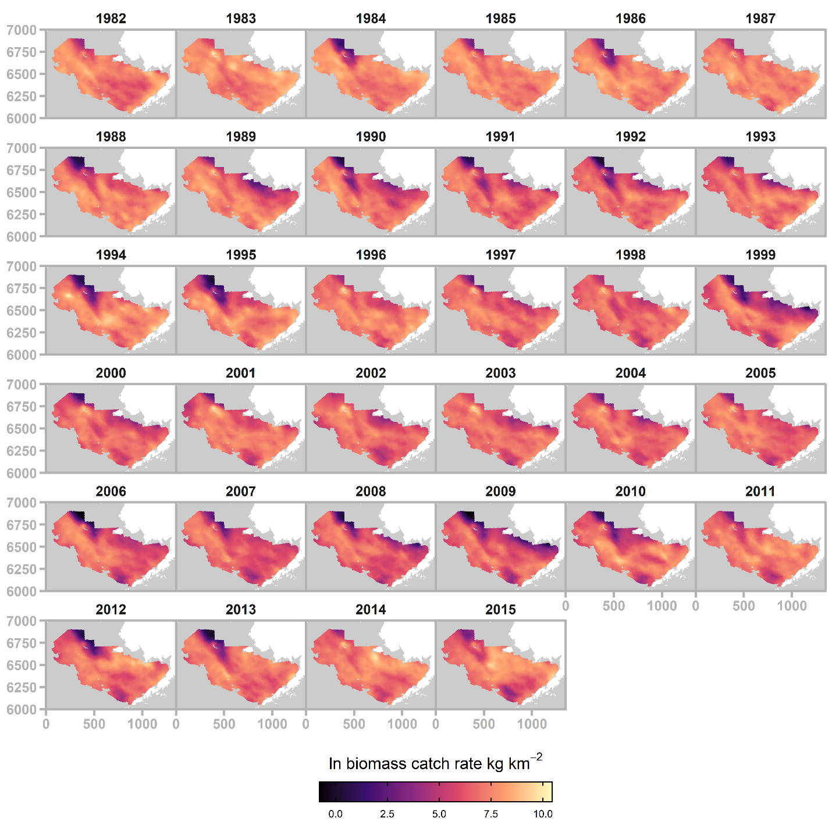
Figure S8. Annual maps of fitted biomass catch rate (ln kg/km²) for Pacific cod.

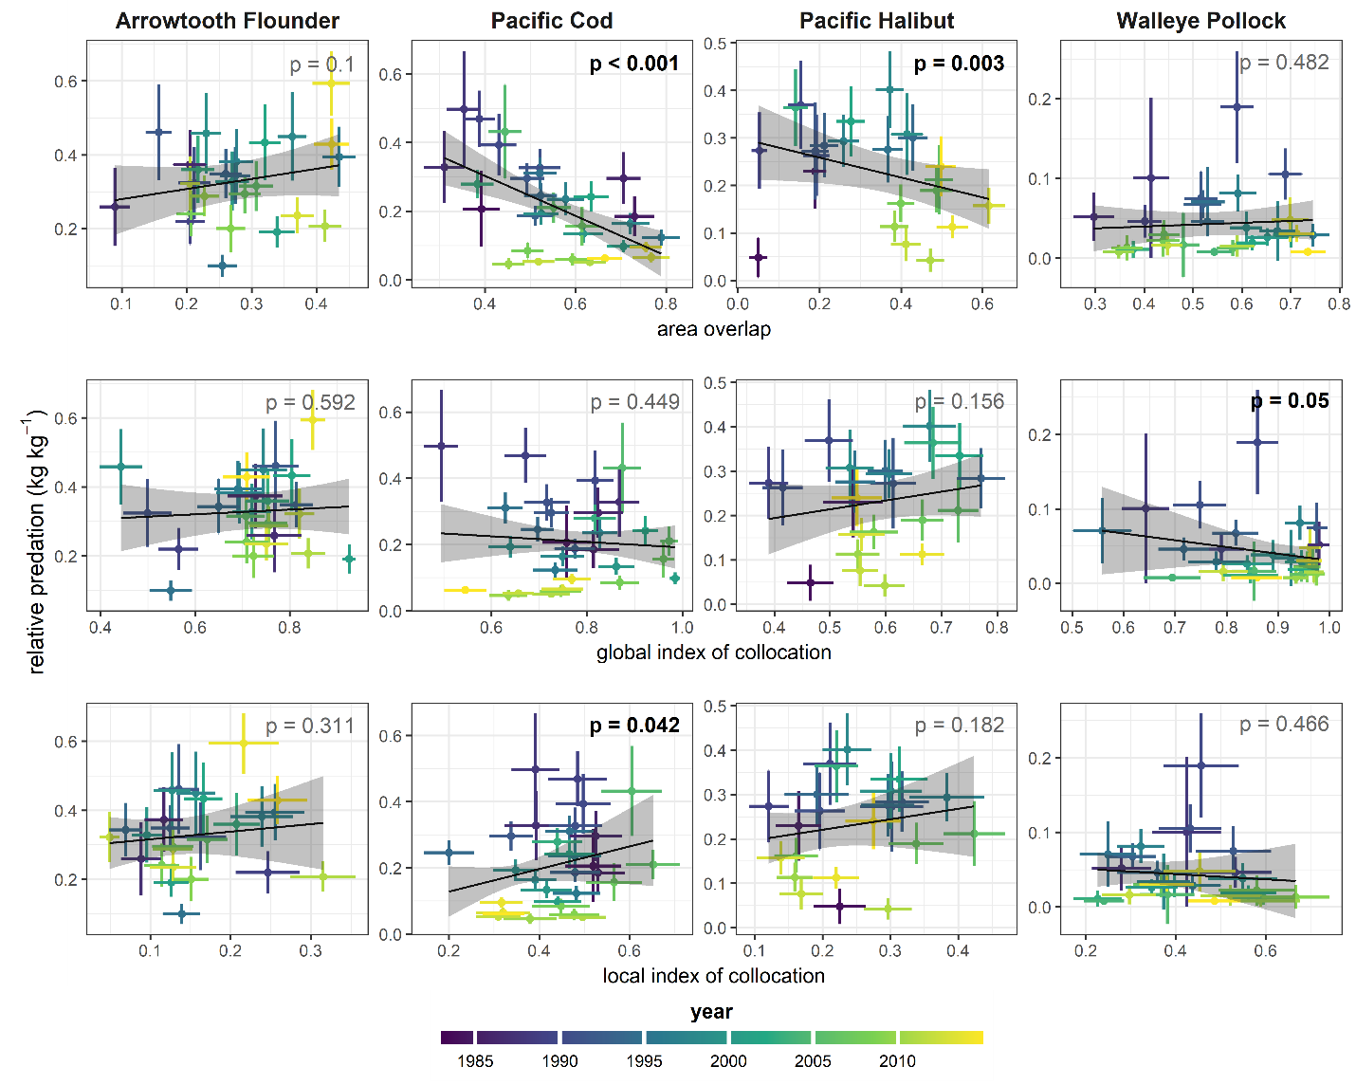
Figure S9. Bivariate scatterplots of predator-prey overlap metrics and relative predation for each year, with vertical and horizontal error bars giving the standard deviation of the predictive distribution samples. Points are placed at the maximum-likelihood estimate. Regression lines represent the linear relationship between relative predation and overlap at their respective annual maximum likelihood estimates, with 95% confidence bands computed using samples from the predictive distribution of each variable.

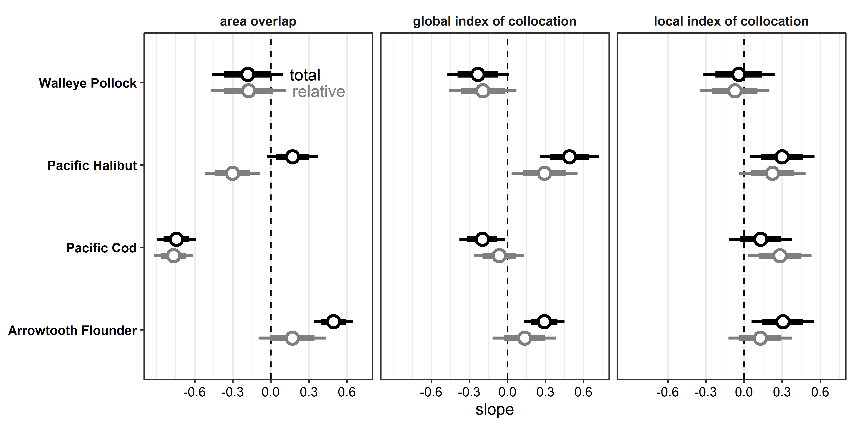
Figure S10. Standardized slope coefficients assessing the linear relationship of each overlap metric with total (black) and relative (grey) predation, estimated by aggregating samples from the predictive distribution. Coefficients were adjusted for the effect of juvenile pollock biomass by including standardized pollock biomass as a predictor in each regression. Points are placed at the maximum-likelihood estimate. 95% and 80% confidence intervals are given assuming a normal approximation to the sampling distribution.

References
Hurlbert, S. 1978. The Measurement of Niche Overlap and Some Relatives. - Ecology 59: 67–77.
Jiménez-Valverde, A. and Lobo, J. M. 2007. Threshold criteria for conversion of probability of species presence to either-or presence-absence. - Acta Oecologica 31: 361–369.
Kotwicki, S. and Lauth, R. R. 2013. Detecting temporal trends and environmentally-driven changes in the spatial distribution of bottom fishes and crabs on the eastern Bering Sea shelf. - Deep. Res. Part II Top. Stud. Oceanogr. 94: 231–243.
Liu, C. et al. 2016. On the selection of thresholds for predicting species occurrence with presence-only data. - Ecol. Evol. 6: 337–348.
Saraux, C. et al. 2014. Spatial structure and distribution of small pelagic fish in the northwestern mediterranean sea. - PLoS One in press.
Woillez, M. et al. 2007. Indices for capturing spatial patterns and their evolution in time, with application to European hake (Merluccius merluccius) in the Bay of Biscay. - ICES J. Mar. Sci. 64: 537–550.

