To develop estimates of changes in benefits associated with observed Chl a yearly trends, the coefficient for Chl a from the first stage and the coefficient for predicted landings in the second stage were multiplied to calculate the indirect marginal effect of Chl a on permits (Eq. 3). This value was added subsequently to the coefficient of Chl a in the second stage, the direct marginal effect of Chl a on permit sales (Eq. 4), to obtain the total marginal effect of Chl a on permits (Eq. 5; Table 8).

$1st Stage Chl a coefficient\left( \frac{SD Total Landings}{SD Chl a}\right)*2nd Stage Predicted Landing Coefficient \left(\frac{SD Permits Per Capita}{SD Total Landings}\right)=Indirect Marginal Effect \left(\frac{SD Permits Per Capita}{SD Chl a}\right)$ (Eq. 3)

$2nd Stage Chl a coefficient \left(\frac{SD Permits Per Capita}{SD Chl a}\right)=Direct Marginal Effect$ (Eq. 4)

$Indirect Marginal Effect+Direct Marginal Effect=Total Marginal Effect \left(\frac{SD Permits Per Capita}{SD Chl a}\right)$ (Eq. 5)

To transform the total marginal effect of Chl a on into total losses or gains in annual value associated with Chl a trends over the study period, the total marginal effect of Chl a on permits value was multiplied by the value associated with a standard deviation in the variable of permits sold per capita. This value was subsequently multiplied with population numbers in 2015, providing the total marginal effect of Chl a on permit sales. Dividing this value by the number of years it would take to achieve a standard deviation change in Chl a based on Chl a decadal trends within Buzzards Bay from 1992-2015 (i.e., the Chl a decadal trend divided by the log₁₀(Chl a mg m⁻³) value associated with a one standard deviation change in Chl a) provides the change in permits sold per decade (Eq. 6). The two alternative welfare measures from Damery and Allen (2004), WTP ($79.25/permit) and WTA ($626.75/permit), were applied to approximate the change in benefits per decade associated with Chl a trends (Eq. 7). Losses and gains in asset value were calculated by applying a 3% discount rate (Table 8). Reference values for the coefficient transformations are provided in (Table 9 in the Supplement).

$Total Marginal Effect \left(\frac{SD Permits Sold Per Capita}{SD Chl a}\right)*\frac{Permits Sold Per Capita}{1 SD Permits Sold Per Capita }*2015 Population*\frac{1 SD Chla}{Decade}=\frac{Change in Permits Sold}{Decade}$
(Eq. 6)

$\frac{Change in Permits Sold}{Decade}*\frac{Value \left(WTP or WTA\right)}{Permit}= Change in value per decade \left(\frac{USD 2017}{Decade}\right)$ (Eq. 7)

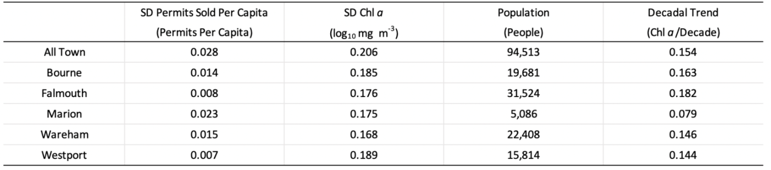
Table 9: Reference values for coefficient transformation illustrates the standard deviation for number of permits sold per capita, the standard deviation for Chl a, 2015 population numbers, and the Chl a decadal trends across all towns (“All Town”) and for individual towns. These reference values were used to transform the regression coefficients into variations in asset values over the 1992-2015 study period associated with Chl a trends.

