

*JGR: Biogeosciences*

Supporting Information for

**Watershed-scale drivers of air-water CO2 exchanges in two lagoonal, North Carolina (USA) estuaries**

Bryce R. Van Dam1*, Joseph R. Crosswell1,2,3, Iris C. Anderson3, Hans W. Paerl1

1 Institute of Marine Sciences, University of North Carolina at Chapel Hill, Morehead City, NC, USA

2 CSIRO Oceans and Atmosphere, Brisbane, QLD, Australia

3 Virginia Institute of Marine Science, College of William & Mary, Gloucester Point, VA, USA

*Corresponding author: Bryce Van Dam, bvandam@live.unc.edu

**Contents of this file**

Text S1 to S3

Figures S1 to S5

Table S1

**Introduction**

Three text sections are included in this Supporting Information document. The first addresses methodological concerns with our pCO2 analyzer calibration, and includes an assessment of analytical uncertainty that is inherent with this calibration. In the second section, we attempt to constrain other sources of uncertainty in our CO2 flux determinations. Focus is placed on the impact of different gas transfer velocity parameterizations on calculated fluxes. The last text section (S3) details additional sources of pCO2 variability that could not be constrained in the present study, and could be considered to be potential limitations. Figures S3 and S4 show trends in FW age, CO2 flux, and other parameters over time. Figure S5 shows anticipated changes in pH across both estuaries in due to anthropogenic CO2 additions. Figures S3, S4, and S5 are referenced in the text of the main manuscript. Figures S1-S2, and Table S1 pertain to text in the Supporting Information. Raw data used in this study, along with most of the relevant calculations, are provided as a compressed file associated with this supporting information; more detailed inquiries may be directed towards the corresponding author.

Text S1. Methods

During some cruises, the same standards used for calibration were measured *during* the trip as check standards, in an attempt to check the assumption that analytical drift is linear. The slope and y-intercept that was interpolated linearly through time (same as was used to calibrate SHE pCO2) was applied to each measured check standard xCO2. The difference between this calibrated value and the stated standard concentration is a type of analytical error related to both the instrument’s linear response, and the assumption of linear drift. This error is insignificant at high CO2 concentration, but becomes large at low concentration (Figure S1). The average calibrated concentration for the 100 ppm check standard was 33 ppm, an error of 33%. This error was 3.2% for the 2000 ppm standard, and 0.15% at 5000 ppm. Because this error changes with concentration, the application of a single correction factor to measured values over the entire calibration range would be inappropriate. Surface water pCO2 was occasionally above 5000 µatm (maximum segment-wide average of 5033 µatm in the NeuseRE in Sept 2016), beyond the range over which error could be constrained. However, the manufacturer’s stated measurement range extends to 20,000 ppm, so we feel it is reasonable to extend linear calibrations across this range.

Text S2. Uncertainty

The uncertainty in estimating air-sea gas exchange is complex and stems from multiple sources of error, namely the following: analytical error for equilibrated CO2, error in calculating CO2 solubility (Henry’s Law, and its temperature and salinity dependence), and error in parameterization of the gas transfer velocity. Each of these uncertainty components is composed of error compounded from its own unique sources. For example, when the CO2 concentration in the SHE headspace is used to estimate pCO2, the SHE CO2 concentration is corrected based on the difference between the in-situ water temperature and that in the SHE (often a difference of > 1 degree C) using two temperature sensors that have their own, individual error. This temperature difference corrected CO2 concentration is then used to estimate CO2 solubility using the salinity and temperature dependence of Henry’s Law that has its own uncertainty. In this section, I seek to determine which sources of uncertainty are the most significant for our attempt to accurately constrain air-water CO2 exchange.

The largest source of error in the estimation of air-sea gas exchange is related to the parameterization of gas transfer velocity (Upstill-Goddard, 2006; Frankignoulle et al., 1998; Wanninkhof and McGillis, 1999). As described in the methods section, gas transfer velocity, *k*, is parameterized as a non-linear function of wind speed, determined empirically in a diverse suite of marine and fresh systems. This relationship is particularly tenuous in estuaries, where factors like variable fetch (Woolf, 2005; Vachon and Prairie 2013), bottom generated friction (Rosentreter et al., 2016), the presence of biological surfactants (Wanninkhof et al., 2009), and other chemical and physical factors at the air-water interface introduce uncertainty (Raymond and Cole, 2001). The methods used to determine this relationship are also diverse, including: eddy covariance (and eddy accumulation), natural tracers (222Rn or O2), artificial tracers (SF6), and floating domes, each of which have their individual advantages and disadvantages. For example, floating domes are often used in coastal systems because of their ease of deployment and excellent temporal resolution, but can overestimate fluxes by a factor of ~2 due to inflated turbulence at the air-water interface (Raymond and Cole, 2001).

As seen in Wanninkhof et al., 2009, even when *k* is determined using the same method, different relationships are obtained for different environmental systems for the reasons listed earlier. This makes the parameterization of air-sea CO2 flux more problematic, because one relationship must be decided on and used consistently. For this reason, a *k* sensitivity analysis was conducted for both the NeuseRE and NewRE. Three gas transfer parameterizations were chosen, spanning the range of reasonable relationships. In order of low to high, these were: Ho et al. (2006), Jiang et al. (2008), and Prytherch et al. (2010). The parameterization used for the remainder of this study was Jiang et al. (2008). All parameterizations generate the same trends in CO2 flux, but the magnitude at any given time is different for each model, particularly when wind speed is high (Figure S2). This sensitivity analysis was collapsed into estimates of annual average fluxes in Table S1. Despite the widely different methods used to produce these parameterizations (Prytherch et al. (2010) used an eddy covariance technique, Ho et al. (2006) conducted a dual 3He/SF6 tracer experiment, and Jiang et al. (2008) compiled estimates from a literature review), all agreed that both estuaries were small sources of CO2 to the atmosphere, with the greatest rates occurring in the upper regions. While this analysis does help to quantify the uncertainty in estimated CO2 fluxes resulting from chosen gas transfer parameterizations, it does not address how analytical error is compounded during these calculations.

**Text S3. Limitations**

A combination of ecosystem respiration, wetland input, and nonlinearities arising from the mixing of water masses of different carbonate chemistries cause DIC in the upper NewRE to exceed what would be suggested by conservative mixing alone. Therefore, the application of conservative mixing plots between DIC and salinity to estimate the riverine end-member DIC concentration (DICmixing w/R) likely introduced a slight overestimation of [CO2]river in the NewRE. Because [CO2]estuary was calculated as the difference between measured [CO2] and [CO2]river (accounting for CO2 loss to the atmosphere), this estimate of [CO2]estuary in the NewRE is likely an underestimate. It is also important to note that river discharge was above average during the study period, 180 and 153% of the antecedent 10-year average in the New and Neuse River, respectively. During years experiencing more typical discharge conditions, [CO2]river will likely decrease. Supporting this, Crosswell et al. (2012; 2014) found that the NeuseRE was a CO2 sink during a year of drought and a smaller CO2 source than observed in this study during a year with moderate discharge.

Due to field limitations, it was not possible to constrain pCO2 variability in the lateral (cross-channel) and vertical dimensions. Previous studies have shown that tidal pumping of salt marshes can be an important source of ‘outwelled’ DIC and DOC, supporting large CO2 fluxes in estuaries surrounded by wetlands (Cai and Wang 1998; Neubauer and Anderson 2003; Wang and Cai 2004; Jiang et al. 2008). However, neither estuary in this study is bounded by marshes to a significant extent, suggesting that this source of CO2 is likely small. Tidal exchange could also flush oceanic DIC into the estuary, influencing pCO2. Hence, variability may also be introduced due to the choice to conduct surveys at the same time of day regardless of tidal stage. This factor can be significant in estuaries, especially those located along active margins during upwelling favorable conditions (Evans et al. 2013; Feely et al. 2010). In this study, however, the pCO2 range in lower segments was relatively small (263-778 µatm and 236-2426 µatm in the NewRE and NeuseRE respectively), suggesting that tidal exchange with the ocean was probably not a significant source of DIC to these estuaries.

While tidal exchange with wetlands and the ocean was likely insignificant, it is well established that biological processes acting on a diel time scale, namely net productivity vs ecosystem respiration, may be a significant source of variability in surface water pCO2 in estuaries (Akhand et al. 2016; Baumann et al. 2014; Call et al. 2015; Cotovicz et al. 2015; Maher et al. 2015; Mørk et al. 2016). Unpublished results of a related study in the NewRE show that diel fluctuations in both pH and pCO2 are large (Anderson et al. unpubl.), similar to other productive estuaries (Maher et al. 2015), and may have contributed to net autotrophy in this estuary during a low discharge year (Crosswell et al. 2017 in press). While some surveys in this study were conducted on a dawn-dusk-dawn schedule, with the intention of quantifying diel variability, a detailed analysis of these data is beyond the scope of this study, and is reported in Crosswell et al. (2017 in press). Diel vertical migration of motile phytoplankton like dinoflagellates is common in both the NewRE and NeuseRE (Hall et al. 2015), and may also contribute to variability in any relationship between pCO2 and chl-a.



**Figure S1.** Absolute value of the percent difference between calibrated pCO2 and check standard pCO2 at each standard concentration.

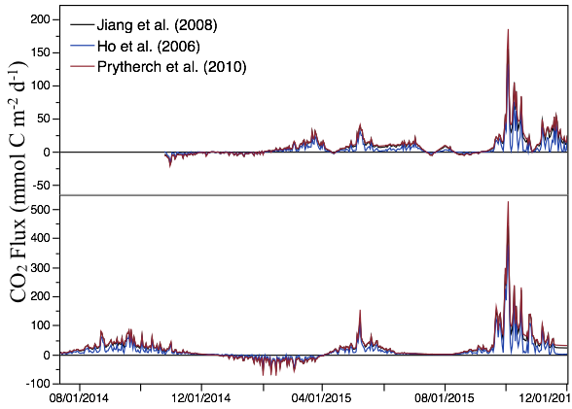

Figure S2. Sensitivity of CO2 flux to different gas transfer velocity parameterizations



Figure S3. Time-series plot of average FW age (days) for the NeuseRE (solid line) and NewRE (dashed line).

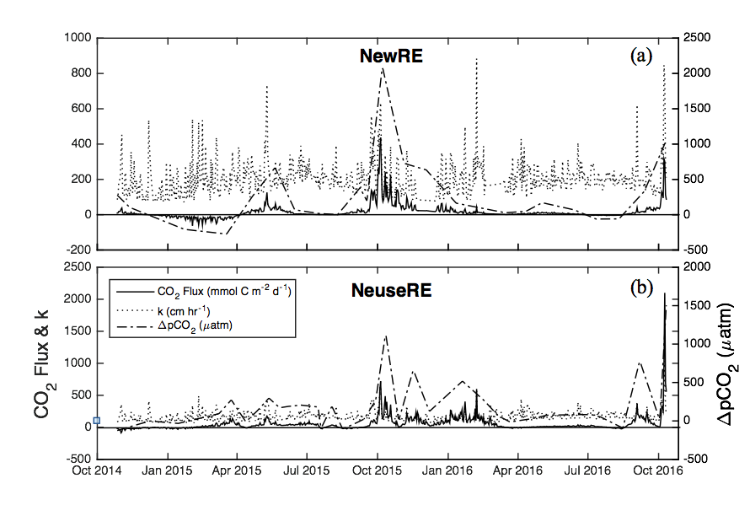

**Figure S4.** Drivers of air-water CO2 exchange (solid line, mmol C m-2 d-1) for the (a) NewRE and (b) NeuseRE. Gas transfer velocity, (k, cm hr-1) and ∆pCO2 (*µ*atm) are shown as the dotted and dashed lines, respectively.

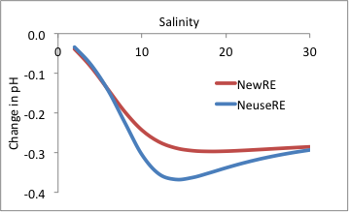

**Figure S5.** Modeled changes in pH due to an increase in atmospheric pCO2 of 380 to 800 µatm.

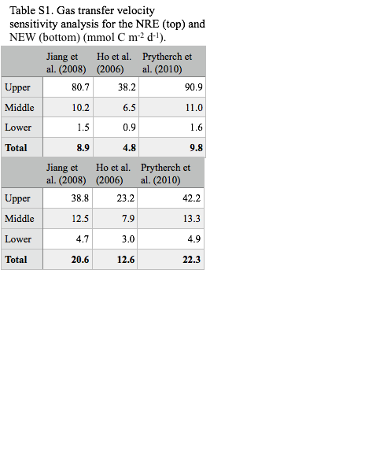

**Table S1.** Gas transfer velocity sensitivity analysis for the NeuseRE (top) and NewRE (bottom)