Supplemental Section

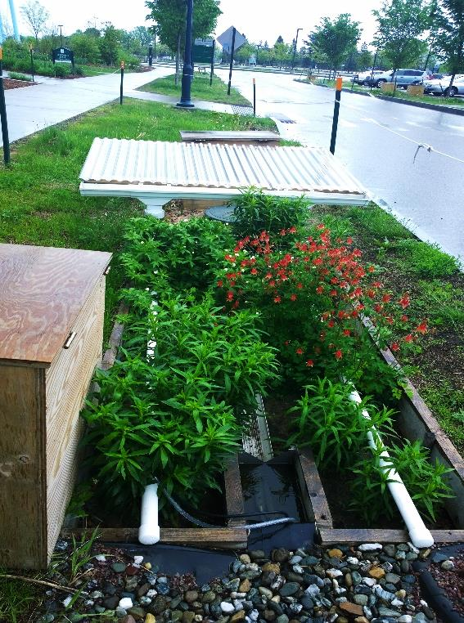
Supplement 1 Fig. 1. Bioretention cell with rainpan and PVC precipitation-distribution pipes. The rainpan is installed outside of the cell. Rainwater from the corrugated pan drains into gutters, vertical downspouts, and to pipes that run horizontally along the length of the cell and contains perforations at the bottom to deliver water evenly across the cell.

Supplemental 2 Table 1. Weir equations for each cell’s inflow and outflow.

 | Cell | Treatment | Weir equation
Inflow weir | 1 | VH RR20 | Q = 7.3858 * H^2.7088
 | 2 | VH | Q = 3.5975 * H^2.4424
 | 3 | VH SMRR60 | Q = 4.3192 * H^2.5137
 | 4 | VH SM | Q = 4.8798 * H^2.5761
 | 5 | VH RR15 | Q = 3.8256 * H^2.4750
 | 6 | VH | Q = 4.8967 * H^2.5735
 | 7 | VL | Q = 4.1210 * H^2.4923
 | 8 | VL | Q = 5.3260 * H^2.6022
Outflow weir | 1-8 |  | Q = 3.4166 * H^2.5515
Q: Flow rate (cfs) H: head (ft) above the 90º v-notch
*VL= vegetation low diversity, VH= vegetation high diversity, RR= enhanced rainfall+runoff,
SM= SorbtiveMediaTM

Supplemental 3 Table 2: Mean soil chemical parameters including pH, organic matter percentage (OM %) using the loss-on-ignition method, available P (mg kg soil⁻¹), and exchangeable cation exchange capacity (ECEC; meg/100 g soil) averaged across all eight bioretention cells in Burlington, Vermont. Means are followed by ± 1 S.E.

Date | pH | OM  (% LOI) | Available P  (mg kg soil⁻¹) | ECEC  (meg/100 g soil)
6/8/2015 | 6.92 ± 0.25 | 1.80 ± 0.56 | 12.24 ± 5.79 | 4.47 ± 1.04
8/24/2015 | 6.99 ± 0.13 | 2.25 ± 1.04 | 26.50 ± 4.03 | 7.25 ± 1.71
10/28/2015 | 7.14 ± 0.06 | 2.20 ± 0.49 | 23.12 ± 2.78 | 7.23 ± 0.92
5/17/2016 | 6.97 ± 0.24 | 1.45 ± 0.38 | 27.03 ± 6.30 | 5.51 ± 0.78
7/28/2016 | 7.09 ± 0.11 | 1.80 ± 0.30 | 32.83 ± 10.65 | 6.88 ± 1.13
9/8/2016 | 7.04 ± 0.12 | 1.97 ± 0.65 | 33.35 ± 6.59 | 7.14 ± 1.62
11/8/2016 | 7.20 ± 0.12 | 2.18 ± 0.55 | 39.94 ± 9.85 | 8.25 ± 1.28

Supplemental 4 Table 3: Mean soil heavy metal concentrations (mg kg soil⁻¹) averaged across all eight bioretention cells in Burlington, Vermont. Means are followed by ± 1 S.E.

 | Available Metals (mg kg soil⁻¹)
Date | Zn | Cu | Fe | Al | Pb | Ni
6/8/2015 | 3.18 ± 0.95 | 0.13 ± 0.02 | 2.73 ± 0.46 | 8.25 ± 1.47 | 0.25 ± 0.47 | 0.13 ± 0.02
8/24/2015 | 3.86 ± 1.39 | 0.15 ± 0.04 | 2.94 ± 0.73 | 6.83 ± 1.13 | 0.18 ± 0.06 | 0.10 ± 0.00
10/28/2015 | 4.61 ± 0.98 | 0.25 ± 0.14 | 2.33 ± 0.54 | 5.83 ± 1.03 | 0.32 ± 0.05 | 0.10 ± 0.01
5/17/2016 | 2.95 ± 1.12 | 0.09 ± 0.03 | 3.78 ± 0.65 | 6.67 ± 0.98 | 0.06 ± 0.05 | 0.11 ± 0.02
7/28/2016 | 4.46 ± 0.60 | 0.13 ± 0.03 | 2.34 ± 0.45 | 6.50 ± 0.89 | 0.09 ± 0.07 | 0.15 ± 0.00
9/8/2016 | 3.05 ± 0.53 | 0.08 ± 0.02 | 2.63 ± 0.53 | 5.25 ± 0.88 | 0.12 ± 0.05 | 0.10 ± 0.00
11/8/2016 | 4.60 ± 0.54 | 0.15 ± 0.00 | 3.63 ± 1.21 | 6.83 ± 1.33 | 0.18 ± 0.04 | 0.10 ± 0.02

Supplement 5: Nitrogen mineralization rates methods
N mineralization and nitrification rates were measured two to three times a year from 2014 to 2016 (total of 8 sampling dates spanning spring, summer and fall) as an indicator of soil media microbial activity from ambient vegetation cells. KCl extraction was carried out on fresh soils for ammonium (NH₄⁺) and nitrate (NO₃⁻). At the time of soil collection, in-field incubation was carried out, where three 100-g subsamples of fresh soil were put into polyethylene bags and installed in three separate locations in each cell at 7 cm depth for 21 days, after which the soil was sampled for final NH₄⁺ and NO₃⁻ using a flow injection autoanalyzer. Net N mineralization (potential organic N transformation rates) rates were calculated by subtracting initial field NH₄⁺ and NO₃⁻ concentrations from final NH₄⁺ and NO₃⁻ concentrations. Net nitrification rate was calculated by final NO₃⁻ concentrations minus initial field NO₃⁻ concentrations (Ross et al., 2009). Moisture-correction was done for each sample to correct for differences in soil water content and express results in dry weight equivalents. N mineralization/nitrification rate were expressed in mg N per kg dry soil.

