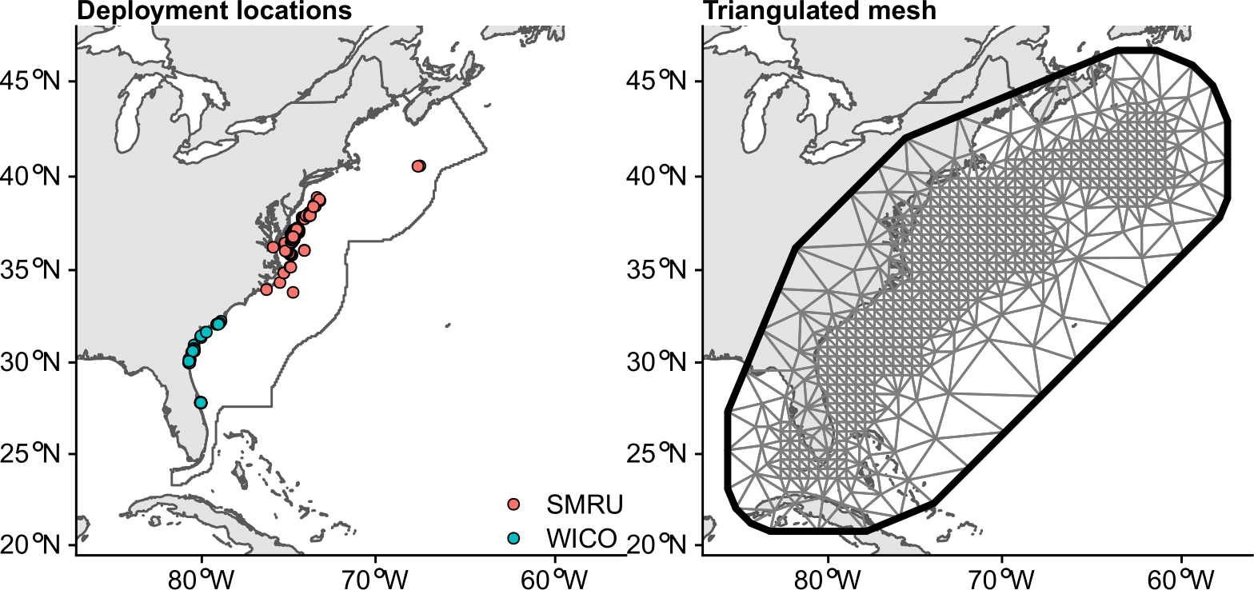
Figure S1. Deployment locations color coded by tag manufacturer (SMRU = Sea Mammal Research Unit, WICO = Wildlife Computers) of 245 satellite relay data loggers (SRDLs) deployed on loggerhead turtles between 2009 and 2018 within the study area off the east coast of North America (black outline) and the triangulated mesh used in the stochastic partial differential equations approach and spatiotemporal regression models fitted to the behavior data collected from the SRDLs.

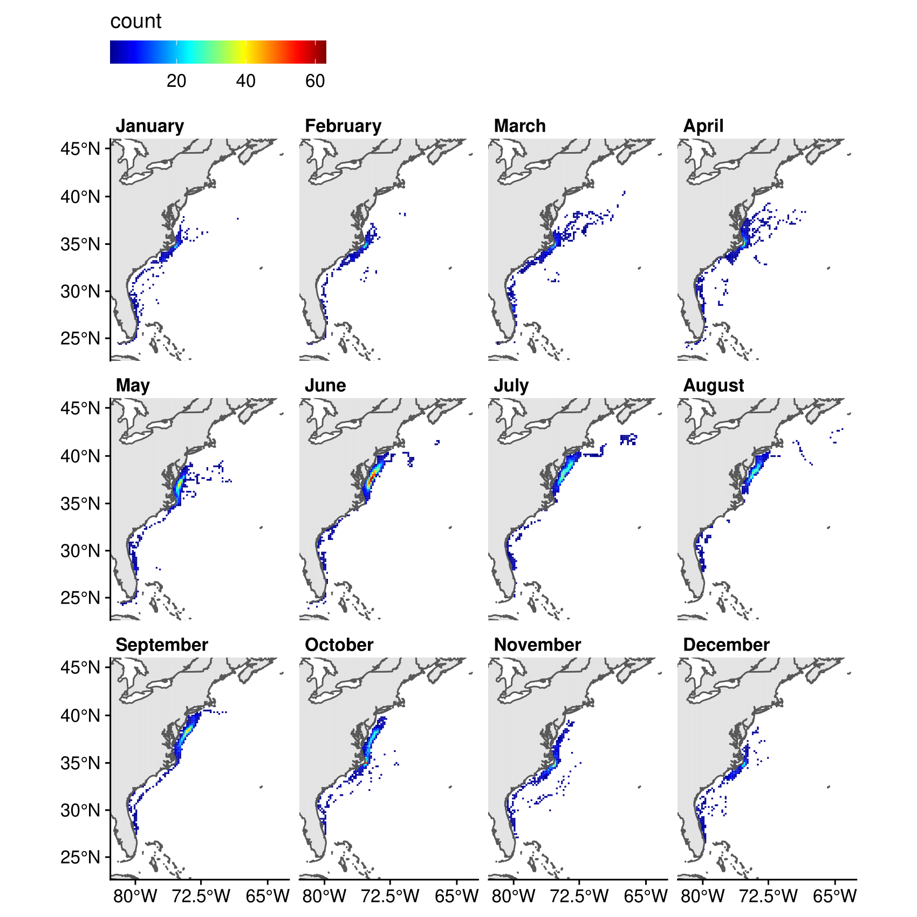
Figure S2. The number of satellite-tagged loggerhead turtles (n = 245) by month summarized over the prediction grid with a cell size of 20 km × 20 km. The loggerhead turtles were tagged with satellite relay data loggers between 2009 and 2018 off the east coast of North America.

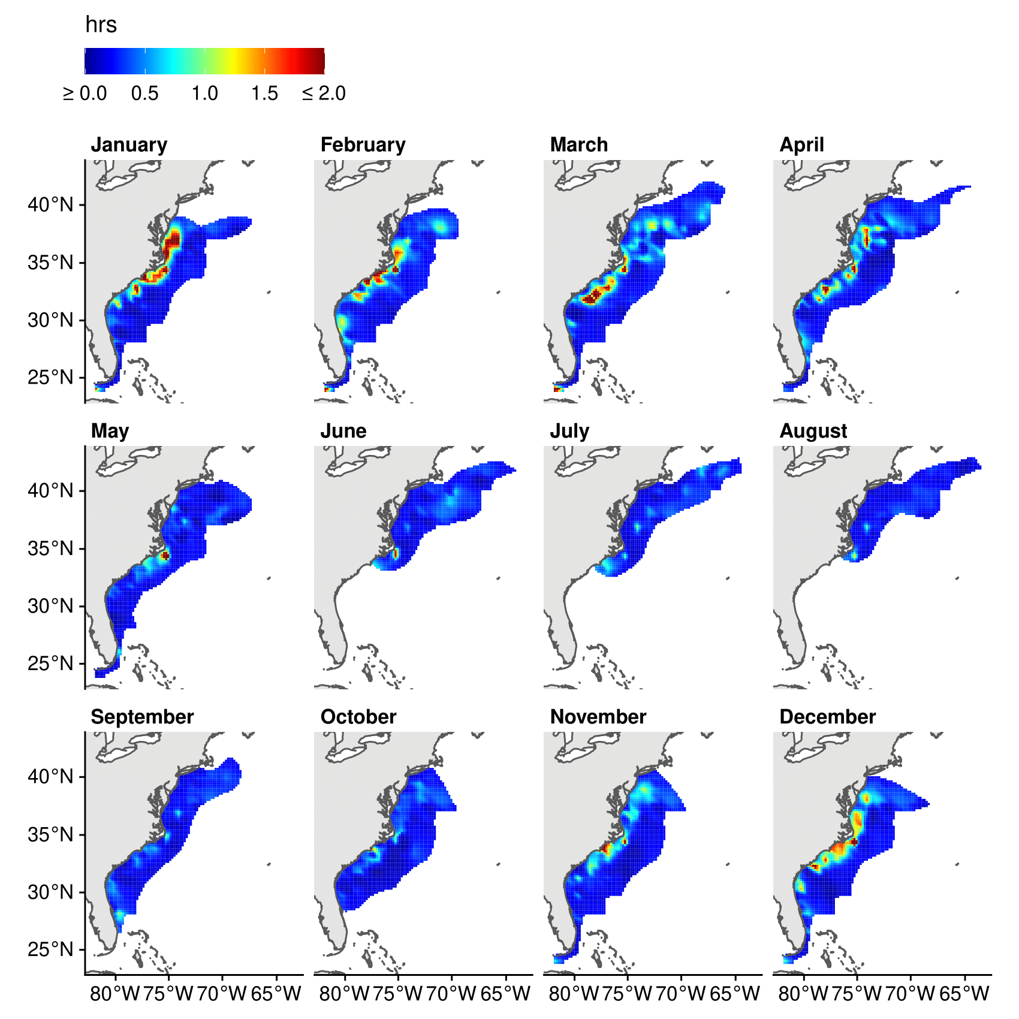
Figure S3. Monthly predictions of the average dive duration from the spatiotemporal regression model fitted with Sea Mammal Research Unit (SMRU) data. The SMRU data contained information from 186 satellite relay data loggers deployed on loggerhead turtles between 2009 and 2018 off the east coast of North America. The prediction grid has a cell size of 20 km × 20 km. The color scale was exceeded in January, February, March, April, May, November, and December with a maximum value of roughly 12.5 hrs. We masked the predictions by buffering the averaged locations by the maximum estimated spatial decorrelation range.

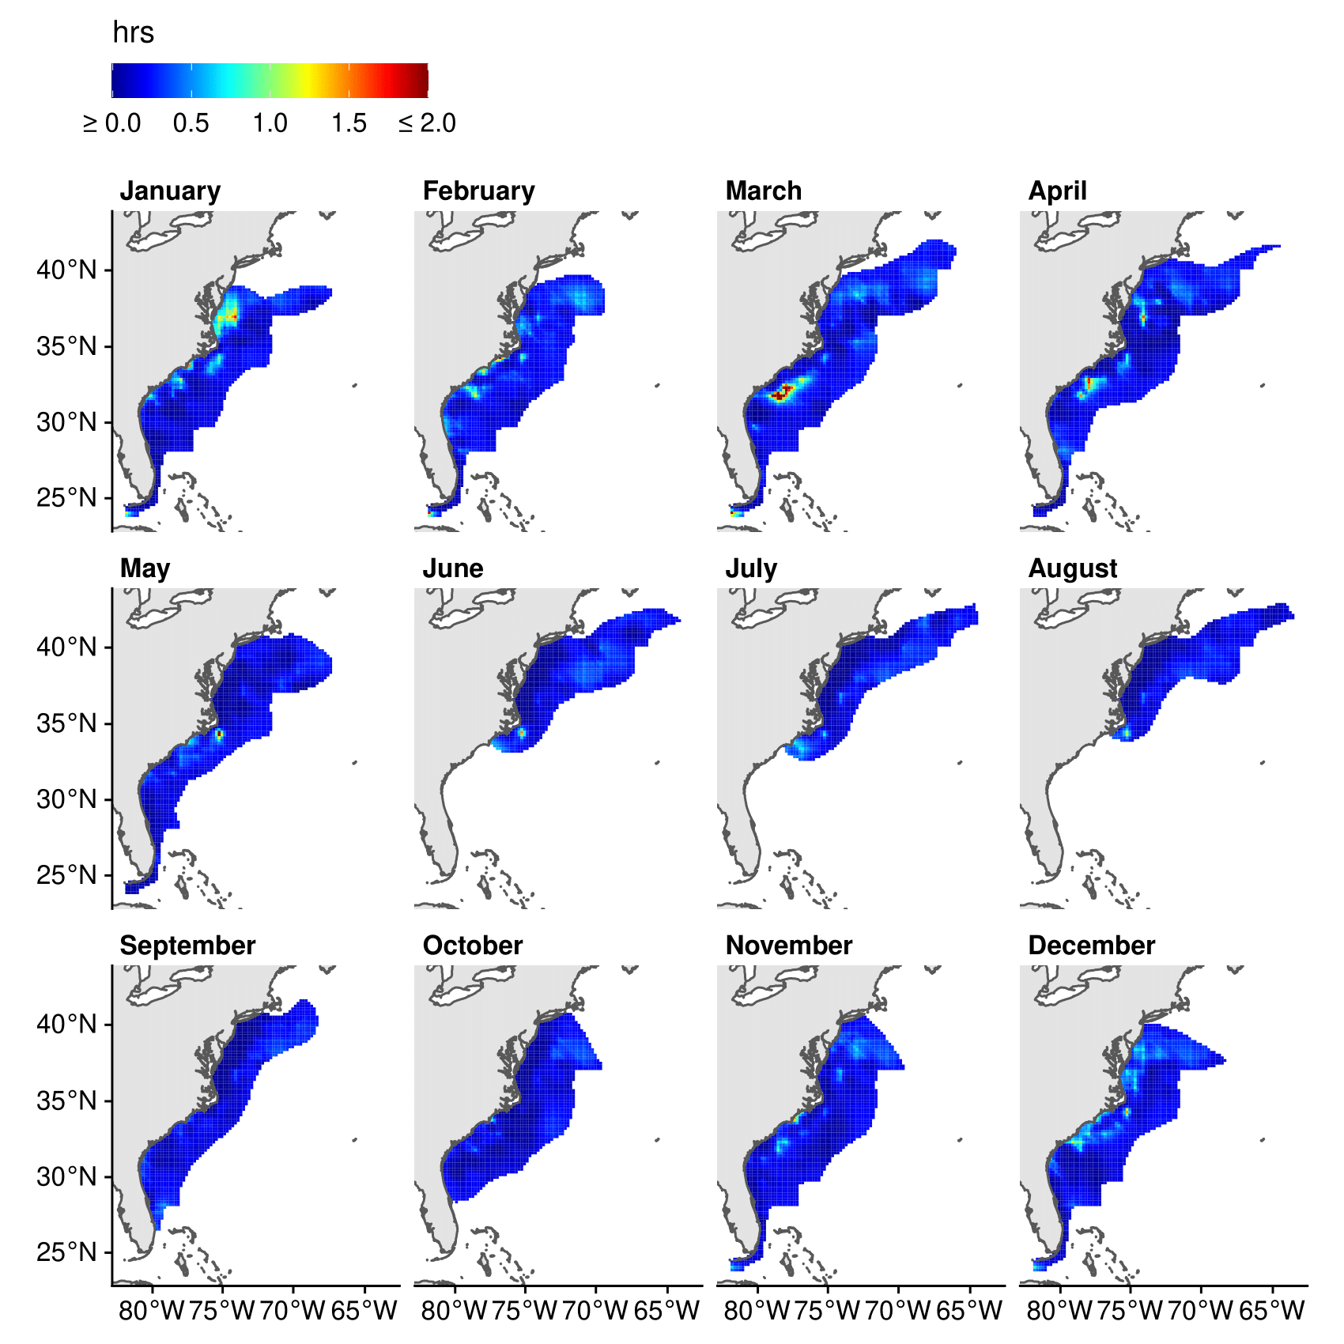
Figure S4. Standard errors for the monthly predictions of average dive duration from the spatiotemporal regression model fitted with Sea Mammal Research Unit (SMRU) data. The SMRU data contained information from 186 satellite relay data loggers deployed on loggerhead turtles between 2009 and 2018 off the east coast of North America. The prediction grid has a cell size of 20 km × 20 km. The color scale was exceeded in February, March, and May with a maximum value of roughly 8.02 hrs. We masked the predictions by buffering the averaged locations by the maximum estimated spatial decorrelation range.

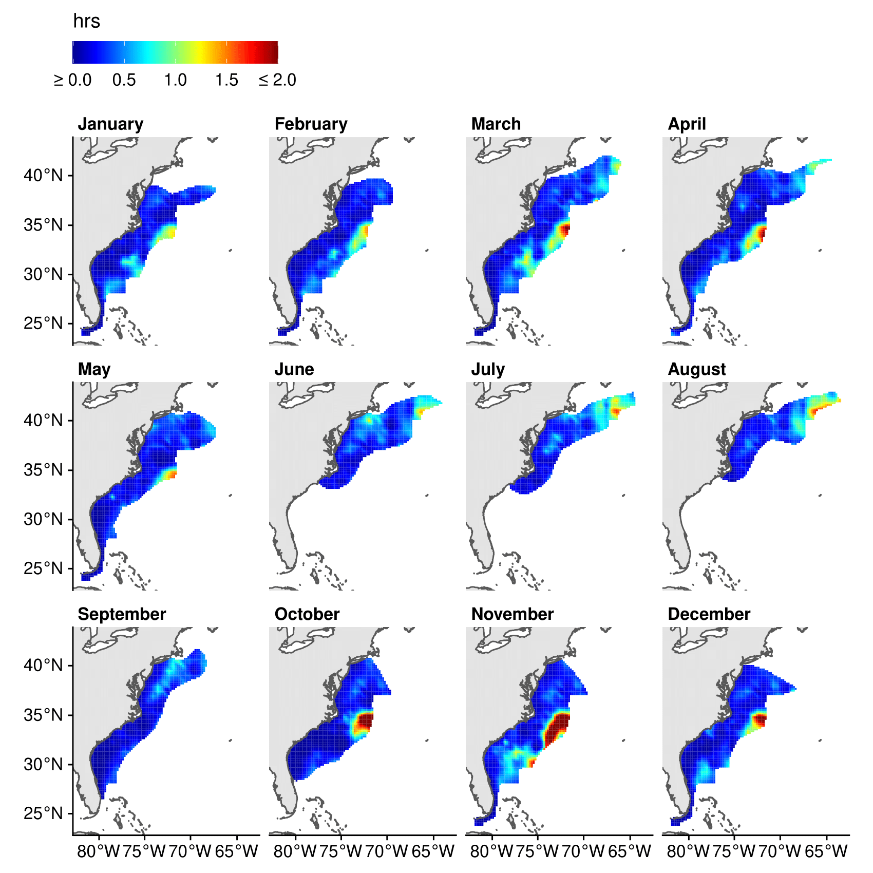
Figure S5. Monthly predictions of the average surface duration from the spatiotemporal regression model fitted with Sea Mammal Research Unit (SMRU) data. The SMRU data contained information from 186 satellite relay data loggers deployed on loggerhead turtles between 2009 and 2018 off the east coast of North America. The prediction grid has a cell size of 20 km × 20 km. The color scale was exceeded in March, April, October, November, and December with a maximum value of roughly 3.38 hrs. We masked the predictions by buffering the averaged locations by the maximum estimated spatial decorrelation range.

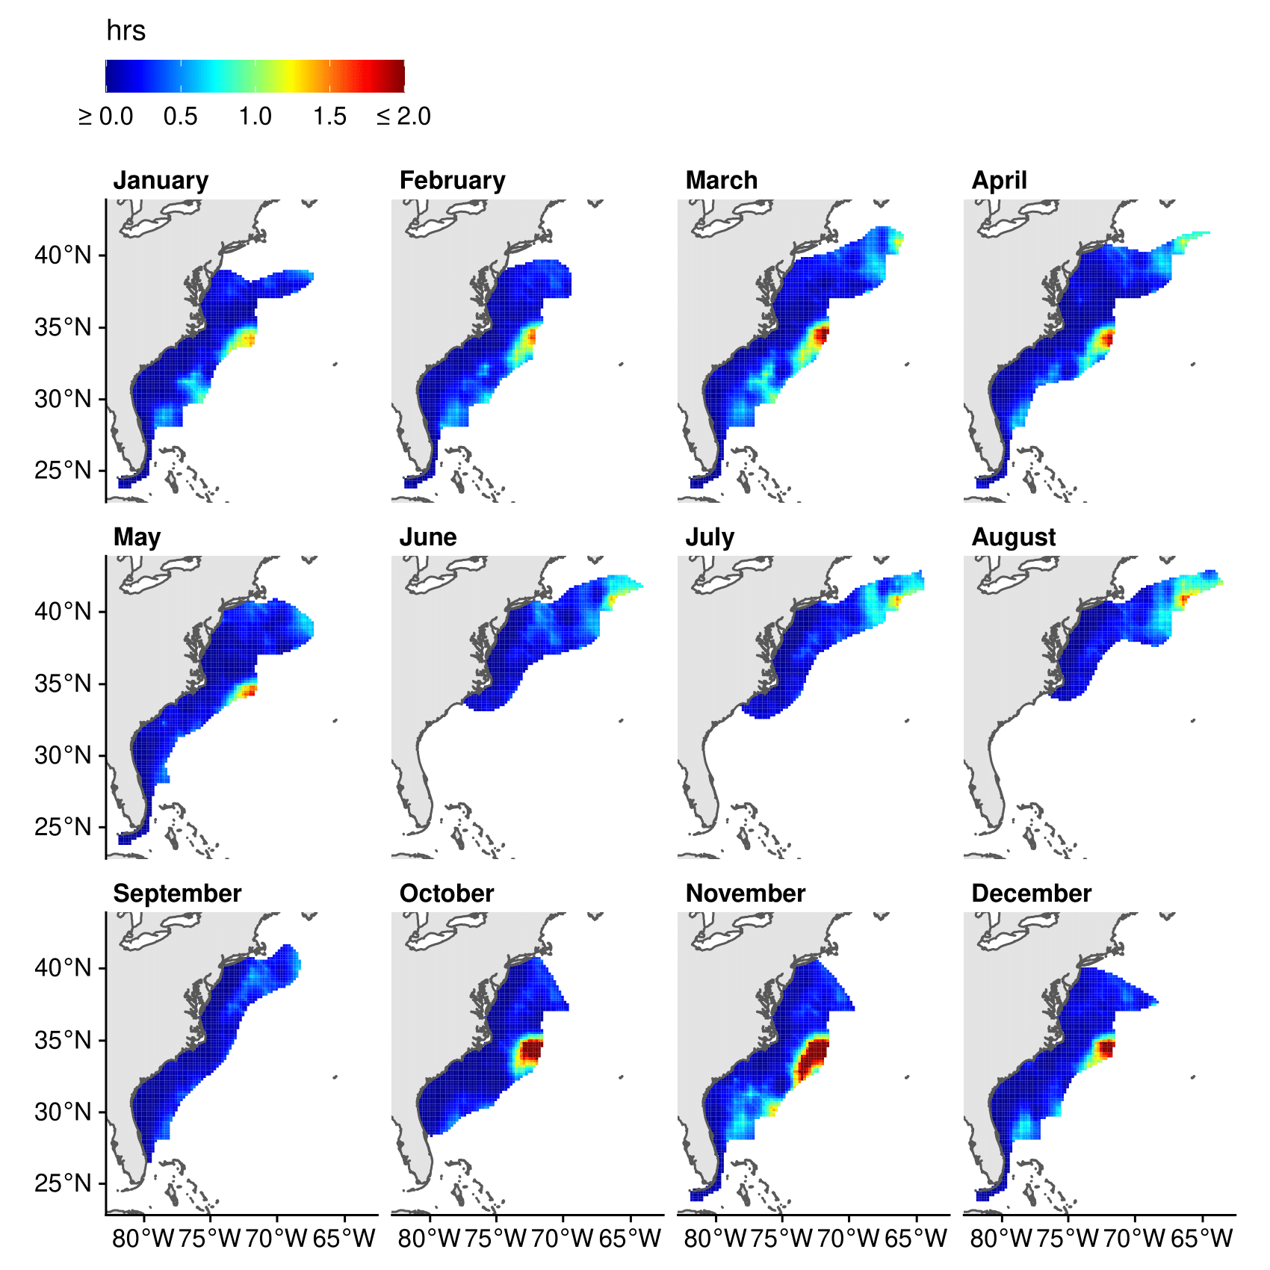
Figure S6. Standard errors for the monthly predictions of the average surface duration from the spatiotemporal regression model fitted with Sea Mammal Research Unit (SMRU) data. The SMRU data contained information from 186 satellite relay data loggers deployed on loggerhead turtles between 2009 and 2018 off the east coast of North America. The prediction grid has a cell size of 20 km × 20 km. The color scale was exceeded in March, April, October, November, and December with a maximum value of roughly 2.97 hrs. We masked the predictions by buffering the averaged locations by the maximum estimated spatial decorrelation range.

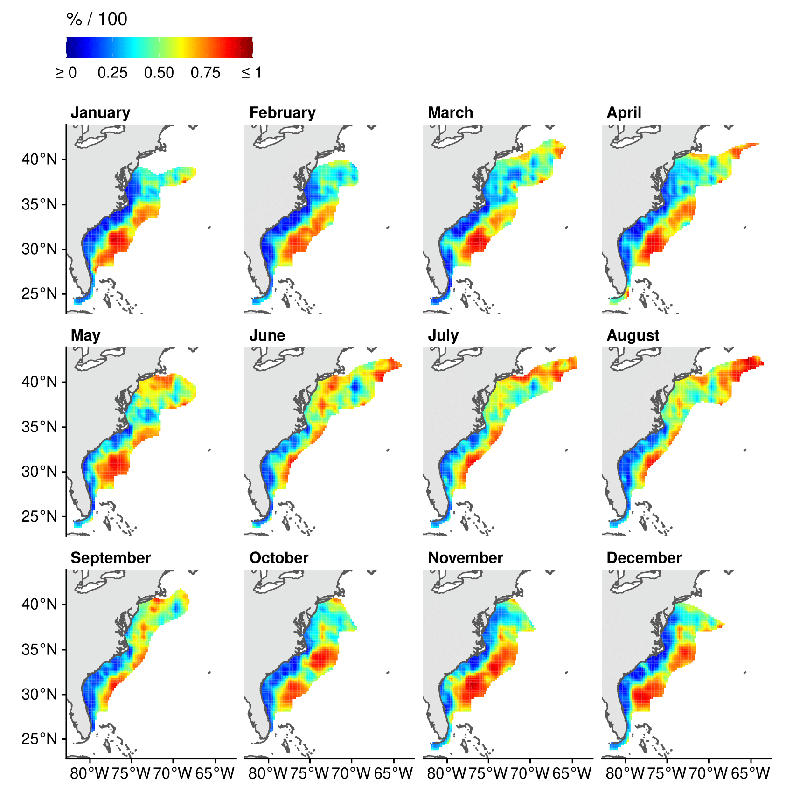
Figure S7. Monthly predictions of the average proportion of time at the surface from the spatiotemporal regression model fitted with Sea Mammal Research Unit (SMRU) + Wildlife Computer (WICO) data. The SMRU + WICO data contained information from 245 satellite relay data loggers deployed on loggerhead turtles between 2009 and 2018 off the east coast of North America. The prediction grid has a cell size of 20 km × 20 km. We masked the predictions by buffering the averaged locations by the maximum estimated spatial decorrelation range.

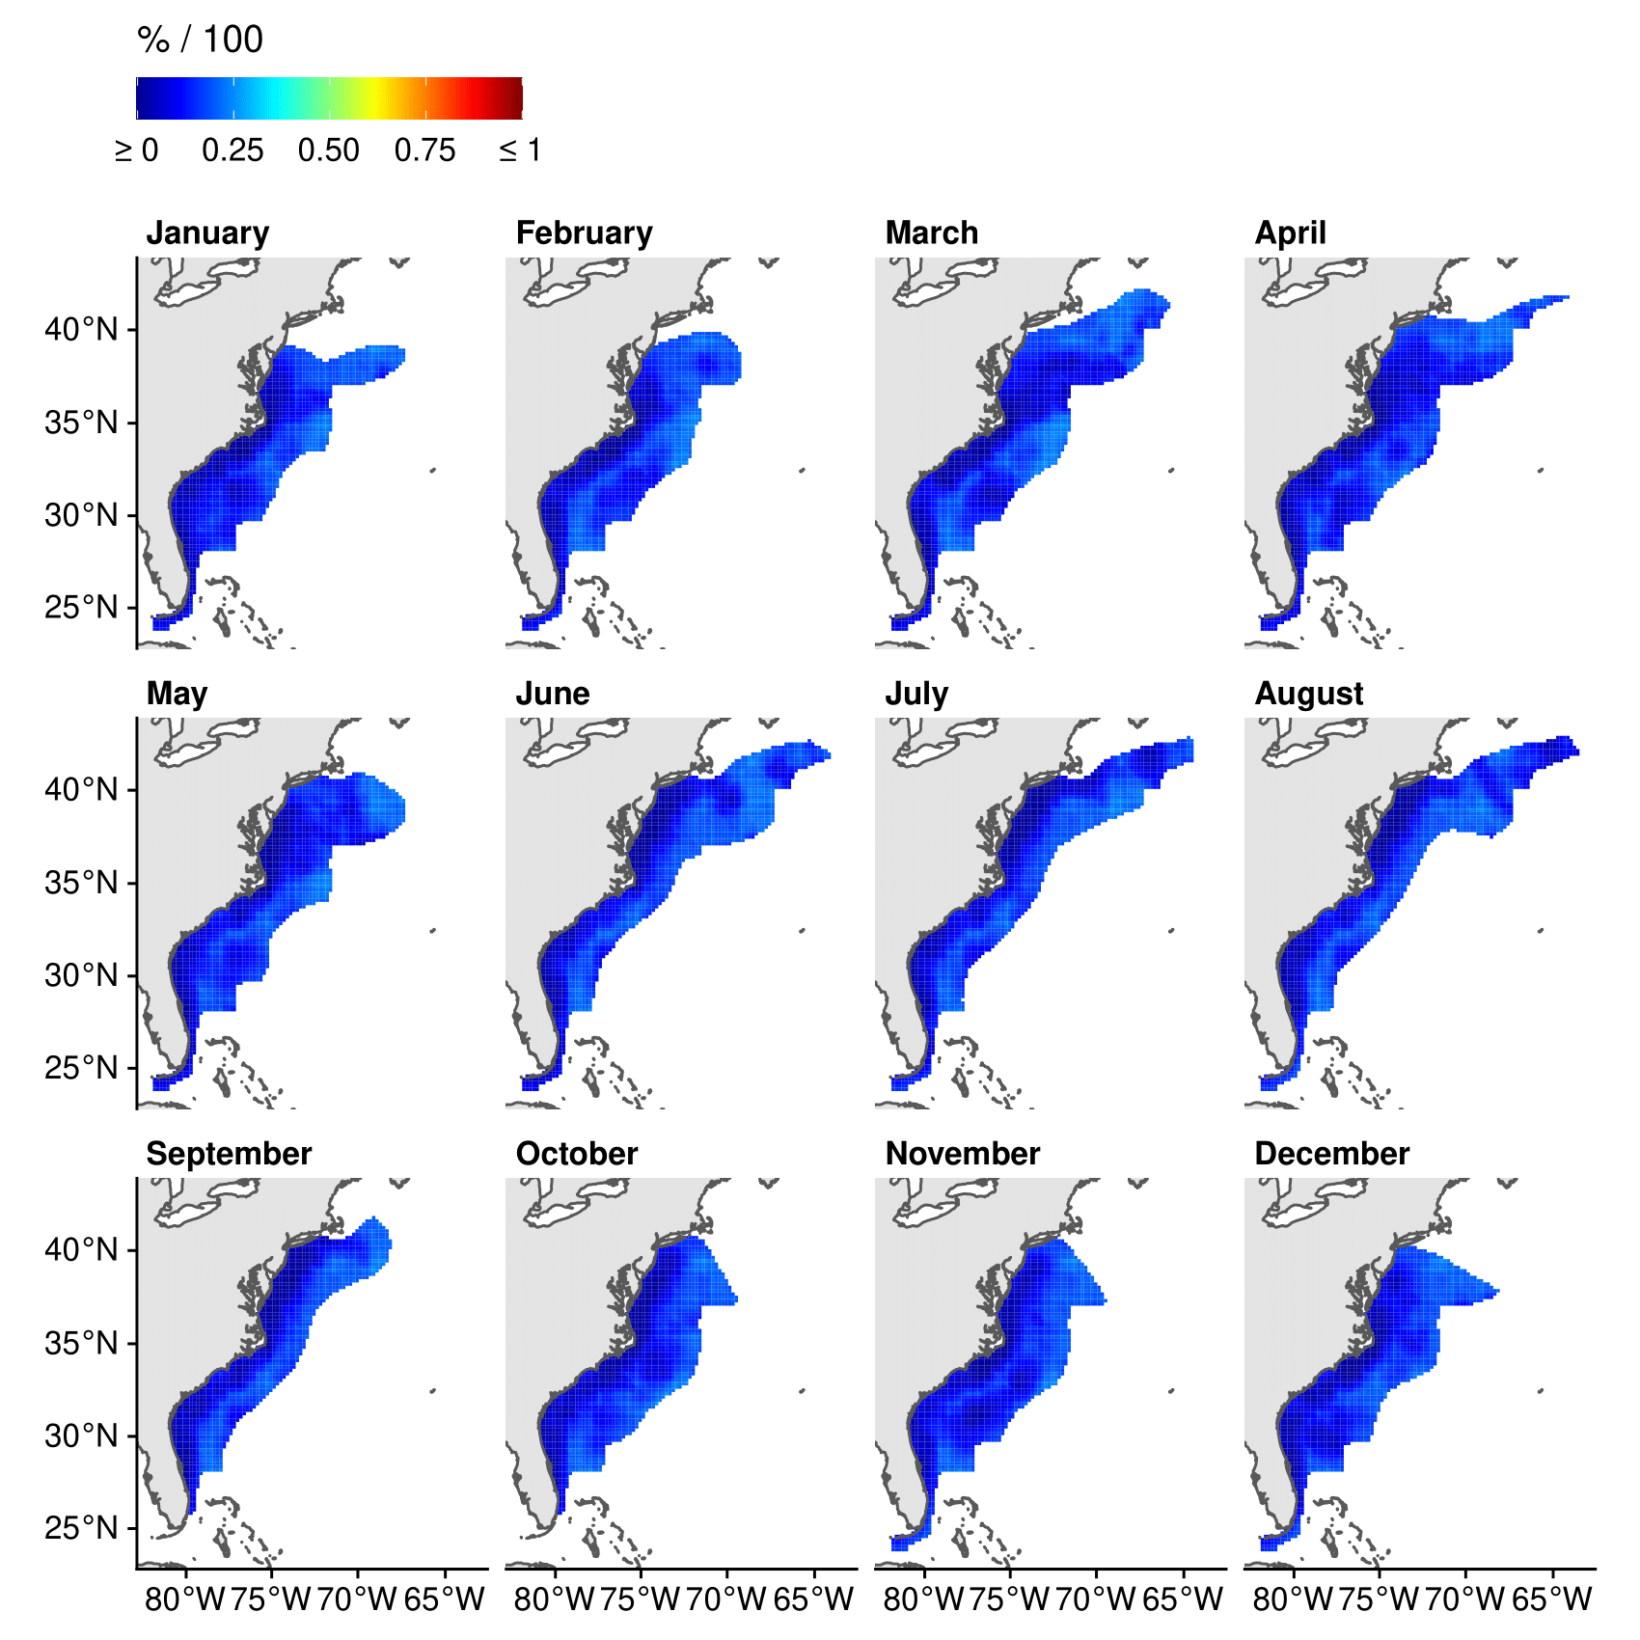
Figure S8. Standard errors for the monthly predictions of the average proportion of time at the surface from the spatiotemporal regression model fitted with Sea Mammal Research Unit (SMRU) + Wildlife Computer (WICO) data. The SMRU + WICO data contained information from 245 satellite relay data loggers deployed on loggerhead turtles between 2009 and 2018 off the east coast of North America. The prediction grid has a cell size of 20 km × 20 km. We masked the predictions by buffering the averaged locations by the maximum estimated spatial decorrelation range.

