**Supplementary Appendix S1: Specifications for bycatch mortality and data generation**

The abundance estimate for year *y*,, is assumed to be log-normally distributed about true abundance $N_{y}$ with a bias, , according to:

   (S1.1)

where  is the CV of the estimates of abundance.

The bycatch mortality for year *y*, *B*y, is assumed to be normally distributed about the limit, *L*y, with a constant CV:

  (S1.2)

where  is the CV of the implementation error. If the bycatch is less than zero, the random deviate $ε_{y}^{L}$ is re-generated.

The estimates of bycatch mortality are assumed to be log-normally distributed about the true bycatch mortality according to

   (S1.3)

where  is the bias in the estimates of bycatch mortality, and  is the CV of the estimates of bycatch mortality.

**Supplementary Appendix S2: Mathematical Specification of the Methods**

**The data**

The data used by the alternative methods are estimates of bycatch mortality, : *y*=,,.., where is the first year with estimates of bycatch mortality, and is the year for which the limit on bycatch mortality is needed, and indices of abundance, :  where *v* is the set of years (between  and ) for which estimates of abundance are available.

**The Depletion-Corrected Average Catch (DCAC) method**

The sustainable level of removals based on DCAC, *Ysust*, is:

 (S2.1)

where  is sum of bycatch mortality estimates over the last *n* (=20) years of the available time series (if there are *n* estimates of bycatch mortality):

 (S2.2)

and is .  is the change in abundance, i.e.  where *s* is the slope of a linear regression of the logarithms of observed abundance, i.e.  where the set of years included in the regression are those years for which there indices of abundance, restricted to those between years  and  and *m*=20, unless there are fewer than five indices in this interval (e.g. if the survey interval is eight years), in which case the most recent five indices of abundance are used in the regression. The delta-method standard error of , , is where σs is the standard error of *s*. *c* is the rate of population increase at the maximum net productivity level (MNPL) divided by adult natural mortality *M*.

A distribution for *Ysust* is computed by generating values for Δ, *M* and *c* from the following probability distributions:

* Δ: A log-normal distribution with mean  and a delta-method CV of , constrained to be less than 1;
* *M*: A uniform distribution over [0.05 and 0.1 yr-1] for the cetaceans (survival between 0.9 and 0.95) and [0.05 and 0.16 yr-1] for the pinnipeds (survival between 0.84 and 0.95);
* *c*: A log-normal distribution with mean 1.0 and standard error of the logarithm of 0.2;

and computing *Ysust* for each generated parameter vector.

**The Replacement Yield (RY) method**

The population dynamics model underlying the RY method is

  (S2.3)

where  is the number of animals at the start of year *y*, *t* is the number of years before yearthat are modelled (*t* =20 for the calculations of this paper), and *P* is the annual net change in population size (assumed to be constant and independent of population size). The likelihood function is based on the assumption that logarithms of the abundance indices are normal:

 (S2.4)

where *q* is a constant of proportionality between the abundance indices and true abundances (i.e., a constant proportion of the population is surveyed each year), σ is the standard error of log abundance indices, and *y*\* denotes the set of years for which abundance indices are available during the most recent *t* years.

A probability distribution for *P* (and hence the limit on bycatch mortality) is computed using Sample-Importance-Resampling algorithm. This involves generating parameter vectors from prior distributions for *N*initial  and *P,* where  is the mean estimate of bycatch mortality for the *m* years before year *y*curr (*m*=20 unless fewer estimates are available), and computing the marginal likelihood of the data for each parameter vector after marginalizing over priors for log(*q)* of U[-∞ ,∞], for σ proportional to 1/σ2, i.e.:

 (S2.5)

  (S2.6)

where *n*\* is the number of abundance indices. The parameter vectors determining the posterior for *P* are obtained by resampling from the parameter vectors with probability given by *L* (Equation S2.5).

**The Slope method**

This method involves first regressing the logarithms of observed abundance on year, i.e. , where the set of years included in the regression are those years for which there are indices of abundance, restricted to those between  and  (*m*=20), unless there are fewer than five indices in this interval in which case the most recent five indices of abundance are used in the regression. The limit on human-caused mortality is calculated using the formula:

 (S2.6)

where is the mean of the estimates of bycatch mortality over the last *n* (=20) years of the available time series (years  to ; if there are *n* estimates bycatch mortality),  is the estimate of the slope of a linear regression of  on year *y* using the five most recent estimates of abundance or those for the most recent *m* (=20) years (i.e. years  to ), whichever leads to more estimates of abundance,  is the standard error of , and *x* is a tuning parameter that determines the extent to which the limit on bycatch mortality is reduced depending on the uncertainty of *.*

Supplementary Table 1. Summary of the results for the tunings of the four base-case trials when the population is initially at 0.3*K* for two levels of conservation risk (corresponding to *F*R=1 and *F*R=0.5). The bold values indicate the lowest values for the performance metrics across abundance CVs for the PBR method. The underlined values (one for each combination of method, life history and abundance CV) are those that determined the tuning parameter for the remaining methods. The ‘scaled’ values are expressed relative to the underlined values for probability of recovery and the lower 5th percentile of the population size relative to *K* in 100 years. The ‘scaled’ values for total limit and average inter-survey variation (AISV; representing the average absolute difference in limit between surveys) are relative to the results for the PBR method for the given CV. For pinnipeds, it was not possible to tune the DCAC and RY methods to match the probability of recovery (1.000) that the PBR method achieves when *F*R=0.5; estimated probabilities of recovery were 0.951 (DCAC) and 0.960 (RY).

|  |  |  |  |  |  |  |  |  |  |  |  |  |  |  |  |
| --- | --- | --- | --- | --- | --- | --- | --- | --- | --- | --- | --- | --- | --- | --- | --- |
|  |  | *F*R = 1 | | | | | | | *F*R = 0.5 | | | | | | |
| Rule | Abundance  CV | Tuning parameter | Prob (rebuild) | | Lower 5th population size | | Total Limit | AISV | Tuning parameter | Prob (rebuild) | | Lower 5th population size | | Total Limit | AISV |
|  |  |  | (original) | (scaled) | (original) | (scaled) | (scaled) | (scaled) |  | (original) | (scaled) | (original) | (scaled) | (scaled) | (scaled) |
| *Cetacean* |  |  |  |  |  |  |  |  |  |  |  |  |  |  |  |
| PBR | 0.2 | 0.842 | **0.903** | 100 | **0.492** | 100 | 100 | 100 | 0.842 | **1.000** | 100 | **0.717** | 100 | 100 | 100 |
| DCAC | 0.2 | 0.327 | 0.970 | 107 | 0.540 | 110 | 57 | 200 | 0.167 | 0.998 | 100 | 0.717 | 100 | 55 | 240 |
| RY | 0.2 | 0.1221 | 0.974 | 108 | 0.522 | 106 | 83 | 238 | 0.0614 | 1.000 | 100 | 0.717 | 100 | 82 | 265 |
| Slope | 0.2 | 0.6654 | 0.948 | 105 | 0.493 | 100 | 78 | 161 | 1.2322 | 1.000 | 100 | 0.717 | 100 | 70 | 196 |
| PBR | 0.8 | 0.842 | 0.993 | 110 | 0.564 | 115 | 100 | 100 | 0.842 | 1.000 | 100 | 0.757 | 106 | 100 | 100 |
| DCAC | 0.8 | 0.327 | 0.949 | 105 | 0.492 | 100 | 42 | 81 | 0.167 | 0.987 | 99 | 0.748 | 104 | 51 | 94 |
| RY | 0.8 | 0.1221 | 0.944 | 105 | 0.493 | 100 | 101 | 61 | 0.0614 | 1.000 | 100 | 0.773 | 108 | 92 | 68 |
| Slope | 0.8 | 0.6654 | 0.963 | 107 | 0.575 | 117 | 42 | 136 | 1.2322 | 0.996 | 100 | 0.859 | 120 | 25 | 161 |
| *Pinniped* |  |  |  |  |  |  |  |  |  |  |  |  |  |  |  |
| PBR | 0.2 | 0.842 | 0.951 | 100 | 0.501 | 102 | 100 | 100 | 0.842 | **1.000** | 100 | **0.745** | 100 | 100 | 100 |
| DCAC | 0.2 | 0.294 | 0.999 | 105 | 0.826 | 168 | 39 | 185 | 0.292 | 1.000 | 100 | 0.828 | 111 | 57 | 191 |
| RY | 0.2 | 0.1983 | 0.984 | 104 | 0.591 | 120 | 85 | 145 | 0.1412 | 1.000 | 100 | 0.745 | 100 | 103 | 162 |
| Slope | 0.2 | 0.6985 | 1.000 | 106 | 0.729 | 148 | 72 | 145 | 0.7343 | 1.000 | 100 | 0.745 | 100 | 103 | 150 |
| PBR | 0.8 | 0.842 | **0.947** | 100 | **0.493** | 100 | 100 | 100 | 0.842 | 0.999 | 100 | 0.757 | 102 | 100 | 100 |
| DCAC | 0.8 | 0.294 | 0.951 | 100 | 0.739 | 150 | 23 | 78 | 0.292 | 0.951 | 95 | 0.882 | 118 | 38 | 81 |
| RY | 0.8 | 0.1983 | 0.949 | 100 | 0.493 | 100 | 86 | 54 | 0.1412 | 0.991 | 99 | 0.803 | 108 | 106 | 62 |
| Slope | 0.8 | 0.6985 | 0.950 | 100 | 0.493 | 100 | 33 | 121 | 0.7343 | 0.960 | 96 | 0.883 | 119 | 51 | 128 |

Figure S1. Values for the conservation-related performance metrics for the base-trials and the nine sensitivity tests in Table 1(b). The circles show results for the cetacean and the triangles for the pinniped, with open symbols corresponding to an abundance CV of 0.2 and closed symbols to an abundance CV of 0.8. The results in this figure pertain to the tunings that match the *F*R=1 tuning of the PBR method.

Figure S2. Values for total limit and AISV based on the PBR method and the three alternative methods, from the sensitivity tests that vary the CV of the estimates of bycatch mortality.

Figure S3. Values for total limit and AISV based on the PBR method and the three alternative methods from the sensitivity tests that vary the survey frequency. The results in the upper panels for each performance metric pertain to the tunings that match the *F*R=1 tuning of the PBR method, and those in the lower panels to the tunings that match the *F*R=0.5 tuning of the PBR method.

Figure S4. Performance of all methods against conservation-related metrics for the cetacean with increasing intervals between surveys, for tunings that match PBR tuning for *F*R=1 (columns 1 and 2) and *F*R=0.5 (columns 3 and 4), and for two levels of the CV of abundance indices. Results are shown for the original implementations of the DCAC and Slope and when the CVs for the slope are based on abundance estimates every four years. The fewer estimates of abundance lead to a higher value for  and a larger reduction in the limit compared to Equation 6. The effect of basing the uncertainty of  on fewer estimates of abundance is qualitatively similar to the effect of basing  on fewer data, but smaller (compare the changes in the results for the DCAC and Slope methods).

Figure S5. Probability of rebuilding to MNPL after 100 years for scenarios in which the first estimates of bycatch are available five (BCyr=-5) or ten (BCyr=-10) years prior to the first application of the management system, and in which the first abundance estimates are available five (Ayr=-5) or ten (Ayr=-10) years prior to the first application of the management system. The four columns show results for the two life histories and choices for the CV for the abundance estimates. *F*R=1 for these results..

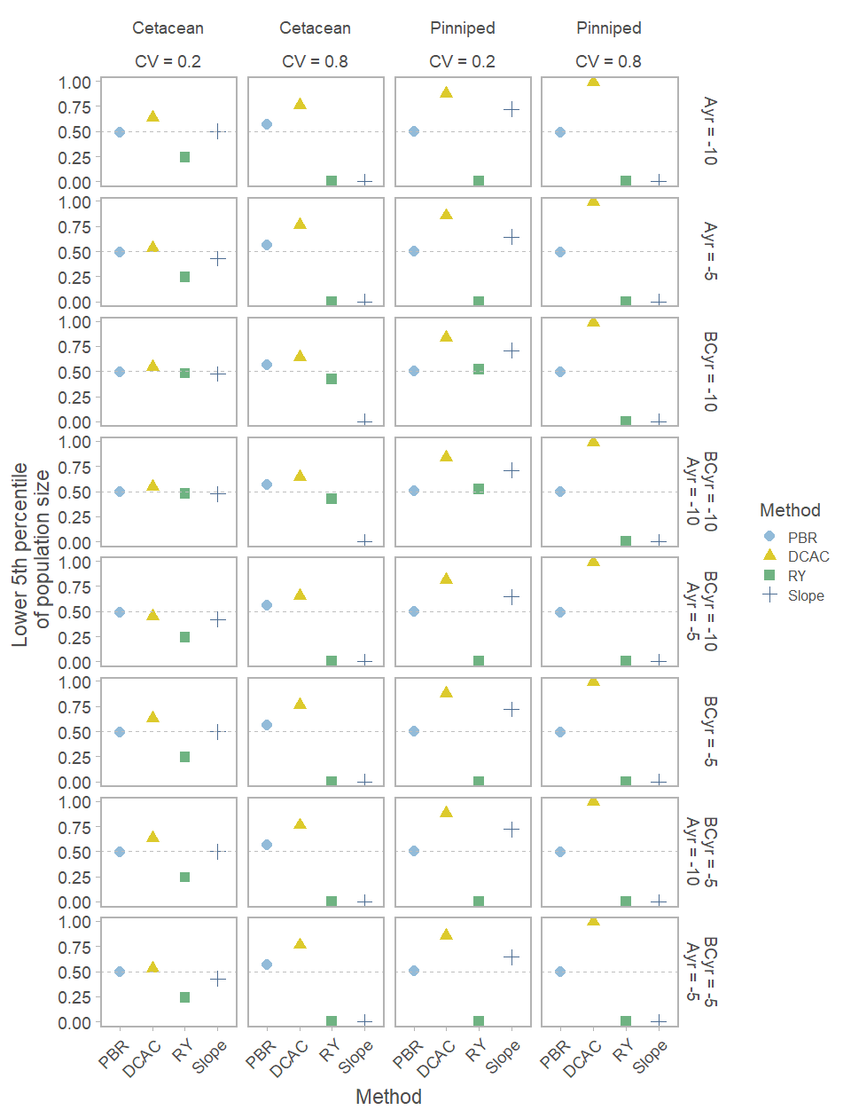Figure S6. As for Figure S5, but the results pertain to the lower 5th percentile of population size after 100 years.

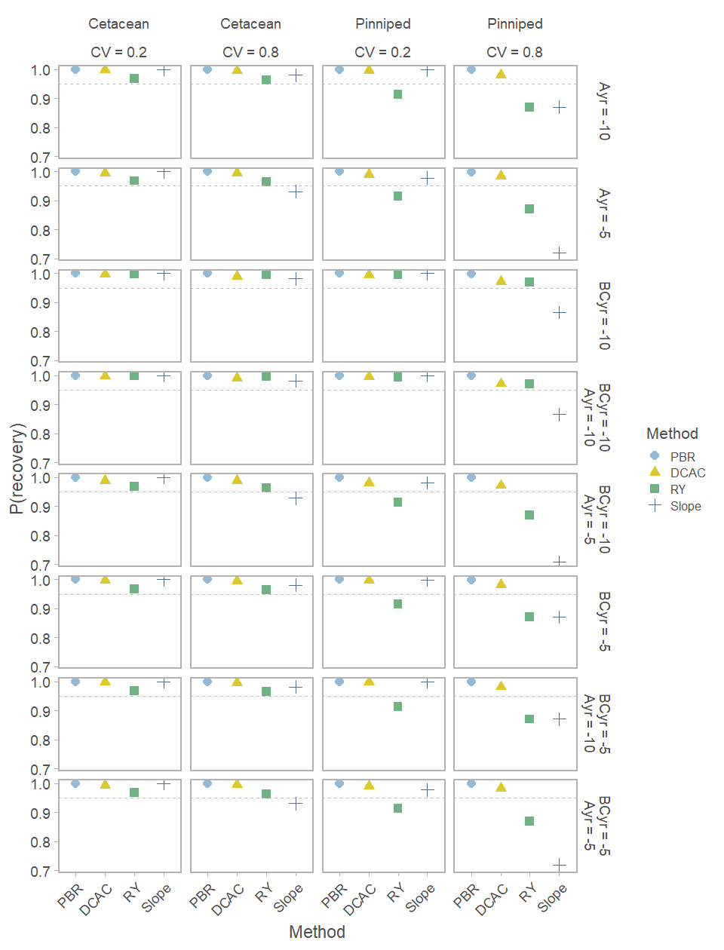Figure S7. As for Figure S5, except that the methods are tuned to match the version of the PBR formula with *F*R=0.5.

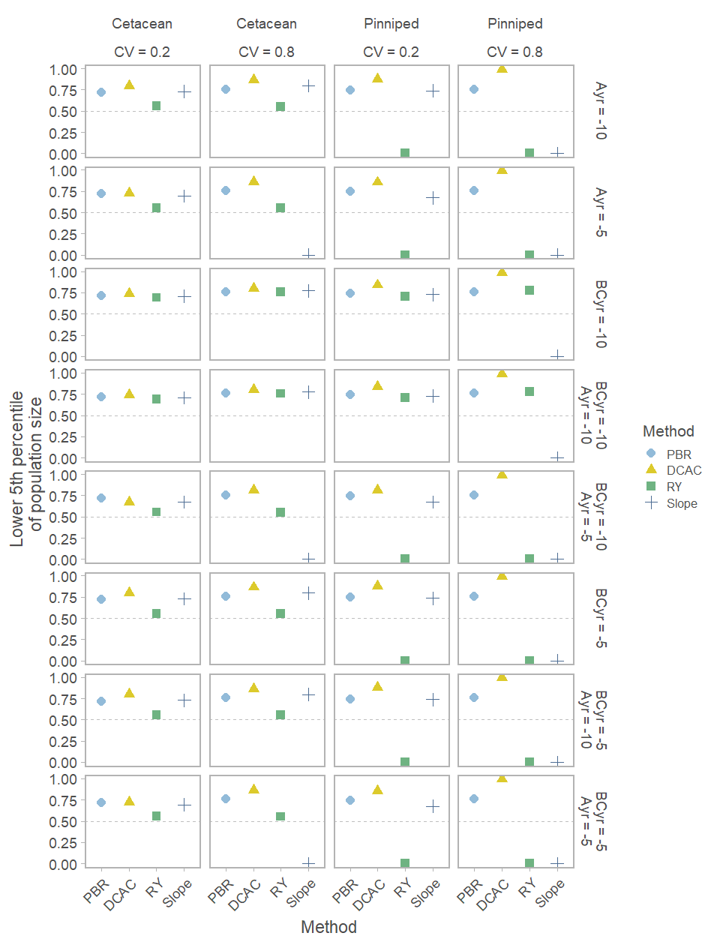Figure S8. As for Figure S6, except that the methods are tuned to match the version of the PBR formula with *F*R=0.5.