Supplementary Table 1. The abundance estimates and pup counts used when fitting the model. The year indicated by an asterisk is the reference year on which a prior on absolute abundance is placed. Source: Sielfeld et al. (1997), Oporto et al. (1999), Bartheld et al. (2008), Sepúlveda et al. (2011), Oliva et al. (2012), Contreras et al (2014) Oliva et al. (2016), Oliva et al. (2020)

- South American sea lions
Year | 1+ abundance | Pups
North
1996* | 28781 | 13083
2007 | 29406 | 10616
2012 | 30016 | 19134
2019 | 30121 | 10127
Central
1997* | 15163 | 1677
2007 | 16052 | 1705
2015 | 24784 | 1855
2019 | 21610 | 1085
South
1998* | 41887 | 13041
2007 | 40588 | 9608
2012 | 44197 | 22486
2019 | 46520 | 18615

- South American fur seals (south zone)
Year | 1+ abundance | Pups
North
1998* | 2565 | 263
2007 | 4116 | 1408
2012 | 6412 | 3183
2019 | 24017 | 5579

References
Bartheld, J., Pavés, H., Contreras, F., Vera, C., Manque, C., Miranda, D., Sepúlveda, D., Artacho, P., Osman, L., 2008. Cuantificación poblacional de lobos marinos en el litoral de I a IV región. Informe final proyecto FIP 2006-50, 124 p.
Contreras, F., Bartheld, J., Montecinos, M., Moreno F., Torres, J., 2014. Cuantificación poblacional de lobo marino común (Otaria flavescens) en el litoral de la XV, I y II Regiones. Informe Final Proyecto 2012-6-FAP-1, 86 p.
Oliva, D., Durán, L.R., Couve, P., Sepúlveda, M., Carrasco, P., Urra, A., Muñoz, L., Pavés G., Pizarro, M., 2016. Estimación poblacional de lobos marinos en la V, VI, VII y VIII Regiones. Informe Final Proyecto FIP 2014-29, 169 pp + Anexos.
Oliva, D., Durán, L.R., Sepúlveda, M., Cárcamo, D., Pizarro, M., Anguita, C., Santos, M., Canto, A., Herrera, P., Muñoz, L., Orellana, M., Vásquez, P., 2020. Estimación poblacional de lobos marinos e impacto de la captura incidental. Informe Final Proyecto FIPA 2018-54, 184 pp + Anexos.
Oliva, D., Sepúlveda, M., Durán, R., Urra, A., Sielfeld, W., Moraga, R., Pavés, G., Muñoz, L., 2012. Cuantificación poblacional de lobos marinos en las Regiones X-XI y propuesta de escenarios de manejo. Informe Final Proyecto FAP ID 4728-46-LP11, 100 p.
Oporto, J., Brieva, L., Navarro, R., Turner, A., 1999. "Cuantificación poblacional de lobos marinos en la X y XI Regiones"., Informe Final Proyecto FIP 97–44, 277 p.
Sepúlveda, M., D. Oliva, A. Urra, MJ. Pérez, R. Moraga, D. Schrader, P. Inostroza, A. Melo, H. Díaz Sielfeld, W., 2011. Abundance and status of South American sea lions (Otaria flavescens) off Central Chilean coast. Revista Chilena de Historia Natural 84(1): 97-106.
Sielfeld, W., Amado, N., Peredo, R., Vargas, M., Guerra, C., Malinarich, A., Acuña, E., Cerda, G., Bolvaran, A., Durán, R., Aguayo, A., Sepúlveda, M., Palma, F., Veloso, X., Guerra, Y., Grau, R., Galaz, J.L.,m 1997. Monitoreo de la pesquería y censo del lobo marino común en el litoral desde la I a IV regiones. Proyecto FIP 95-28, 105 p.
Venegas, C., Gibbons, J., Aguayo, A., Sielfeld, W., Acevedo, J., Amado, N., Capella, J., Guzmán, G., Valenzuela, C., 2002. Distribución y abundancia de lobos marinos (Pinnipedia: Otariidae) en la Región de Magallanes, Chile. Anales Instituto Patagonia, Ser. Cs. Nat. 30: 67-82.
Supplementary Table 2. Further details on the basis for the fisheries included in the analyses for South American sea lions and fur seals off Chile.

Target Species | Gear type | Number of vessels | Zone of operation | Zone based on administrative region numbers
Anchoveta / Chilean silverside | Artisanal Purse seine | 76 | XV-II Regions: 1 Mar-31 Dec; Chilean province (0- 5 nm) XV to II Regions | North
Anchoveta | Artisanal Purse seine | 43 | Chilean province (0-5 nm) III to IV Regions | North
Anchoveta | Artisanal Purse seine | 442 | Jul and 5 Oct-30 Nov X Region: 15 Apr-15 Sep and 15 Oct-15 Mar | Central
Anchoveta / Chilean silverside | Industrial Purse seine | 58 | XV-II Regions: 1 Mar-31 Dec Chilean province (1-200 nm) XV to II Regions | North
Anchoveta | Industrial Purse seine | 14 | Chilean province (5-200 nm) III to IV Regions | North
Anchoveta | Industrial Purse seine | 28 | Jul and 5 Oct-30 Nov X Region: 15 Apr-15 Sep and 15 Oct-15 Mar | Central
Chilean jack mackerel | Artisanal Purse seine | 605 | All year; Chilean province XV to X Regions (0-5 nm (artisanal fishing)) | North / Central
Chilean jack mackerel | Industrial Purse seine | 87 | All year; XV to X Regions 5-200 nm and SPRFMO area (industrial fishing) | North/Central

Supplementary Table 3. Data and information on bycatch of South American sea lions and fur seals off Chile. The column “observer coverage” is the proportion of the annual targeted (fish) catch obtained from observed hauls. Sources: San Martin (2016), Aranis (2017, 2018), Bernal et al. (2017, 2019), Vega et al. (2019) (see Supplementary Table 2 for more information on the basis for the fisheries).

Year | Zone | Fishery | Bycatch |  | Observer
 |  |  | Dead | Alive | Coverage
South American Sea Lion
2017 | North | Artisanal purse seine (anchovy & sardine) | 0 | 89 | 1.40
2018 | North | Artisanal purse seine (anchovy & sardine) | 1 | 267 | 1.58
2017 | North | Industrial purse seine (anchovy & sardine) | 0 | 259 | 4.47
2018 | North | Industrial purse seine (anchovy & sardine) | 2 | 1339 | 14.23
2015 | Central | Industrial purse seine (jack mackerel) | 0 | 316 | 10.51
2016 | Central | Industrial purse seine (jack mackerel) | 4 | 908 | 8.77
2017 | Central | Industrial purse seine (jack mackerel) | 7 | 249 | 19.39
2018 | Central | Industrial purse seine (jack mackerel) | 3 | 264 | 18.47
2015 | Central | Artisanal purse seine (anchovy & sardine) | 0 | 214 | 0.47
2016 | Central | Artisanal purse seine (anchovy & sardine) | 0 | 1092 | 0.80
2017 | Central | Artisanal purse seine (anchovy & sardine) | 1 | 1615 | 2.24
2018 | Central | Artisanal purse seine (anchovy & sardine) | 3 | 355 | 1.34
2015 | Central | Industrial purse seine (anchovy & sardine) | 5 | 564 | 8.29
2016 | Central | Industrial purse seine (anchovy & sardine) | 19 | 572 | 5.87
2017 | Central | Industrial purse seine (anchovy & sardine) | 1 | 341 | 10.11
2018 | Central | Industrial purse seine (anchovy & sardine) | 0 | 177 | 16.67
2015 | Central | Trawl fishery | 27 | 16 | 19.36
2016 | Central | Trawl fishery | 73 | 44 | 72.05
2017 | Central | Trawl fishery | 104 | 17 | 100
2018 | Central | Trawl fishery | 123 | 6 | 100
2015 | South | Ice trawler fleet | 112 | 12 | 29.14
2016 | South | Ice trawler fleet | 91 | 32 | 57.84
2017 | South | Ice trawler fleet | 58 | 5 | 37.53
2018 | South | Ice trawler fleet | 31 | 9 | 35.19
2015 | South | Trawl factory fleet | 1 | 1 | 74.75
2016 | South | Trawl factory fleet | 17 | 14 | 88.06
2017 | South | Trawl factory fleet | 35 | 0 | 42.76
2018 | South | Trawl factory fleet | 117 | 11 | 81.04
South American fur seal
2015 | South | Ice trawler fleet | 0 | 0 | 29.14
2016 | South | Ice trawler fleet | 1 | 1 | 57.84
2017 | South | Ice trawler fleet | 2 | 1 | 37.53
2018 | South | Ice trawler fleet | 2 | 0 | 35.19
2015 | South | Trawl factory fleet | 11 | 3 | 74.75
2016 | South | Trawl factory fleet | 85 | 47 | 88.06
2017 | South | Trawl factory fleet | 24 | 12 | 42.76
2018 | South | Trawl factory fleet | 33 | 1 | 81.04

References
Aranis, A., 2017. Programa de seguimiento de las principales pesquerías pelágicas de la zona centro-sur de Chile, V-XI regions, año 2016. Informe final. (available at https://www.ifop.cl/busqueda-de-informes/)
Aranis, A,. 2018. Programa de seguimiento de las principales pesquerías pelágicas de la zona centro-sur de Chile, V-XI regions, año 2017. Informe final. (available at https://www.ifop.cl/busqueda-de-informes/)
Bernal C., San Martín M.A., Bravo C., et al. 2019. Programa de Investigación del Descarte y Captura de Pesca Incidental, 2016-2017. Programa de Monitoreo y Evaluación de los Planes de Reducción del Descarte. Informe final. (available at https://www.ifop.cl/busqueda-de-informes/)
Bernal C., San Martín M.A., Bravo C., et al. 2018. Programa de Investigación del Descarte y Captura de Pesca Incidental, 2016-2017. Informe final. (available at https://www.ifop.cl/busqueda-de-informes/)
San Martín, M.A. 2016. Programa de Investigación del Descarte y Captura de Pesca Incidental 2015. Informe final (available at https://www.ifop.cl/busqueda-de-informes/)
Vega, R., Ossa, L., Henríquez, S. 2019. Programa de investigación del descarte y captura de pesca incidental en pesquerías pelágicas 2018-2019. Informe final. (available at https://www.ifop.cl/busqueda-de-informes/)

Supplementary Table 4. Prior distribution for catchability and the probability of dying immediately, given captured in the gear

Zone | Fishery | Catchability | Probability of dying immediately
South American Sea Lion
North | Artisanal purse seine (anchovy & sardine) | U[0.01, 0.95] | U[0, 0.01]
North | Industrial purse seine (anchovy & sardine) | U[0.01, 0.95] | U[0, 0.01]
Central | Industrial purse seine (jack mackerel) | U[0.2, 0.95] | U[0, 0.02]
Central | Artisanal purse seine (anchovy & sardine) | U[0.2, 0.95] | U[0, 0.04]
Central | Industrial purse seine (anchovy & sardine) | U[0.02, 0.60] | U[0, 0.04]
Central | Trawl fishery | U[0.01, 0.05] | U[0.05, 0.90]
South | Ice trawler fleet | U[0, 0.01] | U[0.45, 0.95]
South | Trawl factory fleet | U[0, 0.01] | U[0.45, 0.95]
South American fur seal
South | Ice trawler fleet | U[0, 0.001] | U[0.35, 0.95]
South | Trawl factory fleet | U[0, 0.05] | U[0.35, 0.85]

Supplementary Table 5. Posterior distributions (medians and 90% probability intervals) for the base-case model for the key parameters and model outputs.

Species / Zone | MSYR₁₊ | K¹⁺ | Population Size in reference year | Sampling CV (1+ numbers) | Sampling CV (pups) | N₁₉₉₀/K
South American Sea Lion
North | 0.042 | 34,549 | 24,306 | 0.179 | 0.385 | 0.617
 | [0.022; 0.094] | [28,613; 56,605] | [19,880; 29,674] | [0.106; 0.669] | [0.208; 0.798] | [0.311; 0.693]
Central | 0.029 | 29,604 | 14010 | 0.454 | 0.31 | 0.492
 | [0.021; 0.092] | [17,765;353,701] | [10,407; 19,652] | [0.154; 0.943] | [0.149; 0.669] | [0.04; 0.662]
South | 0.052 | 46,823 | 35,480 | 0.138 | 0.389 | 0.574
 | [0.021; 0.096] | [42,035;103,513] | [27,927; 41,070] | [0.1; 0.407] | [0.217; 0.719] | [0.272; 0.676]
South American fur seal
South | 0.108 | 15,130 | 1,208 | 0.704 | 0.297 | 0.024
 | [0.071; 0.138] | [7,232; 47,934] | [658; 2,632] | [0.349; 0.949] | [0.132; 0.762] | [0.012; 0.121]

Supplementary Table 6. Posterior distributions (medians and 90% probability intervals) for the base-case model and the 8 alternative models for 2020 depletion and the total removals by fishery over years 2010-2019.

- South American sea lion (north zone)
Model | 2020 depletion | Fishery 1 | Fishery 2
Base case | 0.925 | 723 | 361
 | [0.67; 0.993] | [98; 2259] | [50; 2003]
Model 1 | 0.925 | 754 | 475
 | [0.642; 0.991] | [90; 2387] | [71; 1829]
Model 2 | 0.928 | 678 | 355
 | [0.606; 0.992] | [77; 2517] | [58; 1593]
Model 3 | 0.917 | 720 | 398
 | [0.651; 0.99] | [106; 2126] | [62; 1362]
Model 4 | 0.973 | 666 | 304
 | [0.945; 0.987] | [88; 2216] | [55; 1681]
Model 5 | 0.812 | 839 | 297
 | [0.602; 0.912] | [127; 2297] | [44; 1215]
Model 6 | 0.927 | 728 | 368
 | [0.729; 0.989] | [119; 2290] | [48; 1736]
Model 7 | 0.944 | 729 | 324
 | [0.659; 0.992] | [47; 2289] | [59; 1439]
Model 8 | 0.915 | 587 | 457
 | [0.611; 0.991] | [89; 2511] | [43; 1950]

- South American sea lion (central zone)
Model | 2020 depletion | Fishery 1 | Fishery 2 | Fishery 3 | Fishery 4
Base case | 0.503 | 412 | 2147 | 1024 | 1258
 | [0.044; 0.913] | [117; 1183] | [480; 5009] | [259; 2602] | [1204; 1358]
Model 1 | 0.418 | 460 | 2134 | 998 | 1294
 | [0.095; 0.828] | [165; 1112] | [478; 4206] | [252; 3132] | [1240; 1368]
Model 2 | 0.457 | 351 | 1848 | 1066 | 1489
 | [0.066; 0.85] | [104; 1168] | [528; 4469] | [297; 2345] | [1331; 1906]
Model 3 | 0.476 | 344 | 2435 | 1072 | 1246
 | [0.096; 0.881] | [105; 1064] | [358; 5056] | [307; 2628] | [1191; 1314]
Model 4 | 0.767 | 368 | 2119 | 1170 | 1240
 | [0.565; 0.895] | [97; 1639] | [526; 5743] | [252; 3234] | [1205; 1326]
Model 5 | 0.486 | 347 | 2035 | 983 | 1268
 | [0.146; 0.681] | [114; 924] | [326; 5028] | [244; 2491] | [1211; 1345]
Model 6 | 0.534 | 381 | 2312 | 954 | 1243
 | [0.037; 0.876] | [134; 1126] | [558; 5251] | [336; 2043] | [1200; 1379]
Model 7 | 0.537 | 383 | 2573 | 1165 | 1189
 | [0.059; 0.881] | [95; 1005] | [750; 4199] | [297; 2646] | [1139; 1270]
Model 8 | 0.373 | 407 | 2327 | 1184 | 1318
 | [0.079; 0.799] | [134; 1380] | [444; 5670] | [313; 2446] | [1263; 1436]
(c) South American sea lion (south zone)
Model | 2020 depletion | Fishery 1 | Fishery 2
Base case | 0.956 | 1179 | 1182
 | [0.459;0.982] | [1122;1813] | [1116;1406]
Model 1 | 0.876 | 1241 | 1196
 | [0.533;0.983] | [1136;1809] | [1134;1414]
Model 2 | 0.895 | 1411 | 1303
 | [0.435;0.983] | [1212;1962] | [1193;1636]
Model 3 | 0.911 | 1189 | 1172
 | [0.434;0.983] | [1117;1731] | [1123;1482]
Model 4 | 0.961 | 1161 | 1180
 | [0.946;0.969] | [1126;1646] | [1161;1409]
Model 5 | 0.766 | 1224 | 1174
 | [0.505;0.891] | [1128;1788] | [1113;1379]
Model 6 | 0.955 | 1164 | 1197
 | [0.688;0.984] | [1123;1633] | [1138;1404]
Model 7 | 0.893 | 1201 | 1118
 | [0.319;0.985] | [1117;1778] | [1055;1315]
Model 8 | 0.882 | 1166 | 1255
 | [0.218;0.98] | [1125;1784] | [1171;1456]

(d) South American fur seal (south zone)
Model | 2020 depletion | Fishery 1 | Fishery 2
Base case | 0.861 | 23 | 832
 | [0.31;0.961] | [18;42] | [771;1005]
Model 1 | 0.909 | 24 | 846
 | [0.402;0.976] | [19;41] | [796;1021]
Model 2 | 0.877 | 31 | 1050
 | [0.202;0.97] | [22;48] | [937;1197]
Model 3 | 0.925 | 25 | 827
 | [0.347;0.975] | [18;37] | [757;1010]
Model 4 | 0.454 | 24 | 838
 | [0.07;0.777] | [18;40] | [801;986]
Model 5 | 0.646 | 24 | 824
 | [0.255;0.886] | [19;42] | [779;972]
Model 6 | 0.883 | 23 | 849
 | [0.316;0.977] | [18;41] | [773;1000]
Model 7 | 0.894 | 23 | 812
 | [0.371;0.972] | [17;42] | [761;973]
Model 8 | 0.897 | 26 | 851
 | [0.267;0.967] | [18;49] | [778;1029]

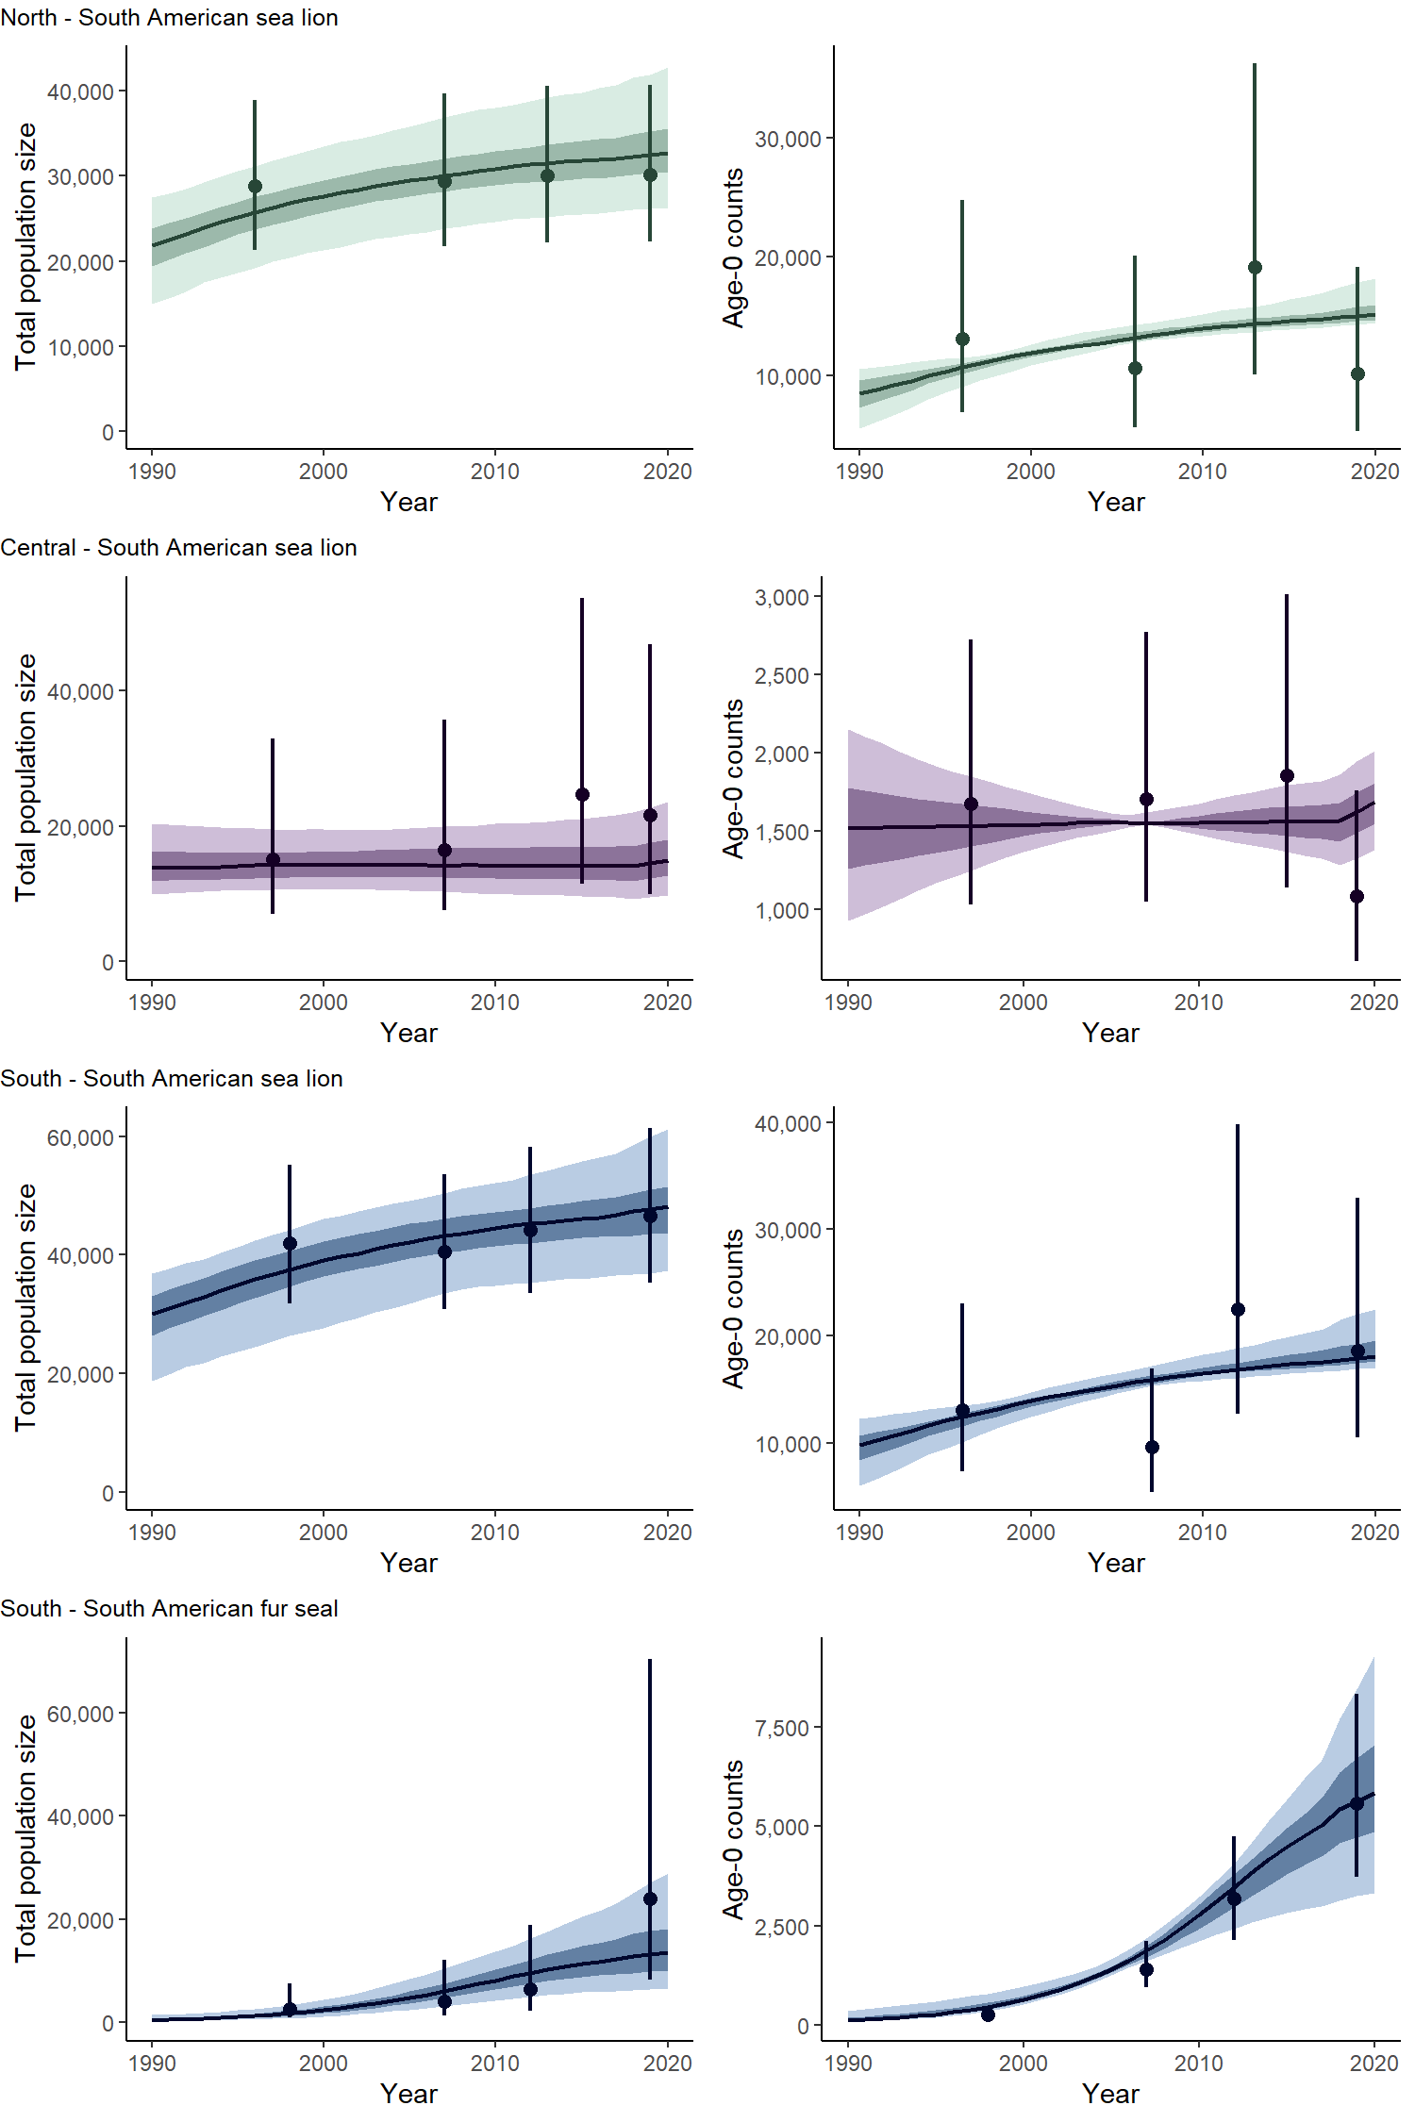
Supplementary Figure 1. Time series of total population (age 1+ abundance) and age-0 (pup) numbers by species/zone, along with the data used to fit the model for the base-case model. The dark lines are posterior medians, while the dark and light shading covers the 50% and 90% probability intervals, respectively. The sampling intervals for the abundance indices account for estimated sampling variance.
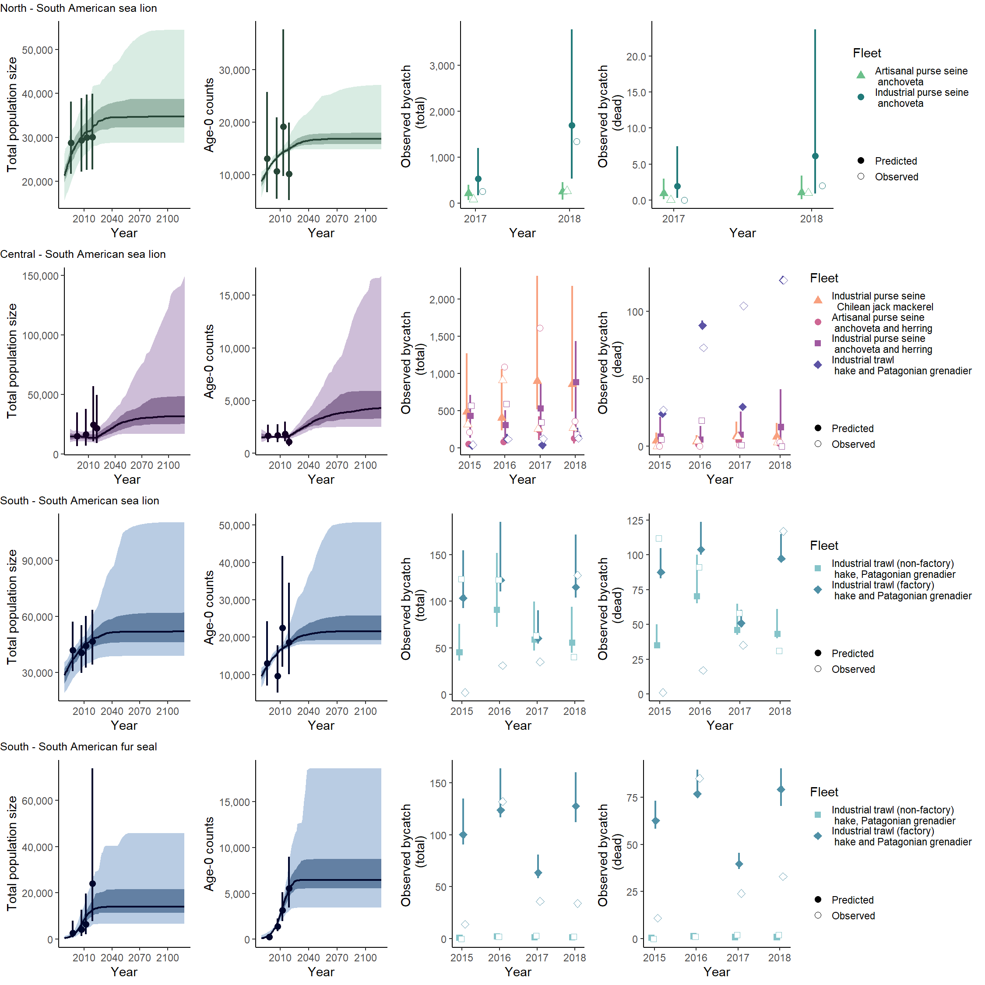
Supplementary Figure 2. Time series of total population (age 1+ abundance) and age-0 (pup) numbers by species/zone, along with the data used to fit the model (left two columns). The dark lines in the left two columns are posterior medians, while the dark and light shading covers the 50% and 90% probability intervals, respectively. The sampling intervals for the abundance indices account for estimated sampling variance. The two right columns show the fit to the bycatch data (data open symbols; closed symbols posterior medians and lines posterior 90% intervals). The results are for the alternative model 1.
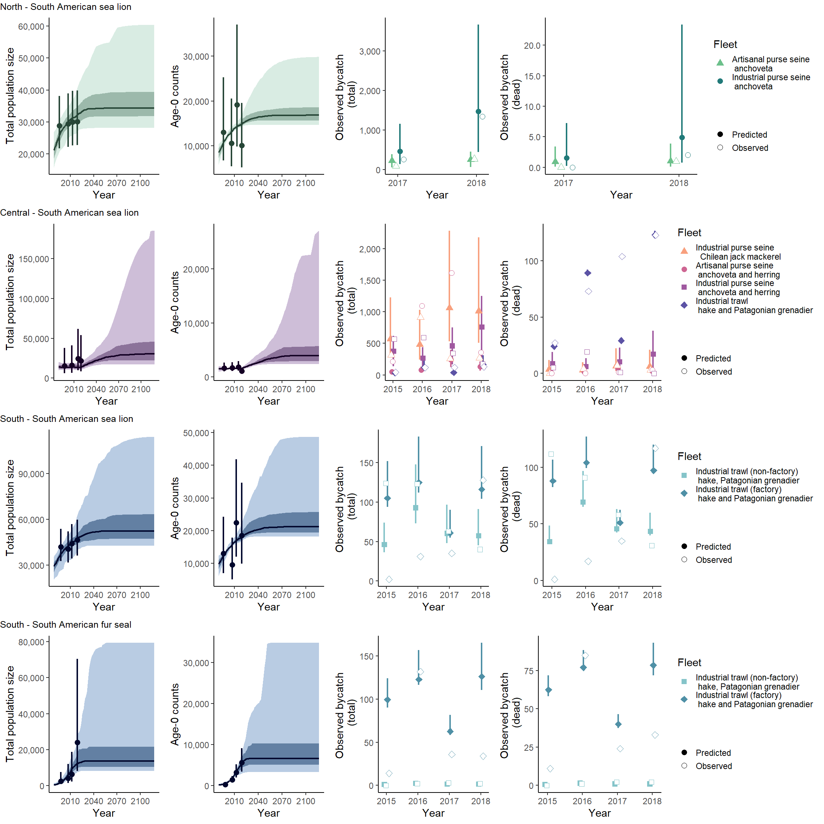Supplementary Figure 3. Time series of total population (age 1+ abundance) and age-0 (pup) numbers by species/zone, along with the data used to fit the model (left two columns). The dark lines in the left two columns are posterior medians, while the dark and light shading covers the 50% and 90% probability intervals, respectively. The sampling intervals for the abundance indices account for estimated sampling variance. The two right columns show the fit to the bycatch data (data open symbols; closed symbols posterior medians and lines posterior 90% intervals). The results are for the alternative model 2.
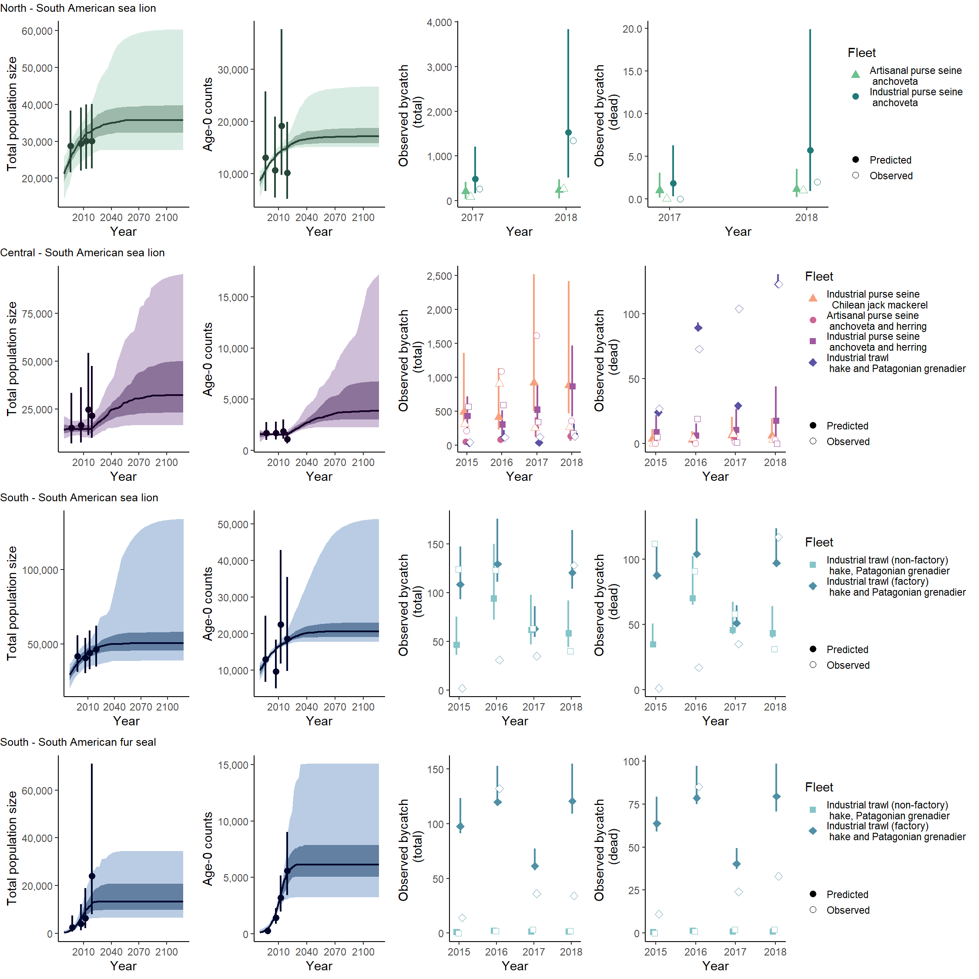Supplementary Figure 4. Time series of total population (age 1+ abundance) and age-0 (pup) numbers by species/zone, along with the data used to fit the model (left two columns). The dark lines in the left two columns are posterior medians, while the dark and light shading covers the 50% and 90% probability intervals, respectively. The sampling intervals for the abundance indices account for estimated sampling variance. The two right columns show the fit to the bycatch data (data open symbols; closed symbols posterior medians and lines posterior 90% intervals). The results are for the alternative model 3.
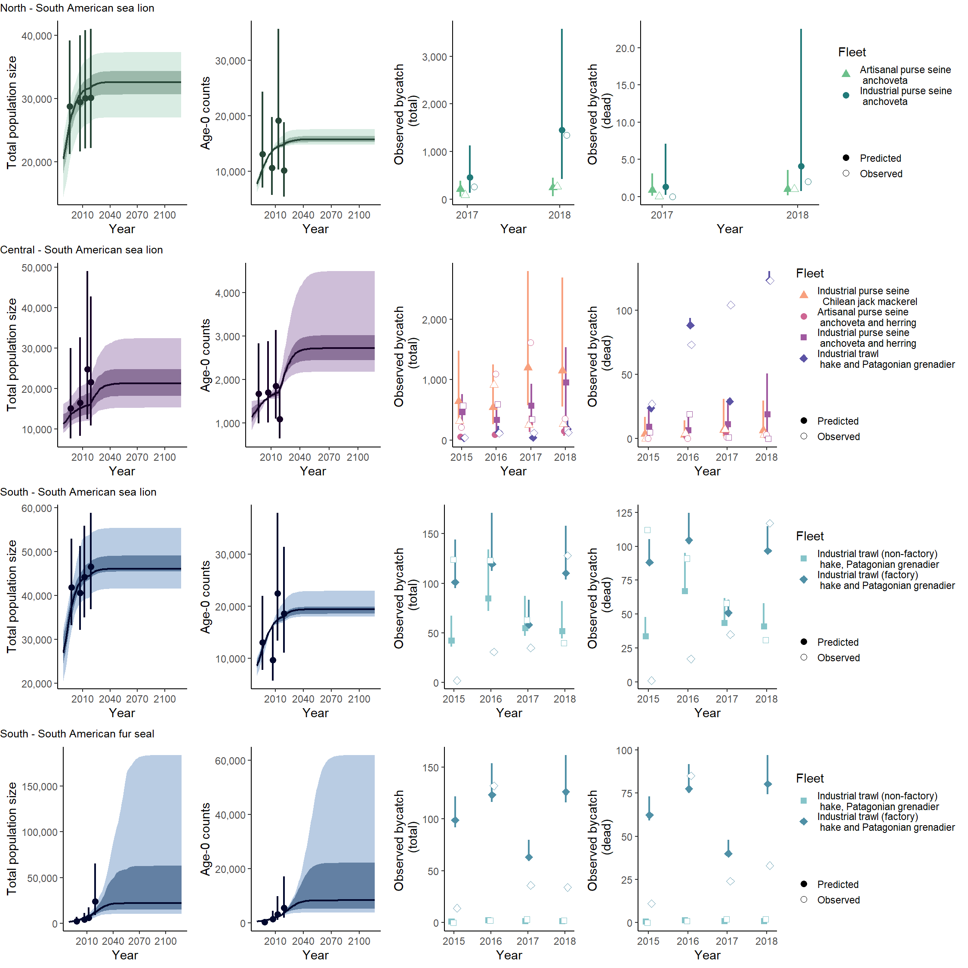Supplementary Figure 5. Time series of total population (age 1+ abundance) and age-0 (pup) numbers by species/zone, along with the data used to fit the model (left two columns). The dark lines in the left two columns are posterior medians, while the dark and light shading covers the 50% and 90% probability intervals, respectively. The sampling intervals for the abundance indices account for estimated sampling variance. The two right columns show the fit to the bycatch data (data open symbols; closed symbols posterior medians and lines posterior 90% intervals). The results are for the alternative model 4.
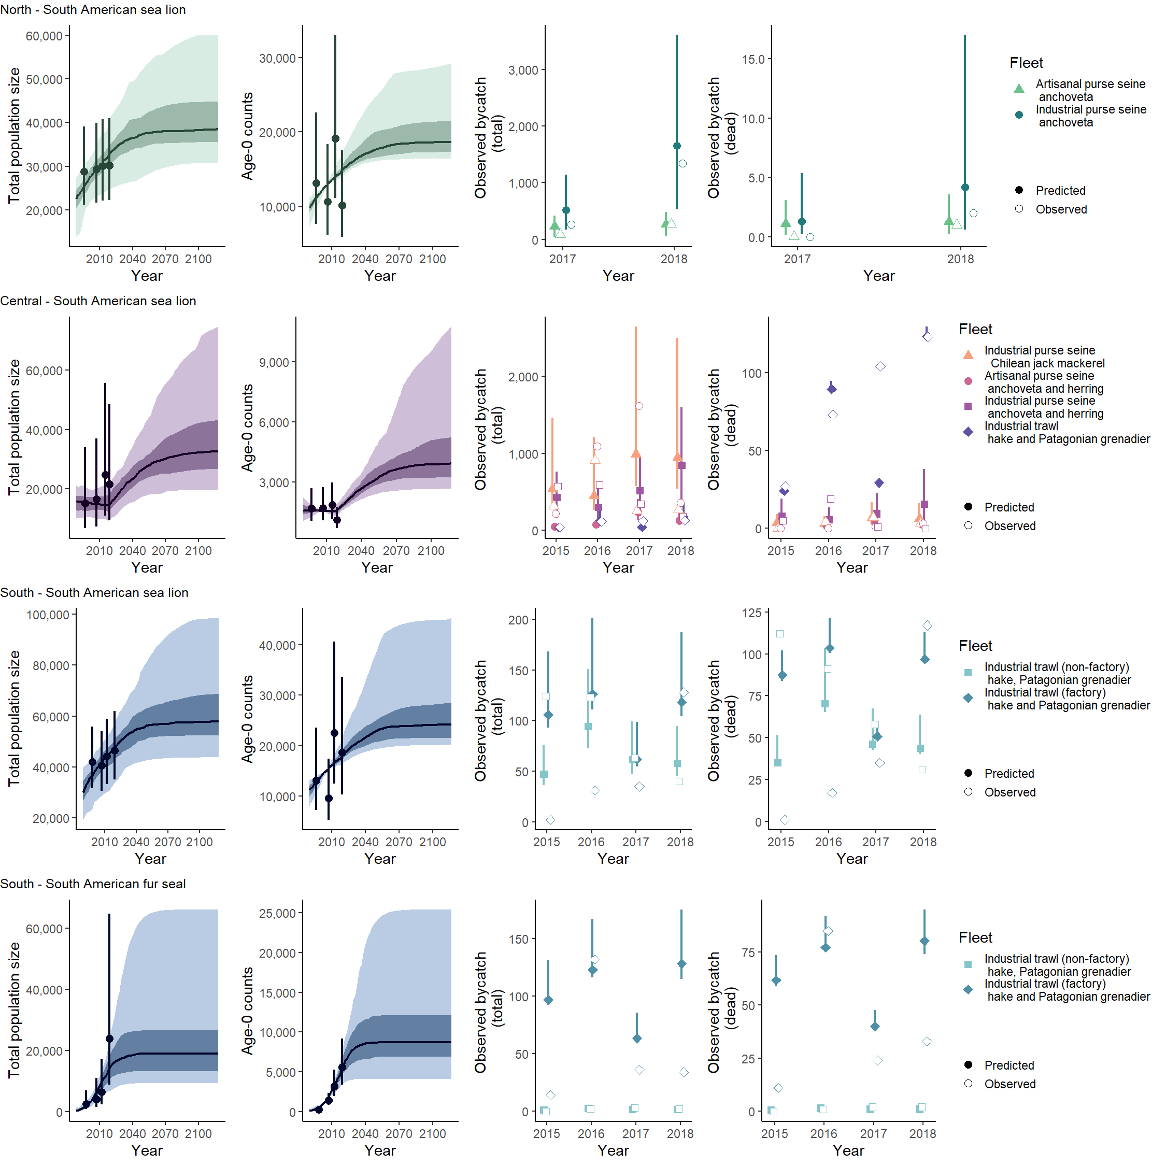Supplementary Figure 6. Time series of total population (age 1+ abundance) and age-0 (pup) numbers by species/zone, along with the data used to fit the model (left two columns). The dark lines in the left two columns are posterior medians, while the dark and light shading covers the 50% and 90% probability intervals, respectively. The sampling intervals for the abundance indices account for estimated sampling variance. The two right columns show the fit to the bycatch data (data open symbols; closed symbols posterior medians and lines posterior 90% intervals). The results are for the alternative model 5.
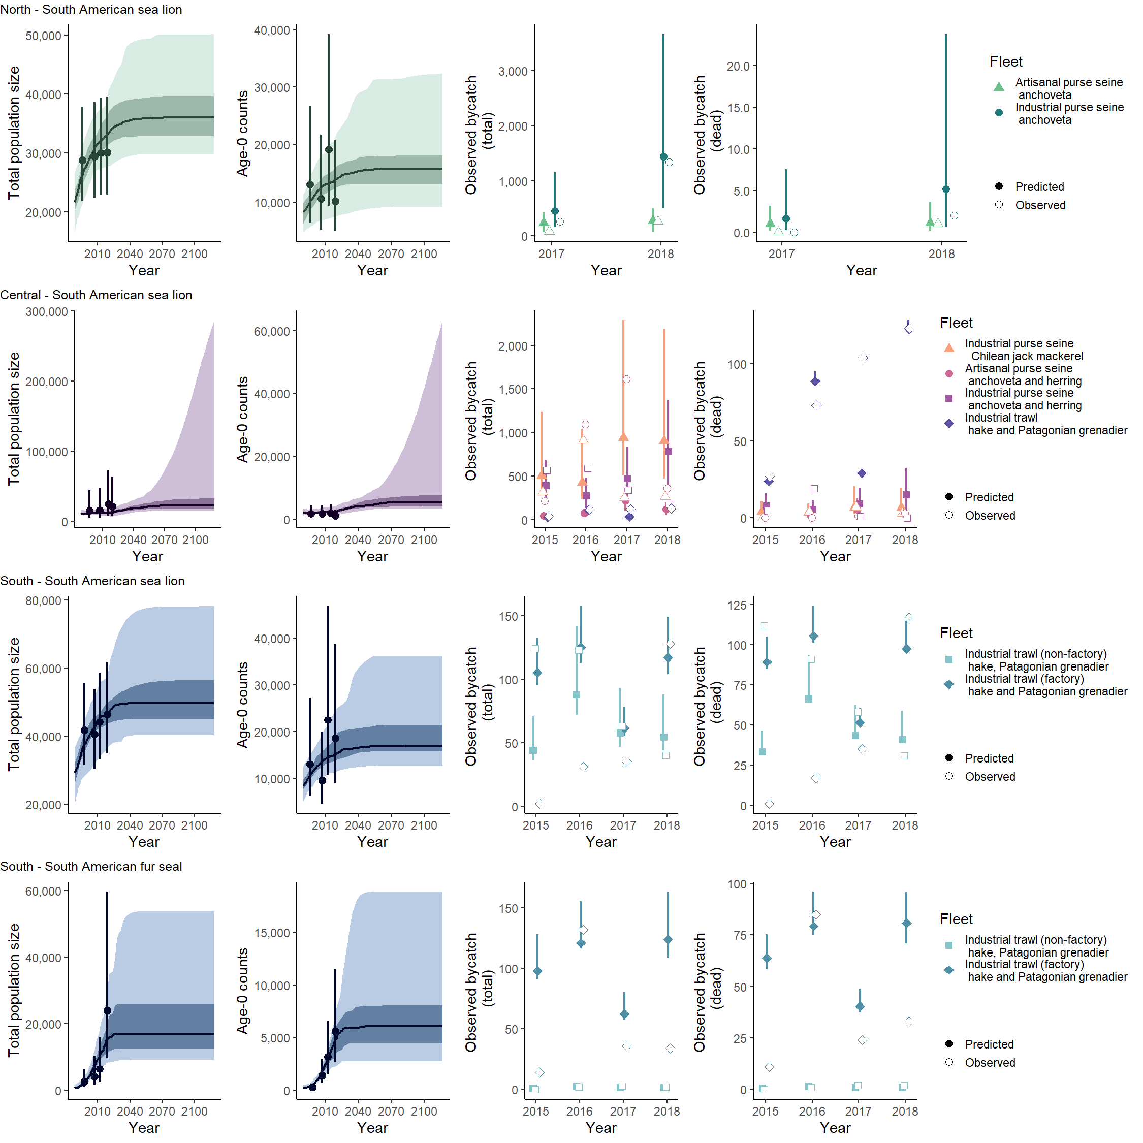Supplementary Figure 7. Time series of total population (age 1+ abundance) and age-0 (pup) numbers by species/zone, along with the data used to fit the model (left two columns). The dark lines in the left two columns are posterior medians, while the dark and light shading covers the 50% and 90% probability intervals, respectively. The sampling intervals for the abundance indices account for estimated sampling variance. The two right columns show the fit to the bycatch data (data open symbols; closed symbols posterior medians and lines posterior 90% intervals). The results are for the alternative model 6.
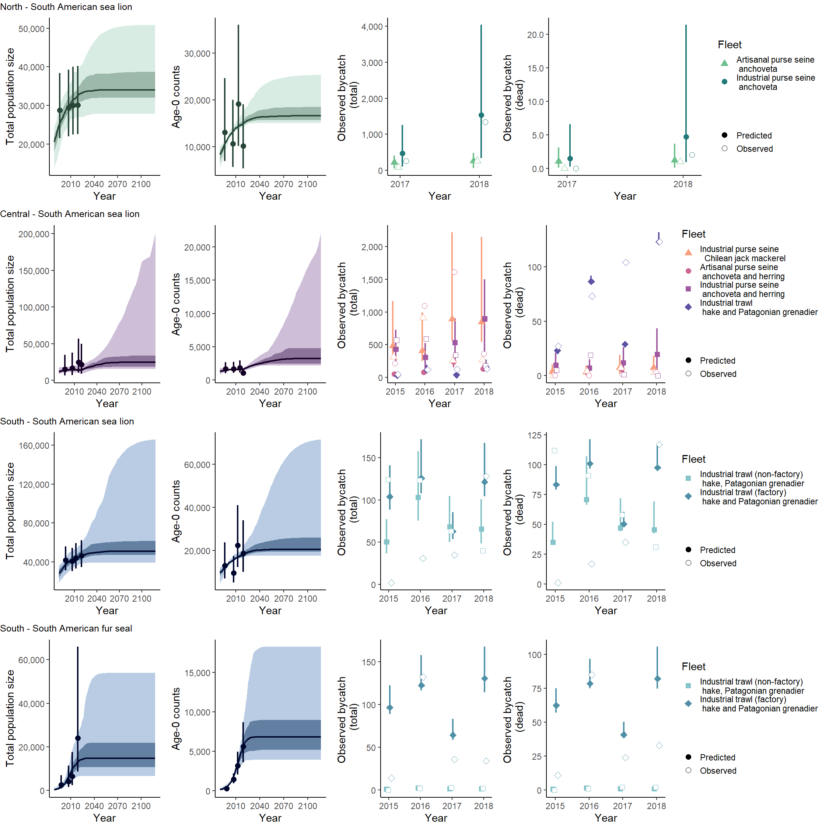Supplementary Figure 8. Time series of total population (age 1+ abundance) and age-0 (pup) numbers by species/zone, along with the data used to fit the model (left two columns). The dark lines in the left two columns are posterior medians, while the dark and light shading covers the 50% and 90% probability intervals, respectively. The sampling intervals for the abundance indices account for estimated sampling variance. The two right columns show the fit to the bycatch data (data open symbols; closed symbols posterior medians and lines posterior 90% intervals). The results are for the alternative model 7.
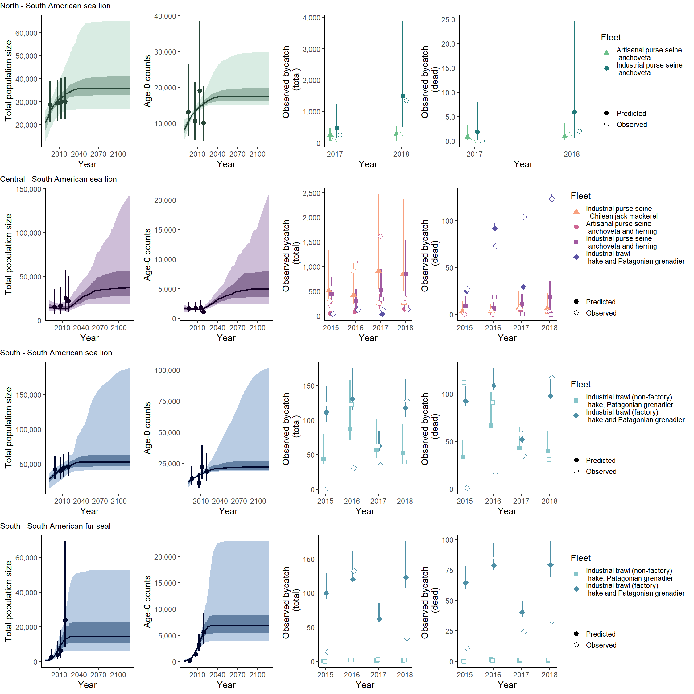Supplementary Figure 9. Time series of total population (age 1+ abundance) and age-0 (pup) numbers by species/zone, along with the data used to fit the model (left two columns). The dark lines in the left two columns are posterior medians, while the dark and light shading covers the 50% and 90% probability intervals, respectively. The sampling intervals for the abundance indices account for estimated sampling variance. The two right columns show the fit to the bycatch data (data open symbols; closed symbols posterior medians and lines posterior 90% intervals). The results are for the alternative model 8.

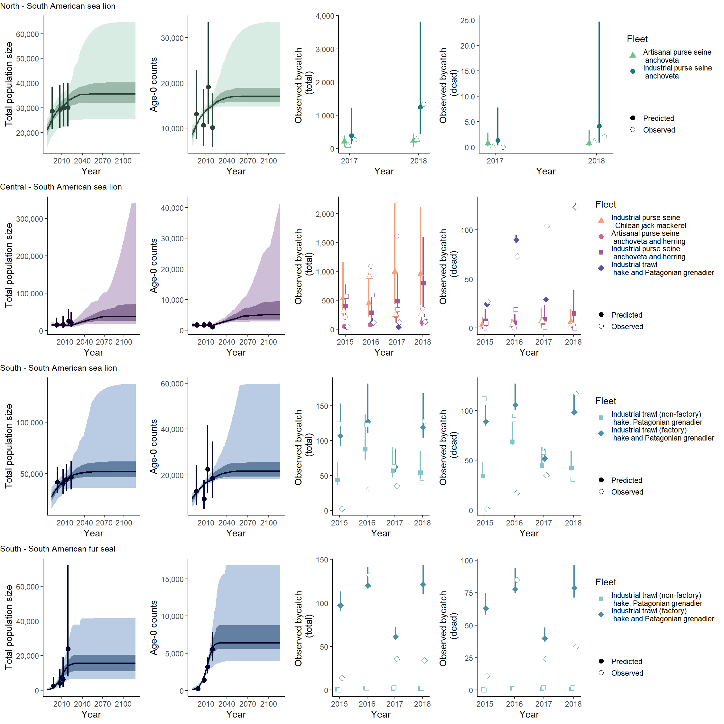
Supplementary Figure 10. Time series of total population (age 1+ abundance) and age-0 (pup) numbers by species/zone, along with the data used to fit the model (left two columns). The dark lines in the left two columns are posterior medians, while the dark and light shading covers the 50% and 90% probability intervals, respectively. The sampling intervals for the abundance indices account for estimated sampling variance. The two right columns show the fit to the bycatch data (data open symbols; closed symbols posterior medians and lines posterior 90% intervals). The results are for a model in which the prior for post-release mortality is U[0,1] for all fleets.

