EX2107: Windows to the Deep 2021

Data Summary
This report is an expedition-level summary of expert annotations of benthic deep-sea communities and substrate for groups of remotely operated vehicle (ROV) dives within the NOAA Ocean Exploration Atlantic Seafloor Partnership for Integrated Research and Exploration (ASPIRE) campaign (2017-2022). Associated NOAA Ocean Exploration cruise reports are available from the NOAA Institutional Repository. Video was collected using protocols described in the NOAA Ocean Exploration ROV and Telepresence Deepwater Exploration Procedures manual.
These annotations have undergone quality control by the France Lab at the University of Louisiana Lafayette following protocols described in the Annotating NOAA Ocean Exploration Video guidance. The annotations in SeaTube can be continuously updated by users. Annotations may have been modified or updated since the quality control process by the France Lab. These summarized annotations only represent the annotations made during the benthic portion of the dives (defined using the on- and off-bottom times in the Dive Summary Reports available for each dive on the expedition-specific landing page).
This report provides data visualizations in the form of tables and graphs of:
- Dive summary metrics (ROV time on bottom; ROV distance traveled; ROV mean depth),
- Annotation metrics by dive (total numbers of benthic biological and geoform/substrate annotations; percentage of annotations identified to each taxonomic level; phylum-level community composition; numbers of annotations of taxonomic groups of interest, i.e., deep-sea corals, Porifera, Echinodermata, and Vertebrata), and
- Quality control metrics (percentage of annotations flagged for review at the time of report generation; number of unidentified biological annotations).

Annotation Information
Input data are .csv files sourced from the Ocean Networks Canada SeaTube website.
This report was generated using annotations downloaded from SeaTube on October 21, 2024.

Expedition Summary
EX2107 consisted of 13 total dives, of which 1 dives explored maritime heritage sites and the remaining 12 dives explored the benthos and water column. ROV time on bottom ranged from 0.36 to 6.17 hours with a median of 3.18 hours across all dives. ROV distance traveled ranged from 259 meters to 2,334 meters with a median distance traveled of 967 meters. The shallowest dive had a mean depth of 779 meters, the deepest dive had a mean depth of 3,628 meters, and the median across all dives was 1,150 meters. The median number of geoform or substrate annotations was 5.5, and median number of benthic biological annotations was 193.

Dive Summary Metrics
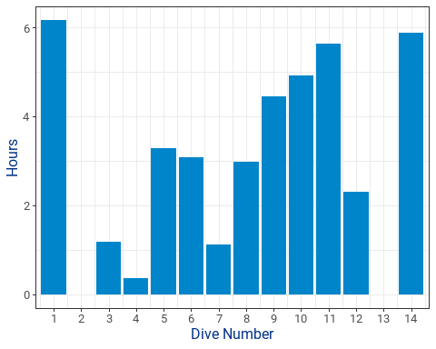

Figure 1. ROV time on bottom in hours.
ROV time on bottom ranged from 0.36 hours to 6.17 hours during EX2107 with a median time on bottom of 3.18 hours. Dive 2 was a maritime heritage dive. Dive 13 was a midwater-only dive.
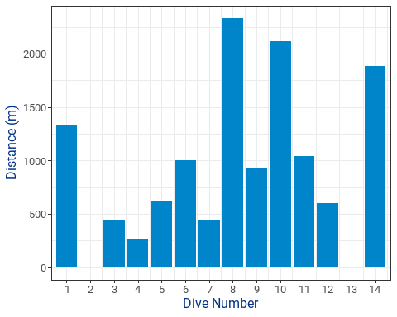

Figure 2. ROV distance traveled in meters during the benthic portion of each dive.
ROV distance traveled ranged from 259 meters to 2,334 meters during EX2107 with a median distance traveled of 967 meters. Dive 2 was a maritime heritage dive. Dive 13 was a midwater-only dive.
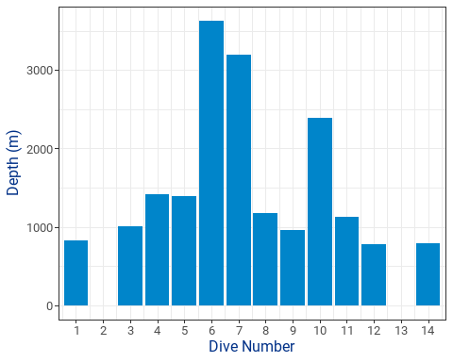

Figure 3. Mean ROV depth in meters during the benthic portion of each dive.
The shallowest dive during EX2107 had a mean depth of 779, and the deepest dive had a mean depth of 3,628. Overall, dives during EX2107 had a median depth of 1,150 meters. Dive 2 was a maritime heritage dive. Dive 13 was a midwater-only dive.

Annotation Metrics
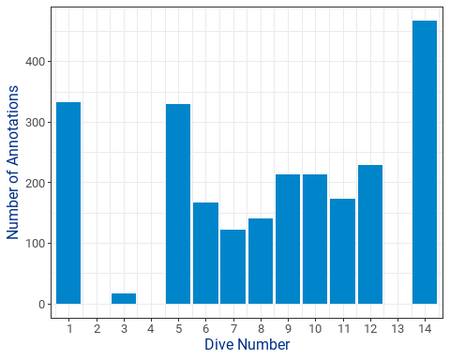

Figure 4. Total biological annotations.
The total number of benthic biological annotations (all phyla) for each dive during EX2107 ranged from 0 to 467 with a median of 193 annotations across all dives. Dive 2 was a maritime heritage dive. Dive 13 was a midwater-only dive.
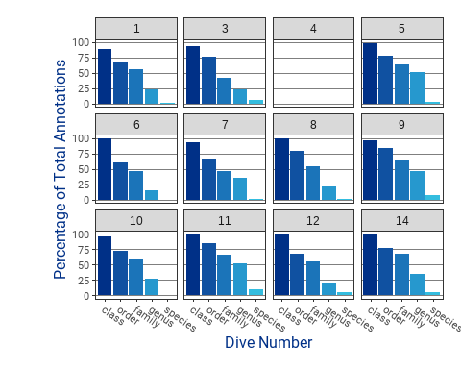

Figure 5. Percentage of annotations identified to each taxonomic level
One common problem in deep-sea biology is that many taxa observed in video can only be identified to high taxonomic levels, like phylum or class, and cannot be identified to lower taxonomic levels, such as genus or species. The figure above shows the percentage of biological annotations (all phyla) that could be identified to each taxonomic level, from class through species, for each dive during EX2107. Dive 2 was a maritime heritage dive. Dive 13 was a midwater-only dive.
Across all dives:
- The percentage of benthic biological annotations that could be identified to the class level ranged from 0-100 with a median of 97%.
- The percentage of benthic biological annotations that could be identified to the order level ranged from 0-85 with a median of 74%.
- The percentage of benthic biological annotations that could be identified to the family level ranged from 0-67 with a median of 55%.
- The percentage of benthic biological annotations that could be identified to the genus level ranged from 0-52 with a median of 25%.
- The percentage of benthic biological annotations that could be identified to the species level ranged from 0-10 with a median of 2%.
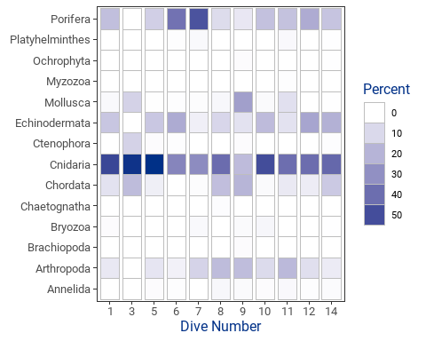

Figure 6. Phylum-level annotations and community composition
Phyla annotated during EX2107 varied by dive and are illustrated here using color intensity, which indicates the relative contribution of each phylum to the total benthic biological annotations for each dive. The most common phyla annotated during EX2107 can be identified by examining the variation in color intensity across rows. The community composition annotated during EX2107 can be compared across dives by examining the variation in color intensity across columns. Dive 2 was a maritime heritage dive. Dive 13 was a midwater-only dive.
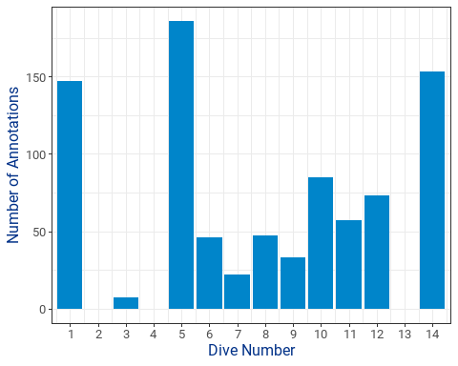

Figure 7. Total deep-sea coral annotations.
Deep-sea corals provide benthic structure and are of interest due to their status as vulnerable marine ecosystems. For more information, the NOAA Deep-Sea Coral Research and Technology Program is dedicated to increasing scientific understanding of deep-sea coral and sponge ecosystems. The total number of deep-sea corals annotated during each dive of EX2107 ranged from 0 to 186 with a median of 52 deep-sea corals annotations across all dives. Dive 2 was a maritime heritage dive. Dive 13 was a midwater-only dive.
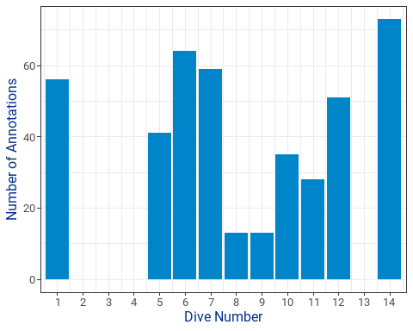

Figure 8. Total Porifera annotations.
The phylum Porifera includes sponges. The total number of porifera annotated during each dive of EX2107 ranged from 0 to 73 with a median of 38 porifera annotations across all dives. Dive 2 was a maritime heritage dive. Dive 13 was a midwater-only dive.
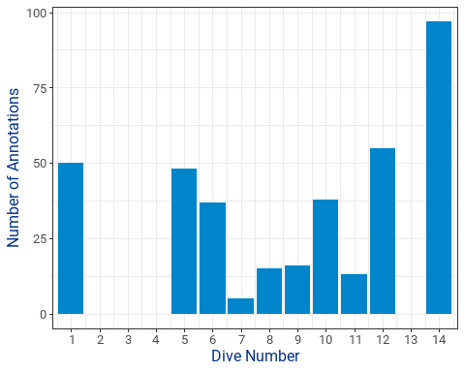

Figure 9. Total Echinodermata annotations.
The phylum Echinodermata includes a variety of invertebrates common to the deep sea, including sea stars (Class: Asteroidea), brittle stars (Class: Ophiuroidea), crinoids (Class: Crinoidea), sea urchins (Class: Echinoidea), and sea cucumbers (Class: Holothuroidea). The total number of echinoderms annotated during each dive of EX2107 ranged from 0 to 97 with a median of 26.5 echinoderm annotations across all dives. Dive 2 was a maritime heritage dive. Dive 13 was a midwater-only dive.
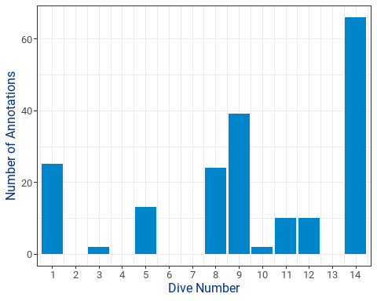

Figure 10. Total Vertebrata annotations.
The subphylum Vertebrata contains all vertebrates within the phylum Chordata. Commonly observed vertebrates include fishes. The total number of vertebrates annotated during each dive of EX2107 ranged from 0 to 66 with a median of 10 vertebrate annotations across all dives. Dive 2 was a maritime heritage dive. Dive 13 was a midwater-only dive.
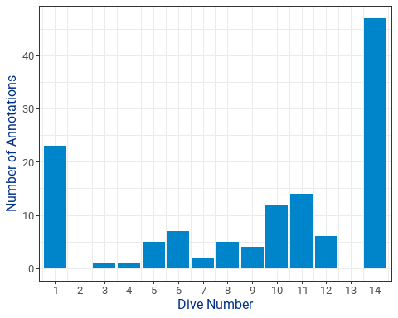

Figure 11. Total geoform or substrate annotations.
The number of geoform and substrate annotations within each dive during EX2107 ranged from 1 to 47 with a median of 5.5 annotations across all dives. Dive 2 was a maritime heritage dive. Dive 13 was a midwater-only dive.

Quality control metrics
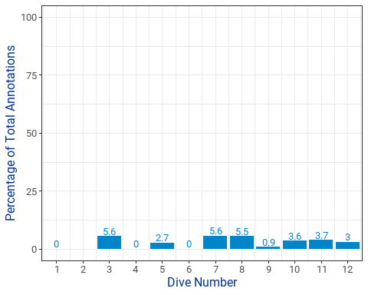

Figure 12. Percentage of annotations flagged for review.
The percentage of annotations flagged for review for each dive of EX2107 ranged from 0 to 5.6 with a median of 2.8 annotations flagged for review across all dives. Dive 2 was a maritime heritage dive. Dive 13 was a midwater-only dive.
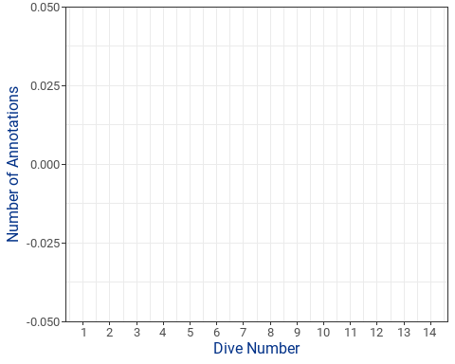

Figure 13. Number of unidentified biological annotations.
The number of annotations that were identified as being biological, but without an associated phylum-level identification during EX2107 ranged from 0 to 0 with a median of 0 unidentified biological annotations across all dives. Dive 2 was a maritime heritage dive. Dive 13 was a midwater-only dive.

