Supplement to:
Post-settlement abundance, condition, and survival in a climate-stressed population of Pacific cod
Alisa A. Abookire, Michael A. Litzow, Michael J. Malick, Benjamin J. Laurel
Contents of this supplement:
Figures S1 – S6

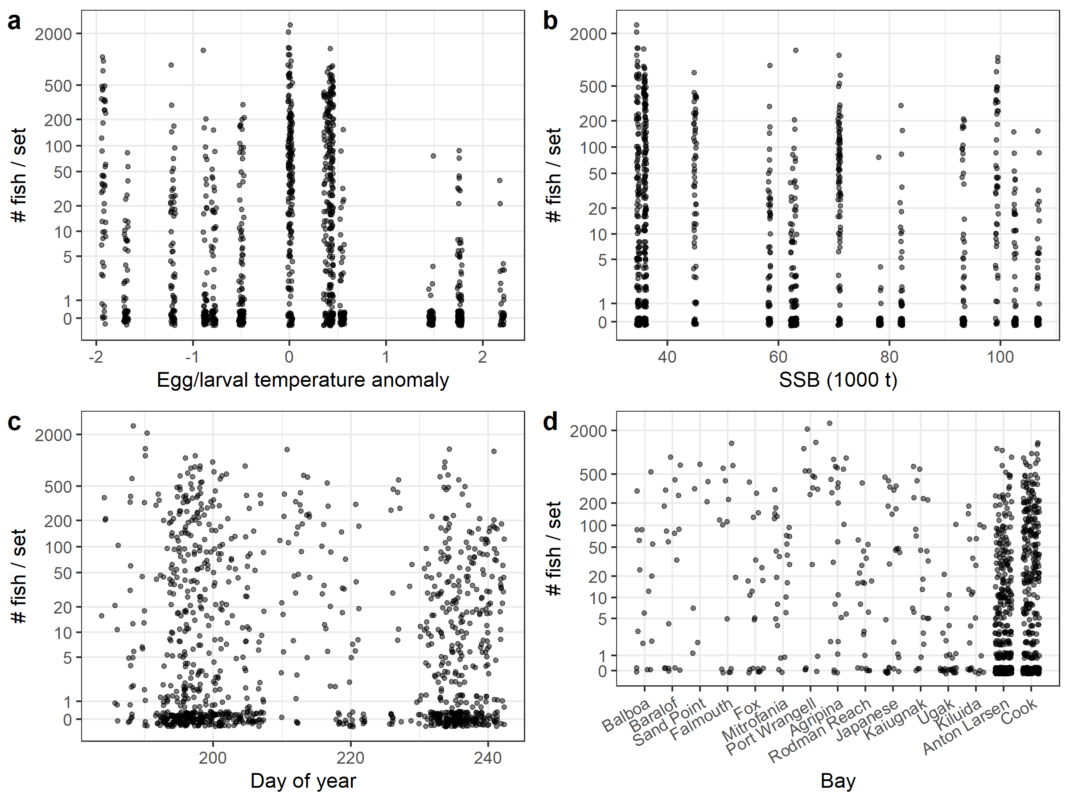

Figure S1. Scatter plots of age-0 Pacific cod abundance (# fish / set) against: a) temperature anomalies during the egg/larval periods; b) spawning stock biomass; c) day of sampling; d) bay effects (west-east). Overlapping values have been jittered to aid visibility.

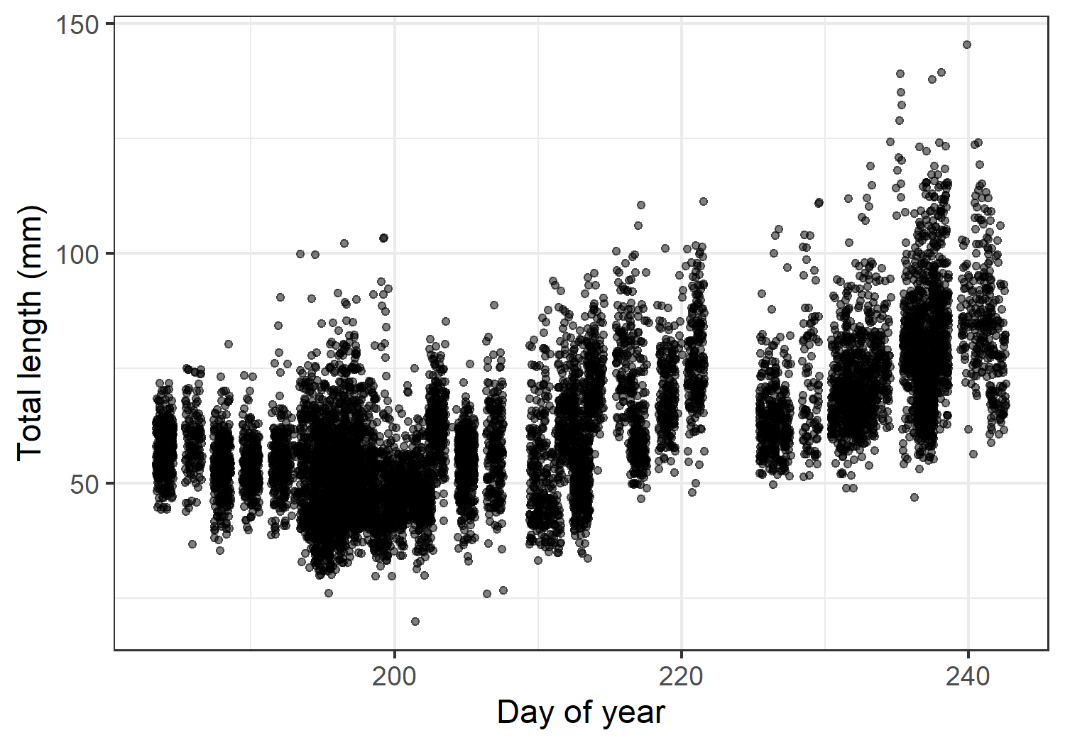

Figure S2. Age-0 cod total length: raw data plotted against day of year. Overlapping values have been jittered to aid visibility.

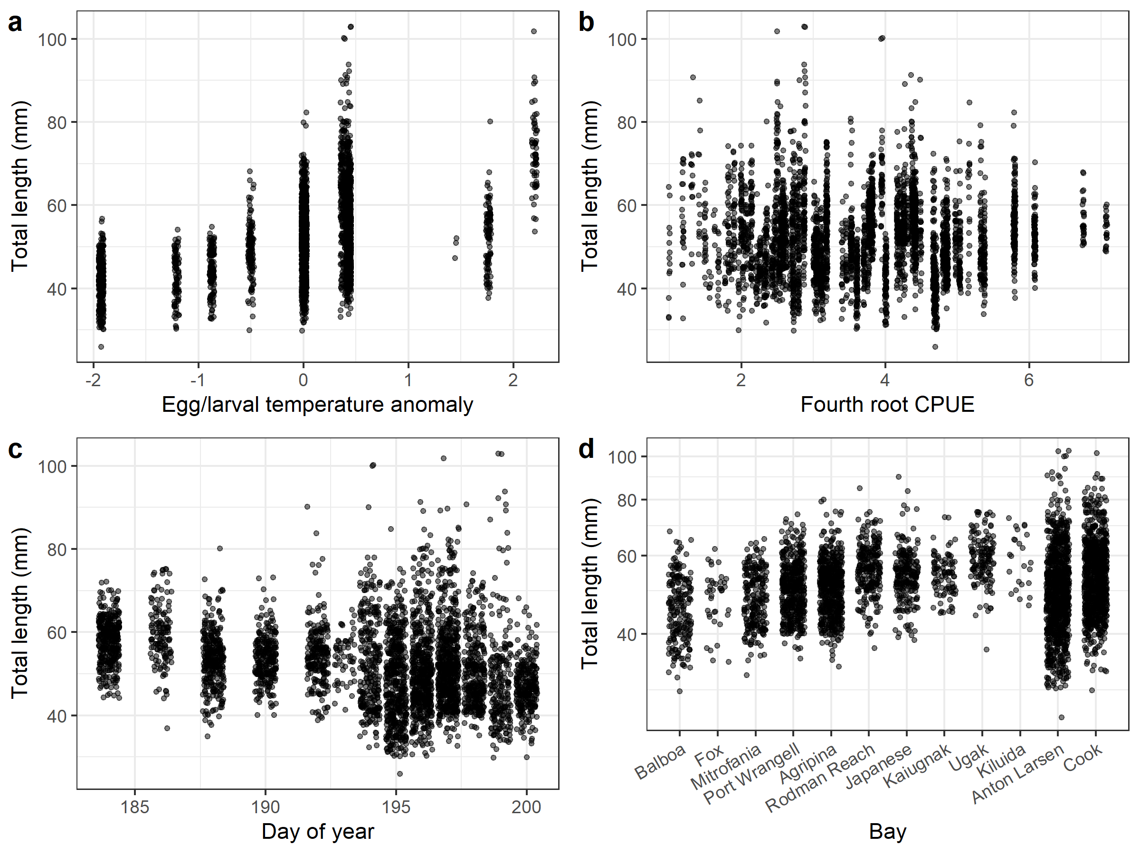

Figure S3. Scatter plots of early season size (total length from samples collected during day of year 184-200) plotted against: a) temperature during the egg/larval periods; b) cod abundance; c) day of year; d) for individual bays (west-east). Overlapping values have been jittered to aid visibility.

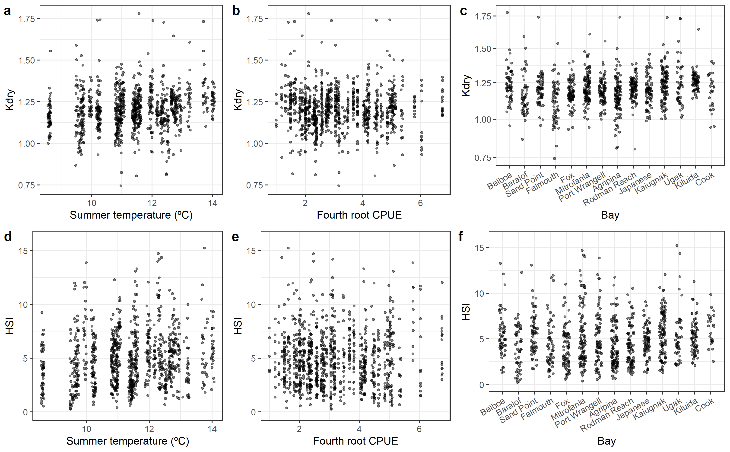

Figure S4. Scatter plots of cod condition data (Kdry and HSI) plotted against a, d) summer temperature; b, e) cod abundance, and c, f) for individual bays (west-east). Overlapping values have been jittered to aid visibility.

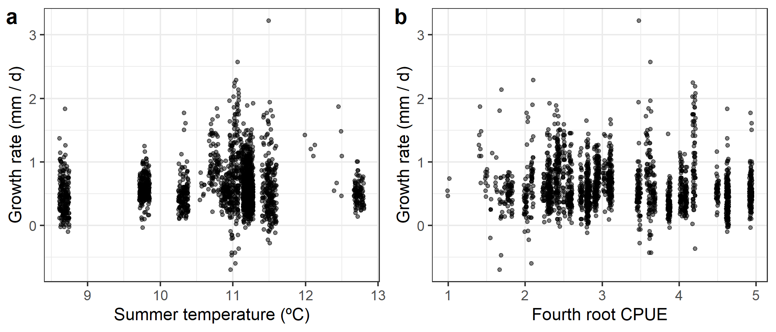

Figure S5. Scatter plots of age-0 growth data against a) summer temperature and b) cod abundance. Growth values are calculated as differences between mean total length for the first sample at a site in a given season and individual total lengths at subsequent sampling events in the same season. Overlapping values have been jittered to aid visibility.

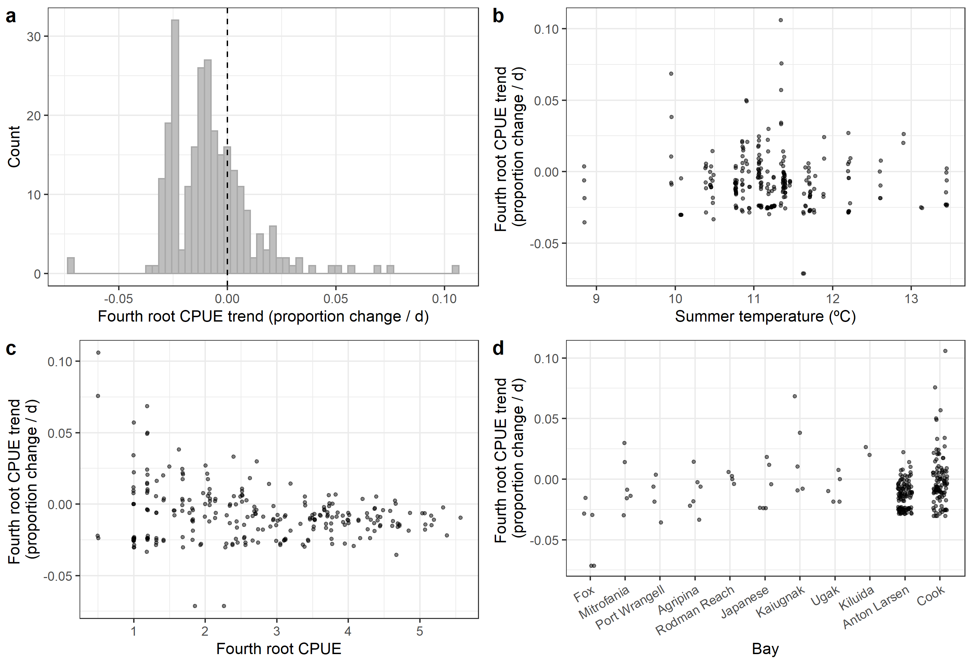

Figure S6. Trends in age-0 Pacific cod abundance (proportional change in fourth-root transformed CPUE / day) as a proxy of survival. a) Histrogram of trend values. Dashed line indicates border between negative values (declining abundance) and positive values (increasing abundance). b) Scatter plot vs. summer temperature. c) Scatter plot against cod abundance (averaged over all visits to a site in a season). d) Scatter plot for individual bays (west-east). Overlapping values have been jittered to aid visibility.

