Supporting Information for:

COVID-19 Induced Fingerprints of a New Normal Urban Air Quality in the United States

S. Kondragunta*, Z. Wei², B. C. McDonald³, D. L. Goldberg⁴, D. Q. Tong⁵
¹NOAA NESDIS Center for Satellite Applications and Research, 5825 University Research Court, College Park, MD
²IM Systems Group, 5825 University Research Court, College Park, MD
³NOAA Chemical Systems Laboratory, Boulder, CO
⁴Milken School of Public Health, George Washington University, Washington, DC
⁵Department of Atmospheric, Oceanic, and Earth Sciences, George Mason University, Fairfax, VA

This PDF file includes:

Figures S1 to S4

Supplemental Figures

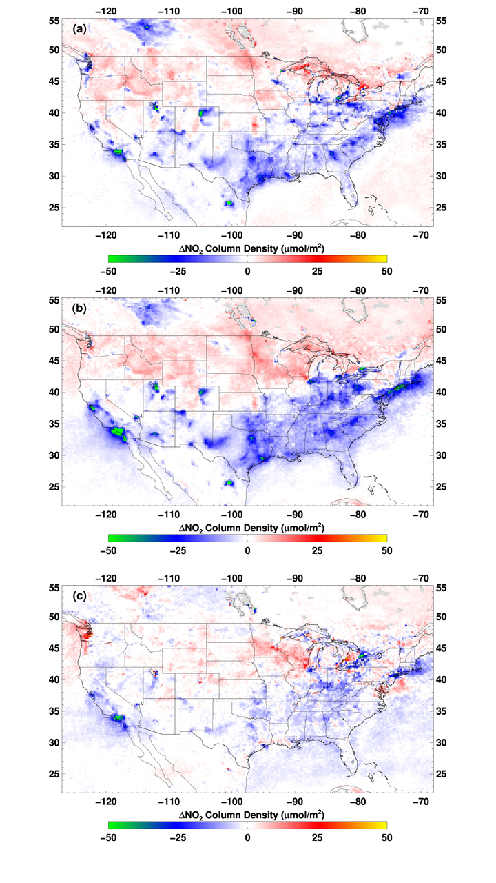

Figure S1. tropNO₂ changes between pre-lockdown period (1 January to 15 March) and lockdown period (16 March to 30 May) for (a) 2019∆NO₂, (b) 2020∆NO₂, and (c) the difference between 2020∆NO₂ and 2019∆NO₂. The double differencing is expected to minimize the seasonal differences and provide a realistic estimate of change in tropNO₂ due to emissions changes.

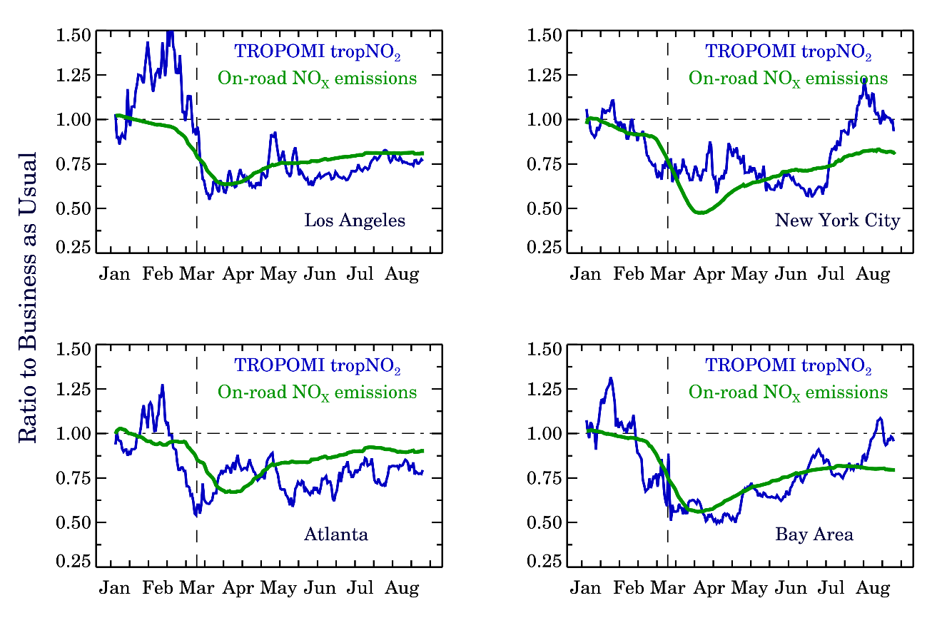

Figure S2. Trends in TROPOMI tropNO₂ and on-road NO_{x} emissions since January 1 2020 after normalizing the data for typical meteorological conditions and sun angles as in Goldberg et al. (2020). Both NO_{x} emissions from traffic and TROPOMI tropNO₂ data show a decline with the onset of the lockdown and the recovery after the lockdown is lifted in May in most of the US. Data for four different locations are shown.

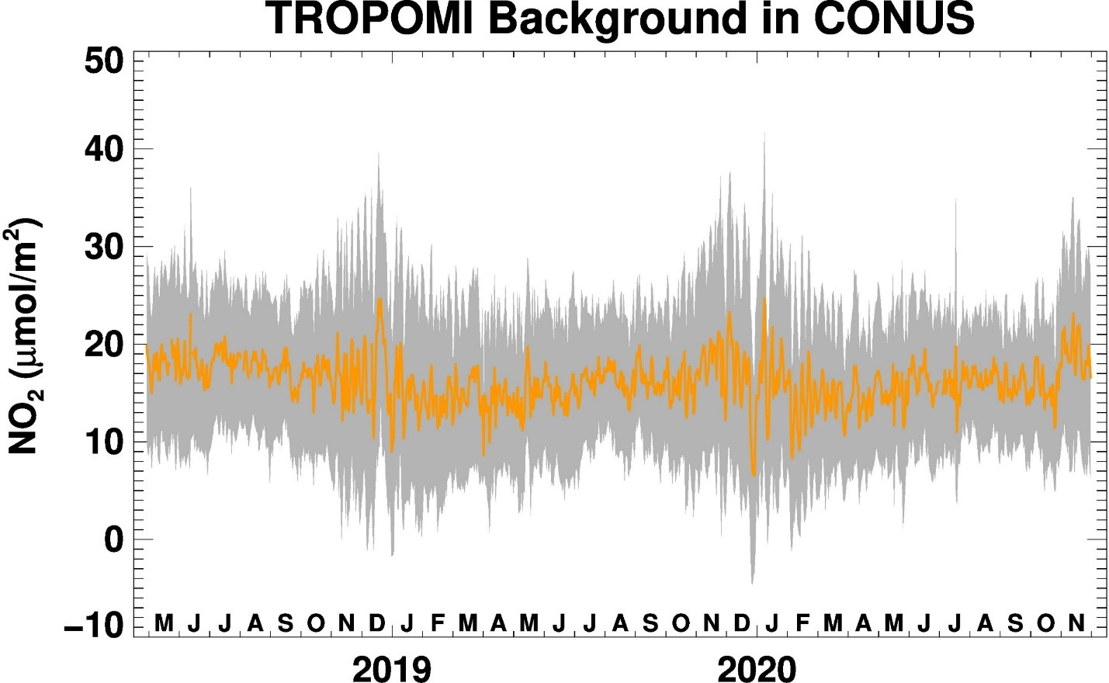

Figure S3. Time series of TROPOMI tropNO₂ representing background tropospheric column NO₂ derived using Silvern et al. (2019) method. The shaded region is the standard deviation of the daily mean tropNO₂.

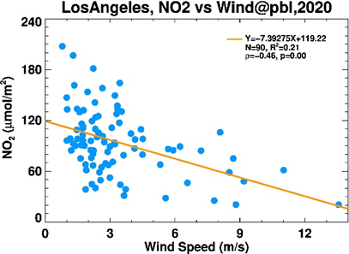

Figure S4. Correlation of daily mean tropNO₂ with planetary boundary layer wind speed (ERA5) for Los Angeles.

References

Goldberg, D. L., Anenberg, S. C., Griffin, D., McLinden, C. A., Lu, Z., & Streets, D. G. (2020). Disentangling the impact of the COVID‐19 lockdowns on urban NO₂ from natural variability. Geophysical Research Letters, 47, e2020GL089269. https://doi.org/10.1029/2020GL089269

Silvern, R. F., D. J. Jacob, L. J. Mickley, M. P. Sulprizio, K. R. Travis, E. A. Marais, R. C. Cohen, J. L. Laughner, S. Choi, J. Joiner, and L. N. Lamsal. Using satellite observations of tropospheric NO₂ columns to infer long-term trends in US NOx emissions: the importance of accounting for the free tropospheric NO₂ background. (2019). Atmos. Chem. Phys., 19, 8863–8878. https://doi.org/10.5194/acp-19-8863-2019

* Corresponding author: Phone: 301-655-7311. Email: Shobha.Kondragunta@noaa.gov

