SUPPLEMENTARY INFORMATION:
SUPPLEMENTARY METHODS
Seawater residence time calculations
Translating measured currents from ADCP data into meaningful residence time estimates is difficult given the high degree of spatial variability of currents in kelp forests (e.g., Gaylord et al. 2007). In the absence of maps of currents perhaps even more detailed than those of Gaylord et al. (2007), any such estimates must be viewed as only very approximate. For example, at the leading edge of the kelp forests there is substantial divergence of the flow as flow slows down entering the kelp forest (Rominger and Nepf 2011). Moreover, the definition of residence time, T_{r}, requires some care (Lucas and Deleersnijder 2020), and is best used in simple geometries with single inflows and outflow such as the Palauan seagrass bed studied by Hirsh (2020). Here we define residence time to be the time a water parcel might spend inside the kelp forest canopy before exiting to open water, and thus, the time over which its chemical properties might be modified by biogeochemical processes operating in the canopy.
Given the large difference between currents inside and outside the kelp forest, velocity measurements outside the kelp cannot be used to infer motions inside the kelp. Thus, we can only calculate T_{r} for the low-flow kelp site. Because the kelp forest at the low-flow site is somewhat longer (ca. 300 m) than it is wide (ca. 80 m), whereas near-surface cross-shore and alongshore currents are comparable, we estimated T_{r} using cross-shore currents. T_{r} was calculated for each time by assuming that a hypothetical water particle was released in the center of the kelp and then calculating its cross-shore displacement by integrating the near-surface cross-shore velocity in time. T_{r} was then the first time that the particle displacement was greater than 40 m.

Sensor deployment methods
Surface measurements of pH, DO, and temperature were made by attaching sensors onto a surface float so that they remained within surface waters. The miniDOTs were oriented vertically with the sensor ~13 cm below the waters’ surface, and the pH sensors were oriented horizontally with the sensor head ~30 cm below the water’s surface (Figure S1). Subsurface sensors were deployed on fixed moorings relative to the bottom; as such, their depth relative to the surface varied with the tides, and ranged from 1.3 to 1.9 m below the surface (mbs) at zero tide (Table, S1, see Table S2 for full range of depths for each mooring given the tides). At the kelp forest sites, the subsurface sensors were just below the bulk of the kelp canopy. DO and temperature were recorded at 1 minute intervals and pH was measured at five minute intervals. Differences between surface and subsurface parameters were standardized by the zero tide depth of the subsurface sensor ((surface-subsurface) / meters of subsurface depth). Bottom sensors were attached to the mooring 1 meter above the bottom. Mean daytime and nighttime values were calculated between 6:00 to 20:00 and 21:00 to 5:00, respectively.
Sensor calibration methods
Oxygen sensors were calibrated using measurements taken in a black bucket with black lid filled with fresh water and bubbling air for 8 hours prior to deployment following PME protocols. A gain correction was applied assuming 100% saturation (Bushinsky and Emerson 2013; Bittig and Körtzinger 2015; Johnson et al. 2015). pH sensors were calibrated using 2-3 discrete water samples collected in situ next to the sensors following best practices (Bresnahan et al. 2014) for an estimated accuracy of pH data on the total scale of ± 0.015. Sensor data was quality controlled by removing data when bubbles from SCUBA divers became caught on the sensor surface and when the surface floats were removed from the water for maintenance.

Kelp growth rate methods
All kelp fronds > 0.5 m in length were tagged initially. Production of new fronds was tracked during subsequent weeks by counting and tagging new fronds (≥ 0.5 m) on each individual. To measure frond and blade growth, five fronds with intact apical scimitars on each individual were chosen at the beginning of the study (Figure S2), with at least two fronds long enough to reach the surface if possible. Total length of tagged fronds were measured to the nearest cm weekly; frond growth rate was calculated in cm d⁻¹. For blade growth, the first detached blade below the apical scimitar of the tagged frond was tagged and a 5 mm diameter hole was punched 2 cm above the pneumatocyst (Figure S2).
For blade growth measurements, the distance between the pneumatocyst and the hole and the total blade length was measured to the nearest 0.5 cm weekly. Blade growth rate was calculated from the change in length between the pneumatocyst and the hole in mm d⁻¹. Holes were punched in blades initially on June 17 at the low-flow kelp site and June 18 at the high-flow kelp site, and new holes were punched on the first detached blade below the apical scimitar on July 1 at the low-flow kelp site and July 2 at the high-flow kelp site and on July 16 at both sites. On these dates fronds where the apical scimitar was lost were replaced with new fronds. Blade growth was measured for all punched blades until they were lost or the study ended (up to 22 days for each punched blade).

SUPPLEMENTARY RESULTS
Patterns in phytoplankton community composition
Samples collected from mid-June to early July, during a period of alternating upwelling-favorable winds and relaxation, were characterized by abundant Pseudo-nitzschia spp. and Chaetoceros spp. (Figure S5, Table S7). Starting in the second week of July after two weeks of sustained upwelling-favorable winds, there was continued dominance of Chaetoceros spp., but with decreased abundance of Pseudo-nitschia spp., and increased abundance of the diatoms Eucampia zoodiacus and Bacteriastrum spp. In late July, after over a week of upwelling-favorable winds, the phytoplankton community became more variable with increased abundance of dinoflagellates including Ceratium spp., Amylax triacantha, and Noctiluca scintillans.

References for supplementary text that are not included in the main text:
Bittig, H. C., and A. Körtzinger. 2015. Tackling Oxygen Optode drift: Near-Surface and In-Air Oxygen Optode Measurements on a Float Provide an Accurate in Situ Reference. J. Atmos. Ocean. Technol. 32: 1536–1543. doi:10.1175/JTECH-D-14-00162.1
Bresnahan, P. J., T. R. Martz, Y. Takeshita, K. S. Johnson, and M. LaShomb. 2014. Best practices for autonomous measurement of seawater pH with the Honeywell Durafet. Methods Oceanogr. 9: 44–60. doi:10.1016/J.MIO.2014.08.003
Bushinsky, S. M., and S. Emerson. 2013. A method for in-situ calibration of Aanderaa oxygen sensors on surface moorings. Marine Chemistry 155: 22-28 doi:10.1016/j.marchem.2013.05.001
Hirsh, H. 2020. Spatiotemporal variability in kelp forest and seagrass ecosystems, PhD Dissertation, Stanford University
Johnson, K. S., J. N. Plant, S. C. Riser, and D. Gilbert. 2015. Air Oxygen Calibration of Oxygen Optodes on a Profiling Float Array. J. Atmos. Ocean. Technol. 32: 2160–2172. doi:10.1175/JTECH-D-15-0101.1
Lucas, L. V., and E. Deleersnijder. 2020. Timescale Methods for Simplifying, Understanding and Modeling Biophysical and Water Quality Processes in Coastal Aquatic Ecosystems: A Review. Water 12(10): 2717. https://doi.org/10.3390/w12102717
Rominger, J.T., and H.M. Nepf, 2011. Flow adjustment and interior flow associated with a rectangular porous obstruction. Journal of Fluid Mechanics 680: 636-659.

SUPPLEMENTARY FIGURES
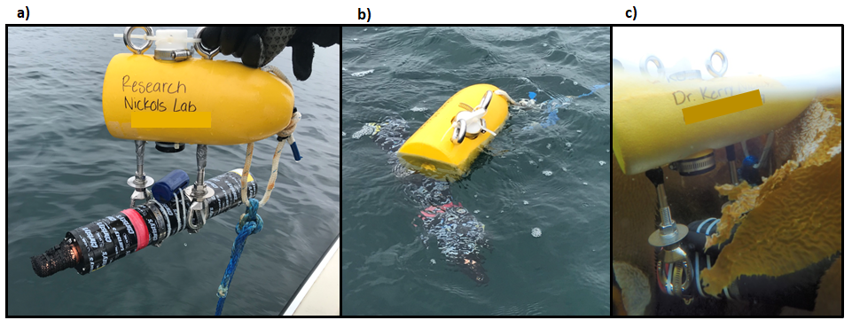
Figure S1. Surface float with miniDOT and DuraFET pH sensor above water (a) and in the water (b and c).

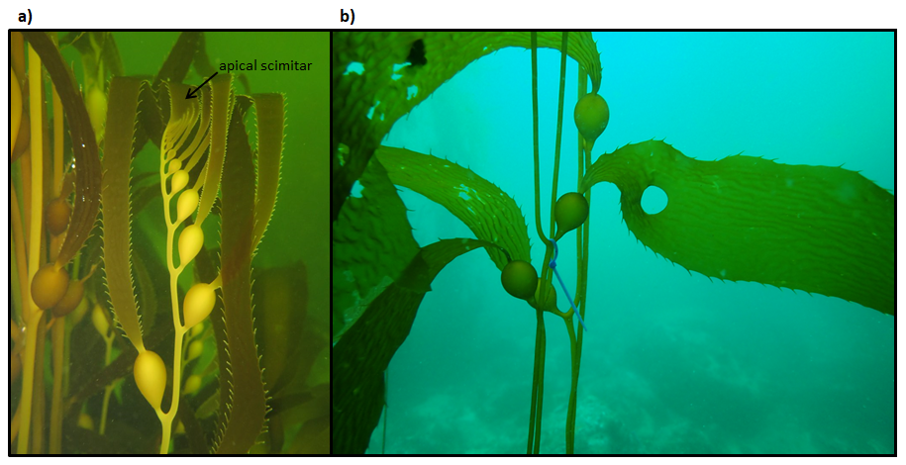
Figure S2. a) A kelp frond with an intact apical scimitar. b) A kelp blade a few weeks after the hole was punched for measuring growth rate. As the blade grows the hole become larger and moves away from the pneumatocyst.

Figure S3. Time series of daily mean temperature (first row), daily mean DO (second row), daily mean pH (third row), and DIC (fourth row) at the surface, subsurface, and bottom at each site (high-flow kelp (HK), high-flow outside (HO), low-flow kelp (LK), low-flow outside (LO)).

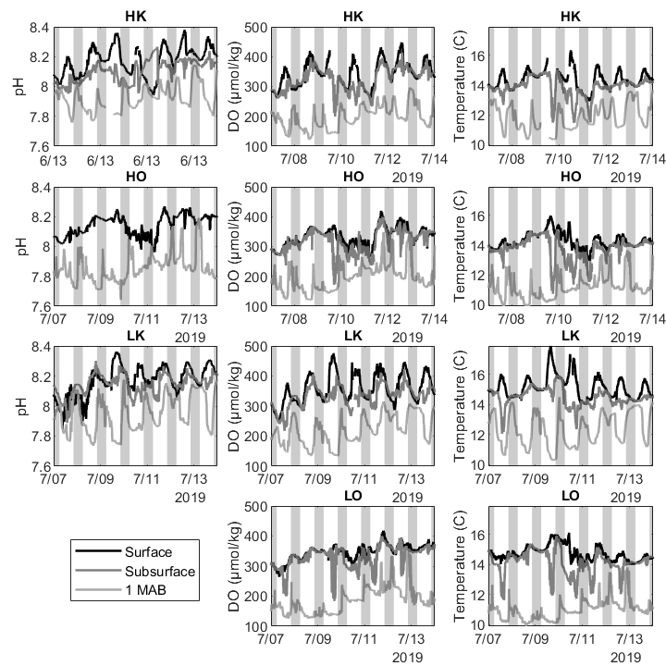
Figure S4. One week of pH, DO, and temperature sensor data at each site (high-flow kelp (HK), high-flow outside (HO), low-flow kelp (LK), low-flow outside (LO)). Grey boxes indicate period of night between sunset and sunrise. Black lines are surface data, dark grey lines are subsurface data, and light grey lines are from 1 meter above the bottom.

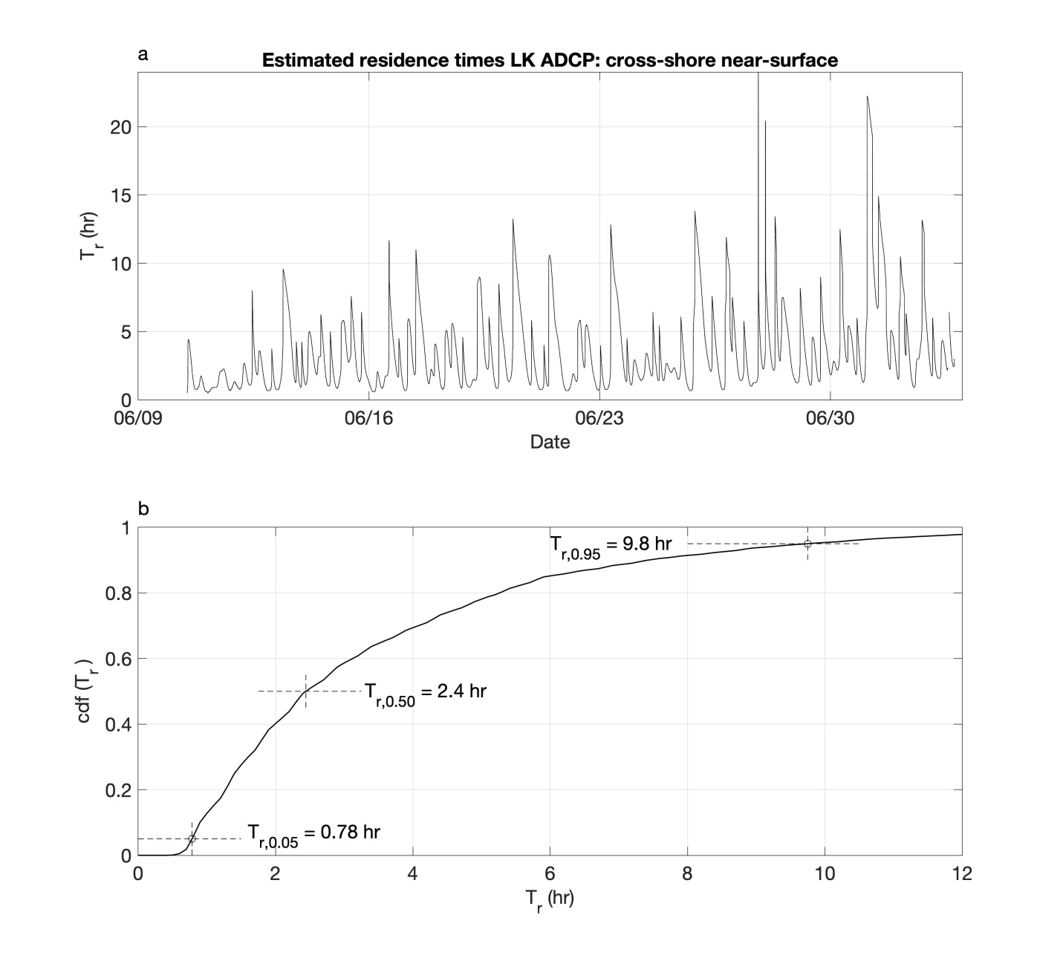
Figure S5. Residence time calculated for kelp canopy at the low-flow kelp site (LK): (a) time series of Tr; (b) cumulative distribution function (cdf) of Tr. In (b), 5%, 50% and 95% exceedance value of Tr are marked.

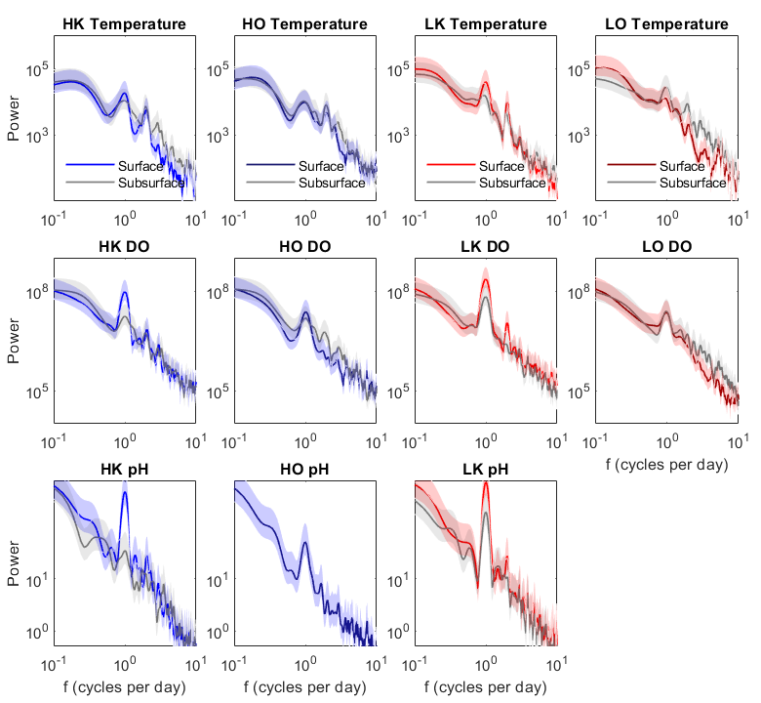
Figure S6. Power spectra for temperature (top panel), DO (middle panel), and pH (bottom panel) at the surface (colored lines) and subsurface (grey lines) at each site (high-flow kelp (HK), high-flow outside (HO), low-flow kelp (LK), low-flow outside (LO)). Shading indicates 95% confidence intervals.

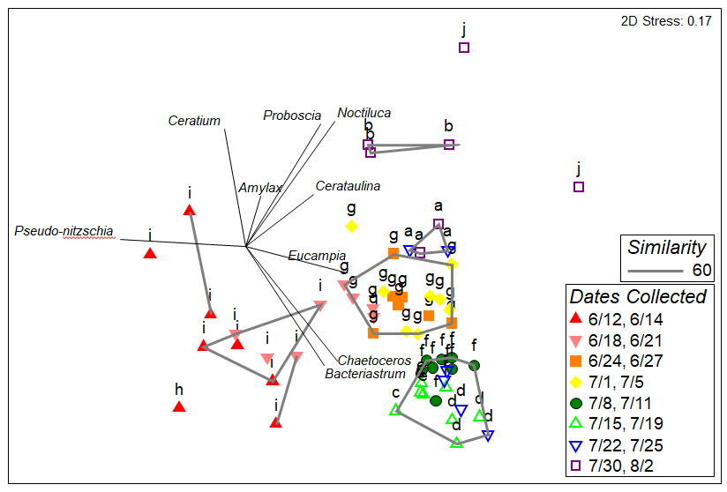
Figure S7. nMDS plot of phytoplankton community composition, color coded by week of sample collection. Letters above points indicate statistically significant clusters (see Supplemental Table 1). Vectors representing Pearson correlations to nMDS axes are shown for selected species contributing to similarity within clusters. Grey polygons indicate groups that at 60% similar.

Figure S8. Time series of mean (± std. err.) frond growth (a), blade growth (b), and new fronds per individual (c) at the high-flow kelp site (HK) and the low-flow kelp site (LK).

Figure S9. Time series of the percent of surface blades with 0% (absent), <1%, 1-50%, or > 50% Membranipora spp. cover at the high-flow kelp site (HK) (a) and the low-flow kelp site (LK) (b).
SUPPLEMENTARY TABLES
Table S1. Study site details for each site (HK: high-flow kelp site, HO: high-flow outside, LK: low-flow kelp site, LO: low-flow outside). Depth range of subsurface sensors is given in meters below surface (mbs).
Location | Site | Latitude, Longitude | Depth (m) at 0 tide | Mean Depth (m) | Depth range of subsurface sensors (mbs)
High-flow | HK | 36°37'47.04"N, 121°55'7.68"W | 10.3 | 11.8 | 0.9 – 3.2
 | HO | 36°37'51.18"N, 121°55'2.40"W | 14.9 | 15.9 | 1.1 – 3.4
Low-flow | LK | 36°37'4.62"N, 121°53'55.38"W | 8.8 | 9.4 | 0.9 – 3.2
 | LO | 36°37'7.62"N, 121°53'49.02"W | 16.4 | 18.1 | 1.1 – 3.4

Table S2. Deployment periods for DO and pH sensors at each site and depth (HK: high-flow kelp site, HO: high-flow outside, LK: low-flow kelp site, LO: low-flow outside). Meters below the surface (mbs) at zero tide is indicated for subsurface sensors.
Site | Depth | Oxygen and Temperature data | pH data
HK | Surface | 6/4 – 8/7/2019 | 6/13 – 8/3/2019
HK | Subsurface (1.3 mbs) | 6/4 – 8/7/2019 | 6/13 – 8/7/2019
HO | Surface | 6/4 – 8/7/2019 | 6/13 – 8/7/2019
HO | Subsurface (1.5 mbs) | 6/4 – 8/7/2019 | no data
LK | Surface | 6/5 – 8/7/2019 | 6/13 – 7/20/2019
LK | Subsurface (1.3 mbs) | 6/5 – 8/7/2019 | 6/13 – 8/7/2019
LO | Surface | 6/5 – 6/21, 7/3 – 7/17/2019 | no data
LO | Subsurface (1.9 mbs) | 6/5 – 6/21, 7/3 – 8/7//2019 | no data

Table S3. PERMANOVAs comparing a) overall temperature, b) overall DO, c) overall pH, and d) daytime DIC among sites and between depths
a) Temperature | df | SS | MS | Pseudo-F | P-value
Site | 3 | 756.460 | 252.150 | 361.390 | 0.001
Depth | 1 | 338.090 | 338.090 | 484.550 | 0.001
Site: Depth | 3 | 2.282 | 0.761 | 1.090 | 0.345
Residual | 5528 | 3857.1 | 0.698
Total | 5535 | 4953.900
b) DO | df | SS | MS | Pseudo-F | P-value
Site | 3 | 3.996 x 10⁵ | 1.332 x 10⁵ | 107.33 | 0.001
Depth | 1 | 2.702 x 10⁵ | 2.702 x 10⁵ | 217.67 | 0.001
Site: Depth | 3 | 11564 | 3854.7 | 3.106 | 0.024
Residual | 5528 | 6.861 x 10⁶ | 1241.1
Total | 5535 | 7.542 x 10⁶
c) pH | df | SS | MS | Pseudo-F | P-value
Site | 2 | 1.289 | 0.645 | 125.79 | 0.001
Depth | 1 | 1.929 | 1.929 | 376.33 | 0.001
Site: Depth | 1 | 0.628 | 0.628 | 122.54 | 0.001
Residual | 4390 | 22.499 | 5.125 x 10⁻³
Total | 4394 | 25.810
d) DIC | df | SS | MS | Pseudo-F | P-value
Site | 3 | 33243 | 11081 | 10.222 | < 0.001
Depth | 1 | 910 | 911 | 0.840 | 0.369
Site: Depth | 3 | 1806 | 602 | 0.555 | 0.652
Residual | 114 | 12358 | 1084
Total | 121 | 15862

Table S4. PERMANOVAs comparing a) daytime DO, b) nighttime DO, c) daytime pH, and d) nighttime pH among sites and between depths.
a) daytime DO | df | SS | MS | Pseudo-F | P-value
Site | 3 | 4.114 x 10⁵ | 1.371 x 10⁵ | 94.850 | 0.001
Depth | 1 | 4.300 x 10⁵ | 4.296 x 10⁵ | 297.170 | 0.001
Site: Depth | 3 | 63186 | 21062 | 14.569 | 0.001
Residual | 3392 | 4.904 x 10⁶ | 1445.7
Total | 3399 | 5.808 x 10⁶
b) nighttime DO | df | SS | MS | Pseudo-F | P-value
Site | 3 | 1.205 x 10⁵ | 40275 | 55.052 | 0.001
Depth | 1 | 117.16 | 117.16 | 0.160 | 0.667
Site: Depth | 3 | 22760 | 7586.8 | 10.370 | 0.001
Residual | 2128 | 1.557 x 10⁶ | 731.58
Total | 2135 | 1.701 x 10⁶
c) daytime pH | df | SS | MS | Pseudo-F | P-value
Site | 2 | 1.285 | 0.643 | 112.930 | 0.001
Depth | 1 | 2.706 | 2.706 | 475.660 | 0.001
Site: Depth | 1 | 0.390 | 0.390 | 68.598 | 0.001
Residual | 2710 | 15.419 | 0.006
Total | 2714 | 18.947
d) nighttime pH | df | SS | MS | Pseudo-F | P-value
Site | 2 | 0.424 | 0.212 | 59.589 | 0.001
Depth | 1 | 0.024 | 0.024 | 6.741 | 0.012
Site: Depth | 1 | 0.238 | 0.238 | 66.805 | 0.001
Residual | 1675 | 5.961 | 0.004
Total | 1679 | 6.655

Table S5. Mean temperature (± std. err.) at each site (HK: high-flow kelp site, HO: high-flow outside, LK: low-flow kelp site, LO: low-flow outside) and depth, using only time periods when there was overlap among all sensors. Differences between surface and subsurface parameters are standardized by depth.
Site | Depth | Temperature  (mean ± std. err.)
HK | Surface | 14.3 ± 0.03
 | Subsurface | 13.8 ± 0.03
 | Surface-Subsurface | 0.3 ± 0.02
HO | Surface | 14.2 ± 0.03
 | Subsurface | 13.8 ± 0.03
 | Surface-Subsurface | 0.3 ± 0.02
LK | Surface | 15.1 ± 0.04
 | Subsurface | 14.6 ± 0.03
 | Surface-Subsurface | 0.4 ± 0.02
LO | Surface | 14.8 ± 0.04
 | Subsurface | 14.3 ± 0.03
 | Surface-Subsurface | 0.3 ± 0.02

Table S6. Average similarities within phytoplankton community clusters and species contributing to at least 50% of similarity within clusters determined from SIMPER analysis. Clusters containing less than two samples are not included.
 | Contribution % | Cumulative %
Cluster i , Average similarity: 59.75
Pseudo-nitzschia spp. | 52.46 | 52.46
Cluster g, Average similarity: 66.49
Chaetoceros spp. | 23.45 | 23.45
Ceratium spp. | 12.38 | 35.83
Pseudo-nitzschia spp. | 10.12 | 45.95
Lioloma pacificum | 8.15 | 54.10
Cluster f, Average similarity: 80.82
Chaetoceros spp. | 18.94 | 18.94
Pseudo-nitzschia spp. | 7.73 | 26.66
Eucampia zoodiacus | 5.56 | 32.22
Bacteriastrum spp. | 4.97 | 37.20
Cylindrotheca spp. | 4.81 | 42.01
Coscinodiscus spp. | 4.73 | 46.75
Guinardia spp. | 4.73 | 51.48
Cluster e, Average similarity: 75.73
Chaetoceros spp. | 24.04 | 24.04
Pseudo-nitzschia spp. | 12.02 | 36.03
Bacteriastrum spp. | 8.11 | 44.17
Eucampia zoodiacus | 7.92 | 52.10
Cluster d, Average similarity: 77.70
Chaetoceros spp. | 22.66 | 22.66
Pseudo-nitzschia spp. | 11.92 | 34.58
Bacteriastrum spp. | 9.08 | 43.66
Eucampia zoodiacus | 8.96 | 52.62
Cluster a, Average similarity: 75.01
Chaetoceros spp. | 13.36 | 13.36
Pseudo-nitzschia spp. | 13.36 | 26.72
Pleurosigma spp. | 8.91 | 35.62
Ceratium spp. | 8.91 | 44.53
Noctiluca scintillans | 8.91 | 53.43
Cluster b, Average similarity: 66.89
Pseudo-nitzschia spp. | 19.26 | 19.26
Cerataulina spp. | 11.51 | 30.77
Proboscia alata | 11.51 | 42.29
Amylax triacantha | 11.51 | 53.80
Group j, Average similarity: 34.78
Proboscia alata | 37.50 | 37.50
Noctiluca scintillans | 37.50 | 75.00

Table S7. Generalized linear mixed-effect model of a) frond growth rates (AIC = 1058.9, BIC = 1103.4), b) blade growth rates (AIC = -461.3, BIC = -352.9), and c) new fronds per individual (AIC = 56.1, BIC = 104.4).
a) Frond growth
Fixed effects | df | SS | MS | F-value | P-value
Sample Event | 7 | 2.58 | 0.37 | 4.62 | < 0.001
Site | 1 | 1.89 | 1.89 | 23.70 | < 0.001
Frond Length | 1 | 2.54 | 2.54 | 31.85 | < 0.001
Sample Event: Site | 6 | 0.85 | 0.14 | 1.78 | 0.047
Sample Event: Frond Length | 7 | 1.67 | 0.24 | 3.00 | 0.002
Site: Frond Length | 1 | 0.21 | 0.21 | 2.67 | 0.102
Sample Event: Site: Frond Length | 6 | 0.37 | 0.06 | 0.78 | 0.583
Random effects | Variance | Std. Dev.
Macrocystis: Frond | < 0.001 | 0.018
Frond | 0.016 | 0.128
Residual | 0.080 | 0.282
b) Blade growth
Fixed effects | df | SS | MS | F-value | P-value
Sample Event | 7 | 27.09 | 3.87 | 19.24 | <0.001
Site | 1 | 4.56 | 4.56 | 22.68 | <0.001
Days Since Punched | 1 | 26.43 | 26.43 | 131.40 | 0.401
Date Punched | 1 | <0.01 | <0.01 | < 0.01 | 0.401
Sample Event: Site | 6 | 5.12 | 0.85 | 4.24 | 0.049
Sample Event: Days Since Punched | 3 | 1.02 | 0.34 | 1.69 | 0.762
Site: Days Since Punched | 1 | 0.71 | 0.71 | 3.51 | 0.851
Site: Date Punched | 1 | 0.09 | 0.09 | 0.42 | 0.517
Random effects | Variance | Std. Dev.
Macrocystis: Frond: Blade | 0.012 | 0.110
Frond: Blade | 0.053 | 0.231
Blade | 0.082 | 0.287
Residual | 0.201 | 0.449
c) New fronds
Fixed effects | df | SS | MS | F-value | P-value
Sample Event | 7 | 15.08 | 2.15 | 2.25 | 0.028
Site | 1 | 0.03 | 0.03 | 0.03 | 0.858
Sample Event: Site | 6 | 7.82 | 1.30 | 1.36 | 0.227
Random effects | Variance | Std. Dev.
Macrocystis | 0.193 | 0.439
Residual | 0.959 | 0.979

