<Supplementary Materials>

Application of satellite remote sensing in monitoring dissolved oxygen variabilities: A case study for mid-western coastal waters of Korea

Yong Hoon Kim ª, Seunghyun Son ^{b}, Hae-Cheol Kim ^{c}, Bora Kim ^{d}, Young-Gyu Park ^{e}, Jungho Nam ^{f*}, and Jongseong Ryu ^{d*}
Table of Contents

Figure S1. Scatter plot of satellite Chl-a (averaged monthly) and in situ Chl-a averaged in region A, B and C ································································································· S2
Figure S2. Time-series of in situ and estimated DO in surface waters of the study area ·············· S3
Table S1. Results of one-way ANOVA and post-hoc test to compare in situ water quality parameters in surface before (Be) and after (Af) the year of 2006 (dike construction), and among three regions (A, B, C) in the study area······························································· S4
Table S2. Results of stepwise multiple regression analysis················································· S5
Table S3. Residual statistics from multiple regression analysis of this study···························· S6

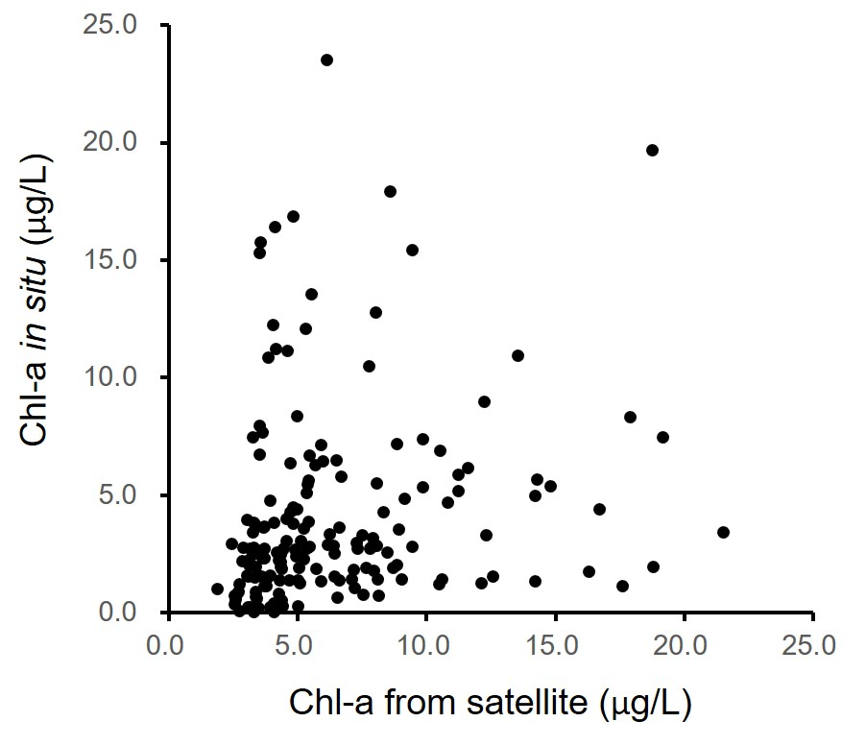
Fig. S1. Scatter plot of satellite Chl-a (averaged monthly) and in situ Chl-a averaged in region A, B and C.

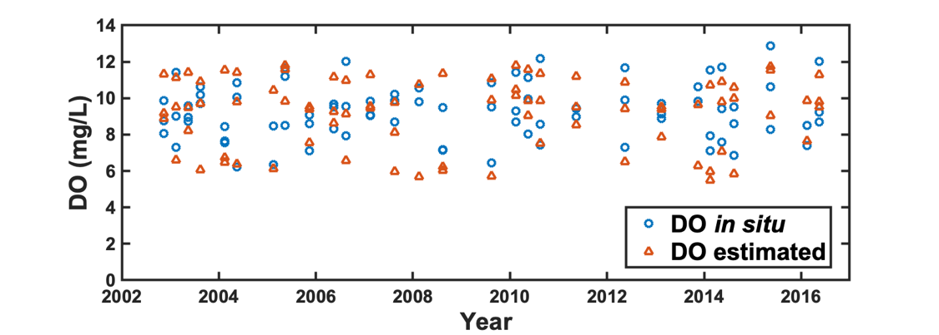
Fig. S2. Time-series of in situ and estimated DO in surface waters of the study area.

Parameters | Before and after dike construction | Among regions
Temperature | n.s. | n.s.
Salinity | n.s. | A<B^{***c}, A<C^{***c}
Suspended sediment | Be>Af^{***a} | n.s.
Chl-a | n.s. | n.s.
pH | n.s. | n.s.
Dissolved oxygen | n.s. | n.s.
Chemical oxygen demand | Be<Af* | n.s.
Ammonia | Be>Af^{*a} | A>B^{*b}, A>C^{*b}
Nitrite | n.s. | A>C^{**b}
Nitrate | Be>Af*** | A>B^{**c}, A>C^{***c}
Dissolved inorganic nitrogen | Be>Af^{***a} | A>B^{**c}, A>C^{***c}
Total nitrogen | Be>Af*** | A>B^{**c}, A>C^{***c}
Dissolved inorganic phosphorus | Be>Af*** | n.s.
Total phosphrus | Be>Af^{***a} | n.s.
Silicate | n.s. | A>C^{*c}
Secchi depth | n.s. | n.s.
Table S1. Results of one-way ANOVA and post-hoc test to compare in situ water quality parameters in surface before (Be) and after (Af) the year of 2006 (dike construction), and among three regions (A, B, C) in the study area
ªWelch's t-test (unequal variances)
^{b}least significant difference (LSD) test
^{c}Games-Howell nonparametric test (unequal variances)

Table S2. Results of stepwise multiple regression analysis
Model | Coefficient |  |  | Constant | R^{2**} | p
 | SST_{m-1}* | SST | Chl-a_{m-1}*
1 | -0.232 | - | - | 12.359 | 0.705 | <0.001
2 | -0.133 | -0.122 | - | 12.607 | 0.798 | <0.001
3 | -0.132 | -0.131 | 0.066 | 12.342 | 0.801 | <0.001
*satellite data of one month prior to in situ measuring
**modified coefficient of determination considering the degree of freedom

Table S3. Residual statistics from multiple regression analysis of this study
 | Mean | Standard deviation | Minimum | Maximum
Predicted value | 8.70 | 1.605 | 6.05 | 11.90
Standard error of predicted values | 0.17 | 0.044 | 0.101 | 0.35
Residual | 0 | 0.781 | -1.87 | -2.58
Standardized residual | 0 | 0.982 | -2.36 | 3.25
Cook's distance | 0.15 | 0.29 | 0 | 0.19
Durbin-Watson (d) | 1.811

