Journal of Geophysical Research: Ocean
Supporting Information for

Interannual variability and multiyear trends of sea surface salinity in the Amazon-Orinoco plume region from satellite observations and an ocean reanalysis
Nguyen Dac Da¹, Gregory R. Foltz^{2*}
- Faculty of Meteorology, Hydrology and Oceanography, University of Science, Vietnam National University, Hanoi, Vietnam.
- Atlantic Oceanographic and Meteorological Laboratory (AOML), National Oceanographic & Atmospheric Administration, Miami, Florida, USA.
* Corresponding author: gregory.foltz@noaa.gov

Contents of this file

Figures S1 to S10

Introduction

Fig. S1 shows the climatological monthly discharge of the Amazon river and Amazon-Orinoco River system, highlighting the phase lags between the Amazon and the Orinoco discharges and their relative contributions to the overall river discharge.
Fig. S2 shows climatological monthly mean plume SSS from the merged satellite data and SODA datasets. Based on this figure, we define the dry and flood seasons to be January - March and July - September respectively.
Fig. S3 shows the interannual variability of SSS in the non-plume region defined in Fig. 1.
Fig. S4 shows the sensitivity analysis of plume SSS under impacts of different forcings over the 2004-2017 period.
Fig. S5 shows the evolution of plume SSS anomalies under impacts of different forcings for 2011 and 2015, which are the years of lowest and highest mean plume SSS anomaly respectively.
Fig. S6 is similar to Fig. 8 in the main text. It helps locate the most crucial region of advection along the plume boundaries in terms of seasonal variability.
Fig. S7 illustrates the relationship between the NAO and different forcings in the flood season in the North Atlantic. The flood season is the most influential time of the NAO inthe plume region.
Fig. S8 illustrates the relationships between ENSO and different forcings in the dry season in the North Atlantic. The dry season is the most influential time of ENSO in the plume region.
Fig. S9 shows the relationships between plume size (area of SSS < 35.5) and plume regional mean SSS in both the merged satellite and SODA datasets.
Fig. S10 shows the relationships between plume size (area of SSS < 35.5) and river discharge.

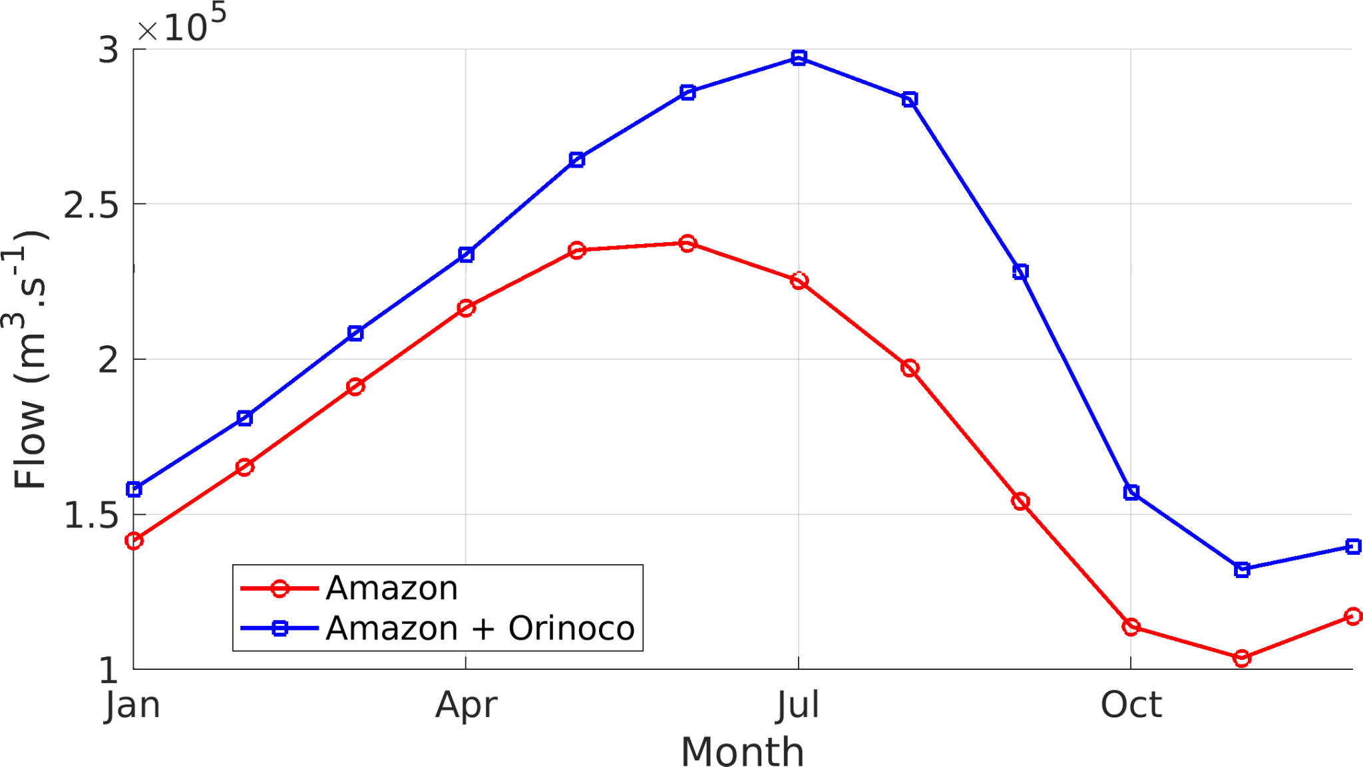
Figure S1. Climatological river flow computed over the period 2003-2019 from the HYBAM dataset.
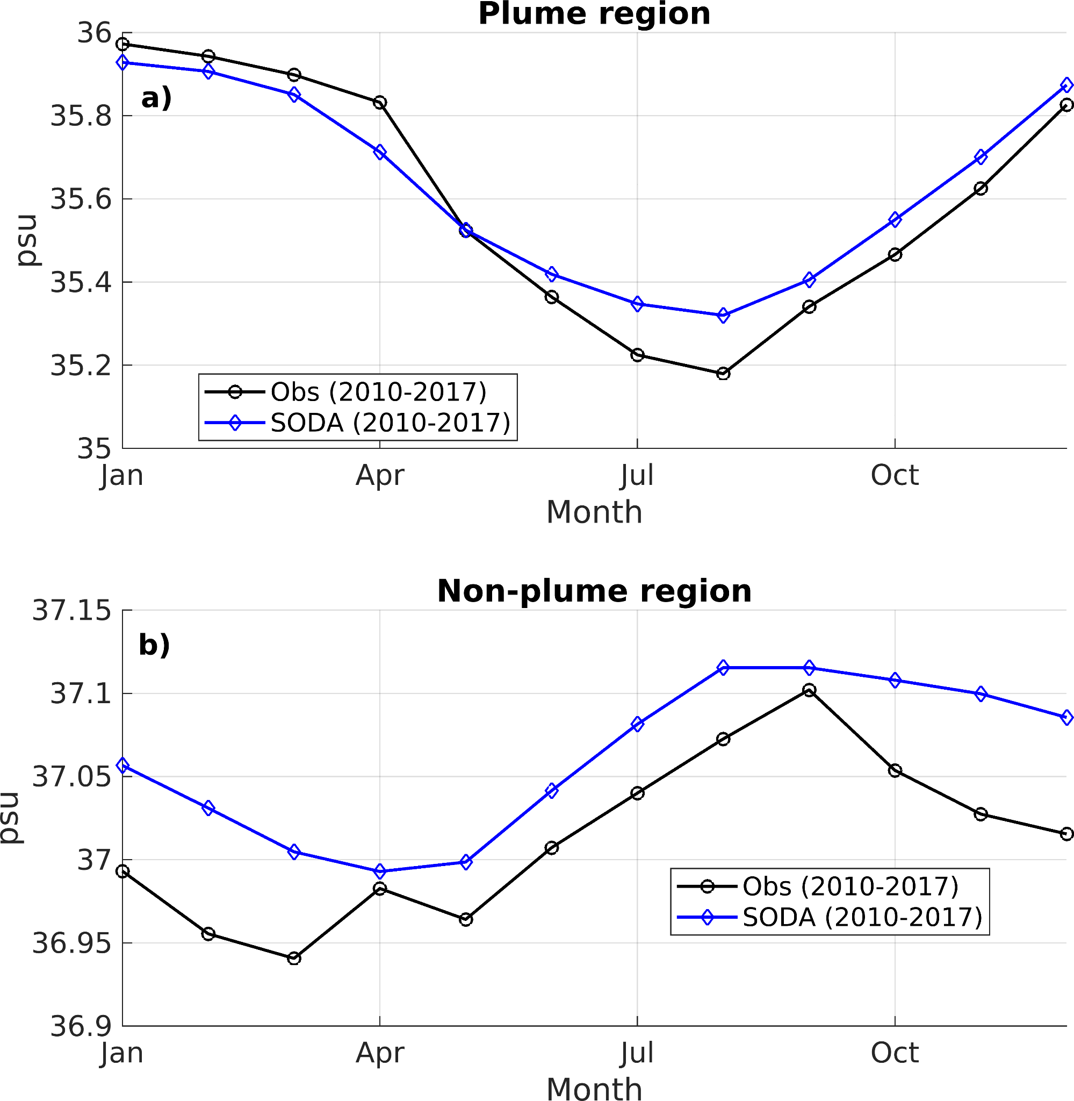
Figure S2. Seasonal variability of SSS in the plume region (a, 70 - 42º W; 0 - 23 ºN), and the non-plume region (b, 40 - 21º W; 18 - 34º N) (b). See Fig.1 in the main manuscript for location of these regions.

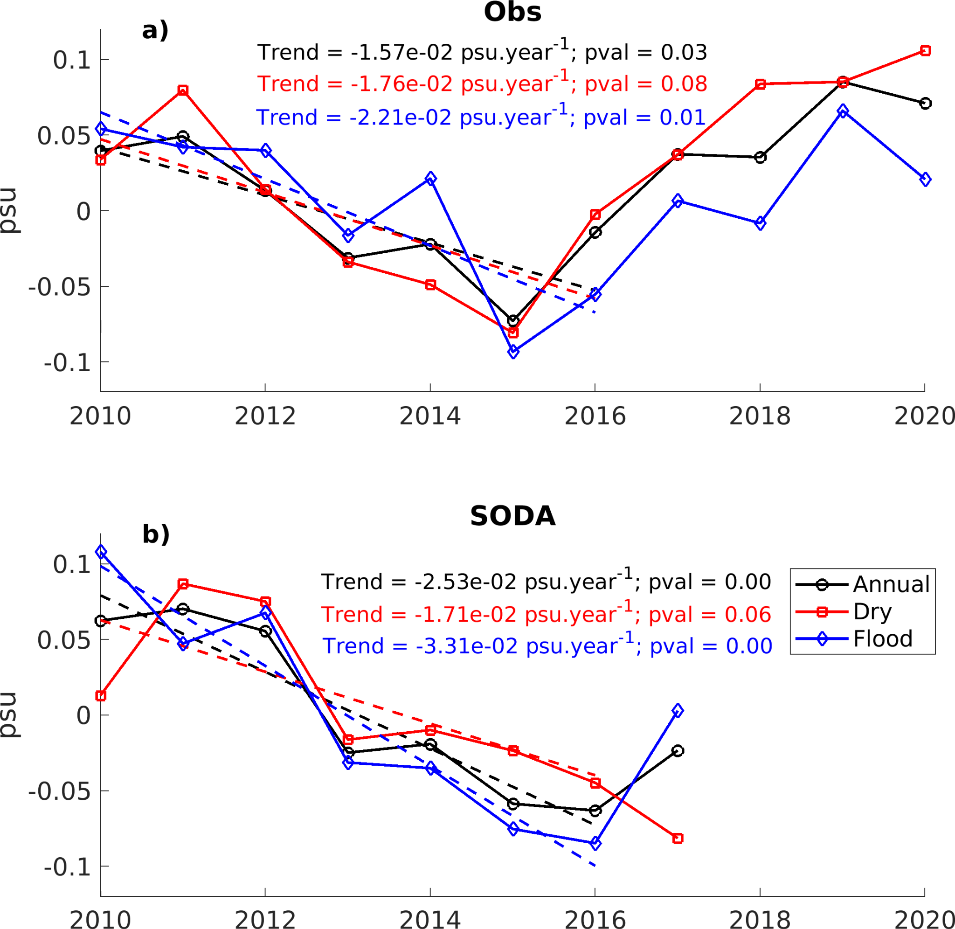
Fig S3. Interannual variability of SSS in the non-plume region northeast of the plume (40 - 21º W; 18 - 34º N).
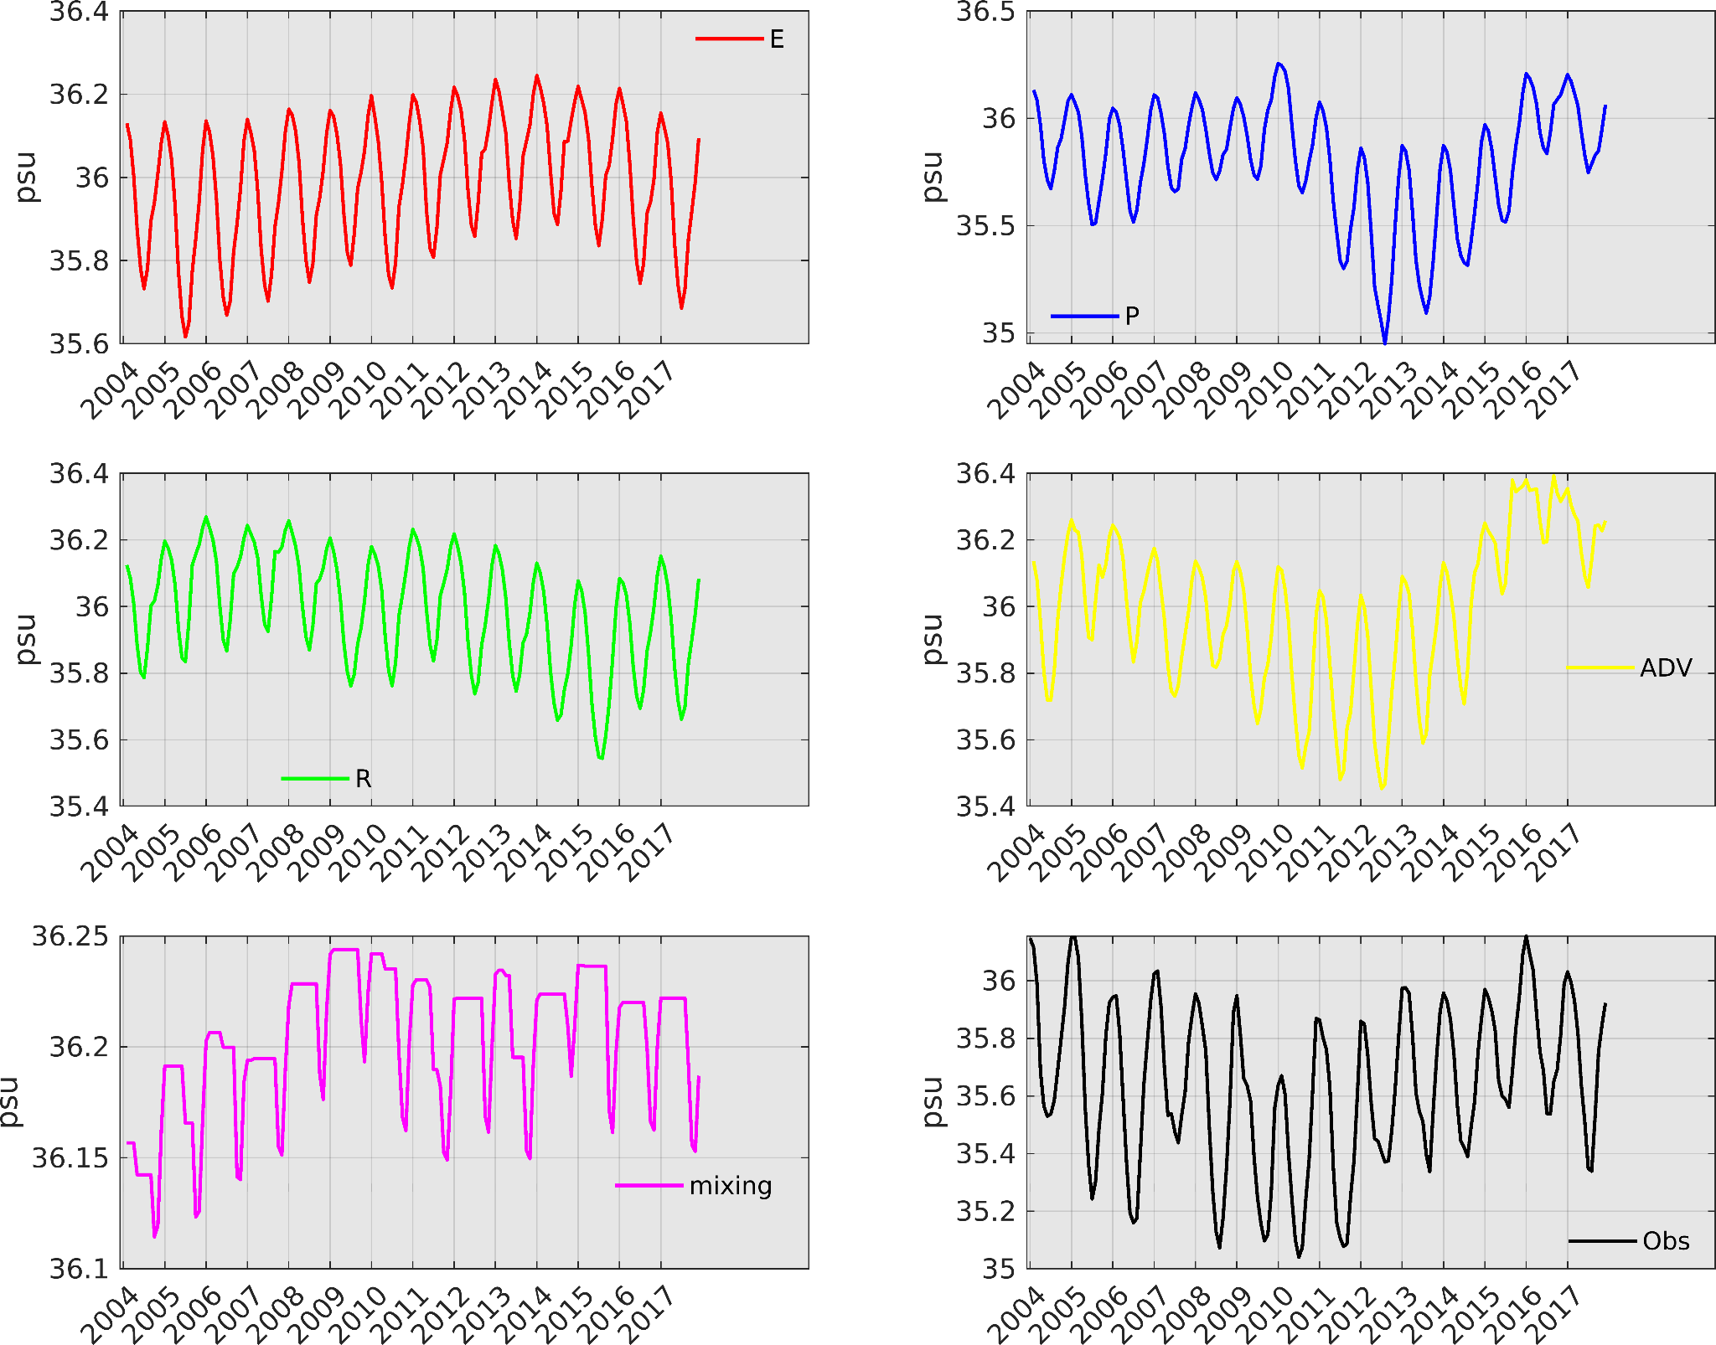
Figure S4. Spatial mean SSS of the Amazon-Orinoco plume under impacts of different forcings: evaporation (E), river (R), precipitation (P), advection (ADV), and vertical mixing. The black line represents the actual plume SSS from SODA reanalysis.

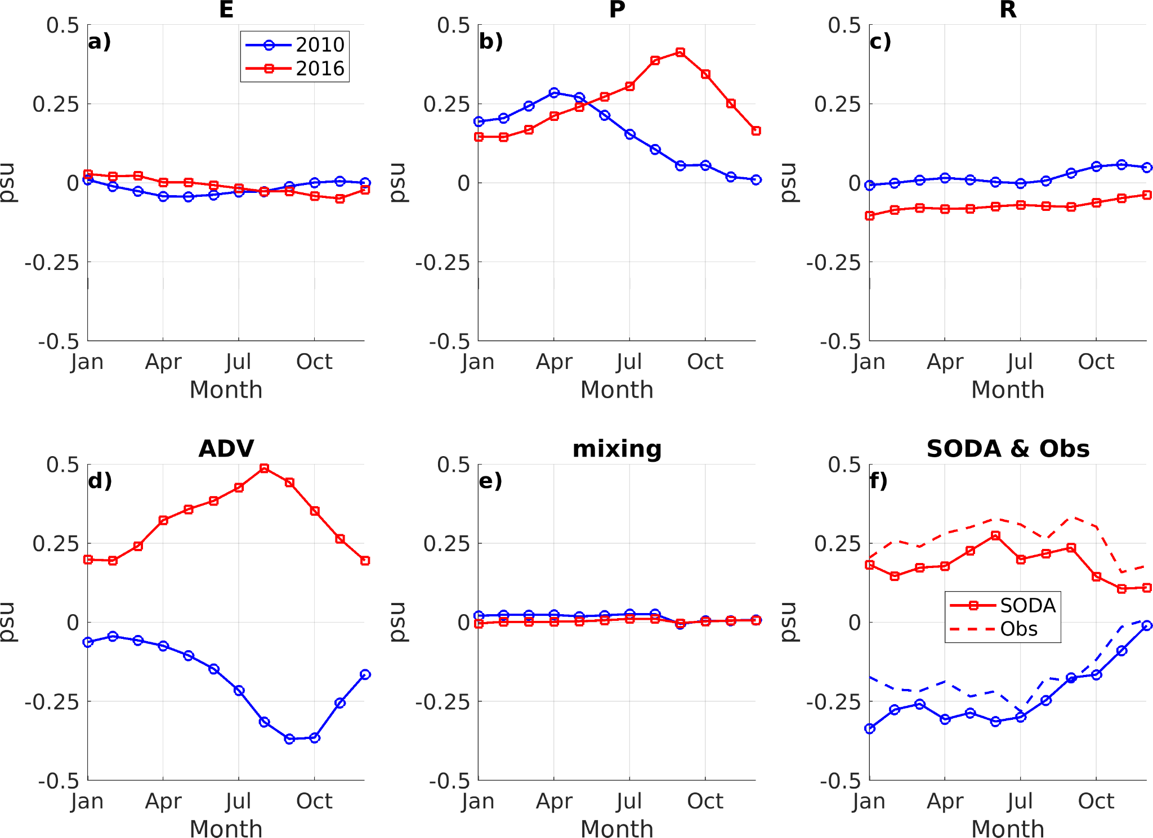
Figure S5. Spatial mean plume SSS anomalies due to different forcings (a-e) and from SODA and observations (f) for the year 2010 (blue lines) and 2016 (red lines).

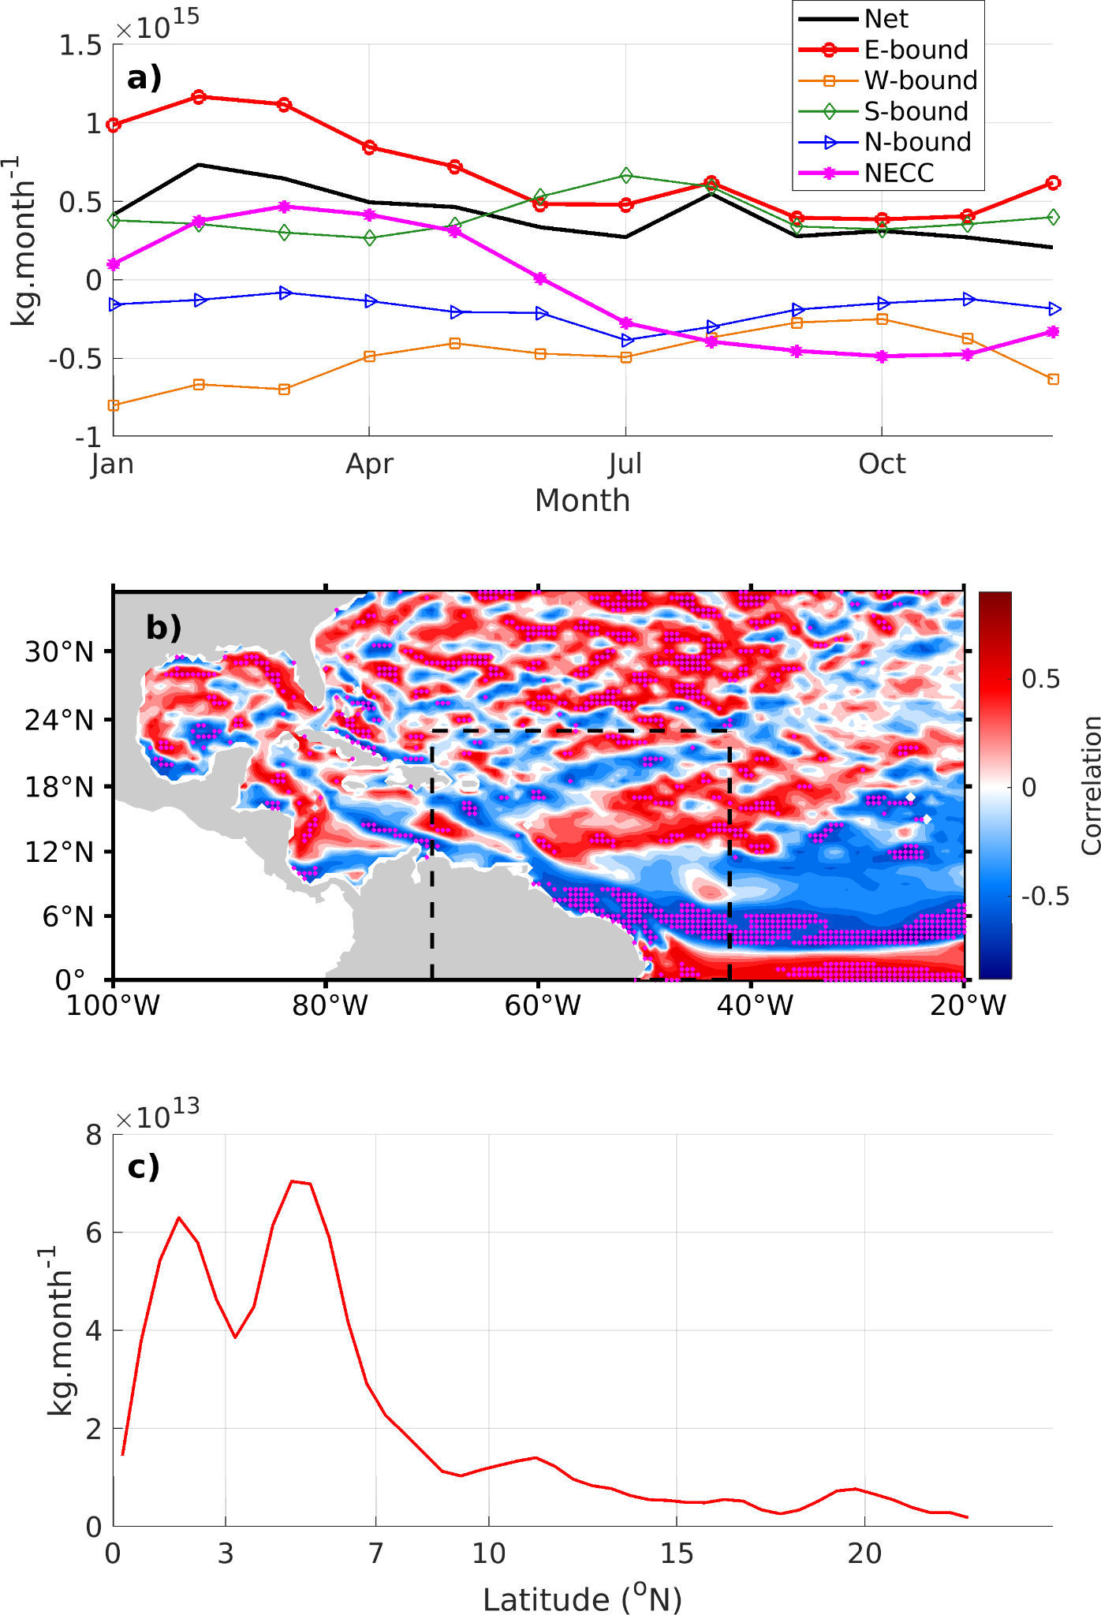
Figure S6 (a) Climatological variability of the integrated salinity flux (positive inward) along different boundaries of the plume region (black dashed rectangle) and associated net salinity flux, computed over the 2004-2017 period. (b) Map of correlation between the net salinity flux anomalies and zonal current anomalies. Dotted regions infer significant correlation at > 90%. (c) Standard deviation of climatological monthly salinity flux along the eastern boundary of the plume region.
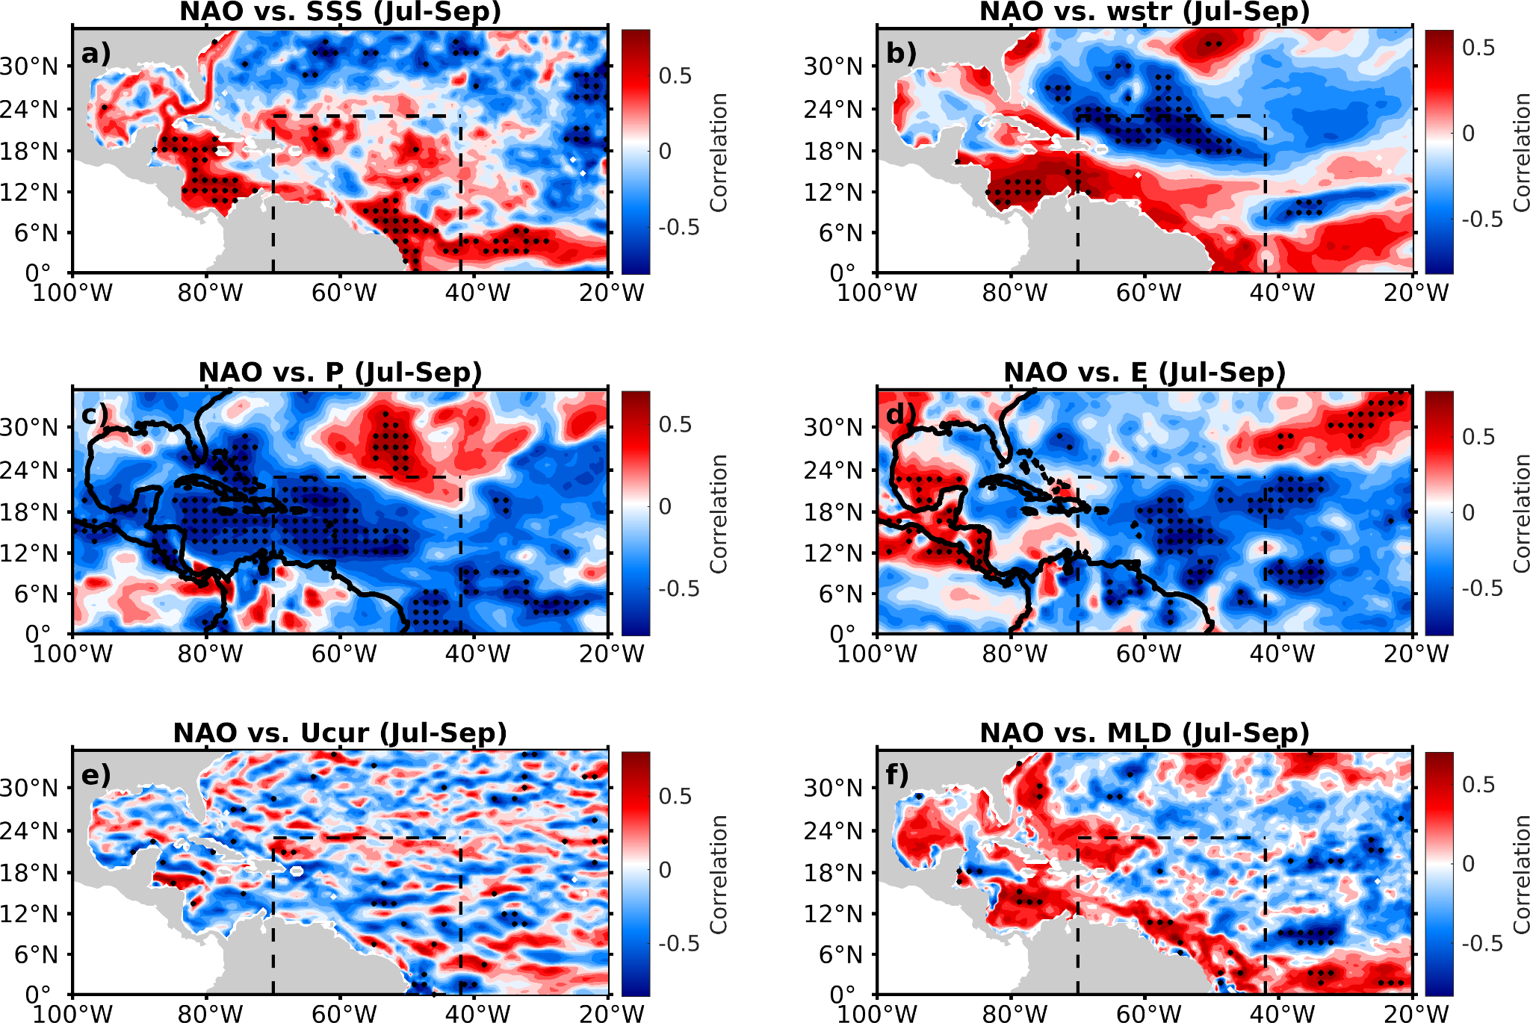
Figure S7. Correlation between winter (Nov-Jan) mean NAO index and mean forcings in the flood season from Jul-Sep. Black dots represent regions of highly significant correlation (> 95%).

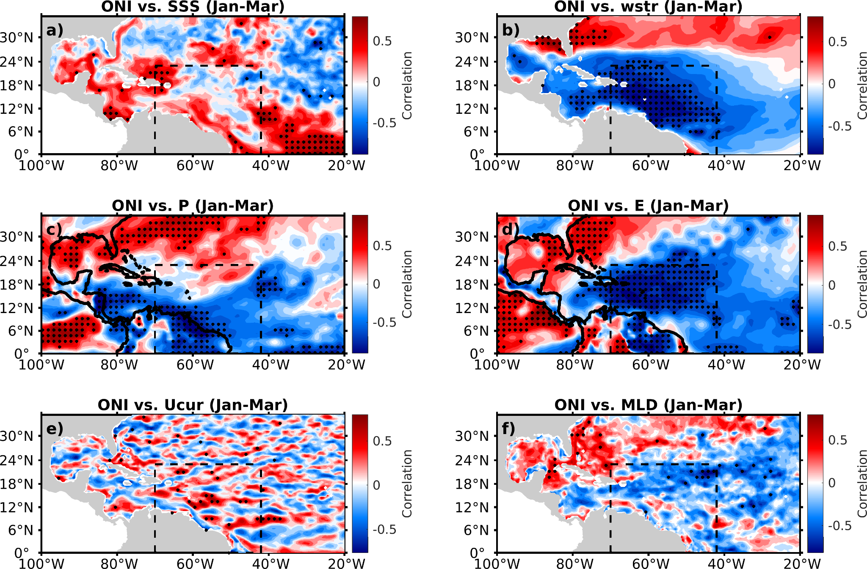
Figure S8. Correlation between winter (Nov-Jan) mean ONI index and mean forcings in the flood season (Jul-Sep). Black dots represent regions of highly significant correlation (> 95%).

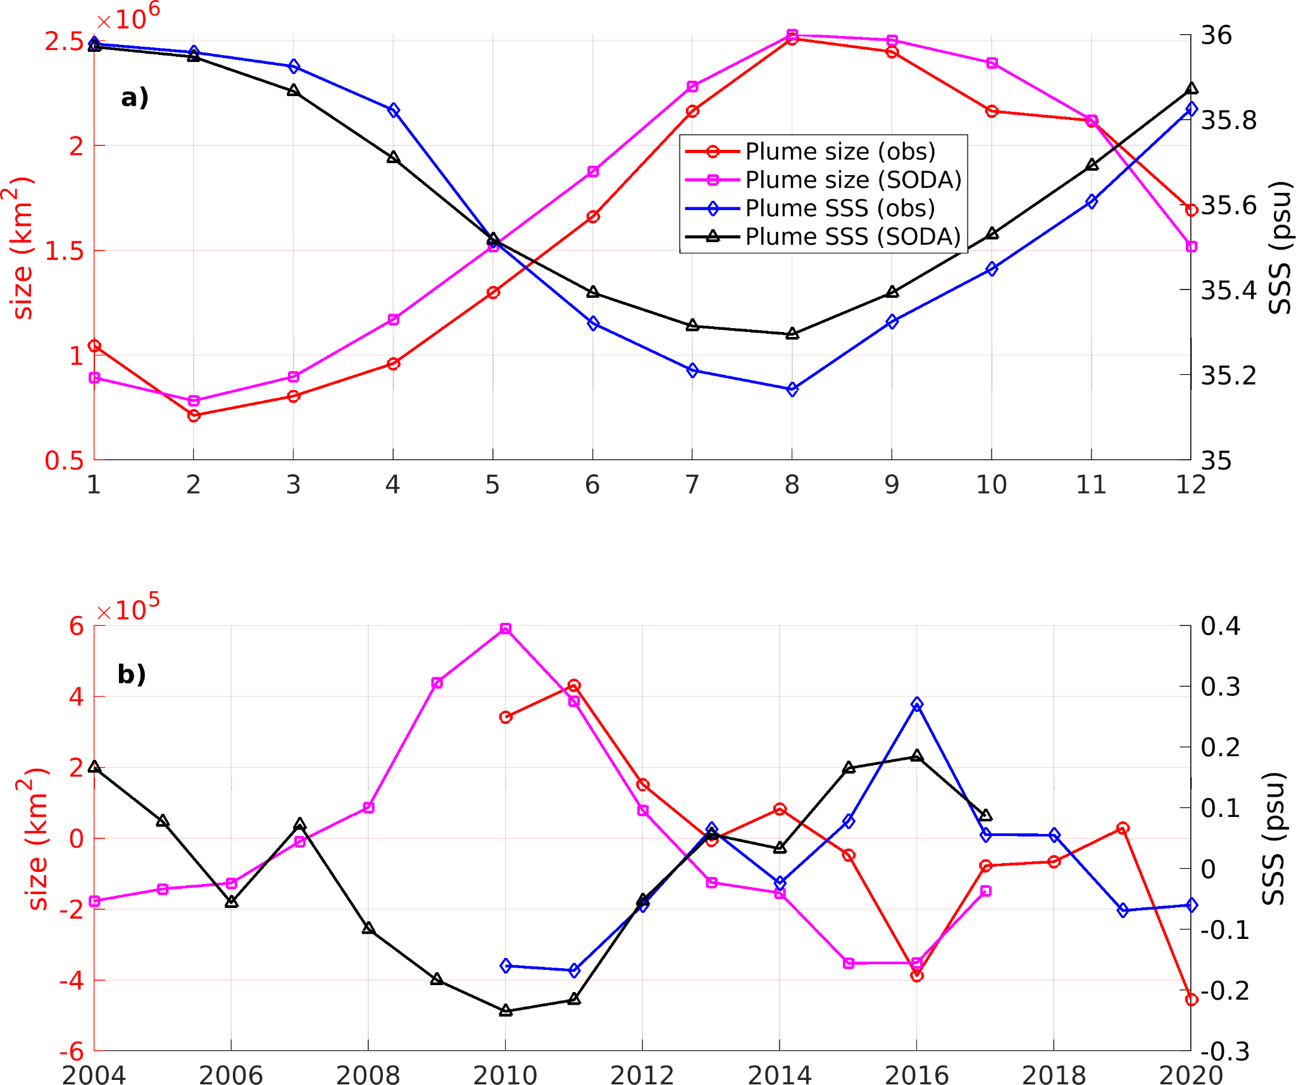
Figure S9. Seasonal (a) and interannual (b) variability of plume size and plume region mean SSS from satellite observation and SODA. Plume size is computed as the total area of SSS < 35.5 psu within the plume region (see Fig. 1 in the main text). The climatological periods are 2010-2020 and 2004-2017 for observed and SODA SSS respectively.
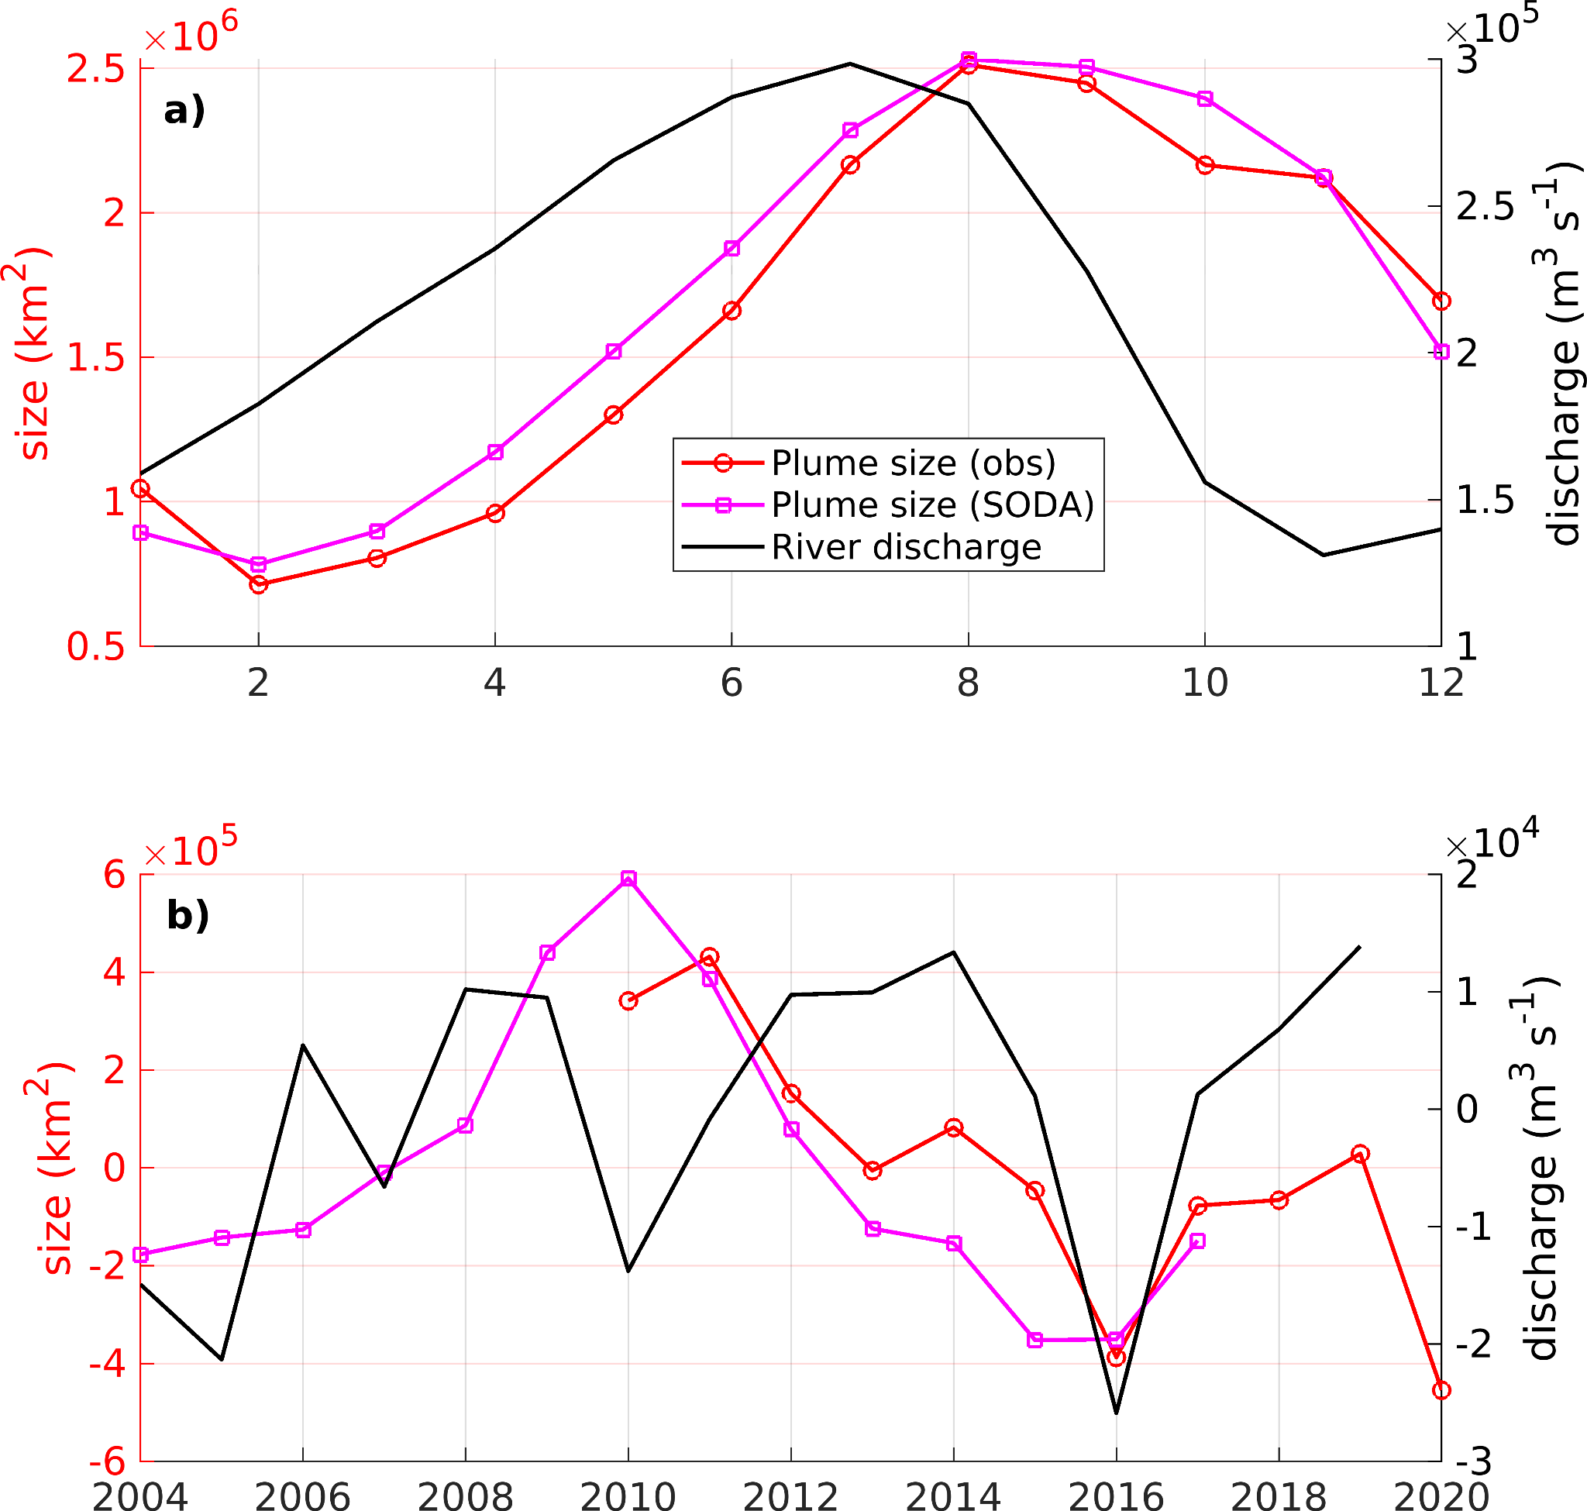
Figure S10. Climatological (a) and interannual (b) variability of river discharge and plume size from satellite observation and SODA. Plume size is computed as the total area of SSS < 35.5 psu within the plume region (see Fig. 1 in the main text). The climatological periods are 2010-2020, 2004-2017, 2004-2019 for observed plume size, SODA plume size and river discharge respectively.

