Journal of Geophysical Research: Atmospheres
Supporting Information for
Recent warming of landfalling atmospheric rivers along the west coast of the United States
Katerina R. Gonzales^{1*}, Daniel L. Swain^{2,3,4}, Kyle M. Nardi⁵, Elizabeth A. Barnes⁵, and
Noah S. Diffenbaugh^{1,6}
¹ Department of Earth System Science, Stanford University, Stanford, CA, USA
² Institute of the Environment and Sustainability, University of California, Los Angeles, Los Angeles, CA, USA
³ The Nature Conservancy of California, San Francisco, CA, USA
⁴ National Center for Atmospheric Research, Boulder, CO, USA
⁵ Department of Atmospheric Science, Colorado State University, Fort Collins, CO, USA
⁶ Woods Institute for the Environment, Stanford University, Stanford, CA, USA

Contents of this file

Figures S1 to S5
Supplementary text for Figure S5
Tables S1 to S7

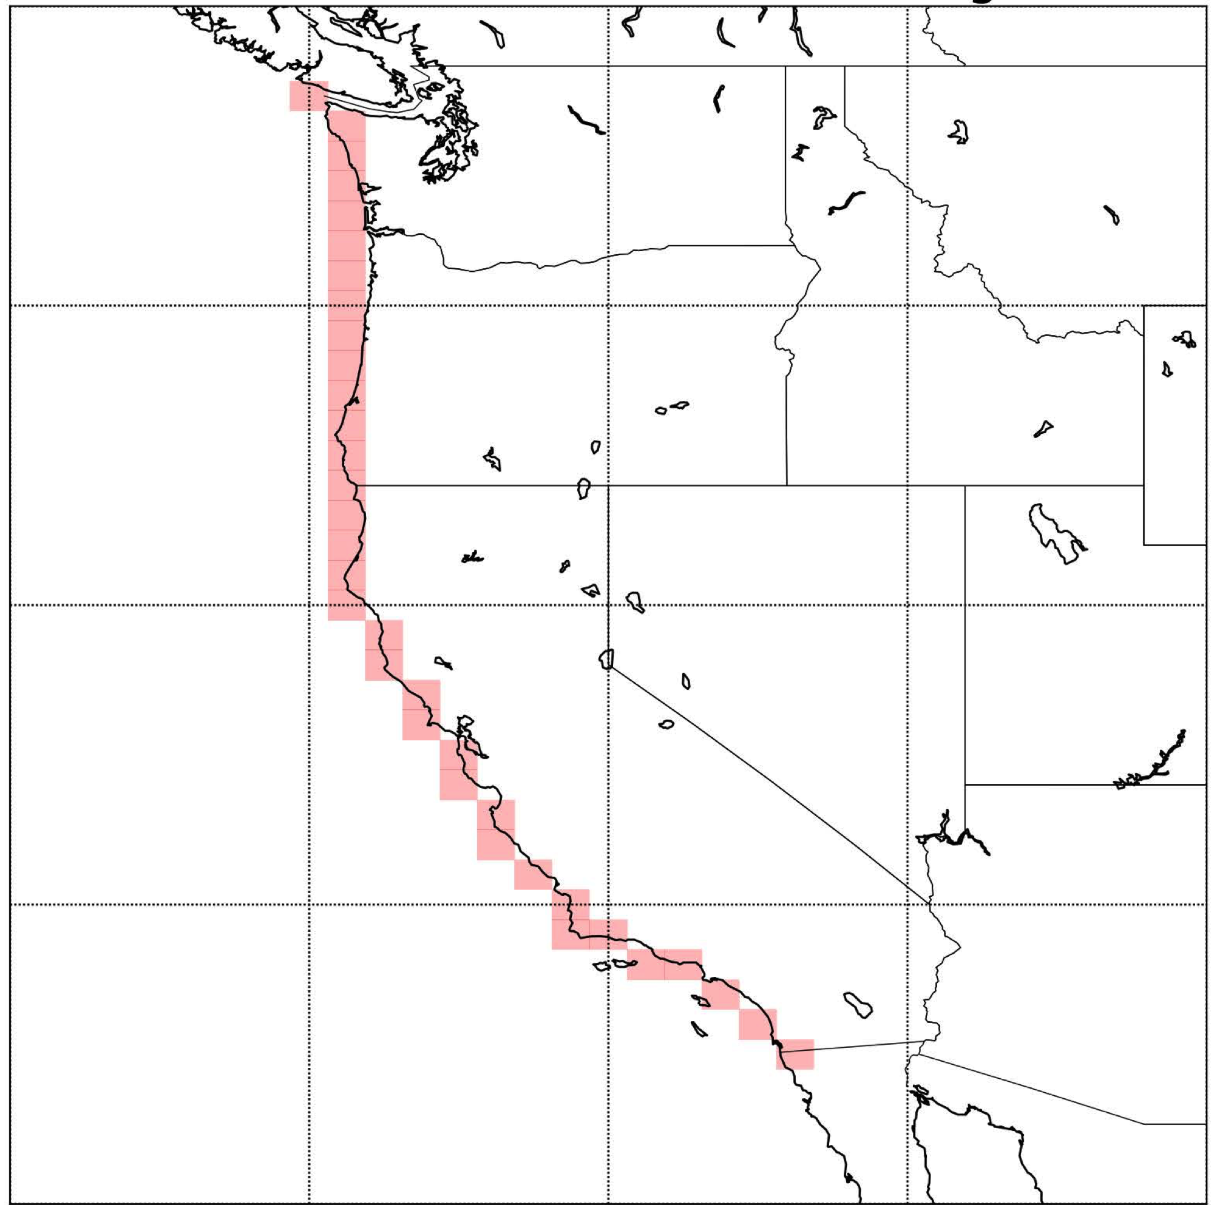
Figure S1. Grid boxes for AR landfall detection for the MBM16-based West Coast AR
catalog. The AR catalog lists time stamps at which an AR is present over the grid boxes.

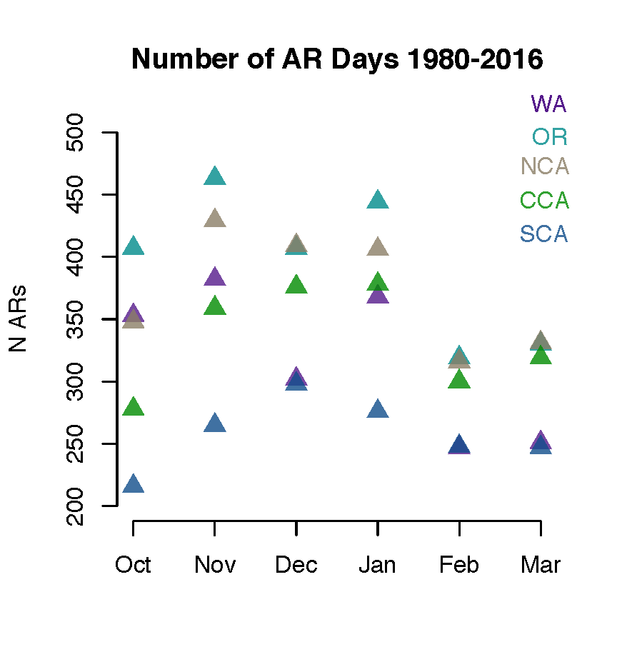
Figure S2: Number of AR days in each month and region used in our analyses.

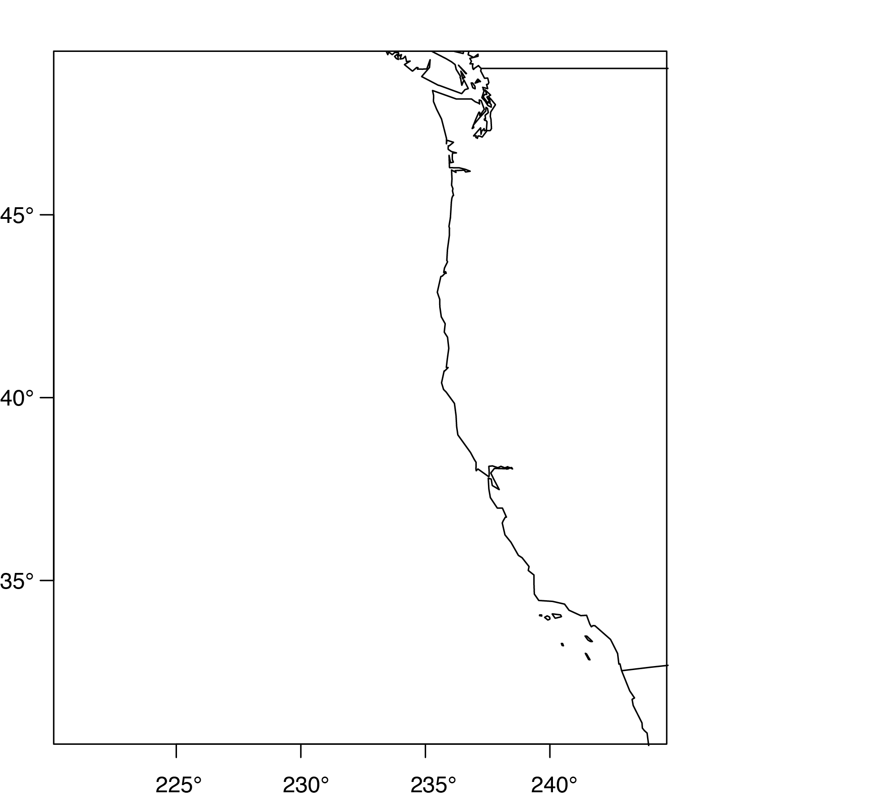
Figure S3 a: Domain over which the IVT threshold is defined.

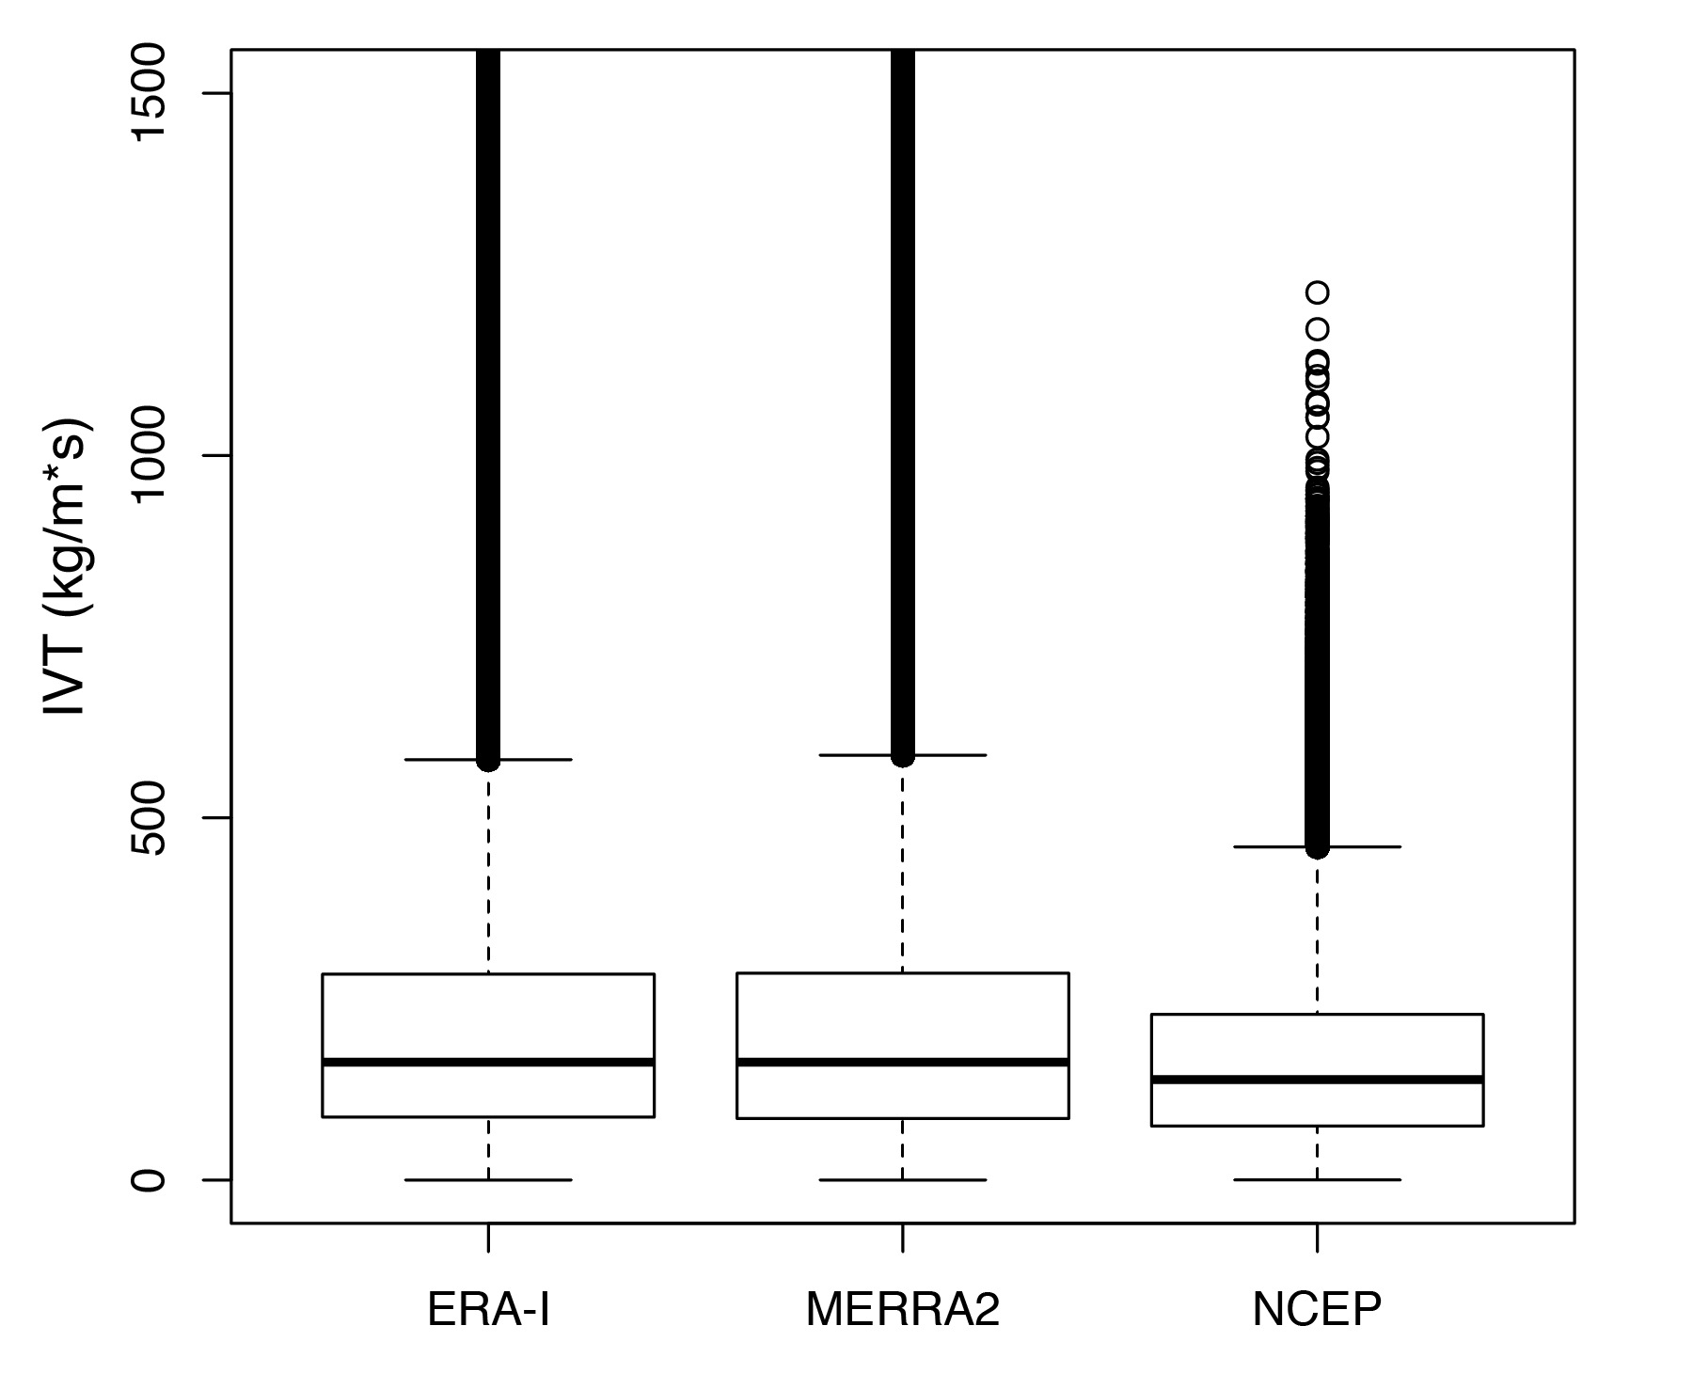
Figure S3 b: Distribution of IVT values found over the domain in a.

Figure S4: AR-coast domains (left, colors) in relation to the original AR-landfall domains (right).

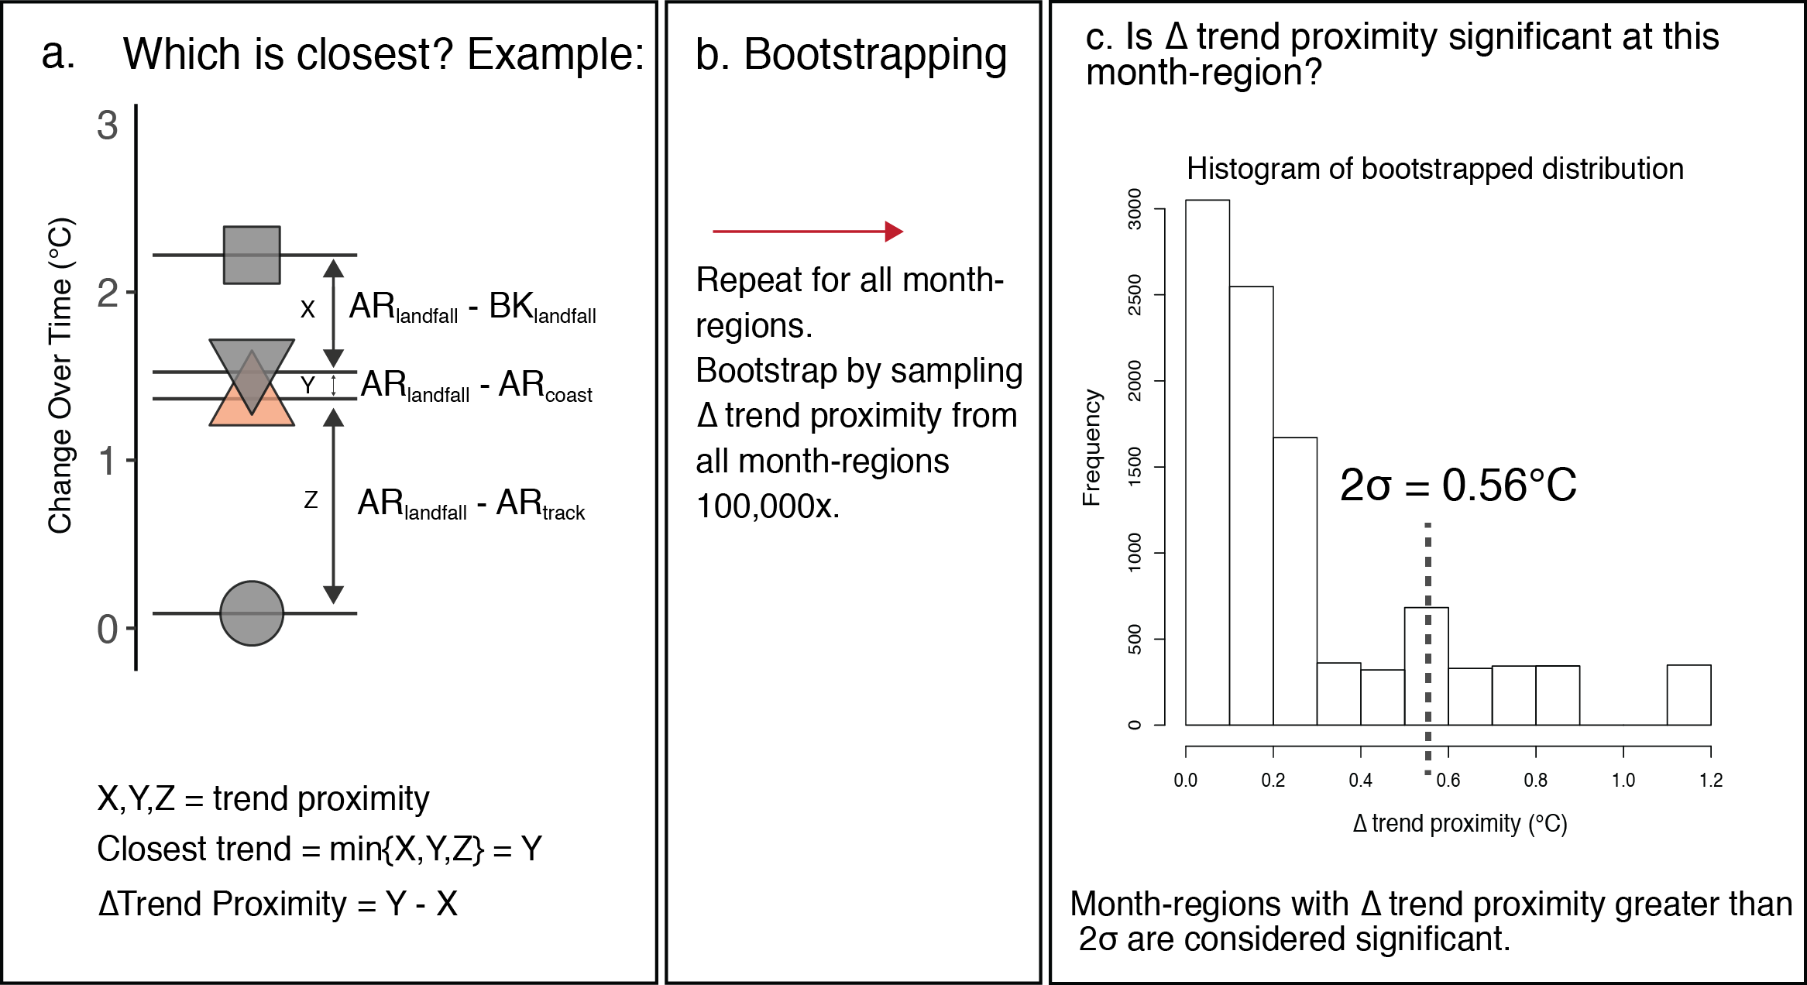
Figure S5: Schematic illustrating our methods for determining the closest trend to AR_{landfall} and the significance level of the closeness. The bootstrapping is conducted once by pooling ∆ trend proximity from all month regions. Each month region is evaluated separately to determine the closest trend to AR_{landfall} and if that trend is significantly closest.

We describe the use of bootstrapped values of ∆ trend proximity in Section 2.6.5. Figure S5 further illustrates this as follows. a) For each month-region, we assess which trend type is closest to AR_{landfall}. We note the closest trend (in the example, Y is associated with AR_{coast}) and visualize this in Figure 6 in the lower regions of each panel in the gray bar. We also note the ∆ trend proximity value for this month-region, which is defined as the difference between the closest and second-closest trend (in the example, Y-X). b) We repeat the process in a) and bootstrap the ∆ trend proximities from all 30 month-regions. c) With the estimated distribution of ∆ trend proximities from part b), we then estimate the standard deviation of the distribution. In this case, it equals 0.56°C. Therefore the month-region with ∆ trend proximity greater than this threshold is considered “significantly closest”.

Table S1: Number of AR days counted in each region that also are counted in the other four regions.
 | WA | OR | NCA | CCA | SCA
WA | 1903 | 1838 | 1578 | 1224 | 804
OR | 1838 | 2370 | 2073 | 1666 | 1152
NCA | 1578 | 2073 | 2239 | 1757 | 1234
CCA | 1224 | 1666 | 1757 | 2010 | 1397
SCA | 804 | 1152 | 1234 | 1397 | 1550

Table S2: AR temperature and frequency trends by month and region. Temperature trend magnitudes are summarized by ∆ (°C), the change over the time period. Significance of trend is assessed with the F-test for α=0.05 (red cells) and α=0.10 (orange cells).

 |  | Oct | Nov | Dec | Jan | Feb | Mar | All Months
WA | Temp Trend ∆ | 0.53 | 0.75 | -0.48 | 0.60 | 0.25 | 1.54 | 0.69
WA | Temp Trend P-Value | 0.48 | 0.24 | 0.47 | 0.43 | 0.76 | 0.07 | 0.15
WA | Freq Trend ∆ | 0.61 | 0.32 | 1.01 | 1.19 | -1.81 | 6.04 | 7.70
WA | Freq Trend P-Value | 0.79 | 0.88 | 0.63 | 0.54 | 0.34 | 0.00 | 0.22
OR | Temp Trend ∆ | 0.85 | 1.07 | -0.55 | 0.73 | 0.02 | 1.70 | 0.85
OR | Temp Trend P-Value | 0.29 | 0.10 | 0.48 | 0.36 | 0.97 | 0.04 | 0.09
OR | Freq Trend ∆ | 1.41 | -2.01 | 1.25 | 1.70 | -2.48 | 4.69 | 5.10
OR | Freq Trend P-Value | 0.61 | 0.41 | 0.65 | 0.49 | 0.26 | 0.03 | 0.50
NCA | Temp Trend ∆ | 0.94 | 1.35 | -0.02 | 0.79 | -0.31 | 1.91 | 0.96
NCA | Temp Trend P-Value | 0.28 | 0.05 | 0.98 | 0.26 | 0.71 | 0.02 | 0.02
NCA | Freq Trend ∆ | 1.93 | -2.21 | 2.12 | 0.93 | -2.69 | 3.25 | 3.70
NCA | Freq Trend P-Value | 0.47 | 0.40 | 0.50 | 0.74 | 0.25 | 0.20 | 0.63
CCA | Temp Trend ∆ | 1.46 | 1.12 | 0.62 | 1.84 | 0.33 | 2.18 | 1.43
CCA | Temp Trend P-Value | 0.13 | 0.14 | 0.45 | 0.04 | 0.71 | 0.01 | 0.00
CCA | Freq Trend ∆ | 2.48 | -2.81 | 4.04 | 1.25 | -3.15 | 1.54 | 3.25
CCA | Freq Trend P-Value | 0.29 | 0.29 | 0.21 | 0.62 | 0.19 | 0.57 | 0.67
SCA | Temp Trend ∆ | 1.74 | 0.62 | 0.81 | 2.19 | 1.02 | 1.26 | 1.65
SCA | Temp Trend P-Value | 0.10 | 0.44 | 0.45 | 0.03 | 0.32 | 0.17 | 0.00
SCA | Freq Trend ∆ | 2.57 | -2.44 | 4.04 | 1.41 | -1.36 | -0.74 | 3.34
SCA | Freq Trend P-Value | 0.25 | 0.27 | 0.17 | 0.54 | 0.54 | 0.76 | 0.63

Table S3: AR temperature trend magnitudes and p-values by month and region only using the ERA-Interim reanalysis.
 |  | Oct | Nov | Dec | Jan | Feb | Mar
WA | Temp Trend ∆ | 0.91 | 1.24 | -0.14 | 0.73 | 0.69 | 1.26
WA | Temp Trend P-Value | 0.25 | 0.05 | 0.84 | 0.35 | 0.40 | 0.11
OR | Temp Trend ∆ | 1.15 | 1.69 | -0.22 | 1.11 | 0.07 | 1.92
OR | Temp Trend P-Value | 0.17 | 0.02 | 0.78 | 0.13 | 0.93 | 0.01
NCA | Temp Trend ∆ | 1.35 | 1.61 | 0.03 | 1.43 | 0.17 | 2.38
NCA | Temp Trend P-Value | 0.12 | 0.02 | 0.97 | 0.09 | 0.86 | 0.00
CCA | Temp Trend ∆ | 1.79 | 1.46 | 0.62 | 1.58 | 0.41 | 2.59
CCA | Temp Trend P-Value | 0.06 | 0.06 | 0.44 | 0.07 | 0.67 | 0.01
SCA | Temp Trend ∆ | 1.92 | 0.70 | 0.46 | 2.26 | 1.17 | 2.17
SCA | Temp Trend P-Value | 0.09 | 0.40 | 0.64 | 0.02 | 0.29 | 0.02

Table S4: AR temperature trend magnitudes and p-values by month and region only using the MERRA2 reanalysis.
 |  | Oct | Nov | Dec | Jan | Feb | Mar
WA | Temp Trend ∆ | 0.55 | 0.82 | -0.47 | 0.30 | 0.39 | 0.76
WA | Temp Trend P-Value | 0.48 | 0.22 | 0.54 | 0.70 | 0.59 | 0.34
OR | Temp Trend ∆ | 0.36 | 1.33 | -0.66 | 0.40 | -0.11 | 1.24
OR | Temp Trend P-Value | 0.67 | 0.08 | 0.44 | 0.62 | 0.89 | 0.13
NCA | Temp Trend ∆ | 0.74 | 1.10 | -0.70 | 0.72 | -0.16 | 1.84
NCA | Temp Trend P-Value | 0.41 | 0.15 | 0.41 | 0.40 | 0.86 | 0.03
CCA | Temp Trend ∆ | 1.17 | 0.98 | -0.05 | 0.99 | -0.10 | 2.11
CCA | Temp Trend P-Value | 0.23 | 0.22 | 0.95 | 0.27 | 0.92 | 0.03
SCA | Temp Trend ∆ | 1.51 | 0.29 | -0.19 | 1.73 | 0.26 | 1.52
SCA | Temp Trend P-Value | 0.18 | 0.74 | 0.85 | 0.06 | 0.81 | 0.10

Table S5: AR temperature trend magnitudes and p-values by month and region only using the NCEP-DOE reanalysis.
 |  | Oct | Nov | Dec | Jan | Feb | Mar
WA | Temp Trend ∆ | 0.42 | 0.51 | -0.70 | 0.46 | 0.05 | 1.36
WA | Temp Trend P-Value | 0.59 | 0.42 | 0.30 | 0.54 | 0.95 | 0.12
OR | Temp Trend ∆ | 0.67 | 0.67 | -0.77 | 0.52 | 0.14 | 1.71
OR | Temp Trend P-Value | 0.37 | 0.29 | 0.31 | 0.49 | 0.85 | 0.06
NCA | Temp Trend ∆ | 1.05 | 1.09 | -0.10 | 0.63 | -0.32 | 2.03
NCA | Temp Trend P-Value | 0.18 | 0.10 | 0.90 | 0.35 | 0.69 | 0.02
CCA | Temp Trend ∆ | 1.22 | 1.09 | 0.70 | 1.81 | 0.33 | 2.13
CCA | Temp Trend P-Value | 0.13 | 0.13 | 0.38 | 0.04 | 0.68 | 0.01
SCA | Temp Trend ∆ | 1.41 | 0.88 | 0.97 | 1.95 | 0.95 | 0.98
SCA | Temp Trend P-Value | 0.13 | 0.26 | 0.31 | 0.03 | 0.31 | 0.22

Table S6: Sensitivity analysis for cool-season and monthly trends removing water years 2014 and 2015. Significance of trend is assessed with the F-test for α=0.05 (red cells) and α=0.10 (orange cells).

 |  | Oct | Nov | Dec | Jan | Feb | Mar | All Months
WA | Temp Trend ∆ | -0.09 | 0.66 | -0.84 | 0.26 | 0.51 | 1.02 | 0.35
WA | Temp Trend P-Value | 0.91 | 0.30 | 0.20 | 0.72 | 0.54 | 0.22 | 0.45
OR | Temp Trend ∆ | 1.16 | 0.88 | -0.98 | 0.22 | 0.23 | 1.12 | 0.60
OR | Temp Trend P-Value | 0.14 | 0.16 | 0.21 | 0.78 | 0.77 | 0.17 | 0.22
NCA | Temp Trend ∆ | 1.32 | 1.12 | -0.46 | 0.49 | -0.36 | 1.33 | 0.76
NCA | Temp Trend P-Value | 0.13 | 0.11 | 0.55 | 0.49 | 0.68 | 0.10 | 0.08
CCA | Temp Trend ∆ | 1.98 | 1.06 | 0.16 | 1.23 | 0.24 | 1.72 | 1.14
CCA | Temp Trend P-Value | 0.03 | 0.17 | 0.85 | 0.17 | 0.79 | 0.04 | 0.00
SCA | Temp Trend ∆ | 1.00 | 0.82 | 0.55 | 1.33 | 0.28 | 0.78 | 1.26
SCA | Temp Trend P-Value | 0.33 | 0.31 | 0.62 | 0.16 | 0.78 | 0.39 | 0.01

Table S7: ∆Trend proximity values (°C) by month-region. ∆ trend proximity values are calculated from the closest trend and the second-closest (or middle) trend. ∆ trend proximities that are above the two-sigma threshold (0.56°C) are highlighted in red.
 | Oct | Nov | Dec | Jan | Feb | Mar
WA | 0.05 | 0.22 | 0.25 | 0.07 | 0.03 | 0.11
OR | 0.10 | 0.05 | 0.25 | 0.63 | 0.03 | 0.57
NCA | 0.15 | 0.34 | 0.10 | 0.54 | 0.48 | 0.19
CCA | 0.02 | 0.16 | 0.23 | 0.76 | 0.06 | 0.26
SCA | 0.16 | 0.13 | 0.12 | 0.90 | 0.09 | 1.14

