Geophysical Research Letters
Supporting Information for
Optimal Climate Normals for North Atlantic Hurricane Activity
Carl J. Schreck III¹, Philip. J. Klotzbach², and Michael M. Bell²
¹Cooperative Institute for Satellite Earth System Studies (CISESS), North Carolina State University, Asheville, NC USA
² Department of Atmospheric Science, Colorado State University, Fort Collins, CO USA

Contents of this file

Figures S1 to S3

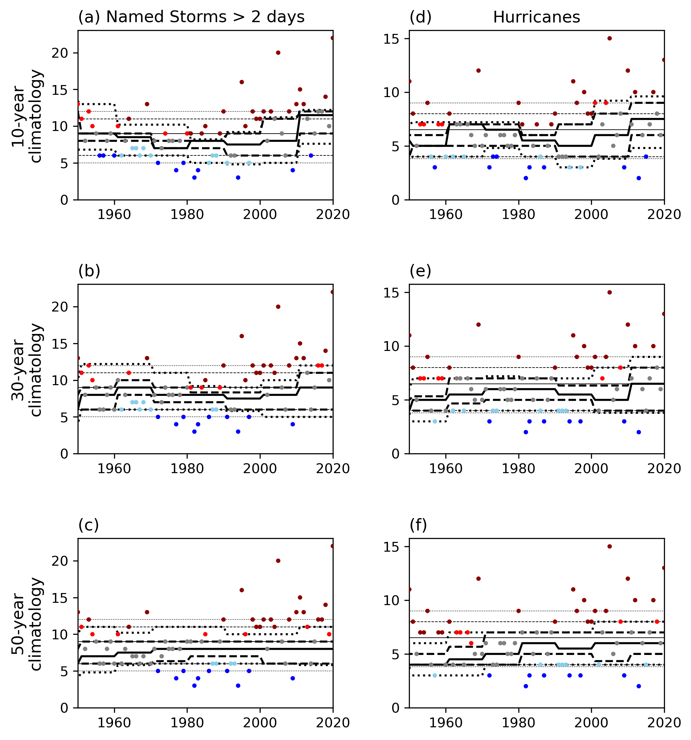Figure S1. As in Fig. 2 but for named storms lasting at least 2 days (left column) and hurricanes (right column).

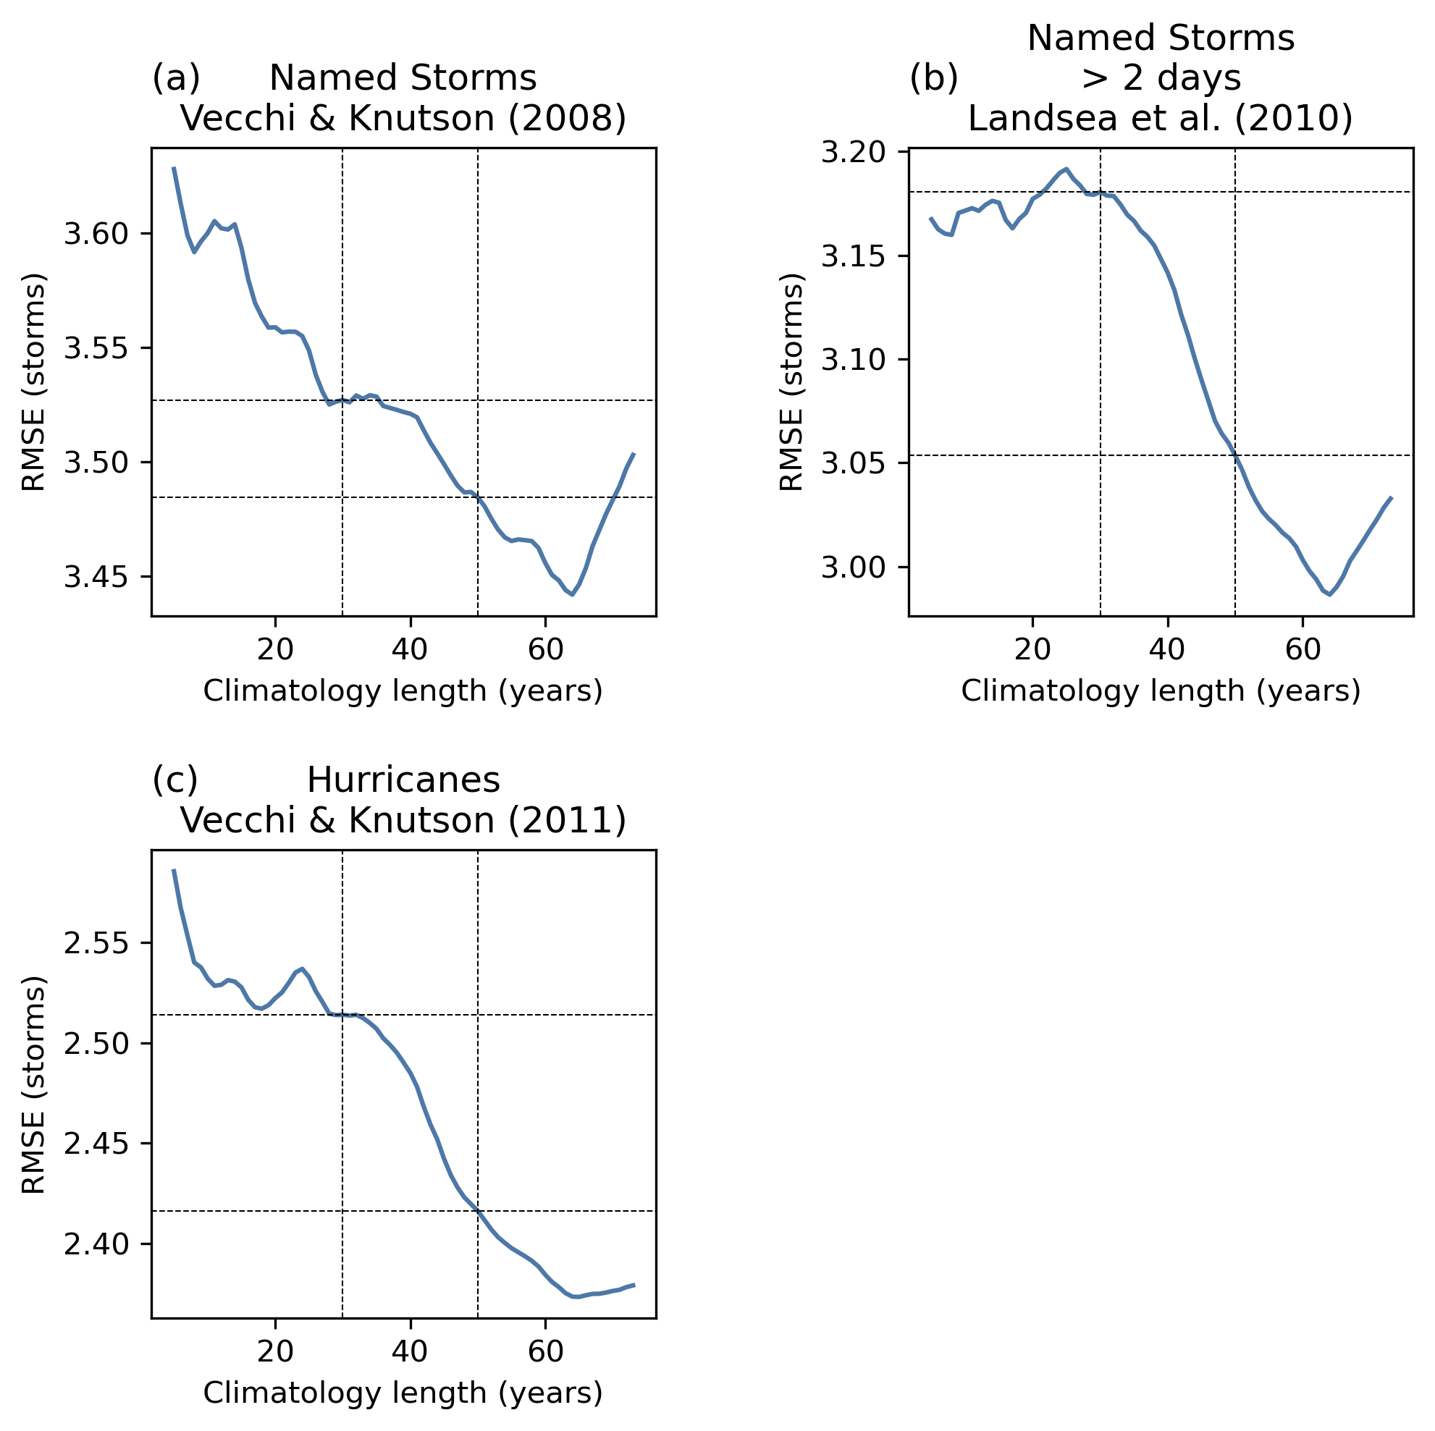

Figure S2. As in Fig. 4 but using data that have been adjusted for changes in the observing network for (a) named storms by Vecchi & Knutson (2008), (b) named storms lasting longer than 2 days by Landsea et al. (2010), and (c) hurricanes by Vecchi & Knutson (2011).

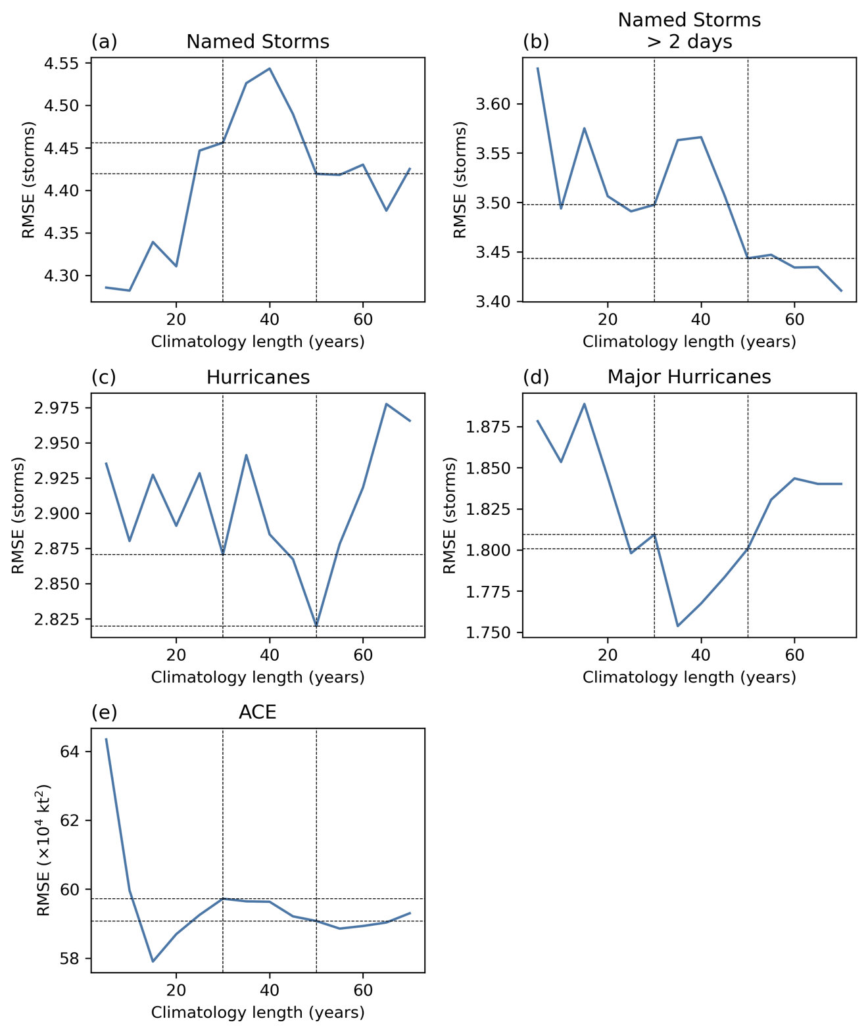

Figure S3. As in Fig. 4 but using climatological medians instead of means.

