Supplementary information

Supplementary information 1. Human dimension related objectives of agencies classified by category

Color-coded categories for classification of human dimension related objectives in Table S1.1:
1. Support sustainable fisheries
2. Support ecosystem goods and services
3. Human well-being
4. Social safeguard
5. Support resource governance/Assess management results on society
6. Support partnership
7. To support management/conservation process (different shades of blue)
8. Societal trade-offs (different shades of grey)

Table S1.1: Human dimension related objectives gleaned from agency documents and classified by category. Only the dark orange objectives (# 3 in the list above) were being considered in this study.
Agency | Document | Overall Goal | Human related objectives
PIFSC | 2017 Atlantis workshop | 1. Assess how an increase in MHI monk seal population may affect the bottomfish fishery and vice versa
 |  | 2. Evaluate the socio-economic/ecological tradeoffs of existing bottomfish and coral reef fish fishery regulations compared to alternative regulations (e.g. catch limits, different inclusions of BRFAs such as open half)
 |  | 3. How are the ecosystem goods and services provided by the shallow (0-30 m) coral reef ecosystems impacted by temperature-sensitive coral species loss?
 |  | 4. Are coral reef ecosystems more or less resilient to the effects of climate change if there is a larger population of herbivores?
 |  | 5. Can coral reef ecosystem resilience be changed through spatial management, such as, no-take areas or Herbivore Enhancement areas?
PIFSC | Science Plan 2019-2023 | Produce science to support the conservation and management of living marine resources – in paeticular:
 |  | * promote sustainable fisheries | C.(3) Promote incorporation of climate, habitat, socioeconomic, or ecosystem considerations for select species based on data availability
 |  | *conserve protected species | F. (3) Improve understanding of ecological (including climate) and social  drivers that affect protected species populations and effectiveness of  management strategies to address them
 |  | *research to support ecosystem-based fisheries and living marine resource management | G. (2) Identify key socioeconomic, environmental, and management drivers  affecting regional ecosystems and associated fisheries, markets and fishing communities
G. (3) Determine and fill information gaps to integrate social, ecological,
and biophysical research to evaluate management strategies and societal tradeoffs
H. (1) Sustain socioeconomic, ecological, environmental, and climate observing programs to monitor status and trends of ecological and human communities, habitats, and processes influencing living
marine resources and human well-being
PIFSC | NCRMP US Coral Reef Monitoring Data Summary 2018, NOAA Tech Memo CRCP 31; | To support conservation of the nation’s coral reef ecosystems through documenting and understanding the status and trends of climate, fish, benthic, and socioeconomic variables | Status of human connections
PIRO | Mandates | Magnuson-Stevens Act (includes EFH) | Securing sustainable fisheries
 |  |  | Minimizing impact to human communities
 |  |  | Optimizing food production
 |  |  | Optimize economic use/profitability
 |  |  | Optimize employment
 |  |  | Optimize recreation
 |  |  | Optimize atability and sustainability
 |  |  | Safety at sea
 |  | Marine Mammal Protection Act
 |  | Endangered Species Act | Halt and reverse the trend toward species extinction and identification and protection of all lands, water and air necessary to recover endangered species
 |  | Coral Reef Conservation Act
 |  | National Environmental Protection Act
 |  | Marine Sanctuaries Act | Ensure thriving sanctuaries, deepen understanding
PIRO | Strategic Plan 2016-2020 | Ensure productivity and sustainability of fisheries and fishing communitites through science-based decisions and regulatory compliance. Recover and preserve protected resources through natural and social science.
PIFSC, PIRO, Council | EBFM implementation plan 2018-2022 | To meet our fisheries conservation and management mandates by balancing ecological well-being and human well-being through good governance. | 1. Implement ecosystem-level planning
 |  |  | 2. Advance our understanding of ecosystem processes
 |  |  | 3. Prioritize vulnerabilities and risks to ecosystems and their components
 |  |  | 4. Explore and address trade-offs within an ecosystem
 |  |  | 5. Incorporate ecosystem considerations into management advice
 |  |  | 6. Maintain resilient ecosystems
CI | OHI technical report 2018 | Promote healthy ocean and sustainable ocean management | Food Provision (Offshore Fisheries, Nearshore Fisheries and Mariculture)
 |  |  | Sense of Place
 |  |  | Sustainable Tourism
 |  |  | Coastal Protection
 |  |  | Biodiversity (Habitats and Species)
 |  |  | Economies & Livelihoods
TNC | website | Restore coral reefs and reef fisheries | Strengthening conservation and management leadership
 |  |  | Working with partners to restore essential habitat
Multiple | Micronesia Challenge Imitative | To conserve at least 30% of near-shore marine resources and 20% of terrestrial resources across Micronesia by 2020 | • Sustain our unique island biodiversity;
 |  |  | • Ensure a healthy future for our island people;
 |  |  | • Protect our unique island cultures;
 |  |  | • Guard the foundations of our future development, our pristine island environments;
 |  |  | • Sustain the livelihoods of our island communities;
 |  |  | • Contribute to global and national targets
DAR | 30x30 draft | effectively manage 30% of coastline by 2030 | 1. Manage resources guided by Native Hawaiian tradition, beliefs, practices and values
 |  | Social | 2. Ensure equitable access to sustainable marine resource use and employment
 |  |  | 3. Manage natural resources that are important to the cultural heritage of Hawaii
 |  |  | 4. Promote sustainable use to ensure the long-term enjoyment of ocean recreation for local residents
 |  |  | 5. manage in a way that promotes social cohesion and resilience
 |  |  | 6. Recognize the diverse intangible benefits that the ocean provides
 |  | Economic | 1. Prioritize areas and resources that are important to the livelihoods and food supply of residents
 |  |  | 2. Maintain access to places key to sustainable subsistence and/or livelihood pursuits
 |  |  | 3. Support and develop sustainable and diverse ocean-based economies when consistent with effective management
 |  |  | 4. Minimize conflicts between current and future economic use in the nearshore environment by recognizing and upholding the public trust
 |  |  | 5. Build coastal resilience through natural resources protection
 |  | Governance | Recognize and consider the interests of all ocean stakeholders
 |  |  | Recognize the needs, values and interests of the broader society and future generations consistent with the public trust doctrine
 |  |  | Use an open, transparent, consultative process
 |  |  | Manage areas with clear, appropriate, transparent, and consistent rules.
 |  |  | Manage adaptively by tracking progress, evaluating results, and refining actions accordingly.
 |  |  | Ensure sufficient human, financial, and other resources for management and enforcement
 |  |  | Build in conflict resolution systems
 |  |  | Ensure easy violation reporting and rapid response by enforcement officers.
 |  |  | Provide opportunities for direct public involvement in effective management.
 |  |  | Promote coordination and knowledge sharing among stakeholders, partners and sites within the network.
Council | FEPs | Objective 1: To maintain biologically diverse and productive marine ecosystems and foster the long-term sustainable use of marine resources in an ecologically and culturally sensitive manner through the use of a science-based ecosystem approach to resource management.
 |  | Objective 2: To provide flexible and adaptive management systems that can rapidly address new scientific information and changes in environmental conditions or human use patterns.
 |  | Objective 3: To improve public and government awareness and understanding of the marine environment in order to reduce unsustainable human impacts and foster support for responsible stewardship.
 |  | Objective 4: To encourage and provide for the sustained and substantive participation of local communities in the exploration, development, conservation, and management of marine resources.
 |  | Objective 5: To minimize fishery bycatch and waste to the extent practicable.
 |  | Objective 6: To manage and co-manage protected species, protected habitats, and protected areas.
 |  | Objective 7: To promote the safety of human life at sea.
PIRO OHC/Restoration Center | NOAA Fisheries Habitat Enterprise Strategic Plan | Increase resilience of coastal ecosystems, communities and economies through habitat conservation | By 2020, demonstrate measurable progress toward achieving the objectives for each Habitat Focus Area (HFA), and use the HFAs as models to promote collaborative habitat conservation for multiple benefits
 |  |  | By 2020, identify and implement targeted conservation approaches to build resiliency of coastal ecosystems and communities threatened by climate change and extreme weather events in each region.
 | West Hawaii Habitat Focus Area Implementation Plan | Coordinate NOAA efforts and work with local communities to restore critical marine ecosystems and their function | Reduce vulnerability of communities and natural resources to the localized effects of climate change

Supplementary information 2. Model development and validation

Ecopath
The Ecopath with Ecosim software (EwE version 6.5.14040.0) is widely used to evaluate temporal changes in biomass flow through a trophic web of functional groups in response to simulated perturbations in the system.
Ecopath models are mass-balanced, steady-state models representing instantaneous ecosystem resources and interactions based upon a master equation describing the division of the production term and the principle of conservation of matter within each trophically-linked species or aggregated species in functional groups (Polovina, 1984; Walters et al., 1997). The framework for Ecopath utilizes four algorithms for each of the functional groups in a model: biomass (B), production/biomass ratio (or total mortality) (P/B), consumption/biomass ratio (Q/B), and ecotrophic efficiency (EE) (Christensen et al., 2008). Generally, three of the four parameters are required as an initial input to the model, and unknown values are solved using a series of simultaneous linear equations. Besides these ecological parameters, catches, diet composition, assimilation, net migration rate, and biomass accumulation rate are also needed for each functional group (Christensen and Walters, 2004)). Data included in the Ecopath input are typically available from existing published literature or local databases of survey data.
We modeled marine organisms present in the 0−400m depth range around the inhabited Hawaiian Islands. These species were grouped in functional groups based on their diet, life history characteristics (maximum age, growth rate, maximum length), habitat affinity, mode of reproduction, and being of particular interest to fishers and/or managers (Table S2.1).

Table S2.1. Functional groups with examples
Category | Code | No. | Functional group name (with examples of main families/species)
Marine mammals | MonkSeals SpinnerD BottlenoseD | 1  2  3 | Monk seals  Spinner dolphins  Bottlenose dolphins
Sea turtles | GreenTurtles HawksbillT | 4  5 | Green sea turtle  Hawksbill turtles
Reef fish | R_Coralliv R_Browser R_Grazer Parrotfish R_BenthCarn R_LargePlankt R_SmallPlankt R_Other R_BenthPisc | 6  7  8  9  10  11  12  13  14 | Corallivores (butterflyfishes)  Herbivore browsers (chubs, unicornfish)  Herbivore grazers (surgeonfish)  Parrotfishes  Benthic carnivores (snappers, goatfish, squirrelfish)  Large planktivores (unicornfish, soldierfish)  Small planktivores (sergeants, chromisses, cardinalfish)  Other reef fish  Benthic piscivores (groupers, eels, scorpionfish)
Meso-&Sub- benthic piscivores | D_BenthPisc | 15 | Deep benthopelagic piscivores (eels, scorpionfish, trumpetfish)
Mesophotic fish | M_BenthCarn M_Plankt | 16  17 | Benthic carnivores (wrasse, goatfish, flounder, perch)  Planktivores (anthias, flame wrasse, triggerfish)
Subphotic fish | S_BenthCarn S_Plankt | 18  19 | Benthic carnivores (flounder, beard fish, orange rakefish)  Planktivores (spikefish, boarfish, armorhead)
Bottomfish | BFW_group  BFB_group  Uku | 20  21  22 | Onaga, Opakapaka, Kaleakale, Lehi (feeding in watercolumn)  Ehu, Hapu’upu’u, Gindai (feeding on bottom)  Uku
Invertivorous rays | StingRay | 23 | Invertivorous rays (sting rays)
Coastal pelagics | RovPis  Sharks  PreyFish  MantaRay | 24  25  26  27 | Roving piscivores (jacks, barracudas, rainbow runner)  Sharks (reef & pelagic sharks)  Mackerel scad, bigeye scad  Manta ray
Micronekton | MesoPelScatter Squid | 28  29 | Planktivorous micronekton (myctophids, gonostomatids)  Squid
Mobile inverts | Lobster  BenthCarn BenthDetr BenthGrazer Octopus | 30  31  32  33  34 | Large crabs, lobster, heterocarpus  Benthic Carnivores (sea stars, mollusks, crustaceans)  Benthic Detritivores (amphipod, isopod, sea cucumber, crab)  Benthic Grazers (urchins, snails, sea hare)  Octopus
Meiobenthos | BenthMeio  Infauna | 35  36 | Small inverts (small shrimps, crabs, foraminiferas)  Infauna (burrowing inverts e.g., polychaetes, nematods)
Filter feeders | ShallowFilterFeed  Bivalve  Deep_FilterFeed | 37  38  39 | Shallow filter feeders (sponges, tunicates, octocoral, zoanthids  Bivalves, clams, oysters, pen snails  Deep filter feeders (deep water corals, anemones, benthic ctenophores, feather stars, gorgonians)
Structural benthic species | Porites_mass Porites_branch Montipora Pocillopora Leptoseris  CCA | 40  41  42  43  44  45 | Porites massive  Porites branching  Montipora  Pocillopora  Leptoseris  Crustose coralline algae
Primary producers | MA_Fleshy  MA_Calc  Turf  LargePhyto  SmallPhyto | 46  47  48  49  50 | Macroalgae fleshy  Macroalgae calcareous  Turf algae  Large phytoplankton (diatoms, Trichodesmium (bloom based), dinosflag. (bloom), diazotrophs)  Small phytoplankton (cyanos (prochlorococcus & synecacoccus), picoeukaryotes, ccoccolithophorids)
Micronekton | SmallZoo  MedZoo  LargeZoo  GelatZoo | 51  52  53  54 | Small zooplankton (ciliates, protozoa, nanoflagellates)  Meso zooplankton (copepods, pteropods, polychaetes)  Large zooplankton (chaetognaths, Stomadidae, larvae, decapod shrimps, amphipods, ostracods, euphausiids)  Gelatinous zooplankton (jellies, salps, siphonophores, pyrosome, ctenophores, hydrozoan, pelagic tunicates)
Detritus | Detritus | 55 | Detritus

Initial biomass data for all coral reef associated groups (0−30m) came from surveys conducted by the NOAA Fisheries Pacific Islands Fisheries Science Center (PIFSC) Ecosystem Sciences Division (https://www.pifsc.noaa.gov/cred/pacific_ramp.php). Biomass for the octopus and lobster functional groups were derived from commercial fishery data where we assumed a sustainable fishery effort of 0.2/yr and a ratio of commercial to recreational (un-reported) catch of 1:5. For the deeper water layers (> 30 m), phytoplankton data came from the Hawaiʻi Ocean Time-Series database (http://hahana.soest.hawaii.edu/hot/hot_jgofs.html). Zooplankton biomass came from literature (Steinberg et al., 2008, Choy et al., 2016). The predicted presence/absence of Leptoseris and Montipora (Veazey et al., 2016) was compared with in-situ observational data (Pyle et al., 2016) to get a conversion factor which was subsequently applied to the rest of the study area. For turf algae, we assumed a cover of 1% at mesophotic depths. We further assumed that when substrate is suitable for Leptoseris growth, it is also suitable for crustose coralline algae (CCA) and multiplied the estimated Leptoseris cover by 0.5 to get an assumed CCA cover (Rhodolithophores) at mesophotic depths. For macroalgae (e.g., Halimeda beds) we calculated the ratio of macroalgae to Leptoseris cover, which was 1.25 for calcareous macroalgae and 1 for fleshy macroalgae and multiplied the Leptoseris cover with these ratios to get an estimate of macroalgal cover. The, data at deeper depth ranges for deep filter feeder, octopus, lobster and large crab, and bivalves functional groups came directly from University of Hawaiʻi, Hawaiʻi Undersea Research Lab (HURL) where abundance was estimated for sessile and mobile invertebrates. For the deep filter feeder group, we assumed that 1 organism occupies 0.1 m² to convert abundance to cover. These abundance estimates were multiplied with average weight for the functional species group, i.e., 375 g (Wilinson and Chester, 1990), 750 g (Van Heukelen, 1976), 500 g (assumed), and 10 g (assumed), respectively. Since bivalves can be very small and often overlooked, we multiplied this group by 100. Similarly, we multiplied the octopus and lobster groups by 10 to account for undetected species. Fish biomass came from surveys conducted by PIFSC (Asher et al., 2017; PIFSC unpublished data), Struhsaker (1973), the University of Hawaiʻi at Manoa (UH) Drazen lab (Moore et al., 2016), and HURL (Weijerman et al., 2019). Biomass for the two bottomfish groups came from fishery and fishery independent survey data (Ault et al., 2018). The prey fish biomass estimates came from a dynamic production model stock assessment which used State of Hawaiʻi commercial catch reports from 1966−1997 (Weng and Sibert, 2004). Data on marine mammals and sea turtles were provided by the PIFSC Protected Species Program (www.pifsc.noaa.gov/psd/) and literature (NOAA 2012 Stock assessment report).
Diet data and vital rate parameters came primarily from Weijerman et al. (2013) and references therein with additional data from literature (Benoit-Bird, 2004; Bernal et al., 2015; Bradley et al., 2016; Choy et al., 2017; Drazen and Sutton, 2017; Leigh et al., 2017; Brandl et al., 2018), expert opinion (Dr. Eileen Nalley, Dr Stacie Robison, Dr T. Todd Jones, Dr. Ben Richardson all from PIFSC), or calculated (Brey, 2001). For each functional group, we used weighted means of species-specific data for all parameters where possible.
We followed the pre-balance diagnostics (Link, 2010) and best practices (Heymans et al., 2016) for development of the model. Rebalancing was needed to lower ecotrophic efficiencies (EE) for some groups and to adjust the production/consumption ratio to be within the 0.05−0.3 range (Christensen et al., 2008). During rebalancing we also needed to adjust diet composition to comply with the various tropho-dynamic rules. Final input values are shown in Table S2.2.

Table S2.2. Basic estimates for the balanced Ecopath model. Values in italics are model derived.
Group name | Trophic level | Biomass (t/km²) | Production / biomass (/year) | Consumption / biomass (/year) | Ecotrophic Efficiency | Production / consumption
BottlenoseD | 4.292 | 0.045 | 0.090 | 12.800 | 0.044 | 0.007
SpinnerD | 4.250 | 0.021 | 0.150 | 15.300 | 0.140 | 0.010
Sharks | 4.117 | 0.653 | 0.800 | 2.700 | 0.053 | 0.296
D_BenthPisc | 4.102 | 0.277 | 0.190 | 2.800 | 0.646 | 0.068
MonkSeals | 4.097 | 0.013 | 0.154 | 8.610 | 0.088 | 0.018
BFB_group | 4.041 | 0.319 | 0.150 | 3.190 | 0.724 | 0.047
RovPisc | 3.964 | 1.326 | 0.430 | 1.890 | 0.538 | 0.228
StingRay | 3.927 | 0.689 | 0.960 | 5.800 | 0.100 | 0.166
BFW_group | 3.820 | 1.670 | 0.170 | 2.850 | 0.624 | 0.060
S_Plankt | 3.727 | 0.220 | 0.700 | 4.000 | 0.678 | 0.175
R_BenthPisc | 3.680 | 1.573 | 0.230 | 3.500 | 0.139 | 0.066
Octopus | 3.630 | 0.422 | 3.000 | 8.000 | 0.549 | 0.375
Uku | 3.615 | 0.125 | 0.450 | 3.380 | 0.782 | 0.133
MantaRay | 3.609 | 0.530 | 0.130 | 10.000 | 0.026 | 0.013
S_BenthCarn | 3.488 | 0.244 | 0.560 | 3.000 | 0.634 | 0.187
PreyFish | 3.475 | 0.400 | 3.500 | 15.500 | 0.622 | 0.226
M_BenthCarn | 3.471 | 1.290 | 1.050 | 4.430 | 0.484 | 0.237
R_LargePlankt | 3.423 | 1.120 | 0.620 | 9.170 | 0.343 | 0.068
M_Plankt | 3.342 | 0.865 | 0.900 | 6.000 | 0.504 | 0.150
R_BenthCarn | 3.319 | 4.404 | 1.600 | 7.470 | 0.388 | 0.214
MesoPelScatter | 3.299 | 4.000 | 2.100 | 8.000 | 0.336 | 0.263
Squid | 3.263 | 0.492 | 4.000 | 13.500 | 0.990 | 0.296
R_SmallPlankt | 3.230 | 0.840 | 1.090 | 11.370 | 0.567 | 0.096
R_Other | 3.182 | 3.040 | 1.200 | 9.000 | 0.496 | 0.133
BenthCarn | 3.157 | 10.135 | 3.340 | 11.340 | 0.950 | 0.295
Lobster | 3.054 | 2.000 | 2.000 | 14.884 | 0.850 | 0.134
LargeZoo | 2.919 | 8.000 | 7.500 | 25.000 | 0.910 | 0.300
R_Coralliv | 2.485 | 0.340 | 1.700 | 13.910 | 0.687 | 0.122
BenthMeio | 2.367 | 32.325 | 2.640 | 10.520 | 0.990 | 0.251
Bivalves | 2.357 | 2.400 | 3.722 | 11.120 | 0.514 | 0.335
GelatZoo | 2.317 | 3.478 | 5.138 | 23.400 | 0.990 | 0.220
BenthDetr | 2.166 | 19.586 | 2.500 | 16.130 | 0.871 | 0.155
R_Browser | 2.136 | 1.950 | 0.900 | 24.950 | 0.836 | 0.036
HawksbillT | 2.127 | 0.030 | 0.120 | 5.200 | 0.073 | 0.023
GreenTurtles | 2.112 | 0.310 | 0.170 | 6.200 | 0.248 | 0.027
Infauna | 2.111 | 69.025 | 3.900 | 15.000 | 0.990 | 0.260
R_Grazer | 2.110 | 8.892 | 0.970 | 31.780 | 0.448 | 0.031
Deep_FilterFeed | 2.100 | 5.400 | 1.200 | 4.020 | 0.263 | 0.299
ShallowFilterFeed | 2.100 | 0.340 | 1.067 | 6.480 | 0.084 | 0.165
Leptoseris | 2.100 | 2.839 | 2.100 | 3.450 | 0.211 | 0.609
MedZoo | 2.100 | 10.310 | 20.000 | 66.667 | 0.990 | 0.300
Parrotfish | 2.031 | 2.496 | 0.600 | 23.850 | 0.295 | 0.025
BenthGrazer | 2.006 | 26.800 | 0.670 | 8.560 | 0.713 | 0.078
SmallZoo | 2.000 | 11.130 | 18.0 | 60 | 0.389 | 0.300
Porites_mass | 1.443 | 2.181 | 1.40 | 3.450 | 0.651 | 0.406
Porites_branch | 1.443 | 1.240 | 1.40 | 3.450 | 0.600 | 0.406
Montipora | 1.443 | 2.486 | 1.40 | 3.450 | 0.795 | 0.406
Pocillopora | 1.443 | 1.388 | 1.400 | 3.450 | 0.604 | 0.406
CCA | 1.000 | 14.110 | 6.130 |  | 0.285
Turf | 1.000 | 90.605 | 18.038 |  | 0.192
MA_Fleshy | 1.000 | 31.022 | 11.963 |  | 0.583
MA_Calc | 1.000 | 21.508 | 9.957 |  | 0.277
LargePhyto | 1.000 | 3.499 | 120.0 |  | 0.990
SmallPhyto | 1.000 | 10.940 | 180.0 |  | 0.425
Detritus | 1.000 | 100 |  |  | 0.400

In accordance with best practices, we added the EE and let the model calculate the biomass of a top predator (Heymans et al., 2016) for which we did have biomass data based on surveys. We had survey data for the monk seals and compared the model derived biomass (0.013 t/km²) with survey estimated biomass (0.010 t/km²) which was almost identical. Production/Consumption should be between 0.05 and 0.30 except for marine mammals as they are endothermic and corals which are also primary producers due to their symbiotic zooxanthellae. Most groups conformed to this rule; exceptions were herbivores (<0.05), octopus (>0.3), and bivalves (>0.3). Herbivores generally have a high consumption rate, lowering their P/Q because the nutritional value of plants is lower than animal-based proteins.
Figure S2.1 shows the flow diagram with light blue weak connections and in green stronger connections with the strongest represented by a red line. The size of the circles represent the relative biomass.
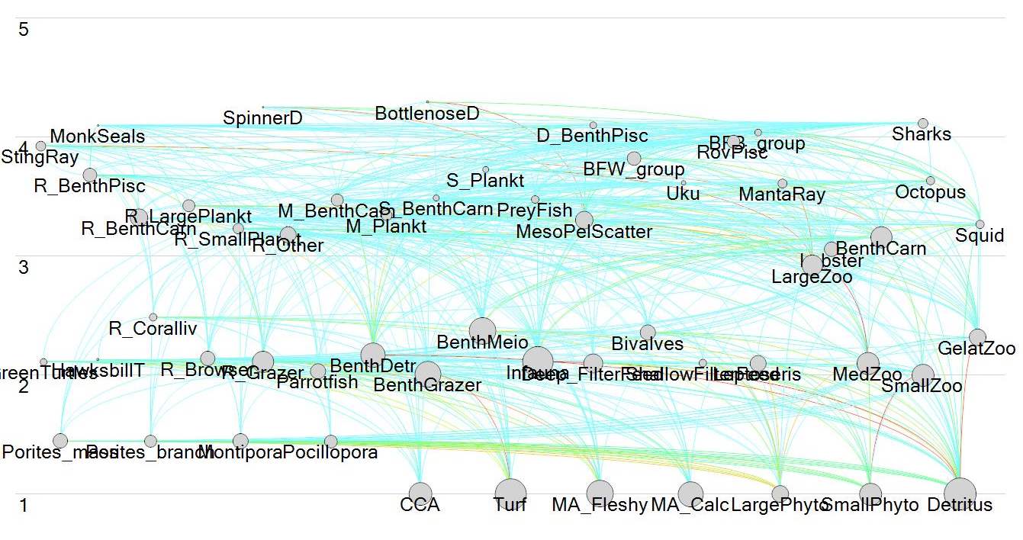
Figure S2.1. Trophic connections among all 55 functional groups represented in Ecopath. Rainbow colors represent strength of trophic flow with blue low and red high values.

Ecosim
To simulate the benthic space competition between corals and algae, we added a linear mediation function. With an increase in algae, whereby the impacts of fleshy macroalgae were 10 times higher than the other algal groups, the search rate for corals to find food decreased. We also added a linear mediation function to represent the structural habitat corals provide to juvenile fishes which decreases their vulnerability to predation. Hence, with an increase in corals, the vulnerability for all prey reef fishes were assumed to decrease.
To validate the model, we did a hindcast simulation, forcing the model with (1) historical catch time series from 2000−2019, and (2) thermal stress related coral mortalities (DAR Coral Bleaching Recovery Plan, Kramer et al., 2016). Commercial catch data were requested from the Western Pacific Fisheries Information Network and aggregated by functional group. Total recreational landings were calculated using datasets from the Marine Recreational Information Program (McCoy et al., 2018) updated with missing weights (Williams and Ma, 2013). Reliable time series data on total recreational landings are only available on an archipelagic scale from 2004−2015. Compositional catch data were available across islands and gears for each functional group and were assumed to be constant across years. Recreational reef catch was aggregated by functional group per year. For the years between 2000−2003 and 2016−2018, not covered by the recreational dataset, values were imputed by bootstrapping values from 2004−2015. For bottomfish recreational landings, we used a 1:1 ratio (commercial to recreational landings) as an approximation of the unreported catch ratio used by the PIFSC stock assessment group (Langseth et al., 2018). For other subphotic and mesophotic fishes and all invertebrate groups, we also assumed a 1:1 commercial to recreational catch ratio. Table S2.3 shows the catch composition per gear type for the reef fish and deepwater fisheries.
Table S2.3. Catches per fishery and gear type in t/km²/y for each functional group. Rec = recreational; Com = commercial; BF is bottomfish.
 | Deepwater-based Fishery |  | Reef-based Fishery
Group name | Rec BF Catch | Com BF Catch | Spear | Net | Line | Other | Total
StingRay | 0 | 0 | 0 | 0 | 0 | 0 | 0
MonkSeals | 0 | 0 | 0 | 0 | 0 | 0 | 0
SpinnerD | 0 | 0 | 0 | 0 | 0 | 0 | 0
BottlenoseD | 0 | 0 | 0 | 0 | 0 | 0 | 0
GreenTurtles | 0 | 0 | 0 | 0 | 0 | 0 | 0
HawksbillT | 0 | 0 | 0 | 0 | 0 | 0 | 0
R_Coralliv | 0 | 0 | 0 | 1.10E-06 | 0.00036 | 0 | 0.000361
R_Browser | 0 | 0 | 0.165 | 0.513 | 0.302 | 0.00252 | 0.98252
R_Grazer | 0 | 0 | 0.341 | 0.407 | 0.065 | 0.0427 | 0.8557
Parrotfish | 0 | 0 | 0.251 | 0.0258 | 0.00554 | 0.00748 | 0.28982
R_BenthPisc | 0 | 0 | 0.011 | 6.40E-05 | 0.00128 | 0.00033 | 0.012674
R_BenthCarn | 0 | 0 | 0.155 | 0.0924 | 0.726 | 0.00762 | 0.98102
R_LargePlankt | 0 | 0 | 0.073 | 0.0362 | 0.0608 | 0.0206 | 0.1904
R_SmallPlankt | 0 | 0 | 0.0006 | 0.00351 | 0.0233 | 0.00041 | 0.0278
R_Other | 0 | 0 | 0.016 | 0.00481 | 0.227 | 0.0322 | 0.28001
D_BenthPisc | 0 | 0 | 2.21E-05 | 4.00E-06 | 0.00028 | 6.30E-05 | 0.000369
M_BenthCarn | 0 | 0 | 0.0039 | 0.034 | 0.0056 | 0.0299 | 0.07344
M_Plankt | 0 | 0 | 0.0037 | 0.00423 | 0.001 | 0.01647 | 0.0254
S_BenthCarn | 0 | 0 | 0 | 0.00059 | 0.00125 | 0.00132 | 0.00316
S_Plankt | 0 | 0 | 0 | 1.10E-05 | 6.30E-05 | 5.30E-05 | 0.000127
PreyFish | 0 | 0 | 0.0049 | 0.166 | 0.0372 | 0.0586 | 0.26667
MesoPelScatter | 0 | 0 | 0 | 0 | 0 | 0 | 0
BFW_group | 0.05119 | 0.05119 | 0 | 0 | 0 | 0 | 0.10238
BFB_group | 0.006861 | 0.006861 | 0 | 0 | 0 | 0 | 0.013723
Uku | 0 | 0 | 0.0063 | 8.70E-06 | 0.0326 | 0.00225 | 0.041199
RovPisc | 0 | 0 | 0.0019 | 0.00123 | 0.0388 | 0.0016 | 0.04355
Sharks | 0 | 0 | 8.90E-07 | 1.60E-05 | 0.00142 | 2.60E-05 | 0.001463
MantaRay | 0 | 0 | 0 | 0 | 0 | 0 | 0
Lobster | 0 | 0 | 0.0007 | 3.50E-05 | 1.00E-07 | 0.00627 | 0.007015
BenthCarn | 0 | 0 | 1.00E-07 | 1.00E-07 | 0 | 0.00136 | 0.00136
BenthDetr | 0 | 0 | 1.00E-07 | 0 | 0 | 2.00E-05 | 2.01E-05
BenthGrazer | 0 | 0 | 1.00E-07 | 0 | 0 | 9.37E-08 | 1.94E-07
Octopus | 0 | 0 | 0.00146 | 1.20E-05 | 1.00E-07 | 0.000671 | 0.002143
BenthMeio | 0 | 0 | 0 | 0 | 0 | 0 | 0
Infauna | 0 | 0 | 0 | 0 | 0 | 0 | 0
Deep_FilterFeed | 0 | 0 | 0.00049 | 0 | 0 | 0 | 0.00049
Bivalves | 0 | 0 | 1.00E-07 | 0 | 0 | 1.00E-07 | 2.00E-07
ShallowFilterFeed | 0 | 0 | 1.00E-07 | 0 | 0 | 1.00E-07 | 2.00E-07
Porites_mass | 0 | 0 | 0 | 0 | 0 | 0 | 0
Porites_branch | 0 | 0 | 0 | 0 | 0 | 0 | 0
Montipora | 0 | 0 | 0 | 0 | 0 | 0 | 0
Pocillopora | 0 | 0 | 0 | 0 | 0 | 0 | 0
Leptoseris | 0 | 0 | 0 | 0 | 0 | 0 | 0
CCA | 0 | 0 | 0 | 0 | 0 | 0 | 0
Turf | 0 | 0 | 0 | 0 | 0 | 0 | 0
MA_Fleshy | 0 | 0 | 1.00E-07 | 0 | 0 | 0.00223 | 0.00223
MA_Calc | 0 | 0 | 0 | 0 | 0 | 0 | 0
LargePhyto | 0 | 0 | 0 | 0 | 0 | 0 | 0
SmallPhyto | 0 | 0 | 0 | 0 | 0 | 0 | 0
Squid | 0 | 0 | 1.00E-07 | 0 | 0.00037 | 0.00012 | 0.00049
LargeZoo | 0 | 0 | 0 | 0 | 0 | 0 | 0
MedZoo | 0 | 0 | 0 | 0 | 0 | 0 | 0
SmallZoo | 0 | 0 | 0 | 0 | 0 | 0 | 0
GelatZoo | 0 | 0 | 0 | 0 | 0 | 0 | 0
Detritus | 0 | 0 | 0 | 0 | 0 | 0 | 0
Sum | 0.058 | 0.058 | 1.036 | 1.289 | 1.530 | 0.235 | 4.206

For thermal stress related coral mortalities, we created a biomass forcing time series of corals. In 2014−2015, statewide coral mortality was 31% (PIFSC unpublished data) and since the thermal stress was about half 2015 levels (NOAA Coral Reef Watch Virtual Stations) in 2019, we assumed statewide mortality was 15%. It is expected that the bleaching threshold temperature will be reached annually by ~2032 (Van Hooidonk et al., 2014). Given the fact that two bleaching events already occurred in the past decade, we assume that for 2020−2030, three more will occur and annual bleaching will occur after 2032. We simulated coral mortality as 15% in all other heat-stress events with a recovery of 1% per year of massive Porites corals and 2% per year for the other 3 shallow-water coral groups based on growth rates.
To fit the model to time series data, we used the ‘fit to series’ functionality in Ecosim which adjusts the vulnerability parameters of prey to their predators (one value for each predator applicable to all prey sources) to minimize the sum of squared deviations between observed and modeled biomass and catch data. We then manually adjusted these parameters to reach the criteria for a robust model:
- No group goes extinct or has a biomass 3 times higher than initial biomass after a 20−year simulation.
- Each functional group that is targeted in the fishery has a plausible surplus production curve (i.e., domed-shaped, with an increase in fishing mortality catches go up until MSY is reached after which they go down).
Biomass trajectories under the hindcast scenario showed no groups going extinct or having a biomass > 3x initial biomass (Figs. S2.2, S2.3). Surplus production curves showing catch against an increase in fishing mortality were all plausible (Figs. S2.4, S2.5).
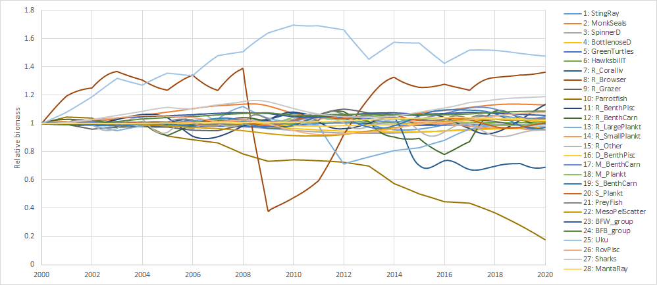
Figure S2.2. Relative biomass of vertebrate groups of a 2000−2020 hindcast simulation.

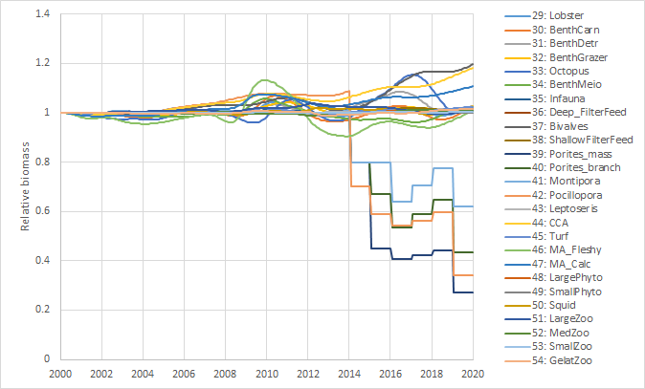
Figure S2.3. Relative biomass of invertebrate groups of a 2000−2020 hindcast simulation.

Figure S2.4. Modeled biomass trajectories (solid line) and observational data (dots). The number in parenthesis is the weighing and the value after the colon indicates the sum of mean squares between the observational and modeled data.

Figure S2.5. Modeled catch trajectories (solid line) and observational data (dots). The number in parenthesis is the weighing and the value after the colon indicates the sum of mean squares between the observational and modeled data.

Supplementary information 3. Model skill assessment
To assess the model skill, we compared (1) time series data of the observed relative number of green turtles and relative biomass of bottomfish from NOAA-PIFSC surveys against the simulated biomass; and (2) the mean of simulated 2015−2019 relative biomass of coral reef fish functional groups (n=13) against mean observed relative biomass from NOAA-PIFSC surveys. We employed six complementary model skill assessments (Stow et al., 2009).
1. The Pearson correlation coefficient of the model predictions and the observations, r;
2. The root mean squared error (RMSE) according to:
RMSE = $\sqrt{\frac{\sum_{i=1}^{n}{}\left({P_{i} - O_{i}}_{}\right){}^{2}}{n}}$
where n = the number of observations, O_{i} = the i^{th} of n observations, P_{i} = the i^{th} of n projections, and O and P are the observation and projected annual averages, respectively.
3. The reliability index (RI) according to:
RI = exp$\sqrt{\frac{1}{n}\sum_{i=1}^{n}{}\left(log\frac{Oi}{Pi}\right){}^{2}}$
4. The average error (bias) according to:
$$AE = \frac{\sum_{i=1}^{n}{}\left(P_{i}-O_{i}\right)}{n}$$

5. The average absolute error (AAE) according to:
$$AAE = \frac{\sum_{i=1}^{n}{}\left|P_{i}-O_{i}\right|}{n}$$

6. The modeling efficiency (MEF) according to:
$$MEF = 1 - \frac{{RMSE}^{2}}{s^{2}}$$
where s² is the variance of the observations.

The model efficiency was very good for reef fish (Table A3.1) but less so for turtles and bottomfish (BFW). For these latter groups, the annual variability is quite large which was not picked up by the model. However, the trend was the same as is also shown by the low bias (Average Error, AE)
Table A3.1. Model skill assessment using 6 complementary assessments methods. BFW= bottomfish in water column; GRT = green turtles, reef fishes consisted of 14 groups: 9 reef fish groups, roving piscivores, uku (Aprion virescens), sharks, stingrays, and manta rays.
Method | BFW | log  (GRT) | Reef  fishes | Target  value | Measure of:
r | 0.451 | -0.114 | 0.274 | 1 | tendency of the predicted and observed value to vary together
RMSE | 0.137 | 0.268 | 0.016 | 0 | size of discrepancies between predicted and observed value - focus on magnitude
AE | 0.078 | -0.015 | 0.198 | 0 | size of discrepancies between predicted and observed value - focus on aggregate model bias
AAE | 0.114 | 0.207 | 0.352 | 0 | size of discrepancies between predicted and observed value - focus on magnitude
RI | 1.1463 | 1.308 | 1.016 | 1 | average factor by which model predictions differ from observations
MEF | -0.428 | -0.071 | 0.998 | 1 | prediction relative to the average of the observations, a value <0 means observation average would be a better predictor than the model results

Supplementary information 4. Dive enjoyment indicator

Dive “Enjoyment” Model
A dive expenditure survey was conducted in 2018 (PIFSC unpublished literature) to estimate the economic impacts associated with diving and snorkeling on Hawaiian coral reefs. Apart from expenditures, the survey also included questions related to motivations and opinions of coral reef activities and health to understand the importance of reef related recreation in Hawaiʻi. Five hundred seventy−two Hawaiian residents and 237 non-residents responded.
Two major types of questions from the dive expenditure survey were used to identify important ecological facets of the dive experience and the effects of changes in those ecological facets on future participation in diving activities. First, survey participants were asked how important on a scale from “Not important” to “Very important” these ecological attributes were to their diving experience: healthy coral, fish abundance, fish diversity, and sea turtle sightings. Second, survey participants were asked how increases or decreases in these ecological attributes would affect their decision to go diving in the future.
Coral biomass, fish biomass, Kempton’s Q, and turtle biomass were the indicators in the Ecopath model that corresponded to these attributes, respectively. Importance was translated to a numerical score as follows: 1: Not Important; 2: Somewhat Important; 3: Important; 4: Very Important. Total enjoyment for a participant was calculated as the importance scores summed across ecological attributes. Changes in ecological attributes in the EwE scenarios affect the future total utility by applying a multiplicative factor to the current importance score of an attribute. A change (positive or negative) that leads to no effect in deciding go diving/snorkeling in the future has a multiplicative factor of 1; if the change leads the participant to be more or less likely to go diving in the future, the multiplicative factor is 2 or 0.5, respectively. The impacted enjoyment of each ecological attribute is calculated as the product of its importance and the factor depending on the reaction of the change, and when summed across ecological attributes, this is the impacted total enjoyment. An example is provided in Table A4.1. Given a distribution of enjoyment values across the respondents, the future change in enjoyment as a result of a management decision can be quantified as the median change in enjoyment.

Table A4.1. Example of ecological facets of dive enjoyment and factors influencing the enjoyment for one respondent.
 | Importance | Change | Reaction to Change | Factor | Impacted Enjoyment  (Importance * Factor)
Coral | 2 | No Change | Not Affected | 1 | 2
Fish biomass | 4 | Increase | More Likely | 2 | 8
Diversity | 3 | Increase | Not Affected | 1 | 3
Turtle Biomass | 2 | Decrease | Less Likely | 0.5 | 1
Current Total Enjoyment | 11 |  |  | Impacted Total Enjoyment | 14
 |  |  |  |  | %Δ in enjoyment | 27%

The numerical assignments for the importance and factor values were arbitrarily chosen, ecological aspects were naively assumed to be independent of each other and weighed similarly, and we assumed that the decision-maker is risk neutral (Prato 2003). That said, these assignments were necessary to quantify the enjoyment that people gain from the dive experience similar to other studies (Prato, 2003; Convertino et al., 2013).

Supplementary information 5. Simulations with effort displacement for the reef-based fishery
Since we do not know how fishers will respond to a restriction in fishing gear, we added simulations with effort displacement under the assumption that effort in allowed gear types will increase in the same proportion as gear types are currently used. From the catch data, we quantified the proportion gear-hours of line fishing, spear fishing, and net fishing, which was 0.52:0.29:0.19. We then increased each of the three gear types as follows: For “No Spearfishing”, we increased line fishing by 0.29*0.81% and net fishing by 0.29*0.19%. For “No Net fishing”, line fishing was increased by 0.19*0.64% and spearfishing by 0.19*0.36%, and for “Line only fishing”, we increased line fishing by 0.48%. Changes were minimal with the exception of catches of apex predators (Figs. A5.1, A5.2) where the catches increased by ~22% under No Spear, 11% under No Net, and 43% under Line Only fishing.

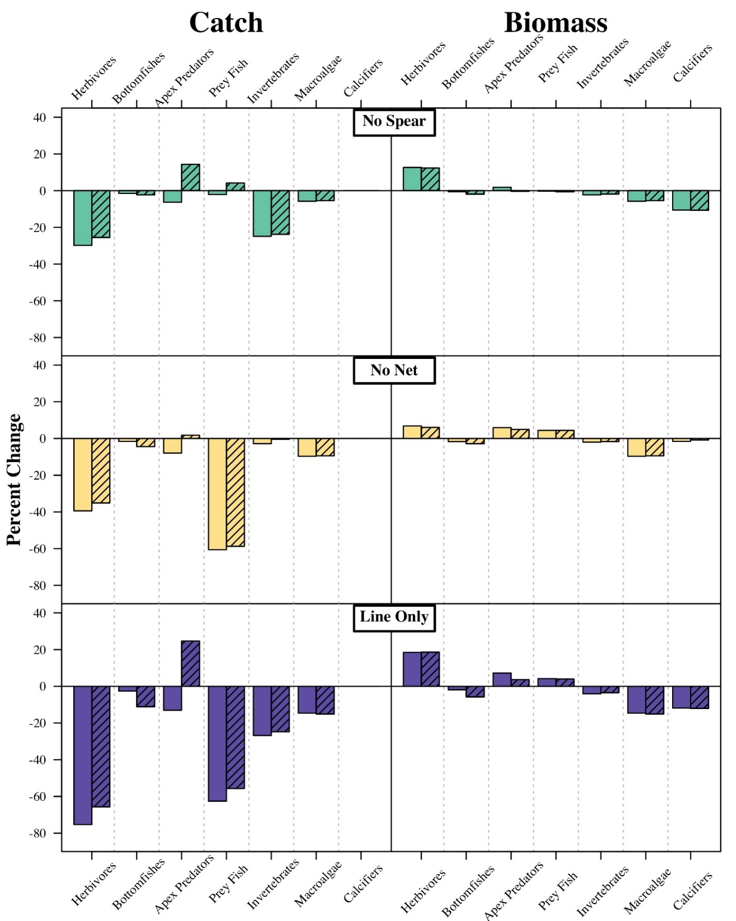
Figure A5.1: Effects of effort displacement assumptions for the fisheries management scenarios in which a gear type is fully restricted on relative percent changes of catch and biomass terminal value relative to the “Constant Effort” scenario. The solid bars are the scenarios referred to in Figure 4 in the main text and the hatched bars assume that effort is displaced to the other gear types (refer to the main text for details on effort displacement assumptions).
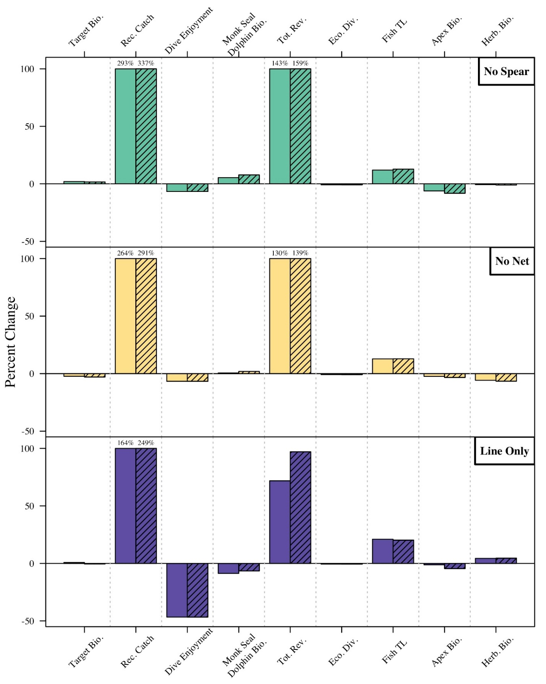
Figure A5.2. Effects of effort displacement assumptions for the fisheries management scenarios in which a gear type is fully restricted on relative percent changes of indicator values over the length of the management scenario period. The solid bars are the scenarios referred to in Figures 5−6 in the main text, and the hatched bars assume that effort is displaced to the other gear types (refer to the main text for details on effort displacement assumptions). When changes > 100% we denoted actual change above the bar.

Supplementary information 6. Relative change in biomass of all functional groups
All figures show the percent change in biomass of the functional groups calculated over the length of the management scenario period (2020−2040) across fisheries management scenarios. Please refer to the main text for descriptions for each fisheries management scenario. Herb. = herbivores (reef fishes); MPA = no take Marine Protected Area.

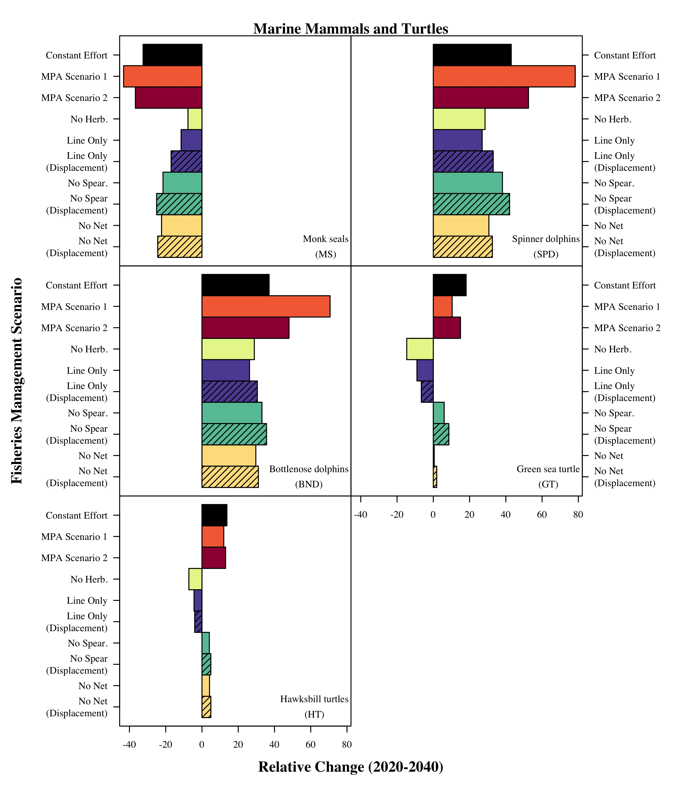

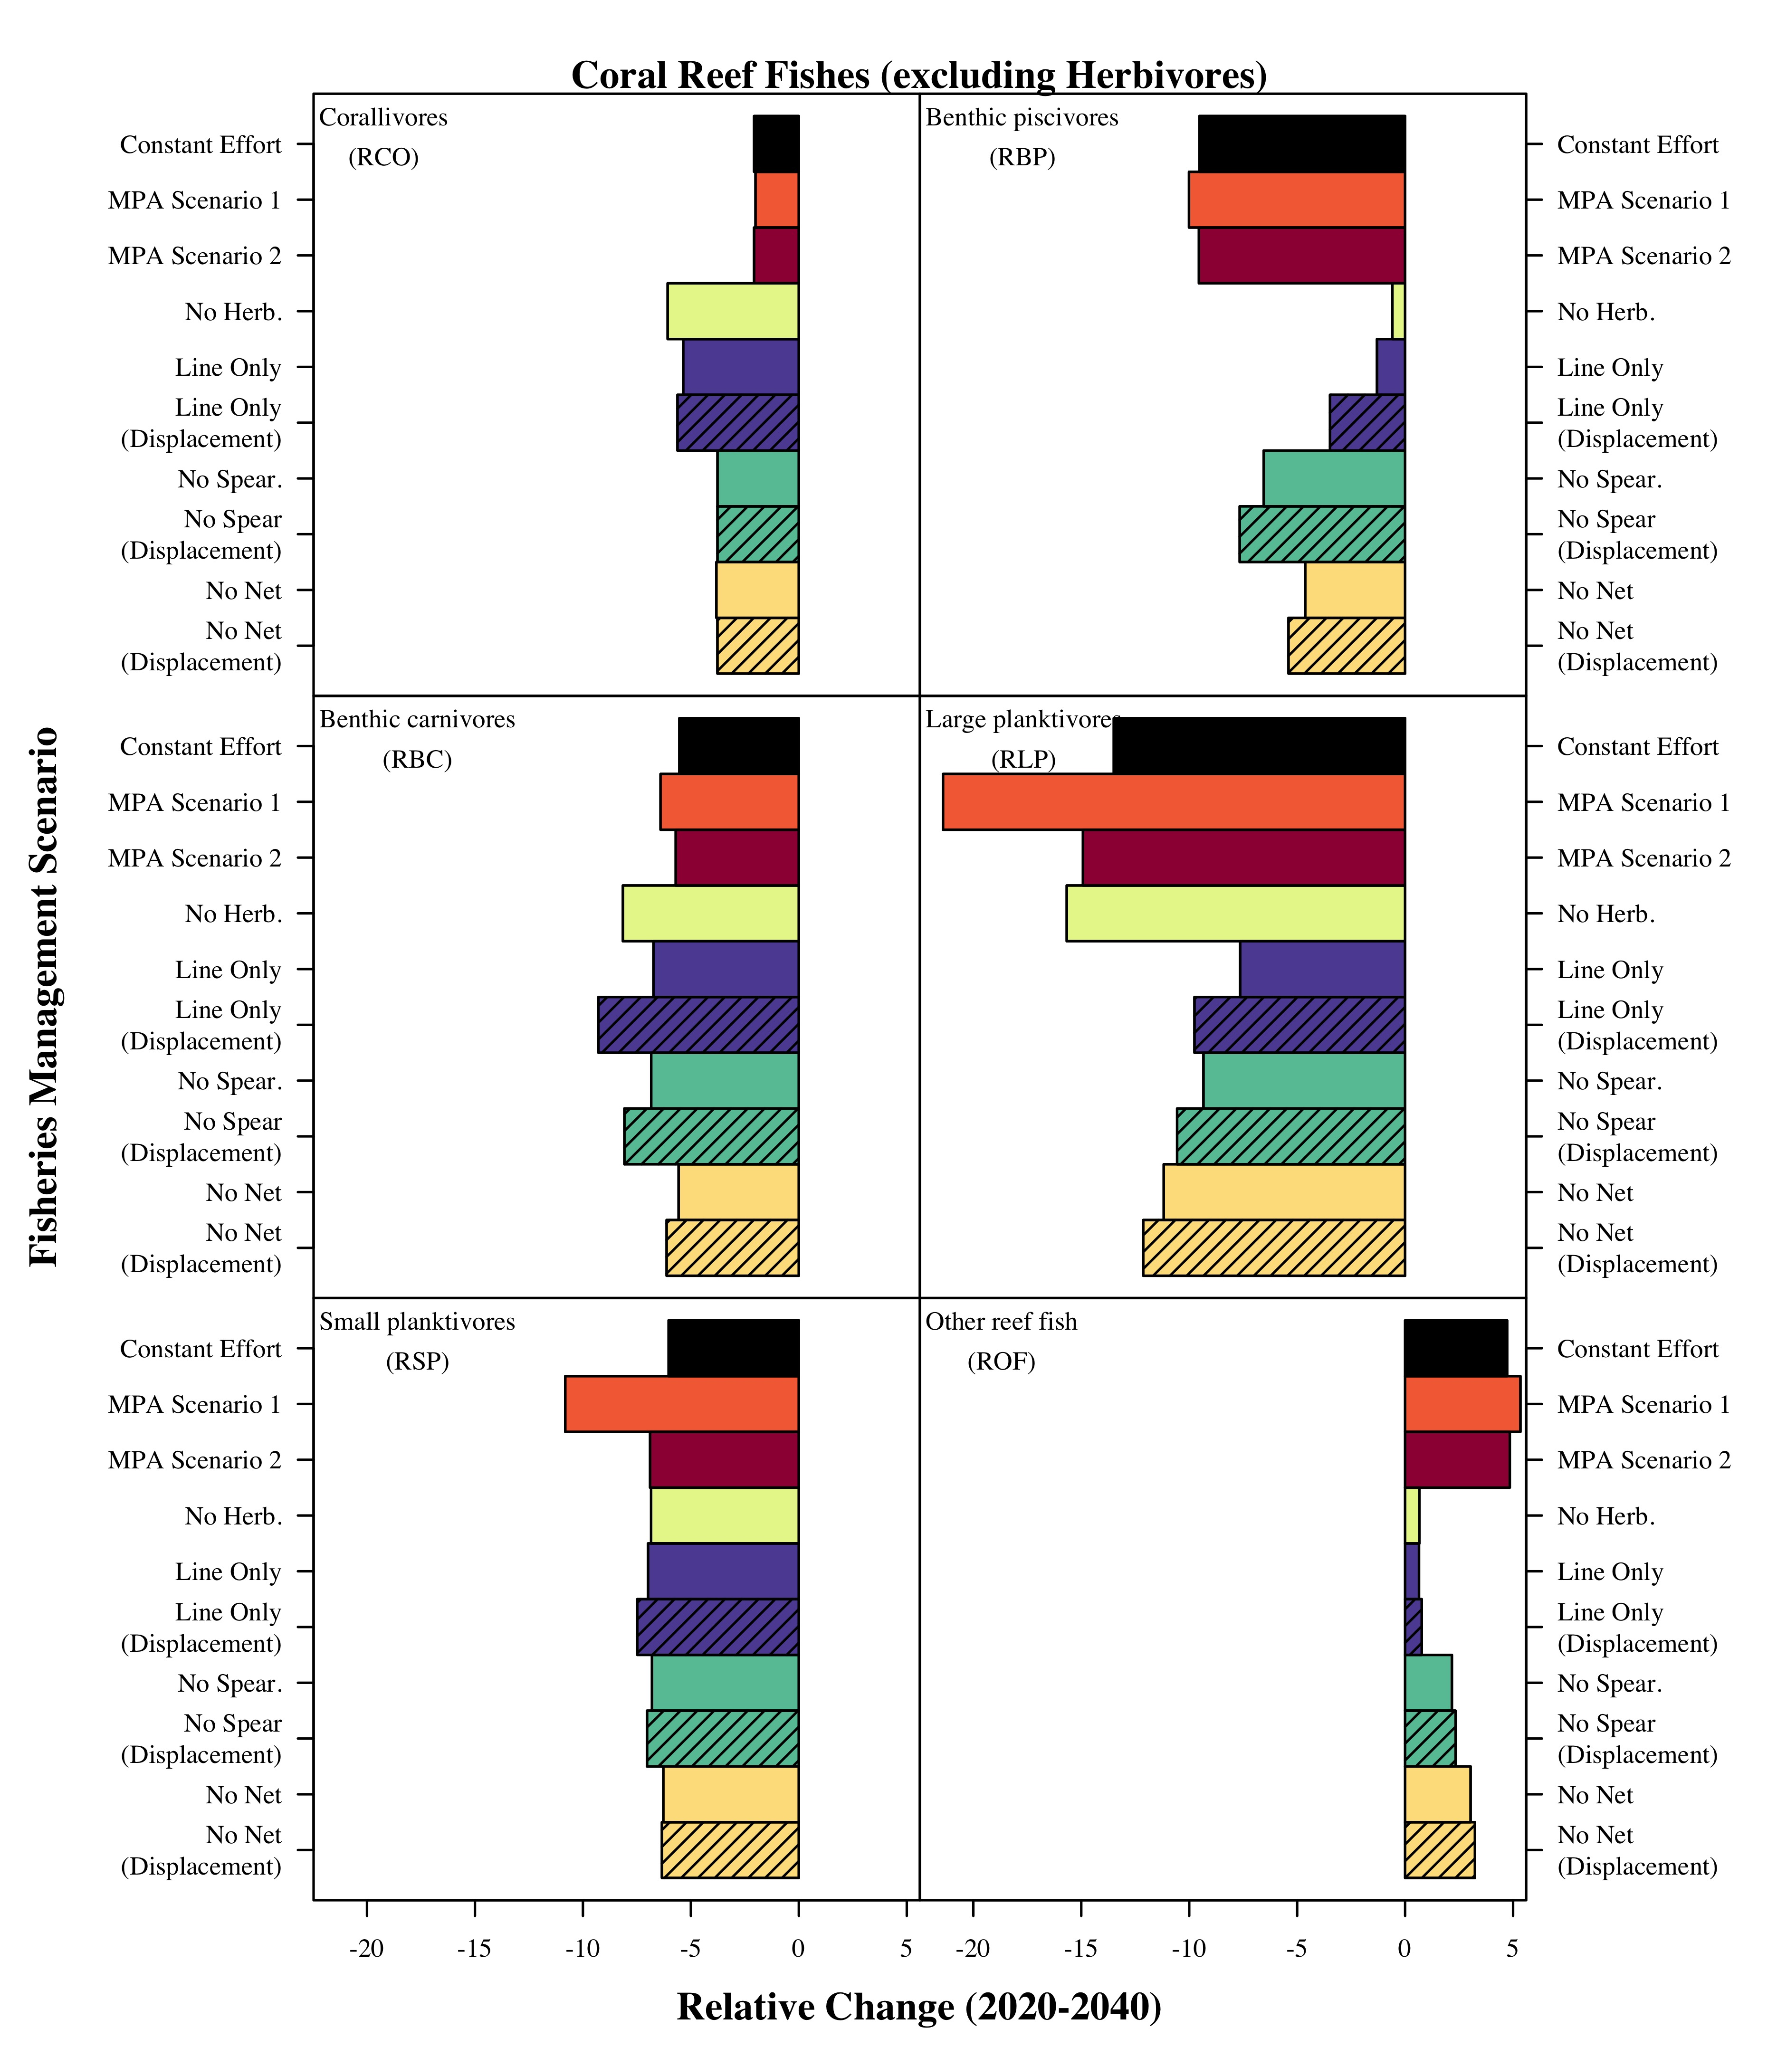

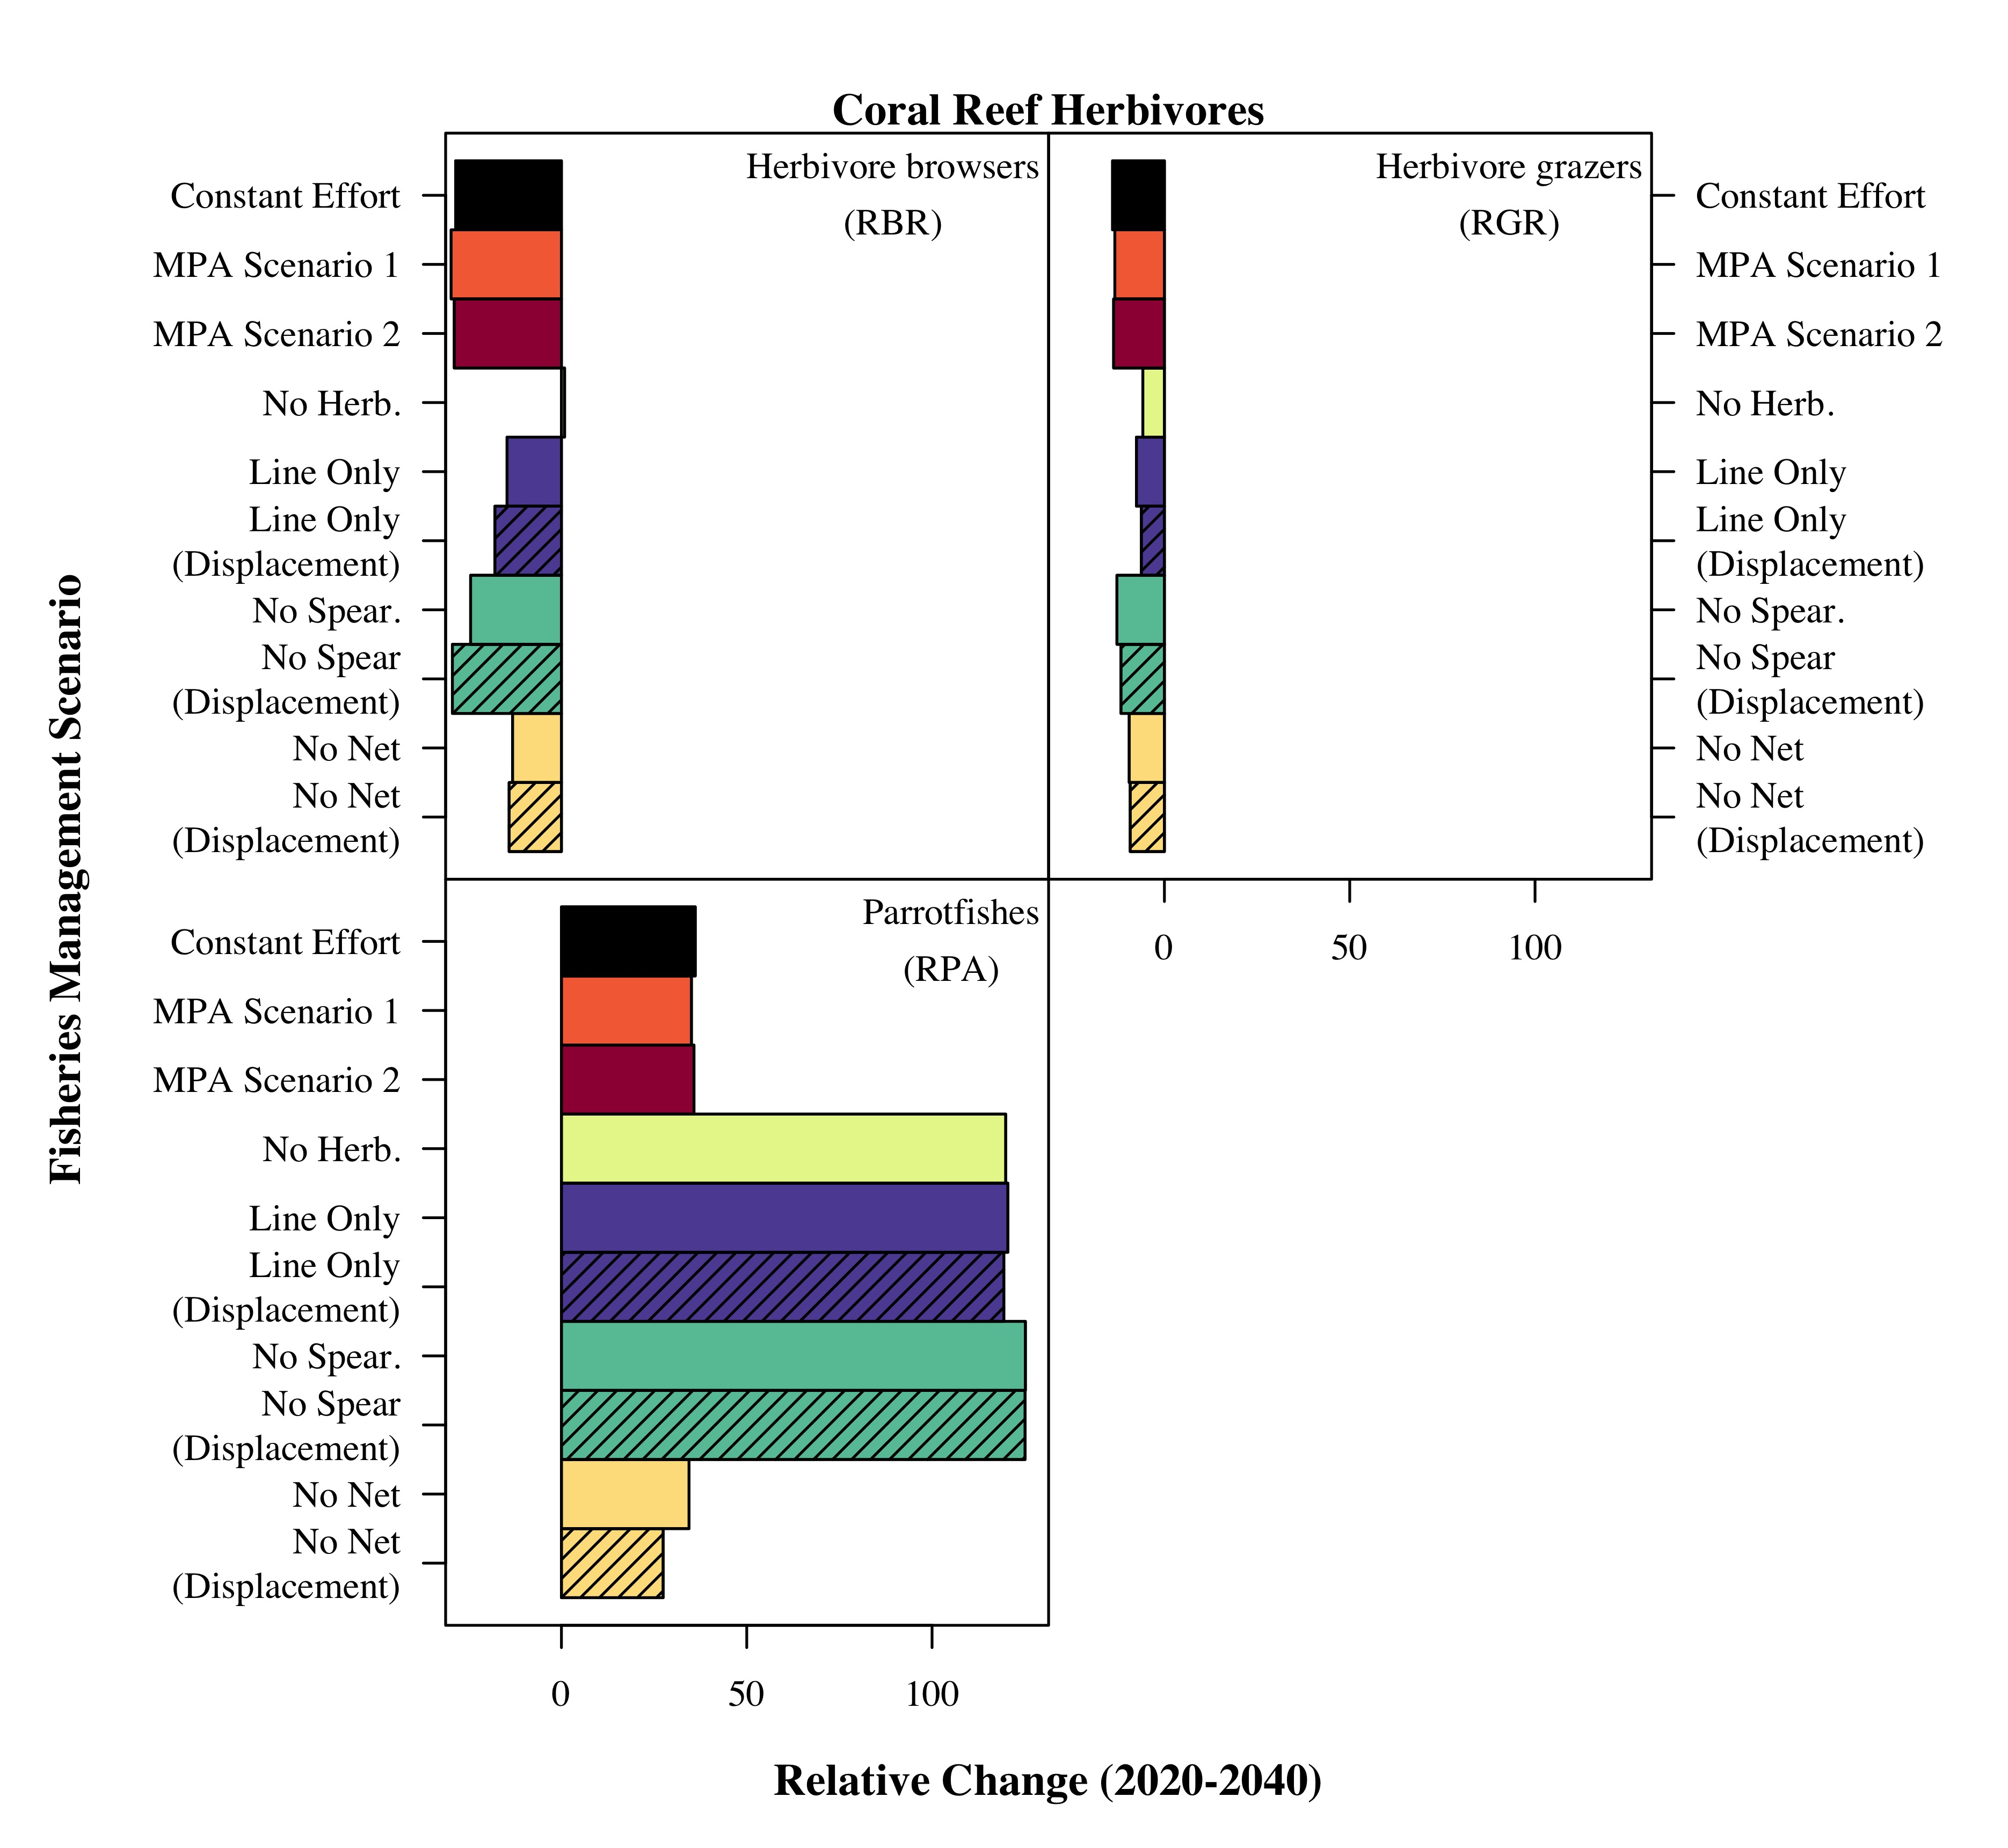

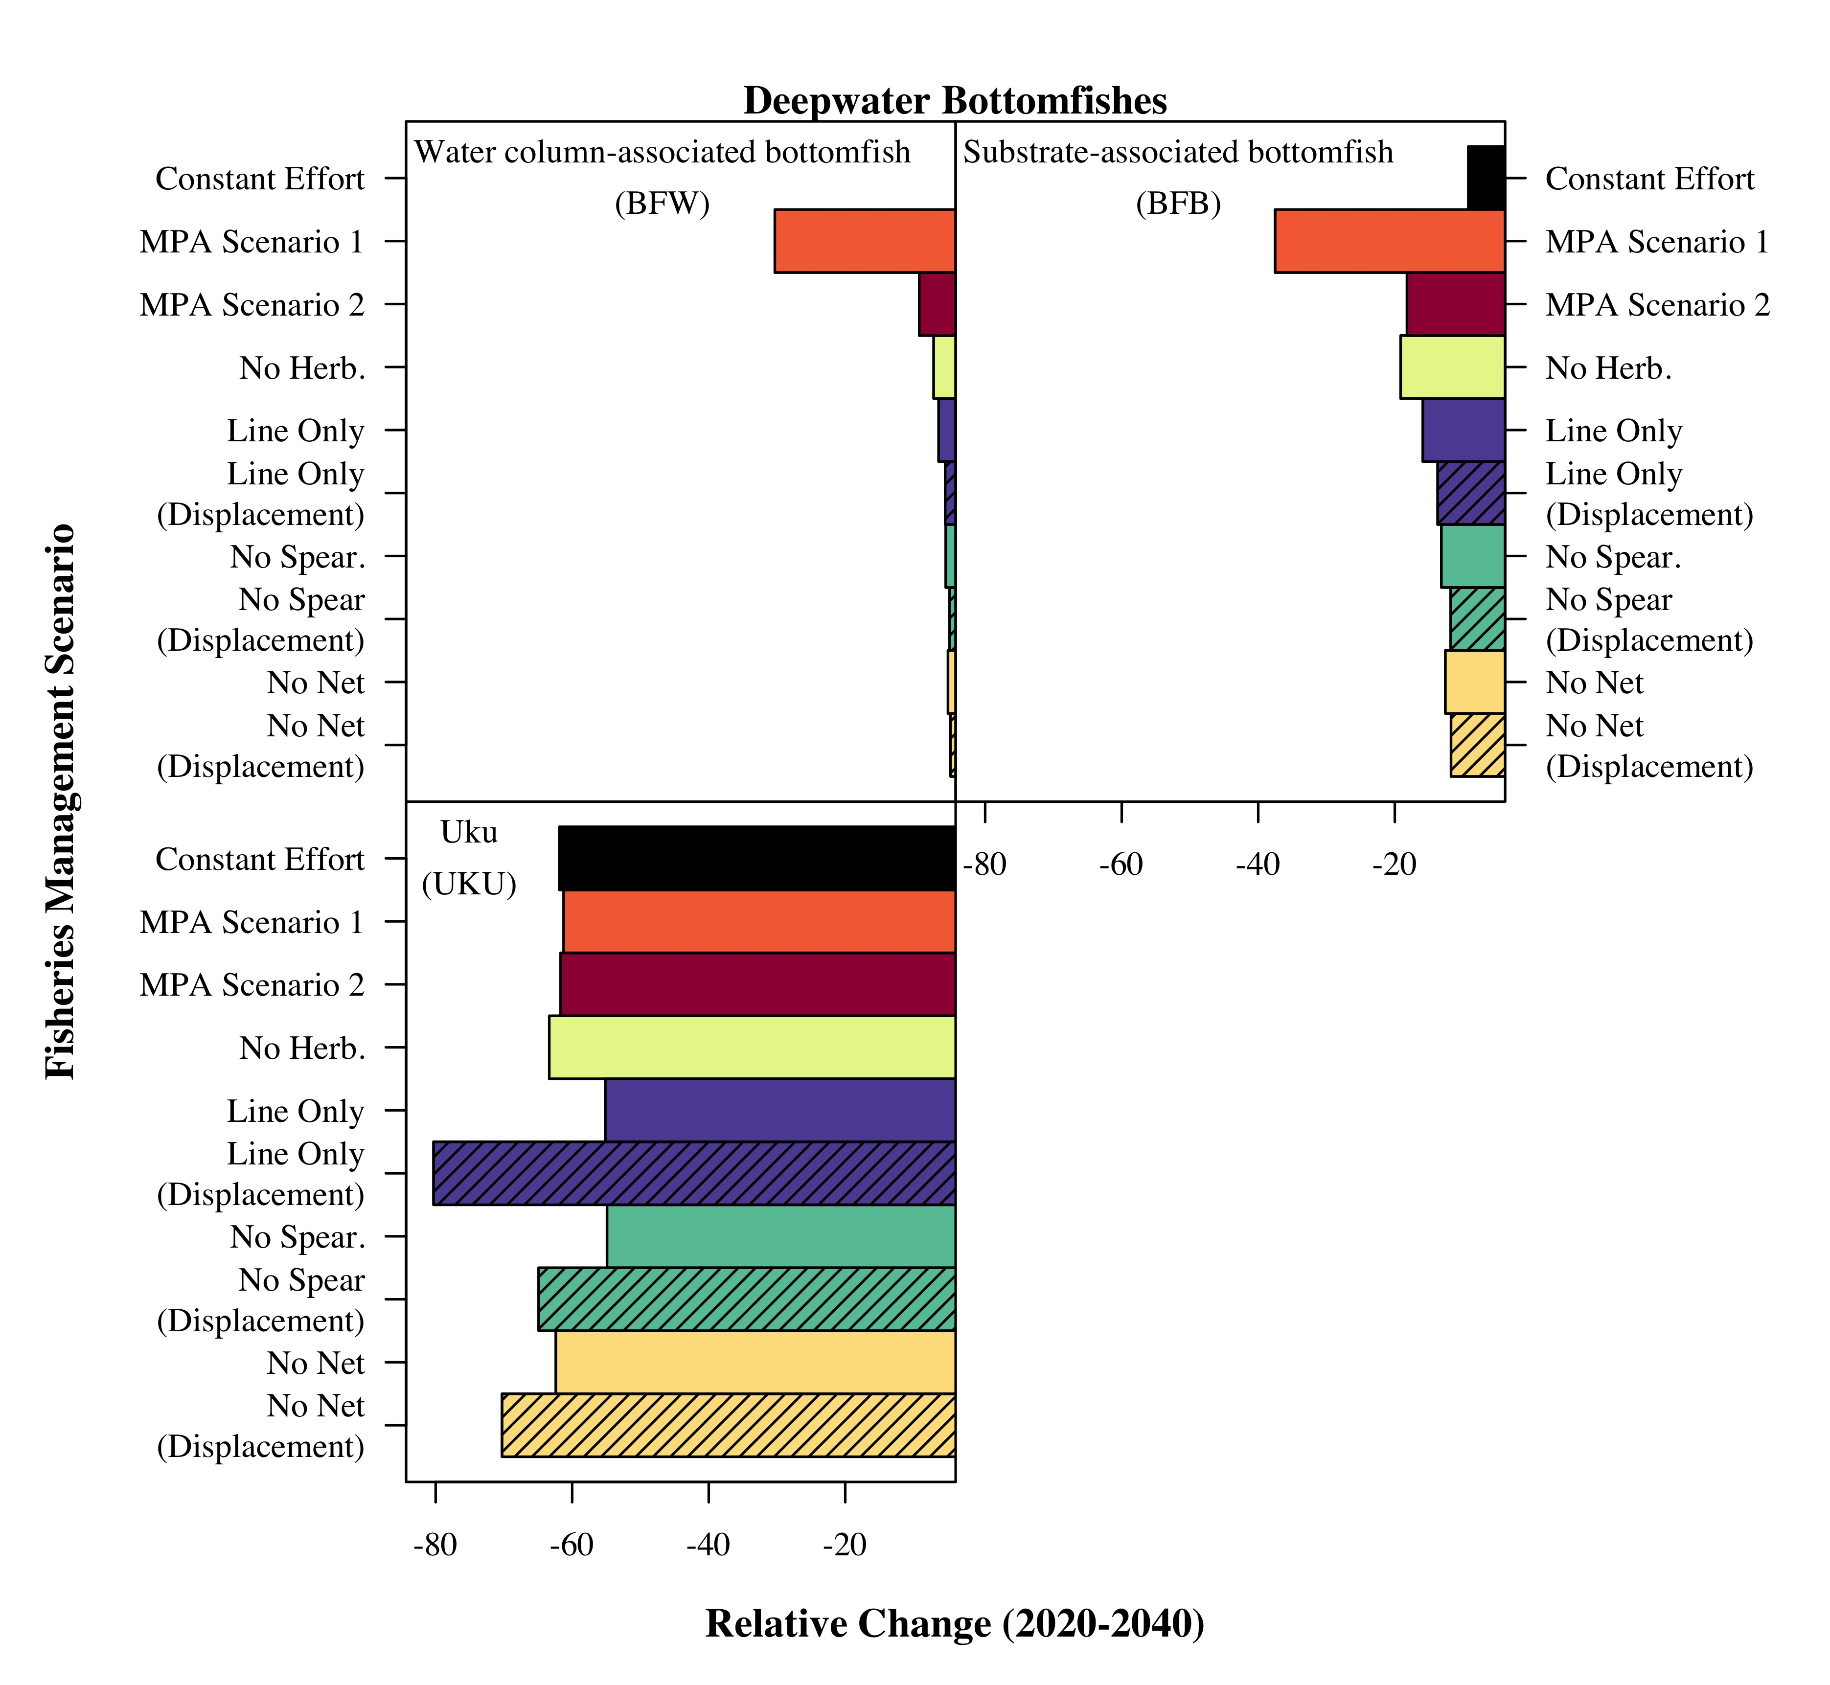

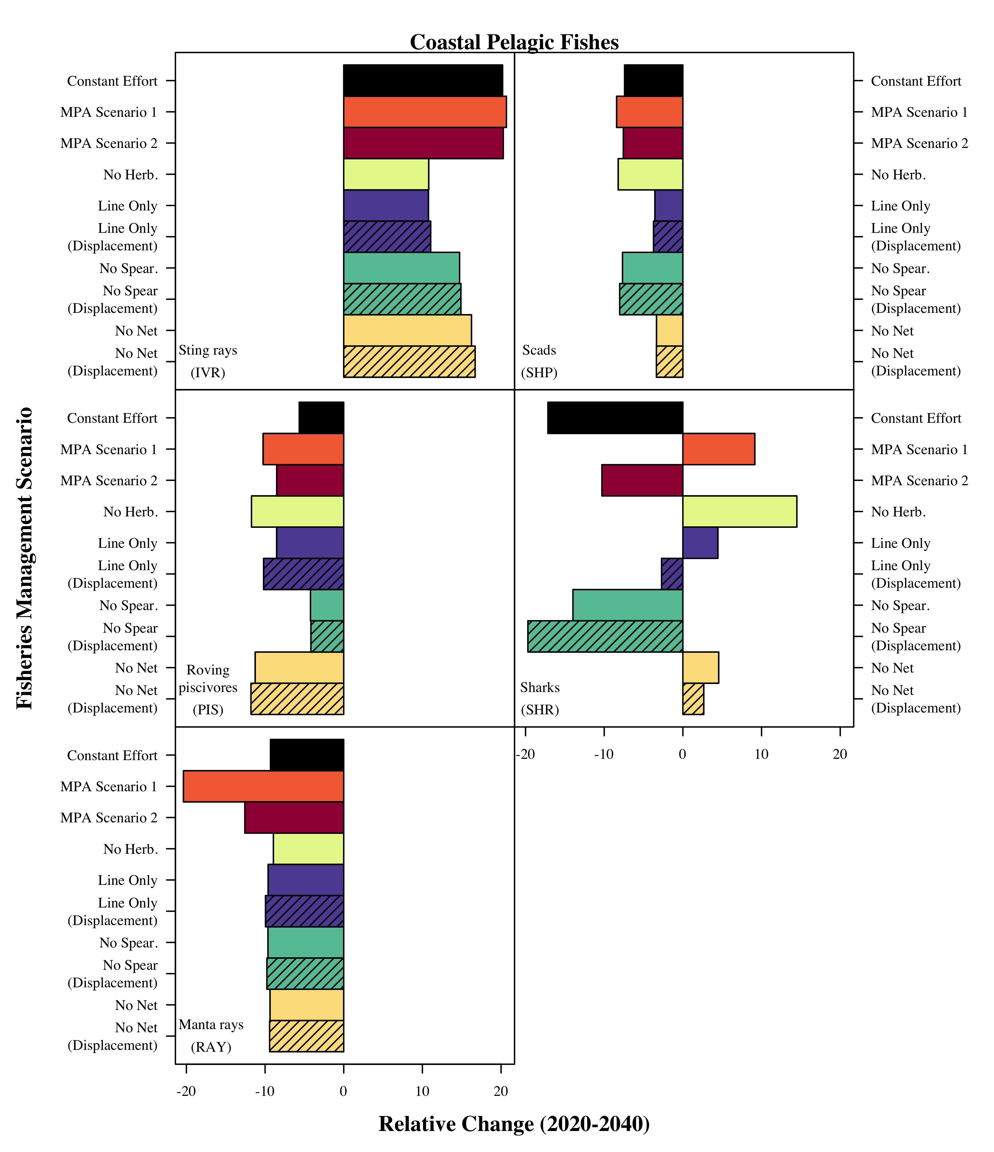

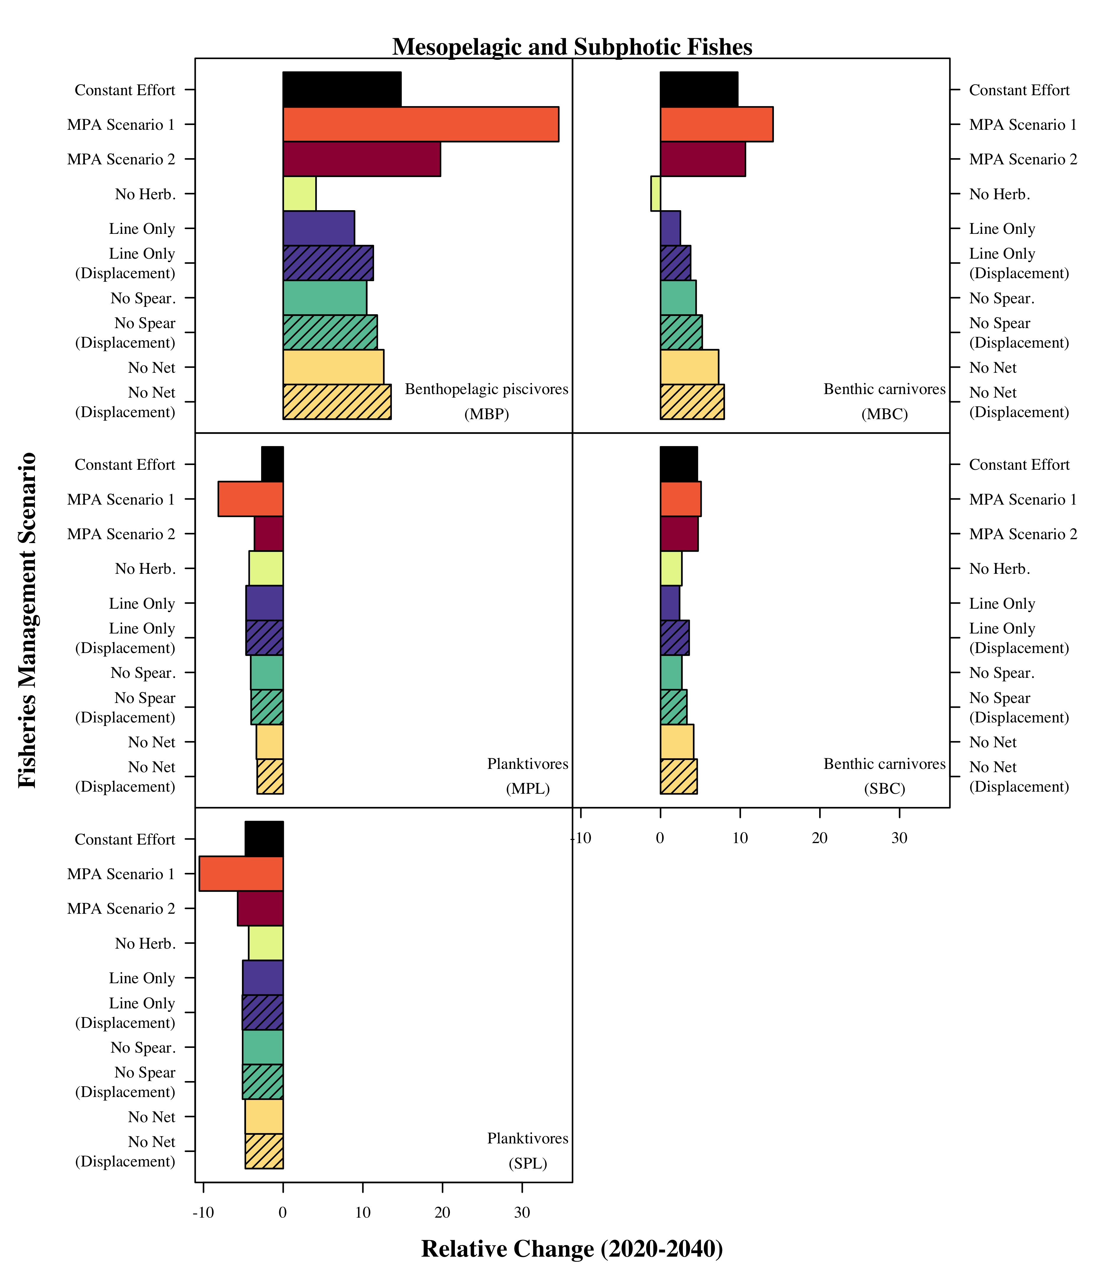

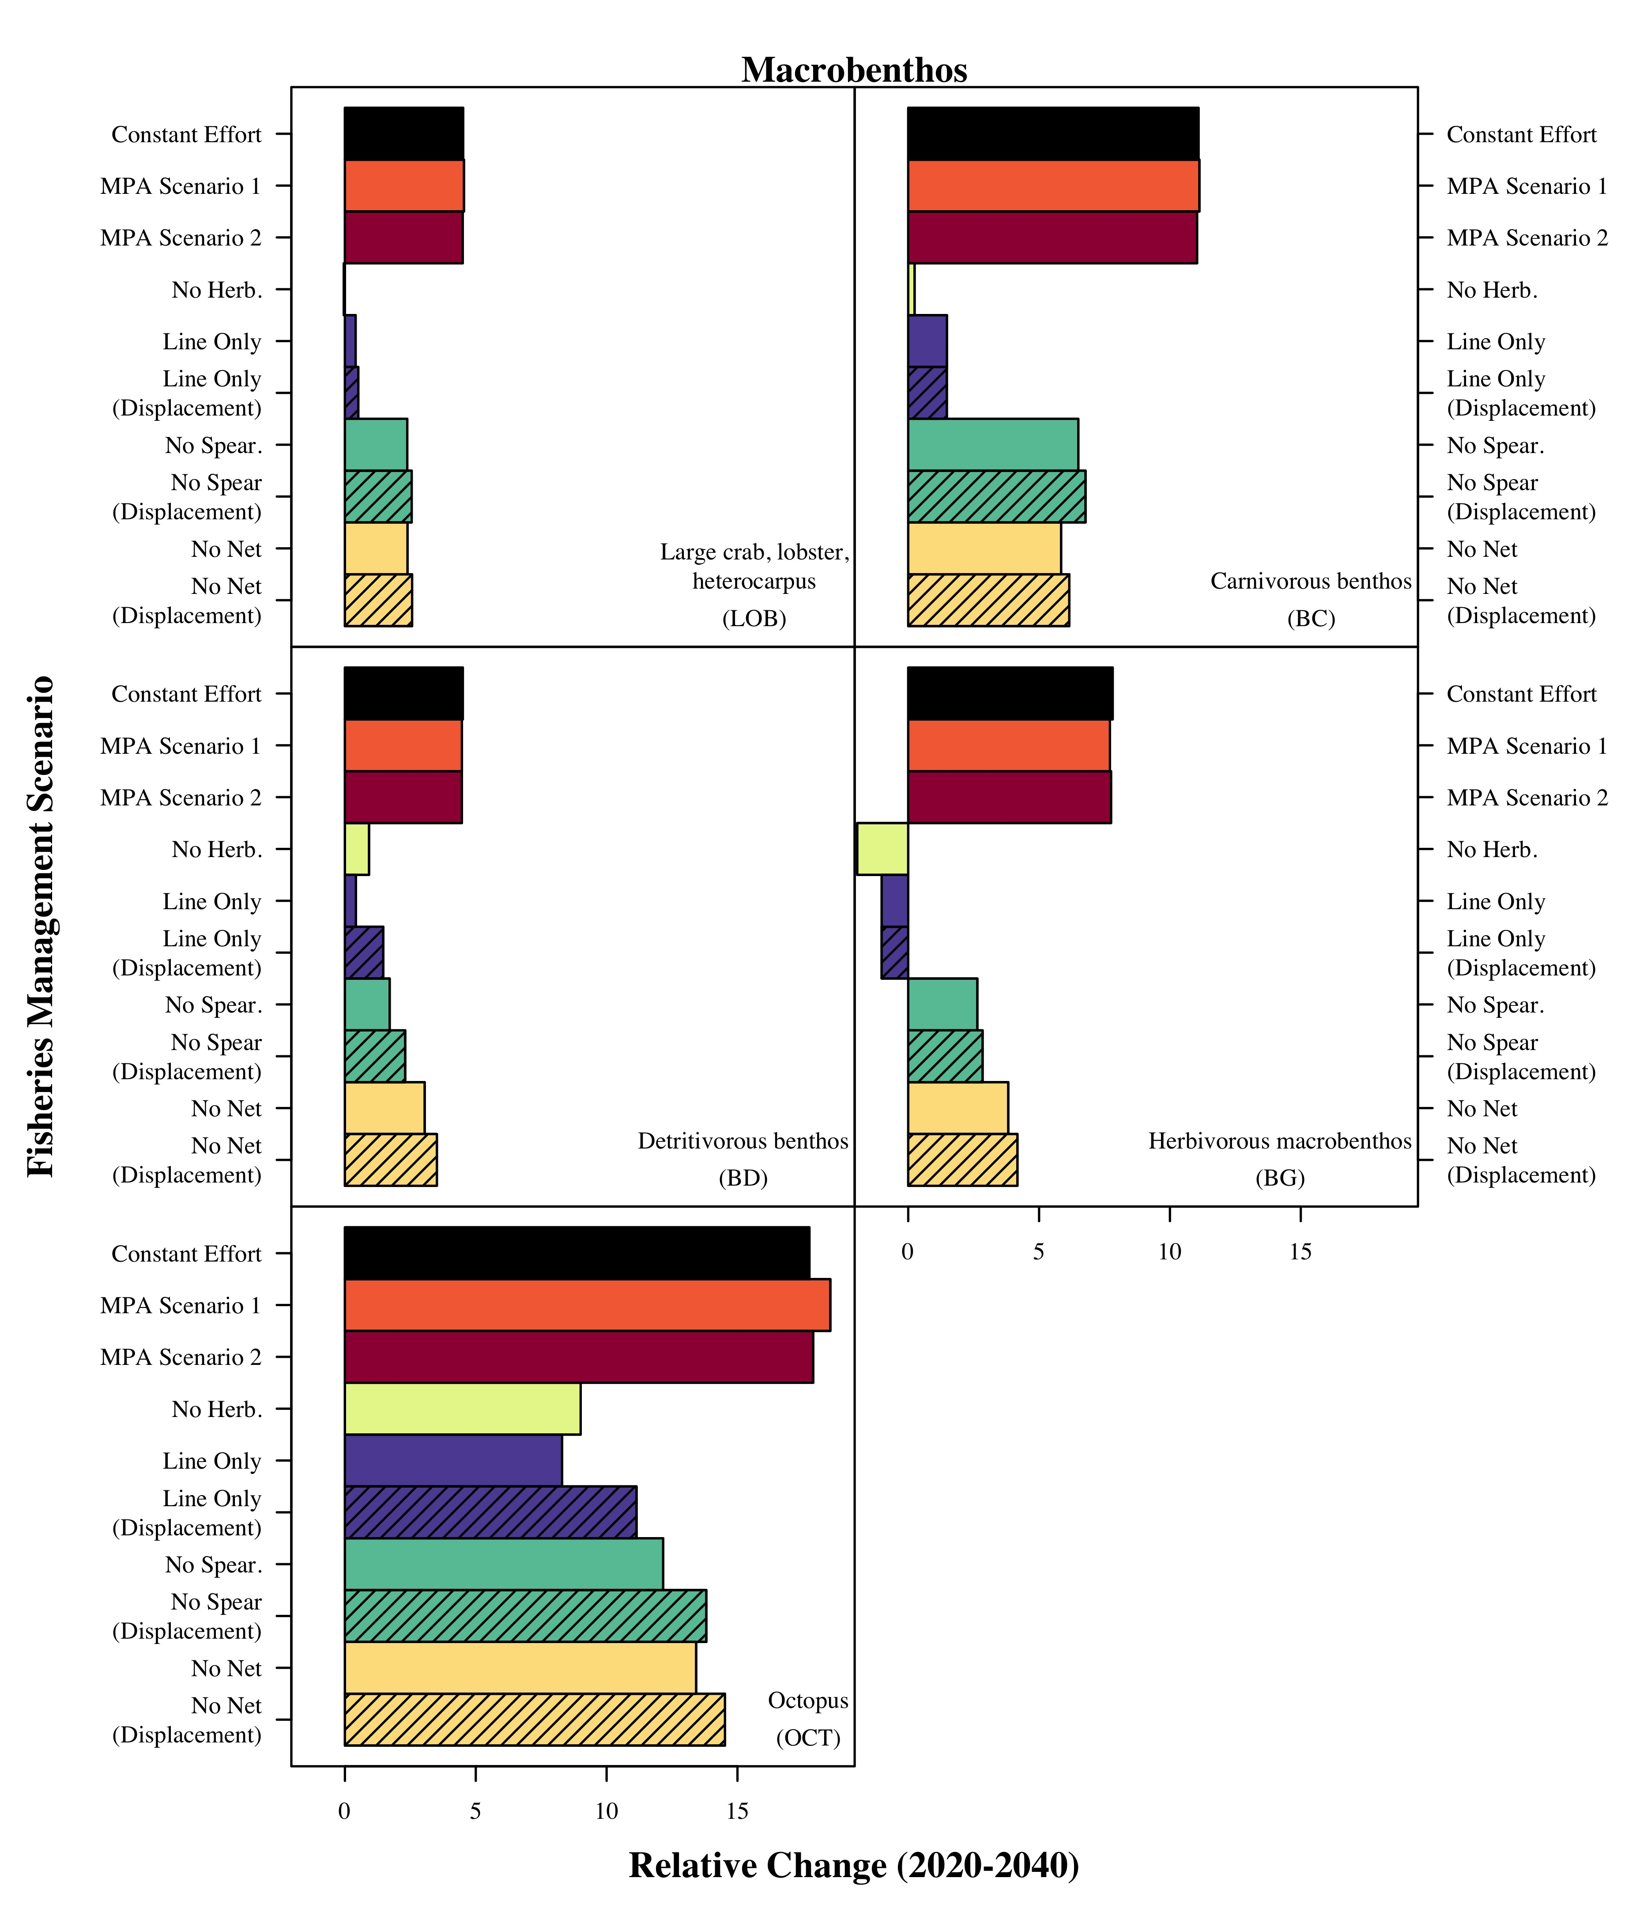

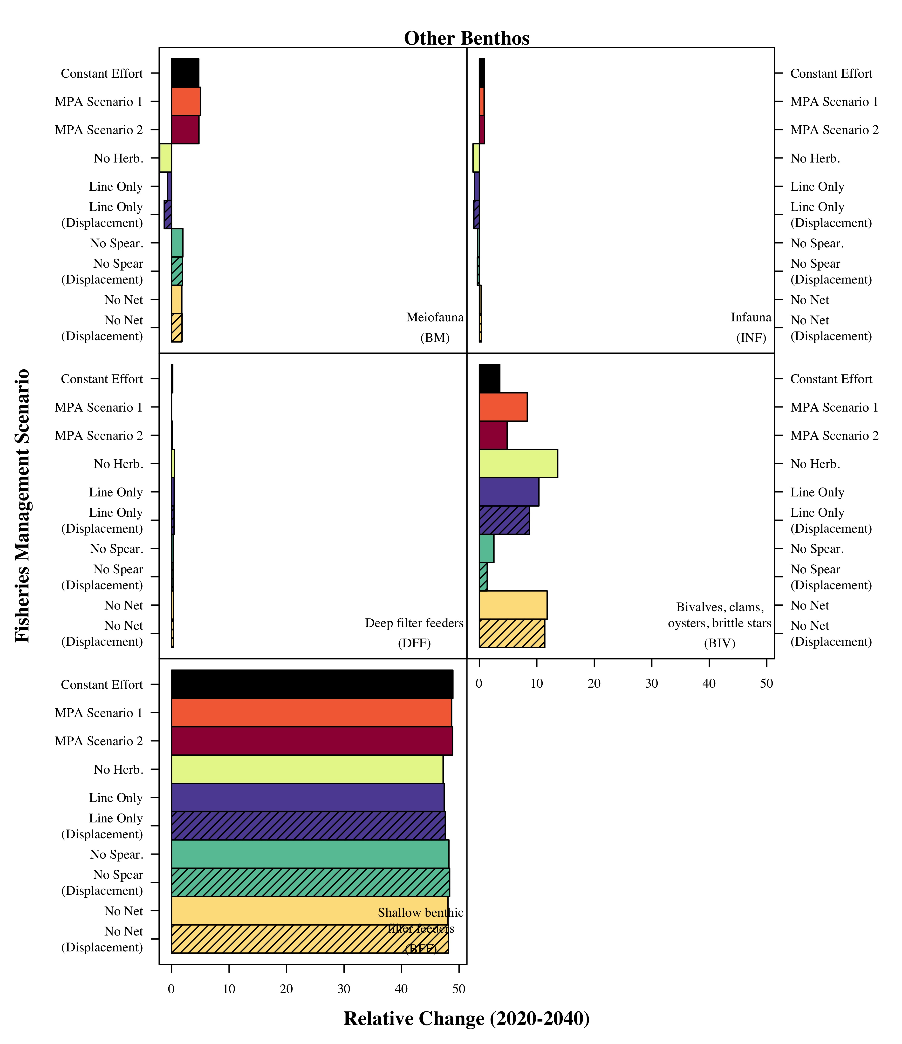

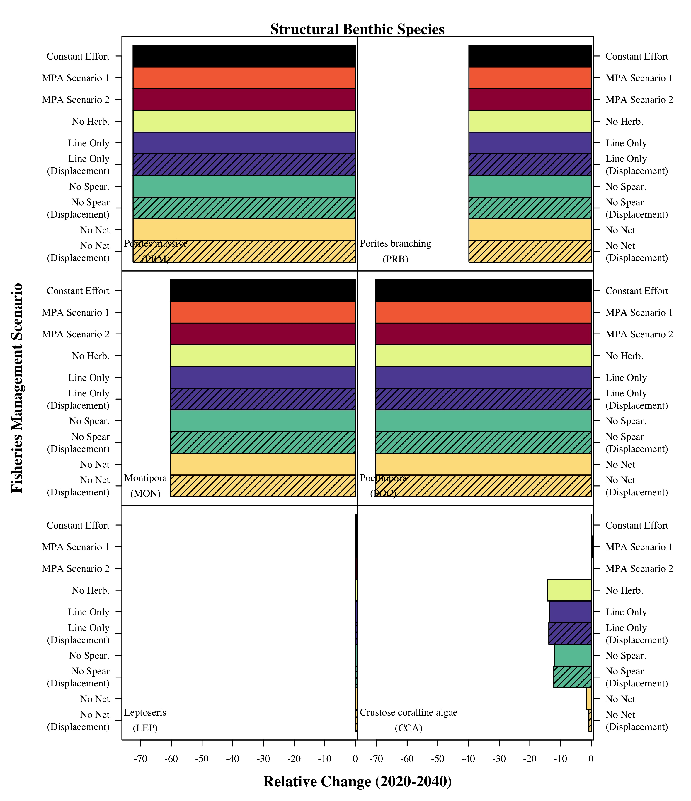
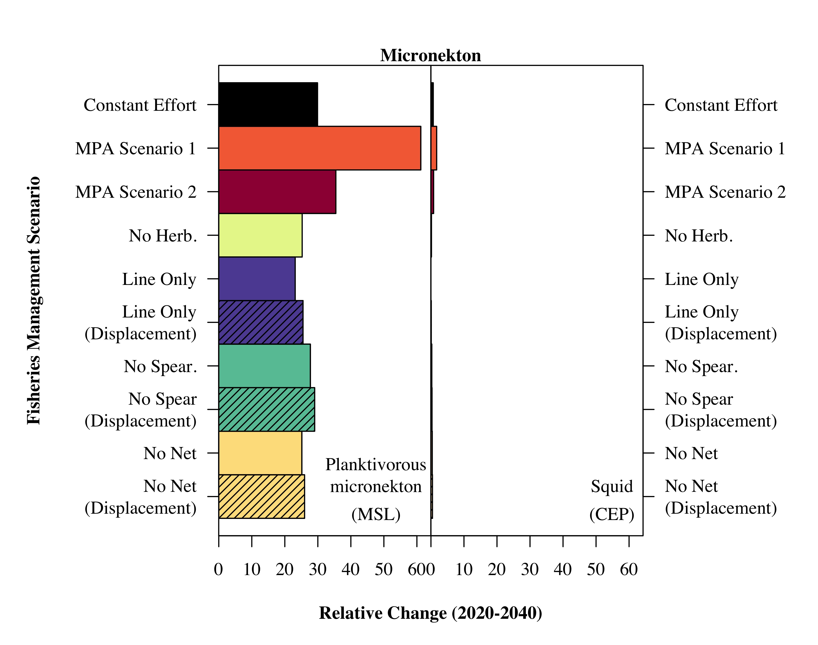

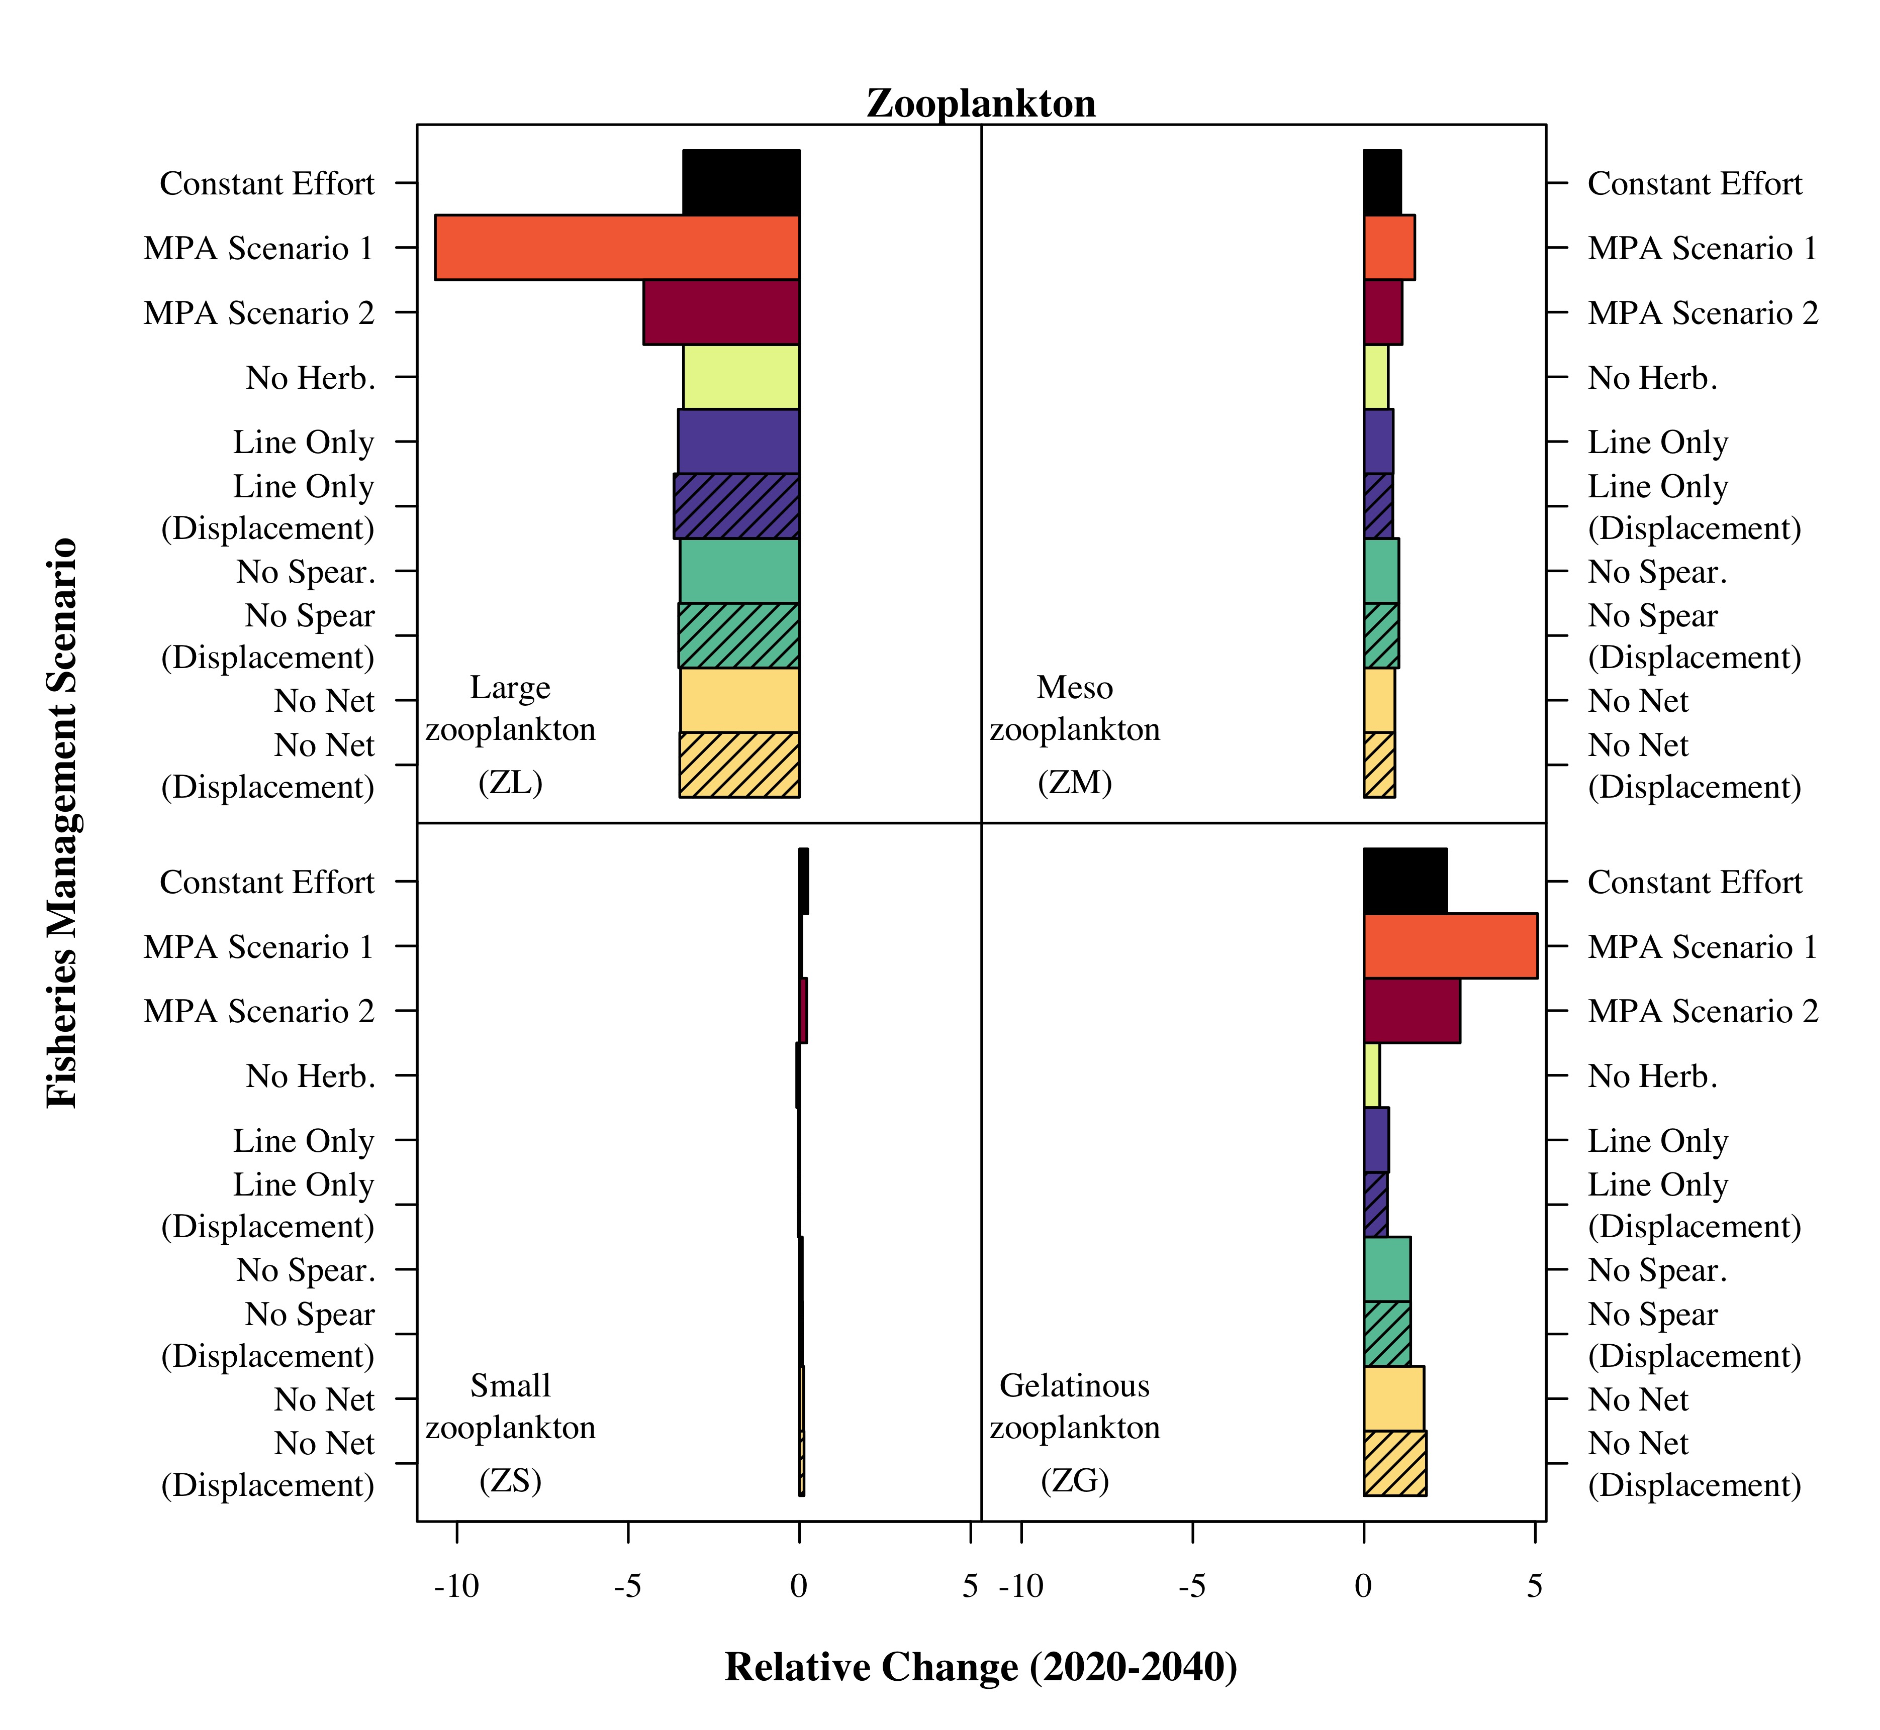

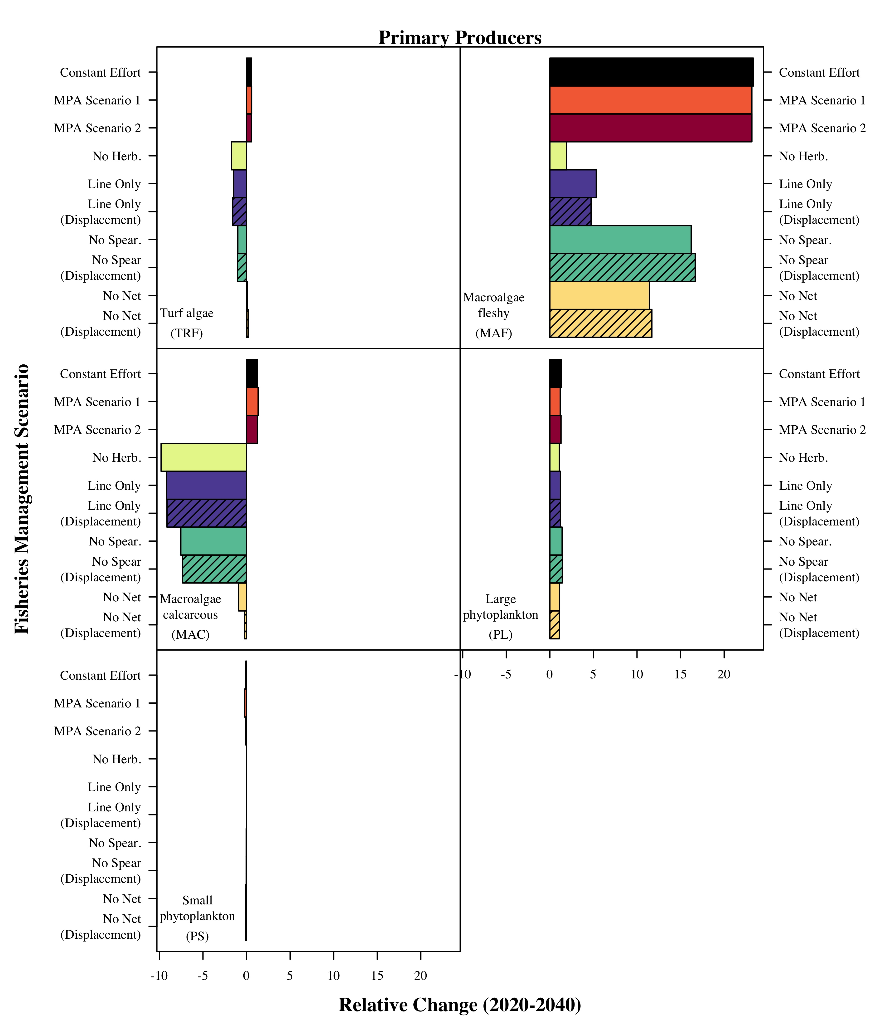

References cited in all Supplementary information
Asher, J., Williams, I. D., and Harvey, E. S. 2017. Mesophotic Depth Gradients Impact Reef Fish Assemblage Composition and Functional Group Partitioning in the Main Hawaiian Islands. Frontiers in Marine Science, 4: 1–18. http://journal.frontiersin.org/article/10.3389/fmars.2017.00098/full.
Ault, J. S., Smith, S. G., Richards, B. L., Yau, A., Langseth, B., Humphreys, R. L., Boggs, C. H., et al. 2018. Towards Fishery-independent Biomass Estimation for Hawaiian Deep 7 Bottomfish. NOAA Tech Memo. NMFS-PIFSC-67: 29. US Department of Commerce, National Oceanic and Atmospheric Administration, National Marine Fisheries Service, Pacific Islands Fisheries Science Center, NOAA Tech Memo. NMFS-PIFSC-67. http://hawaiibottomfish.info/wp-content/uploads/2018/02/2018-BF-IndpendSurvey-Rpt-pdf.pdf.
Benoit-Bird, K. J. 2004. Prey caloric value and predator energy needs : foraging predictions for wild spinner dolphins. Martine Biology, 145: 435–444.
Bernal, A., Olivar, M. P., Maynou, F., Fernández, M. L., and Puelles, D. 2015. Progress in Oceanography Diet and feeding strategies of mesopelagic fishes in the western Mediterranean. Progress in Oceanography, 135: 1–17. Elsevier Ltd. http://dx.doi.org/10.1016/j.pocean.2015.03.005.
Bradley, C. J., Longenecker, K., Pyle, R. L., and Popp, B. N. 2016. Compound-specific isotopic analysis of amino acids reveals dietary changes in mesophotic coral-reef fish, 558: 65–79.
Brandl, S. J., Goatley, C. H. R., Bellwood, D. R., and Tornabene, L. 2018. The hidden half: ecology and evolution of cryptobenthic fishes on coral reefs. Biological Reviews, 93.
Brey, T. 2001. Population dynamics in benthic invertebrates. A virtual handbook. Alfred Wegener Institute for Polar and Marine Research, Germany, http://www.awi-bremerhaven.de/Benthic/Ecosystem/FoodWeb/Handbook/main.html.
Choy, C. A., Wabnitz, C. C. C., Weijerman, M., Woodworth-jefcoats, P. A., and Polovina, J. J. J. 2016. Finding the way to the top: How the composition of oceanic mid-trophic micronekton groups determines apex predator biomass in the central North Pacific. Marine Ecology Progress Series, 549: 1–15.
Choy, C. A., Haddock, S. H. D., and Robison, B. H. 2017. Deep pelagic food web structure as revealed by in situ feeding observations. Proceedings of the Royal Society B: Biological Sciences, 284: 20172116. http://rspb.royalsocietypublishing.org/lookup/doi/10.1098/rspb.2017.2116.
Christensen, V., and Walters, C. J. 2004. Ecopath with Ecosim: methods, capabilities and limitations. Ecological Modelling, 172: 109–139. http://www.sciencedirect.com/science/article/pii/S030438000300365X (Accessed 23 November 2015).
Christensen, V., Walters, C. J., Pauly, D., and Forrest, R. 2008. Ecopath with Ecosim version 6: user guide. November 2008. Fisheries Centre, University of British Columbia, Vancouver, Canada: 235.
Convertino, M., Baker, K. M., Vogel, J. T., Lu, C., Suedel, B., and Linkov, I. 2013. Multi-criteria decision analysis to select metrics for design and monitoring of sustainable ecosystem restorations. Ecological Indicators, 26: 76–86. http://www.sciencedirect.com/science/article/pii/S1470160X12003561.
Drazen, J. C., and Sutton, T. T. 2017. Dining in the Deep: The Feeding Ecology of Deep-Sea Fishes. Annual Review of Marine Science, 9: 337–366. http://www.annualreviews.org/doi/10.1146/annurev-marine-010816-060543.
Heymans, J. J., Coll, M., Link, J. S., Mackinson, S., Steenbeek, J., Walters, C., and Christensen, V. 2016. Best practice in Ecopath with Ecosim food-web models for ecosystem-based management. Ecological Modelling, 331: 173–184. Elsevier B.V. http://dx.doi.org/10.1016/j.ecolmodel.2015.12.007.
Kramer, K. L., Cotton, S. P., Lamson, M. R., and Walsh, W. J. 2016. Bleaching and catastrophic mortality of reef-building corals along west Hawai‘i island: findings and future directions. In Proceedings of the 13th International Coral Reef Symposium, pp. 229–241. Honolulu, Hawaii.
Langseth, B., Syslo, J., Yau, A., Kapur, M., and Brodziak, J. 2018. Stock assessment for the Main Hawaiian Islands Deep 7 bottomfish complex in 2018, with catch projections through 2022. Honolulu, Hawai’i. 217 pp.
Leigh, S. C., Papastamatiou, Y., and German, D. P. 2017. The nutritional physiology of sharks. Reviews in Fish Biology and Fisheries. Springer International Publishing.
Link, J. S. 2010. Adding rigor to ecological network models by evaluating a set of pre-balance diagnostics: a plea for PREBAL. Ecological Modelling, 221: 1580–1591. Public Library of Science, Honolulu, HI. http://dx.doi.org/10.1016/j.ecolmodel.2010.03.012 (Accessed 9 February 2016).
McCoy, K. S., Williams, I. D., Friedlander, A. M., Hongguang, M., Teneva, L. T., and Kittinger, J. N. 2018. Estimating nearshore coral reef-associated fisheries production from the main Hawaiian Islands using commercial and non-commercial data. PLoS ONE: 1–13.
Moore, C., Drazen, J. C., Radford, B. T., Kelley, C., and Newman, S. J. 2016. Improving essential fish habitat designation to support sustainable ecosystem-based fisheries management. Marine Policy, 69: 32–41. Elsevier. http://dx.doi.org/10.1016/j.marpol.2016.03.021.
Polovina, J. J. 1984. Model of a coral reef ecosystem. Coral Reefs, 3: 1–11. http://dx.doi.org/10.1007/BF00306135.
Prato, T. 2003. Multiple-attribute evaluation of ecosystem management for the Missouri River system. Ecological Economics, 45: 297–309. http://www.sciencedirect.com/science/article/pii/S0921800903000776.
Pyle, R. L., Boland, R., Bolick, H., Bowen, B. W., Bradley, C. J., Kane, C., Kosaki, R. K., et al. 2016. A comprehensive investigation of mesophotic coral ecosystems in the Hawaiian Archipelago. PeerJ, 4: e2475. https://peerj.com/articles/2475 (Accessed 4 October 2016).
Steinberg, D. K., Cope, J. S., Wilson, S. E., and Kobari, T. 2008. Deep-Sea Research II A comparison of mesopelagic mesozooplankton community structure in the subtropical and subarctic North Pacific Ocean, 55: 1615–1635.
Stow, C. A., Jolliff, J., McGillicuddy Jr, D. J., Doney, S. C., Allen, J. I., Friedrichs, M. A. M., Rose, K. A., et al. 2009. Skill assessment for coupled biological/physical models of marine systems. Journal of Marine Systems, 76: 4–15.
Struhsaker, P. 1973. A contribution to the systematics and ecology of Hawaiian bathyal fishes. University of Hawaii at Manoa. 239 pp.
Van Hooidonk, R., Maynard, J. A., Manzello, D., and Planes, S. 2014. Opposite latitudinal gradients in projected ocean acidification and bleaching impacts on coral reefs. Global Change Biology, 20.
Veazey, L. M., Franklin, E. C., Kelley, C., Rooney, J., Frazer, L. N., and Toonen, R. J. 2016. The implementation of rare events logistic regression to predict the distribution of mesophotic hard corals across the main Hawaiian Islands. PeerJ, 4: e2189. https://peerj.com/articles/2189.
Walters, C., Christensen, V., and Pauly, D. 1997. Structuring dynamic models of exploited ecosystems from trophic mass-balance assessments. Reviews in Fish Biology and Fisheries, 7: 139–172. http://dx.doi.org/10.1023/A:1018479526149.
Weijerman, M., Fulton, E. A., and Parrish, F. A. 2013. Comparison of coral reef ecosystems along a fishing pressure gradient. PLoS ONE, 8: e63797. Public Library of Science. http://dx.doi.org/10.1371%2Fjournal.pone.0063797.
Weijerman, M., Grüss, A., Dove, D., Asher, J., Williams, I. D., Kelley, C., and Drazen, J. C. 2019. Shining a light on the composition and distribution patterns of mesophotic and subphotic fish communities in Hawai’i. Marine Ecology Progress Series, 630: 161–182.
Weng, K. C. M., and Sibert, J. R. 2004. Analysis of the Fisheries for two pelagic carangids in Hawaii. University of Hawaii, Joint Institute for Marine and Atmospheric Research, Honolulu, Hawaii.
Williams, I., and Ma, H. 2013. Estimating catch weight of reef fish species using estimation and intercept data from the Hawaii Marine Recreational Fishing Survey. Honolulu, Hawai’i. 53 pp.

available at https://dlnr.hawaii.gov/dar/files/2017/04/Coral_Bleaching_Recovery_Plan_final.pdf
https://www.fisheries.noaa.gov/resource/tool-app/western-pacific-fisheries-information-network-data-portal

